Supporting Information
In Vivo Phenotypic Validation of Adenosine Receptor-Dependent Activity of Non-adenosine Drugs

Cuiying Xiao,^{c*} Oksana Gavrilova,^{b*} Naili Liu,^{b} Sarah A. Lewicki,ª Marc L. Reitman,^{c} Kenneth A. Jacobson^{a+}

ªLaboratory of Bioorganic Chemistry, ^{b}Mouse Metabolism Core, ^{c}Diabetes, Endocrinology, and Obesity Branch, National Institute of Diabetes and Digestive and Kidney Disease, National Institutes of Health, 9000 Rockville Pike, Bethesda, MA, USA 20892.

*These authors contributed equally
Contents Page
Tables S1. Human A_{2A}AR binding affinity of diverse drugs. S2 – S3
Tables S2. Details of statistical analysis. S3 – S14
Figures S1. Effects of cannabidiol. S15
Figures S2. Effects of canrenoate. S15
Figures S3. Effects of sildenafil. S15
Figures S4. Effects of ketamine. S15 – S16
Figures S5. Effects of ethanol. S17

Tables S1 – S2
Table S1. Binding affinity of diverse drugs at the human A_{2A}AR, as listed in the bioactivity database of PubChem (https://pubchem.ncbi.nlm.nih.gov/, accessed April 12, 2022). Note: Other adenosine receptor activities are not listed in this database.

hA_{2A} K_{i} (µM) | Drug | Action of drug | Reference link
3.99 | Tamox-ifen | estrogen modulator | https://pubchem.ncbi.nlm.nih.gov/compound/tamoxifen#section=BioAssay-Results&fullscreen=true
4.22 | Noco-dazole | antineoplastic | https://pubchem.ncbi.nlm.nih.gov/compound/Nocodazole#section=BioAssay-Results&fullscreen=true
2.28 | Nisol-dipine | calcium channel blocker | https://pubchem.ncbi.nlm.nih.gov/compound/nisoldipine#section=BioAssay-Results&fullscreen=true
8.00 | Mico-nazole | antifungal | https://pubchem.ncbi.nlm.nih.gov/compound/miconazole#section=BioAssay-Results&fullscreen=true
9.79 | Genis-tein | angiogenesis inhibitor | https://pubchem.ncbi.nlm.nih.gov/compound/genestein#section=BioAssay-Results&fullscreen=true
8.21 | Econazole | antifungal | https://pubchem.ncbi.nlm.nih.gov/compound/econazole#section=BioAssay-Results&fullscreen=true
1.19 | Raloxifene | osteoporosis medication | https://pubchem.ncbi.nlm.nih.gov/compound/raloxifene#section=BioAssay-Results&fullscreen=true
11.8 | Ethinyl-estra-diol | estrogen medication | https://www.guidetopharmacology.org/GRAC/LigandActivityRangeVisForward?ligandId=7071
0.906 | Hexa-chloro-phene | disinfectant | https://pubchem.ncbi.nlm.nih.gov/compound/hexachlorophene#section=BioAssay-Results&fullscreen=true
1.89 | Gentian violet | topical antiseptic | https://pubchem.ncbi.nlm.nih.gov/compound/gentian%20violet#section=BioAssay-Results&fullscreen=true
0.844 | Oxfend-azole | anthelmintic | https://pubchem.ncbi.nlm.nih.gov/compound/oxfendazole#section=BioAssay-Results&fullscreen=true
2.99 | Imiqui-mod | topical anti-tumor | https://www.guidetopharmacology.org/GRAC/LigandActivityRangeVisForward?ligandId=5003
2.99 | Imiqui-mod | topical anti-tumor | https://journals.asm.org/doi/10.1128/JVI.01196-12
7.14 | Clotrimazole | antifungal | https://pubchem.ncbi.nlm.nih.gov/compound/clotrimazole#section=BioAssay-Results&fullscreen=true
0.142 | Silden-afil | erectile dysfunction treatment | https://www.guidetopharmacology.org/GRAC/LigandActivityRangeVisForward?ligandId=4743
0.655 | Bithio-nol | Antibacter.,  anti-helmintic,  & algaecide | https://www.guidetopharmacology.org/GRAC/LigandActivityRangeVisForward?ligandId=2338

Table S2. Details of statistical analysis.
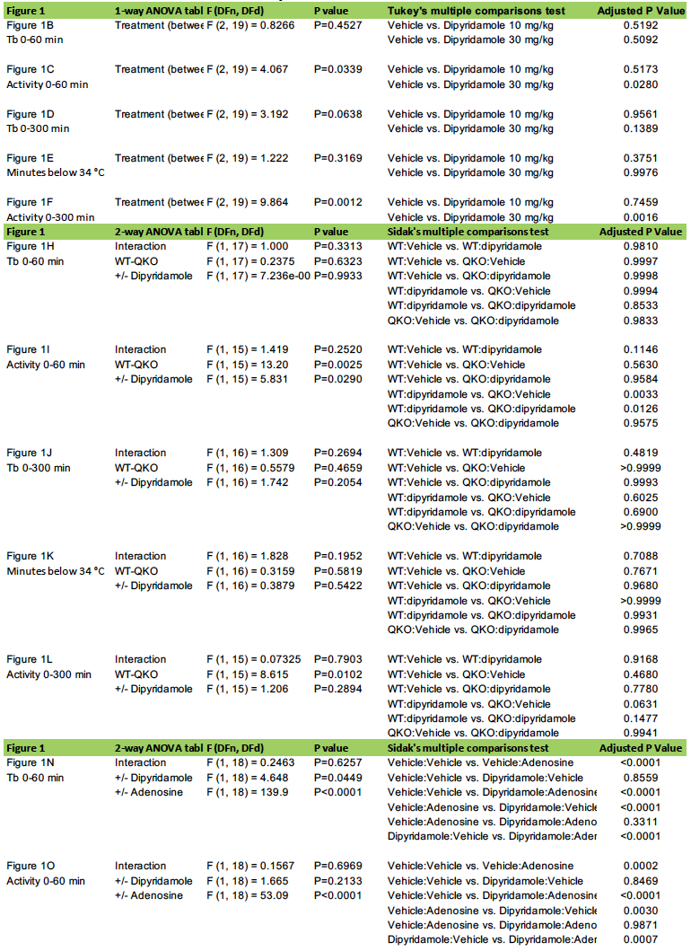
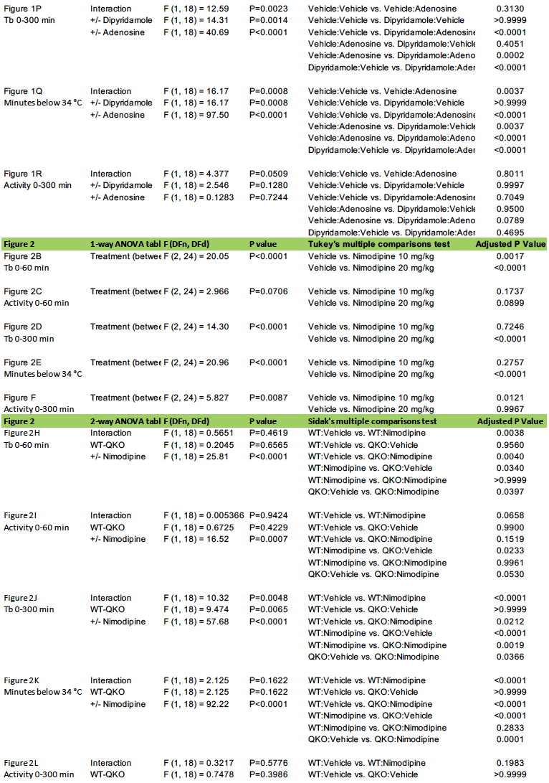
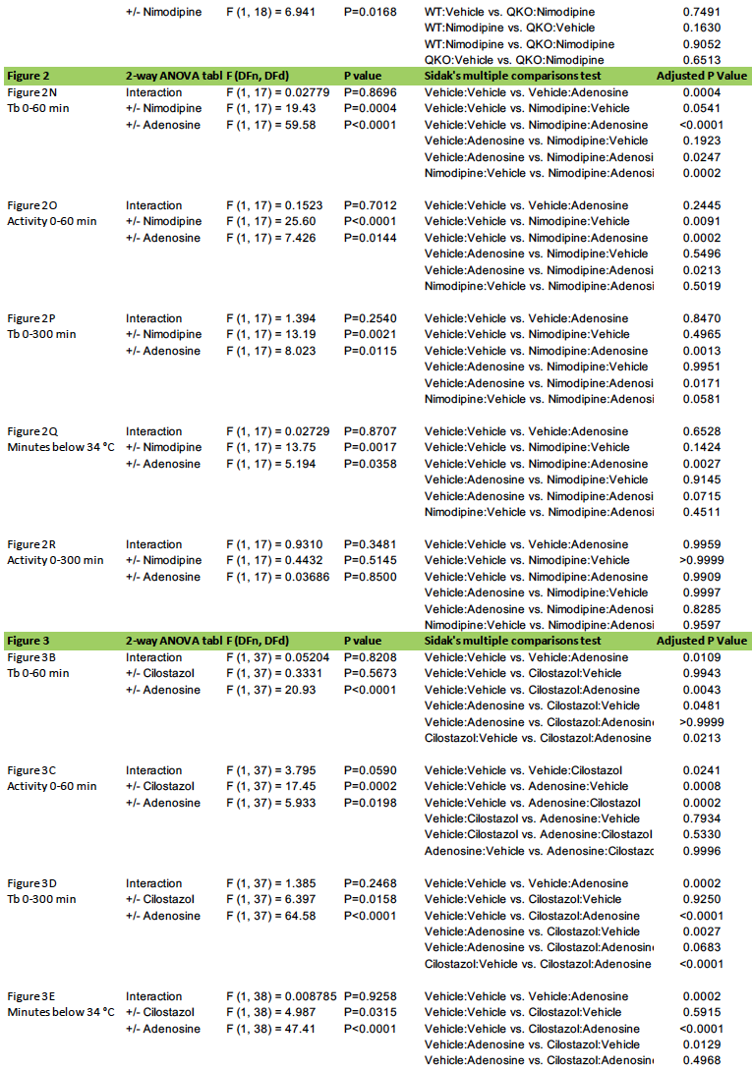
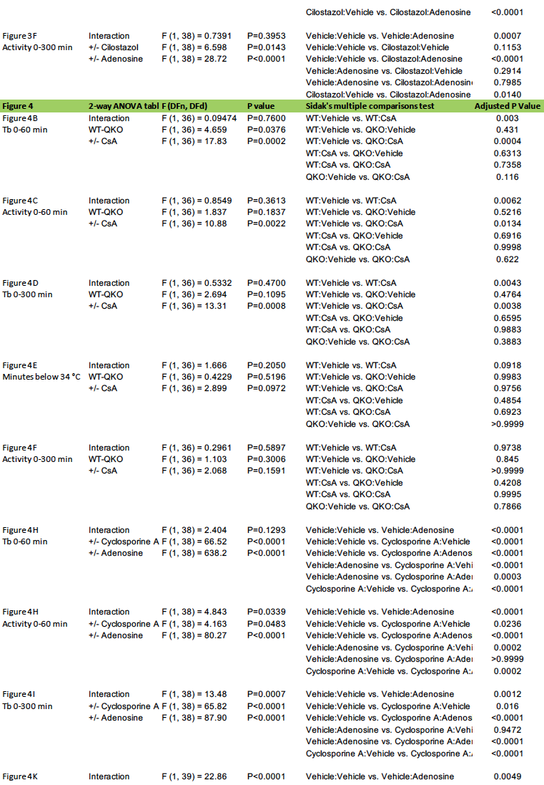
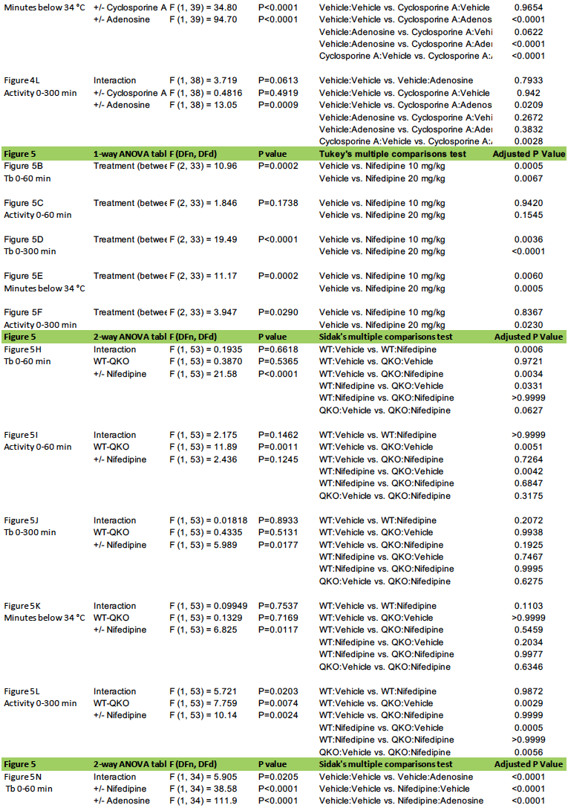
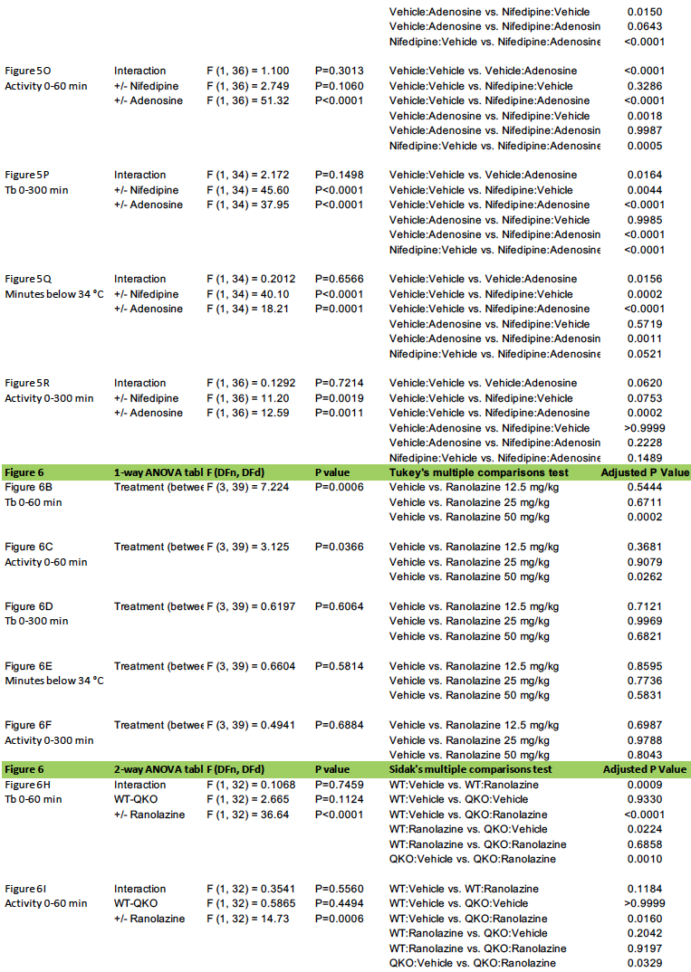
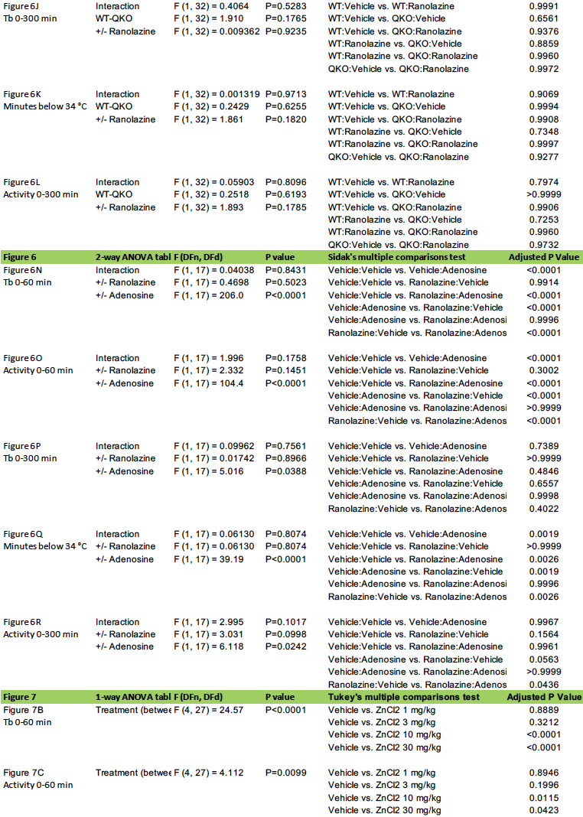
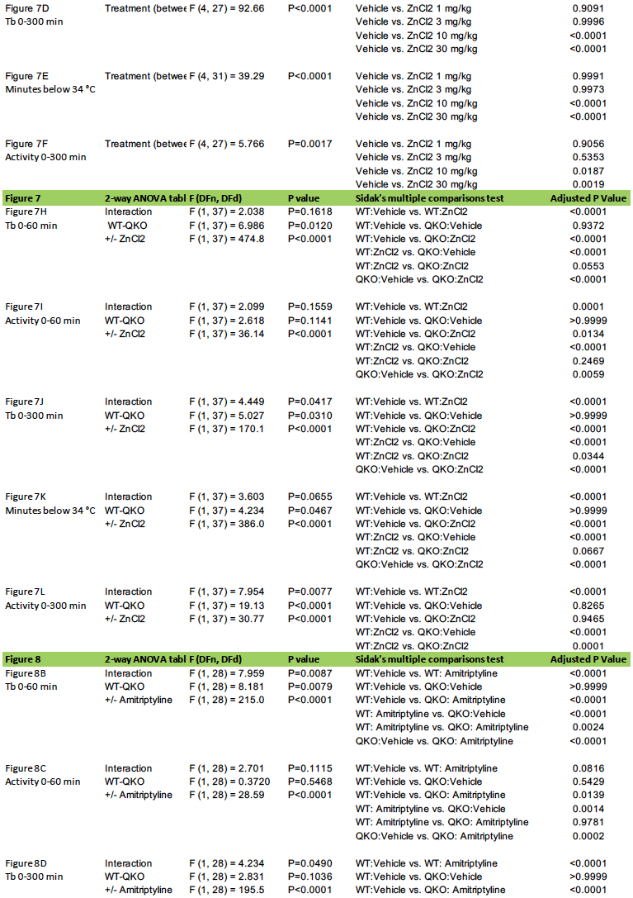
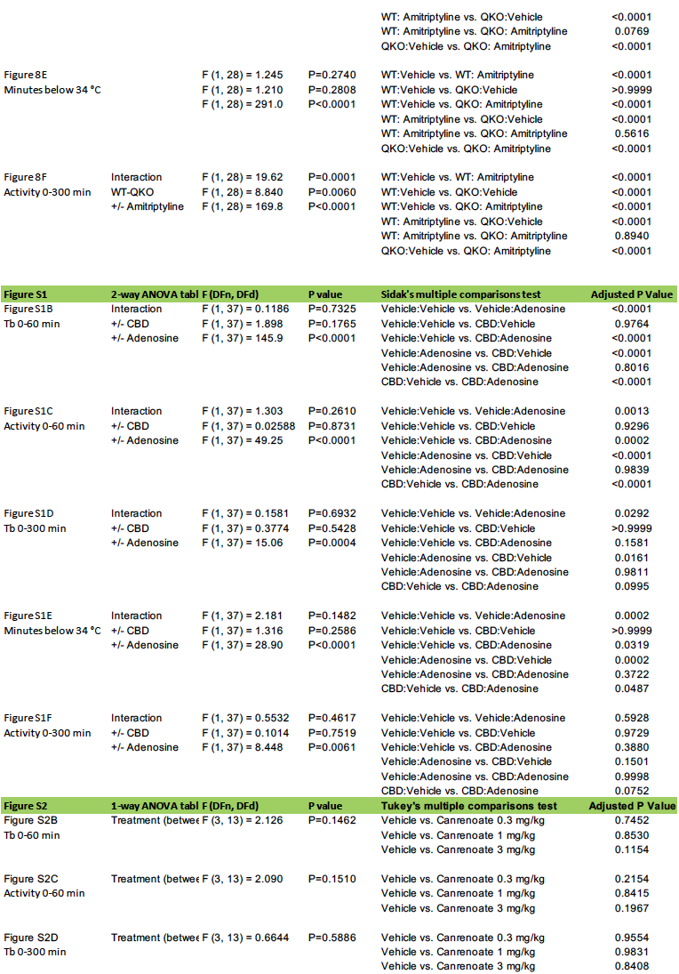
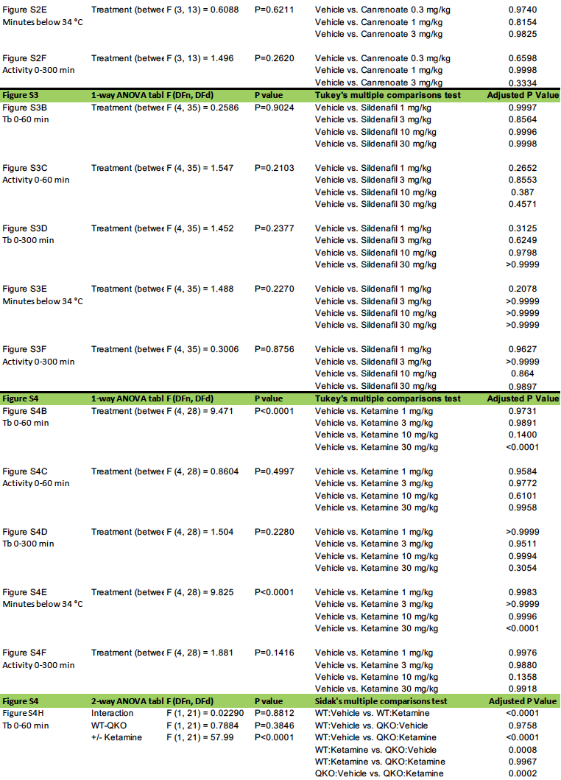
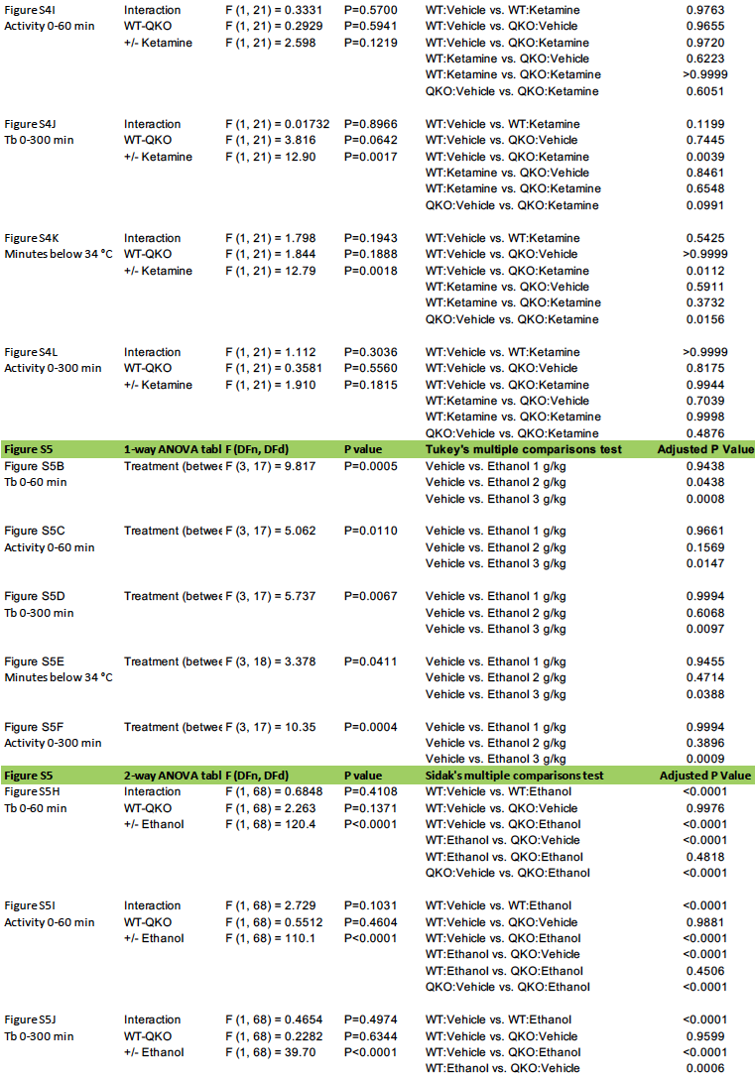
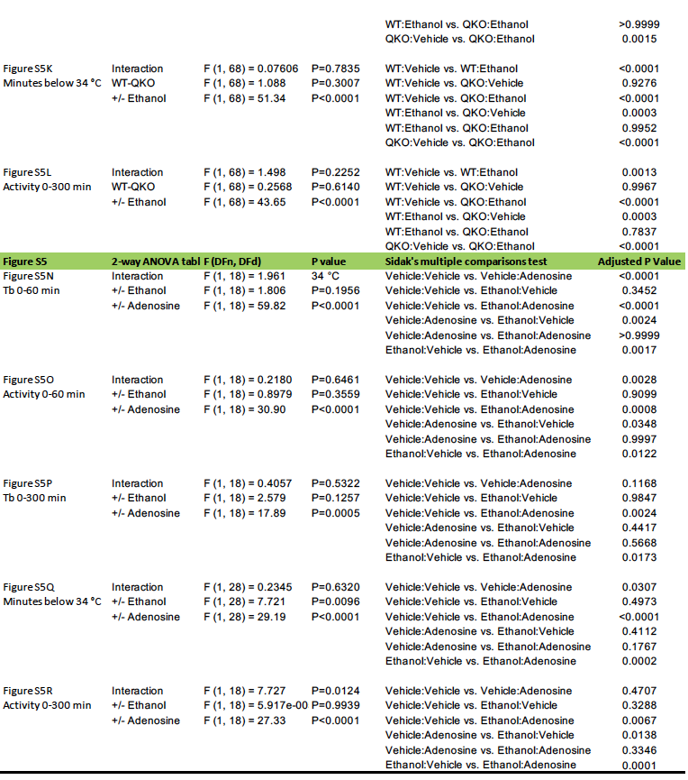

Figures S1 – S5
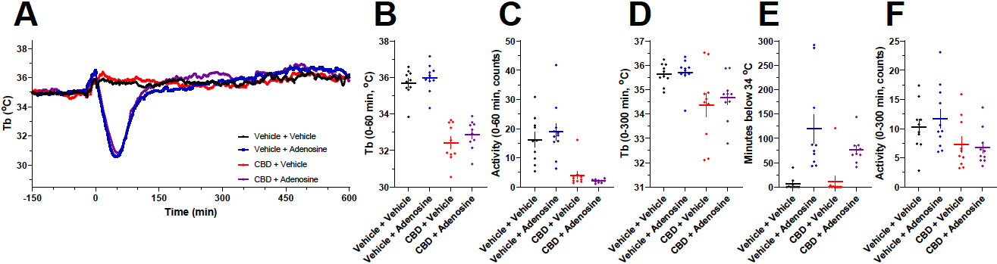
Figure S1. Effects of cannabidiol (10 mg/kg) pretreatment on adenosine (100 mg/kg) induced hypothermia. (A) Time course, (B) mean Tb at 0-60 min, (C) mean activity at 0-60 min, (D) mean Tb at 0-300 min, (E) time below 34 °C, and (F) mean activity at 0-300 min; n=10-11/group. Statistical analyses are in Table S1.

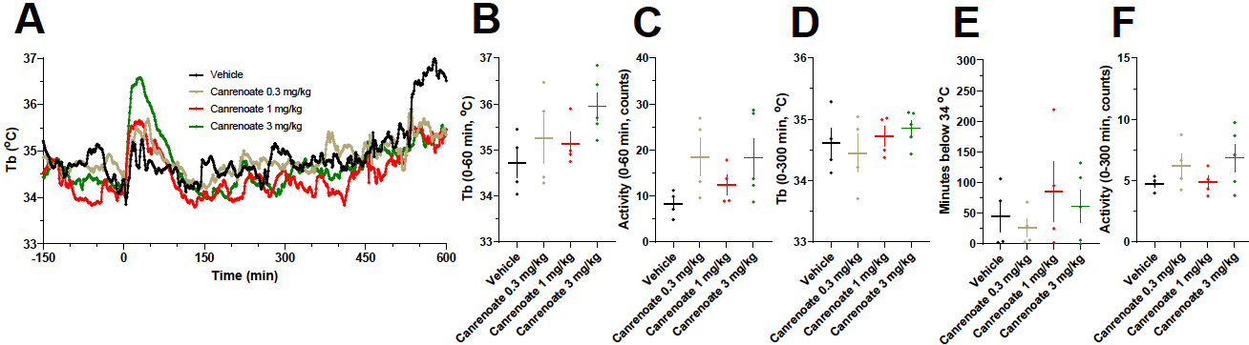
Figure S2. Effects of canrenoate. (A) Vehicle or canrenoate (0.3, 1, or 3 mg/kg) treatment of WT mice. (B) Mean Tb at 0-60 min, (C) mean activity at 0-60 min, (D) mean Tb at 0-300 min, (E) time below 34 °C, and (F) mean activity at 0-300 min; n=4-5/group. Statistical analyses are in Table S2.
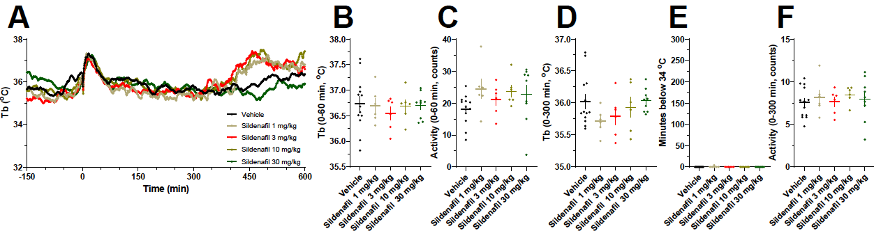
Figure S3. Effects of sildenafil. (A) Vehicle or sildenafil (1, 3, 10 or 30 mg/kg) treatment of WT mice. (B) Mean Tb at 0-60 min, (C) mean activity at 0-60 min, (D) mean Tb at 0-300 min, (E) time below 34 °C, and (F) mean activity at 0-300 min; n=6-13/group. Statistical analyses are in Table S2.
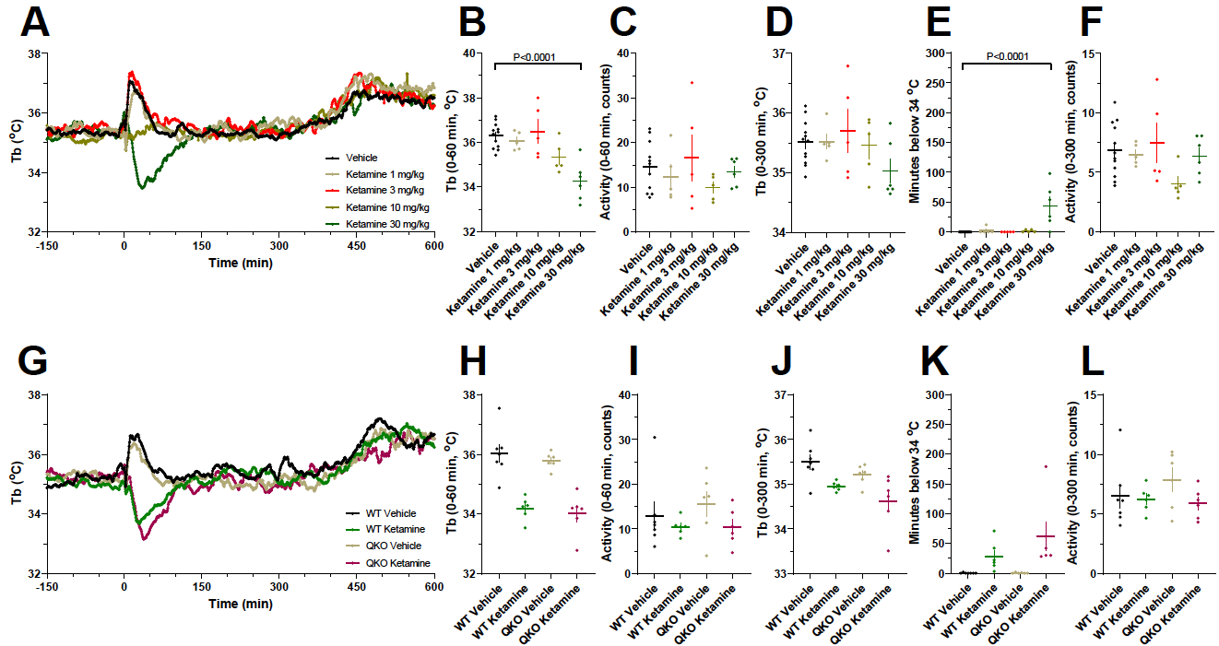
Figure S4. Effects of ketamine. (A) Vehicle or ketamine (1, 3, 10, or 30 mg/kg) treatment of WT mice. (B) Mean Tb at 0-60 min, (C) mean activity at 0-60 min, (D) mean Tb at 0-300 min, (E) time below 34 °C, and (F) mean activity at 0-300 min; n=5-12/group. (G) Treatment of QKO and control mice with ketamine (30 mg/kg). (H) Mean Tb at 0-60 min, (I) mean activity at 0-60 min, (J) mean Tb at 0-300 min, (K) time below 34 °C, and (L) mean activity at 0-300 min; n=6-7/group. Statistical analyses are in Table S2.
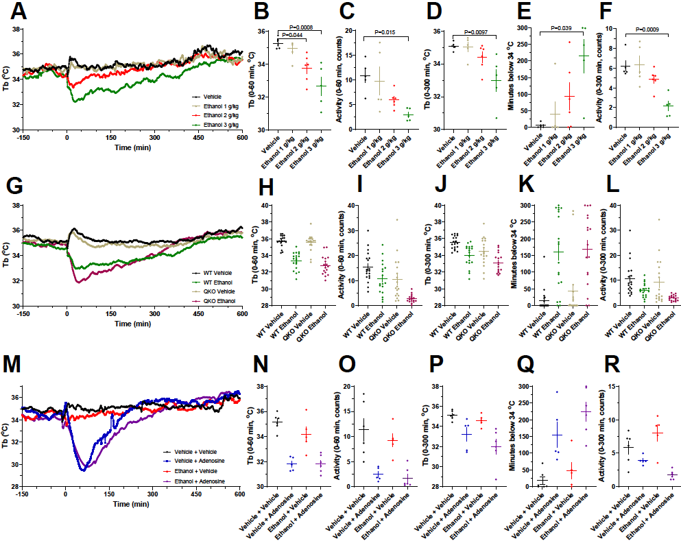
Figure S5. Effects of ethanol. (A) Vehicle or ethanol (1, 2, or 3 g/kg) treatment of WT mice. (B) Mean Tb at 0-60 min, (C) mean activity at 0-60 min, (D) mean Tb at 0-300 min, (E) time below 34 °C, and (F) mean activity at 0-300 min; n=5-6/group. (G) Treatment of QKO and control mice with ethanol (3 g/kg). (H) Mean Tb at 0-60 min, (I) mean activity at 0-60 min, (J) mean Tb at 0-300 min, (K) time below 34 °C, and (L) mean activity at 0-300 min; n=16-18/group. (M) Effect of ethanol (50 mg/kg) pretreatment on adenosine (100 mg/kg) induced hypothermia. (N) Mean Tb at 0-60 min, (O) mean activity at 0-60 min, (P) mean Tb at 0-300 min, (Q) time below 34 °C, and (R) mean activity at 0-300 min; n=5-6/group. Statistical analyses are in Table S2.

