ADDITIONAL MATERIALS
Additional Table 1. Correlative Biomarkers*
Correlative Biomarkers | No. of Studies
PD-L1 expression | 111
Tumor mutational burden | 20
Mutations (sequencing) | 17
TILs | 15
MSI/MMRd | 10
Signatures (gene expression/RNA-based) | 10
CD8 | 8
HPV | 7
PD-L1 mRNA | 3
Blood immune cell phenotypes | 2
Cytokine analysis | 2
miRNA expression | 2
Positive immune score | 1
mRNA immune profiling | 1
ctDNA | 1
CTCs | 1
PD-L2 expression | 1
PD-L2 (ELISA) | 1
NK cell activity | 1
Baseline neutrophil-to-lymphocyte ratio | 1
CCR4 expression | 1
Clonal T-cell expansion | 1
DNA copy alterations | 1
Epigenomic promoter alterations | 1
EBV positivity | 1
HLA zygosity | 1
mutational signature 3 | 1
PAM50 subtype analysis | 1
Myeloid-derived suppressor cells | 1
Plasma angiogenic activity | 1
EBV DNA clearance | 1
T-cell–inflamed gene-expression profile | 1
TCR sequencing | 1
*Prospective biomarkers were not included owing to the limited number of studies (19 of 174, 10.9%) that examined such biomarkers. Many studies included multiple biomarkers; studies were included only if the biomarker-positive versus biomarker-negative subgroups were identified in the study.
Abbreviations: CCR4, C-C motif chemokine receptor 4; CD8, cluster of differentiation 8; CTCs, circulating tumor cells; ctDNA, circulating tumor DNA; EBV, Epstein-Barr virus; HLA, human leukocyte antigen; HPV, human papillomavirus; MMRd, mismatch repair deficiency; MSI, microsatellite instability; NK, natural killer; PD-L1, programmed death-ligand 1; PD-L2, programmed death-ligand 2; TCR, T-cell receptor; TILs, tumor infiltrating lymphocytes

Additional Table 2. Studies and cohorts reporting summaries for correlative analyses of ORR, PFS, and OS
Endpoint | No. of studies | No. of cohorts * | No. of patients | No. of datapoints
ORR | 82 | 123 | 7939 | 11692
PFS | 36 | 46 | 2727 | 3065
OS | 25 | 30 | 2099 | 2256
*Cohorts include outcomes by different drugs, tumor types, and biomarkers. Studies that reported only qualitative summaries with an incomplete outcome summary (e.g., provided the correlation without specific numbers) or missing number of patients were excluded from the analysis.
Abbreviations: ORR, overall response rate; OS, overall survival; PFS, progression-free survival

Additional figure legends
Additional Figure 1. Estimated true ORR for subgroups by agent, tumor type, mono-therapy versus combination therapy, line of therapy, and tumor types associated with response to immunotherapy based on FDA approval status. Line segments show 95% CI. Numbers in parentheses next to the subgroup labels indicate the number of cohorts for each level of the covariates. The figure shows lack of evidence for significant effects of moderators. We carried out mixed-effects model analyses for agent (panel A), tumor type (panel B), mono-therapy versus combination therapy (panel C), line of therapy (panel D), and tumor types that are associated with response to immunotherapy based on FDA approval status (panel E), respectively. The p-values for chi-square omnibus tests for each moderator are shown at the bottom of each panel. None show significant effects.
Additional Figure 2. Estimated true log HR for subgroups by agent, tumor type, mono-therapy versus combination therapy, line of therapy, and tumor types associated with a favorable response to immunotherapy. Line segments show 95% CI. Numbers in parentheses next to the subgroup labels indicate the number of cohorts for each level of the covariates. Note: In some cases, investigators reported separate summaries by biomarkers, drugs, or tumor types. Such reports are treated as separate cohorts and included as separate lines in the forest plot. The figure shows lack of convincing evidence for effects of moderators. We carried out mixed-effects model analyses for agent (panel A), tumor type (panel B), mono-therapy versus combination therapy (panel C), line of therapy (panel D), and tumor types that are associated with response to immunotherapy based on FDA approval status (panel E), respectively. The p-values for chi-square omnibus tests for each moderator are shown at the bottom of each panel. The analysis with tumor type as a moderator shows a nominally significant p-value of p=.00007. This difference across tumor types (p<0.0001) is driven by outliers, including a study in 24 patients with melanoma and correlative studies for two biomarkers. The analysis with therapeutic agent as moderator suggests some evidence for a significant effect, with a p-value of 0.031. However, after multiplicity adjustment for the K=5 tests were carried out this result did not rise to statistical significance.

Additional Figure 1.
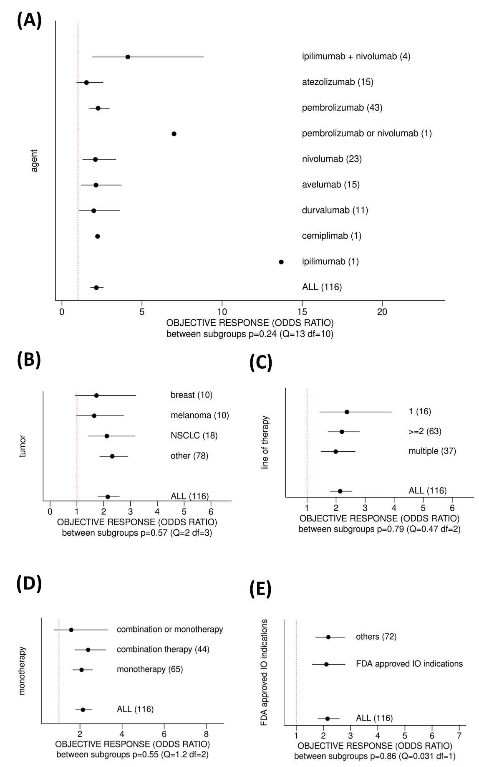

Additional Figure 2.
