Supplemental Materials
Do birds enjoy flying? An analysis of affect after flight in galah (Eolophus roseicapilla)

Contents
FLIGHT CHOICE 3
Dataset: 3
Packages for R 3
R script: Flight Choice 3
COGNITIVE BIAS 4
Datasets: 4
Packages for R 5
R script: Rescaling data 6
R script: Cognitive bias 8
R script: Model CBT near S++ 11
R script: Model CBT 50% 14
R script: Model CBT near S+ 17
BEHAVIOUR 20
Ethogram 20
Behaviour Analysis 24
Packages for R 24
GCMs 29
ELISA Manual 29
Dataset 29
R script: Wilcoxon signed ranks test GCM 29
R script: Model GCM 29
Figure S1 34
Figure S2 34

FLIGHT CHOICE

Dataset:
DATA.flightchoice.proportion

Shows the proportion of possible flight events in which each individual chose to fly 'Flight.chosen.proportion' and the proportion which they chose not to fly 'Flight.not.chosen.proportion’

Packages for R
library(readxl)
library(ggplot2)
library(reshape)
library(data.table)

R script: Flight Choice

DATA.flightchoice.proportion

random.chance <- rep(0.5,17)

DATA.flight.chance <- data.frame(DATA.flightchoice.proportion$Individual,DATA.flightchoice.proportion$Flight.chosen.proportion,random.chance)
colnames(DATA.flight.chance) <- c(“ID”, “Flight.chosen”, “Random” )

LONG.flight.chance <- melt(setDT(DATA.flight.chance), id.vars = c(“ID”),variable.name = “Flight.v.random” )

wilcox.test(LONG.flight.chance$value[LONG.flight.chance$Flight.v.random == “Flight.chosen”], LONG.flight.chance$value[LONG.flight.chance$Flight.v.random == “Random”], paired = T)
V = 153, p-value = 8.901e-05

COGNITIVE BIAS

Datasets:
- DATA.CBT.prop.opt : Each individual has one measurement for flight, one for non-flight, and one overall, showing the proportion of optimistic choices per cue (S++, NS++, S+, NS+ and 50%)
  - Split into separate datasets for flight (DATA.CBT.prop.FLY), non-flight (DATA.CBT.prop.NOFLY), overall / no distinction (DATA.CBT.prop.ND), and both flight and non-flight (DATA.CBT.prop.FLY.NOFLY), then each turned into a long dataset.
  - Also split by cue, then per cue per flight condition (Amb50, Amb50.FLY, Amb50.NOFLY etc.)
- Dataset: Table ‘Xp’ includes:
  - Date yyyy-mm-dd
  - Day Continuous days, starting from the 25th feb ‘21
  - ID Individual bird
  - Amb50 CBT 50%
  - Amb++ CBT near S++
  - Amb+ CBT near S+
  - Sample ID Individual fecal sample number
  - GCM Glucocorticoid metabolites in feces (ng/g feces)
  - Cort2 Glucocorticoid metabolites in feces (pg/g feces)
  - Fly If they flew that specific day (1= flight, 0=no flight)
  - Fly cont How long in a row they did or did not fly:
          - Did not fly X number of days (-X)
          - Did fly X number of days (X)
  - Datetime yyyy-mm-dd
  - Temp temperature in degrees Celsius
  - Precip precipitation in mm per day
  - Daylighthours number of daylight per day in hours
  - Humidity relative humidity (%)
  - Windgust speed in kph
  - Windspeed speed in kph
  - Sunrise yyyy-mm-dd hh-mm-ss UTC
  - Sunset yyyy-mm-dd hh-mm-ss UTC

Packages for R

library(readxl)
library(MuMIn)
library(lme4)
library(parallel)
library(doParallel)
library(ggplot2)
library(ggpubr)
require(EnvStats)
library(data.table)
library(knitr)
library(rmarkdown)
library(tools)
library(tidyverse)
library(latexpdf)
library(lpSolve)
library(irr)
library(nlme)
library(ggnewscale)
library(effects)
library(gridExtra)
library(hrbrthemes)
library(viridisLite)
library(viridis)
library(jtools)
library(gridExtra)
library(readr)
library(data.table)
library(lmerTest)
library(writexl)
library(corrgram)
library(glmmTMB)
library(performance)
library(lattice)
library(pscl)
library(broom)
library(gmodels)
library(DHARMa)

R script: Rescaling data

#rescale data: Xp --> Yp
#to make the model less complex for R

Xp <- read_excel("…") #load table

Yp<- Xp

Xp.means <- lapply(Xp[,c(8, 11, 13:17, 20)], FUN = mean, na.rm = T)
view(Xp.means)

DFXp.means <- data.frame(Xp.means)

Xp.sd <- lapply(Xp[,c(8, 11, 13:17, 20)], FUN = sd, na.rm = T)

DFXp.sd <- data.frame(Xp.sd)

Yp.means <- lapply(Yp[,c(8, 11, 13:17, 20)], FUN = mean, na.rm = T)
DFYp.means <- data.frame(Yp.means)

Yp.sd <- lapply(Yp[,c(8, 11, 13:17, 20)], FUN = sd, na.rm = T)
DFYp.sd <- data.frame(Yp.sd)

#for loop to make table:

i=1

Zp<- Xp[, c(8, 11, 13:17, 20)] #Y=x

for(i in 1:8){if(colnames(Zp)[i] == colnames(DFXp.means)[i]){
Zp[,i] <- Zp[,i]-DFXp.means[,i]
Zp[,i] <- Zp[,i]/DFXp.sd[,i]}}

Yp[,c(8, 11, 13:17, 20)] <- Zp[,c(1:8)]

view(Yp)

#----------------------------
Y.paper.DT<- data.table(Yp)

YAB <-Y.paper.DT[ID == "AB"]
YBO <-Y.paper.DT[ID == "BO"]
YBR <-Y.paper.DT[ID == "BR"]
YGR <-Y.paper.DT[ID == "GR"]
YKL <-Y.paper.DT[ID == "KL"]
YLB <-Y.paper.DT[ID == "LB"]
YLT <-Y.paper.DT[ID == "LT"]
YMO <-Y.paper.DT[ID == "MO"]
YPB <-Y.paper.DT[ID == "PB"]
YRP <-Y.paper.DT[ID == "RP"]
YTE <-Y.paper.DT[ID == "TE"]
YTJ <-Y.paper.DT[ID == "TJ"]
YZP <-Y.paper.DT[ID == "ZP"]
YZM <-Y.paper.DT[ID == "ZM"]

Y <- rbind(YAB, YBO, YBR, YGR, YKL, YLB, YLT, YMO, YPB, YRP, YTE, YTJ, YZP, YZM)

# remove NA GCM
Y.GCM <- Y %>% drop_na(`Sample ID`)

#remove NA CBT
Y.CBT <- Y %>% drop_na(`Amb++`)

#remove NA CBT & GCM
Y.GCM.CBT <- Y.CBT %>% drop_na(`Sample ID`)

R script: Cognitive bias

DATA.CBT.prop.opt <- read_excel(…)

DATA.CBT.prop.ND <-DATA.CBT.prop.opt[1:11,2:7]

DATA.CBT.prop.FLY<- DATA.CBT.prop.opt[12:22,2:7]

DATA.CBT.prop.NOFLY<-DATA.CBT.prop.opt[23:33,2:7]

DATA.CBT.prop.FLY.NOFLY<-DATA.CBT.prop.opt[12:33,]

long.CBT.prop <-melt(setDT(DATA.CBT.prop.FLY.NOFLY), id.vars = c("ID","FLIGHT"), variable.name = "CHOICE")

long.CBT.prop.ND <-melt(setDT(DATA.CBT.prop.ND), id.vars = c("ID"), variable.name = "CHOICE")

long.CBT.prop.FLY <-melt(setDT(DATA.CBT.prop.FLY), id.vars = c("ID"), variable.name = "CHOICE")

long.CBT.prop.NOFLY <-melt(setDT(DATA.CBT.prop.NOFLY), id.vars = c("ID"), variable.name = "CHOICE")

wilcox.test(long.CBT.prop.FLY[12:44]$value,long.CBT.prop.NOFLY[12:44]$value, paired = T)
# p-value = 0.8204 V = 228.5

ggplot(long.CBT.prop, aes(x=CHOICE, y=value, fill=FLIGHT)) +
geom_boxplot() +
labs(title = "Proportion of optimistic choices made per background cue, no flight vs flight, n = 11", x = "Background cue", y = "Proportion of positive choices") +
theme(axis.line=element_line(color="black"))

ggplot(data = long.CBT.prop.ND, aes(x = CHOICE, y = value, group = ID)) + scale_y_continuous(expand = c(0, 0), limits = c(0, 1.01))+ geom_line(aes(colour = ID)) + labs(y="Proportion of positive choices", x="Background cue",title="Proportion of positive choices per background cue for each individual, no distinction made on flight")

##significance for each ambiguous cue

## All ambiguous cues together
# First have to split flight and non flight

NearSplusplus.FLY <- long.CBT.prop[23:33]
Amb50.FLY <- long.CBT.prop[45:55]
NearSplus.FLY <- long.CBT.prop[67:77]

long.CBT.prop.amb.FLY <- rbind(NearSplusplus.FLY,Amb50.FLY,NearSplus.FLY)

NearSplusplus.NOFLY <- long.CBT.prop[34:44]
Amb50.NOFLY <- long.CBT.prop[56:66]
NearSplus.NOFLY <- long.CBT.prop[78:88]

long.CBT.prop.amb.NOFLY <- rbind(NearSplusplus.NOFLY,Amb50.NOFLY,NearSplus.NOFLY)

wilcox.test(long.CBT.prop.amb.FLY$value,long.CBT.prop.amb.NOFLY$value, paired = T)
#p-value = 0.8204 V = 228.5

#significance for Amb++
wilcox.test(long.CBT.prop[23:33]$value,long.CBT.prop[34:44]$value, paired = T)
#p-value = 0.8334 V = 20

# direction?
NearSplusplus <- long.CBT.prop[23:44]

ggplot(NearSplusplus) +
aes(x = FLIGHT, y = value) +
geom_boxplot(fill = "#0c4c8a") +
labs(title = "Difference between optimistic choices, flight v non flight on Amb++ cue, n = 11", x = "Flight status", y = "Positive choices")

#significance for 50%
wilcox.test(long.CBT.prop[45:55]$value,long.CBT.prop[56:66]$value, paired=T)
## p value = 0.5935 V = 39.5

# direction?
Amb50 <- long.CBT.prop[45:66]

ggplot(Amb50) +
aes(x = FLIGHT, y = value) +
geom_boxplot(fill = "#0c4c8a") +
labs(title = "Difference between optimistic choices, flight v non flight on Amb++ cue, n = 11", x = "Flight status", y = "Positive choices")

#significance for Amb+
wilcox.test(long.CBT.prop[67:77]$value,long.CBT.prop[78:88]$value, paired = T)
#p= 0.5746 V = 21.5

# direction?
NearSplus <- long.CBT.prop[67:88]

ggplot(NearSplus) +
aes(x = FLIGHT, y = value) +
geom_boxplot(fill = "#0c4c8a") +
labs(title = "Difference between optimistic choices, flight v non flight on Amb+ cue, n = 11", x = "Flight status", y = "Positive choices")

## Line graphs used in manuscript

#No distinction made on flight

ggline(long.CBT.prop.ND, x = "CHOICE", y = "value", desc_stat = "mean_se",error.plot = "errorbar", add = "mean_se",palette = c("Black"), position = position_dodge(0)) +
labs(title = "Average Optimistic choices per background cue, no distinction on flight, n = 11",x = "Background cue", y = "Proportion of optimistic choices") +
theme_gray()+theme(axis.line=element_line(color="black"))

# Flight v Non-flight

ggline(long.CBT.prop, x = "CHOICE", y = "value",
desc_stat = "mean_se", error.plot = "errorbar",add = "mean_se",
color = "FLIGHT", position = position_dodge(0)) +
labs(title = "Average Optimistic choices per background cue, Flight and Non-flight, n= 11",
x = "Background cue", y = "Proportion of optimistic choices") + theme_gray()+theme(axis.line=element_line(color="black"))

R script: Model CBT near S++

options(ggrepel.max.overlaps = Inf)

Model.ALL.ambplusplus <- glmmTMB(`Amb++` ~ Day + FLY + FLYcont + (1|ID) + GCM + temp + precip + daylighthours + humidity + windgust + windspeed, data = Y.GCM.CBT, family = binomial)
res.ambplusplus = simulateResiduals(Model.ALL.ambplusplus)
plot(res.ambplusplus, rank = T)
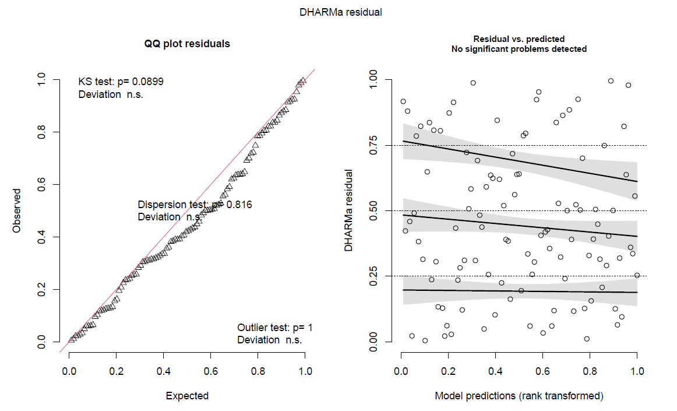
summary(Model.ALL.ambplusplus)
Family: binomial ( logit )
Formula: `Amb++` ~ Day + FLY + FLYcont + (1 | ID) + GCM + temp + precip + daylighthours + humidity + windgust + windspeed
Data: Y.GCM.CBT
AIC | BIC | logLik | deviance | df.resid
105.8 | 138.0 | -40.9 | 81.8 | 96
Random effects:
Conditional model:
Groups | Name | Variance | Std.Dev.
ID | (Intercept) | 1,79E-06 | 4,23E-02
Number of obs: 108, groups: ID, 11
Conditional model:
 | Estimate | Std. Error | z value | Pr(>|z|)
(Intercept) | -48.062 | 87.973 | -0.546 | 0.5848
Day | 0.1026 | 0.1500 | 0.684 | 0.4938
FLY1 | -0.6624 | 0.8676 | -0.764 | 0.4451
FLYcont | 28.827 | 36.663 | 0.786 | 0.4317
GCM | 0.3762 | 0.3333 | 1.129 | 0.2590
temp | 0.9054 | 0.9615 | 0.942 | 0.3463
precip | 11.162 | 0.4797 | 2.327 | 0.0200 *
daylighthours | -53.348 | 53.751 | -0.993 | 0.3210
humidity | -0.2441 | 0.4226 | -0.578 | 0.5636
windgust | 21.785 | 13.076 | 1.666 | 0.0957 .
windspeed | -23.896 | 12.916 | -1.850 | 0.0643 .
---
Signif. codes: 0 ‘***’ 0.001 ‘**’ 0.01 ‘*’ 0.05 ‘.’ 0.1 ‘ ’ 1
Model.ALL.ambplusplus.0 <- glmmTMB(`Amb++` ~ (1|ID), data = Y.GCM.CBT, family = binomial)
anova(Model.ALL.ambplusplus, Model.ALL.ambplusplus.0 )
Data: Y.GCM.CBT
Models:
Model.ALL.ambplusplus.0: `Amb++` ~ (1 | ID), zi=~0, disp=~1
Model.ALL.ambplusplus: `Amb++` ~ Day + FLY + FLYcont + (1 | ID) + GCM + temp + precip + , zi=~0, disp=~1
Model.ALL.ambplusplus: daylighthours + humidity + windgust + windspeed, zi=~0, disp=~1
 | Df | AIC | BIC | logLik | deviance | Chisq Chi | Df | Pr(>Chisq)
Model.ALL.ambplusplus.0 | 2 | 98.035 | 103.4 | -47.017 | 94.035
Model.ALL.ambplusplus | 12 | 105.813 | 138.0 | -40.907 | 81.813 | 12.222 | 10 | 0.2705

Model.ALL.ambplusplus.1 <- glmmTMB(`Amb++` ~ FLY + FLYcont + (1|ID)+ GCM + precip + daylighthours + humidity + windgust , data = Y.GCM.CBT, family = binomial)
check_collinearity(Model.ALL.ambplusplus.1) #removed during: Day + windspeed + temp
#check assumptions again:
res.ambplusplus.1 = simulateResiduals(Model.ALL.ambplusplus.1)
plot(res.ambplusplus.1, rank = T)
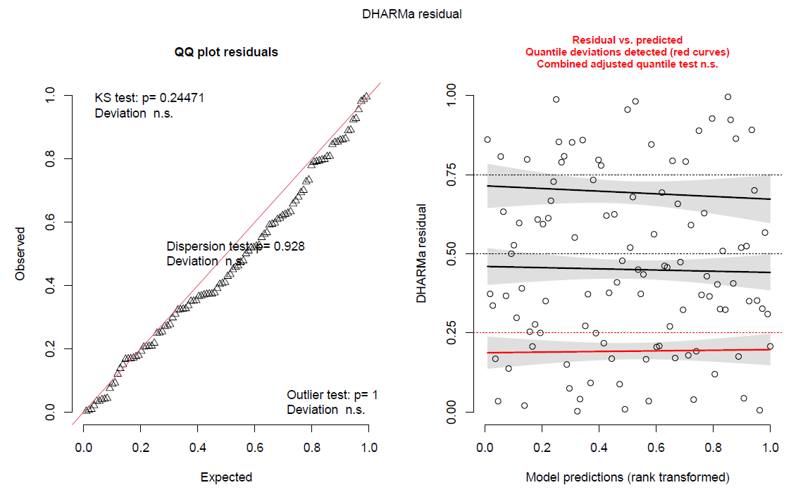
summary(Model.ALL.ambplusplus.1)
Family: binomial ( logit )
Formula: `Amb++` ~ FLY + FLYcont + (1 | ID) + GCM + precip + daylighthours + humidity + windgust
Data: Y.GCM.CBT
AIC | BIC | logLik | deviance | df.resid
107.4 | 131.6 | -44.7 | 89.4 | 99
Random effects:
Conditional model:
 | Groups | Name | Variance | Std.Dev.
 | ID | (Intercept) | 1.03e-08 | 0.0001015
Number of obs: 108, groups: ID, 11
Conditional | model:
 | Estimate | Std. Error | z value | Pr(>|z|)
(Intercept) | 0.98484 | 214.432 | 0.459 | 0.646
FLY1 | 0.08431 | 0.71907 | 0.117 | 0.907
FLYcont | 0.72703 | 313.210 | 0.232 | 0.816
GCM | 0.33995 | 0.32626 | 1.042 | 0.297
precip | 0.75419 | 0.42218 | 1.786 | 0.074 .
daylighthours | 0.10371 | 0.69111 | 0.150 | 0.881
humidity | -0.39305 | 0.34344 | -1.144 | 0.252
windgust | -0.38880 | 0.30442 | -1.277 | 0.202
---
Signif. codes: 0 ‘***’ 0.001 ‘**’ 0.01 ‘*’ 0.05 ‘.’ 0.1 ‘ ’ 1

R script: Model CBT 50%

options(ggrepel.max.overlaps = Inf)

Model.ALL.amb50 <- glmmTMB(Amb50 ~ Day + FLY + FLYcont + (1|ID) + GCM + temp + precip + daylighthours + humidity + windgust + windspeed, data = Y.GCM.CBT, family = binomial)
res.amb50 = simulateResiduals(Model.ALL.amb50)
plot(res.amb50, rank = T)
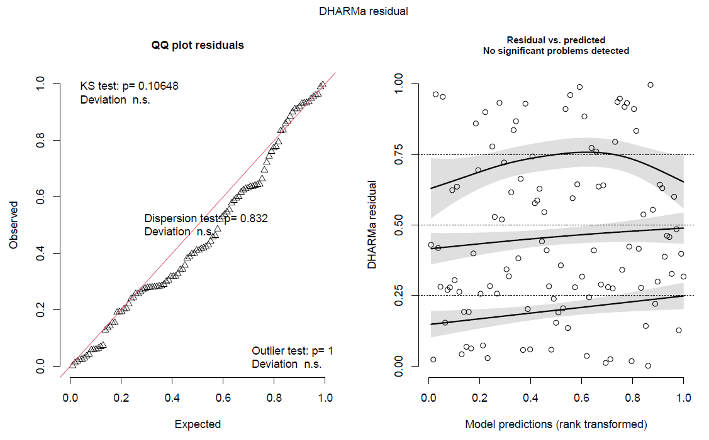
summary(Model.ALL.amb50)
Family: binomial ( logit )
Formula: `Amb++` ~ FLY + FLYcont + (1 | ID) + GCM + precip + daylighthours + humidity + windgust
Data: Y.GCM.CBT
AIC | BIC | logLik | deviance | df.resid
149.8 | 182.0 | -62.9 | 125.8 | 96
Random effects:
Conditional model:
 | Groups | Name | Variance | Std.Dev.
 | ID | (Intercept) | 0.6137 | 0.7834
Number of obs: 108, groups: ID, 11
Conditional | model:
 | Estimate | Std. Error | z value | Pr(>|z|)
(Intercept) | -1.107.491 | 669.165 | -1.655 | 0.0979 | .
Day | 0.13178 | 0.11138 | 1.183 | 0.2367
FLY1 | -0.60151 | 0.68250 | -0.881 | 0.3781
FLYcont | 782.223 | 349.342 | 2.239 | 0.0251 | *
GCM | -0.29080 | 0.29173 | -0.997 | 0.3188
temp | -0.16506 | 0.68096 | -0.242 | 0.8085
precip | -0.33351 | 0.31893 | -1.046 | 0.2957
daylighthours | -693.476 | 412.578 | -1.681 | 0.0928 | .
humidity | -0.04828 | 0.33185 | -0.146 | 0.8843
windgust | 0.21661 | 0.92350 | 0.235 | 0.8146
windspeed | 0.15677 | 0.87734 | 0.179 | 0.8582
---
Signif. codes: 0 ‘***’ 0.001 ‘**’ 0.01 ‘*’ 0.05 ‘.’ 0.1 ‘ ’ 1

Model.ALL.amb50.0 <- glmmTMB(Amb50 ~ (1|ID), data = Y.GCM.CBT, family = binomial)
anova(Model.ALL.amb50, Model.ALL.amb50.0 )
Data: Y.GCM.CBT
Models:
Model.ALL.amb50.0: Amb50 ~ (1 | ID), zi=~0, disp=~1
Model.ALL.amb50: Amb50 ~ Day + FLY + FLYcont + (1 | ID) + GCM + temp + precip + , zi=~0, disp=~1
Model.ALL.amb50: daylighthours + humidity + windgust + windspeed, zi=~0, disp=~1
 | Df | AIC | BIC | logLik | deviance | Chisq Chi | Df | Pr(>Chisq)
Model.ALL.amb50.0 | 2 | 150.43 | 155.79 | -73.215 | 146.43
Model.ALL.amb50 | 12 | 149.84 | 182.02 | -62.919 | 125.84 | 20.594 | 10 | 0.02411 | *
---
Signif. codes: 0 ‘***’ 0.001 ‘**’ 0.01 ‘*’ 0.05 ‘.’ 0.1 ‘ ’ 1

Model.ALL.amb50.1 <- glmmTMB(Amb50 ~ FLY + FLYcont + (1|ID) + GCM + temp + precip + daylighthours + humidity + windgust , data = Y.GCM.CBT, family = binomial)
check_collinearity(Model.ALL.amb50.1) #removed during: Day + windspeed
#check assumptions again:
res.amb50.1 = simulateResiduals(Model.ALL.amb50.1)
plot(res.amb50.1, rank = T)
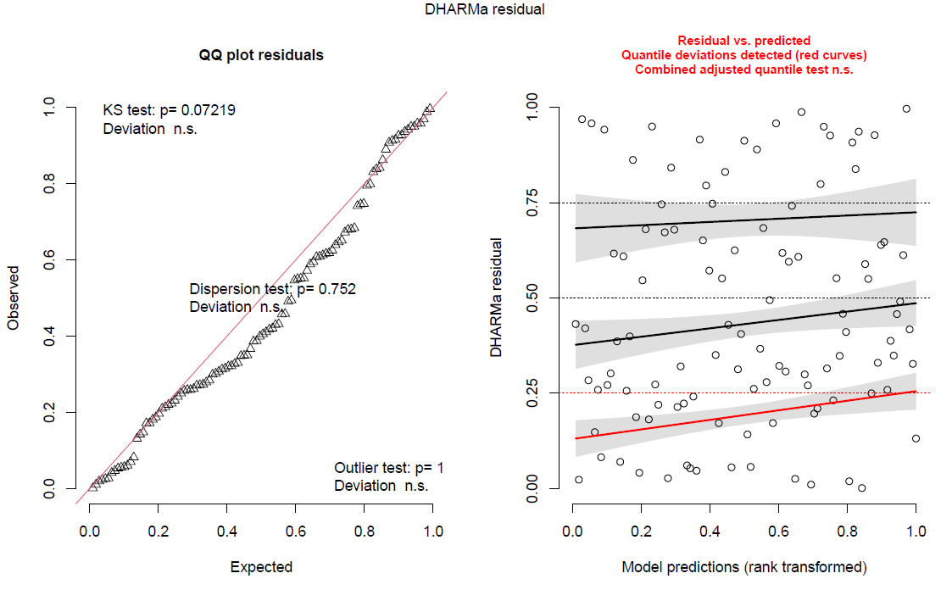
summary(Model.ALL.amb50.1)
Family: binomial ( logit )
Formula: Amb50 ~ FLY + FLYcont + (1 | ID) + GCM + temp + precip + daylighthours + humidity + windgust
Data: Y.GCM.CBT
AIC | BIC | logLik | deviance | df.resid
147.4 | 174.3 | -63.7 | 127.4 | 98
Random effects:
Conditional model:
 | Groups | Name | Variance | Std.Dev.
 | ID | (Intercept) | 0.7376 | 0.8588
Number of obs: 108, groups: ID, 11
Conditional model:
 | Estimate | Std. Error | z value | Pr(>|z|)
(Intercept) | -418.989 | 225.718 | -1.856 | 0.0634 | .
FLY1 | -0.47465 | 0.60443 | -0.785 | 0.4323
FLYcont | 779.017 | 330.070 | 2.360 | 0.0183 | *
GCM | -0.28557 | 0.28714 | -0.995 | 0.3200
temp | 0.07746 | 0.58682 | 0.132 | 0.8950
precip | -0.35052 | 0.31836 | -1.101 | 0.2709
daylighthours | -218.085 | 116.295 | -1.875 | 0.0608 | .
humidity | -0.15000 | 0.32524 | -0.461 | 0.6446
windgust | 0.31146 | 0.27542 | 1.131 | 0.2581
---
Signif. codes: 0 ‘***’ 0.001 ‘**’ 0.01 ‘*’ 0.05 ‘.’ 0.1 ‘ ’ 1

R script: Model CBT near S+

options(ggrepel.max.overlaps = Inf)

Model.ALL.ambplus <- glmmTMB(`Amb+` ~ Day + FLY + FLYcont + (1|ID) + GCM + temp + precip + daylighthours + humidity + windgust + windspeed, data = Y.GCM.CBT, family = binomial)
res.ambplus = simulateResiduals(Model.ALL.ambplus)
plot(res.ambplus, rank = T)
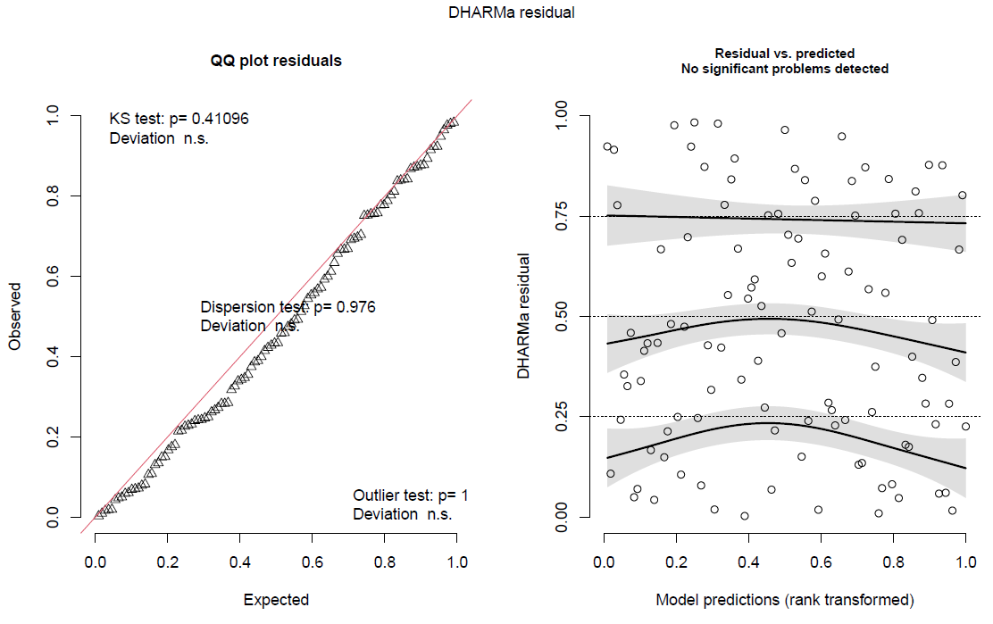
summary(Model.ALL.ambplus)
Family: binomial ( logit )
Formula: `Amb+` ~ Day + FLY + FLYcont + (1 | ID) + GCM + temp + precip + daylighthours + humidity + windgust + windspeed
Data: Y.GCM.CBT
AIC | BIC | logLik | deviance | df.resid
120.1 | 152.3 | -48.0 | 96.1 | 96
Random effects:
Conditional model:
 | Groups | Name | Variance | Std.Dev.
 | ID | (Intercept) | 8,85E-06 | 9,41E-02
Number of obs: 108, groups: ID, 11
Conditional model:
 | Estimate | Std. Eror | z value | Pr(>|z|)
(Intercept) | 252.236 | 764.616 | 0.330 | 0.741
Day | -0.07250 | 0.13032 | -0.556 | 0.578
FLY1 | -0.29881 | 0.80717 | -0.370 | 0.711
FLYcont | -0.77787 | 331.406 | -0.235 | 0.814
GCM | 0.08029 | 0.28816 | 0.279 | 0.781
temp | -0.10193 | 0.76958 | -0.132 | 0.895
precip | -0.21373 | 0.34387 | -0.622 | 0.534
daylighthours | 333.284 | 480.364 | 0.694 | 0.488
humidity | 0.42692 | 0.38672 | 1.104 | 0.270
windgust | -0.60471 | 101.962 | -0.593 | 0.553
windspeed | 0.53589 | 101.507 | 0.528 | 0.598

Model.ALL.ambplus.0 <- glmmTMB(`Amb+` ~ (1|ID), data = Y.GCM.CBT, family = binomial)
anova(Model.ALL.ambplus, Model.ALL.ambplus.0 )
Data: Y.GCM.CBT
Models:
Model.ALL.ambplus.0: `Amb+` ~ (1 | ID), zi=~0, disp=~1
Model.ALL.ambplus: `Amb+` ~ Day + FLY + FLYcont + (1 | ID) + GCM + temp + precip + , zi=~0, disp=~1
Model.ALL.ambplus: daylighthours + humidity + windgust + windspeed, zi=~0, disp=~1
 | Df | AIC | BIC | logLik | deviance | Chisq Chi | Df | Pr(>Chisq)
Model.ALL.ambplus.0 | 2 | 104.47 | 109.84 | -50.237 | 100.47
Model.ALL.ambplus | 12 | 120.08 | 152.27 | -48.040 | 96.08 | 43.943 | 10 | 0.9278

Model.ALL.ambplus.1 <- glmmTMB(`Amb+` ~ FLY + FLYcont + (1|ID) + GCM + temp + precip + daylighthours + humidity + windgust , data = Y.GCM.CBT, family = binomial)
check_collinearity(Model.ALL.ambplus.1) #removed during: Day + windspeed
#check assumptions again:
res.ambplus.1 = simulateResiduals(Model.ALL.ambplus.1)
plot(res.ambplus.1, rank = T)
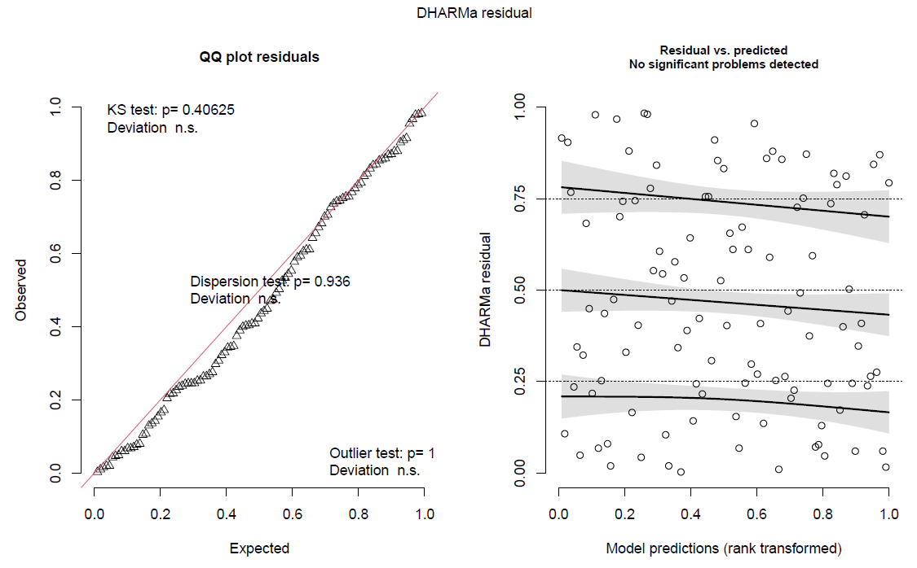
summary(Model.ALL.ambplus.1)
Family: binomial ( logit )
Formula: `Amb+` ~ FLY + FLYcont + (1 | ID) + GCM + temp + precip + daylighthours + humidity + windgust
Data: Y.GCM.CBT
AIC | BIC | logLik | deviance | df.resid
116.6 | 143.4 | -48.3 | 96.6 | 98
Random effects:
Conditional model:
 | Groups | Name | Variance | Std.Dev.
 | ID | (Intercept) | 8,42E-06 | 9,18E-02
Number of obs: 108, groups: ID, 11
Conditional model:
 | Estimate | Std. Error | z value | Pr(>|z|)
(Intercept) | -187.586 | 215.397 | -0.871 | 0.384
FLY1 | -0.52904 | 0.71380 | -0.741 | 0.459
FLYcont | 0.09142 | 294.981 | 0.031 | 0.975
GCM | 0.06515 | 0.29053 | 0.224 | 0.823
temp | -0.36428 | 0.66736 | -0.546 | 0.585
precip | -0.13121 | 0.32199 | -0.408 | 0.684
daylighthours | 0.84849 | 118.339 | 0.717 | 0.473
humidity | 0.41959 | 0.36744 | 1.142 | 0.253
windgust | -0.07028 | 0.32007 | -0.220 | 0.826

BEHAVIOUR

Ethogram
If a behaviour with a duration pauses for 3 seconds or more, a new behaviour begins. Otherwise it can be considered a continuation of the same behaviour.

Behaviours highlighted in green were retained for further analysis. Other behaviours were not performed sufficiently often to be retained; our criteria for retaining behaviours were that at least 50% of the individuals performed the behaviour at least once. This allowed us to remove excessive 0’s from the data for improved statistical power and to analyse relevant behaviours.

Behaviour | Description | State/Point
Threaten | Individual holds bill open, directed at opponent. The plumage is sleeked, and carpal joints are often held away from the body. | Point
Bite | Individual bites opponent (and opponent reacts as being in pain). | Point
Bill-thrust | Individual thrusts bill towards opponent by extending the neck; bill may or may not contact opponent. | Point
Redirected bill-thrust | Individual threatens another bird, but directs bill-thrusts at inanimate objects, such as perches, cage walls, etc. | Point
Kick | Individual directs a kick at another, its foot may or may not make contact but it is directed. | Point
Displace | Individual displaces or attempts to displace another individual by flying at it and/or landing next to the other bird | Point
Chase | Individual runs or flies after opponent. | Point
Fight | Birds stand upright, facing one another, with sleeked plumage and carpal joints held away from body. Both birds direct bill-thrusts at the head, neck, and shoulders of their opponent. | State
Receive aggression | Individual is: threatened, bitten, bill-thrusted-at, or kicked. (Displace and chase have specific responses) | Point

Aggressive behaviours

Affiliative behaviours
Behaviour | Description | State/Point
Allopreen | Individual preens another’s head and neck, often their social partner. Encompasses being in proximity or contact sitting with another individual. | State
Be preened | Individuals receives allopreening from another individual. Encompasses being in proximity or contact sitting with another individual. | State
Solicit preening | Soliciting bird places own head and neck (with ruffled feathers) under partner’s bill. Encompasses being in proximity or contact sitting with another individual. | State
Social play | Individual is playing with another individual. This includes bite attempts (only if partner does not react as if pain was inflicted), mutual foot pushing, head cocking, hopping to each other, jumping, wing flapping, etc. Encompasses being in proximity or contact sitting with another individual. | State
Food share- active | Focal animal gives food directly to social partner, by putting it in the receiver’s bill. Encompasses being in proximity or contact sitting with another individual. | State
Food share- passive | Another individual takes food from focal animal. Encompasses being in proximity or contact sitting with another individual. | Point
Bill twine | Focal animal and social partner move their bills together. It may look like they are kissing. Encompasses being in proximity or contact sitting with another individual. | State
In proximity or in contact | Individuals sit near each other, from within a wing’s length to touching wings - usually occurs between social partners. They can engage in any other behaviours while in proximity or in contact with another individua. | State

Fearful behaviours
Behaviour | Description | State/Point
Alert posture | Bird sits upright on perch or ground with eyes completely open, and may have plumage sleeked. May include wariness around other individuals. | State
Startle | Bird is briefly in alert posture, can be followed by rapid movement away from stimulus, often accompanied by rapid wing flapping and loud vocalisations. | Point
Make room | Individual moves a short distance away from another which is displacing it, usually without flying; response to displacement behaviour | Point
Flee | Individual rapidly moves far from another which is chasing it, usually by flying; the response to being chased | Point

Non-social behaviours
Behaviour | Description | State/Point
Object manipulate | Individual manipulates objects such as stones, branches or plants, by chewing, moving, or carrying them. They are not eating the item, which distinguishes this from forage. | State
Forage | Individual walks on the ground turning stones or digging in the ground and eating what it finds, or sits elsewhere eating. Looks regularly at the ground during standing or walking. | State
Drink | Individual drinks water from the water pool. | State
Sleep | Individual sits with its head tucked into its back feathers and stays still (as opposed to preening) with its eyes closed, or sits upright while having its eyes closed for at least 3 seconds. It may ruffle its neck feathers to get comfortable. | State
Hang | Individual hangs from the barrier of the aviary. | State
Preen | Individual preens own plumage and/or feet. Bird nibbles on contour feathers and feet and passes rectrices (tail feathers) and remiges (wing feathers) through bill. | State
Feather ruffle | Bird ruffles its feathers, often accompanied by shaking the body or flapping the wings. | Point
Out of sight | Individual is not in the line of sight of the observer / camera. | State
Solo play | Individual plays by at the climbing and swinging objects in the enclosure (branches, rope, fence) or plays with an object on the ground, sometimes accompanied with laying on its back. Often accompanied by vocalisations. | State
Chew | Individual appears moves its beak and tongue up and down as if it is munching/chewing on something, without holding an actual object in its beak. Often done before preening or sleeping. | State
Yawn | Individual yawns. | Point
Scratch | Individual scratches itself with its feet. Often on the head but can be elsewhere. | Point
Stretch | Individual pulls one wing back, normally together with the foot on the same side, or pulls both of its wings upwards at the same time. | Point
Pace | Individual walks back and forth in or around the same place. | State
Beak clean | Individual runs its beak across a surface. | State
Lick | Individual touches a surface repeatedly with its tongue (fence, beam of fence, window of inside enclosure or other surface). | State
Bathe | Individual spreads it wings, flaps wings, then preens. Often while it’s raining, or when bathing in the ground water pool in the enclosure. | State
Crest raise | Bird raises its crest, but leaves its wings folded to the side of the body. Often when the individual is in an alert posture, accompanied by vocalisations. | State
Impress (cockatoo’s) | Bird raises its crest and spreads its wings to look bigger. Often accompanied by vocalisations. | State
Investigative look | Individual looks around while sitting in an upright, alert position or sticks its head into one of the inside enclosures, looking inside. | State
Body shake | Individual shakes parts of it body, but does not ruffle its feathers | Point
Toe lick | Individual licks one or multiple toes or nails without an obvious purpose such as having an object held in its feet or cleaning its feet. Klok is often seen doing this. | State
Sound | Description | State/Point
Screech | Long, very loud alarm call which sounds like screaming; emitted when there is a threat. | Point
Ie ie ie | Short (more staccato) chirping sound, often multiple times. Alarm call. | Point
Short ie | Short ie, once instead of multiple times like for the ‘ie ie ie’ sound. | Point
Eehuu / eyoo | Soft, short, two toned sound. Usually emitted only once at a time. A contact call | Point
Ah | Very short and soft sound, emitted once at a time. | Point
Other vocal | Other vocalisation not described here | Point

Vocalisations

References
Fox, R. A., & Millam, J. R. (2010). The use of ratings and direct behavioural observation to measure temperament traits in cockatiels (Nymphicus hollandicus). Ethology, 116(1), 59-75.
Coulton, L. E., Waran, N. K., & Young, R. J. (1997). Effects of foraging enrichment on the behaviour of parrots. ANIMAL WELFARE-POTTERS BAR-, 6, 357-364.
Diamond, J., Eason, D., Reid, C., & Bond, A. B. (2006). Social play in kakapo (Strigops habroptilus) with comparisons to kea (Nestor notabilis) and kaka (Nestor meridionalis). Behaviour, 143(11), 1397.

Behaviour Analysis
Table: Import.Mean.Beh.values

This shows a single value for each behaviour per individual per flight condition. Behaviours are mean values, showing the average number of seconds (state) or number of times (point) a behaviour was performed per minute.

Packages for R
library(readxl)
library(ggplot2)

Mean.Beh.values <- data.frame(Import.Mean.Beh.values[2:16])
Mean.Beh.values$ID <- c(ID2)
Mean.Beh.values$FLIGHT <- c(FLIGHT.reps)

DATA.Mean.Beh.values <- data.frame(Import.Mean.Beh.values[2:16])

## Checking each behaviour alphabetically

#Alert posture
DATA.means.beh.Alert <- DATA.Mean.Beh.values["Alert.posture"]
DATA.means.beh.Alert$ID <- ID2
DATA.means.beh.Alert$Flight <- FLIGHT.reps

wilcox.test(DATA.means.beh.Alert$Alert.posture[DATA.means.beh.Alert$Flight == "Y"],DATA.means.beh.Alert$Alert.posture[DATA.means.beh.Alert$Flight == "N"], paired = T)
#p=0.5477 V=90

ggplot(DATA.means.beh.Alert) +
aes(x = Flight, y = Alert.posture) +
geom_boxplot(fill = "#0c4c8a")
# Increases after flight, not significant

#Allopreen
DATA.means.beh.Allo <- DATA.Mean.Beh.values["Allopreen"]
DATA.means.beh.Allo$ID <- ID2
DATA.means.beh.Allo$Flight <- FLIGHT.reps

wilcox.test(DATA.means.beh.Allo$Allopreen[DATA.means.beh.Allo$Flight == "Y"],DATA.means.beh.Allo$Allopreen[DATA.means.beh.Allo$Flight == "N"], paired = T)
#p=0.4755 V=20

ggplot(DATA.means.beh.Allo) +
aes(x = Flight, y = Allopreen) +
geom_boxplot(fill = "#0c4c8a")
# Decreases after flight, not significant

#Body shake
DATA.means.beh.Bodyshake <- DATA.Mean.Beh.values["Body.shake"]
DATA.means.beh.Bodyshake$ID <- ID2
DATA.means.beh.Bodyshake$Flight <- FLIGHT.reps
wilcox.test(DATA.means.beh.Bodyshake$Body.shake[DATA.means.beh.Bodyshake$Flight == "Y"], DATA.means.beh.Bodyshake$Body.shake[DATA.means.beh.Bodyshake$Flight == "N"], paired = T)
#p=0.9794 V=67

ggplot(DATA.means.beh.Bodyshake) +
aes(x = Flight, y = Body.shake) +
geom_boxplot(fill = "#0c4c8a")
# Increases after flight, not significant

# Chew
DATA.means.beh.Chew <- DATA.Mean.Beh.values["Chew"]
DATA.means.beh.Chew$ID <- ID2
DATA.means.beh.Chew$Flight <- FLIGHT.reps

wilcox.test(DATA.means.beh.Chew$Chew[DATA.means.beh.Chew$Flight == "Y"], DATA.means.beh.Chew$Chew[DATA.means.beh.Chew$Flight == "N"], paired = T)
#p=0.4307 V=59

ggplot(DATA.means.beh.Chew) +
aes(x = Flight, y = Chew) +
geom_boxplot(fill = "#0c4c8a")
# Decreases after flight, not significant

# Crest raise
DATA.means.beh.Crest <- DATA.Mean.Beh.values["Crest.raise"]
DATA.means.beh.Crest$ID <- ID2
DATA.means.beh.Crest$Flight <- FLIGHT.reps

wilcox.test(DATA.means.beh.Crest$Crest.raise[DATA.means.beh.Crest$Flight == "Y"], DATA.means.beh.Crest$Crest.raise[DATA.means.beh.Crest$Flight == "N"], paired = T)
#p=0.03052 V=122

ggplot(DATA.means.beh.Crest) +
aes(x = Flight, y = Crest.raise) +
geom_boxplot(fill = c("#F8766D","#00BFC4")) + labs(title="Frequency of crest raising behaviour, Flight and Non-flight", x= "Flight status",y="Frequency of Crest raise behaviour per minute")
# Increases after flight, significant

# Displace
DATA.means.beh.Displace <- DATA.Mean.Beh.values["Displace"]
DATA.means.beh.Displace$ID <- ID2
DATA.means.beh.Displace$Flight <- FLIGHT.reps

wilcox.test(DATA.means.beh.Displace$Displace[DATA.means.beh.Displace$Flight == "Y"], DATA.means.beh.Displace$Displace[DATA.means.beh.Displace$Flight == "N"], paired = T)
#p=0.05911 V=31

ggplot(DATA.means.beh.Displace) +
aes(x = Flight, y = Displace) +
geom_boxplot(fill = "#0c4c8a")
## Decreases after flight, not significant

#Forage
DATA.means.beh.Forage <- DATA.Mean.Beh.values["Forage"]
DATA.means.beh.Forage$ID <- ID2
DATA.means.beh.Forage$Flight <- FLIGHT.reps

wilcox.test(DATA.means.beh.Forage$Forage[DATA.means.beh.Forage$Flight == "Y"], DATA.means.beh.Forage$Forage[DATA.means.beh.Forage$Flight == "N"], paired = T)
#p=0.02449 V=112

ggplot(DATA.means.beh.Forage) +
aes(x = Flight, y = Forage) +
geom_boxplot(fill = c("#F8766D","#00BFC4")) + labs(title="Frequency of foraging behaviour, Flight and Non-flight", x= "Flight status",y="Seconds of Forage behaviour per minute")
#Increases after flight, significant

#Proximity.contact
DATA.means.beh.Proximitycontact <- DATA.Mean.Beh.values["Proximity.Contact"]
DATA.means.beh.Proximitycontact$ID <- ID2
DATA.means.beh.Proximitycontact$Flight <- FLIGHT.reps

wilcox.test(DATA.means.beh.Proximitycontact$Proximity.Contact[DATA.means.beh.Proximitycontact$Flight == "Y"], DATA.means.beh.Proximitycontact$Proximity.Contact[DATA.means.beh.Proximitycontact$Flight == "N"], paired = T)
#p=0.9632 V=75

ggplot(DATA.means.beh.Proximitycontact) +
aes(x = Flight, y = Proximity.Contact) +
geom_boxplot(fill = "#0c4c8a")
#Increases after flight, not significant

#Investigative.look
DATA.means.beh.Investigate <- DATA.Mean.Beh.values["Investigative.look"]
DATA.means.beh.Investigate$ID <- ID2
DATA.means.beh.Investigate$Flight <- FLIGHT.reps

wilcox.test(DATA.means.beh.Investigate$Investigative.look[DATA.means.beh.Investigate$Flight == "Y"], DATA.means.beh.Investigate$Investigative.look[DATA.means.beh.Investigate$Flight == "N"], paired = T)
#p=0.1454 V=108

ggplot(DATA.means.beh.Investigate) +
aes(x = Flight, y = Investigative.look) +
geom_boxplot(fill = "#0c4c8a")
#Increases after flight, not significant

#Lick
DATA.means.beh.Lick <- DATA.Mean.Beh.values["Lick"]
DATA.means.beh.Lick$ID <- ID2
DATA.means.beh.Lick$Flight <- FLIGHT.reps

wilcox.test(DATA.means.beh.Lick$Lick[DATA.means.beh.Lick$Flight == "Y"], DATA.means.beh.Lick$Lick[DATA.means.beh.Lick$Flight == "N"], paired = T)
#p=0.2435 V=51

ggplot(DATA.means.beh.Lick) +
aes(x = Flight, y = Lick) +
geom_boxplot(fill = "#0c4c8a")
#Decreases after flight but not significant

#Object Manipulate
DATA.means.beh.ObjMan <- DATA.Mean.Beh.values["Object.manipulate"]
DATA.means.beh.ObjMan$ID <- ID2
DATA.means.beh.ObjMan$Flight <- FLIGHT.reps

wilcox.test(DATA.means.beh.ObjMan$Object.manipulate[DATA.means.beh.ObjMan$Flight == "Y"], DATA.means.beh.ObjMan$Object.manipulate[DATA.means.beh.ObjMan$Flight == "N"], paired = T)
#p=0.2896 V=25

ggplot(DATA.means.beh.ObjMan) +
aes(x = Flight, y = Object.manipulate) +
geom_boxplot(fill = "#0c4c8a")
#Decreases after flight, not signficant

#Preen
DATA.means.beh.Preen <- DATA.Mean.Beh.values["Preen"]
DATA.means.beh.Preen$ID <- ID2
DATA.means.beh.Preen$Flight <- FLIGHT.reps

wilcox.test(DATA.means.beh.Preen$Preen[DATA.means.beh.Preen$Flight == "Y"],DATA.means.beh.Preen$Preen[DATA.means.beh.Preen$Flight == "N"], paired = T)
#p=0.2934

ggplot(DATA.means.beh.Preen) +
aes(x = Flight, y = Preen) +
geom_boxplot(fill = "#0c4c8a")
# Increases after flight, not significant

#Scratch
DATA.means.beh.Scratch <- DATA.Mean.Beh.values["Scratch"]
DATA.means.beh.Scratch$ID <- ID2
DATA.means.beh.Scratch$Flight <- FLIGHT.reps

wilcox.test(DATA.means.beh.Scratch$Scratch[DATA.means.beh.Scratch$Flight == "Y"],DATA.means.beh.Scratch$Scratch[DATA.means.beh.Scratch$Flight == "N"], paired = T)
#p=0.02798 V=111

ggplot(DATA.means.beh.Scratch) +
aes(x = Flight, y = Scratch) +
geom_boxplot(fill = c("#F8766D","#00BFC4")) +labs(title="Frequency of scratching behaviour, Flight and Non-flight", x= "Flight status",y="Frequency of Scratch behaviour per minute")
# Increases after flight, significant

#Sleep
DATA.means.beh.Sleep <- DATA.Mean.Beh.values["Sleep"]
DATA.means.beh.Sleep$ID <- ID2
DATA.means.beh.Sleep$Flight <- FLIGHT.reps

wilcox.test(DATA.means.beh.Sleep$Sleep[DATA.means.beh.Sleep$Flight == "Y"],DATA.means.beh.Sleep$Sleep[DATA.means.beh.Sleep$Flight == "N"], paired = T)
#p=0.5721 V=43

ggplot(DATA.means.beh.Sleep) +
aes(x = Flight, y = Sleep) +
geom_boxplot(fill = "#0c4c8a")
# Decreases after flight, not significant

#Startle
DATA.means.beh.Startle <- DATA.Mean.Beh.values["Startle"]
DATA.means.beh.Startle$ID <- ID2
DATA.means.beh.Startle$Flight <- FLIGHT.reps

wilcox.test(DATA.means.beh.Startle$Startle[DATA.means.beh.Startle$Flight == "Y"],DATA.means.beh.Startle$Startle[DATA.means.beh.Startle$Flight == "N"], paired = T)
#p=0.4038 V=95

ggplot(DATA.means.beh.Startle) +
aes(x = Flight, y = Startle) +
geom_boxplot(fill = "#0c4c8a")
# Increases after flight, not significant

GCMs

ELISA Manual

URL for ELISA manual from kit manufacturer: https://www.arborassays.com/documentation/inserts/K014-H.pdf

Dataset
Dataset: Y.GCM
Dataset: Y.GCM.CBT

R script: Wilcoxon signed ranks test GCM

X.GCM.NF <- X.GCM[FLY == 0]
X.GCM.F <- X.GCM[FLY == 1]

shapiro.test(X.GCM.NF$GCM)

Shapiro-Wilk normality test

data: X.GCM.NF$GCM
W = 0.97705, p-value = 0.001503

shapiro.test(X.GCM.F$GCM)

Shapiro-Wilk normality test

data: X.GCM.F$GCM
W = 0.96254, p-value = 0.0001723

#both not normally distributed

wilcox.test(X.GCM.NF$GCM, X.GCM.F$GCM)

Wilcoxon rank sum test with continuity correction

data: X.GCM.NF$GCM and X.GCM.F$GCM
W = 17424, p-value = 0.6614
alternative hypothesis: true location shift is not equal to 0

R script: Model GCM

Model.ALL.GCM <- lmer(GCM ~ Day + FLY + FLYcont + (1|ID) + Amb50 + temp + precip + daylighthours + humidity + windgust + windspeed, data = Y.GCM.CBT)
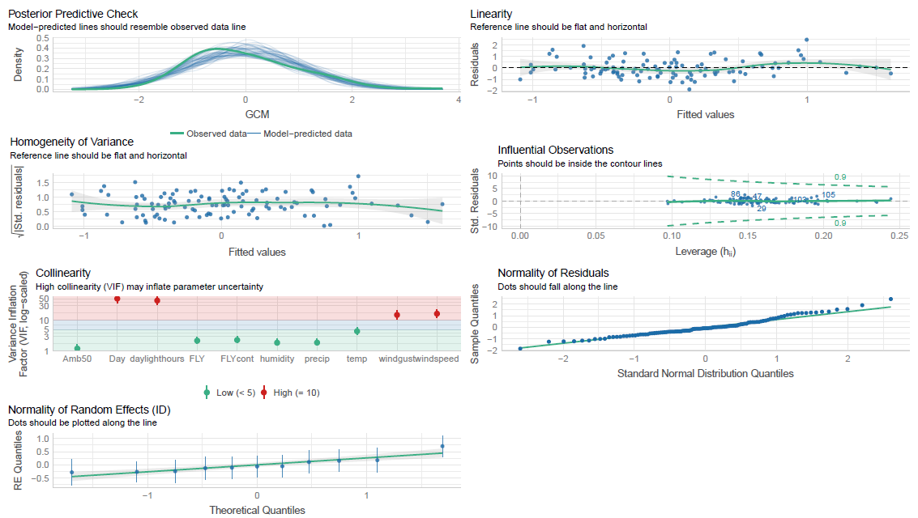
performance::check_model(Model.ALL.GCM.1)

summary(Model.ALL.GCM) #temp (p-value = 0.0196 *), precip (p-value = 0.0425 *)

Linear mixed model fit by REML. t-tests use Satterthwaite's method ['lmerModLmerTest']
Formula: GCM ~ Day + FLY + FLYcont + (1 | ID) + Amb50 + temp + precip + daylighthours + humidity + windgust + windspeed
Data: Y.GCM.CBT
REML criterion at convergence: 286.6
Scaled residuals:
 | Min | 1Q | Median | 3Q | Max
-22.574 | -0.5913 | -0.1028 | 0.5276 | 29.616
Random effects:
 | Groups | Name | Variance | Std.Dev.
 | ID | (Intercept) | 0.1354 | 0.3679
 | Residual | 0.6860 | 0.8282
Number of obs: 108, groups: ID, 11
Fixed effects:
 | Estimate | Std. Error | df | t value | Pr(>|t|)
(Intercept) | -167.903 | 236.292 | 9.287.396 | -0.711 | 0.4791
Day | 0.03543 | 0.04032 | 9.592.153 | 0.879 | 0.3818
FLY1 | -0.16336 | 0.23989 | 9.018.382 | -0.681 | 0.4976
FLYcont | 0.50096 | 115.150 | 9.699.267 | 0.435 | 0.6645
Amb50 | -0.18009 | 0.18718 | 9.676.508 | -0.962 | 0.3384
temp | -0.56488 | 0.23787 | 9.265.432 | -2.375 | 0.0196 | *
precip | -0.21699 | 0.10547 | 9.181.240 | -2.057 | 0.0425 | *
daylighthours | -140.814 | 149.239 | 9.326.445 | -0.944 | 0.3478
humidity | -0.03452 | 0.11425 | 8.935.357 | -0.302 | 0.7632
windgust | 0.48840 | 0.31750 | 9.300.915 | 1.538 | 0.1274
windspeed | -0.42538 | 0.30470 | 9.187.879 | -1.396 | 0.1661
---
Signif. codes: 0 ‘***’ 0.001 ‘**’ 0.01 ‘*’ 0.05 ‘.’ 0.1 ‘ ’ 1
Correlation of Fixed Effects:
 | (Intr) | Day | FLY1 | FLYcnt | Amb50 | temp | precip | dylght | humdty | wndgst
Day | -0.941
FLY1 | 0.417 | -0.258
FLYcont | -0.453 | 0.151 | -0.619
Amb50 | 0.109 | -0.101 | 0.070 | -0.230
temp | 0.505 | -0.406 | 0.224 | -0.269 | -0.001
precip | -0.234 | 0.180 | -0.106 | 0.185 | 0.081 | -0.059
daylighthrs | 0.877 | -0.961 | 0.219 | -0.144 | 0.155 | 0.191 | -0.179
humidity | -0.154 | 0.183 | -0.164 | 0.062 | 0.014 | 0.256 | -0.421 | -0.260
windgust | -0.386 | 0.285 | -0.323 | 0.358 | -0.012 | -0.309 | 0.146 | -0.231 | 0.067
windspeed | 0.353 | -0.236 | 0.396 | -0.374 | -0.032 | 0.354 | -0.267 | 0.164 | 0.045 | -0.948

Model.ALL.GCM.0 <- lmer(GCM ~ (1|ID), data =
Y.GCM.CBT)
anova(Model.ALL.GCM, Model.ALL.GCM.0 ) #Model.ALL.GCM is best (p-value = 0.002284 **)
Data: Y.GCM.CBT
Models:
Model.ALL.GCM.0: GCM ~ (1 | ID)
Model.ALL.GCM: GCM ~ Day + FLY + FLYcont + (1 | ID) + Amb50 + temp + precip + daylighthours + humidity + windgust + windspeed
 | npar | AIC | BIC | logLik | deviance | Chisq | Df | Pr(>Chisq)
Model.ALL.GCM.0 | 3 | 299.26 | 307.30 | -146.63 | 293.26
Model.ALL.GCM | 13 | 291.90 | 326.76 | -132.95 | 265.90 | 27.36 | 10 | 0.002284 | **
---
Signif. codes: 0 ‘***’ 0.001 ‘**’ 0.01 ‘*’ 0.05 ‘.’ 0.1 ‘ ’ 1

Model.ALL.GCM.1 <- lmer(GCM ~ FLY + daylighthours + FLYcont + (1|ID) + Amb50 + temp + precip + humidity + windgust , data = Y.GCM.CBT)
check_collinearity(Model.ALL.GCM.1) #removed during: Day + windspeed
#check assumptions again:
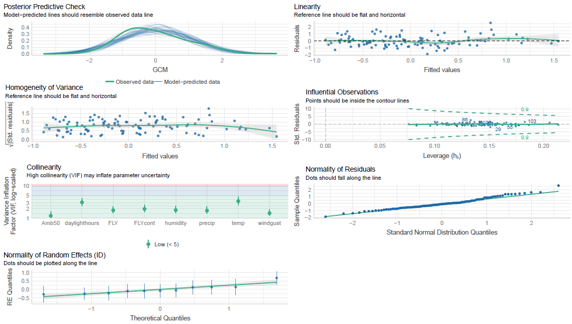
performance::check_model(Model.ALL.GCM.1)

summary(Model.ALL.GCM.1) #precip (p-value = 0.0105 *), temp (p-value = 0.0536 .)
Linear mixed model fit by REML. t-tests use Satterthwaite's method ['lmerModLmerTest']
Formula: GCM ~ FLY + daylighthours + FLYcont + (1 | ID) + Amb50 + temp + precip + humidity + windgust
Data: Y.GCM.CBT
REML criterion at convergence: 283.7
Scaled residuals:
 | Min | 1Q | Median | 3Q | Max
-229.039 | -0.63192 | -0.08321 | 0.50993 | 314.172
Random | effects:
 | Groups | Name | Variance | Std.Dev.
 | ID | (Intercept) | 0.1257 | 0.3545
 | Residual | 0.6912 | 0.8314
Number of obs: 108, groups: ID, 11
Fixed effects:
 | Estimate | Std. Error | df | t value | Pr(>|t|)
(Intercept) | 0.656547 | 0.737858 | 98.550.421 | 0.890 | 0.3757
FLY1 | -0.006817 | 0.217145 | 94.388.042 | -0.031 | 0.9750
daylighthours | -0.261706 | 0.399303 | 98.203.288 | -0.655 | 0.5137
FLYcont | -0.135983 | 1.066.490 | 98.745.239 | -0.128 | 0.8988
Amb50 | -0.174804 | 0.186165 | 98.998.111 | -0.939 | 0.3500
temp | -0.407556 | 0.208600 | 96.311.850 | -1.954 | 0.0536 | .
precip | -0.264105 | 0.101179 | 93.842.351 | -2.610 | 0.0105 | *
humidity | -0.040830 | 0.112217 | 91.804.266 | -0.364 | 0.7168
windgust | 0.057697 | 0.099071 | 95.677.693 | 0.582 | 0.5617
---
Signif. codes: 0 ‘***’ 0.001 ‘**’ 0.01 ‘*’ 0.05 ‘.’ 0.1 ‘ ’ 1
Correlation of Fixed Effects:
 | (Intr) | FLY1 | dylght | FLYcnt | Amb50 | temp | precip | humdty
FLY1 | 0.454
daylighthrs | -0.232 | -0.029
FLYcont | -0.916 | -0.553 | -0.083
Amb50 | 0.069 | 0.071 | 0.199 | -0.253
temp | 0.323 | 0.037 | -0.781 | -0.142 | -0.032
precip | -0.114 | 0.023 | -0.081 | 0.086 | 0.092 | 0.090
humidity | 0.022 | -0.167 | -0.297 | 0.073 | 0.039 | 0.358 | -0.463
windgust | 0.048 | 0.225 | -0.185 | -0.004 | -0.112 | 0.174 | -0.384 | 0.320

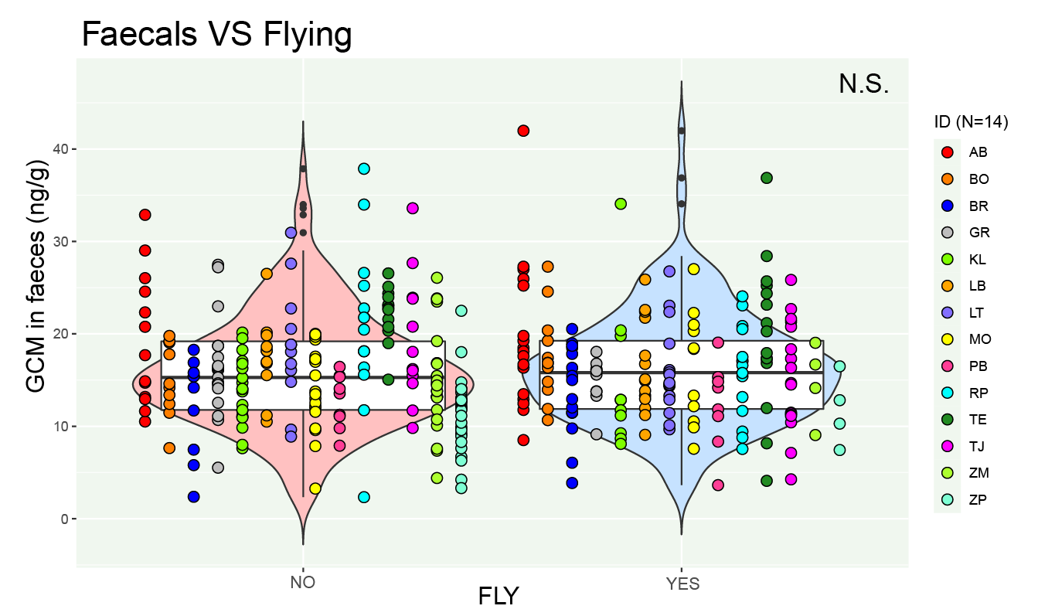

Figure S1 GCM concentrations (ng/gr) after flight (YES) and after no flight (NO). Colored dots represent data points of the different individuals (abbreviations in legend).

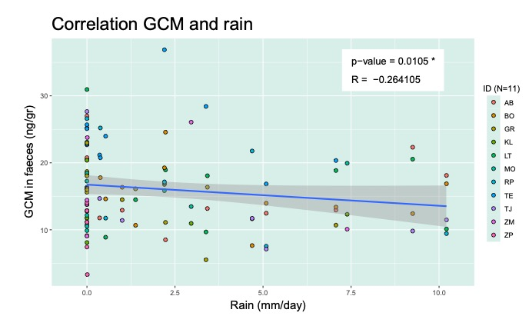
Figure S2 Relationship between GCM (ng/gr) concentration and precipitation (mm/day) on a given day. Colored dots represent data points of the different individuals (abbreviations in legend).

