Supplemental Figures and Tables

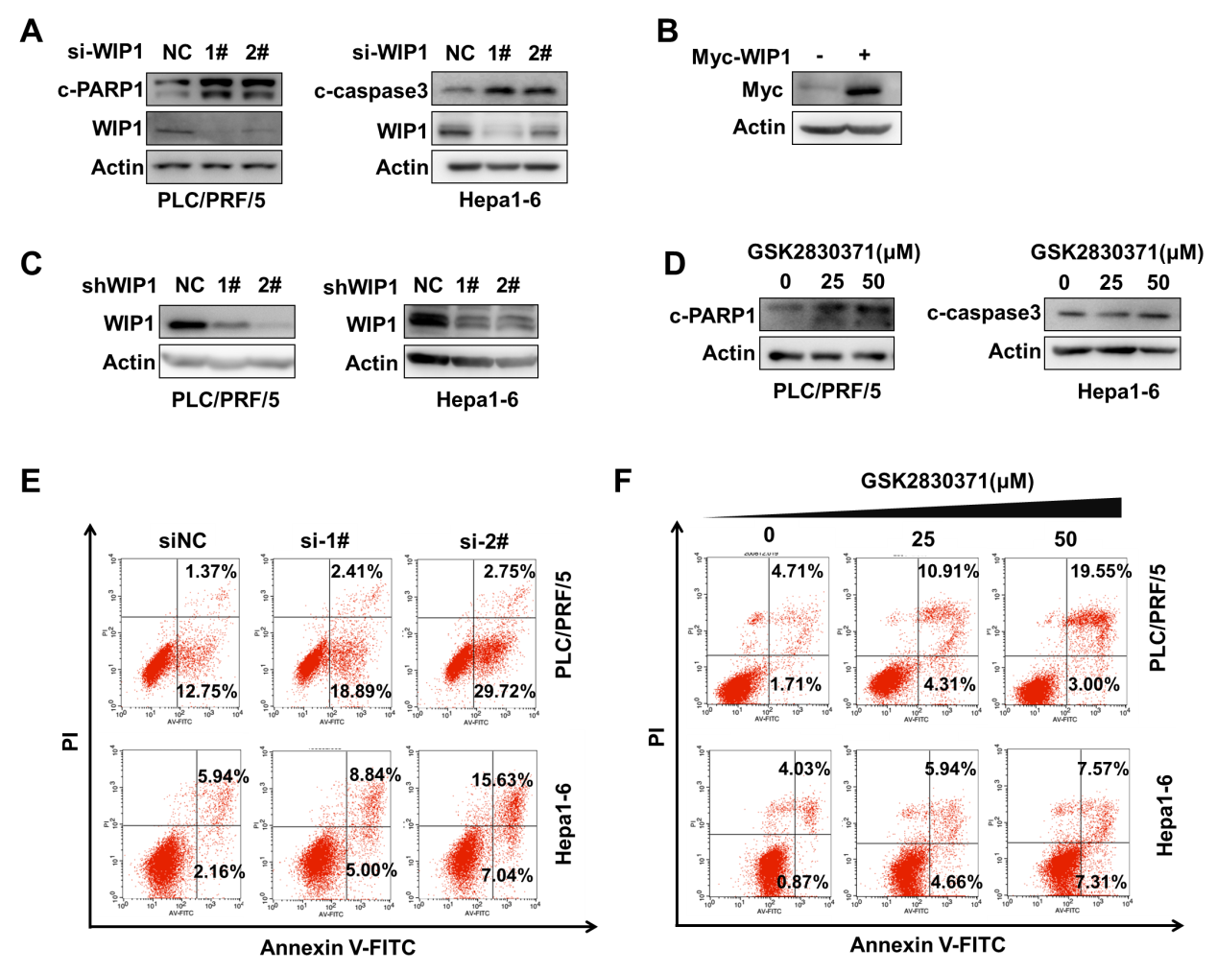
Supplemental Figure 1. WIP1 inhibition suppresses HCC cell proliferation in vitro.
A. The expression of WIP1, Cleave-PARP1 (C-PARP1), Cleaved-Caspase3 (C-caspase3) in HCC cells with or without WIP1 knockdown were measured with western blotting.
B. The expression of Myc-WIP1 in HCC-LM3 cells with Myc-WIP1 overexpression was detected by western blotting.
C. The expression of WIP1 in HCC cells with or without WIP1 knockdown via shRNA was measured with western blotting.
D. The level of C-PARP1 and C-caspase3 in HCC cells with GSK2830371 treatment was measured with western blotting.
The apoptosis of PLC/PRF/5 and Hepa1-6 cells with WIP1 knockdown (E) or WIP1 inhibition (F) was analyzed with the annexinⅤ-PI double staining assay.

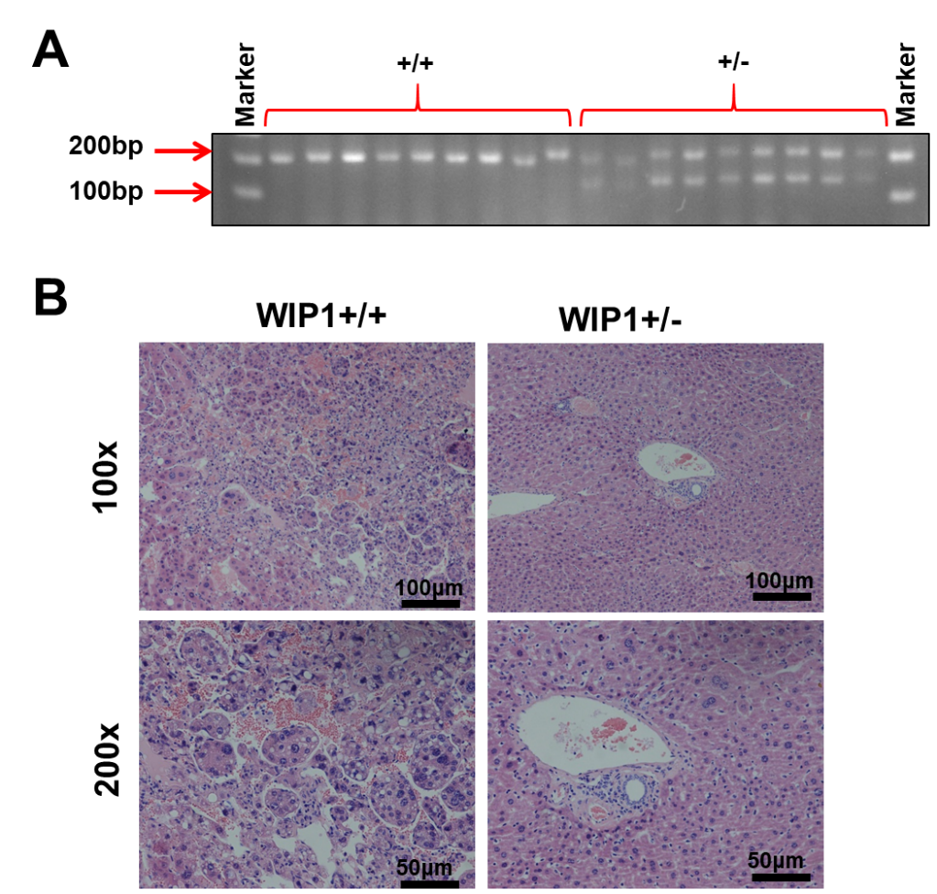
Supplemental Figure 2. WIP1 inhibition suppresses HCC development in vivo
A. Genotype of WIP1 wildtype (+/+) or knockout (+/-) mice was detected by PCR and DNA gel electrophoresis.
B. Representative microscopic images of HCC with H&E staining of WIP1 +/+ or +/- mice with DEN-induced HCC.
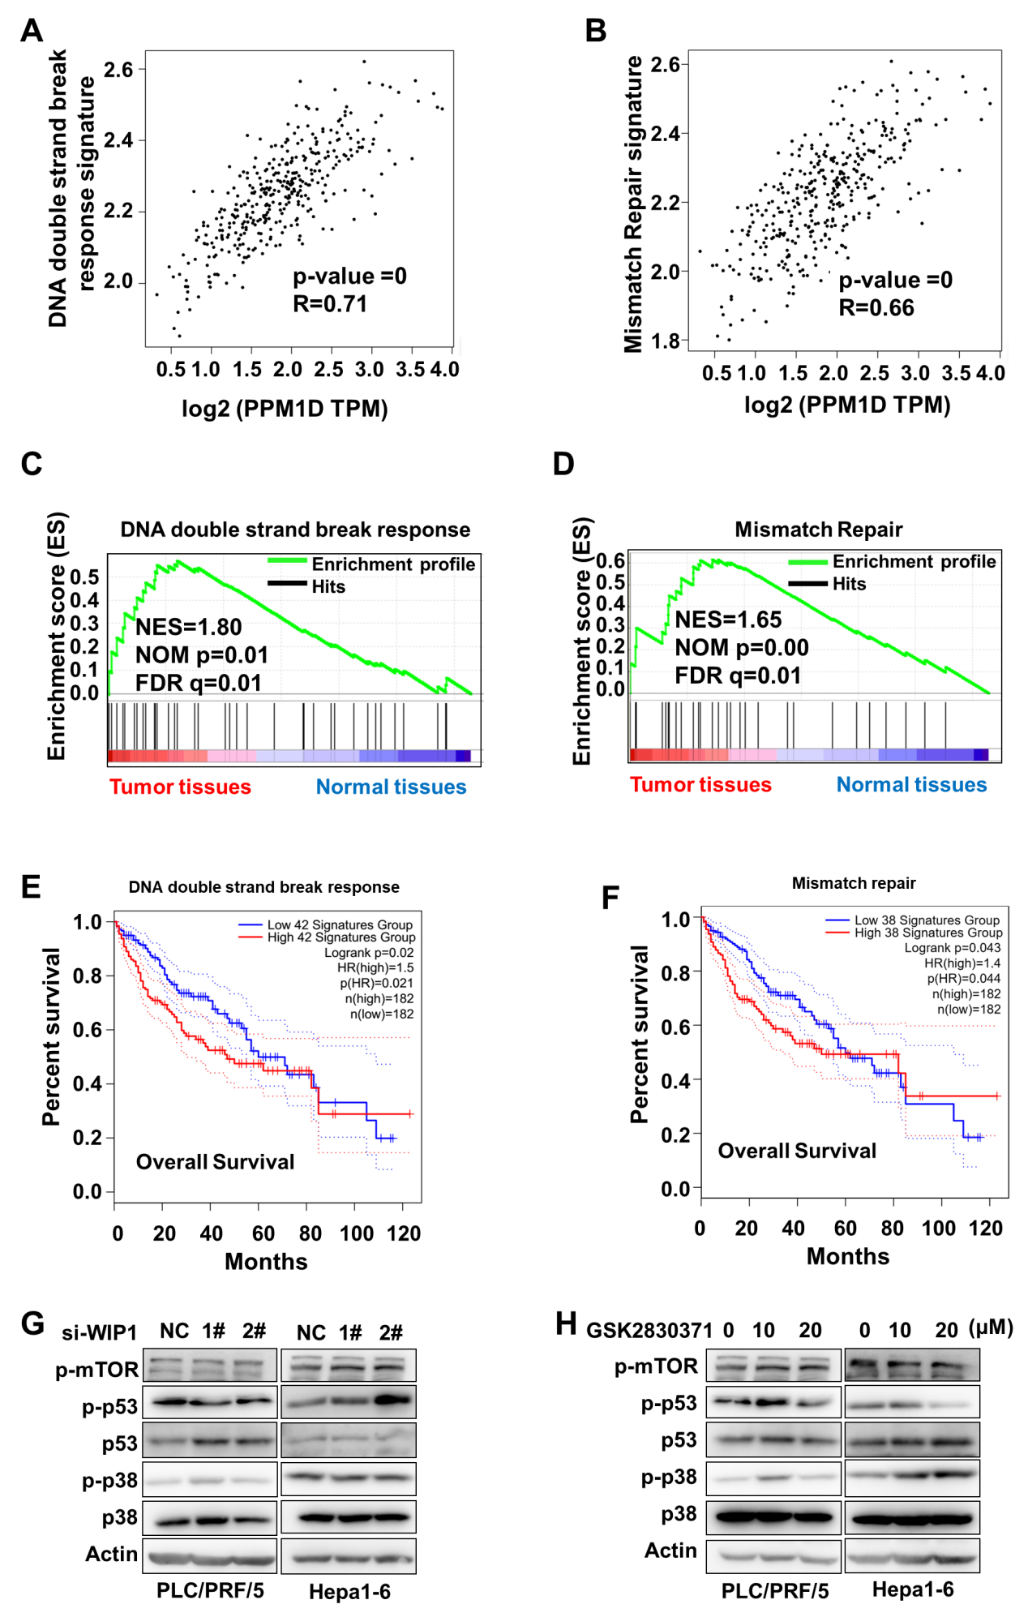
Supplemental Figure 3. WIP1 inhibition disrupts DNA damage repair by increasing H2AX phosphorylation.
A. Correlation analysis of WIP1 TPM and Double strand break response signature was analyzed with GEPIA 2.0.
B. Correlation analysis of WIP1 TPM and Mismatch repair signature was analyzed with GEPIA 2.0.
C-D. Gene set enrichment analysis (GSEA) of normal liver tissues compared to liver tumor tissues. Red indicates tumor tissues; Blue indicated normal liver tissues.
E. The impact of Double strand break signature expression on overall survival (OS) of liver cancer patients was analyzed with GEPIA 2.0.
F. The impact of Mismatch repair signature expression on overall survival (OS) of liver cancer patients was analyzed with GEPIA 2.0.
The p-mTOR, p-p53, p-p38 level was measured after WIP1 knockdown (G) or GSK2830371 inhibition (H) in HCC cells via western blotting.
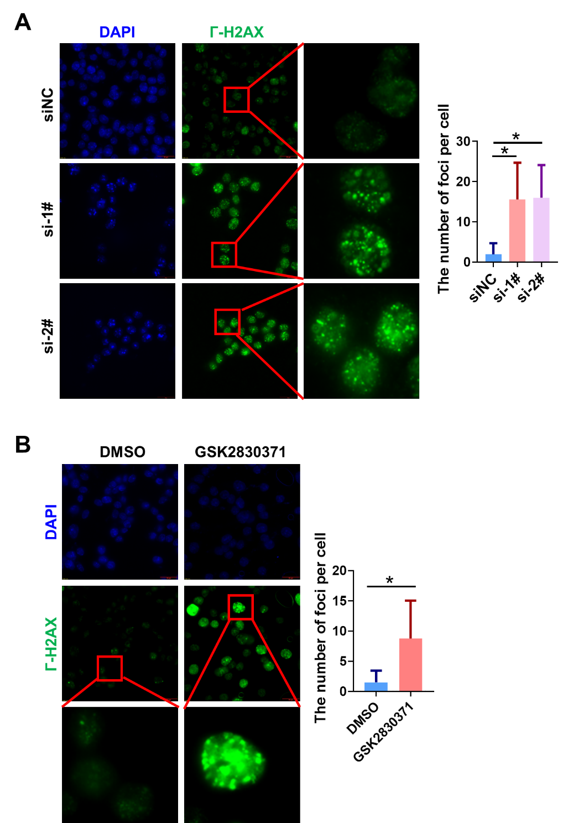
Supplemental Figure 4. WIP1 inhibition disrupts DNA damage repair by increasing H2AX phosphorylation.
The foci of phosphorylation of H2AX at S139(Г-H2AX) was measured via immunofluorescence in Hepa1-6 cells after WIP1 knockdown (A) or GSK2830371 inhibition (B). And the numbers of foci were counted.
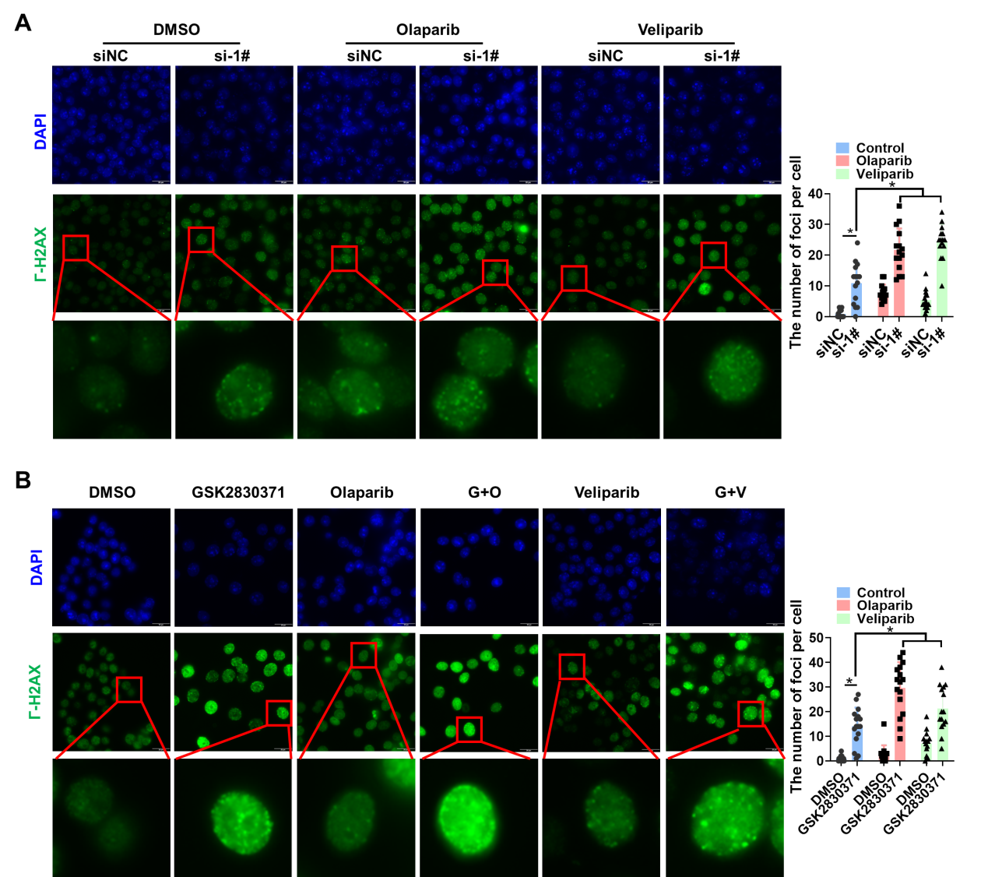
Supplemental Figure 5. WIP1 and PARP inhibition enhances DNA damage
A. The foci of phosphorylation H2AX at S139(Г-H2AX) was measured via immunofluorescence in Hepa1-6 cells after WIP1 knockdown combined with Olaparib (50μM) or Veliparib (50μM) treatment for 24 hours. And the numbers of foci were counted.
B. The foci of phosphorylation H2AX at S139(Г-H2AX) was measured via immunofluorescence in Hepa1-6 cells after GSK2830371(25μM) combined with Olaparib (50μM) or Veliparib (50μM) treatment for 24 hours. And the numbers of foci were counted.
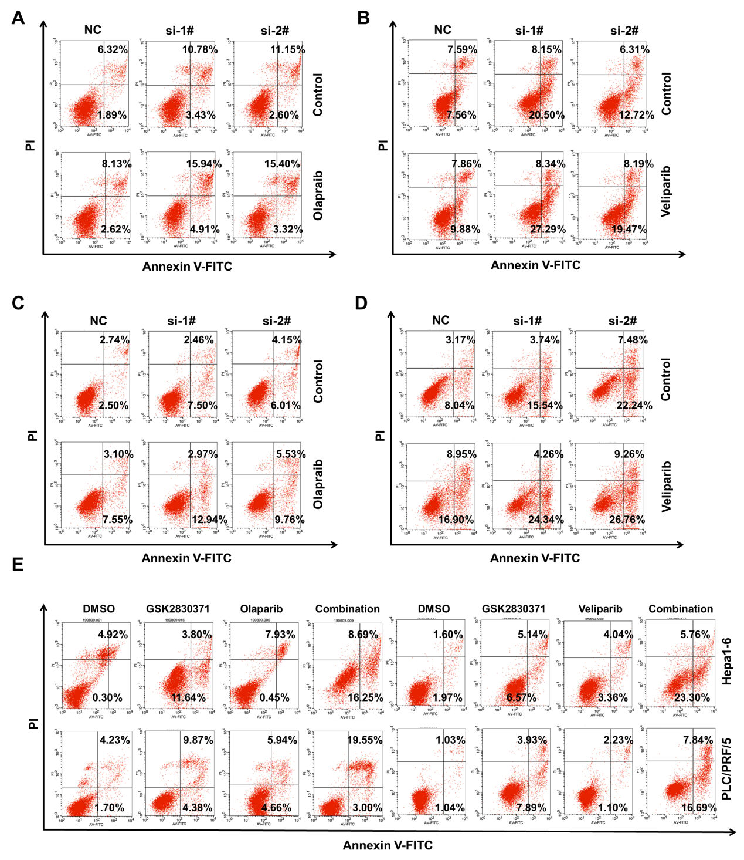
Supplemental Figure 6. WIP1 and PARP inhibition induce synthetic lethality of HCC cells in vitro
A-B. The apoptosis of Hepa1-6 cells after Olaparib or Veliparib treatments and WIP1 knockdown was measured via flow cytometry with PI and annexin V–FITC double staining.
C-D. The apoptosis of PLC/PRF/5 cells after Olaparib or Veliparib treatments and WIP1 knockdown was measured via flow cytometry with PI and annexin V–FITC double staining.
E. The apoptosis of Hepa1-6 or PLC/PRF/5 cells after PARPi and/or without GSK2830371 treatments was measured via flow cytometry.

Table S1. siRNA sequences used for knockdown
Name | Sequence（5’-3’） | Supplier
si-PPM1D-homo-1 | GUGCCUACUAAUUCAACAATT  UUGUUGAAUUAGUAGGCACTT | Gene Pharma Company (Shanghai, China)
si-PPM1D-homo-2 | GUGGGAGUGUAAUGAACAATT  UUGUUCAUUACACUCCCACTT | Gene Pharma Company (Shanghai, China)
si-PPM1D-mus-1 | GCGGCAGUGUGAUGAACAATT  UUGUUCAUCACACUGCCGCTT | Gene Pharma Company (Shanghai, China)
si-PPM1D-mus-2 | GGAAUUCAGGAUGACCCAATT  UUGGGUCAUCCUGAAUUCCTT | Gene Pharma Company (Shanghai, China)

Table S2. shRNA sequences used for knockdown
Name | Sequence（5’-3’）
sh-PPM1D-homo-1 | CCCTTCTCGTGTTTGCTTAAACTCGAGTTTAAGCAAACACGAGAAGGG  CCCTTCTCGTGTTTGCTTAAACTCGAGTTTAAGCAAACACGAGAAGGG
sh-PPM1D-homo-2 | TGATTTGTGGAGCTATGATTTCTCGAGAAATCATAGCTCCACAAATCA  TGATTTGTGGAGCTATGATTTCTCGAGAAATCATAGCTCCACAAATCA
sh-PPM1D-mus-1 | CCTGACTGATAGCCCTACTTACTCGAGTAAGTAGGGCTATCAGTCAGG  CCTGACTGATAGCCCTACTTACTCGAGTAAGTAGGGCTATCAGTCAGG
sh-PPM1D-mus-2 | GCCCTGACTTTAAGGATTCATCTCGAGATGAATCCTTAAAGTCAGGGC  GCCCTGACTTTAAGGATTCATCTCGAGATGAATCCTTAAAGTCAGGGC

