APPENDIX
Age-related mating rates among ecologically distinct lineages of bedbugs, Cimex lectularius
Tomáš Bartonička¹*, Jana Křemenová¹, Ondřej Balvín², Klaus Reinhardt³, Zdeněk Šimek⁴, Oliver Otti⁵
¹Department of Botany and Zoology, Faculty of Science, Masaryk University, Kotlářská 2, 611 37 Brno, Czech Republic, ²Department of Ecology, Faculty of Environmental Science, Czech University of Life Sciences Prague, Kamýcka 129, 165 21, Prague 6, Czech Republic, ³Applied Zoology, Department of Biology, Technische Universität Dresden, 01062 Dresden, Germany, ⁴Masaryk University, Research Centre for Toxic Compounds in the Environment, Brno, 62500, Czech Republic. ⁵Animal Population Ecology, Animal Ecology I, University of Bayreuth, Universitätsstrasse 30, 95440 Bayreuth, Germany

Supplementary methods
Melanisation of mating scars over time
Supplementary figures
Figure S1 – Mating scars on the female ectospermalege
Figure S2 – Melanization of mating scars over time

Supplementary methods

Melanisation of mating scars over time
We mated 120 females from the same population to establish the time point when a mating scar becomes visible. Matings were interrupted after 60s to standardize for copulation duration across males. After each of six different time points, i.e. 30 minutes, 1 hour, 12 hours, 24 hours, 48 hours and five days, we transferred 20 females to EtOH (99%) until further processing. Once all females had been transferred to a 1.5ml Eppendorf tube containing absolute EtOH they were dissected under a stereo microscope and the inner part of the spermalege was photographed with a digital imaging system (Leica DFC290 and Leica Application Suite software, version 2.7.1 R1 [Build: 1384], Leica Microsystems). The person counting mating scars was blind with respect to the time point of the female transfer to a 1.5ml Eppendorf tube containing absolute EtOH.

Supplementary figures
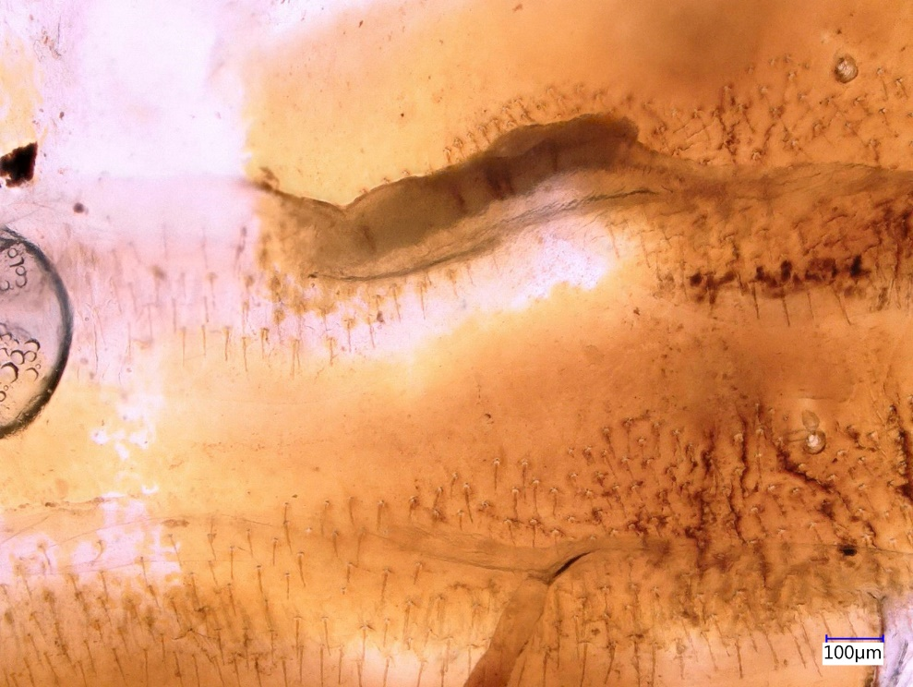
Figure S1 – Mating scars (red arrows) on female ectospermalege.
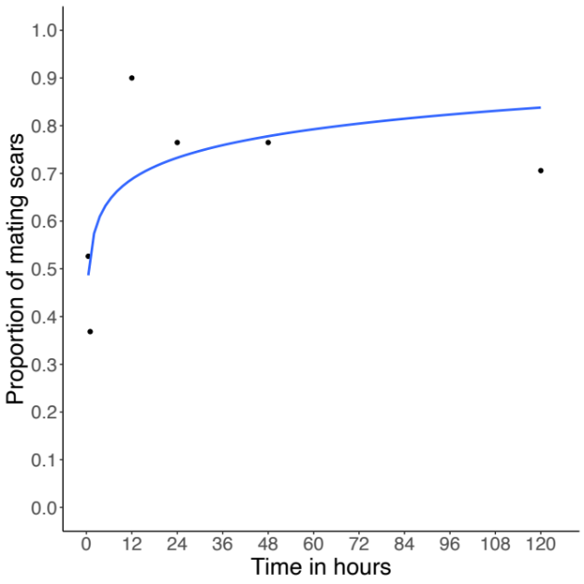
Figure S2 – Melanization of mating scars over time represented the proportion of mating scars observed 30 minutes, 1 hour, 12 hours, 24 hours, 48 hours and five days after a single mating.

