Supplementary Information 1
Micromorphology description
In this results section, we will first give a description of the micromorphological observations per thin section, relating to the layering, the groundmass, anthropogenic admixtures, soil structure and soil- and sedimentary phenomena. These observations will result in the grouping of phenomena into distinct microfacies. Their specific characteristics and their distribution across the different thin sections will be addressed.

Table S1. Micromorphological observations.

Groundmass
In the thin sections of Tegelbarg we can distinguish two separate groundmasses, G1 and G2.
G1 (see figure S1) consists of unsorted angular quartz and other rock fragments in sand size, with channels and planar voids, and a b-fabric of clay illuviation in a concave gefuric c/f distribution. The channel voids include dusty grey clay coatings. This groundmass is indicative of a soil formed on a Pleistocene boulder clay outcrop.
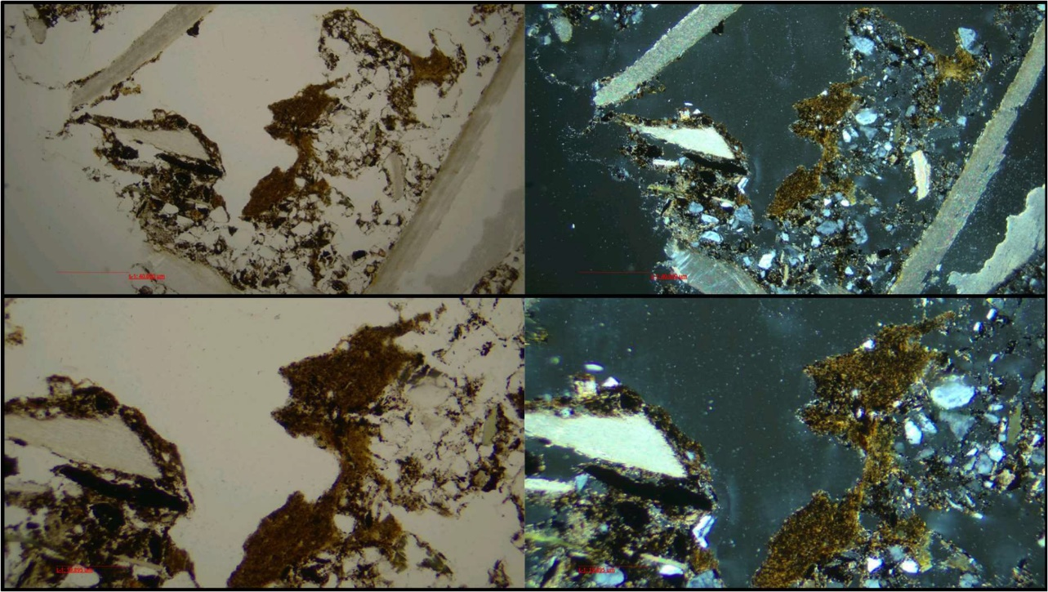
Figure S1. Groundmass G1 with clay coatings.

G2 (see figure S2) consists of humified organic matter with vughy and channel voids, indicating that this microstructure was formed under the influence of the welding of aggregates, experienced drying and cracking, and disruption through plant root activity. Following Babel (1975) we name this a mull, spongy fabric. In this groundmass, we see an upward decrease of randomly oriented unsorted angular quartz grains and rock fragments entrapped in the matrix. This decrease of the mineral component creates a diffuse contact between the first and second groundmass, indicating a gradual transition from a sandy, organic poor/dry, environment to an organic rich/wet environment. Randomly sorted sand grains remain present throughout the profile in this groundmass. In several instances this groundmass exhibits dusty grey/brown clay coatings, indicating clay illuviation due to rain splash on barren surfaces.
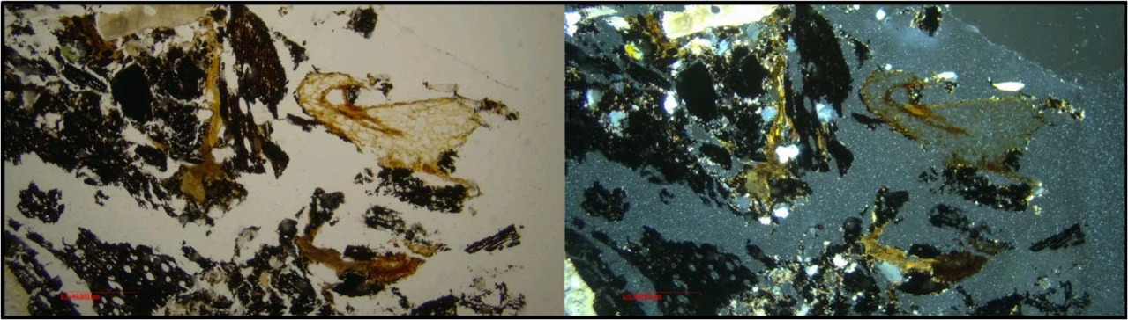
Figure S2. Groundmass G2 with a spongy mull fabric, quartz grains, clay coatings, and both charred and uncharred organic matter (probably a more recent rootlet).

Natural phenomena
For natural phenomena (see figure S3), we primarily speak of root activity for which evidence is present throughout the profile, both in G1 and G2 groundmasses, but primarily in G2. This is indicative of peat formation in G2, postdating the occupation of the site. Several fungal sclerotia are present in G2. These are indicative of the breakdown of organic matter such as peat. In the shell midden layers, several shells appear to be stained with Fe or Mn oxides. This is a localised phenomenon, and no clear explanation for its presence and concentration can be given at this point.
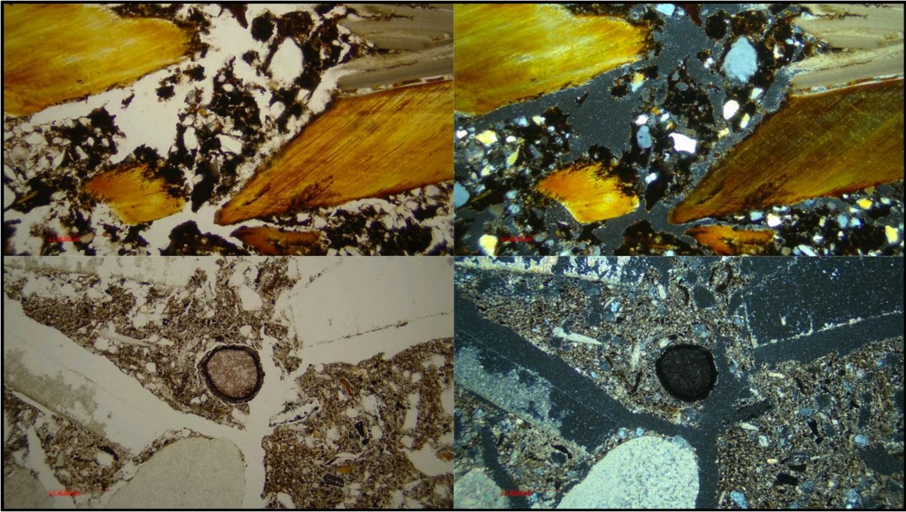
Figure S3. Natural phenomena: Fe/Mn-stained shells in G2, fungal sclerotium in G2.

Anthropogenic admixtures
Shell
The most common admixture at Tegelbarg involves the shells of marine molluscs. In G1, some shells show characteristics of dissolving in an acidic environment. In G2, most shells are either complete, with angular edges, or in a freshly broken state.
Most shells are tightly packed and show a horizontal bedding structure, indicative of dumping and no later reworking or trampling. Analysis of shell orientation patters through mapping indicates that this horizontal bedding is present in slides 3 and 4 (see figure S4). In the top of the sequence, more loose packing and random orientation patterns of shells are visible, and the shells are more fragmented. This indicates that later reworking of deposited shells has taken place.
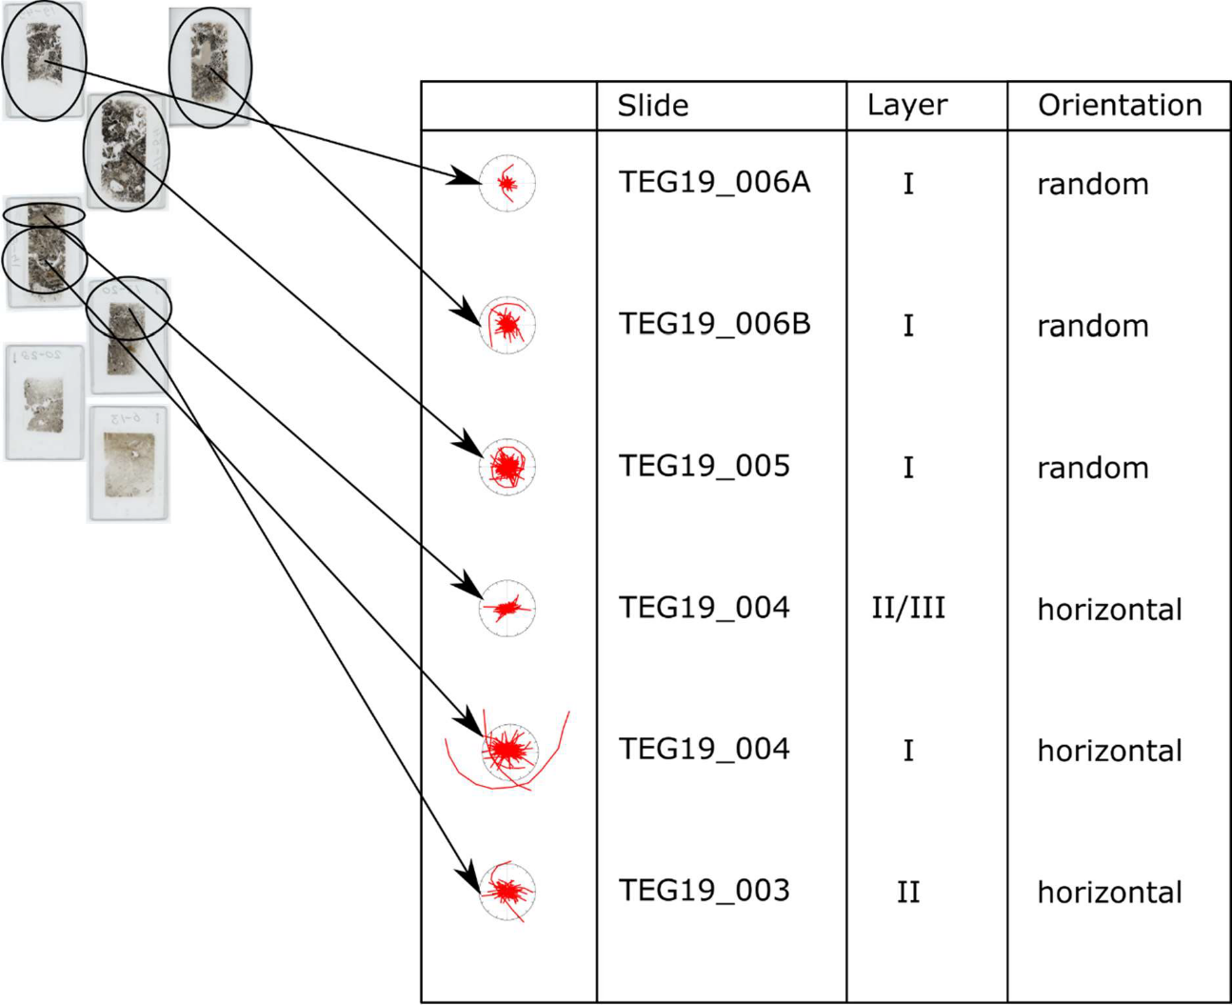
Figure S4. Orientation of the shells in the layers at Tegelbarg.

The human-induced alteration of shells is also visible. Close to, and in, the ash layer, most of the shells show partly blackened surfaces and cracking of the microstructures, indicating secondarily burning. The location of these blackened surfaces on the bottom of the shells, indicate that the shells were only finally deposited after the burning had taken place (see figure S5).
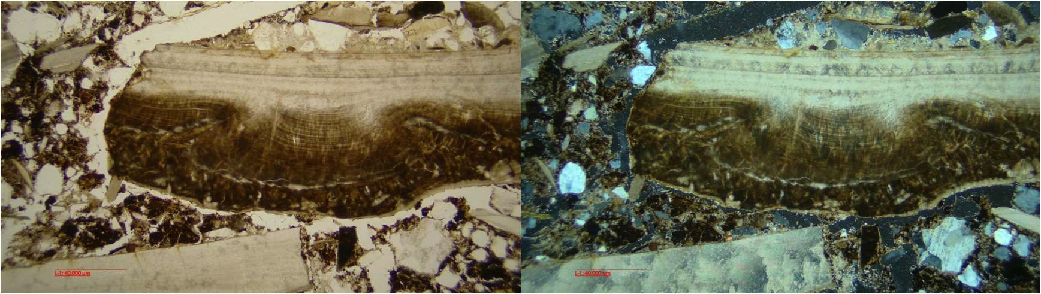
Figure S5. Burning and later reworking of a cockle shell.

Ash
Plant ash is present in the profile in two different forms: firstly, as a 1cm thick layer, and secondly in the form of small aggregates and cemented around clusters of shells throughout the humified organic matter groundmass.
The 1cm thick layer of ash can be described as having a horizontal, almost sedimentary, structure. It consists of a massive, homogenous, sometimes even cemented, layer. The sedimentary structure of this thick layer is probably the result of the leaching and sedimentation of primary ash pseudomorphs. This process is indicative of wet post-depositional conditions, probably the result of minor lateral displacement of hearth material, through rain (see figure S6). While most formation of secondary calcite is attributed to moist cave conditions and water dripping (Karkanas et al 2000; Shahack-Gross et al 2004), it can also be caused by groundwater, where the effects are more massive, and can include sparite (Mallol/Goldberg 2017). Sparite is not observed in the profile here, indicating that we’re not dealing with the unrestricted formation of crystals and groundwater effects, but the flowing cemented structure does indicate wet conditions.
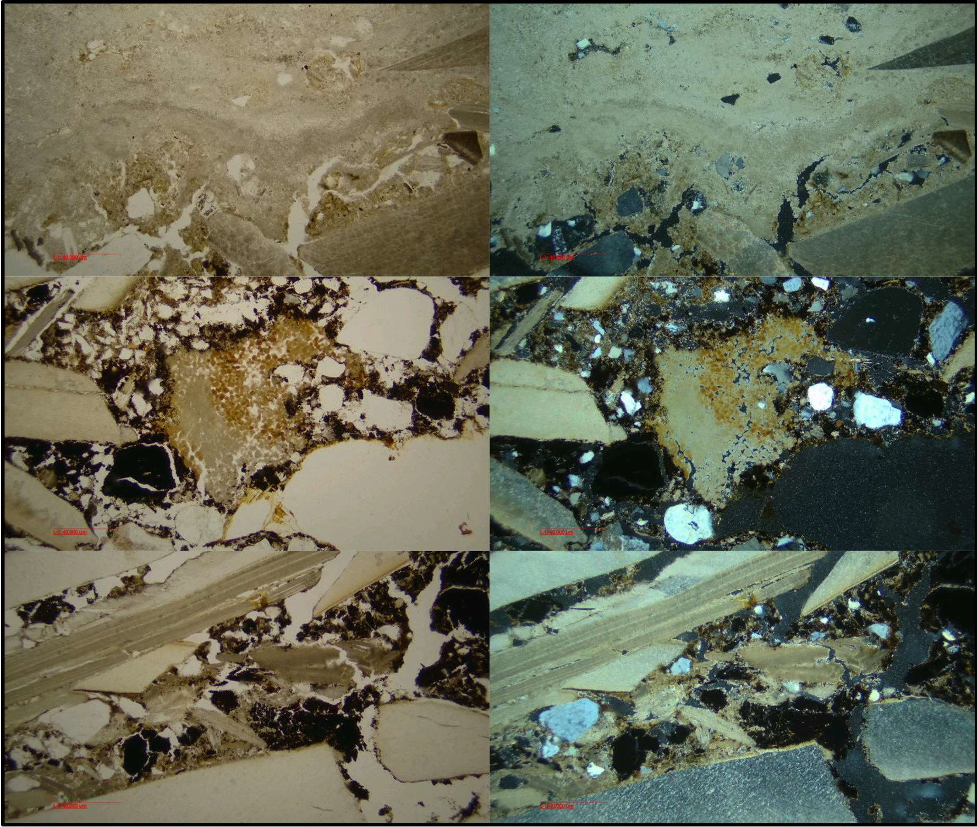
Figure S6. Ash laminated cement, crystal cluster and minor cementation.

Small aggregates of ash are found in both the sandy clay groundmass and in the humified organic matter groundmass, indicating that such secondary calcites could also have been reworked. The smaller cemented clusters of ash, sometimes with shells, indicates that the remains of fires and shells were collected and discarded.
Charred organic matter
Charred organic matter is present throughout the profile, both in G1 and in G2. In G1, a concentration of large particles of charred organic matter is present in thin section 004, layer III. Combined with the evidence for burnt shells and aggregates of ash, we can argue that this charred organic matter concentration is part of a reworked combustion feature. Other fragments of charred organic matter are sand sized and angular, indicating relatively minor displacement.

Uncharred organic matter
Uncharred organic matter consists primarily of roots found in the top of the sequence, as discussed above. A particular example of organic matter that must be mentioned here, also from the top of the sequence, is the freshly broken pericarp of Corylus avellana, a hazelnut, characteristic with its stone cells and resin ducts (see figure S7). Microscope photos of such pericarp were published by Schweingruber (Schweingruber/Börner 2018, 26, fig. 4.137), Ismail-Meyer (2017, 130, fig.13.9) and most recently by Holguin et al (2022). At Tegelbarg, several of these hazelnut pericarp fragments were used for ¹⁴C dating, producing results inconsistent with the main habitation phase of the shell midden (see Höfgen 2018). The implications of this hazelnut pericarp in the top of the micromorphological sequence here, for the site’s chronology and stratigraphy, will be discussed below.
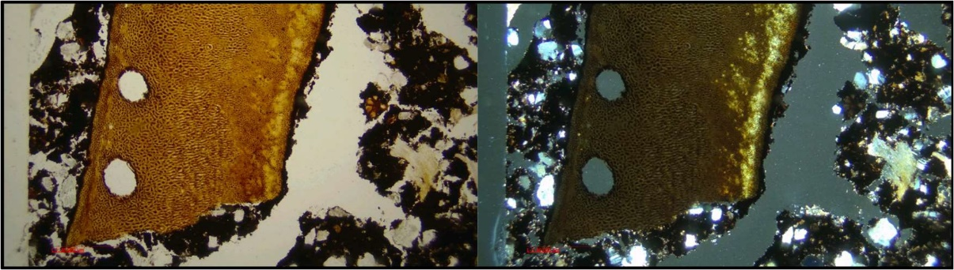
Figure S7. Pericarp of a hazelnut in the top of G2 (note the stone-cells and the resin ducts).

Ceramics
Only two pieces of ceramics were found in the thin sections. In slide 004, a piece of ceramics is part of the shell midden deposit. The second piece of ceramics is found in slide 003 layer I, indicative of anthropogenic input and human activities prior to the deposition of the shell midden in this place. Both pieces show large planar voids and a heterogenous clay composition, indicative of low-burning temperatures. The clay itself is tempered with coarse rock fragments, and burnt in an oxidising environment, considering the yellow and beige colours. Comparatively, Arnold (1981a, 154-155) describes the pottery from the site (most of it, interestingly, coming from below the shell midden) as burnt to low temperature, in an oxygen-rich environment, and tempered with coarse granite grit.

Bone
In total 21 fragments of bone have been identified throughout the profile column (see table S2). To understand site taphonomy and changes in environmental conditions before, during, and after occupation, all 21 bone fragments were studied for their bioerosion characteristics (birefringence, fluorescence, shape, structure, colour), and compared to a wide body of literature available (Huisman et al 2017; Brönnimann et al 2018, 2020a, 2020b; Turner-Walker 2012, 2019; Turner-Walker/Jans 2008; Ismail-Meyer et al 2020; Trueman/Martill 2002; Trueman et al 2004; Booth 2016; Booth/Madgwick 2016).

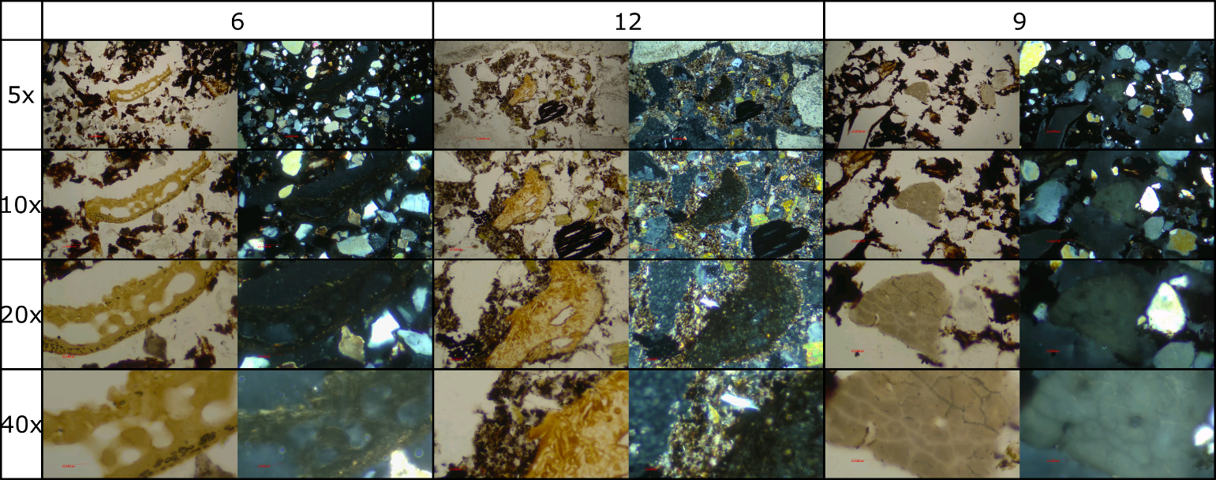Figure S8. A selection of three bone fragments from Tegelbarg, showing blocky degradation (bone 6), cyanobacterial tunneling (bone 12), and modification through heat (bone 9).

Table S2. Overview of all the bone fragments.

Three kinds of degradation are visible (see figure S8): Firstly, bones 6, 7, 10, 11 and 20 show signs of a chemical or physical weathering process. Such bone fragments are described as having an angular-blocky structure by Huisman et al (2017).
A second type of bone degradation present at Tegelbarg is tunnelling in both bone 1, 12 and 15. The three bones however exhibit two different kinds of tunnelling. In bone 1, this tunnelling consists of small tunnels, interconnected and widespread throughout the bone, consistent with the Wedl-type 1 tunnels (see also Brönnimann et al 2018, fig 1). Wedl-type 1 tunnels are the result of fungal decay, and related to moist (but not waterlogged), oxygenated and neutral to acidic environments. Since the shells provide a basic environment, the presence of oxygen must have caused the fungal decay.
In bones 12 and 15, on the other hand, the tunnels are much larger and more concentrated in the small piece of bone. These tunnels are more consistent with a cyanobacterial impact (see examples in Huisman et al 2017, fig. 4; Villagran et al 2017; Brónnimann et al 2018; Ismail-Meyer er al 2020; Turner-Walker/Jans 2008).
The absence of degradation on the other pieces of bone, indicates an oxygen-poor and basic environment, visible in bone 13 and 14, and that mineralogical alterations have had an effect (e.g. due to heating, as visible in bones 9 and 16, 17, 18 and 19), or that the bones were transported from a different environmental situation. This is possibly the case for the small, rounded bone fragments 4, 8, and 10 (although their size might also limit the visibility of any degradation).

Flint
In total, 5 pieces of flint were observed in the thin sections. All the pieces are small and indicative of the micro-debitage of flint working activities occurring at the site (cf. Arnold 1973, 1974, 1981b, 1990, see figure S9). The flint fragments itself are angular in shape, with sharp and prominent curved boundaries, and have a smooth surface (cf. Angelucci 2010, 2017). The flint fragments are found throughout the profile, indicating that flint working activities took place throughout the occupation of the site.
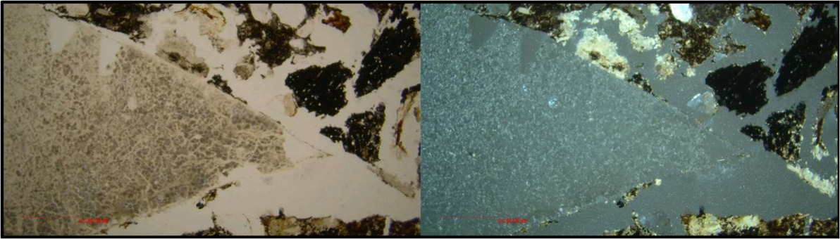
Figure S9. An example of flint debitage.

Supplementary Information 2
Radiocarbon data

Sample overview
In total 33 radiocarbon determinations have been taken throughout the years from material excavated at the site of Tegelbarg (see table S3).

¹⁴C Laboratory | Type | Sample name | Lab code | BP | sd | δ¹³C | Year measured | Context | Material | Depth
Århus | AMS | SID-16069 |  |  |  |  | 2010 | grave, human skeleton (Höfgen 2014, 41) | bone (human)
Hannover | Conventional | Teg:I | Hv-5596 | 3740 | 120 | -26 | 1973 | Q17, post | wood (Oak, last 15 years) | -1.50 NN
Kiel | AMS |  | KIA-43949 | 4330 | 30 | -4,66 | 2011 | Qc6, finds layer, sample 1 | mussel shell, carbonate | +0.53 NN
Kiel | AMS |  | KIA-55749 | 4406 | 25 | 1,43 | 2021 | repeat of KIA-43949 | carbonate
Kiel | AMS |  | KIA-43950 | 4280 | 30 | -1,99 | 2011 | Qb5, finds layer, sample 2 | mussel shell, carbonate | +0.57 NN
Kiel | AMS |  | KIA-55750 | 4447 | 25 | 0,52 | 2021 | repeat of KIA-43950 | carbonate
Kiel | AMS |  | KIA-43952 | 4220 | 30 | -2,87 | 2011 | Qc6, finds layer, sample 4 | mussel shell, carbonate | +0.69 NN
Kiel | AMS |  | KIA-55752 | 4409 | 25 | 0,84 | 2021 | repeat of KIA-43952 | carbonate
Kiel | AMS |  | KIA-43951 | 4210 | 30 | -1,84 | 2011 | Qb3, finds layer, sample 3 | mussel shell, carbonate | +0.49 NN
Kiel | AMS |  | KIA-55751 | 4148 | 25 | 0,4 | 2021 | repeat of KIA-43951 | carbonate
Kiel | AMS |  | KIA-43919 | 3660 | 30 | -24,4 | 2011 | Qb3, finds layer, sample 3 | animal bone (herbivore) | +0.49 NN
Kiel | AMS |  | KIA-55747 | 3678 | 26 | -19,76 | 2021 | repeat of KIA-43919 | collagen
Kiel | AMS |  | KIA-43920 | 3630 | 25 | -22,4 | 2011 | Qc6, finds layer, sample 4 | antler (red deer) | +0.69 NN
Kiel | AMS |  | KIA-55748 | 3560 | 25 | -21,99 | 2021 | repeat of KIA-43920 | collagen
Kiel | AMS |  | KIA-43917 | 2890 | 25 | -28,6 | 2011 | Qc6, finds layer, sample 1 | hazelnut pericarp | -0.53 NN
Kiel | AMS |  | KIA-55745 | 2835 | 27 | -24,61 | 2021 | repeat of KIA-43917 | leach residue
Kiel | AMS |  | KIA-43918 | 2810 | 20 | -27,9 | 2011 | Qb5, finds layer, sample 2 | hazelnut pericarp | -0.57 NN
Kiel | AMS |  | KIA-55746 | 2796 | 27 | -24,78 | 2021 | repeat of KIA-43918 | leach residue
Kiel | Conventional | Tb:2 | KI-813-011 | 4310 | 65 | -0,4 | 1973 | shell layer, lower part | mussel shell, carbonate | +0.38 NN
Kiel | Conventional | Tb:3 | KI-814 | 3960 | 65 | -24,8 | 1973 | grave, second fill, associated with flint dagger | charcoal | +0.65 NN
Kiel | Conventional | Tb:23 | KI-774 | 3810 | 110 | -23,3 | 1972 | grave, upper fill | charcoal | +0.75 NN
Kiel | Conventional | Tb:1 | KI-812-011 | 3810 | 110 | 0,9 | 1973 | shell layer, upper part | mussel shell, carbonate | +0.50 NN
Kiel | Conventional | Tb:2 | KI-813-000 | 3740 | 75 | -24,2 | 1973 | Q2179, shell layer, lower part | charcoal | +0.38 NN
Kiel | Conventional | Tb:21 | KI-772 | 3660 | 70 | -22,9 | 1972 | QE5, sand, shell layer, lower part | bark (Oak) | -1.82 NN
Kiel | Conventional | Tb:1 | KI-812-000 | 3520 | 100 | n/a | 1973 | Q2139, shell layer, upper part | charcoal | +0.50 NN
Kiel | Conventional | Tb:22 | KI-773 | 3490 | 970 | -30,1 | 1972 | shell layer, upper part | bark (Oak) | -1.04 NN
Köln | Conventional |  | KN-1862 | 3920 | 65 | n/a | 1973 | Q17, post | wood (Oak, last 45 years) | -1.50 NN
Köln | Conventional |  | KN-1863 | 3550 | 55 | n/a | 1973 | Q47/48 gyttja | burnt wood | -1.18 NN
Köln | Conventional |  | KN-1860 | 3520 | 65 | n/a | 1973 | Q E1 gyttja | softwood twig | -1.77 NN
Köln | Conventional |  | KN-1861 | 3470 | 55 | n/a | 1973 | Q E3 gyttja | softwood twig | -1.90 NN
Köln | Conventional |  | KN-3012 | 2620 | 50 | n/a | 1980 | Q E1 peat, sample 10 (Meurers-Balke, palynology) | Peat | -0.00 NN
Poznan | AMS | Tegelbarg_2019_1 | Poz-16383 | 2620 | 30 | n/a | 2020 | from column (61-64 cm peat sample) | seeds (Alder) | -0,29 NN
Groningen | MICADAS AMS | Tegelbarg_2022_1 | GrM-30459 | 4096 | 24 | -24,2 | 2022 | from lowest deposit in grave pit | charcoal (Oak) | +0,10 NN
Table S3 Overview of all the radiocarbon determinations

Most of the determinations come from the 1970s excavations and comprise of charcoal of unknown species and own age. These were dated through conventional methods by various institutes (Kiel, Cologne, and Hannover). During the 1970s excavations other samples for radiocarbon dating were taken from unspecified fragments of wood, burnt wood, softwood twigs, and bark. Two radiocarbon dates were taken from Cardium edule shells. A single radiocarbon determination was done in the 1980s in the Cologne lab on bulk peat material for an unpublished palynological study (Meurers-Balke pers. comm.). Human bone from the skeleton found in the grave during the 1970s excavations, was directly dated in 2010 in Aarhus [SID-16069], but the determination failed due to a low collagen yield.
During the 2011 excavations, further samples of bone, antler, hazelnut pericarp, and mussels were dated in the Leibniz laboratory (Höfgen 2018). The 2011 measurements however do fall within a problematic period of radiocarbon dating in this lab (Lull et al 2015; Meadows et al 2015). A re-dating of these 2011 samples was conducted by the Leibniz Lab in 2021. This led to eight additional dates, taken on the same sample material.

Using the R_Combine function to test for the accuracy of the earlier measurements, reveals that 5 out of 8 samples fall within the acceptable X² range. Two of the four dates on shells, and a single date falls only just short of that range. From a statistical standpoint, it is not uncommon that out of the eight re-dated samples, one falls just outside this 5% threshold (KIA-43920/KIA-55748). The two shell dates are more problematic, as their T-values are much higher, and therefore the two 2011 shell dates (KIA-43950 and KIA-43952) are excluded. Concluding we state that most of the 2011-dates are acceptable. Therefore, six of the combined 2011-2021 dates are included in our Bayesian model (see table S4).
Sample | Lab_code_2011 | Lab_code_2021 | X² result (Wilson/Ward 1978)
hazelnut pericarp | KIA-43917 | KIA-55745 | T=2.2
hazelnut pericarp | KIA-43918 | KIA-55746 | T=0.2
animal bone (herbivore) | KIA-43919 | KIA-55747 | T=0.2
antler (red deer) | KIA-43920 | KIA-55748 | Fails at T=3.9
mussel shell, carbonate | KIA-43949 | KIA-55749 | T=2.872
mussel shell, carbonate | KIA-43950 | KIA-55750 | Fails at T=13.470
mussel shell, carbonate | KIA-43951 | KIA-55751 | T=1.879
mussel shell, carbonate | KIA-43952 | KIA-55752 | Fails at T=18.272
Table S4. The 2011 radiocarbon dated samples that were redated in 2021.

In addition to the published dates for Tegelbarg, this analysis added several new dates. Five uncharred seeds of Alnus, taken from a sieved residue from the 2011 profile column used for micromorphology, were dated by the Poznan radiocarbon laboratory in 2020. And charcoal of Quercus was taken from the lower levels of the grave pit excavated in 1971. This material was dated by the University of Groningen Centre for Isotope Research (CIO) in 2022.

Contexts
Having discussed the radiocarbon determinations themselves, we will now discuss the specific contexts of the samples, the influence of our micromorphological analysis, and the way contexts are taken into consideration in our Bayesian model.

The first context that should be mentioned here, is the grave (see figure S10). Next to the failed sample of human bone (see above), a total of three fragments of charcoal have been sampled for radiocarbon dating.
The first sample comes from the mixed layer on top of the grave (50 cm below the surface, KI-774).
The second sample came from the secondary fill of the grave, below this mixed top layer (at +0,70 NN., 60 cm below the surface, KI-814), and is associated with the deposition of a flint dagger.
The third sample (GrM-30459) was taken from a charcoal concentration at the bottom of the grave pit, in close association with the skeletal remains (at +0.10m NN). This piece of charcoal was probably related to a sort of coffin/deathbed on which the deceased individual was laid to rest.

All three samples are charcoal, GrM-30459 specifically is from Quercus, while the other two charcoal samples are of unknown species. These samples therefore carry an Inbuilt Age, which is considered in our model. Stratigraphically, we can state that this is a sequence in which GrM-30459 predates KI-814 and KI-774. The relationship between KI-814 and KI-774, and the partly subsequent midden phase, is a little more complex. Two models were run: in model A, both KI-814 and KI-774 are part of the shell midden phase, which is arguably correct since both contexts contain shell remains indicating contemporaneity. In model B, KI-814 is part of a secondary fill in the grave sequence, and only KI-774 is part of the subsequent shell midden phase. Only in model B do we have an overall agreement.
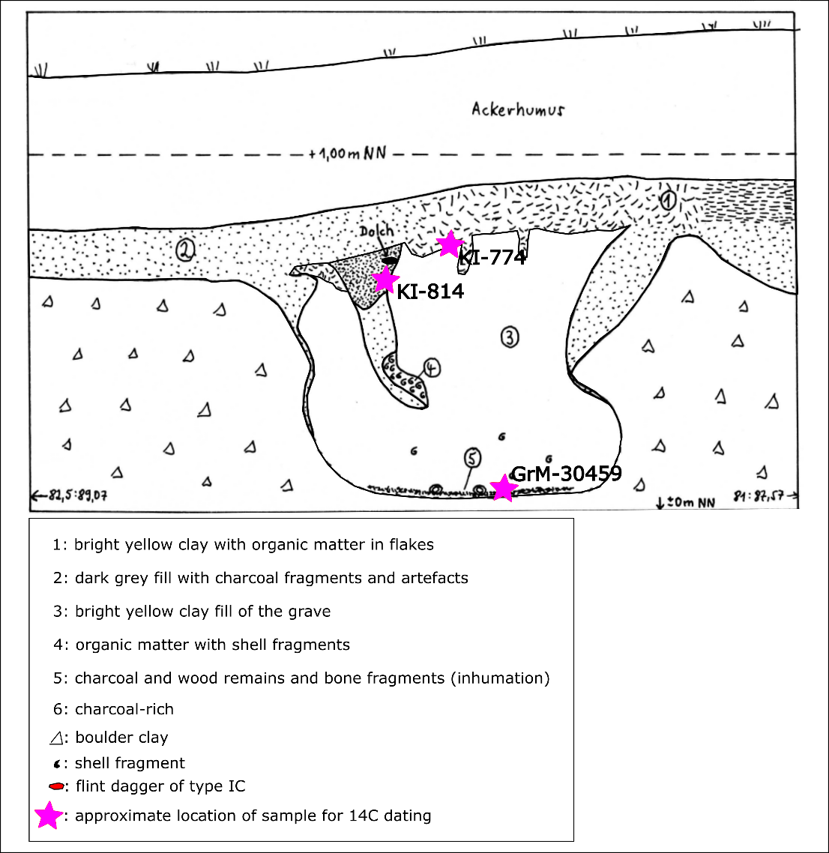
Figure S10 Modified version of Arnold (1981a, Abb 20)’s sketch of the grave profile, based on the recorded horizontal excavation spits. The most likely location of the ¹⁴C dates is noted with purple star symbols and their respective lab codes.

A second context that stratigraphically falls in the pre-midden phase, is material embedded in the Strandsand layer. Two samples were taken from a single wooden post from quadrant 17 (Quercus, KN-1862 and Hv-5596), predating the formation of the gyttja layer. Both the grave and the oak post predate the formation of the settlement shell midden phase, but between themselves no sequence of events can be established. Therefore both the grave and the oak post are treated as separate sub-phases within the first phase of the site.
The settlement phase itself, consisting of both the finds layer and the shell midden, is dated by a total of eight radiocarbon determinations, taken from several quadrants. These determinations can be further divided based on their depth within the layer: all samples were taken from the bottom and top part of the finds layer, within quadrants situated closely to one another (see table S3). Therefore this phase is subdivided into four separate sequences, based on the spatial proximity of the samples. The two dated hazelnut pericarps come from the top of the shell midden layer in a position that is exposed to the surface, as the covering peat has completely oxidized (-0.53 and -0.57 NN in the Eastprofile of 2011, see Höfgen 2018, Abb. 11). This could very well mean that these aberrant dates are the result of material derived from the oxidized peat. Therefore these two dates are not considered in the shell midden/finds layer phase, but as intrusions from the subsequent peat phase.

An additional three determinations were taken from the gyttja layer at the southern part of the site on depths above the Strandsand layer and the oak posts. The gyttja layer cannot be stratigraphically discriminated from the shell midden layer, and some flint artefacts associated with the occupation were also discovered in this gyttja layer. Therefore, together, these sets of dates are treated as two separate sub-phases within the second phase of the site.

The final collection of radiocarbon-dated samples is taken from the layers of peat covering the shell midden and gyttja deposits. In total, two samples have been taken, one from bulk peat (KN-3012; quadrant E1 from profile 10), and one from uncharred seeds of Alnus glutinosa (from the 2011 sampled column at -0.29m NN). Next to these two samples, we include the earlier mentioned two dates on hazelnut pericarp in this phase, as these are most likely the result of bioturbation as the soil micromorphology showed. This collection is treated as a single, third phase of the site.

Bayesian model
In total the Bayesian model consists of a single sequence, subdivided into three main phases (pre-midden, midden, and peat). Two of these main phases contain sub-phases that cannot be stratigraphically separated from each other. The pre-midden phase contains a ‘beach sand’ phase and a ‘grave’ phase. The grave phase consists of a separate sequence, where the lowest levels and the secondary fill contexts are separated.
The midden phase contains a ‘finds layer’ phase, a ‘gyttja’ phase, and a phase for the top of the grave fill. The ‘finds layer’ phase itself is subdivided into four sub-sequences, based on the radiocarbon determinations on samples from specific depths, when these originate from the same quadrant. This is based on the micromorphological observation that no widespread reworking of shell midden material has taken place.

The resulting Bayesian model was created using OxCal 4.2 (Bronk Ramsey 2009) and INTCAL20 (Reimer et al 2020). Using the OxCal function Date we present the optimal date range for each phase. Furthermore, using the OxCal function Interval, we calculate the duration of each phase.

The radiocarbon dates taken from charred wood samples can have an Inbuilt Age effect (GrM-30459, Hv-5596, KI-814, KI-774, KI-813-000, KI-812-000, KN-1862 and KN-1863), and have been treated as possible outliers, using the Exponential Outlier model with an outlier probability of 0.05 (Dee/Bronk Ramsey 2014).

All the shell dates are prone to the Marine Reservoir Effect (e.g. Ascough et al 2004), and possible external carbonate contamination due to diagenesis (e.g. Douka et al 2010). Thus, these dates are included in the Oxcal model using the After function.

Bayesian model code
Plot()
{
Outlier_Model("IA",Prior("Charcoal_Plus_2"),U(0,3),"t");
Sequence(Tegelbarg)
{
Boundary("Start pre-Midden");
Phase("pre-Midden")
{
Phase("Grave")
{
Sequence("Grave_pit")
{
Boundary("Start Grave_primary");
Phase("Grave primary")
{
R_Date("GrM-30459",4096,24);
Date("Grave_primary",);
Interval("Grave_primary");
};
Boundary("End Grave_primary");
Interval("Grave_between");
Boundary("Start Grave_secondary");
Phase("Grave secondary")
{
R_Date("KI-814", 3960, 65)
{
Outlier("IA", 0.05);
};
Date("Grave_secondary",);
Interval("Grave_secondary");
};
Boundary("End Grave_secondary");
};
Date("Grave",);
Interval("Grave");
};
Phase("Oak posts")
{
R_Date("KN-I-862", 3920, 65)
{
Outlier("IA", 0.05);
};
R_Date("HV-5596", 3740, 120)
{
Outlier("IA", 0.05);
};
Date("Oak posts",);
Interval("Oak posts");
};
Date("pre-midden",);
Interval("pre-midden");
};
Boundary("End pre-Midden");
Boundary("Start Shell Midden");
Phase(Shell Midden)
{
Phase(Finds layer)
{
Sequence("1")
{
R_Date("KI-813-000", 3740, 75)
{
Outlier("IA", 0.05);
};
R_Date("KI-812-000", 3520, 100)
{
Outlier("IA", 0.05);
};
};
Sequence("2")
{
R_Date("KI-772", 3660, 70);
R_Date("KI-773", 3490, 970);
};
Sequence("3")
{
R_Combine("Probe 3")
{
R_Date("KIA-43919", 3660, 30);
R_Date("KIA-55747", 3678, 26);
};
};
Sequence("4")
{
R_Combine("Probe 4")
{
R_Date("KIA-43920", 3630, 25);
R_Date("KIA-55748", 3560, 25);
};
};
Date("Finds layer",);
Interval("Finds layer");
After("mussel_shells")
{
Combine("shell_1")
{
R_Date("KIA-43949",4330,30);
R_Date("KIA-55749",4406,25);
};
Combine("shell_2")
{
R_Date("KIA-55750",4447,25);
};
Combine("shell_3")
{
R_Date("KIA-43951",4210,30);
R_Date("KIA-55751",4148,25);
};
Combine("shell_4")
{
R_Date("KIA-55752",4409,25);
};
R_Date("KI-813-011",4310,65);
R_Date("KI-812-011",3810,110);
};
};
Phase("Gyttja")
{
R_Date("KN-I-860", 3520, 65);
R_Date("KN-I-861", 3470, 55);
R_Date("KN-I-863", 3550, 55)
{
Outlier("IA", 0.05);
};
Date("Gyttja",);
Interval("Gyttja");
};
Phase("Grave tertiary fill")
{
R_Date("KI-774", 3810, 110)
{
Outlier("IA", 0.05);
};
Date("grave_tertiary",);
Interval("Grave tertiary");
};
Date("Shell Midden",);
Interval("Shell Midden");
};
Boundary("End Shell Midden");
Interval("Between_midden_peat");
Boundary("Start Peat");
Phase("Peat")
{
R_Date("KN-3012", 2620, 50);
R_Date("Poz-16383", 2620, 30);
R_Combine("Probe 2")
{
R_Date("KIA-43918", 2810, 20);
R_Date("KIA-55746", 2796, 27);
};
R_Combine("Probe 1")
{
R_Date("KIA-43917", 2890, 25);
R_Date("KIA-55745", 2835, 27);
};
Date("peat",);
Interval("peat");
};
Boundary("End Peat");
};
};
References to the supplementary information
Angelucci, D.E. 2010. The recognition and description of knapped lithic artifacts in thin section, Geoarchaeology 25 (2), 220-232.
Angelucci, D.E. 2017. Lithic Artefacts. In: Nicosia, C. and G. Stoops (eds) Archaeological Soil and Sediment Micromorphology, Oxford: Wiley/Blackwell, 223-230.
Arnold, V. 1973. Steinbronzezeitliche Siedlungsreste auf dem "Tegelbarg", Gemeinde Quern - Neukirchen, Kr. Flensburg, Offa 30, 94-95.
Arnold, V. 1974. Tegelbarg, ein spatneolithischer Küistenfangplatz an der Flensburger AuBenförde, Die Heimat 81, 87-93.
Arnold, V. 1979. Tegelbarg, eine spätneolithische Ostsee-Küstenstation und ihre Flinttechnik, Heide (PhD Thesis Universität zu Köln).
Arnold, V. 1981. Ein aus Schlagabfällen rekonstruierbarer Flintdolch vom Tegelbarg, Gemeinde Quern, Kreis Schleswig-Flensburg, Offa 38, 53-160.
Arnold, V. 1981. Tegelbarg, eine spätneolithische Ostsee-Küstenstation und ihre Flinttechnik, Köln (PhD Thesis Universität zu Köln).
Arnold, V. 1990. Refitting of waste material from dagger production of site Tegelbarg (Quern-Neukirchen, Schleswig-Holstein). In: Cziesla, E., S. Eickhoff, N. Arts and D. Winter (eds) The Big Puzzle: International Symposium on Refitting Stone Artefacts, Bonn: Holos Verlag (Studies in modern Archaeology 1).
Ascough, P.L., G.T. Cook, A.J. Dugmore, J. Barber, E. Higney and E.M. Scott 2004. Holocene variations in the Scottish marine radiocarbon reservoir effect, Radiocarbon 46 (2), 611-620.
Babel, U. 1975. Micromorphology of Soil Organic Matter. In: Gieseking, J.E. (ed.) Soil Components Vol. 1: Organic Components, Berlin/Heidelberg/New York: Springer Verlag, 369-473.
Booth, T.J. 2016. An investigation into the relationship between funerary treatment and bacterial bioerosion in European archaeological human bone, Archaeometry 58 (3), 484-499.
Booth, T.J. and R. Madgwick 2016. New evidence for diverse secondary burial practices in Iron Age Britain: a histological case study, Journal of Archaeological Science 67, 14-24.
Bronk Ramsey, C. 2009. Bayesian analysis of radiocarbon dates, Radiocarbon 51 (1), 337-360.
Brönnimann, D., C. Portmann, S.L. Pichler, T.J. Booth, B. Röder, W. Vach, J. Schibler and P. Rentzel 2018. Contextualising the dead – Combining geoarchaeology and osteo-anthropology in a new multi-focus approach in bone histotaphonomy, Journal of Archaeological Science 98, 45-58.
Brönnimann, D., B. Röder, N. Spichtig, H. Rissanen, G. Lassau and P. Rentzel 2020. The Hidden Midden: Geoarchaeological investigation of sedimentation processes, waste disposal practices, and resource management at the La Tène settlement of Basel‐Gasfabrik (Switzerland), Geoarchaeology 46, 522-544.
Brönnimann, D., J. Wimmer, M. Müller-Kissing, B. Stopp, H. Rissanen and N. Spichtig 2020. One man’s trash is another man’s treasure. Interdisciplinary examination of taphonomic aspects of ceramic sherds, animal bones and sediments from the La Tène period settlement at Basel-Gasfabrik, PLoS One 15 (7), e236272.
Dee, M.W. and C. Bronk Ramsey 2014. High-precision Bayesian modeling of samples susceptible to inbuilt age, Radiocarbon 56, 83-94.
Douka, K., R.E.M. Hedges and T.F.G. Higham 2010. Improved AMS 14C dating of shell carbonates using high-precision X-Ray diffraction and a novel density separation protocol (CarDS), Radiocarbon 52 (2-3), 735-751.
Höfgen, W. 2018. Der spätneolithische Muschelhaufen von Quern-Neukirchen LA 28 (Tegelbarg), Kreis Schleswig-Flensburg, Offa 71/72, 155-216.
Holguin, A., M. Charles, S. Mithen and R.J. Schulting 2022. In a nutshell: Using structural and chemical changes to establish the charring conditions of archaeological hazelnut shells, Journal of Archaeological Science 144, 105623.
Huisman, D.J., K. Ismail-Meyer, B.M. Sageidet and I. Joosten 2017. Micromorphological indicators for degradation processes in archaeological bone from temperate European wetland sites, Journal of Archaeological Science 85, 13-29.
Ismail-Meyer, K. 2017. Plant Remains. In: Nicosia, C. and G. Stoops (eds) Archaeological Soil and Sediment Micromorphology, Oxford: Wiley/Blackwell, 121-135.
Ismail-Meyer, K., W. Vach and P. Rentzel 2020. Do Still Waters Run Deep? Formation Processes of Natural and Anthropogenic Deposits in the Neolithic Wetland Site of Zug-Riedmatt (Switzerland), Geoarchaeology
Karkanas, P., O. Bar-Yosef, P. Goldberg and S. Weiner 2000. Diagenesis in Prehistoric Caves: the Use of Minerals that Form In Situ to Assess the Completeness of the Archaeological Record, Journal of Archaeological Science 27, 915-929.
Lull, V., R. Micó, C. Rihuete-Herrada and R. Risch 2015. When 14C dates fall beyond the limits of uncertainty: An assessment of anomalies in western Mediterranean Bronze Age 14C series, Radiocarbon 57 (5), 1029-1040.
Mallol, C. and P. Goldberg 2017. Cave and Rock-Shelter Sediments. In: Nicosia, C. and G. Stoops (eds) Archaeological Soil and Sediment Micromorphology, Oxford: Wiley/Blackwell, 359-382.
Meadows, J., M. Hüls and R. Schneider 2015. Accuracy and reproducibility of 14C measurements at the Leibniz-Labor, Kiel: a first response to Lull et al., "When 14C dates fall beyond the limits of uncertainty: An assessment of anomalies in western Mediterranean Bronze Age 14C series", Radiocarbon 57, 1041-1047.
Reimer, P.J., W.E.N. Austin, E. Bard, A. Bayliss, P.G. Blackwell, C. Bronk Ramsey, M. Butzin, H. Cheng, R.L. Edwards, M. Friedrich, P.M. Grootes, T.P. Guilderson, I. Hajdas, T.J. Heaton, A.G. Hogg, K.A. Hughen, B. Kromer, S.W. Manning, R. Muscheler, J.G. Palmer, C. Pearson, J. Van der Plicht, R.W. Reimer, D.A. Richards, E.M. Scott, J.R. Southon, C.S.M. Turney, L. Wacker, F. Adolphi, U. Büntgen, M. Capano, S.M. Fahrni, A. Fotgmann-Schulz, R. Friedrich, P. Köhler, S. Kudsk, F. Miyake, J. Olsen, F. Reinig, M. Sakamoto, A. Sookdeo and S. Talamo 2020. The INTCAL20 northern hemisphere radiocarbon age calibration curve (0–55 cal kBP), Radiocarbon 62 (4), 725-757.
Schweingruber, F.H. and A. Börner (eds) 2018. The Plant Stem, Cham: Springer.
Shahack-Gross, R., F. Berna, P. Karkanas and S. Weiner 2004. Bat guano and preservation of archaeological remains in cave sites, Journal of Archaeological Science 31, 1259-1272.
Trueman, C.N. and D.M. Martill 2002. The long–term survival of bone: the role of bioerosion, Archaeometry 44 (3), 371-382.
Trueman, C.N.G., A.K. Behrensmeyer, N. Tuross and S. Weiner 2004. Mineralogical and compositional changes in bones exposed on soil surfaces in Amboseli National Park, Kenya: diagenetic mechanisms and the role of sediment pore fluids, Journal of Archaeological Science 31 (6), 721-739.
Turner-Walker, G. 2012. Early bioerosion in skeletal tissue: persistence through deep time, Neues Jahrbuch für Geologie und Palaontologie Abhandlungen 256 (2), 165-183.
Turner-Walker, G. 2019. Light at the end of the tunnels? The origins of microbial bioerosion in mineralised collagen, Palaeogeography, Palaeoclimatology, Palaeoecology 529, 24-38.
Turner-Walker, G. and M.M.E. Jans 2008. Reconstructing taphonomic histories using histological analysis, Palaeogeoglaphy, Palaeoclimatology, Palaeoecology 266, 227-235.
Ward, G.K. and S.R. Wilson 1978. Procedures for Comparing and Combining Radiocarbon Age Determinations: a critique, Archaeometry 20 (1), 19-31.

Because of this low collagen yield, and the poor quality of the bone (Fuchs 2018) no further dating of the skeleton was attempted during this study.
Thanks to Yasmin Dannath (UFG, CAU) for sieving the residue and determining the species of uncharred and charred macrobotanical remains. Next to 39 uncharred Alnus seeds, the residue contained 1 charred twig frament of unknown plant species, 3 fragments of Quercus charcoal, 2 fragments of Corylus charcoal, and some tiny bone fragments.
Thanks to Dr. Sonja Filatova (GIA, RUG) for analysing the charcoal and determining the species. This determination confirms earlier assessments of the charcoal wood species from this feature (Arnold 1979, 15).

