Supporting Information
Graphene Nanoplatelet/Cellulose Acetate Composite Film with Simultaneously and Significantly Enhanced Antistatic, Thermal Dissipative and Mechanical Properties for Packaging

Zijun Gao$∙$Yao Li$∙$Pei Huang$∙$Rui Zou$∙$Yuanqing Li$∙$Shaoyun Fu

Zijun Gao and Yao Li have contributed equally to the study

Z. Gao$∙$Y. Li$∙$P. Huang$∙$Y. Li$∙$S. Fu
College of Aerospace Engineering, Chongqing University, Chongqing 400044, China
State Key Laboratory of Power Transmission Equipment and System Security and New Technology, Chongqing University, Chongqing, 400044, China
Corresponding authors: P. Huang (p.huang@cqu.edu.cn), S. Fu (syfu@cqu.edu.cn)

R. Zou
State Key Laboratory of Reliability and Intelligence Electrical Equipment, Hebei University of Technology, Tianjin, 300130, China
School of Mechanical Engineering, Hebei University of Technology, Tianjin 300401, China

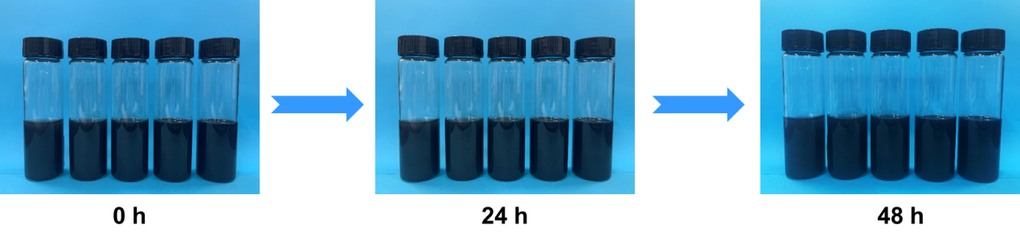
Fig. S1. Digital photos of GNP/CA suspension standing for 24 and 48 h (from left to right are E1/C5, E1/C3, E1/C1, E3/C1and E5/C1).
Table S1. C/O of EG, GNP, CA and G-C
 | C (at%) | O (at%) | C/O
EG | 96.41 | 3.59 | 26.8
GNP | 90.09 | 8.35 | 10.8
CA | 60.89 | 39.11 | 1.6
G-C | 93.41 | 6.59 | 14.2

Table S2. Surface resistivity of graphene- or GNP-based composites.
Matrix | Filler | Filler content (wt%) | Surface resistivity (Ω/sq.) | Ref.
Epoxy | Graphene nanoplatelet | 0.5 | 5.38×10¹² | (Qi et al. 2021)
Poly(vinyl chloride) | Multi-layer graphene | 3.5 | 3×10⁸ | (Wang et al. 2015)
Poly(vinyl chloride) | Graphene nanoplatelet | 1 | 2.5×10⁶ | (Wei et al. 2018)
Methyl-tri-n-butylammonium methylsulfate + acrylic polymer | Graphene nanoplatelet | 0.01 | 9.9×10¹⁰ | (Seki et al. 2019)
Polyester Fabric | Graphene oxide | 2 | 9.8×10⁶ | (Fan et al. 2019)
High-density polyethylene | Polyaniline  encapsulated graphene nanoplatelet | 20 | 2.88×10⁶ | (Wang et al. 2017)
Polyaniline | Cationic reduced graphene oxide | 2 | 9.8×10⁶ | (Mirmohseni et al. 2020)
Cotton fabrics | Graphene | 1.5 | 3×10⁵ | (Kowalczyk et al. 2017)
Poly (vinyl alcohol) | Phosphorus graphene oxide | 2.25 | 1.29×10⁵ | (Li et al. 2017)
Poly(L-lactide) polylactic acid | Reduced graphene oxide | 1 | 7.3×10¹¹ | (Li et al. 2020)

References

Fan L, Tan Y, Amesimeku J et al (2019) A novel functional disperse dye doped with graphene oxide for improving antistatic properties of polyester fabric using one-bath dyeing method. Text Res J 90(5-6): 655-665. https://10.1177/0040517519877464
Kowalczyk D, Fortuniak W, Mizerska U et al (2017) Modification of cotton fabric with graphene and reduced graphene oxide using sol–gel method. Cellulose 24(9): 4057-4068. https://10.1007/s10570-017-1389-4
Li J, Li Y, Niu S et al (2017) Ultrasonic-assisted synthesis of phosphorus graphene oxide/poly (vinyl alcohol) polymer and surface resistivity research of phosphorus graphene oxide/poly (vinyl alcohol) film. Ultrason Sonochem 36: 277-285. https://10.1016/j.ultsonch.2016.12.009
Li K, Fina A, Marrè D et al (2020) Graphite oxide nanocoatings as a sustaibale route to extend the applicability of biopolymer-based film. Appl Surf Sci 522. https://10.1016/j.apsusc.2020.146471
Mirmohseni A, Azizi M, & Dorraji M S S (2020) Cationic graphene oxide nanosheets intercalated with polyaniline nanofibers: a promising candidate for simultaneous anticorrosion, antistatic, and antibacterial applications. Prog Org Coat 139. https://10.1016/j.porgcoat.2019.105419
Qi B, Yao T-P, Zhang Y-D et al (2021) Endowing the sustainable antistatic properties to epoxy-based composites through adding graphene nanoplatelets. J Clean Prod 281. https://10.1016/j.jclepro.2020.124594
Seki Y, Ince M, Yıldız N et al (2019) The effect of methyl-tri-n-butylammonium methylsulfate and graphite nanoplates on production of antistatic acrylic polymer. Polym-Plast Technol Mater 58(13): 1471-1479. https://10.1080/25740881.2018.1563129
Wang H, Xie G, Fang M et al (2015) Electrical and mechanical properties of antistatic PVC films containing multi-layer graphene. Compos Part B 79: 444-450. https://10.1016/j.compositesb.2015.05.011
Wang Q, Wang Y, Meng Q et al (2017) Preparation of high antistatic HDPE/polyaniline encapsulated graphene nanoplatelet composites by solution blending. RSC Adv 7(5): 2796-2803. https://10.1039/c6ra26458a
Wei Z-B, Zhao Y, Wang C et al (2018) Antistatic PVC-graphene composite through plasticizer-mediated exfoliation of graphite. Chin J Polym Sci 36(12): 1361-1367. https://10.1007/s10118-018-2160-5

