Supplementary Material
Title:
A blood-based panel of DNA methylation markers improves diagnosis accuracy of Alzheimer’s disease
Blanca Acha, et al.

The Supplementary materials include the following information:
Supplementary Methods
Supplementary Figure 1. Area under the curve (AUC) of receiver operating characteristic (ROC) graph for each bivariant logistic regression model.
Supplemetary Figure 2. Plasma pTau181 levels measured in iBEAS cohort.
Supplementary Figure 3. DNA methylation levels in peripheral blood leucocytes (PBLs) by sex.
Supplementary Table 1. Baseline characteristics of the iBEAS study participants.
Supplementary Table 2. Bisulfite PCR pyrosequencing primers.
Supplementary Table 3. Analysis stratified by sex.
Supplementary Table 4. Multivariate regression logistic analysis.
Supplementary Table 5. PCR Amplification reaction conditions of APOE gene genotyping.

Supplementary Methods
Study design and Participants
Diagnosis of late-onset AD was performed by neurologists after performing neurological clinical examination, blood tests, neuropsychological tests and brain imaging by magnetic resonance (70%) or computed tomography (30%) scans. Patients’ inclusion also took into account levels of core biomarkers measured in cerebrospinal fluid (CSF) samples when available. Patients with behavioral disorders or other conditions that preclude neuroimaging acquisition were not included in the iBEAS study.
CSF samples collection and AD core biomarkers analysis
CSF samples from AD patients were obtained by lumbar puncture after ruling out contraindications and written informed consent. CSF samples were centrifuged at 2000 x g for 10 minutes, at 4°C, transferred to 1.5 mL polypropylene tubes in 0.5 mL aliquots, within next two hours and subsequently stored at -80°C. CSF levels of core AD biomarkers Aβ1–42, Aβ1–40, total Tau (tTau) and pTau181 were measured in the Lumipulse fully-automated platform using commercially available kits (Fujirebio Europe, Ghent, Belgium)¹ at the Sant Pau Hospital (Barcelona, Spain) (Supplementary Table 1).
APOE genotyping
Polymerase Chain Reaction-Restriction Fragment Length Polymorphism (PCR-RFLP) performed APOE genotyping. DNA was amplified by PCR using 10 µM oligonucleotide primers forward 5'-TAAGCTTGGCACGGCTGTCCAAGGA-3' and reverse 5' ACAGAATTCGCCCCCCGGCCTGGTACACAC-3'² in a VeritiTM Thermal Cycler (Applied Biosystems). Amplification reaction conditions are described in Supplementary Table 5. Amplified APOE sequences were incubated with 10 U FastDigest HhaI restriction enzyme (New England BioLabs, Missisauga, ON, Canada) at 37ºC overnight and electrophoresed on a 4% agarose gel at 120 V for 50 minutes.
References
1. Alcolea D, Delaby C, Muñoz L, et al. Use of plasma biomarkers for AT(N) classification of neurodegenerative dementias. J Neurol Neurosurg Psychiatry. Jun 08 2021;doi:10.1136/jnnp-2021-326603
2. Hixson JE, Vernier DT. Restriction isotyping of human apolipoprotein E by gene amplification and cleavage with HhaI. J Lipid Res. Mar 1990;31(3):545-8.

Supplementary Figures
Supplementary Figure 1. Area under the curve (AUC) of receiver operating characteristic (ROC) graph for each bivariant logistic regression model.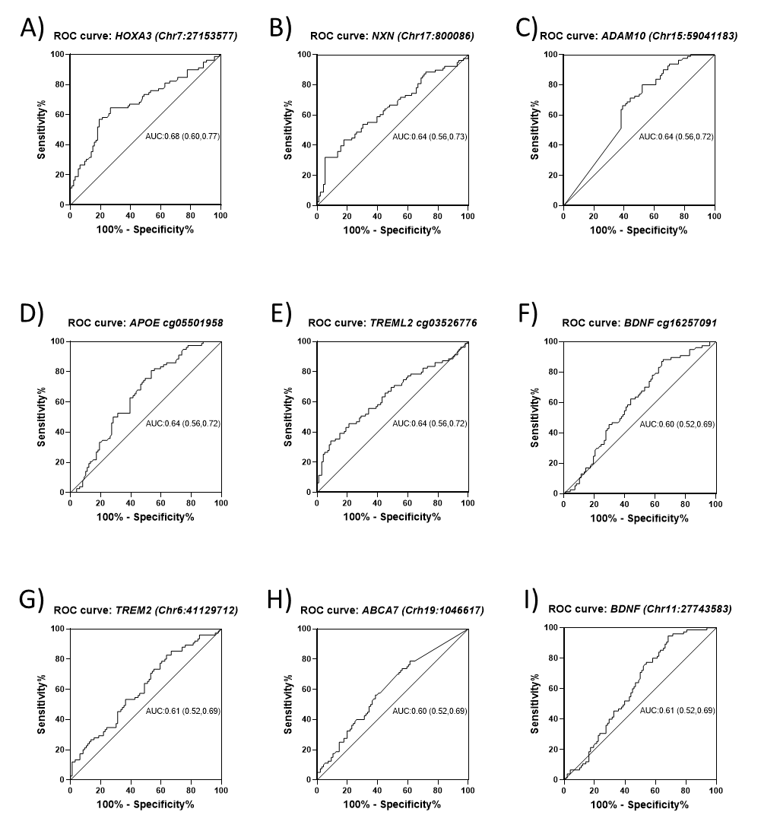
Figure Legend:
The graphs represent the AUC showing the performance of diagnostic prediction for HOXA3 (A), NXN (B), ADAM10 (C), APOE (D), TREML2 (E), BDNF (F,I), TREM2 (G), ABCA7 (H) genes.

Supplementary Figure 2. Plasma pTau181 levels measured in iBEAS cohort.
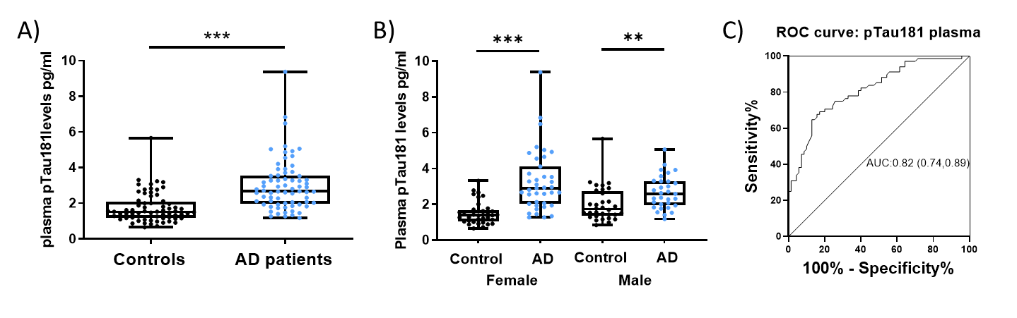 Figure Legend:
(A,B) Box-plots represent plasma levels of pTau181 in whole iBEAS cohort and after stratified in female and male subset. (C) The graph represents the AUC showing the performance of diagnostic prediction for plasma levels of pTau181. **P-value < 0.01; ***P-value < 0.001.

Supplementary Figure 3. DNA methylation levels in peripheral blood leucocytes (PBLs) by sex.
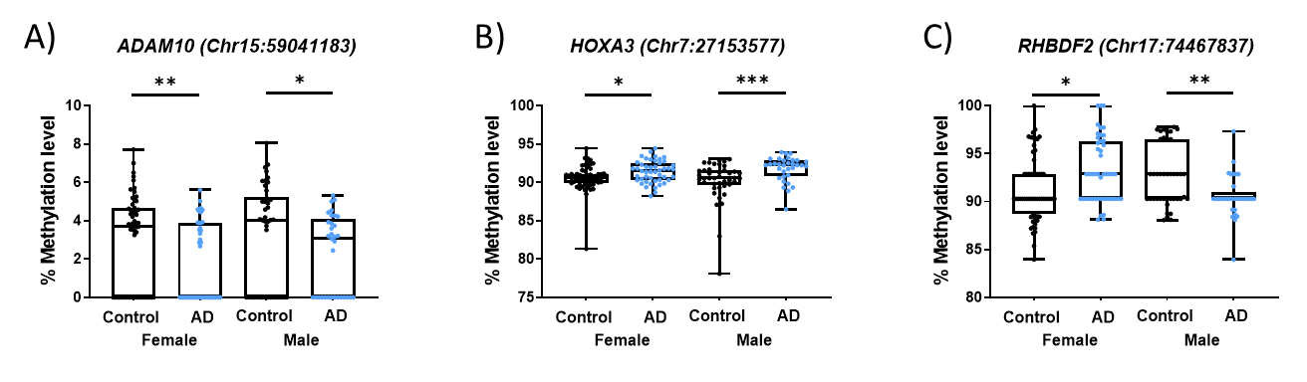Figure Legend:
The panel show box-plot which represent the percentage of DNA methylation to DMPs for ADAM10 (A), HOXA3 (B), RHBDF2 (C) genes in whole cohort, males and females

Supplementary Figure 4. Area under the curve (AUC) of receiver operating characteristic (ROC) graph for each multivariate logistic regression model (LRM).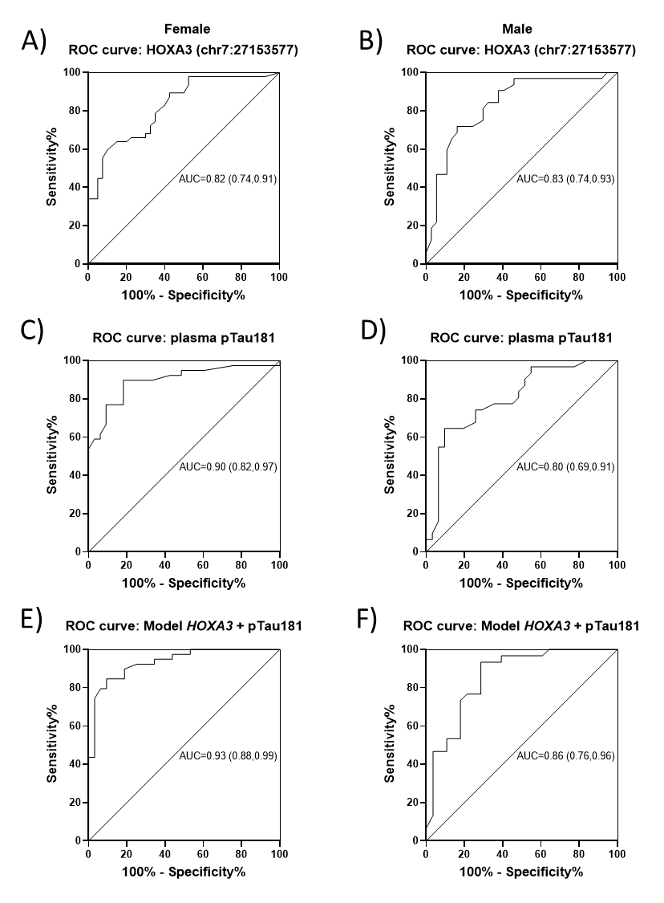Figure Legend:
The graphs represent the AUC showing the performance of diagnostic prediction for LRM DNA methylation of HOXA3 (A,B), LRM plasma pTau181 (C,D), LRM combination DNA methylation of HOXA3 gene + pTau181 (E,F) in female and male subset

Supplementary Tables
Supplementary Table 1. Baseline characteristics of the iBEAS study participants.
Demographic & clinical characteristics |  | AD (n=80) | CONTROLS (n=100) | P value
Demographic & clinical characteristics | Age, median (IQR), years | 79.00 (11) | 77.00 (10) | 0.086
Demographic & clinical characteristics | Sex, female/male, (% female) | 47/33 (58.8) | 58/42 (58.0) | 0.919
Demographic & clinical characteristics | APOE ɛ4 carrier, pos/neg (%pos) | 43/37 (53.8) | 10/89 (10.1) | <0.001
Demographic & clinical characteristics | MMSE score, median (IQR) | 22.50 (6.25) | 30.00 (1.00) | <0.001
Demographic & clinical characteristics | GDS score, median (IQR) | 4.00 (1.00) | 1.00 (0.00) | <0.001
AD Biomarkers | Plasma biomarkers | AD (n=70) | CONTROLS (n=70) | P value
AD Biomarkers | Plasma pTau181, median (IQR), pg/ml | 2.69 (1.56) | 1.52 (0.91) | <0.001
AD Biomarkers | CSF biomarkers | AD (n=26)
AD Biomarkers | CSF Aβ42, media ± SD, pg/ml | 363.19 ± 90.71
AD Biomarkers | CSF Aβ40, media ± SD, pg/ml | 8039.89 ± 2258.10
AD Biomarkers | CSF Aβ42 /Aβ40, media ± SD | 0.047 ± 0.010
AD Biomarkers | CSF tTau, median (IQR), pg/ml | 703.00 (339.00)
AD Biomarkers | CSF pTau, median (IQR), pg/ml | 111.80 (61.43)

Abbreviations: AD, Alzheimer’s disease; APOE ε4, apolipoprotein ε4; ;MMSE, Mini-Mental State Examination; GDS, Global/Geriatric Deterioration Scale de Reisberg; IQR, Interquartile Range; SD, standard deviation; CSF, Cerebrospinal fluid

Supplementary Table 2. Bisulfite PCR pyrosequencing primers.
Gene ID | Amplicon size (bp) | Tm1 | Forward Primer | Tm2 | Reverse Primer
ABCA7 pyro | 196 | 59.1 | AGTTTTTGGTTTTTAGGTATTAGTGTAG | 59.4 | ATAAACCCAAACTCTATTAAAAACCTTC
ABCA7 seq |  | 45.2 | AGTGTAGTTTAGGTTGTT
ADAM10 pyro | 211 | 58.6 | ATTTAGGTTGGTGGTTGTATTTT | 60.5 | CCCAACTACAAACAACACAACTT
ADAM10 seq |  |  |  | 46.3 | ACAACACAACTTCCC
ANK1 pyro | 140 | 57.4 | AGAGGAAGTTTTTATTGTTTGTAATT | 58.6 | CTCCATCATTTTAATTCCAACCTAATAC
ANK1 seq |  | 44.4 | ATTAAGATTATTTAGGGTTTAGT
APOE pyro | 190 | 57.7 | TGTTTTGGTAGAGTATGGTTTGTATTT | 56.9 | ACCATAAAAAAATTAAAAACCTACAAATC
APOE seq |  | 40.0 | GTTTGTAGTTTTTTGGATA
BDNF seq | 87 | 58.9 | GGGAAGATAGTTGGGGAATTTGT | 58.6 | CCCCTCCCTACTACCCTTTTCTAATATTAT
BDNF seq |  | 44.9 | GGGGAATTTGTTGTTTAT
BIN1 pyro | 179 | 57.2 | TGGTTTTTTAGGTGTTAGTTTTTTAAT | 58 | ACATCATAAAATATAATTCCTACCCATAA
BIN1 seq |  |  |  | 39.8 | ACCACAACCATATATCTAAATAAT
GP1BB pyro | 162 | 53.7 | GTTTTGGGTTGTTGTAGT | 54.9 | AAAACCCCTCCAACAAAATCCT
GP1BB seq |  | 39.9 | AGAGAATAGGAGTTGGGTAATA
HAND2 pyro | 147 | 57.9 | TTGAGGTATTAGTTATTAAAAGATTAAGGT | 59.9 | CCAACAACCACTTATTTTATACACTT
HAND2 seq |  | 42.3 | ATTAAATTTTATTTAGTTTTAGAGG
HIST pyro | 176 | 57.2 | GGAAAAAGATTTGTTTGAAAGAGTTAGTT | 57.8 | CCCCTCTATATAAAAACAAAATCACT
HIST seq |  |  |  | 35.9 | ATTAATAATCCATTACTAAATTCC
HOXA3 pyro | 92 | 53.8 | TTTGTTTTTTTAGAGGGTAGTAGT | 57.3 | ATACCCAAATCCATACCACTAACCC
HOXA3 seq |  |  |  | 44.5 | CTAACCCAAACAAAACC
HOXB6 pyro | 140 | 58.7 | AGGAGGGGATAGGTATTTATTTGTAG | 56.3 | CAAAAAACAAACCCAATCTATATTCTCCT
HOXB6 seq |  | 41.1 | TGTAGATATTAATAGTTTTTAGAAA
IRS2 pyro | 66 | 58.7 | AGGGAGTAGGGGTTGGTG | 58.8 | ACACAACCCCTCCATATCCATACC
IRS2 seq |  |  |  | 47.9 | ACCCCTCCATATCCATACCC
KCNN4 pyro | 221 | 57.2 | TAGGGATAGTAGAGTTTTTTTTTGGTTTAG | 57.8 | ACCCCCTACCCACAACTATTCATA
KCNN4 seq |  | 44.9 | GGTTGAGGGGAGGTT
MAP4K1 pyro | 163 | 56.2 | GGTAGTGGGAATAGTATTTGTT | 58.1 | AACCTTATCCCCTAACATTTCT
MAP4K1 seq |  | 45.1 | GTGGGAATAGTATTTGTTG
NXN pyro | 229 | 58.3 | AGAGAGTTGTTTTTGGTAATAGAATT | 57.7 | ACAACAAACCTAAAAAAAAACTAACTTAA
NXN seq |  | 44.3 | GTAGATTTAGAAGATGTTAAAATGG
PAX3 pyro | 252 | 59.8 | GGGTTATTTAAAAGTTTTTAGGGTTGAG | 58.8 | ACTTTTCATTTTCATTAACCATCTACTT
PAX3 seq |  | 45.1 | GGTGAGGAGGAATTAGTTAG
RHBDF2 pyro | 177 | 58.6 | GTTAGTTAATGGGGTAGATGTATAGT | 58.3 | CCCACATCTTCCACTTCCTCAATAAC
RHBDF2 seq |  | 46.6 | ATGGGGTAGATGTATAGTT
RHOB pyro | 229 | 58.3 | AGAGTAGGGTTTTAGAGTGTGTG | 60.0 | ATATAACATCCCCCCATCCTC
RHOB seq |  | 46.3 | ATTGGAGAGGGAGTGTGG
SIX3 pyro | 185 | 60.2 | GGGAGTAGGATTTTTAGTTGTTGATAG | 58.7 | CTCTCCACAAAAAAACCTTAACTTA
SIX3 seq |  | 45.7 | GTTTGATGAGGGGAG
TREM2 pyro | 179 | 59.8 | AAGGGGAATAAAGTTATAGAAATAGGG | 58.7 | CCTCCAATTCTATTCTACACATCT
TREM2 seq |  | 45.5 | GGAAGTTAAAGGTTAGGAA
TREML2 pyro | 105 | 59.1 | AATAGTGATTAAAAGTTGGGGATTTATAG | 61.7 | CAACCCCAATCAAAACAAAACCATC
TREML2 seq |  | 47.8 | GAGGGGTTGGTAGTT
The table shows the primer pairs used in the study. Abbreviations: ID: identification; bp: base pair; Tm: Melting Temperature.
Supplementary Table 3. Analysis stratified by sex.
Female (N=89)
ID | Genomic coordinates GRCh37/Hg19 |  | AD (n=47) | CONTROLS (n=42) | P value
Age, median (IQR), years |  |  | 80.00 (9) | 77.00 (7) | 0.265
APOE ɛ4 carrier, pos/neg (%pos) |  |  | 24/23 (51.1) | 5/37 (11.9) | <0.001
ABCA7, median (IQR), % Meth | 19 | 1046617 | 98.38 (3.25) | 99.65 (2.32) | <0.05
ADAM10, median (IQR), % Meth | 15 | 59041183 | 0.00 (3.89) | 3.72 (4.90) | <0.01
APOE, median (IQR), % Meth | 19 | 45411874 | 91.43 (1.04) | 90.87 (2.05) | <0.01
BDNF, media ± SE, % Meth | 11 | 27743580 | 5.76 ± 1.54 | 6.91 ± 2.16 | <0.01
BDNF, median (IQR), % Meth | 11 | 27743583 | 5.90 (2.39) | 6.51 (2.75) | <0.05
HOXA3, median (IQR), % Meth | 7 | 27153577 | 91.50 (2.24) | 90.76 (1.06) | <0.05
RHBDF2, median (IQR), % Meth | 17 | 74467837 | 92.88 (6.00) | 90.29 (6.15) | <0.05
TREM2, media ± SE, % Meth | 6 | 41129736 | 26.56 ± 6.29 | 29.73 ± 6.46 | <0.05
TREM2, media ± SE, % Meth | 6 | 41129712 | 31.03 ± 6.54 | 34.64 ± 6.21 | <0.05
TREML2, median (IQR), % Meth | 6 | 41159608 | 27.06 (10.53) | 32.65 (10.66) | <0.05
pTau181, median (IQR), pg/ml |  |  | 2.90 (2.08) | 1.41 (0.57) | <0.001
Male (N=75)
ID | Genomic coordinates GRCh37/Hg19 |  | AD (n=33) | CONTROLS (n=42) | P value
Age, media ± SE, years |  |  | 78.06 ± 6.50 | 79.76 ± 6.25 | 0.254
APOE ɛ4 carrier, pos/neg (%pos) |  |  | 19/14 (57.6) | 4/37 (9.8) | <0.001
ADAM10, median (IQR), % Meth | 15 | 59041183 | 3.06 (4.08) | 4.04 (5.25) | <0.05
ADAM10, median (IQR), % Meth | 15 | 59041185 | 0.00 (3.18) | 0.00 (0.00) | <0.05
HOXA3, median (IQR), % Meth | 7 | 27153577 | 92.25 (2.01) | 90.57 (1.86) | <0.001
NXN, media ± SD, % Meth | 17 | 800086 | 79.68 ± 3.22 | 76.65 ± 3.47 | <0.001
PAX3, media ± SD, % Meth | 2 | 223154176 | 46.37 ± 7.81 | 43.11 ± 5.80 | <0.05
RHBDF2, median (IQR), % Meth | 17 | 74467829 | 92.07 (1.14) | 92.94 (3.68) | <0.001
RHBDF2, median (IQR), % Meth | 17 | 74467837 | 90.29 (0.66) | 92.88 (6.22) | <0.01
pTau181, median (IQR), pg/ml |  |  | 2.59 (1.35) | 1.73 (1.37) | <0.01

The table shows the variables with significant differences after stratifying by sex. Abbreviations: ID=identification; AD, Alzheimer’sdisease; APOE ε4, apolipoprotein ε4; IQR, Interquartile Range; SD, standard deviation; % Meth, % Methylation.

Female
HOXA3 | ID | P value | OR (95%CI) | AUC (95%CI) | Sensitivity | Specifity | Hosmer-Lemeshow test
HOXA3 | Age | 0.072 | 1.08 (0.99-1.17) | 0.824 (0.738 - 0.909) | 72.30% | 67.50% | 0.053
HOXA3 | APOE ɛ4 carrier | <0.001 | 7.139 (2.19-23.26)
HOXA3 | HOXA3 methylation level > 0.913 | <0.01 | 5.48 (1.87-16.01)
pTau181 | ID | P value | OR (95%CI) | AUC (95%CI) | Sensitivity | Specifity | Hosmer-Lemeshow test
pTau181 | Age | 0.429 | 1.05 (0.93-1.18) | 0.896 (0.821 - 0.971) | 89.70% | 75.80% | 0.602
pTau181 | APOE ɛ4 carrier | <0.01 | 8.74 (1.75-43.53)
pTau181 | Plasma pTau181 > 1.82 | <0.0001 | 19.34 (4.91-76.22)
Model HOXA3 + pTau181 | ID | P value | OR (95%CI) | AUC (95%CI) | Sensitivity | Specifity | Hosmer-Lemeshow test
Model HOXA3 + pTau181 | Age | 0.342 | 1.07 (0.93-1.22) | 0.934 (0.879 - 0.989) | 84.60% | 90.60% | 0.548
Model HOXA3 + pTau181 | APOE ɛ4 carrier | 0.023 | 10.85 (1.40-84.28)
Model HOXA3 + pTau181 | Plasma pTau181 > 1.82 | <0.001 | 21.26 (3.95-114.44)
Model HOXA3 + pTau181 | HOXA3 methylation level > 0.913 | <0.01 | 11.35 (2.04-63.06)
Male
HOXA3 | ID | P value | OR (95%CI) | AUC (95%CI) | Sensitivity | Specifity | Hosmer-Lemeshow test
HOXA3 | Age | 0.924 | 0.99 (0.91-1.09) | 0.834 (0.737 - 0.932) | 59.40% | 89.20% | 0.454
HOXA3 | APOE ɛ4 carrier | <0.001 | 11.24 (2.88-43.92)
HOXA3 | HOXA3 methylation level > 0.913 | <0.01 | 5.13 (1.53-17.22)
pTau181 | ID | P value | OR (95%CI) | AUC (95%CI) | Sensitivity | Specifity | Hosmer-Lemeshow test
pTau181 | Age | 0.392 | 0.95 (0.85-1.07) | 0.803 (0.692-0.914) | 64.50% | 90.30% | 0.298
pTau181 | APOE ɛ4 carrier | <0.01 | 8.86 (2.07-37.84)
pTau181 | Plasma pTau181 > 1.82 | .111 | 2.84 (0.79-10.28)
Model HOXA3 + pTau181 | ID | P value | OR (95%CI) | AUC (95%CI) | Sensitivity | Specifity | Hosmer-Lemeshow test
Model HOXA3 + pTau181 | Age | 0.346 | 0.94 (0.83-1.07) | 0.856 (0.757 - 0.955) | 80.00% | 71.40% | 0.083
Model HOXA3 + pTau181 | APOE ɛ4 carrier | <0.01 | 7.69 (1.63-36.38)
Model HOXA3 + pTau181 | Plasma pTau181 > 1.82 | 0.160 | 2.98 (0.65-13.68)
Model HOXA3 + pTau181 | HOXA3 methylation level > 0.913 | <0.01 | 5.69 (1.41-22.93)
Supplementary Table 4. Multivariate regression logistic analysis.
The table shows the variables included in the different multivariate logistic regression models adjusted by age and APOE ɛ4 genotype with p-value and OR for each variable after stratified by sex. Abbreviations: ID=identification; AUC= area under the curve; 95%CI=95% Confidence interval; OR=Odds ratio.
Supplementary Table 5. PCR Amplification reaction conditions of APOE gene genotyping.
Step | Temperature | Time (minutes)
Denaturation | 95 | 0:05:00
Denaturation | 95 | 0:01:00
Annealing | 60 | 0:01:00
Elongation | 70 | 0:02:00
35 cycles
Elongation | 72 | 0:05:00
 | 4 | ∞

The table shows the different steps of PCR amplification used for APOE genotyping.

