Table 1: Docking score of different molecules with the Secreted in Xylem 1 protein.

S.No. | Molecule Name | Ligand | Docking Score with Secreted in Xylem | Interacting amino  acid
1 | 4-[[2-(3-methoxyphenoxy)acetyl]amino]benzamide | 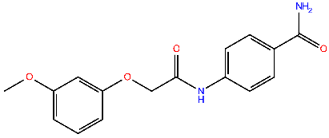 | -7.5068 | Lys94, Gln109, His116,
2 | 4-[[2-(3-methoxyphenoxy)acetyl]amino]benzamide | 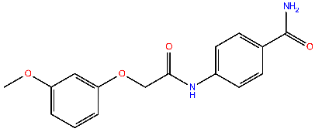 | -7.29619 | Lys94, Glu101, Gln109, His116,
3 | N-(2,3-dihydro-1,4-benzodioxin-6-yl)-2-[(6-methyl-2-oxo-1H-pyrimidin-4-yl)sulfanyl]acetamide | 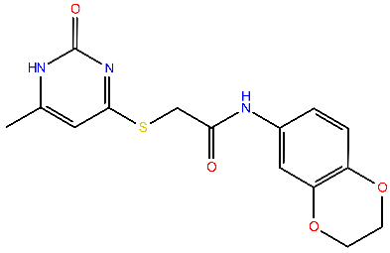 | -7.46133 | Tyr37, Glu109, His116,
4 | Methyl 4-[[2-[(6-methyl-2-oxo-1H-pyrimidin-4-yl)sulfanyl]acetyl]amino]benzoate | 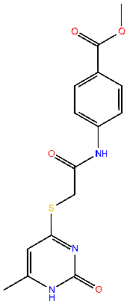 | -7.2778 | Lys94, Gln109
5 | Methyl 5-[[5-[[(2-chloro-6-fluorobenzoyl)amino]methyl]-1,3,4-oxadiazol-2-yl]sulfanylmethyl]furan-2-carboxylate | 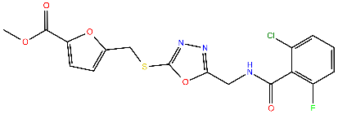 | -7.05516 | Lys94, Glu101, Gln109, His116, Arg128

