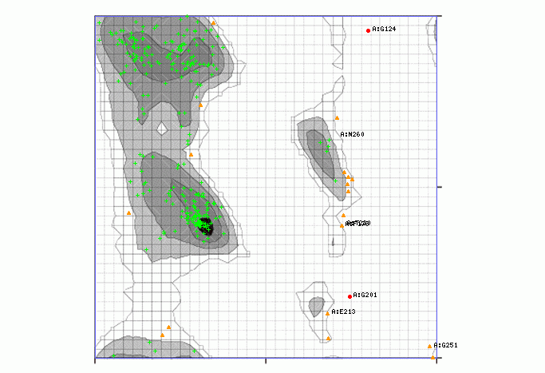
Supplementary Figure1: Ramachandran plot of SIX1 protein: White with black grid represents preferred conformations. Highly preferred observations shown as green crosses: 262 (92.908%). Preferred observation shown as brown triangles: 18 (6.383%) and questionable observations shown as red circles: 2 (0.709%).

