Supporting Information
The novel immunosuppressant Cloxyquin activates hTRESK by allosteric modulation of the selectivity filter

Julian A. Schreiber ^{a),b),*}, Anastasia Derksen^{b)}, Gunnar Goerges^{a)}, Sven Schütte^{c)}, Jasmin Sörgel^{b)}, Aytug K. Kiper^{c)}, Nathalie Strutz-Seebohm^{a)}, Tobias Ruck^{d)}, Sven G. Meuth^{d)}, Niels Decher^{c)}, Guiscard Seebohm^{a),e)}

a) Institute for Genetics of Heart Diseases (IfGH), Department of Cardiovascular Medicine, University Hospital Münster, D-48149 Münster, Germany.
b) Westfälische Wilhelms-Universität Münster, Institut für Pharmazeutische und Medizinische Chemie, Corrensstr. 48, Münster, D-48149, Germany.
c) Institute of Physiology and Pathophysiology, Vegetative Physiology, Philipps-University of Marburg, Deutschhausstr. 1-2, 35037 Marburg, Germany.
d) Department of Neurology, Medical Faculty, Heinrich-Heine University, Düsseldorf, Germany.
e) Chembion, University of Münster, D-48149 Münster, Germany.

*Corresponding author:
Dr. Julian Alexander Schreiber
Robert-Koch-Straße 45
D-48149 Münster
Tel. +49-251-835872
j.schreiber@uni-muenster.de

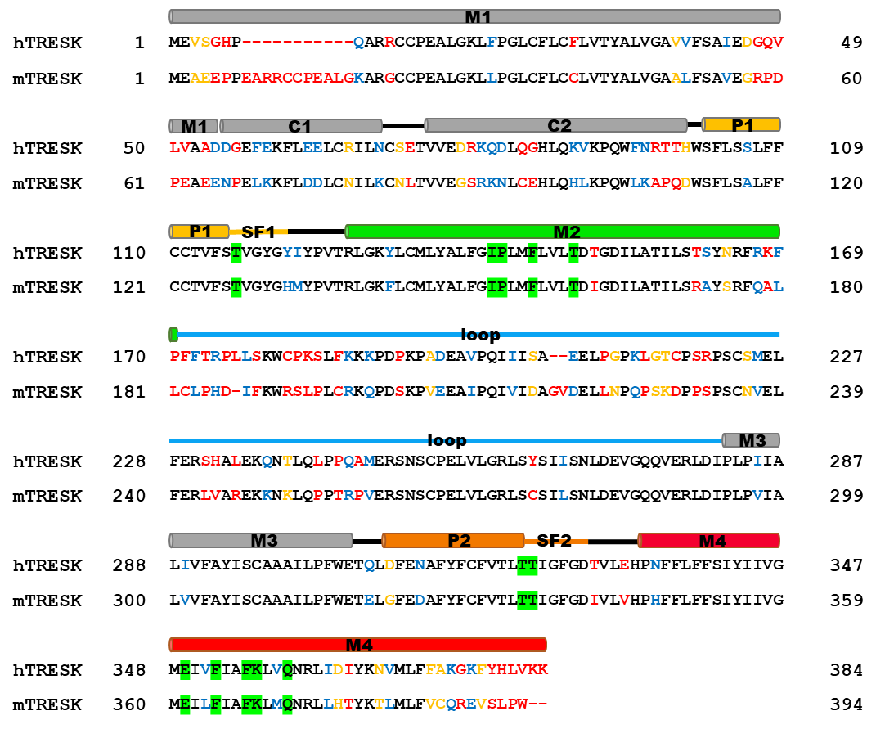
SI Fig. 1 | Protein sequence alignment of hTRESK and mTRESK. Sequences for hTRESK (UniProt Q7Z418) and mTRESK (UniProt Q6VV64) were aligned using Clustal Omega. Sequence identity is 64.5 %. Identical residues are written in black, conserved residues written in blue, semi-conserved written in yellow and non-conserved residues are written in red. Residues, that are used for mutational analyses are marked in green.

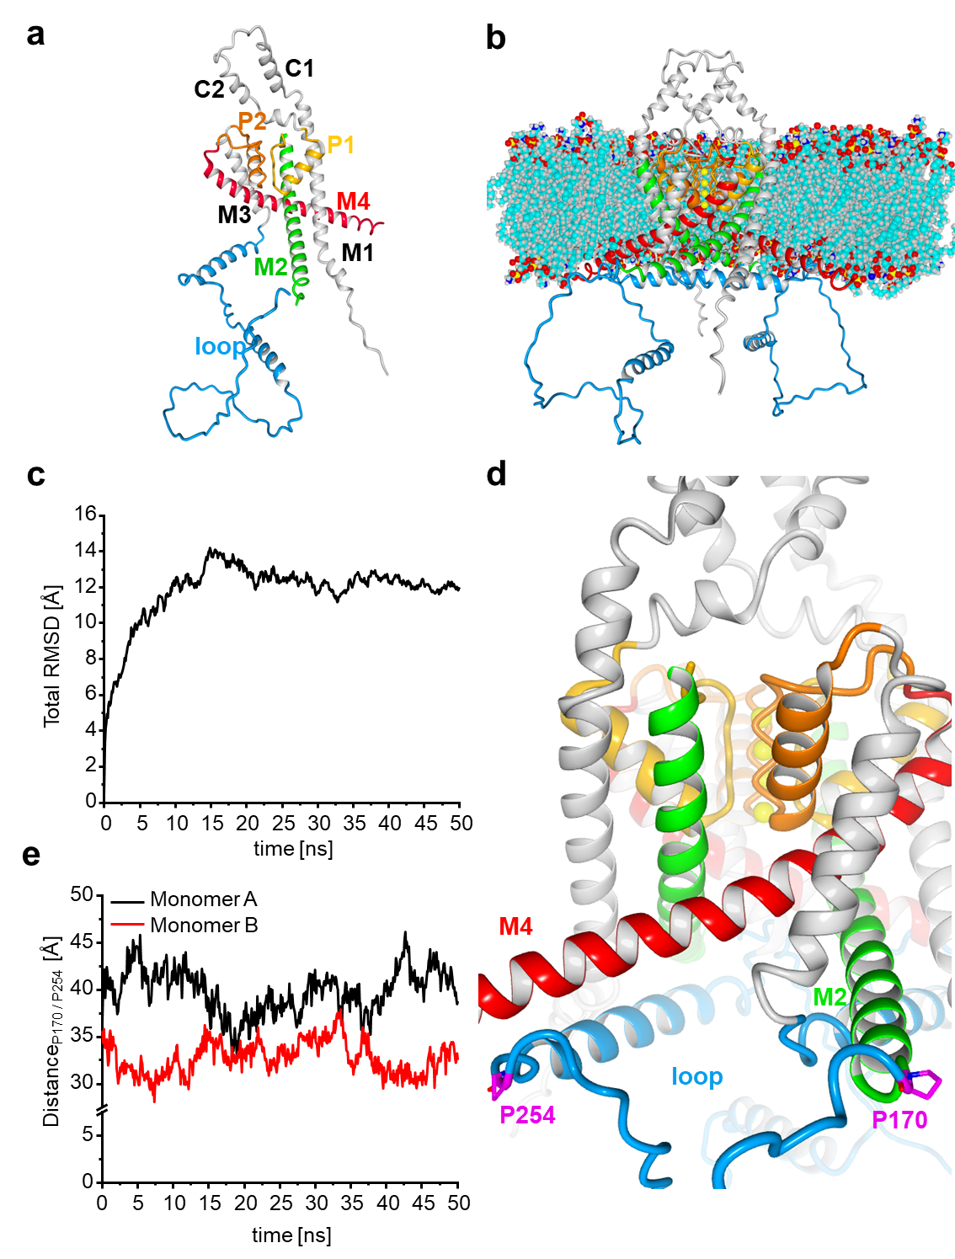
SI Fig. 2 | In silico generation of hTRESK model. a monomeric Alphafold structure (Uniprot Q7Z418)^{1,2}. The monomer can be subdivided into the four transmembrane helices M1-M4, the two extracellular helices C1/C2, the two pore helices P1/P2 and the intracellular loop (blue) between M2 and M3. b homodimeric structure of hTRESK model embedded into the membrane. c total RMSD of homodimeric channel derived from backbone movements for a 50 ns MD simulation. d close-up depiction of P170 and P254 (magenta). Both residues are located at the end of the structurally not well characterized M2/M3 loop. e Distances between P170 and P254 over 50 ns for each monomer.
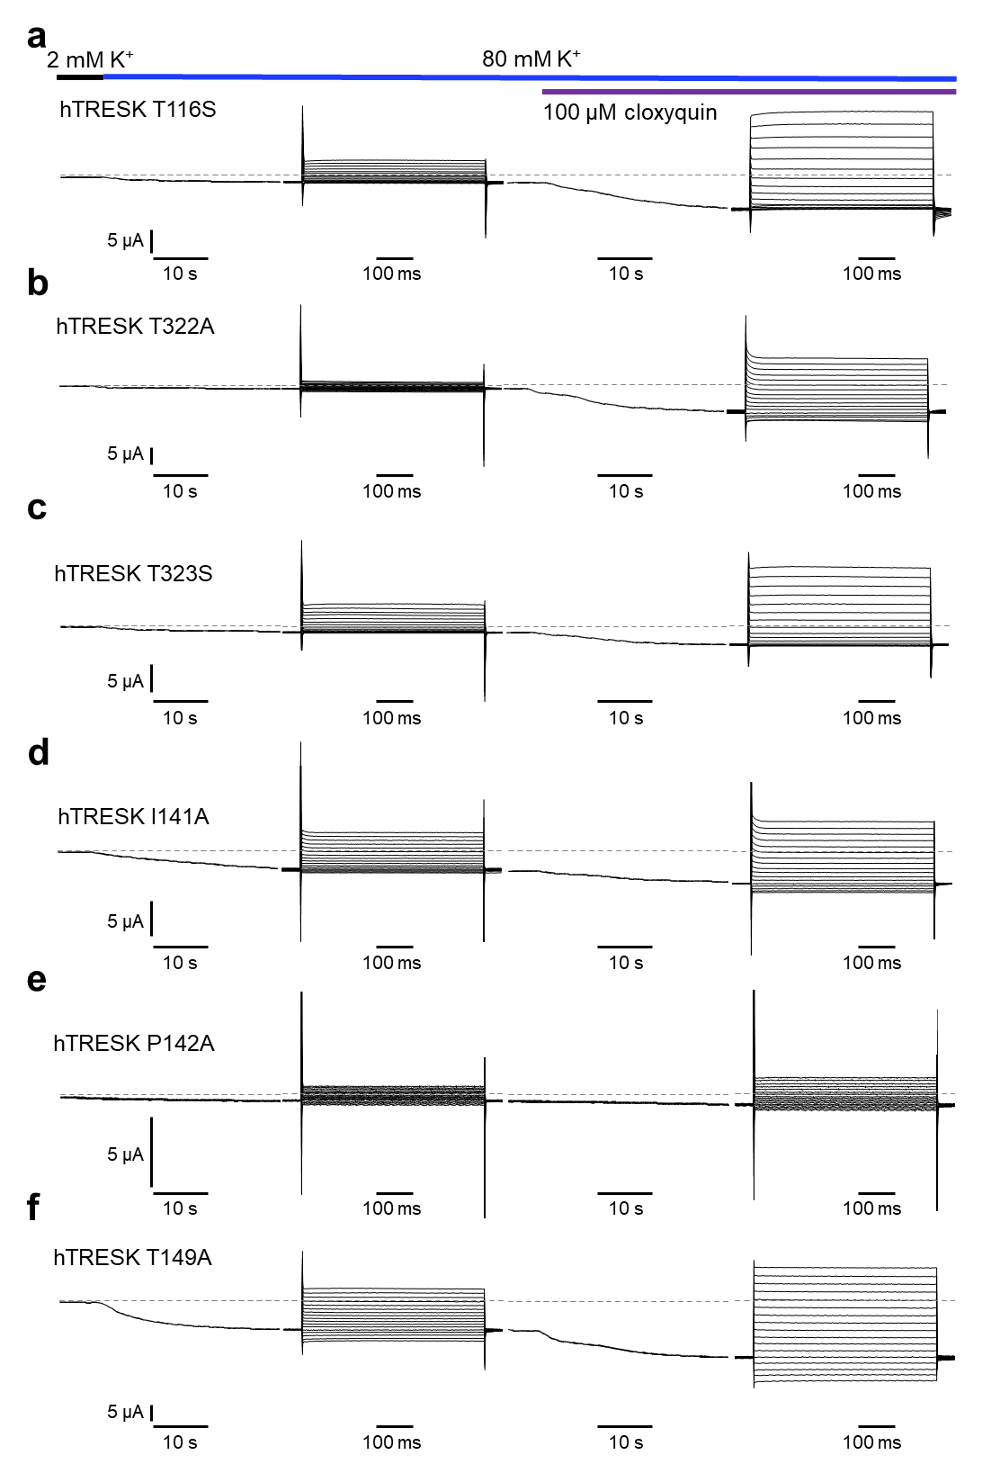
SI Fig. 3 | TEVC sample traces of different SF (a-c) and M2 (d-f) hTRESK mutants.

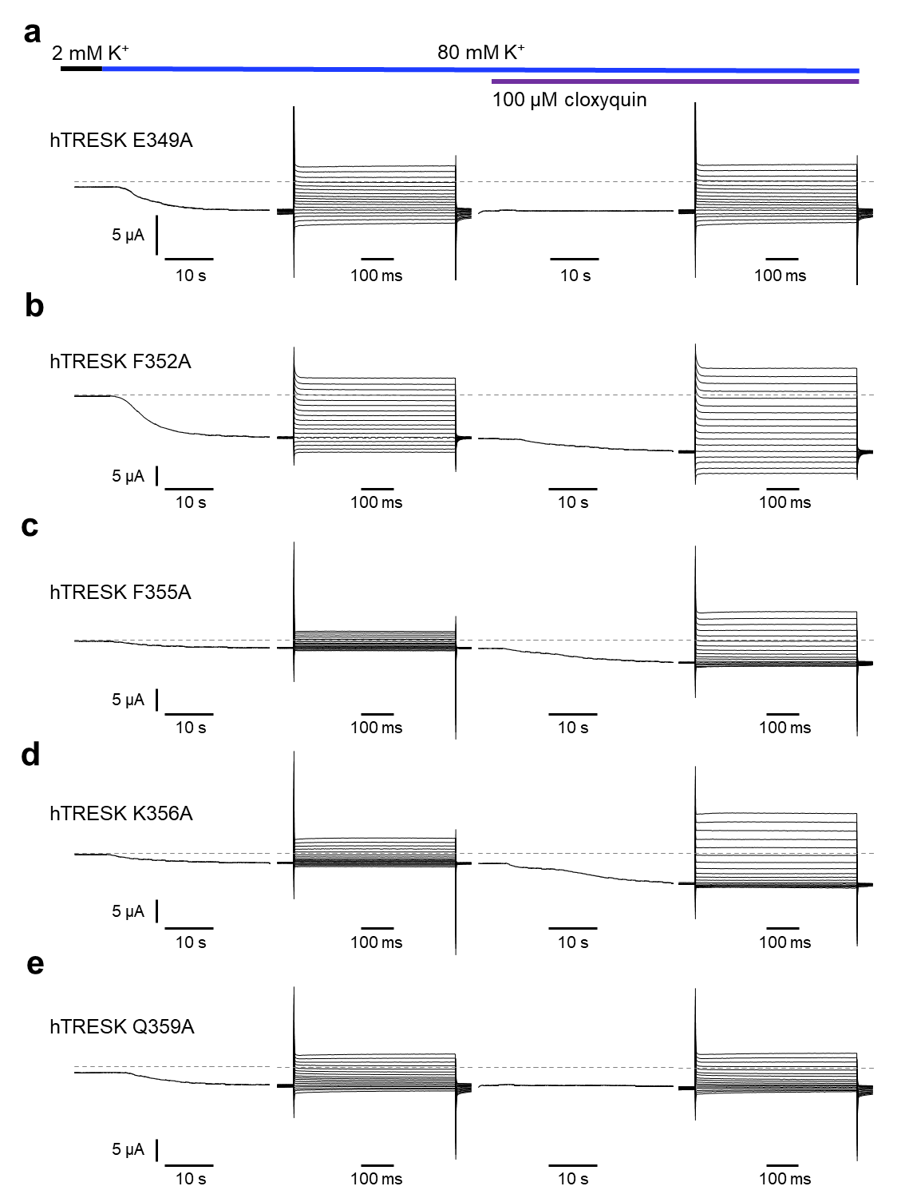
SI Fig. 4 | TEVC sample traces of different M4 hTRESK mutants.

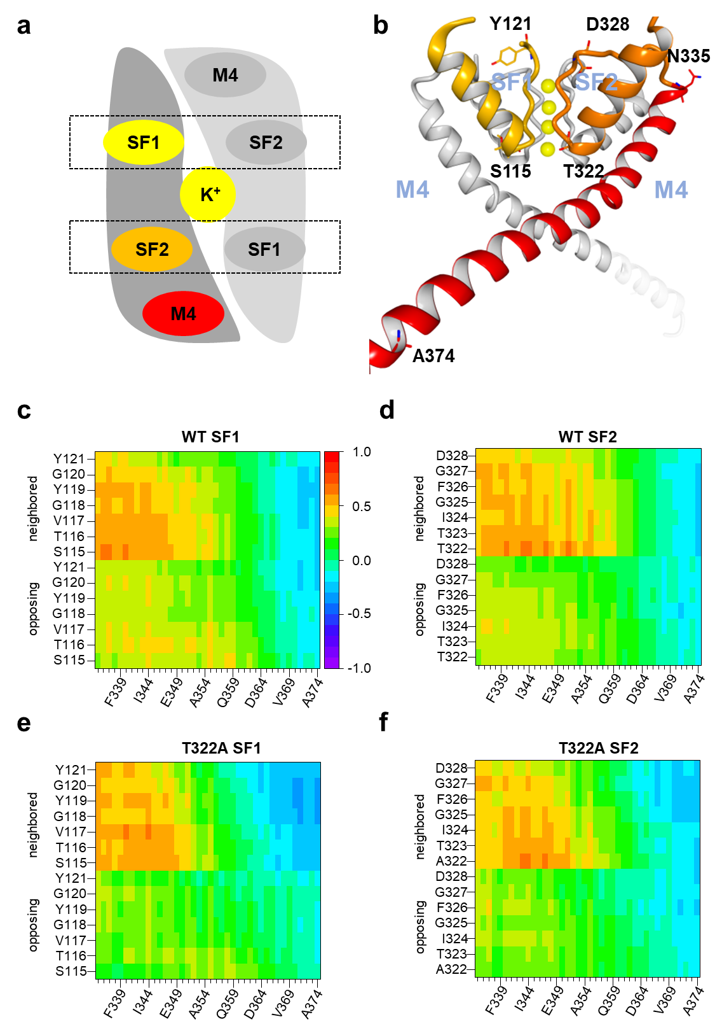
SI Fig. 5 | Dynamic cross correlation matrices (DCCM) for SF1/SF2 coupling with M4. a, b schematic depiction of homodimeric assembly to form the hTRESK channel. Each monomer possesses one M4 helix, one SF1 and one SF2 loop. Each M4 helix of one subunit is neighbored to the SF2 loop of the same and to the SF1 loop of the second monomer. Consequently, SF1 loop of the same and SF2 loop of the second monomer are opposed to the M4 helix. d-f Dynamic cross correlation matrices (DCCM) for M4/SF1 and M4/SF2 coupling of WT (c, d) and T322A channels. Correlations are derived from 3 independent in silico electrophysiological simulations (100 ns) for each variant. Heat maps are generated from mean correlation values from these three independent simulations per variant as well as a mean of correlations for both M4 helices present in each simulation. Colors of heat map reflect the degree of correlation from fully correlating (+1.0, red) over non-correlating (0; green) to fully anti-correlating (-1.0; blue).

SI Table 1 | Mean current potentiation (I_{clox} / I_{ctrl}) determined by 100 µM screening at hTRESK WT expressing oocytes. Values derived from n independent oocytes are given for each compound as mean ± SEM.
compound | I_{clox} / I_{ctrl} | n
cloxyquin | 3.75 ± 0.21 | 5
nitroxoline | 1.15 ± 0.01 | 5
Q01 | 1.28 ± 0.05 | 5
Q02 | 1.68 ± 0.04 | 5
Q03 | 1.10 ± 0.02 | 5
Q04 | 4.25 ± 0.23 | 5
Q05 | 1.32 ± 0.05 | 5
Q06 | 1.16 ± 0.04 | 5
Q07 | 1.34 ± 0.02 | 5
Q08 | 1.11 ± 0.03 | 5
Q09 | 2.45 ± 0.26 | 5
Q10 | 1.75 ± 0.07 | 5
Q11 | 1.50 ± 0.06 | 5
Q12 | 1.22 ± 0.01 | 5
Q13 | 2.40 ± 0.13 | 5
Q14 | 1.61 ± 0.05 | 5
Q15 | 1.12 ± 0.03 | 5

SI Table 2 | Significance of mean differences for 100 µM compound screening. Significance of mean differences for Q01-Q15, nitroxoline (nit) and cloxyquin (clox) are indicated by ns for p values > 0.05, * for p < 0.05, ** for p < 0.01 and *** for p < 0.001.
 | nit | Q01 | Q02 | Q03 | Q04 | Q05 | Q06 | Q07 | Q08 | Q09 | Q10 | Q11 | Q12 | Q13 | Q14 | Q15 | clox
nit | - | ns | ns | ns | *** | ns | ns | ns | ns | *** | * | ns | ns | *** | ns | ns | ***
Q01 | ns | - | ns | ns | *** | ns | ns | ns | ns | *** | ns | ns | ns | *** | ns | ns | ***
Q02 | ns | ns | - | * | *** | ns | ns | ns | * | *** | ns | ns | ns | ** | ns | * | ***
Q03 | ns | ns | * | - | *** | ns | ns | ns | ns | *** | ** | ns | ns | *** | ns | ns | ***
Q04 | *** | *** | *** | *** | - | *** | *** | *** | *** | *** | *** | *** | *** | *** | *** | *** | ns
Q05 | ns | ns | ns | ns | *** | - | ns | ns | ns | *** | ns | ns | ns | *** | ns | ns | ***
Q06 | ns | ns | ns | ns | *** | ns | - | ns | ns | *** | * | ns | ns | *** | ns | ns | ***
Q07 | ns | ns | ns | ns | *** | ns | ns | - | ns | *** | ns | ns | ns | *** | ns | ns | ***
Q08 | ns | ns | * | ns | *** | ns | ns | ns | - | *** | ** | ns | ns | *** | ns | ns | ***
Q09 | *** | *** | *** | *** | *** | *** | *** | *** | *** | - | ** | *** | *** | ns | *** | *** | ***
Q10 | * | ns | ns | ** | *** | ns | * | ns | ** | ** | - | ns | ns | ** | ns | * | ***
Q11 | ns | ns | ns | ns | *** | ns | ns | ns | ns | *** | ns | - | ns | *** | ns | ns | ***
Q12 | ns | ns | ns | ns | *** | ns | ns | ns | ns | *** | ns | ns | - | *** | ns | ns | ***
Q13 | *** | *** | ** | *** | *** | *** | *** | *** | *** | ns | ** | *** | *** | - | *** | *** | ***
Q14 | ns | ns | ns | ns | *** | ns | ns | ns | ns | *** | ns | ns | ns | *** | - | ns | ***
Q15 | ns | ns | * | ns | *** | ns | ns | ns | ns | *** | * | ns | ns | *** | ns | - | ***
clox | *** | *** | *** | *** | ns | *** | *** | *** | *** | *** | *** | *** | *** | *** | *** | *** | -

SI Table 3 | Mean currents and current potentiation elicit at WT / mutant hTRESK expressing oocytes. All values are given as mean ± SEM. Currents in absence of cloxyquin (clox) at -120 mV and +40 mV are written in µA, while current potentiation (I_{clox} / I_{ctrl}) values have no dimension. For each hTRESK variant number of independent oocytes (n) is given.
hTRESK variant | current in absence of clox [µA] |  | current potentiation  I_{clox} / I_{ctrl} |  | n
hTRESK variant | -120 mV | +40 mV | -120 mV | +40 mV | n
WT | -2.57 ± 0.43 | 3.98 ± 0.22 | 2.96 ± 0.11 | 2.91 ± 0.07 | 40
T116S | -1.28 ± 0.13 | 3.08 ± 0.21 | 4.37 ± 0.36 | 4.39 ± 0.25 | 19
I141A | -1.92 ± 0.23 | 2.32 ± 0.20 | 2.03 ± 0.10 | 2.40 ± 0.08 | 28
P142A | -1.13 ± 0.09 | 0.53 ± 0.04 | 1.25 ± 0.04 | 2.25 ± 0.29 | 16
F145A | -18.71 ± 1.88 | 6.49 ± 1.12 | 1.29 ± 0.03 | 1.59 ± 0.07 | 11
T149A | -8.90 ± 2.14 | 4.14 ± 0.76 | 2.14 ± 0.16 | 2.72 ± 0.27 | 14
T322A | -0.95 ± 0.11 | 1.04 ± 0.10 | 4.50 ± 0.26 | 7.79 ± 0.50 | 23
T323S | -1.50 ± 0.14 | 3.49 ± 0.24 | 3.58 ± 0.16 | 3.31 ± 0.18 | 25
E349A | -4.23 ± 0.42 | 1.78 ± 0.18 | 1.05 ± 0.02 | 1.17 ± 0.03 | 17
F352A | -18.74 ± 1.71 | 5.30 ± 0.76 | 1.31 ± 0.02 | 1.74 ± 0.05 | 9
F355A | -2.35 ± 0.30 | 2.42 ± 0.24 | 2.95 ± 0.22 | 2.91 ± 0.22 | 10
K356A | -2.51 ± 0.20 | 3.95 ± 0.42 | 2.81 ± 0.19 | 2.32 ± 0.09 | 20
Q359A | -3.49 ± 0.31 | 2.33 ± 0.28 | 1.03 ± 0.03 | 1.30 ± 0.05 | 24

SI Table 4 | Fitting parameters of dose-response curves at different homo- / heterodimeric hTRESK channels. Fitting parameters were derived from logistic fits (see materials and methods) of recorded dose-response relationships. Number (n) of independent oocyte is given for each channel group. Values for concentration of half maximal activation (EC₅₀), maximal activation (E_{max}) and Hill-coefficient are given as mean ± SE derived from free logistic fitting. Fixed parameters are indicated by *. Using equations given in SI materials and methods, values for heterodimeric channels (WT / E349A and WT / Q359A) were calculated (calc.) from values measured (meas.) at oocytes injected with equimolar cRNA of mutant and WT.
channel group | EC₅₀ [µM] | E_{max} [%] | Hill | n
WT | 64.2 ± 10.9 | 359.6 ± 25.3 | 1.17 ± 0.14 | 13
WT / E349A meas. | 186.3 ± 45.8 | 254.6 ± 25.0 | 0.85 ± 0.05 | 9
WT / E349A calc. | 607.2 ± 186.8 | 359.6 * | 0.81 ± 0.17 | 9
E349A | 83.4 ± 214.3 | -50.9 ± 26.3 | 0.43 ± 0.17 | 9
WT / Q359A meas. | 65.2 ± 16.6 | 193.6 ± 18.6 | 1.00 ± 0.14 | 11
WT / Q359A calc. | 65.6 ± 24.6 | 156.1 ± 20.4 | 0.88 ± 0.15 | 11
Q359A | 13.3 ± 11.0 | -6.5 ± 2 | 1.17 ± 1.23 | 8

SI Table 5 | Transition time of K4 evaluated by in silico electrophysiology. Occurrence time for 1st, 2nd, 3rd and 4th transition for each 100 ns simulation (Sim 1-3) is given. Further, mean values ± SEM are given for each channel variant.
 | 1st (S4S3) | 2nd (S3 S2) | 3rd (S2S1) | 4th (S1 out)
WT Sim 1 | 2.7 ns | 9.4 ns | 35.1 ns | 37.6 ns
WT Sim 2 | 1.3 ns | 7.2 ns | 15.4 ns | 20.2 ns
WT Sim 3 | 0.6 ns | 7.4 ns | 40.6 ns | 42.2 ns
T322A Sim 1 | 2.6 ns | 14.6 ns | 100.0 ns | 100.0 ns
T322A Sim 2 | 1.2 ns | 5.7 ns | 100.0 ns | 100.0 ns
T322A Sim 3 | 1.0 ns | 12.8 ns | 46.0 ns | 52.2 ns
WT Mean ± SEM | 1.5 ± 0.5 ns | 8.0 ± 0.6 ns | 30.4 ± 6.2 ns | 33.3 ± 5.5 ns
T322A Mean ± SEM | 1.6 ± 0.4 ns | 11.0 ± 2.2 ns | 82.0 ± 14.7 ns | 84.1 ± 13.0 ns

SI Table 6 | Loss of K1 / Rb1 and K4 / Rb4 in MD simulations without ESF. Occurrence time of K1 / Rb1 and K4 / Rb4 leaving the S1 or S4 binding site, respectively. If ions remain in the SF for the whole simulation time (50.0 ns) this is indicated by “-“.
 | K1 / Rb1 | K4 / Rb4
WT K⁺ Sim 1 | - | 10.0 ns
WT K⁺ Sim 2 | - | 20.7 ns
WT K⁺ Sim 3 | - | -
WT Rb⁺ Sim 1 | 1.0 ns | -
WT Rb⁺ Sim 2 | 5.9 ns | -
WT Rb⁺ Sim 3 | 1.3 ns | -
T322A K⁺ Sim 1 | - | -
T322A K⁺ Sim 2 | - | 47.7 ns
T322A K⁺ Sim 3 | - | -
T322A Rb⁺ Sim 1 | 4.7 ns | -
T322A Rb⁺ Sim 2 | 4.0 ns | -
T322A Rb⁺ Sim 3 | 5.5 ns | -

SI Table 7 | TEVC recordings using 100 mM K⁺ / Rb⁺ solutions. Values for currents [µA] and ratios of currents elicited in 100 mM Rb⁺ versus 100 mM K⁺ in absence of cloxyquin (I_{Rb} / I_{K}) as well as ratios for current potentiation caused by 100 µM cloxyquin using different permeating ions (I_{clox} / I_{ctrl}) are given as mean ± SEM. Number of independent oocytes are given for measurements in absence (n_{ctrl} for currents and I_{Rb}/I_{K}) and presence (n_{clox} for I_{clox} / I_{ctrl}) of cloxyquin.
 | voltage | WT / K⁺ | WT / Rb⁺ | T322A / K⁺ | T322A / Rb⁺
Current [µA] | -120 mV | -3.48 ± 0.23 | -6.58 ± 0.39 | -0.80 ± 0.01 | -1.32 ± 0.07
Current [µA] | +40 mV | 2.41 ± 0.13 | 2.35 ± 0.12 | 0.29 ± 0.04 | 0.31 ± 0.03
I_{Rb} / I_{K} | -120 mV | 1.91 ± 0.07 |  | 1.69 ± 0.09
I_{Rb} / I_{K} | +40 mV | 0.98 ± 0.02 |  | 1.10 ± 0.06
n_{ctrl} | - | 22 |  | 20
I_{clox} / I_{ctrl} | -120 mV | -2.60 ± 0.13 | -2.03 ± 0.09 | -3.02 ± 0.19 | -4.02 ± 0.20
I_{clox} / I_{ctrl} | +40 mV | 2.94 ± 0.20 | 2.85 ± 0.26 | 3.16 ± 0.41 | 4.10 ± 0.53
n_{clox} | - | 19 | 21 | 14 | 17

SI MATERIALS AND METHODS

Calculation of compound activity at heterodimeric hTRESK channels
To evaluate the effect of cloxyquin on heterodimeric hTRESK channels oocytes were injected with 0.5 ng WT and 0.5 ng mutated hTRESK cRNA. Injection of equimolar amounts of different hTRESK cRNAs statistically resulted in expression of three randomly assembling populations of hTRESK dimers with each 25 % WT and mutated hTRESK homodimers and 50 % heterodimeric channels comprised of WT and mutated monomer. The overall current (I_{x}) resulting from this combination of different homo- and heterodimers in TEVC measurements can be calculated by addition of the partial currents from homodimeric WT (I_{WT}) and mutated (I_{mut}) hTRESK channels as well as the current generated by heterodimeric channels (I_{1:1}) expressed by the oocyte:
$$I_{x}=I_{WT}+I_{1:1}+I_{mut}$$
Oocytes injected with 1 ng of WT and mutated cRNA served as control. Since the number of homodimeric WT and mutated hTRESK channels in co-injected oocytes can be estimated to 25 % of the channels expressed on the control oocytes I_{WT} and I_{mut} can be calculated using the mean currents generated from oocytes, that were injected with 1 ng of WT (I_{WT}^{1ng}) or 1 ng of mutated (I_{mut}^{1ng}) hTRESK cRNA:
$$I_{WT}=\frac{1}{4}*I_{WT}^{1 ng}$$
$$I_{mut}=\frac{1}{4}*I_{mut}^{1 ng}$$
While the relative amount of different dimer population can be estimated as constant, differences in total current I_{X} can occur compared to the control oocytes injected with 1 ng WT or mutated cRNA. Therefore, ratios of mean currents from homodimeric WT and mutated hTRESK channels and mean currents measured at co-injected oocytes were calculated:
$$c_{1}=\frac{I_{WT}^{1 ng}}{I_{x mean}}$$
$$c_{2}=\frac{I_{mut}^{1 ng}}{I_{x mean}}$$
Using c₁ and c₂, partial currents I_{WT} and I_{mut} were calculated for each co-injected oocyte by the following equation:
$$I_{WT}=\frac{1}{4}*I_{WT}^{1 ng}=\frac{1}{4}*c_{1}*I_{x}$$
$$I_{mut}=\frac{1}{4}*I_{mut}^{1 ng}=\frac{1}{4}*c_{2}*I_{x}$$
Combining previous equations of partial currents I_{WT} and I_{mut} can be replaced by fractions of I_{x}:
$$I_{x}=\frac{1}{4}*I_{x}*c_{1}+I_{1:1}+\frac{1}{4}*I_{x}*c_{2}$$
After transposition of the equation I_{1:1} can be calculated for each co-injected oocyte separately:
$$I_{1:1}=I_{x}-(\frac{1}{4}*I_{x}*c_{1}+\frac{1}{4}*I_{x}*c_{2})$$
While WT hTRESK channels are strongly activated by cloxyquin, activation of homo- and heterodimeric mutated hTRESK channels can be heavily altered. Therefore, the resulting current after application of cloxyquin results from partial currents I_{WT}, I_{1:1} and I_{mut} multiplicated by the specific factors of current increment for homodimeric WT (E_{WT}) and mutated (E_{mut}) as well as heterodimeric (E_{1:1}) hTRESK channels:
$$I_{cloxiquin}=I_{WT}*E_{WT}+I_{1:1}*E_{1:1}+I_{mut}*E_{mut}$$
To solve this equation, I_{cloxyquin} is measured directly while the partial currents I_{WT}, I_{1:1}, and I_{mut} are calculated by the previous mentioned equation for each oocyte. E_{WT} and E_{mut} result from the mean factor of current increment evaluated by measurements at homodimeric WT and mutated hTRESK channels. Transposition of the equation allows calculation of factor of current increment at heterodimeric hTRESK channels:
$$E_{1:1}=\frac{I_{cloxyquin}-(I_{WT}*E_{WT}+I_{mut}*E_{mut})}{I_{1:1}}$$

SI REFERENCES
1. Jumper, J. et al. Highly accurate protein structure prediction with AlphaFold. Nature 596, 583–589 (2021).
2. Varadi, M. et al. AlphaFold Protein Structure Database: massively expanding the structural coverage of protein-sequence space with high-accuracy models. Nucleic Acids Research 50, D439–D444 (2022).

