Figure S1: Percentage of changes in respiratory function in the chronic bronchitis model group compare to the normal group.
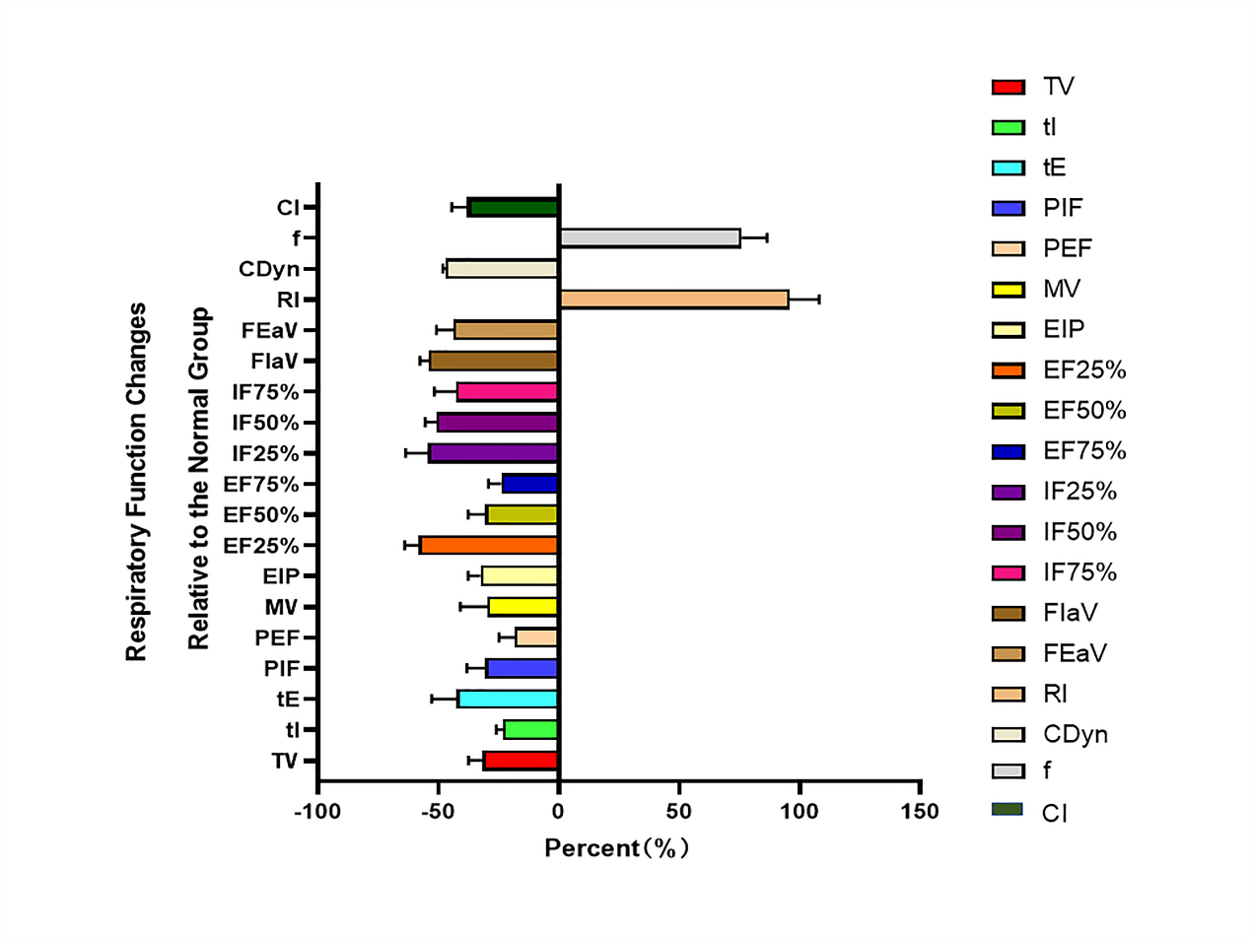

Figure S2: Percentage of changes in respiratory function at 1-, 3-, and 6- month intervals after SCT compared to the chronic bronchitis model group.
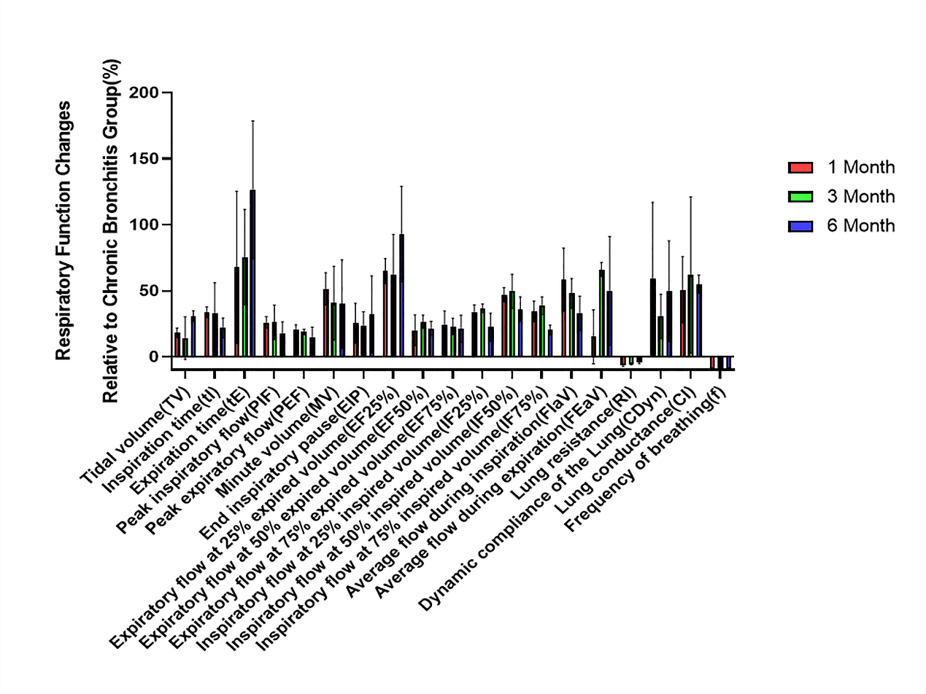

Figure S3: Changes in airway epithelial morphology. A. Basement membrane; B. Epithelial layer; C. Goblet cell.
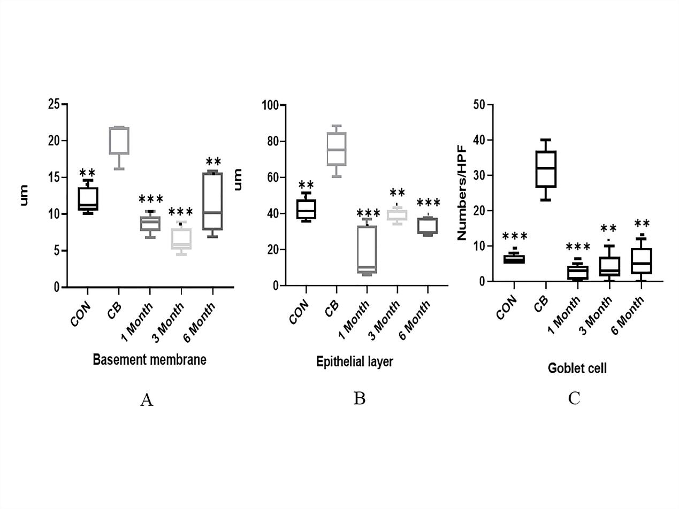

Figure S4: Percentage of changes in airway epithelial morphology at 1-, 3-, and 6- month intervals after SCT compared to the chronic bronchitis model group. A. Basement membrane; B. Epithelial layer; C. Goblet cell.
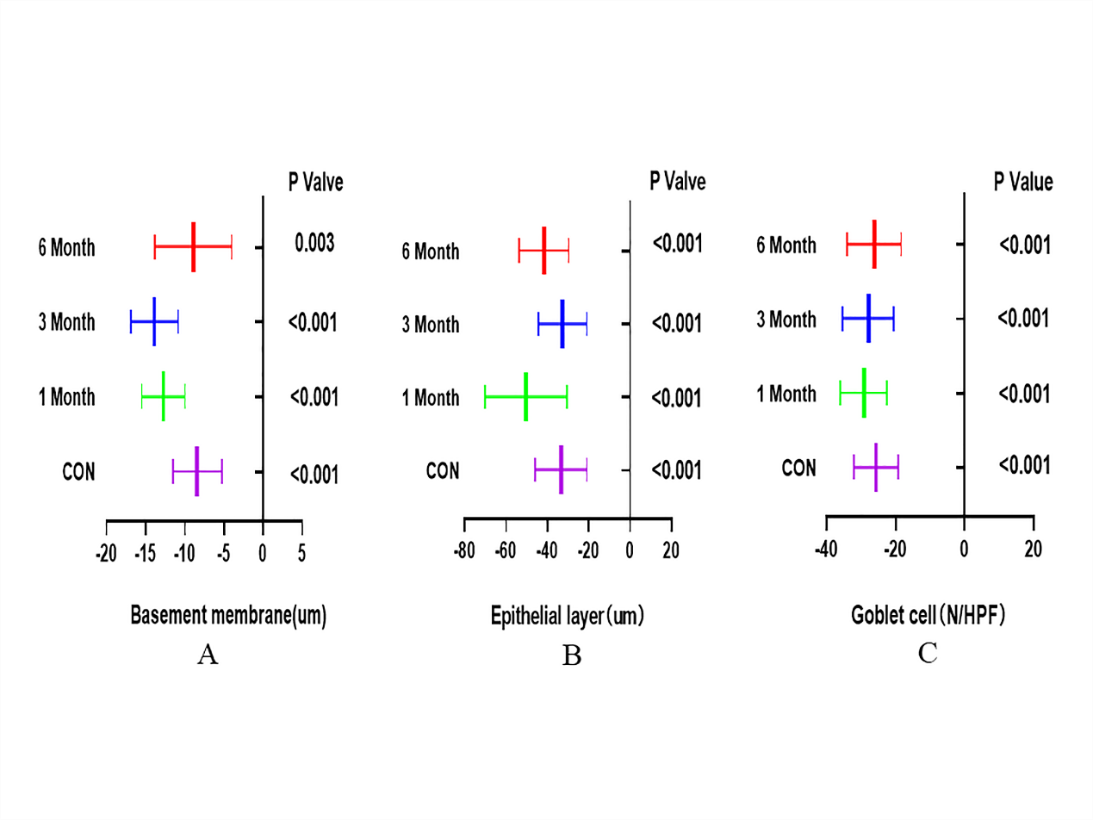

Figure S5: Correlation analysis between airway basement membrane thickness and respiratory function indicators. A. Correlation analysis between airway basement membrane thickness and PIF; B. Correlation analysis between airway basement membrane thickness and PEF; C. Correlation analysis between airway basement membrane thickness and tI.
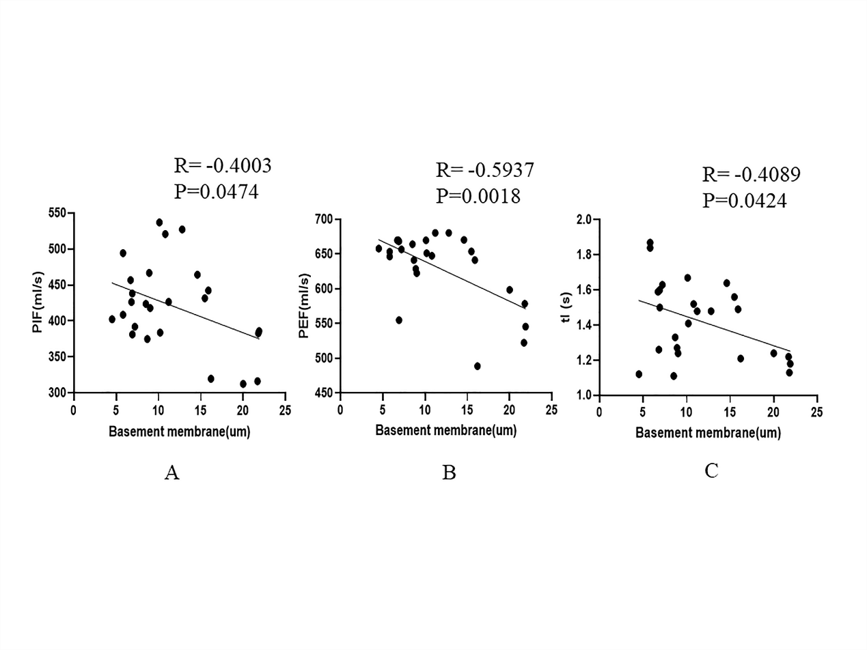

Figure S6: Correlation analysis between airway epithelial layer thickness and respiratory function indicators. A. Correlation analysis between airway epithelial layer thickness and PIF; B. Correlation analysis between airway epithelial layer thickness and PEF; C. Correlation analysis between airway epithelial layer thickness and tI.
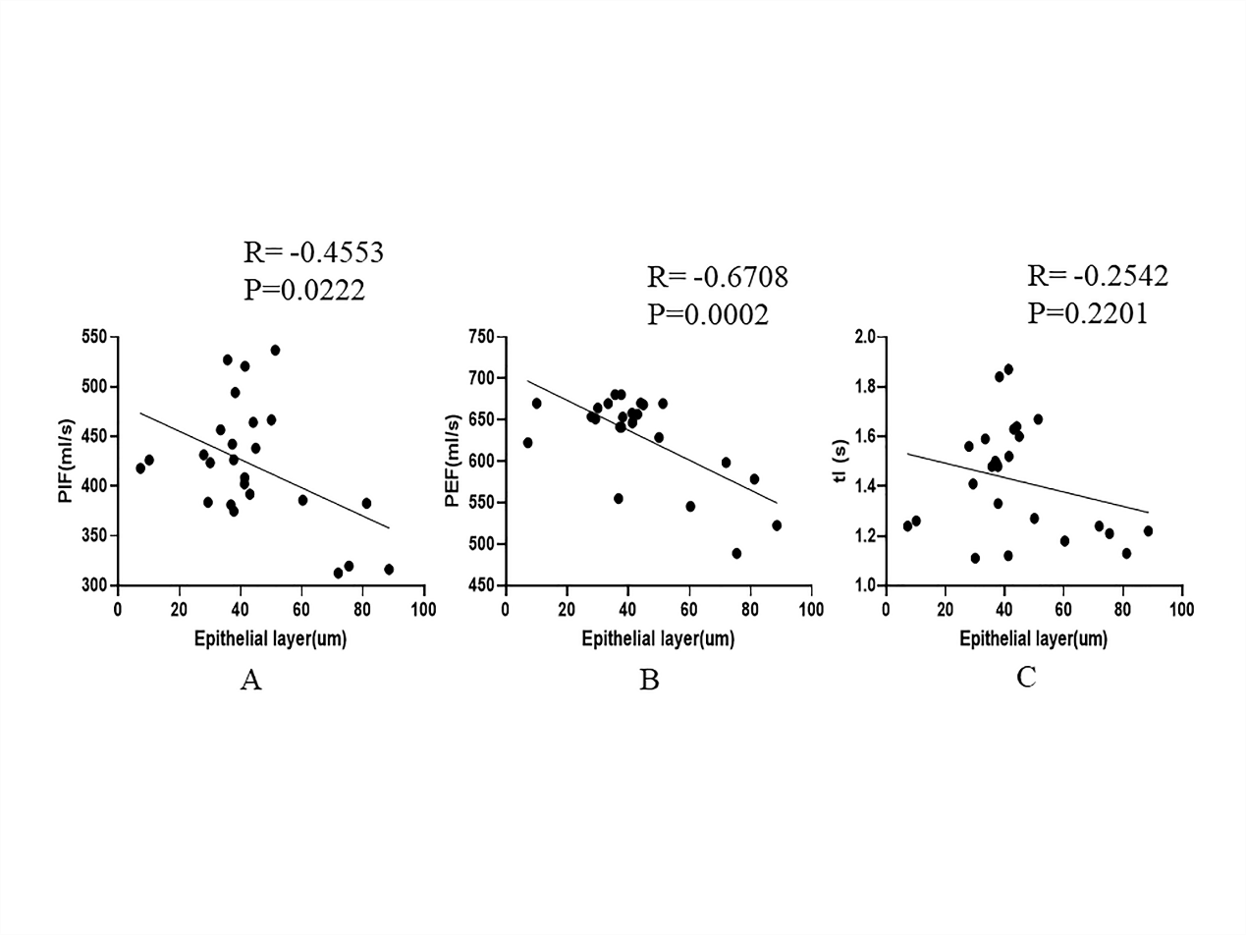

Figure S7: Correlation analysis between the number of goblet cells in the airway epithelium per unit area and respiratory function indicators. A. Correlation analysis between the number of goblet cells and PIF; B. Correlation analysis between the number of goblet cells and PEF; C. Correlation analysis between the number of goblet cells and tI.
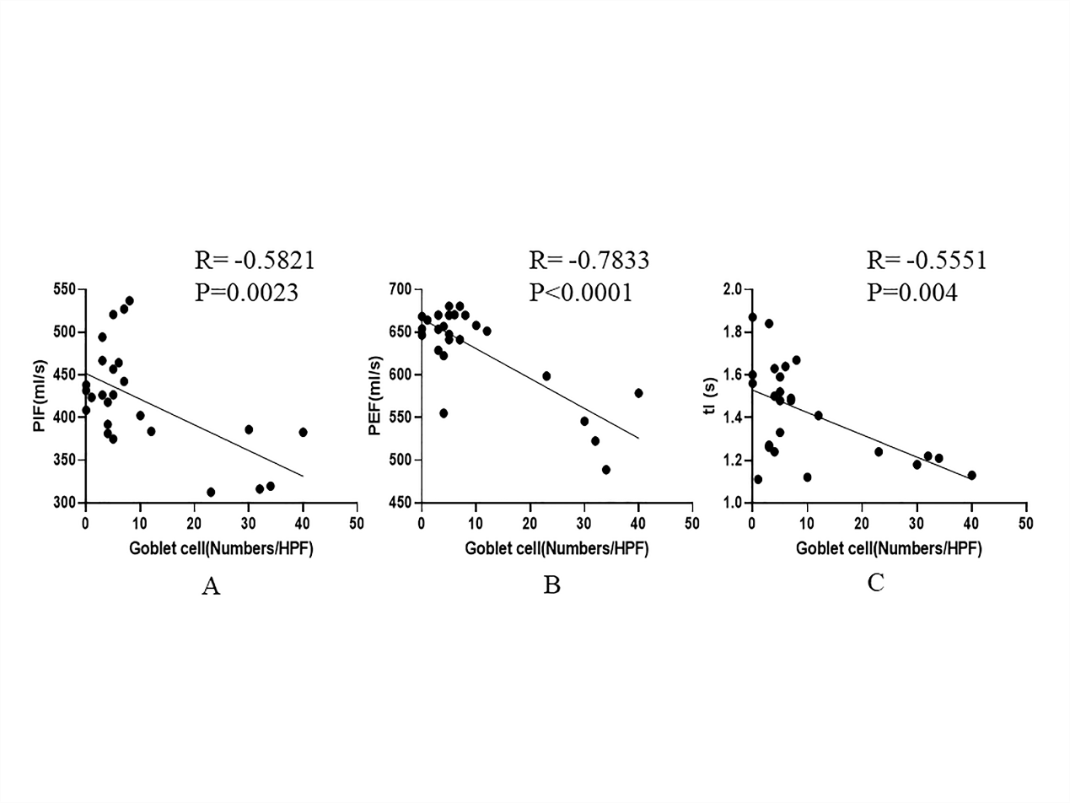

Figure S8: Correlation analysis between the number of neutrophils in the airway epithelium per unit area and respiratory function indicators. A. Correlation analysis between the number of neutrophils and PIF; B. Correlation analysis between the number of neutrophils and PEF; C. Correlation analysis between the number of neutrophils and EF75%; D. Correlation analysis between the number of neutrophils and tI.
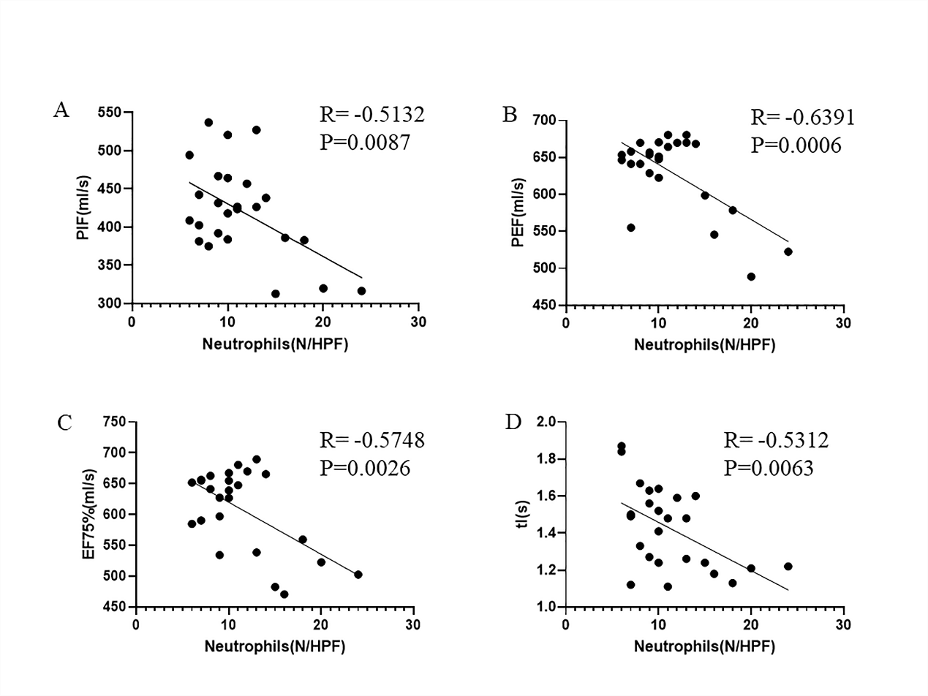

Figure S9: Correlation analysis between the number of macrophages in the airway epithelium per unit area and respiratory function indicators. A. Correlation analysis between the number of macrophages and PIF; B. Correlation analysis between the number of macrophages and PEF; C. Correlation analysis between the number of macrophages and EF75%; D. Correlation analysis between the number of macrophages and tI.
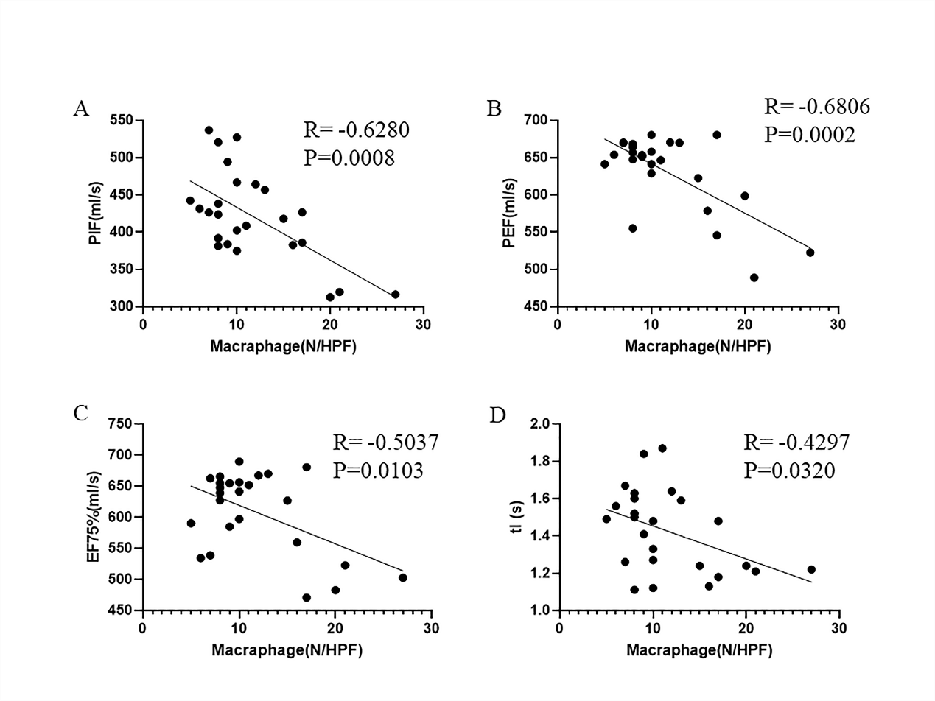

Figure S10: Pair-wise correlation (Spearman) and clustering among airway epithelial morphology and infiltrating inflammatory cells before and after SCT.
