Supplementary Information for

Polyunsaturated Fatty Acids Promote Protumoral Macrophage Polarization via a RhoA-YAP1 Signaling Pathway in the Ovarian Cancer Microenvironment

Huogang WANG¹, Mingo MH YUNG¹, Yang XUAN¹, Fushun CHEN¹, Waisun CHAN¹, Michelle KY SIU¹, Runying LONG¹, Yonghao LIANG², Dakang XU⁴, Stephen KW Tsui², Hextan YS NGAN¹, Karen KL CHAN^{1,*} and David W CHAN^{1, 2,3*}

¹Department of Obstetrics & Gynaecology, LKS Faculty of Medicine, The University of Hong Kong, Hong Kong, China.
²School of Biomedical Sciences, The Chinese University of Hong Kong, Hong Kong, China.
³School of Medicine, The Chinese University of Hong Kong-Shenzhen, Shenzhen, China.
⁴Faculty of Medical Laboratory Science, Ruijin Hospital, School of Medicine, Shanghai Jiao Tong University, Shanghai 200030, China.

*Correspondence should be addressed to:
Dr. David W CHAN, School of Medicine Start-up Building, CUHK-Shenzhen, 2001 Longxiang Blvd., Longgang District, Shenzhen 518172, China. Phone: (86) 755-23516153; E-mail: dwchan@cuhk.edu.cn, or Dr. Karen KL CHAN, Department of Obstetrics and Gynaecology, 6/F Professorial Block, Queen Mary Hospital, Pokfulam, Hong Kong, China. Phone: (852) 2255-4518; Fax: (852) 2255-0947; E-mail: kklchan@hku.hk

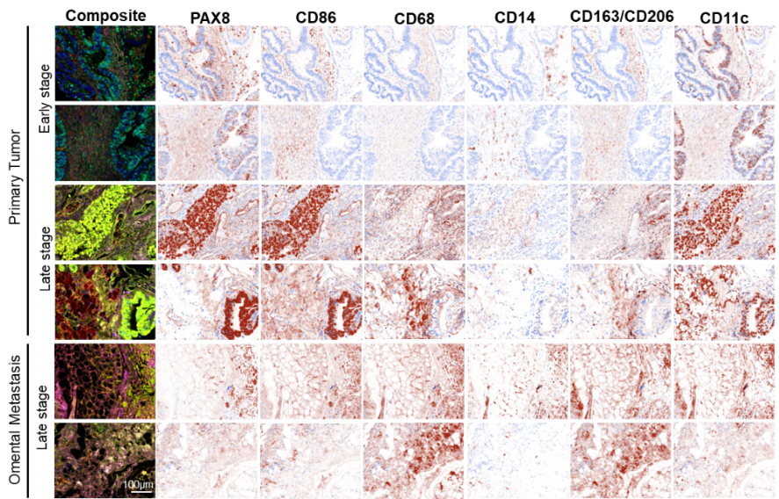
B.
A.

D.
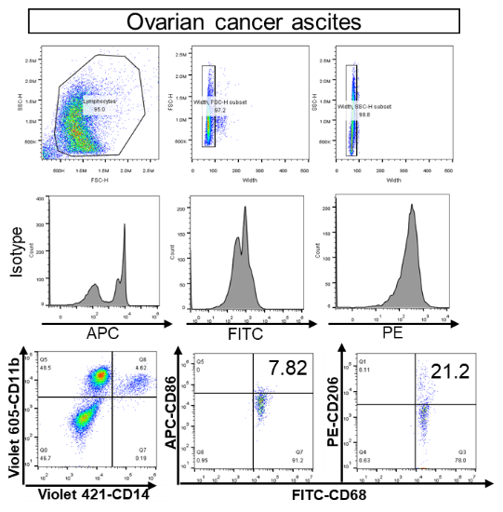

C.
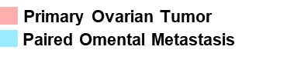
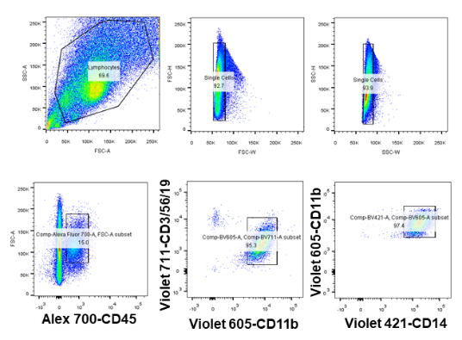
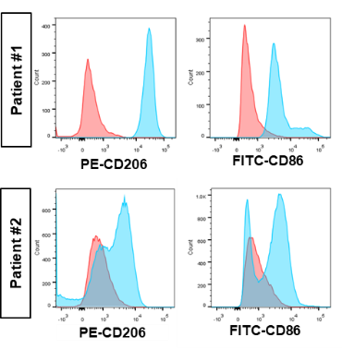

E.
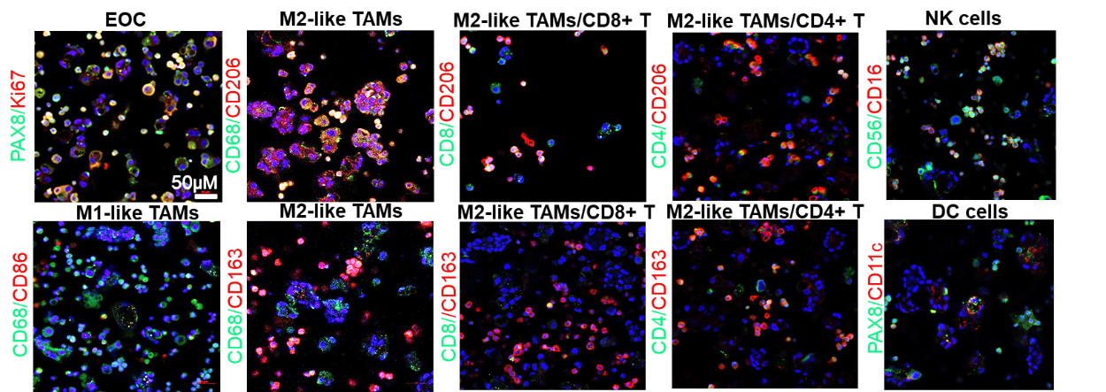

Figure S1. The distribution of TAMs in EOC peritoneal metastases.
A.Representative composite and single-stained IHC images of the m-IHC panel. Scale bar: 100μm. B. Ratio of M1-like TAMs to EOC. C. CD45⁺CD11b⁺CD14⁺CD3⁻CD56⁻CD19⁻ TAMs were isolated from the primary tumors and paired with omental metastatic tumors of patients with EOC. Comparison of the percentages of CD86⁺ and CD206⁺ TAMs derived from the primary and metastasis site. N=2. D. Gating strategy for CD14⁺CD11b⁺ TAMs derived from EOC ascites. E. Immunofluorescent staining of PAX8⁺Ki67⁺, CD68⁺CD86⁺, CD68⁺CD206⁺, CD68⁺CD163⁺, CD8⁺CD206⁺, CD8⁺CD163⁺, CD4⁺CD206⁺, CD4⁺CD163⁺, CD56⁺CD16⁺, PAX8⁺CD11c⁺ cells on malignant ascites spheroids from patients with EOC (n=3). Hoechst was used to stain nuclei. Scale bar: 50μm.

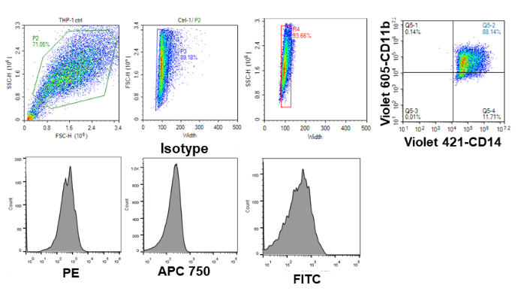
B.
A.

C.
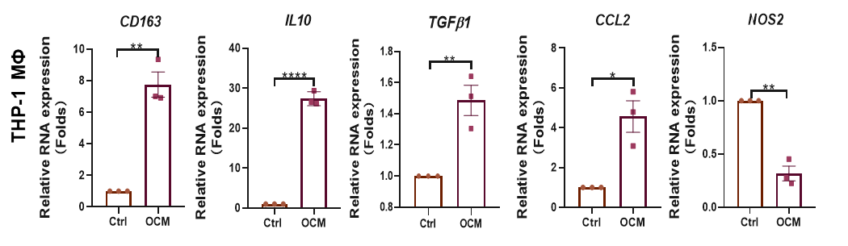

D.
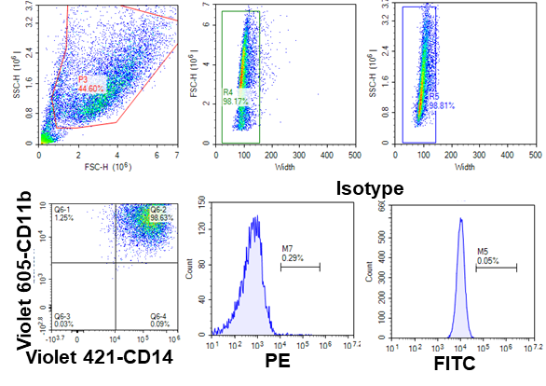
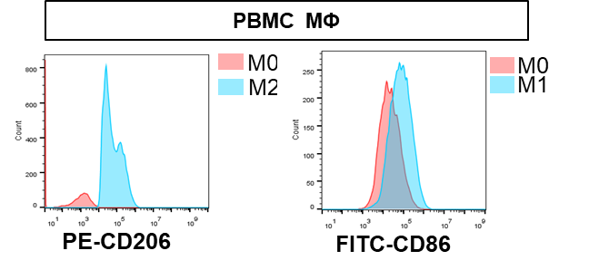

Figure S2. Macrophages polarization in the malignant ascites microenvironment (MAM).
A. Gating strategy for CD14⁺CD11b⁺ macrophages (THP-1-derived MΦs).B. The bar chart summarizes the expressions of CD11b⁺CD14⁺CD86⁺ PBMC MΦs upon treatment with OCM or ascites (AS). C. QPCR analysis of CD163, IL10, TGFβ, CCL2 and NOS2 mRNA expression levels in THP-1 MΦs upon treatment with OCM or ascites (AS). The gene expression data were normalized to the reference gene 18S, and are presented as the fold change relative to the control. D. Gating strategy for flow cytometry analysis of CD14⁺CD11b⁺ macrophages (PBMC MΦ) and the comparison of the percentages of CD206 and CD86 among PBMC MΦs stimulated with either control medium (1% FBS RPMI) or human LPS/IFNγ (20pg/ml). 20 ng/ml) or IL4/IL13 (20ng/ml, 20ng/ml).

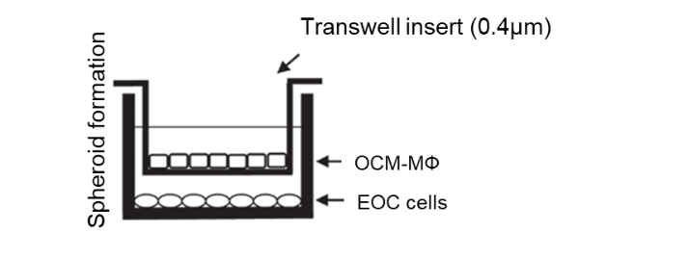
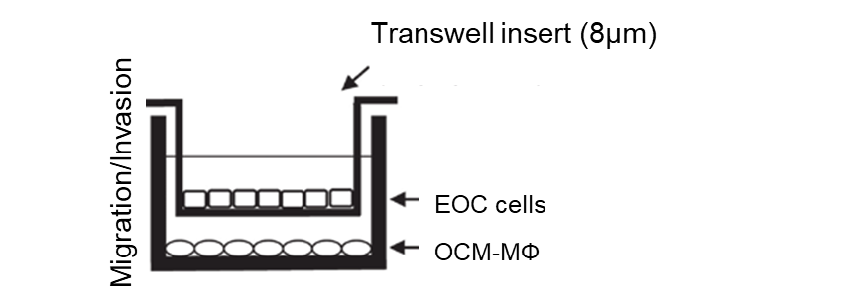
B.
A.

Figure S3. Macrophages co-cultural model.
A. Schematic representation of the migration/invasion experiment.
B. Schematic representation of the spheroid formation experiment.

A.
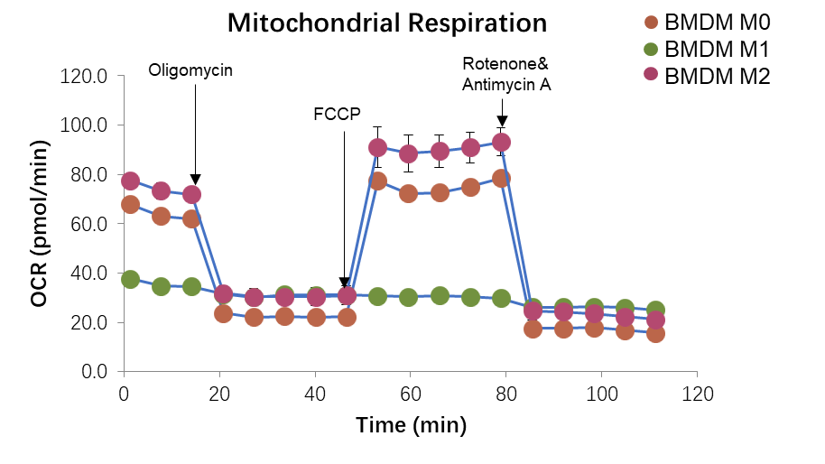

C.
B.

Figure S4. The Metabolic patterns of M1-like and M2-like macrophages.
A. Representative measurements of the oxygen consumption rate (OCR) after the addition of oligomycin A (1 mM), FCCP (1.5mM), and rotenone and antimycin (Rot/Ant) (0.5mM) to resting macrophages, M1-like macrophages or M2-like macrophages derived from murine BMDMs. B. Quantified basal OXPHOS. C. Maximal OXPHOS. The data are shown as the mean ± SEM and analyzed by unpaired Student’s t-tests. ***, P ≤ 0.001; ****; P ≤ 0.0001.

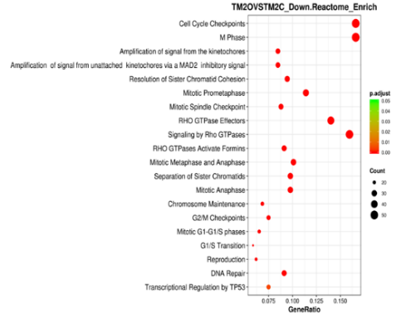
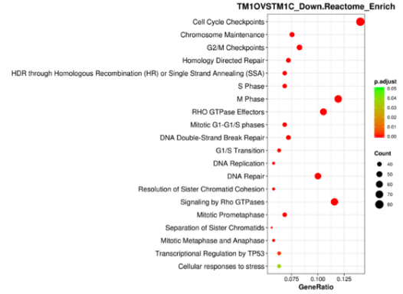
A.

B.
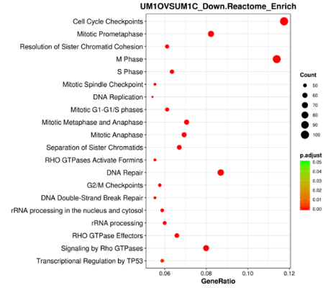
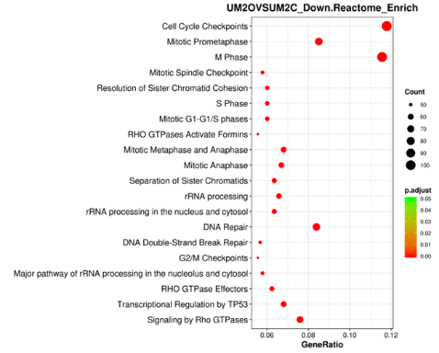

C.
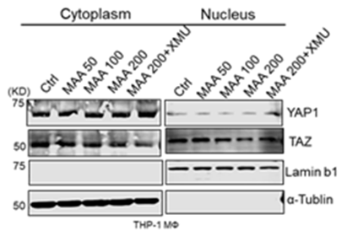
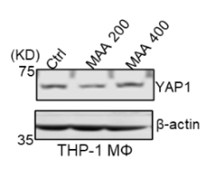
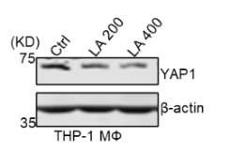
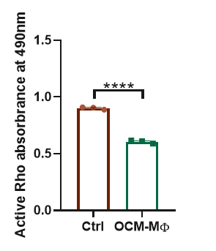
F.
E.

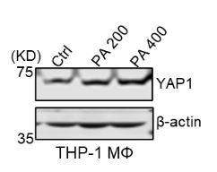
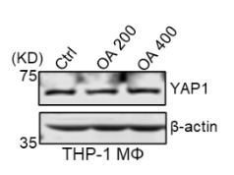

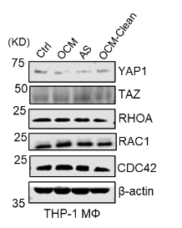
G.
D.
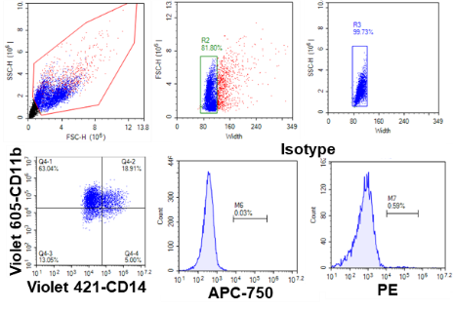

Figure S5. PUFAs-enriched MAM modulates the RHOA-YAP1 axis in macrophages (MΦs).
A & B.Top 20 significantly downregulated enriched pathways in the Reactome analysis results in M1 TAMs with or without OCM coculture and M2 TAMs with or without OCM coculture. M1 and M2 TAMs were derived from THP-1 or U937. C. G-LISA activation assays showed that active RHOA was attenuated in THP-1 MΦs coultured with OCM. D. OCM or ascites (AS) reduced the expression level of YAP1 but not TAZ in THP-1 macrophages. The removal of lipids in OCM by pre-treated with CleanasciteTM lipid removal reagent could restore YAP1 expression in THP-1 macrophages. E. YAP1 expression was reduced by Linoleic acid (LA) only but not by methyl arachidonate (MAA), oleic acid (OA), or Palmitic acid (PA) in THP-1 MΦs. F. MAA reduced nucleus YAP1 activity in THP-1 MΦs after 24h treatment. XMU MP1 (5μM) restore nucleus YAP1 in MAA treated MΦs. G. Gating strategy for CD14⁺CD11b⁺ macrophages (THP-1 MΦ) and a bar chart summarizes the expression of CD11b⁺CD14⁺CD163⁺ cells among THP-1 MΦs after treatment with control (1%FBS/BSA RPMI), different doses of linoleic acid (LA), methyl arachidonate (MAA) or LA (200 μM), MAA(200 μM) in combined with XMU MP1 (5μM) for 48 h. The data are shown as the mean ± SEM and analyzed by unpaired Student’s t-tests.**,P ≤ 0.01; ***, P ≤ 0.001; ****; P ≤ 0.0001.
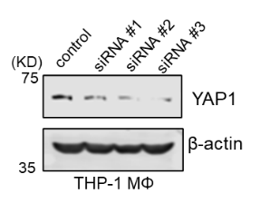
B.
A.

C.
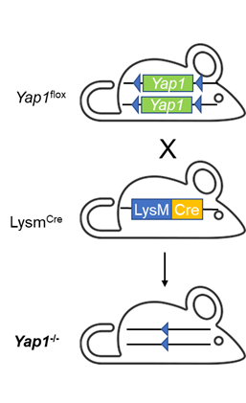
D.
F.
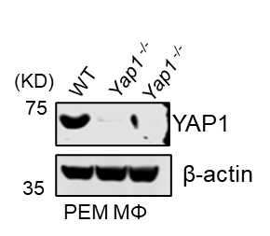
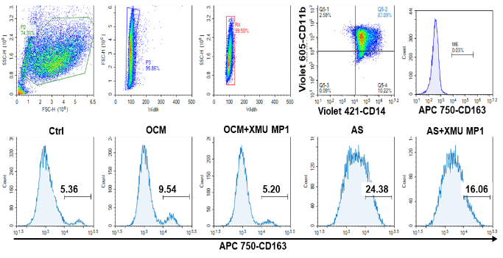

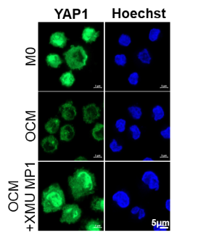
H.
G.
E.
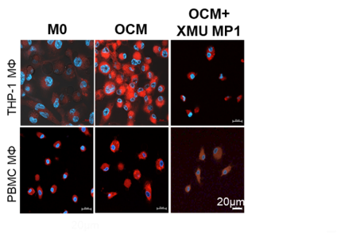

Figure S6. Yap1-specific conditional knockout (cKO)in macrophages determines TAMs polarization in a mouse model.
A. YAP1 depletion by siRNA approach in human THP-1 MΦs. B. CD163, IL10, TGFβ and NOS2 mRNA expression levels were measured by qPCR in THP-1 MΦs treated with control siRNA or YAP1 siRNA. The gene expression data were normalized to the reference gene 18S, and the results are presented as the fold change relative to the control. C. Schematic diagram shows the procedure of the generation of Yap1-cKO mice by crossbreeding Yap1fl/fl and LysMcre mice. D. Yap1 expression at the protein level was assessed in PEMs from WT and Yap1^{-/-} mice. E. Immunofluorescence analysis YAP1 (green) in THP-1 MΦs embedded in OCM or OCM plus XMU MP1 (500nM). Nuclei were counterstained with Hoechst (blue). Scale bar: 5μm. F. Gating strategy for CD14⁺CD11b⁺ macrophages (PBMC MΦ) and comparison of the percentages of CD163 among PBMC MΦs stimulated with control, OCM, OCM plus XMU MP1 (5μM), Ascites (AS) or Ascites (AS) plus XMU MP1 for 24h. G. Quantified basal OXPHOS and maximal and respiration-linked ATP in TAMs derived from PBMC MΦs with or without XMU MP1 (5μM) treatment. H. Lipid droplet formation assays revealed the formation of lipid droplets in macrophages in control, OCM or OCM plus XMU MP1 groups (5μM) groups. Scale bar: 20μM. The data are shown as the mean ± SEM and analyzed by unpaired Student’s t-tests.*, P ≤ 0.05; **,P ≤ 0.01; ***, P ≤ 0.001; ****; P ≤ 0.0001.

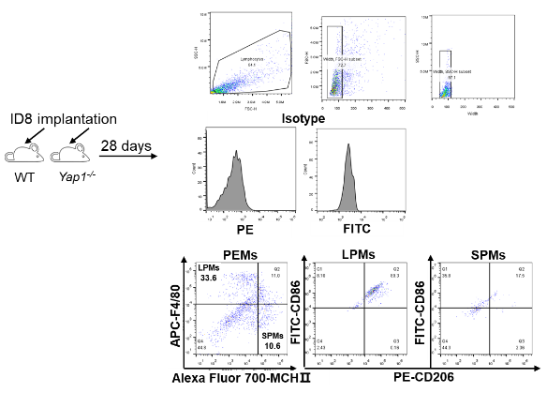
B.
A.

C.
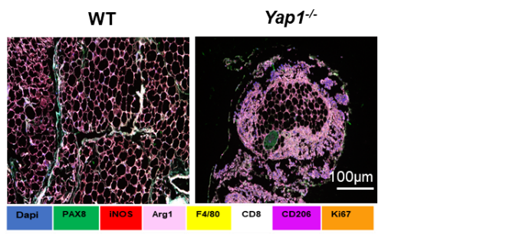

D.

E.

F.
G.
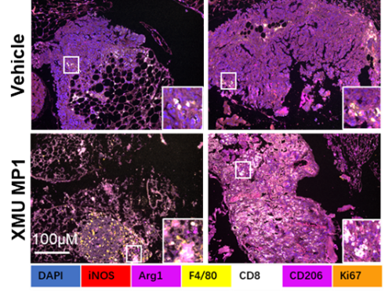

Figure S7, Yap1 in macrophages affects EOC peritoneal metastases progression.
A.Gating strategy of murine PEMs by flow cytometry 28 days after intraperitoneal (i.p.) injection of ID8 cells. LPMs were subsequently gated as F4/80⁺ MHCII⁻, and SPMs were gated as F4/80⁻MHCII⁺. B. Percentages of LPMs and SPMs in WT and Yap1^{-/-} mice. C. Representative composite images of the m-IHC panel in WT and Yap1^{-/-} mice 28 days after intraperitoneal ((i.p.) injection of ID8 cells. Scale bar: 100μm. D. ID8- GFP/Lucifer cells were intraperitoneally injected into WT and Yap1^{-/-} mice. After 7 days, tumor burden was evaluated by bioluminescence imaging (n=4). E. Body-weight changes in mice that received XMU MP1 or vehicle for 28 days treatment. F. Representative composite images of the m-IHC panel in Vehicle and XMU MP1 treated mice. Scale bar: 100μm. G. Percentages of LPMs and SPMs in PEMs derived from vehicle- or XMU MP1-treated mice. The data are shown as the mean ± SEM and analyzed by unpaired Student’s t-tests.*, P ≤ 0.05

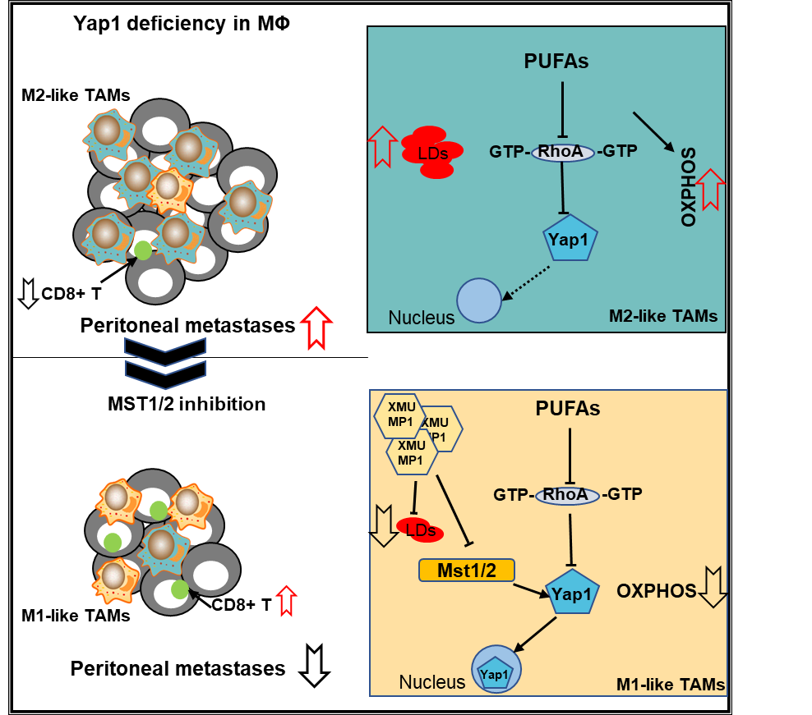

Figure S8, Graph summary

