Supplementary information for
Fully automatic transfer and measurement system for structural superlubric materials
Li Chen, Cong Lin, Diwei Shi, Quanshui Zheng, Jinhui Nie*, and Ming Ma*
Corresponding authors: niejh@Tsinghua-sz.org, maming16@tsinghua.edu.cn,

In this supplementary information, we provide additional details on certain aspects of the study reported in the manuscript. The following contents are provided:
Additional Supplementary Figures
Supplementary Notes
1. Friction curves for transferred graphite flakes
2. GUI design for transfer and measurement system
3. Time analysis for transfer graphite flakes
4. The performance of deep learning algorithms.

Additional Supplementary Figures
Supplementary Figure 1 Schematic and results of generating graphite flakes. a, The schematic of the production process for SSL graphite flakes. b, Microscope view of the prepared graphite flakes and the scale bar is 10 μm.

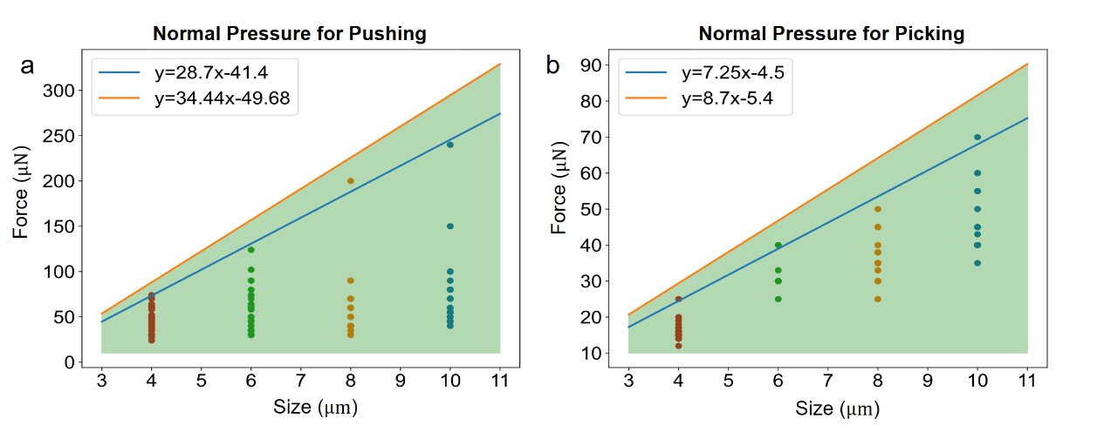
Supplementary Figure 2. Normal pressures introduced for the first time pushing (a) and after self-recovery picking (b) for different sizes of graphite flakes. The different colored dots are measurements of the normal pressure for pushing the different sizes of graphite flakes. The blue lines show the result of the linear fit to the maximum positive pressure and the orange lines show the positive pressure after retaining a 20% margin, and the final transferred force parameters are calculated from the two orange lines.

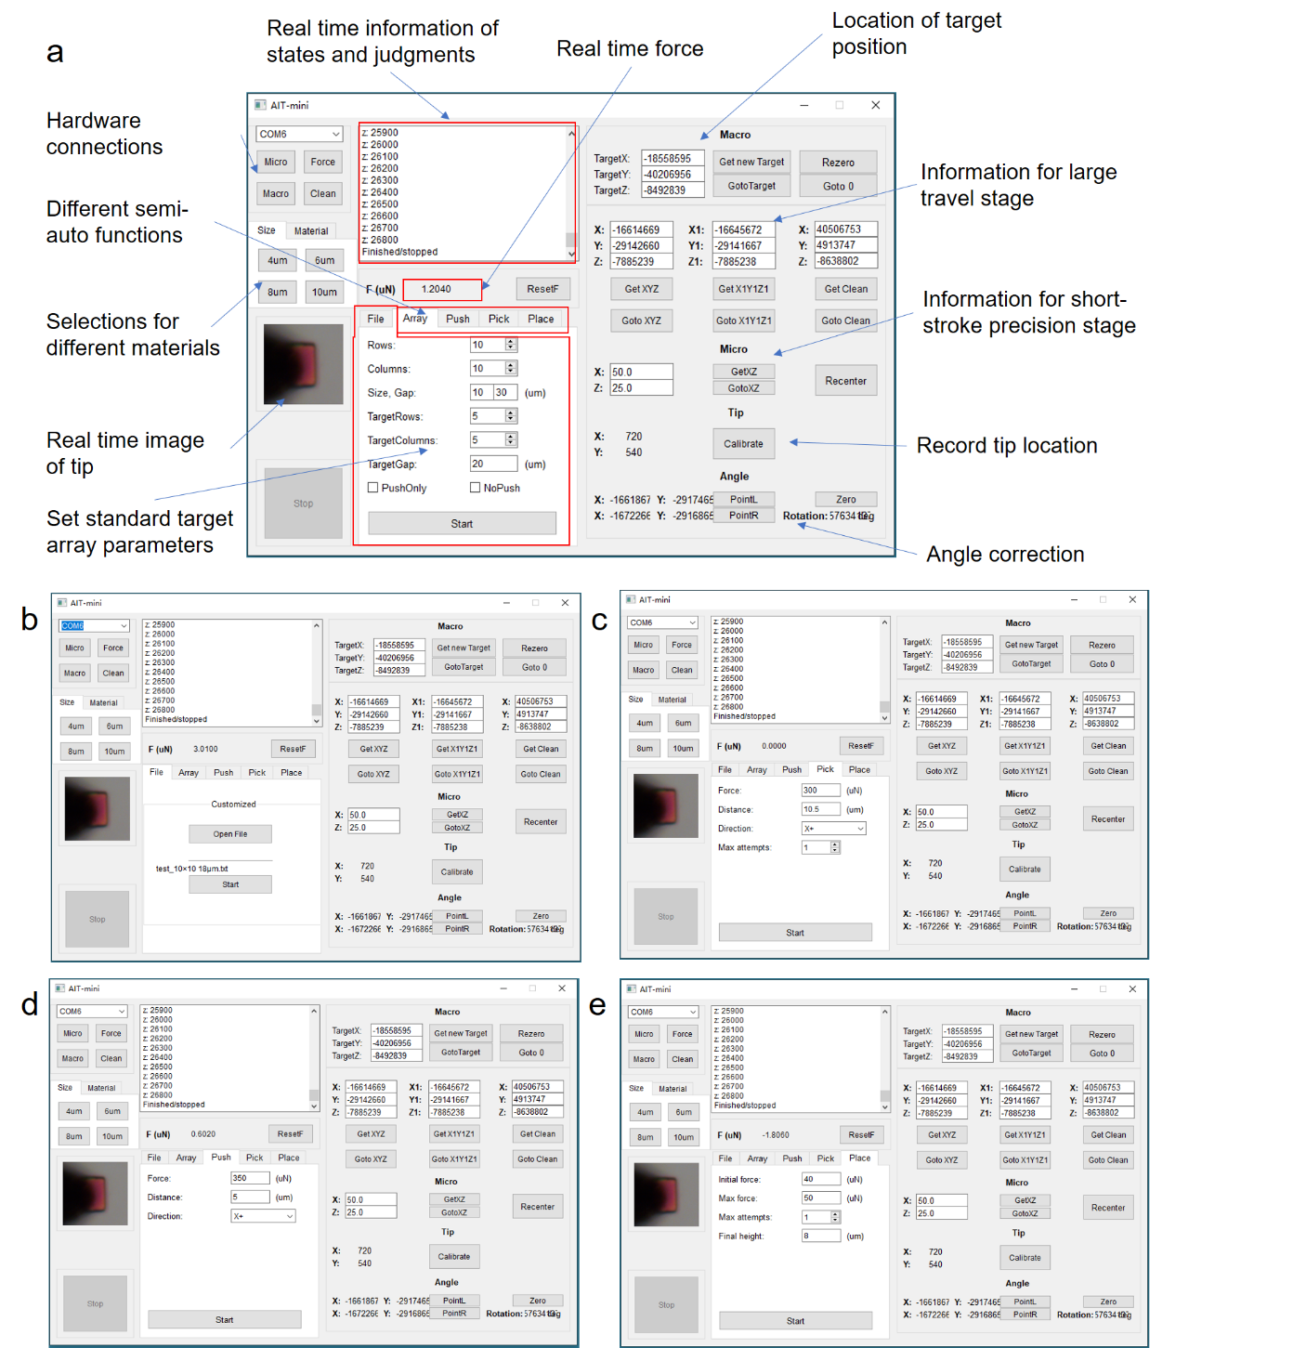
Supplementary Figure 3. Detailed graphical user interface (GUI) window screenshots of our CAD software. a Fully automatic transfer interface and descriptions of the functions of each section. b Detailed custom target array transfer interface. c-e Semi-automatic functions for different transfer step: (c), picking (d), pushing (e), placement.

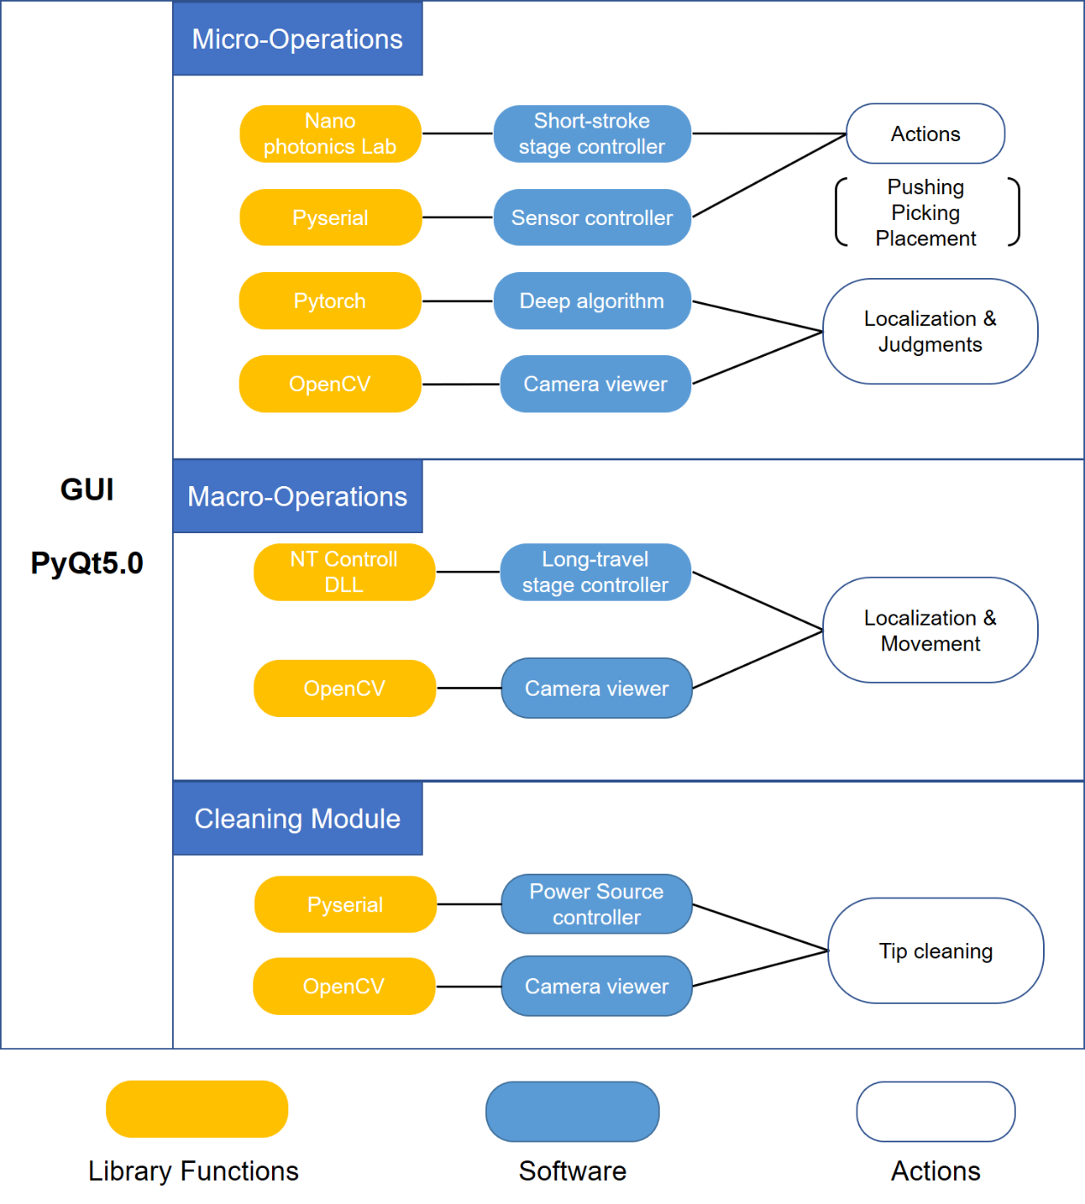
Supplementary Figure 4. The connectivity diagram of the software components in the system. The GUI consists of three major components: micro-operations, macro-operations and cleaning module. Each component sends commands through the presented libraries and python-Qt slot functions. The software and image processing algorithms are provided with different libraries; thus, the algorithms can be switched without shutting down the software.

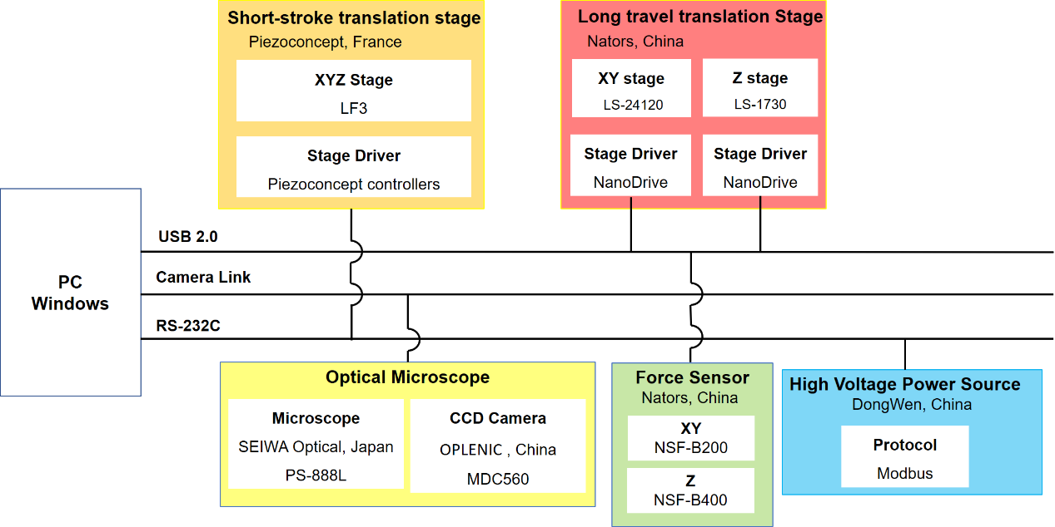
Supplementary Figure 5. The connectivity diagram of the hardware components utilized in the system.

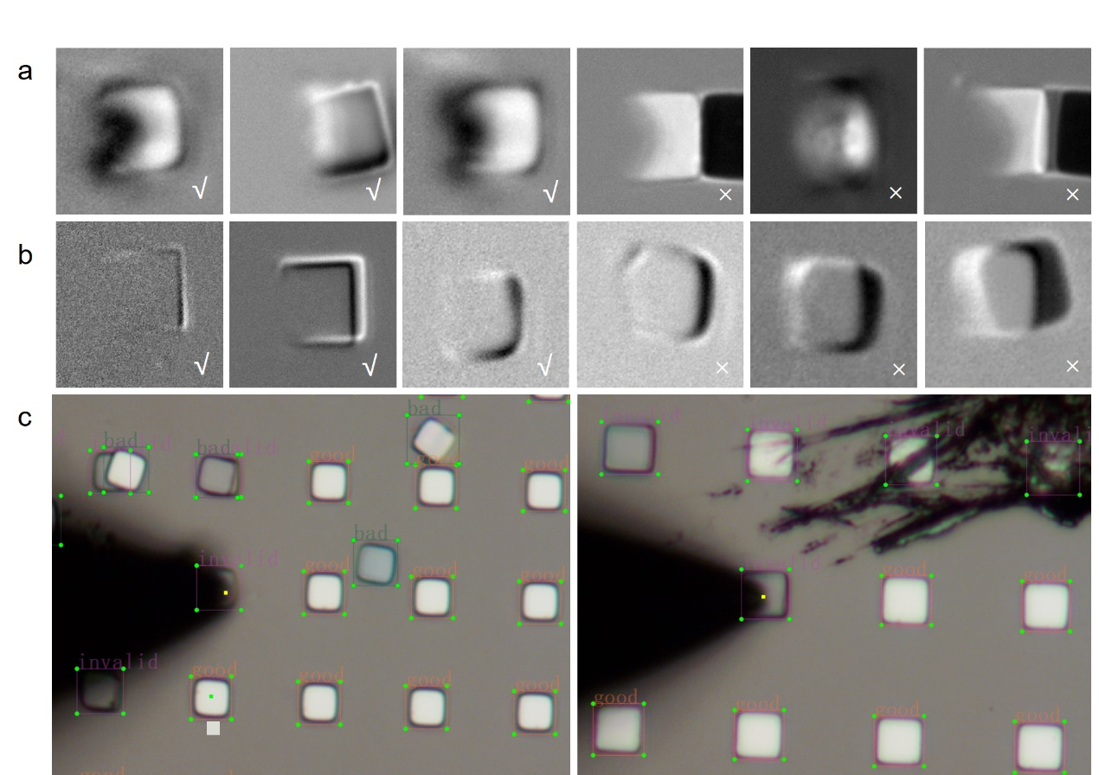
Supplementary Figure 6. Some sample data in our collected datasets, where √ means positive sample and × means negative sample. a Samples for determining whether a graphite flake is on the probe. b Samples for determining whether a graphite flake is superlubricity. c Samples for position target flakes and tungsten tip.

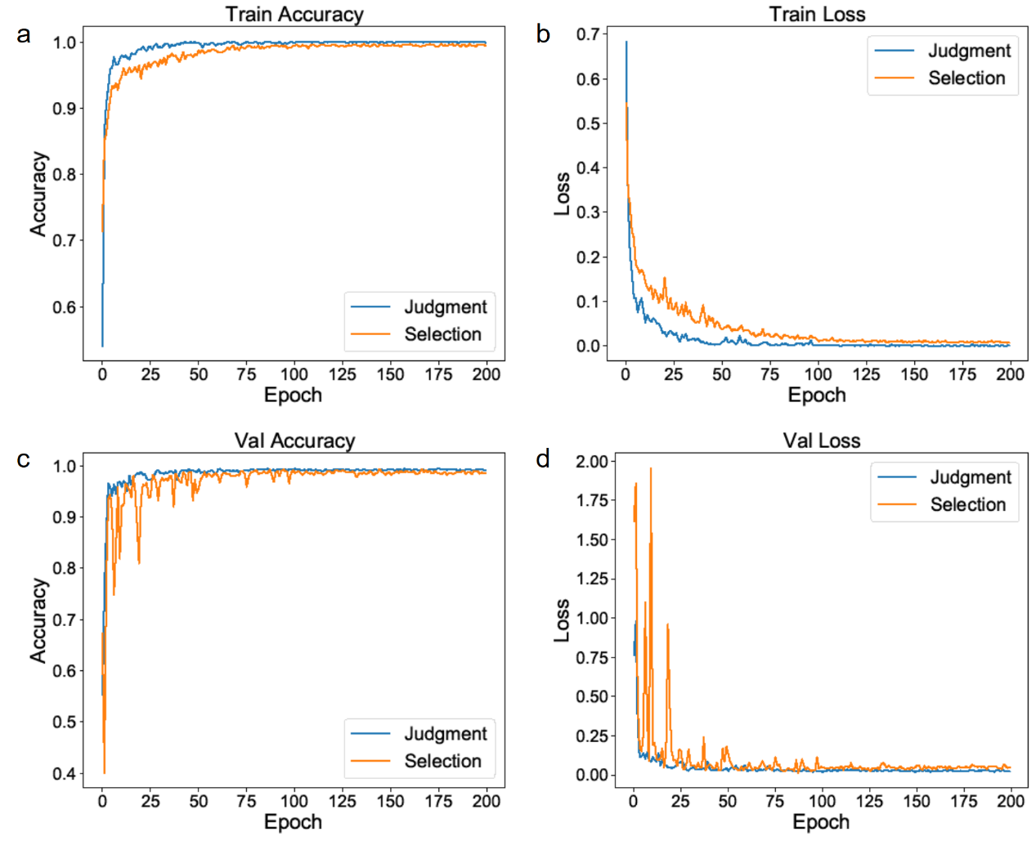
Supplementary Figure 7. Different models performance metrics during training, a training accuracy; b training loss; c validation accuracy; d validation loss. The blue line shows the model for determining whether the graphite flake is on the probe and the orange line indicates the model for determining whether the graphite flake is SSL.

Supplementary Notes
Supplementary Note 1
Friction curves for transferred graphite flakes. Supplementary Figure 8 shows the friction curves of the graphite flakes transferred onto graphite substrates by the automated transfer system. The friction coefficients of the six groups tested range from 0.0013 to 0.0031, which are all less than 0.01, indicating that the transfer process of the system will not affect the SSL performance of the graphite flakes.
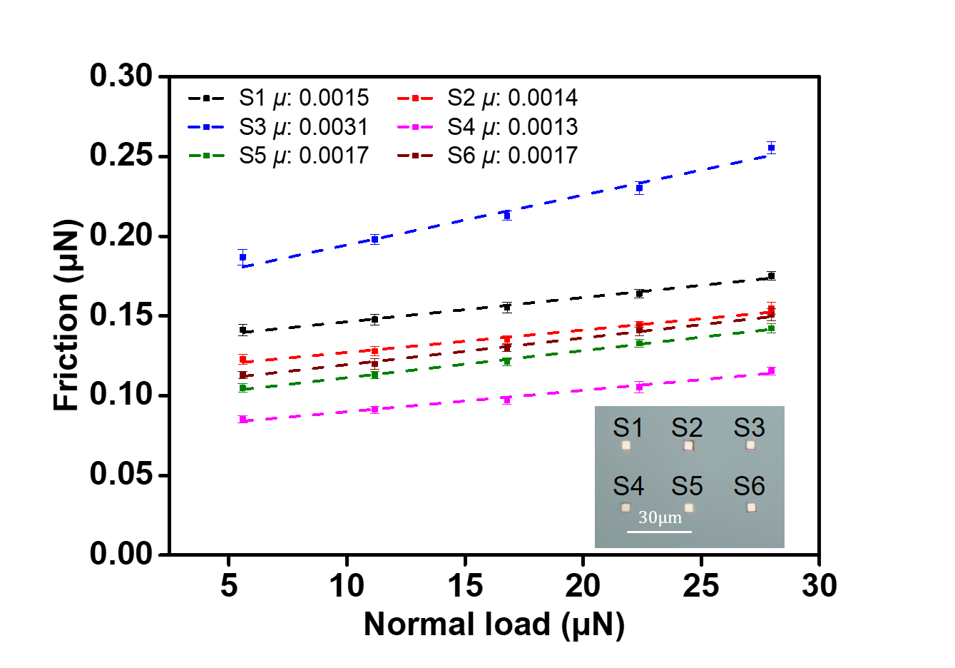
Supplementary Figure 8. Friction curves for the transferred graphite flakes measured under loaded conditions by AFM, all with a coefficient of friction of less than 0.01.

Supplementary Note 2
GUI design for transfer and measurement system. In Supplementary Figure 7, we show the GUI for each of the different functions. The main interface, as presented in Supplementary Fig. 8a, consists of three parts: 1) an information display section containing real-time information about the force sensor, the image of the tip section, the position of each displacement platform, etc. In this section, we have also added other interactive functions such as manual tip position calibration, displacement stages, force transducer zeroing and angle calibration. 2) A hardware connection section to connect to the corresponding hardware by selecting the cluster communication (COM) port. The serial number of the COM ports in this connection section are automatically searched for avoid manual checking. 3) A transfer parameter setting and semi-automatic selection interaction section for selecting the specific function required. In this section, users can transfer the SSL materials fully or semi-automatically according to the needs of the experiment or assembly.

Supplementary Note 3
Time analysis for transfer graphite flakes. The current basic manufacturing processes relies on the manual operation of the experimental apparatus. Considering the yield rate $P_{1}$, the expected time needed to transfer N micro graphite flakes with the incommensurate interface as $\left(A/{P_{1}}+B/{P_{2}}+C\right)×N$, where $A$ is the time for pushing the flakes, $B$ is the time for picking them onto tips, C is the time for transfer to the target position, and $P_{2}$ is the success rate for picking. For the current process of generating graphite flakes, $P_{1}≈60\%$. When we estimate $A=2 min$, $B = 1 min$, $C = 10 min$, and $P_{2} = 70\%$, which can be an optimistic value even for a well-trained researcher, the time required to complete a millimeter-scale macrostructure superlubricity which requires at least $N=1000$ flakes with incommensurate counts up to ~250h of successive process. Performing such repetitive manual tasks is practically impossible.

Supplementary Note 4
The performance of deep learning algorithms. The additional test datasets have been collected to evaluate the robustness of our trained models, where the performances for each task are presented in Supplementary Table 1. For each judgment task, our system transferred SSL flakes and collected over 1,000 input images simultaneously, and on images not trained by these models, each model performed well, with an accuracy of over 98%, and an F1 score of over 96%. Besides, it is worth noting that the size of our trained models is only 9 MB and each model takes less than 200 ms to return its determination, ensuring the efficiency of our transfer system.

Supplementary Table 1 The judgment results of this system for the three key decisions
Task | Positive | Negative | TPR^{①} | TNR^{②} | F1-score | Accuracy
Recover | 1176 | 2204 | 98.21% | 98.09% | 0.977 | 98.14%
Place | 1176 | 141 | 99.15% | 99.29% | 0.965 | 99.16%
Pick | 1924 | 2482 | 99.43% | 99.23% | 0.993 | 99.34%
- TPR: True Positive Rate
- TNR: True Negative Rate

