A genetic risk score model to enhance prediction of future Multiple Sclerosis diagnosis at first presentation with undifferentiated optic neuritis

SUPPLEMENTARY MATERIAL PART B

The data presented in this supplementary document repeats the primary analysis approach but is limited to the white unrelated European ancestry population only, who form the largest racial/ethnic subgroup in the UKBB dataset.

- White European Population definition
The white European population was defined based on the UKBB data-field 22006, which defines European ancestry based on self-reported data and genetic principal components (See https://biobank.ndph.ox.ac.uk/ukb/field.cgi?id=22006).
1.1 White European only population: MS, ON and MS-ON cases and demographic characteristics
From 405,479 unrelated individuals of white European origin with available genetic and phenotype data, we identified 1845 MS cases, the vast majority of whom came from at least two sources. We identified 583 ON cases diagnosis, including 172 cases with diagnostic Read3 codes (F4H3 or F4H32) omitted from the UKBB definition of ON. Of these, 224 (38.4%) were diagnosed with MS during cumulative follow-up. This was similar to 39% MS-ON in our primary analysis.
We analysed demographic characteristics and present results in eTable 8 below. Female: male ratio remained similar in white European population in all groups: MS-ON (3.39), MS only (2.54), ON only (1.39).
We found that from 224 people with MS-ON, 103 people had ON diagnosed first, 105 had MS diagnosed first, and 16 people had both diagnoses appear on the same day.
For the MS-free survival analysis, we limited our primary analysis to ‘undifferentiated’ ON cases after excluding people with MS diagnosed before ON (n=105 out of 224 MS-ON cases), simultaneous MS-ON cases (n=16 out of 224) and people who have died before the end of the follow-up (n=16).

eTable 8. Demographic characteristics of white British population.
Characteristic | MS-ON at presentation | MS Only | Controls | Undifferentiated ON at presentation | Adjusted Hazard Ratio of MS diagnosis amongst those with undifferentiated ON*
Study participants (n) | 121 | 1,845 (87.73) | 403,051 (83.85) | 462
Median age at UKBB enrolment (IQR, range) | 55 (49-59, 41-69) | 54 (48.5-59, 41-69) | 58 (51-63, 41-69) | 58 (50-63, 41-69) | 0.995 (0.9924-0.997), p<0.005
n Females (F:M) | 91 (3,03) | 1,322 (2,53) | 217,370 (1.17) | 291 (1,7) | 2.31 (1.41-3.78), P<0.005**
ON diagnosed between 18 and 50 | 75 (61.98) | NA | NA | 288 (62.34) | 2.63 (1.44-4.81), P<0.005**
Mean MS-GRS (SD) | 3.81 (1.10) | 3.62 (1.23) | 2.63 (1.16) | 3.19 (1.32) | 1.27 (1.06–1.52), P<0.01**
Ever smoked
No | 54 (44.63) | 892 (48.35) | 218,897 (54.31) | 225 (48.7) | –
Yes | 66 (54.55) | 937 (50.79) | 182,626 (45.31) | 234 (50.65) | 1.04 (0.7-1.53), P=0.86
Missing data | 1 (0.83) | 16 (0.87) | 1,528 (0.38) | 3 (0.65) | 1.38 (0.19-10.04), P=0.75
Serum 25-hydroxyvitamin D level at baseline assessment
Sufficient (> 50 nmol/L) | 38 (31.40) | 695 (37.67) | 173,306 (43.00) | 157 (33.98) | –
Insufficient (25-50 nmol/L) | 43 (35.54) | 677 (36.69) | 152,445 (37.82) | 197 (42.64) | 0.78 (0.49-1.23), P=0.28
Deficient (<25 nmol/L) | 29 (23.97) | 316 (17.13) | 44,104 (10.94) | 69 (14.94) | 1.27 (0.73-2.2), P=0.39
Missing data | 11 (9.09) | 157 (8.51) | 33,196 (8.24) | 39 (8.44) | 0.97 (0.47-2.02), P=0.94
Mean (sd) body mass index at UBKBB baseline assessment, kg/m2 | 26.9 (5.4) | 26.9 (5.0) | 27.4 (4.8) | 27.7 (5.0) | 0.99 (0.95 - 1.03), P=0.69
Country of Birth |  |  |  |  | –
England | 96 (79.34) | 1,542 (83.58) | 340,673 (84.52) | 371 (80.30) | 0.73 (0.23-2.32), P=0.59
Wales | 7 (5.79) | 85 (4.61) | 19,658 (4.88) | 28 (6.06) | 0.79 (0.29-2.17), P=0.65
Scotland | 18 (14.88) | 179 (9.70) | 34,209 (8.49) | 49 (10.61) | 1.38 (0.79-2.4), P=0.2
Northern Ireland | / | 9 (0.49) | 1,864 (0.46) | 4 (0.87) | 1.13 (0.16-8.1), P=0.91
Republic of Ireland | / | / | 225 (0.06) | / | NA
Elsewhere/not known | / | 30 (1.63) | 6,422 (1.59) | 10 (2.16) | 1.37 (0.43-4.34), P=0.59
VARIABLES NOT INCLUDED IN COX REGRESSION ANALYSIS
Died before end of follow-up (n) | 6 (5.0) | 129 (7.0) | 16,442 (4.1) | 13 (2.8)
Mean age at onset ON (sd, range) | 43.2 (11.9, 19.9-73.5) | NA | NA | 44.7 (15.1, 1.3-80.3)
Mean age at onset MS (sd, range) | 38.4 (9.82, 18–58) | 44.9 (12.5, 15.4-80.4) | NA | 45.8 (10.9, 20.5-73.6)
HLA-DRB1*15:01
0 | 50 (41.32) | 937 (50.79) | 294,979 (73.19) | 297 (64.29)
1 allele | 63 (52.07) | 775 (42.01) | 99,577 (24.71) | 147 (31.82)
2 allele | 8 (6.61) | 133 (7.21) | 8,495 (2.11) | 18 (3.90)
* Excluding participants who died before end of follow-up
** HR and P values from multivariable Cox regression model

1.2 MS-GRS ROC-AUC
MS-GRS performed equally well in White EUR population only.
We assessed the MS-GRS in UKBB MS cases and controls in a population if white Europeans only using ROC-AUC (eFig. 12A). Both the HLA and non-HLA scores were independently discriminative of MS (ROC-AUC 0.668 (95% CI 0.665-0.671) and 0.663 (0.660-0.666) respectively, eFig. 12 B) and had a combined ROC AUC of 0.726 (0.723-0.729). This was only a slight improvement when compared to the performance of MS-GRS on the whole of the UKBB (0.721 (0.718-0.723). When combined with other known risk factors for MS, namely sex, age at UKBB entry, Townsend deprivation index and first four PCs, the ROC-AUC was 0.749 (0.747 - 0.752) (compared to 0.752 the whole of UKBB). This could be explained by some covariates, such as genetic principal components, not being as significant in the white only population.
1.3 Genetic overlap of MS, ON and MS associated ON
We first assessed the distribution of MS-GRS in Controls, ON only, MS-ON and MS only (eFig. 13 A,B). The pattern was the same in White European only as in the whole of the UKBB, with the same significant differences.
1.4 MS-GRS is predictive of future MS in individuals with first occurrence of ON.
We assessed MS-GRS in 449 individuals with a first occurrence of ON where either there was no pre-existing diagnosis of MS or there was no diagnosis of MS at the same time (eTable 8). This included individuals with ON who never received a diagnosis of MS with a median of 22 (IQR 13-35) years of follow up. Both prevalent (before UKBB entry) and incident (after UKBB entry) were used, with 84/449 of ON diagnoses being incident. 101 individuals had an ON diagnosis that was followed by a diagnosis of MS, with a median interval of 3.25 years (IQR 0.67–9.9) years.
When the Cox hazard model was fitted with MS-GRS, Sex and binary age at diagnosis, MS-GRS was significant in the model (P < 0.01); the Hazard Ratio (95% CI) of future MS diagnosis amongst participants presenting with undifferentiated ON was 1.31 (1.07-1.61, P < 0.01) per standard deviation increase in MS-GRS. Stratifying by the predicted risk quartiles, each subsequent quartile had a higher occurrence of MS-ON, as shown in eFig. 15. This identified people who were at relatively low risk of MS (Percent diagnosed with MS-ON at the end of the follow up, 95% CI: 3.5% (0.1%–6.9%), intermediate risk groups 13.4% (7.1% –19.7%), higher MS risk group, 33.0% (24.3%–41.7%) and highest MS risk group 40.2% (31.1%–49.3%) (eFig. 16). Importantly, the model with MS-GRS performed significantly better than the null model with covariates only (Partial log-likelihood ratio test P value < 0.01 on 1 DF).
It is worth noting that adjusting the model for age at UKBB entry (age at enrolment) either alongside the binary age of ON diagnosis or instead of it resulted in significant improvement of the model. This resulted in reduction of the P value of MS-GRS in the model to less than 0.005, and the log-likelihood ratio test, when comparing the full model to that without MS-GRS was reduced. However, we decided to include in our analysis only those variables that would be available in other cohorts would not be specific to UKBB.

2. Summary of other subgroup analyses
We performed main analysis, including MS-GRS validation using ROC-AUC on MS cases vs the rest and Cox proportional hazard model of MS-free survival in undifferentiated ON, using two rigid exclusion criteria separately: excluding early diagnoses and excluding self-reported and/or unverified first-occurrence diagnoses.

2.1 Excluding cases diagnosed before 20 years of age
26 cases of MS and 19 cases of ON were diagnosed before 20 years of age. Excluding these cases resulted in removal of 22 MS cases, 16 ON cases and 7 MS-ON, bringing the numbers to 2081, 405 and 259 respectively.

2.2 Strict definition of diagnoses
We performed main analysis including only cases obtained from either Hospital Episode Statistics (HES) or primary-care data (See Supplement A eFig. 1). These excluded cases coming only from self-reports or first-occurrence. This resulted in exclusion of 217 MS only, 104 ON only and 36 MS-ON cases, bringing the total number of cases to 1887, 317 and 230 for MS, ON and MS-ON respectively.
2.3 Summary and comparison of subgroup analyses
Summary of main analysis in all subgroups is provided in eTable 9. MS-GRS was comparably discriminative of MS cases in all subgroups, both on its own and when combined with covariates, as shown by ROC-AUC after cross-validation. Furthermore, in Cox predictive analysis of future MS in undifferentiated ON, MS-GRS remained significant in all subgroups, and HR per standard deviation of MS-GRS was comparable (eTable 9).
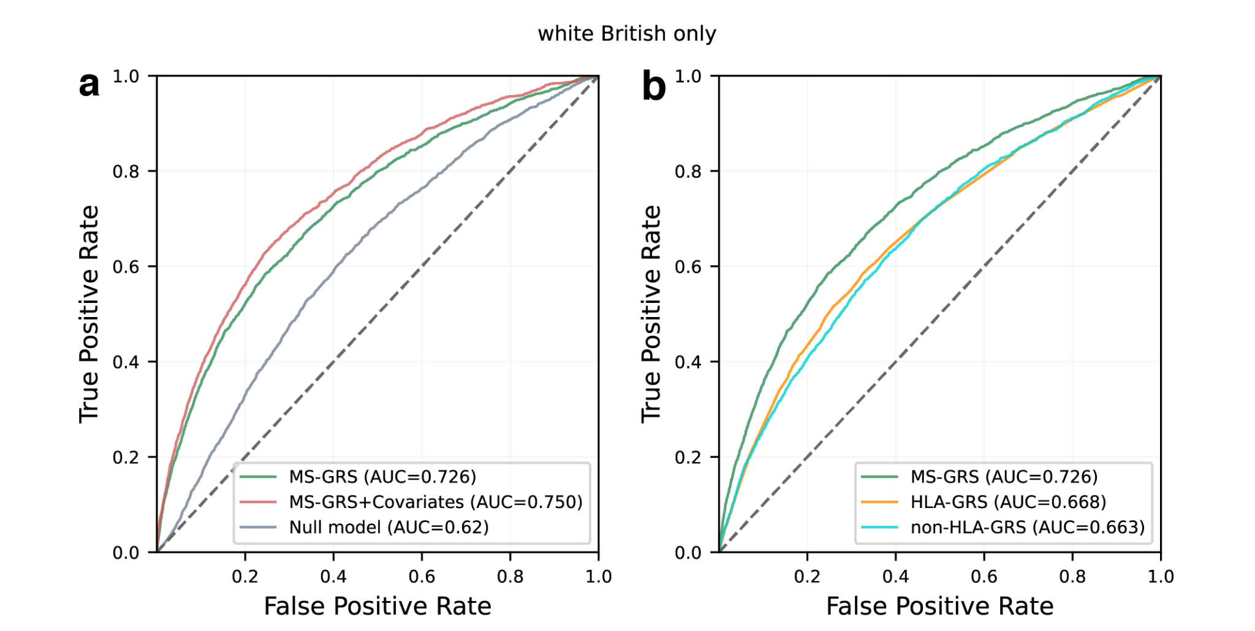eFig. 12 summarises performance of MS-GRS in white British only population A ROC-AUC of MS-GRS and covariates. B ROC-AUC curves of non-HLA- and HLA-GRS.
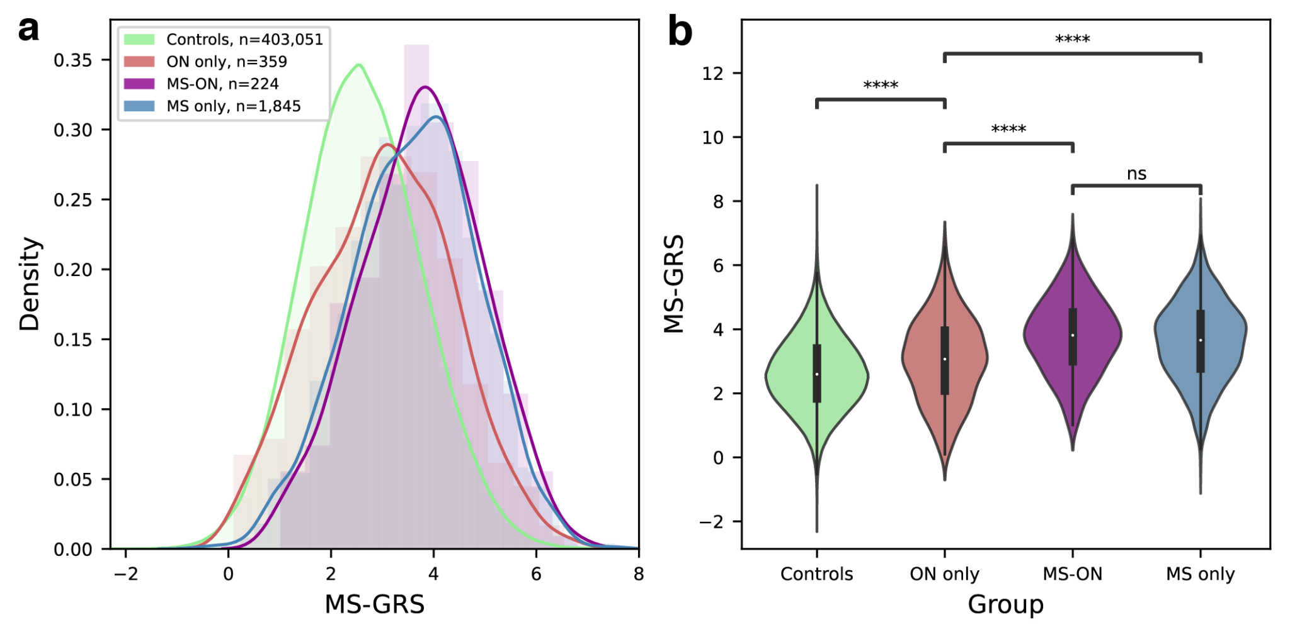
eFig. 13 illustrates MS-GRS distribution graphs comparing controls, undifferentiated ON, MS-ON and MS without ON in white British only. A shows a histogram plot with kernel density estimate (solid lines). B shows a violin plot with Welch’s t-test statistical significance: **** – P < 1.00e-04, ns – not statistically significant at P > 0.05

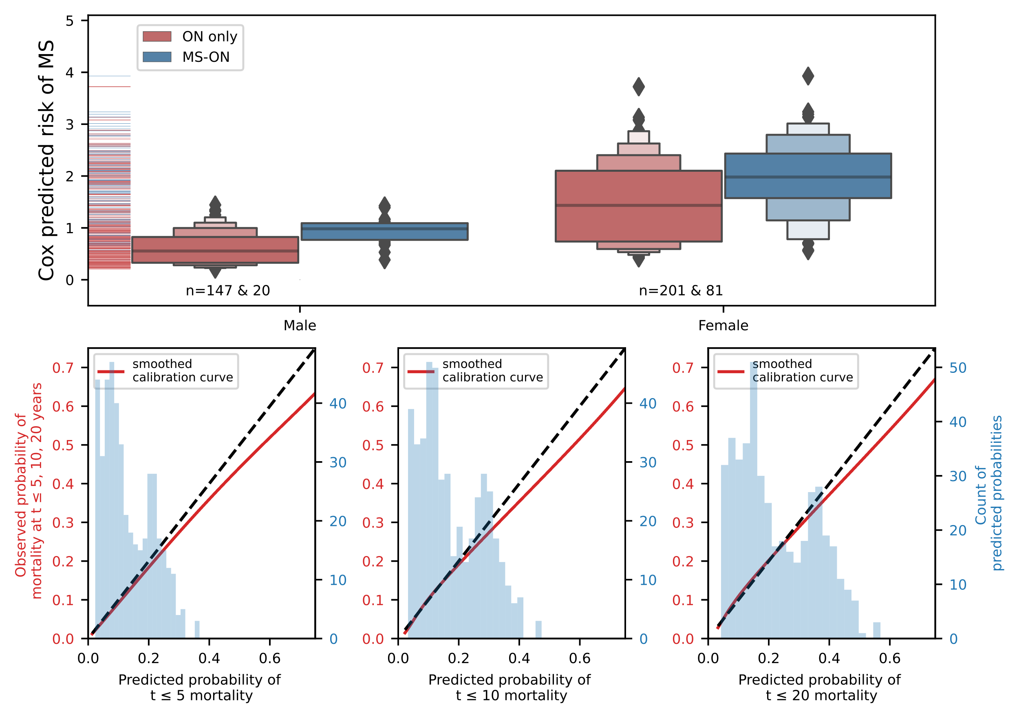eFig. 14 shows a boxen plot illustrating predicted risk of MS in undifferentiated ON stratified by sex, showing that predicted risk is higher in MS-ON cases in both males and females. Risk predicted by Cox proportional hazard model based on sex, age of ON diagnosis [18 to 50] and MS-GRS. Panels b-d illustrate calibration plots of the Cox model at three points in time (5,10, and 20 years, respectively). Smoothed calibration curve is shown in red, and ideal calibration in black dotted line.
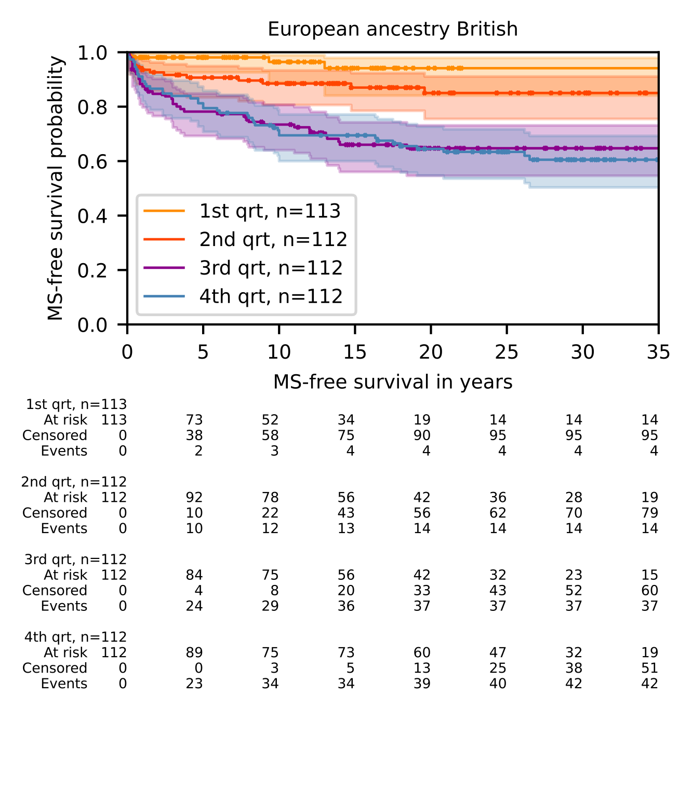
eFig. 15. Kaplan-Meier plot of undifferentiated ON stratified by quartiles of predicted MS risk.
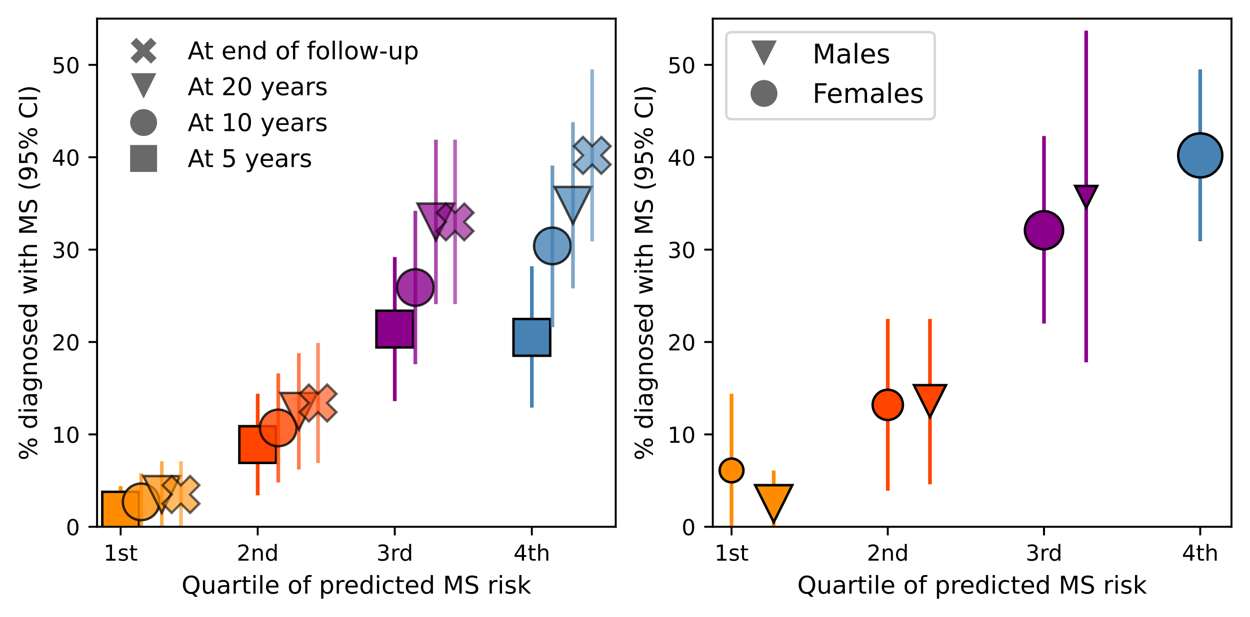eFig. 16 summarises proportion of MS-ON out of all initially undifferentiated ON A. Shows at different time points following ON diagnosis in each quartile of predicted MS risk at 5 years, 10 years, 20 years and at the end of follow-up (squares, circles triangles and crosses, respectively). Shows proportion of MS-ON at the end of follow-up (median 22.0, IQR 13-34) for males and females (triangles and circles, respectively) in each quartile of predicted MS risk, with the marker size proportional to the proportion of that sex within each quartile

eTable 9. Summary of statistical analysis in all subgroups, including all the UKBB, white British only, excluding early cases, and strict definition of diagnoses.
Population | Whole of UKBB | European ancestry British | Non-European ancestry-British | Without diagnoses at <20 y.o.a. | Strict diagnoses
Controls, n | 480 690 | 403,051 | 77,639 | 480,690 | 480,690
MS only, n | 2,103 | 1,845 | 258 | 2,081 | 1,887
ON only, n | 421 | 359 | 62 | 405 | 317
MS-ON, n | 266 | 224 | 42 | 259 | 230
MS-GRS ROC-AUC | 0.721 (0.718-0.723) | 0.726 (0.723-0.728) | 0.696 (0.688-0.703) | 0.720 (0.716-0.724) | 0.721 (0.717-0.725)
MS-GRS & Covariates ROC-AUC | 0.752 (0.750-0.755) | 0.749 (0.747-0.752) | 0.753 (0.746 - 0.760) | 0.751 (0.749-0.754) | 0.751 (0.748-0.753)
n undifferentiated ON, no MS (F:M ratio) | 408 (1.46) | 348 (1.37) | 60 (2.16) | 392 (1.48) | 306 (1.49)
N undifferentiated ON, progressed to MS (F:M ratio) | 121 (4.50) | 101 (4.05) | 20 (9.0) | 118 (4.62) | 104 (4.78)
HR of female sex | 2.40 (1.51-3.82), P=0.00021 | 2.30 (1.40-3.75), P=0.00092 | 2.56 (0.58-11.22), P=0.213 | 2.40 (1.50-3.85), P=0.00028 | 2.22 (1.34-3.71), P=0.00213
HR of ON diagnosed between 18 and 50 | 2.32 (1.34-3.99), P=0.00248 | 2.39 (1.31-4.38), P=0.00465 | 2.27 (0.64-8.12), P=0.206 | 2.25 (1.24-4.09), P=0.00774 | 2.0 (1.11-3.58), P=0.02022
HR of MS-GRS per SD | 1.31 (1.09-1.58), P=0.00475 | 1.31 (1.06-1.61), P=0.01097 | 1.41 (0.87-2.26), P=0.160 | 1.27 (1.05-1.54), P=0.01242 | 1.30 (1.06-1.59), P=0.01095
Concordance | 0.67 | 0.66 | 0.70 | 0.65 | 0.64
LLR test P value* | 0.0038 | 0.0104 | 0.149 | 0.01183 | 0.0157
partial AIC | 1379.63 | 1120.88 | 140.00 | 1325.52 | 1122.48
* Partial Log-likelihood ratio test, comparing models with MS-GRS, sex, and age at ON diagnosis [18-50] to a null model (sex and age at ON diagnosis)

