A genetic risk score model to enhance prediction of future Multiple Sclerosis diagnosis at first presentation with undifferentiated optic neuritis

SUPPLEMENTARY MATERIAL PART A

- Supplementary Methods
  - Source of diagnosis based on diagnostic codes
  - Generating MS-GRS

- Supplementary Results
  - Demographic data
2.1.1 Tables for all ON cases and all MS cases by end of cumulative follow-up
2.1.2 Age at diagnosis of MS
2.1.3 Age at diagnosis of ON
2.1.4 Age at diagnosis of ON in undifferentiated ON
2.1.5 Causes of death in MS & ON
  - MS-GRS in MS-ON: MS first VS ON first
  - MS-GRS association with other variables:
    - Age at diagnosis of MS/ON
    - Sex
    - Ethnicity
  - Unadjusted Kaplan-Meier of MS-free survival
  - Adjusting for age at cohort entry
1. Supplementary Methods

1.1 Source of diagnosis based on diagnostic codes

1.1.1 Case Identification

Our case identification process is detailed in eFigure1. In brief, we first included the UKBB-defined ‘first occurrence’ cases of MS and ON. These are centrally generated by UKBB from HES data (using International Classification of Disease version 10 (ICD-10) and ICD-9 codes), primary care records (using Read2 and Read3 codes) and self-report (See supplement eTable 1).¹ Second, in order to verify first-occurrence data, we searched data-fields with self-reported illnesses (self-report codes) and UKBB HES data (ICD-10 & ICD-9) and retrieved an additional 113 MS and 54 ON cases. These cases were all identified from HES data, with no additional cases from ‘self-report’. Third, we manually searched primary care data in all participants with missing ‘first occurrence data’, using additional Read codes identified by our neuro-ophthalmologists (See eTable 1). We identified an additional 5 MS cases and 196 ON cases. Through this process, we identified that where the UKBB ‘first occurrence’ cases were defined by Read3 codes (rather than Read2 codes), two key ON codes were omitted from capture, namely, F4H3 ‘Optic Neuritis’ (n= 128 added) and F4H32 ‘Acute retrobulbar neuritis’ (n=66 added). Two cases were identified from Read3 code, ‘Retrobulbar optic neuritis classified elsewhere’ (FyuJ1). Four MS cases were identified from Read2 codes, ‘Management of multiple sclerosis in palliative phase’ (8Cc4, n=2) and ‘Multiple sclerosis multidisciplinary review’ (666B, n=2), with the fifth case (F20z) subsequently removed due to missing event date.

1.1.2 Case Exclusion

Following code review by our neuro-ophthalmologists, we excluded multiple UKBB codes. These included: ‘drug-induced optic neuropathy’ (F4H34, n=13); ‘Inherited optic neuropathy’ (XaE6B, n=0); ‘idiopathic optic disc swelling’ (XaE6C, n=0); ‘infiltrative optic neuropathy’ (XaE6E, n=0); ‘Optic papillitis’ (XaF1F and F4H31, n=7); UKBB code X75hh (n=0), and additional codes not used centrally by UKBB, but which could still appear in data from ‘self-report’, HES or primary care record data, namely, ‘Meningococcal Optic Neuritis’ (A36y0, n=2) and ‘Syphilitic optic atrophy’ (A36y3 and A36y4, n=2).

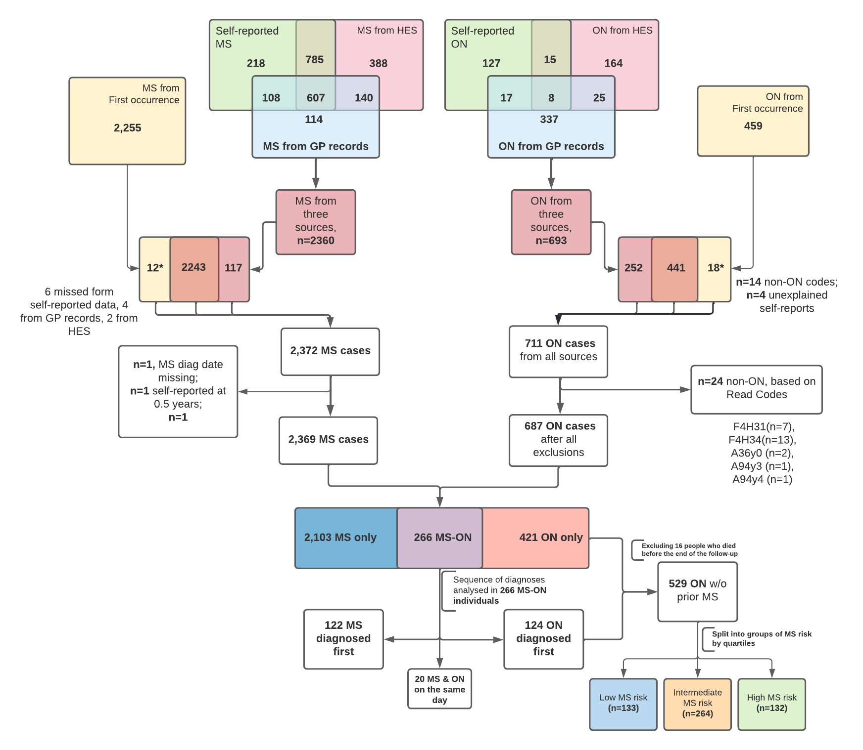
eFigure 1. Extended flow diagram showing the sources of diagnoses

eTable 1- Case definition of optic neuritis and multiple sclerosis, based on Read codes included and excluded

CODES | Optic Neuritis | Multiple Sclerosis
ICD-10 | H46 | G35
ICD-9 | 377.3 | 340
Self-report | 1435 | 1261
UKBB Read 2 codes | F4H3 Optic neuritis | F20.. Multiple sclerosis
 | F4H30 Unspecified optic neuritis | F200. Multiple sclerosis of the brain stem
 | F4H3z ON Not otherwise specified | F201. Multiple sclerosis of the spinal cord
 | F4H32 Acute retrobulbar neuritis | F203. exacerbation of Multiple sclerosis
UKBB Read 3 codes | F4H30 Unspecified optic neuritis | F20.. Multiple sclerosis
 | F4H3z ON Not otherwise specified | F200. Multiple sclerosis of the brain stem
 |  | F201. Multiple sclerosis of the spinal cord
 |  | F203. exacerbation of Multiple sclerosis
Additional Read codes  included in our analysis | FyuJ100 Retrobulbar neuritis in diseases classified elsewhere | 666B.00 MS MDT Review
 | F4H3 Optic Neuritis (in Read3) | 8Cc4.00 Management of MS  in palliative phase
 | F4H32 Acute retrobulbar neuritis (in Read 3)
Codes used for exclusion | F4H31 Optic papillitis
 | F4H33 Nutritional optic neuropathy
 | F4H34 Drug induced optic neuropathy
 | XaE6B Inherited optic neuropathy
 | XaE6C Idiopathic optic disc swelling
 | XaE6E Infiltrative optic neuropathy
 | XaF1F Infiltrative optic neuropathy
Additional codes for exclusion | A36y000 Meningococcal optic neuritis
 | A94y400 Syphilitic optic atrophy
 | A94y300 Syphilitic optic atrophy
 | F4H1200 Post-inflammatory optic atrophy

eTable 2- Detailed optic neuritis Read codes description used in our analysis and by UKBB when translating Primary care data to UKBB ‘first occurrence’. Diagnostic codes coinciding between data sources are colour coded in green, discrepancies are highlighted in red. In yellow shown are additional codes that were included, and in blue are codes that resulted in participant exclusion. Where Read codes are reported in the first column, they were used both as Read2 and Read3.

Searched in Primary care linked data | Data-coding 1834 | Data-coding 1835 | Description
Read 2 / Read 3 | Read2 used by UKBB | Read3 (CTV3) used by UKBB
A36y000 |  |  | Meningococcal optic neuritis
F4H3.00 | F4H3. | Absent in UKBB | Optic neuritis (ON)
F4H3000 | F4H30 | F4H30 | Unspecified ON
F4H3z00 | F4H3z | F4H3z | ON not otherwise specified
F4H3200 | F4H32 | Absent in UKBB | Acute retrobulbar neuritis
F4H31 | F4H31 | F4H31 | Optic papillitis
F4H33 | F4H33 | F4H33 | Nutritional optic neuropathy
F4H34 | F4H34 | F4H34 | Drug induced optic neuropathy
A94y400 |  |  | Syphilitic optic atrophy
FyuJ100 |  |  | Retrobulbar neuritis in diseases classified elsewhere
A94y300 |  |  | Syphilitic optic atrophy
F4H1200 |  |  | Post inflammatory optic atrophy
X75hh |  | X75hh | Corneal nerves inflamed
XaE6B |  | XaE6B | Inherited optic neuropathy
XaE6C |  | XaE6C | Idiopathic optic disc swelling
XaE6E |  | XaE6E | Infiltrative optic neuropathy
XaF1F |  | XaF1F | Optic papillitis (same as F4H31)
Links to UKBB GP – ICD10 mapping | https://biobank.ctsu.ox.ac.uk/crystal/coding.cgi?id=1834&nl=1 | https://biobank.ctsu.ox.ac.uk/crystal/coding.cgi?id=1835&nl=1

eTable 3- Multiple sclerosis Read codes description used by us and by UKBB. In the first column, we show all Read codes that were used for searching the UKBB GP records. In the second and third columns, we show codes that were used centrally by the UKBB when translating Primary care linked data to ‘first occurrence’
Searched in Primary care linked data | Data-coding 1834 | Data-coding 1835 | Description
Read 2 / Read 3 | Read2 used by UKBB | Read3 (CTV3) used by UKBB
666A.00 |  |  | Multiple sclerosis review
666B.00 |  |  | Multiple sclerosis multidisciplinary review
8Cc0.00 |  |  | Management of multiple sclerosis in onset phase
8Cc1.00 |  |  | Management of multiple sclerosis in early disease phase
8Cc2.00 |  |  | Management of multiple sclerosis in stable disability phase
8Cc4.00 |  |  | Management of multiple sclerosis in palliative phase
8CS1.00 |  |  | Multiple sclerosis care plan agreed
8Hkv.00 |  |  | Referral to community multiple sclerosis team
8IAb.00 |  |  | Multiple sclerosis review declined
9kG..00 |  |  | Spec. serv. for pat with multiple sclerosis
9mD..00 |  |  | Multiple sclerosis monitoring administration
9mD0.00 |  |  | Multiple sclerosis monitoring first letter
9mD1.00 |  |  | Multiple sclerosis monitoring second letter
9mD2.00 |  |  | Multiple sclerosis monitoring telephone invitation
9mD3.00 |  |  | Multiple sclerosis monitoring third letter
F20..00 | F20.. | F20.. | Multiple sclerosis
F200.00 | F200. | F200. | Multiple sclerosis of the brain stem
F201.00 | F201. | F201. | Multiple sclerosis of the spinal cord
F202.00 | F202. | F202. | Generalised multiple sclerosis
F203.00 | F203. | F203. | Exacerbation of multiple sclerosis
F204.00 | F204. |  | Benign multiple sclerosis
F205. | F205. |  | Malignant multiple sclerosis
F206.00 | F206. |  | Primary progressive multiple sclerosis
F207.00 | F207. |  | Relapsing and remitting multiple sclerosis
F208.00 | F208. |  | Secondary progressive multiple sclerosis
F20z.00 | F20z. | F20z. | Multiple sclerosis NOS
ZRVE.00 |  |  | Kurtzke multiple sclerosis rating scale
F20..11 |  |  | Disseminated sclerosis
XaP1B |  | XaP1B | Relapsing and remitting multiple sclerosis
XaOzZ |  | XaOzZ | Benign multiple sclerosis
XaP0X |  | XaP0X | Malignant multiple sclerosis
XaP0r |  | XaP0r | Primary progressive multiple sclerosis
X005d |  | X005d | Chronic progressive multiple sclerosis
X005c |  | X005c | Acute relapsing multiple sclerosis
XaP1V |  | XaP1V | Secondary progressive multiple sclerosis
X005e |  | X005e | Remittent-progressive multiple sclerosis

1.2 Generating MS-GRS
non-HLA-GRS
First, we extracted variants associated with MS from summary statistics of IMSGC GWAS meta-analysis discovery phase.² We selected variants with association statistic P value <10⁻⁵. Next, in pairs of variants in linkage disequilibrium (r² >0.2) we manually removed one variant. We excluded all variants from the extended HLA region on chromosome 6 (chr6:25 Mbp to chr6:35 Mbp, hg19), sex-chromosome variants. Next, we ensured that palindromic (strand-ambiguous) variants, such A/T or C/G and vice versa were removed, and removed duplicated variants. We did not exclude variants based on either Hardy-Weinberg equilibrium, minor allele frequency (MAF) or imputation quality, as these quality control steps were performed centrally by the UKBB on the imputed genotypes we used, and thus would not have significantly affected the results.³

HLA-GRS
For the HLA-GRS, we used a ten-allele interaction model reported by Moutsianas et al.⁴ It consisted of eight HLA alleles and two SNPs from the HLA region (29.9 to 33.6 Mbps on chr6 hg19). We captured interactions between the alleles by calculating the interactive model, scoring imputed HLA alleles while employing both additive effects, homozygote correction terms ($I_{xHOM}$) and conditional scoring of some HLA alleles ($I_{x}$), where $x$ is an HLA allele. This is summarised in the equation by Moutsianas et al⁴:

$${HLA}_{GRS}= G_{DRB1501}* β1+ I_{DRB1501HOM}* {β1}_{HOM}+ G_{A0201}* β2+I_{A0201HOM}* {β2}_{HOM}+ I_{DRB0301HOM}* {β3}_{HOM}+ G_{DRB1303}*β4+ G_{DRB0801}*β5+ G_{rs9277565}*β6+G_{B4402}*β7+ G_{B3801}*β8+ G_{DQA0101}*I_{DRB1501}*{β9}_{INT}+ G_{rs2229092}*β10$$

$$where G_{x} ∈\left\{0,1,2\right\}, I_{xHOM}=\{_{0, otherwise}^{1, if G_{x}==2 }, I_{x}=\{_{0, otherwise}^{1, if G_{x}≥2 } for HLA allele or SNP x,$$
$$G_{x} is the allele genotype, and β is the corresponding beta coefficient (\ln{x})$$

The HLA alleles and SNPs and their respective terms used in the model are described (eTable 4). We used HLA alleles imputed centrally by the UKBB,³ using hard-called alleles, rather than probabilities.

eTable 4. HLA alleles, coefficients used in for the HLA-GRS calculation. Adapted from Moutsianas et al.,⁴

HLA allele or SNP | Parameter | OR | Beta Coefficients | Notation (β)
HLA-DRB1*15:01 | Additive Effect | 3,92 | 1,37 | β1
HLA-DRB1*15:01 | Homozygote correction | 0,54 | -0,62 | β1HOM
HLA-A*02:01 | Additive Effect | 0,67 | -0,4 | β2
HLA-A*02:01 | Homozygote correction | 1,26 | 0,23 | β2HOM
HLA-DRB1*03:01 | Homozygote correction | 2,58 | 0,95 | β3HOM
HLA-DRB1*13:03 | Additive Effect | 2,62 | 0,96 | β4
HLA-DRB1*08:01 | Additive Effect | 1,55 | 0,44 | β5
rs9277565[T] | Additive Effect | 1,32 | 0,28 | β6
HLA-B*44:02 | Additive Effect | 0,78 | -0,25 | β7
HLA-B*38:01 | Additive Effect | 0,48 | -0,73 | β8
HLA-DQA1*01:01 | Additive Effect in the presence of DRB1*15:01 | 0,65 | -0,43 | β9INT
rs2229092[C] | Additive Effect | 1,33 | 0,29 | β10
2. Supplementary results

2.1 Demographic data in all ON cases and all MS cases by end of cumulative follow-up

eTable 5: ​​Demographic data for all cases of ON, subdivided into MS and non-MS ON at end of 20.4 years (IQR 12.1–31.6) cumulative follow-up

Characteristic | All MS-ON | ON without MS
Study participants (n) | 266 | 421
Of which white (%) | 224 (84.21) | 359 (85.27)
Mean age at UKBB enrolment (SD, range) | 54 (48-59, 40 to 69) | 58 (51-63, 40 to 70)
n Females (F:M) | 206 (3.43) | 252 (1.49)
ON diagnosed between 18 and 50 | 197 (74.1) | 231 (54.9)
Mean MS-GRS (SD) | 2.66 (1.15) | 3.02 (1.30)
Ever smoked
No | 124 (46.62) | 209 (49.64)
Yes | 140 (52.63) | 207 (49.17)
Missing data | 2 (0.75) | 5 (1.19)
Serum 25-hydroxyvitamin D level at baseline assessment
Sufficient (> 50 nmol/L) | 88 (33.1) | 139 (33.0)
Insufficient (25-50 nmol/L) | 98 (36.8) | 181 (43.00)
Deficient (<25 nmol/L) | 57 (21.4) | 65 (15.4)
Missing data | 23 (8.7) | 36 (8.6)
Mean (SD) body mass index at UBKBB baseline assessment, kg/m2 | 27.1 (5.3) | 27.8 (5.0)
Country of Birth
England | 199 (74.81) | 318 (75.53)
Wales | 13 (4.89) | 26 (6.18)
Scotland | 36 (13.53) | 39 (9.26)
Northern Ireland | 1 (0.38) | 3 (0.71)
Republic of Ireland | 1 (0.38) | 6 (1.43)
Elsewhere/not known | 16 (6.02) | 29 (6.89)
Townsend Deprivation Index Quintile
1 | 85 (31.95) | 146 (34.68)
2 | 62 (23.31) | 78 (18.53)
3 | 51 (19.17) | 69 (16.39)
4 | 39 (14.66) | 69 (16.39)
5 | 29 (10.9) | 59 (14.01)
Missing data | 0 (0) | 0 (0)
Died before end of follow-up (n) | 9 (3.4) | 13 (3.1)
Mean age at onset ON (SD, range) | 42.73 (12.41, 16.8–73.5) | 46.83 (15.55, 1.3-80.3)
Mean age at onset MS (SD, range) | 41.84 (10.88, 34-49) | NA
HLA-DRB1*15:01
0 | 127 (47.74) | 288 (68.41)
1 allele | 121 (45.49) | 121 (28.74)
2 allele | 18 (6.77) | 12 (2.85)

eTable 6: Demographic data for subgroups of patients all diagnosed with MS by end of cumulative follow up

Characteristic | MS-ON at presentation | ON prior to MS | MS without ON
Study participants (n) | 142 | 124 | 2103
Of which white (%) | 121 (85.2) | 103 (83.06) | 1,845 (87.7)
Mean age at UKBB enrolment (SD, range) | 54.5 (48-59, 40 to 69) | 53 (48-58, 40 to 69) | 56 (49-62, 40 to 70)
n Females (F:M) | 106 (2.9) | 100 (4.2) | 1,504 (2.5)
ON diagnosed between 18 and 50 | 89 (62.7) | 108 (87.1) | NA
Mean MS-GRS (SD) | 3.74 (1.15) | 3.67 (1.19) | 3.71 (1.17)
Ever smoked
No | 61 (43.0) | 63 (50.8) | 998 (47.5)
Yes | 80 (56.3) | 60 (48.4) | 1,085 (51.6)
Missing data | 1 (0.7) | 1 (0.8) | 20 (1.0)
Serum 25-hydroxyvitamin D level at baseline assessment
Sufficient (> 50 nmol/L) | 42 (29.6) | 46 (37.1) | 779 (37.0)
Insufficient (25-50 nmol/L) | 52 (36.6) | 46 (37.1) | 771 (36.7)
Deficient (<25 nmol/L) | 35 (24.7) | 22 (17.7) | 373 (17.7)
Missing data | 13 (9.2) | 10 (8.1) | 180 (8.6)
Mean (SD) body mass index at UBKBB baseline assessment, kg/m2 | 26.6 (5.2) | 27.6 (5.5) | 26.9 (5.0)
Country of Birth
England | 108 (76.1) | 91 (73.4) | 1,692 (80.5)
Wales | 9 (6.3) | 4 (3.2) | 92 (4.4)
Scotland | 18 (12.7) | 18 (14.5) | 201 (9.6)
Northern Ireland | 0 (0) | 1 (0.8) | 12 (0.6)
Republic of Ireland | 0 (0) | 1 (0.8) | 13 (0.6)
Elsewhere/not known | 7 (4.9) | 9 (7.3) | 93 (4.4)
Townsend Deprivation Index Quintile
1 | 47 (33.1) | 38 (30.7) | 733 (34.9)
2 | 28 (19.7) | 34 (27.4) | 479 (22.8)
3 | 26 (18.3) | 25 (20.2) | 311 (14.8)
4 | 24 (16.9) | 15 (12.1) | 328 (15.6)
5 | 17 (12.0) | 12 (9.7) | 249 (11.8)
Missing data | 0 (0) | 0 (0) | 3 (0.1)
Died before end of follow-up | 6 (4.2) | 3 (2.4) | 149 (7.1)
Mean age at onset ON (SD, range) | 47.3 (12.2, 20 to 73) | 37.5 (10.4, 17-67) | NA
Mean age at onset MS (SD, range) | 38.7 (9.6, 18 to 58) | 45.5 (11.2, 21-74) | 44.9 (12.5, 15 to 80)
HLA-DRB1*15:01
0 | 61 (43.0) | 66 (53.2) | 1,091 (51.9)
1 allele | 72 (50.7) | 49 (39.5) | 867 (41.2)
2 allele | 9 (6.3) | 9 (7.3) | 145 (6.9)

2.1.2 Age at diagnosis of MS
For Multiple Sclerosis, we excluded one individual with a self-reported age at diagnosis of 0.5 years, as it was a clear outlier. 98% of the cases were between 19.5 and 73.75 years of age. The earliest report of MS was at 15.41 years, and the latest at 80.4. 5th and 95th percentiles were 24.67 and 67 years, respectively. Age at MS report is summarised in eFig. 2.
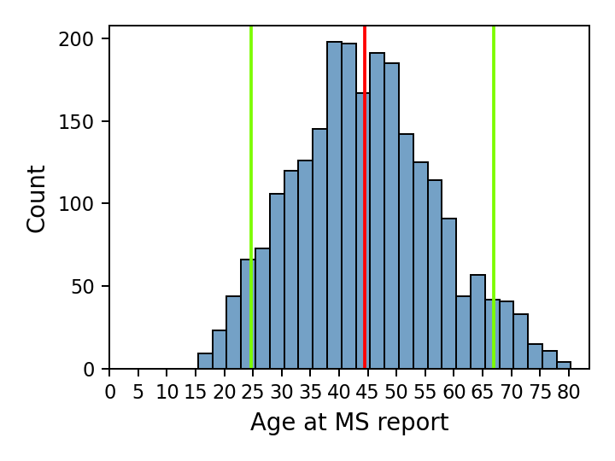
eFig. 2. Histogram showing the distribution of age at MS diagnosis. The vertical red line shows the mean, green lines show the 5th and the 95th percentiles.
2.1.3 Age at diagnosis of ON
No exclusions were made based on age at ON diagnosis. Age at ON diagnosis ranged from 1 to 80 years, with the median (IQR) of 44.6 (35.1-55.4). 98% of cases were reported between 13.8 and 77.3 years of age, and 95th percentiles were 23.9 and 70.1 years, respectively. Age at ON report is summarised in eFig. 3.

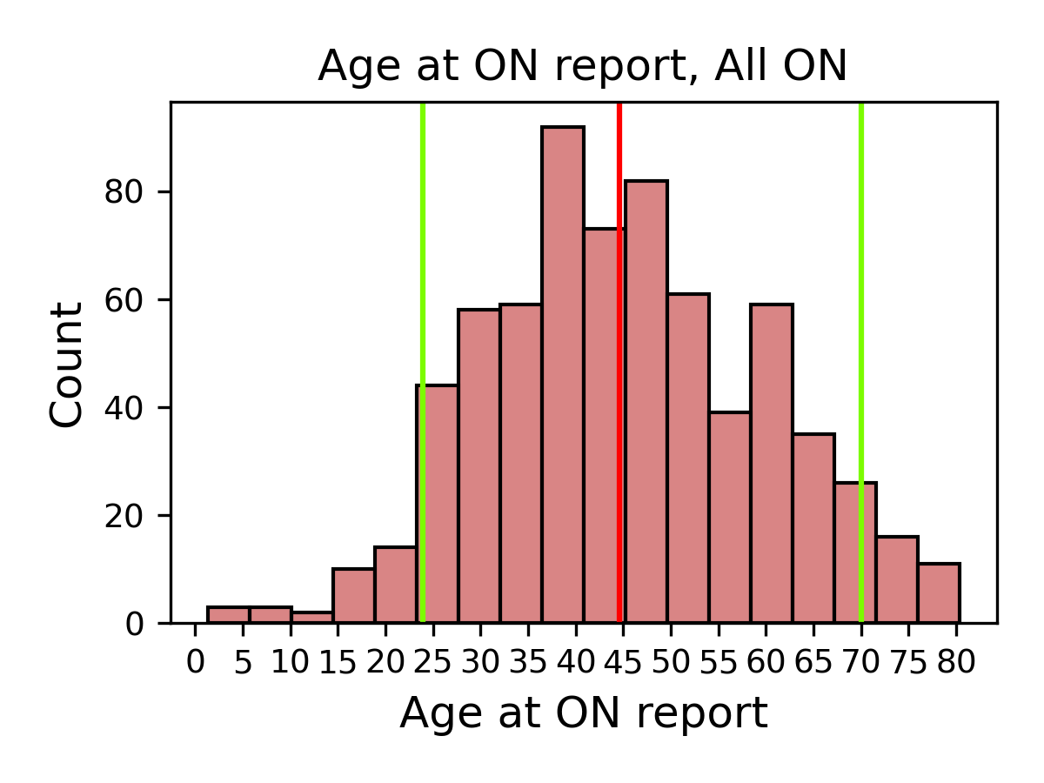

eFig. 3. Age at ON report for All ON cases (n=689). The vertical red line shows the mean, green lines show the 5th and the 95th percentiles.

2.1.4 Age at diagnosis of ON in undifferentiated ON

In undifferentiated ON (n=545) 98% of the cases were between 9.8 and 78.2 years of age. The earliest report of MS was at 1.3 years, and the latest at 80.3. the 5th and 95th percentiles were 22.3 and 71.0 years, respectively. Age at ON report for undifferentiated ON is summarised in eFig.4. In ON that progressed to MS (n=124/545), 98% of ON were diagnosed between 17.3 and 63.3 years of age, with 5th and 95th percentiles being 22.8 and 53.8 years, respectively. 87.1% (109/124) of ON cases where ON progressed to MS were diagnosed between 18 and 50 years of age. eFig.5 summarises age at ON diagnosis in MS-ON vs ON only.
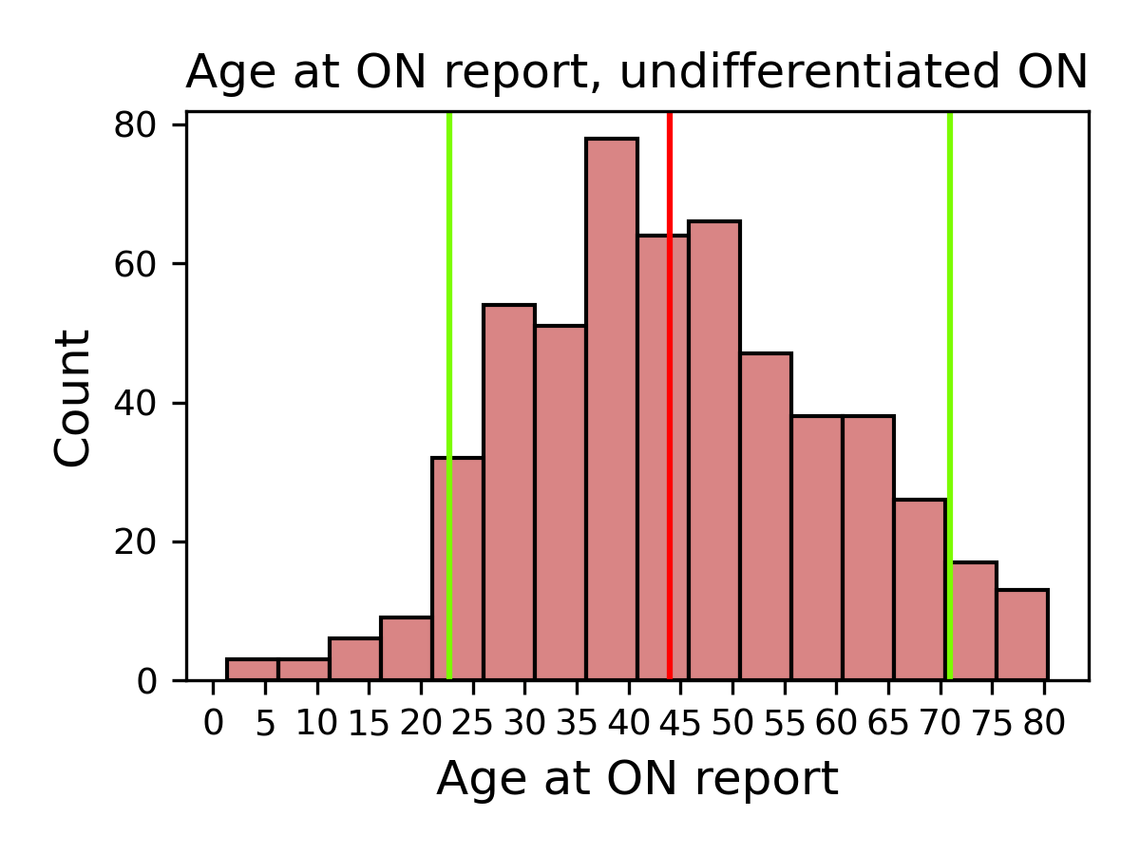
eFig. 4. Histogram plot summarising age at ON diagnoses in undifferentiated ON (n=545). The vertical red line shows the mean, green lines show the 5th and the 95th percentiles.

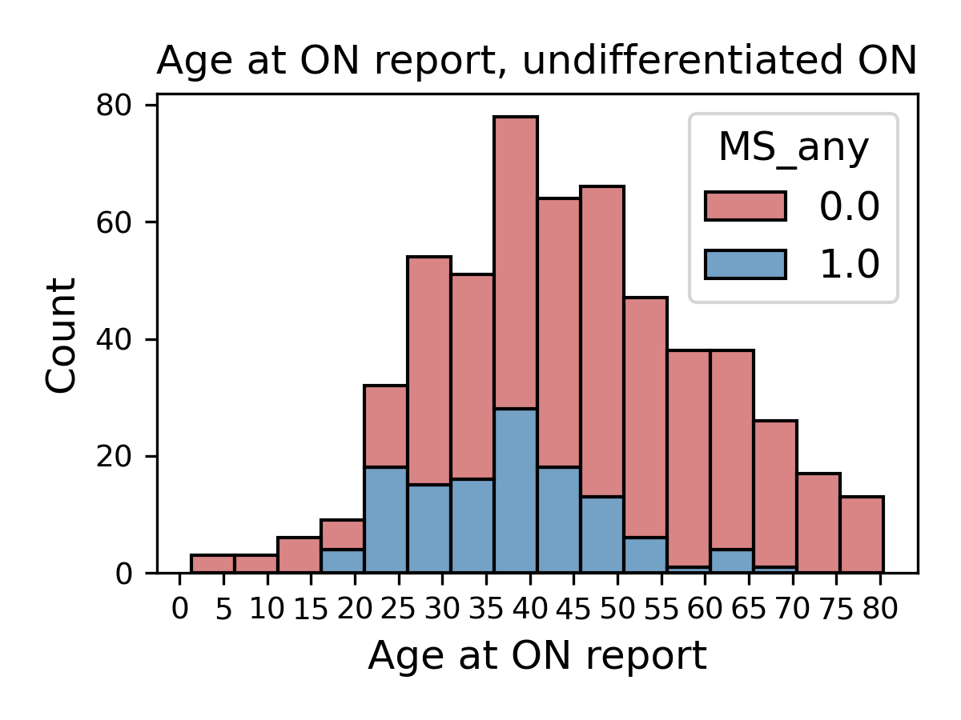
eFig. 5 showing a stacked histogram summarising age at ON diagnosis in undifferentiated ON cases that progressed to MS (blue, n=124) versus those that did not (red, n=421). Red and blue bars are stacked on top of each other.

2.1.5 Causes of death in MS & ON
Causes of death are described below for undifferentiated ON & MS-ON at presentation in eTable 7.
eTable 7. Summarises causes of death for participants with undifferentiated ON (n=16) and MS-ON at presentation (n=6)
Group |  | Primary Cause of Death | Underlying cause of death | Underlying cause of death
Undifferentiated ON at presentation | ON only | I251 Atherosclerosis Heart | I259 Chronic ischaemic heart disease
Undifferentiated ON at presentation | ON only | E142 Diabetic Nephropathy | N185 stage 5 CKD | E149 Diabetes mellitus, unspec.
Undifferentiated ON at presentation | ON only | K709 Alcoholic liver disease | K729 Hepatic coma
Undifferentiated ON at presentation | ON only | I679 Cerebrovascular disease, unspec. | R688 Abiotrophy | A419 Sepsis, unspec.
Undifferentiated ON at presentation | ON only | C541 Endometrial cancer
Undifferentiated ON at presentation | ON only | C439 Malignant melanoma
Undifferentiated ON at presentation | ON only | C259 Pancreatic cancer | D70 Hyperleukocytosis | A419 Sepsis, unspec
Undifferentiated ON at presentation | ON only | C160 Gastric cancer (cardia) | J189 Pneumonitis (Acute primary)
Undifferentiated ON at presentation | ON only | X815 Intentional self-half/ suicide | T07 Unspec multiple injuries
Undifferentiated ON at presentation | ON only | I609 Subarachnoid haemorrhage | G919 Macrohydrochephalus | I615 Bulbar haemorrhage
Undifferentiated ON at presentation | ON only | F019 Vascular dementia | E119 Non-insulin-dependent DM
Undifferentiated ON at presentation | ON only | C80 Mesonephroma | D473 Essential thrombocytosis
Undifferentiated ON at presentation | ON only | C159 Oesophageal cancer
Undifferentiated ON at presentation | Progressed to MS-ON | G35 Multiple sclerosis | J189 Pneumonitis (Acute primary)
Undifferentiated ON at presentation | Progressed to MS-ON | G35 Multiple sclerosis
Undifferentiated ON at presentation | Progressed to MS-ON | G35 Multiple sclerosis | J180 Bronchopneumonia
MS-ON at presentation |  | C64 Hypernephroma | G35 Multiple sclerosis
 |  | C349 Mal neoplasm of bronchus/lung, unspec | K315 Duodenal obstruction | K318 Apepsia
 |  | J449 COPD, unspec | G35 Multiple sclerosis
 |  | A047 C. difficile enterocolitis | A419 sepsis, unspec | I10 Essential hypertension
 |  | G35 Multiple sclerosis | J180 Bronchopneumonia
 |  | J440 COPD with acute LRTI | J22 Acute lower resp. infection, unspec | J449 COPD, unspec

2.2. First MS vs first ON in MS-ON

MS-GRS was not statistically different in people with MS in whom MS was reported before ON (MS first, n=122) when compared with those who ON progressed to MS (ON first, n=124). eFig. 6.
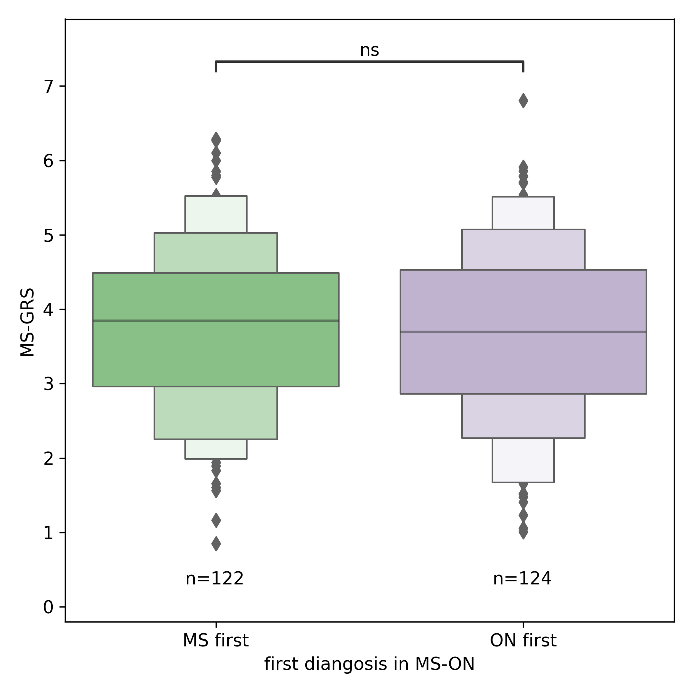
eFig. 6 a boxen plot showing the distribution of MS-GRS in people with MS-ON in whom MS was diagnosed first vs ON diagnosed first. Welch’s t-test P = 0.56
2.3 MS-GRS and other variables

2.3.1 There was a weak (adjusted R² = 0.0108) yet significant (P < 0.0001) association between MS-GRS and Age at MS diagnosis, as shown in eFig. 7
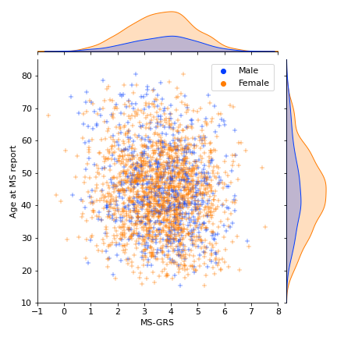
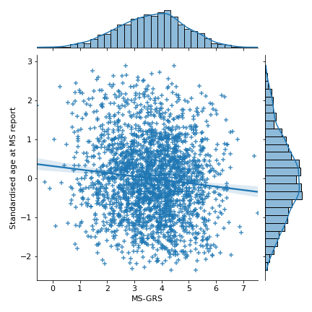
eFig. 7 A. Scatterplot and regression showing a weak association between MS-GRS and age at MS diagnosis. B. Scatterplot showing the MS-GRS vs age at MS report in males and females
2.3.2 Sex

There were no significant differences between the HLA-GRS in females and males in either group (controls, MS only, ON only, MS-ON), eFig. 8A. non-HLA GRS was generally insignificantly different between cases and controls (P = 0.067, Unequal variance Welch’s t-test), and significantly higher in men with MS only when compared to women with MS, P < 0.05, (eFig. 8 B).

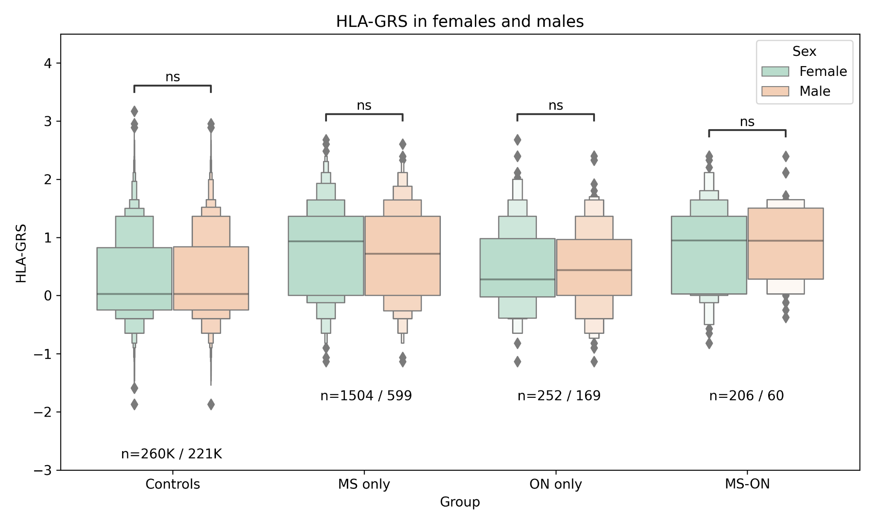

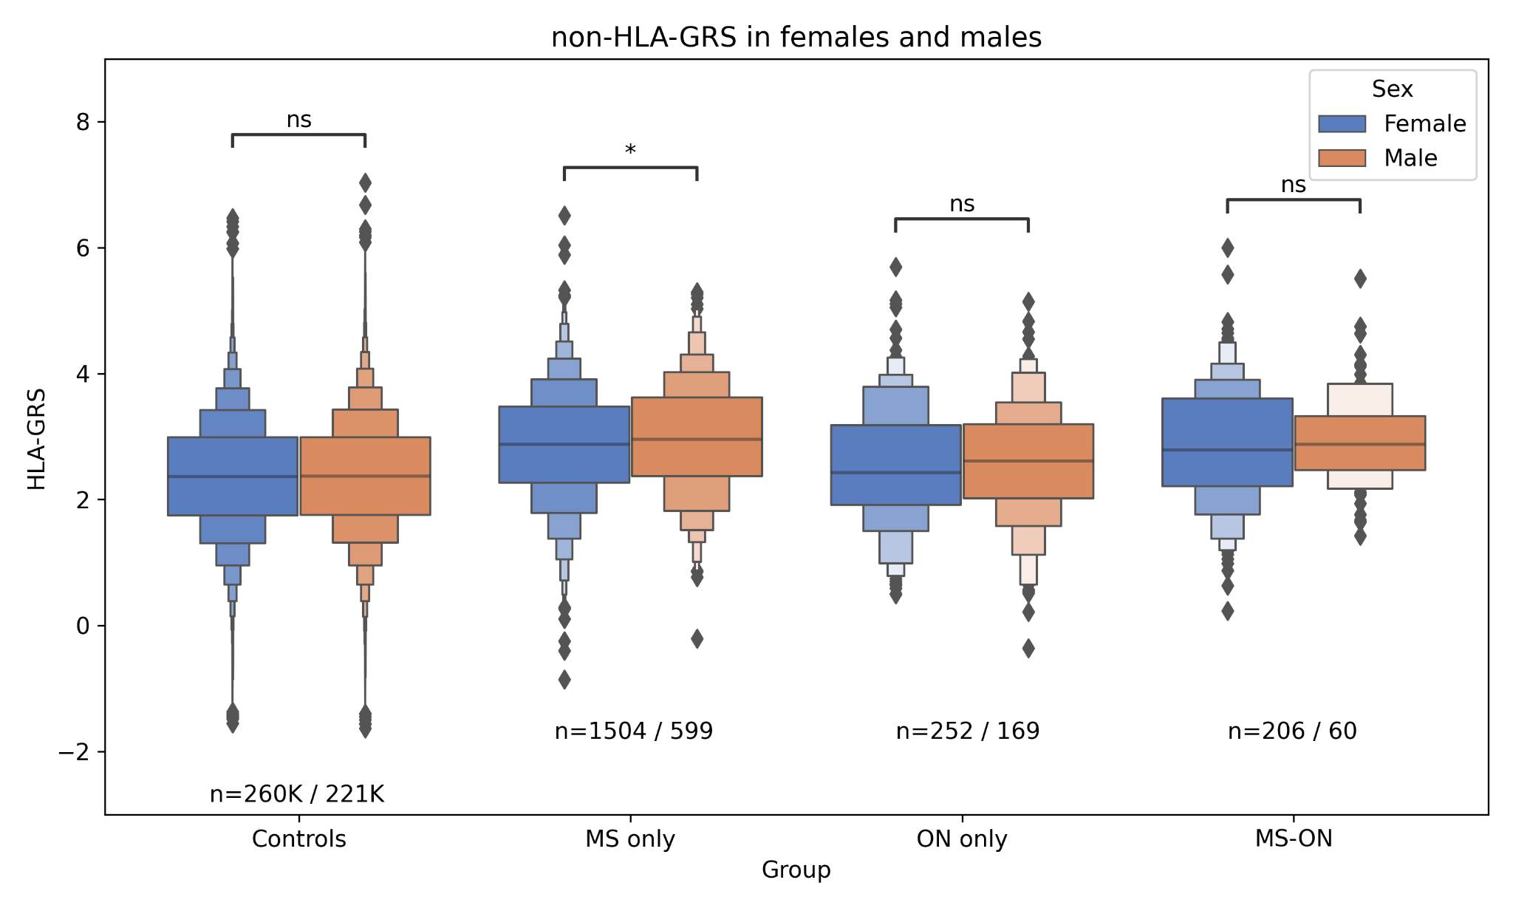
eFig. 8 A. HLA-GRS distribution in Females and Males in four groups. B. non-HLA-GRS distribution in four groups. Welch’s unequal variance t-test P value annotation: ns: P > 0.05; *: 0.01 < P < 0.05

2.3.3 Ethnicity

We used the UKBB definition of ethnicity (Data-Field 22006) to visualise the difference of MS-GRS between ethnicities, although non-European populations are underrepresented in the UKBB. In most non-European populations, the number of MS cases was too low to allow meaningful statistical comparison (eFig. 9A).

For the European ancestry British population used in sub-group analysis (see Supplement B), we visualised MS-GRS in MS cases and controls stratified by binary ethnicity (eFig. 9B). MS-GRS did not differ significantly between MS cases irrespective of ethnicity (eFig. 9B). European ancestry British controls had a slightly lower MS-GRS than European ancestry British controls (mean MS-GRS (SD), independent samples Welch’s t-test with Bonferroni correction P value: 2.63 (1.16) vs 2.80 (1.14), P < 0.0001 for European ancestry British and the rest of UKBB, respectively), although the effect was small.

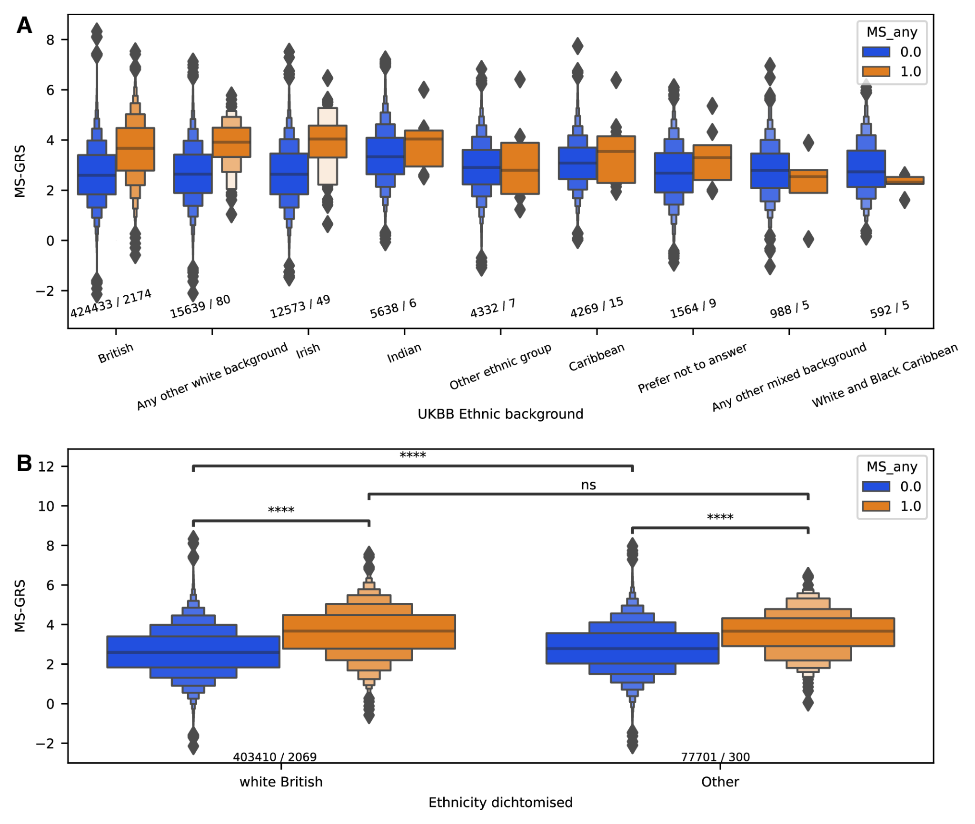

eFig. 9 illustrates the MS-GRS difference between ethnicities. A uses ethnic groups defined by the UKBB. Numbers of MS cases and controls are shown under each pair of box plots. B shows MS-GRS by binary ethnicity and statistical significance of independent sample Welch’s t-test with Bonferroni correction: ns P > 0.05; ****: P < 0.0001

2.4 Unadjusted Kaplan Meier of MS-free survival

We stratified the undifferentiated ON population (ON without baseline MS and did not die before the end of the follow-up) by quartiles of MS-GRS and plotted an empirical Kaplan-Meier MS-free survival plot (eFig. 10)
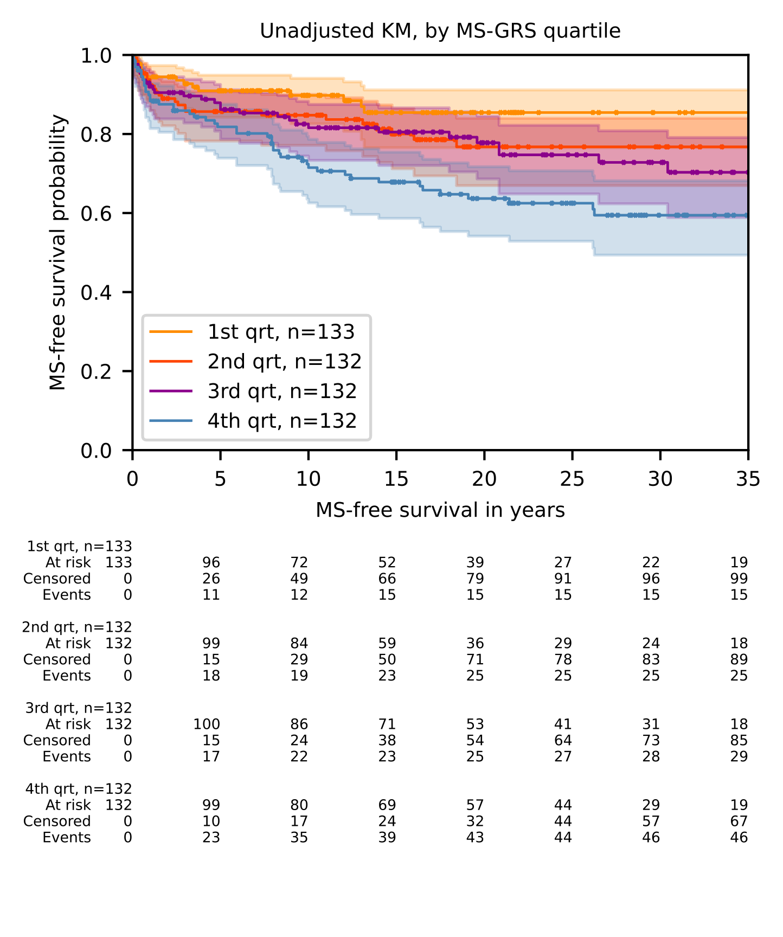
eFig. 10. Unadjusted Kaplan Meier Plot Stratified by quartiles of MS-GRS showing MS-free survival for quartiles of MS-GRS

2.5 Cox survival regression models

For the Cox survival regression models, we performed backward selection based on the partial Akaike Information Criterion (AIC). We then manually expected P values of included covariates for statistical significance. For the initial set of covariates, we used
variables reaching statistical significance (P < 0.05) in single variable analysis, biologically plausible covariates, and genetic principal components.

In the main MS-free survival model in undifferentiated ON, we used binary age at ON diagnosis and sex as covariates. However, adjusting for some other variables improved the model further, increasing the significance of MS-GRS in the model, and reducing the P value of a partial log-likelihood test comparing the resulting model to a null one (same covariates minus MS-GRS). We decided against including them in the main analysis, as the aim of our main findings was to propose a model that would be straightforward to replicate in a different dataset.

2.5.1 Age at UKBB entry

Age at UKBB enrolment was significant in the model (P value < 0.005, HR (95% CI) 0.95 (0.92-0.97)), with younger entrants of UKBB being more likely to be diagnosed with MS-ON rather than ON (eTable 9). Adjusting for age at UKBB entry increased the significance of MS-GRS in the model and resulted in better overall prediction of future MS (HR (95% CI)1.37 (1.14-1.65), P = 0.00094) (eFig. 11). Importantly, P value of a partial log-likelihood test comparing the full model (MS-GRS, age at UKBB entry, sex, and binary age at ON diagnosis) to a null model (covariates without MS-GRS) decreased. When we removed all incident (after UKBB enrolment) ON cases (n=104 /529), this association remained unchained, retaining the P value and the HR of age at UKBB entry (P < 0.005, HR 0.95 (0.93-0.98))

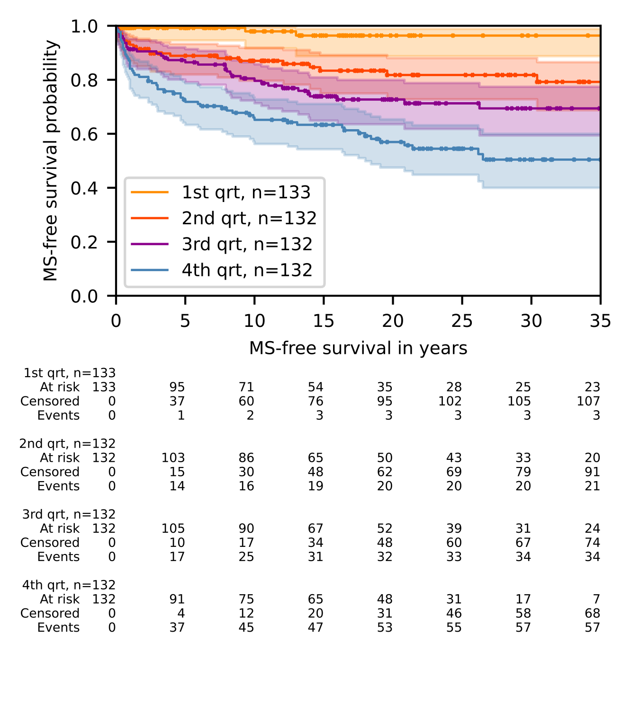

eFigure 11. Kaplan-Meier of undifferentiated ON MS-free survival plotted by quartile of MS risk. Quartiles were defined by quartiles of predicted partial hazard of MS by the Cox model. Time to event is from diagnosis of ON to the diagnosis of MS, or end of follow-up in censored cases.

References

1. The UK Biobank. Health Outcomes Overview. vol. 58 275–277 (2019).
2. Patsopoulos, N. A. et al. Multiple sclerosis genomic map implicates peripheral immune cells and microglia in susceptibility. Science (80-. ). 365, (2019).
3. Bycroft, C. et al. The UK Biobank resource with deep phenotyping and genomic data. Nature 562, (2018).
4. Moutsianas, L. et al. Class II HLA interactions modulate genetic risk for multiple sclerosis. Nat. Genet. 47, 1107–1113 (2015).

