Supplementary data

Materials and methods

Cells
Human aortic smooth muscle cells (HAoSMCs) were purchased from Cambrex Corporation (East Rutherford, NJ). They were grown in Dulbecco's modified Eagle's medium-high glucose (DMEM) supplemented with 15% fetal bovine serum (FBS), 50 units/ml penicillin and 50 μg/ml streptomycin in a humidified atmosphere of 5% CO₂. Jurkat T cells, clone E6-1, were purchased from ATCC and maintained as recommended.

Reverse-transcriptase (RT) - polymerase chain reaction (PCR)
Total RNA isolated using TRIzolTM was reverse-transcribed to complementary DNA (cDNA) for 1 h at 42 °C using Moloney murine leukemia virus reverse transcriptase and oligo d(T)₁₅ primer (Promega Corporation, Madison, WI, USA), followed by non-quantitative RT-PCR. Target gene transcripts were amplified using Hot Start Taq Polymerase (Promega Corporation). The cDNA was denatured at 90 °C for 5 min, followed by 25 cycles of 95 °C for 30 s, 55 °C for 30 s, and 72 °C for 30 s using the appropriate forward and reverse primers. Glyceraldehyde-3-phosphate dehydrogenase (GAPDH) was the internal control. Primers for non-quantitative PCR were GAPDH, 5’-gagtcaacggatttggtcct-3’ (forward) and 5’-tgtggtcatgagtccttcca-3’ (reverse) and CD14, 5’-aggcctcaaggtactgagca-3’ (forward) and 5’-ctgttgcagctgagatcgag-3’ (reverse).

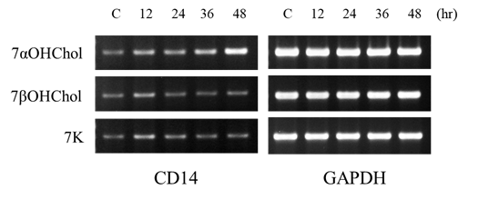

supplementary Fig. 1. Time course expression of CD14 mRNA in THP-1 cells after treatment with the indicated 7-oxysterols.
THP-1 cells were serum-starved for 24 h in RPMI 1640 containing 0.1% endotoxin-free BSA, and then incubated with or without 7αOHChol, 7βOHChol or 7K (5 μg/mL each) for the indicated time periods. CD14 transcripts were amplified by RT-PCR. PCR products were separated on 2% agarose gels and stained with ethidium bromide. BSA: bovine serum albumin; 7αOHChol: 7α-hydroxycholesterol; 7βOHChol: 7β-hydroxycholesterol; 7K: 7-ketocholesterol; GAPDH: glyceraldehyde-3-phosphate dehydrogenase

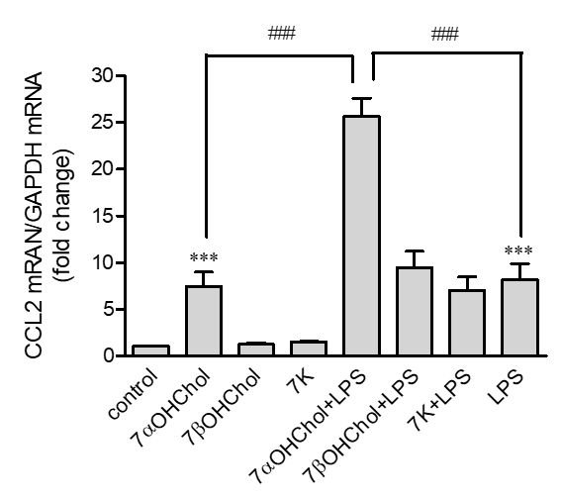

supplementary Fig. 2. CCL2 expression in the THP-1 cells stimulated with LPS in presence of 7-oxysterols.
Serum-starved THP-1 cells were incubated for 24 h with the indicated 7-oxysterols (5 μg/mL each), and then stimulated for 9 h with or without LPS (100 ng/mL) from Escherichia coli K12. CCL2 transcript levels were assessed by real-time PCR. Data are expressed as mean ± SD (n = 3 replicates/ group). ***P < 0.001 vs. control; ### P < 0.001 vs. 7αOHChol or LPS. 7αOHChol: 7α-hydroxycholesterol; 7βOHChol: 7β-hydroxycholesterol; 7K: 7-ketocholesterol; LPS: lipopolysaccharide; SD: standard deviation

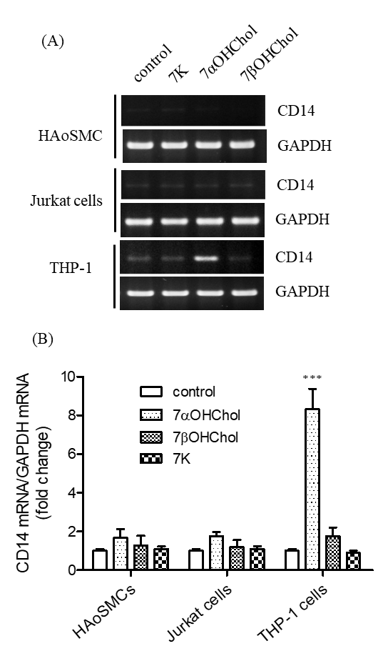
supplementary Fig. 3. The effects of 7-oxysterols on the CD14 expression in vascular cells in the atherosclerotic lesions.
human aortic smooth muscle cells (HAoSMCs), Jurkat T cells, and THP-1 monocytes/macrophages were serum-starved for 24 h in RPMI 1640 containing 0.1% endotoxin-free BSA, and then incubated for 48 h with or without 7αOHChol, 7βOHChol or 7K (5 μg/mL each).
(A) CD14 mRNA was amplified by RT-PCR. PCR products were separated on 2% agarose gels and stained with ethidium bromide.
(B) CD14 transcript levels were assessed by RT-PCR. Y-axis values represent fold increases in CD14 mRNA levels normalized to those of control cell types incubated without an oxygenate cholesterol molecule. Data are expressed as mean ± SD (n = 3 replicates/group). ***P < 0.001 vs. control. BSA: bovine serum albumin; 7αOHChol: 7α-hydroxycholesterol; 7βOHChol: 7β-hydroxycholesterol; 7K: 7-ketocholesterol; GAPDH: glyceraldehyde-3-phosphate dehydrogenase

