Bee species perform distinct foraging behaviors that are best described by different movement models

Johanne Brunet¹, Qi Jiang^{2$}, Yang Zhao²⁺, Margaret W. Thairu^{3#} and Murray K. Clayton²

¹ Vegetable Crops Research Unit, United States Department of Agriculture-Agricultural Research Service, Madison, WI 53706, United States
² Department of Statistics, University of Wisconsin, Madison, WI 53706, USA
³ Department of Entomology, University of Wisconsin, Madison, WI 53706, USA
$ Current address: Goldman Sachs, 200 West Street, New York, NY 10282
⁺ Current address: Gilead Sciences, 333 Lakeside Dr, Foster City, CA 94402
# Current address: Department of Bacteriology, University of Wisconsin, Madison, WI.

Corresponding author: Johanne Brunet Johanne.Brunet@usda.gov

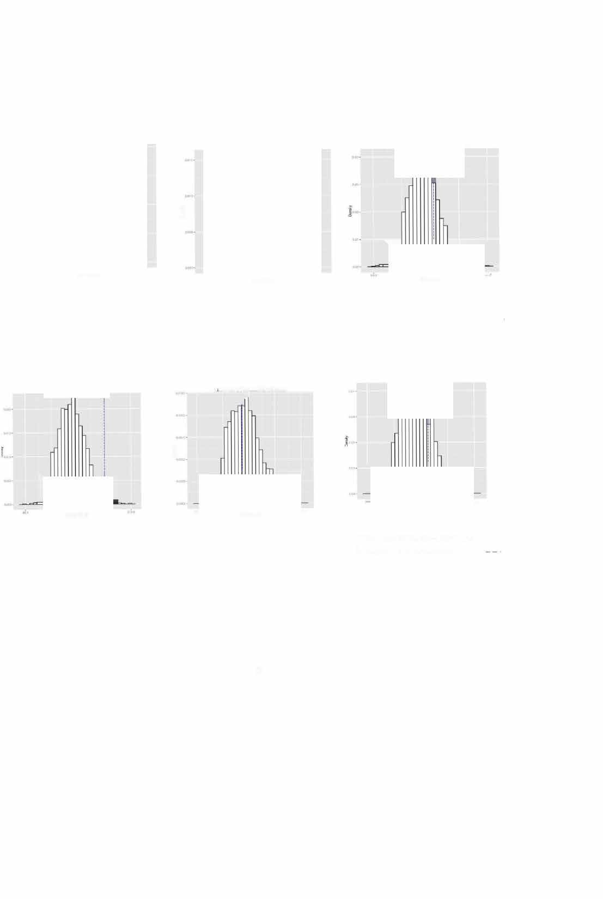
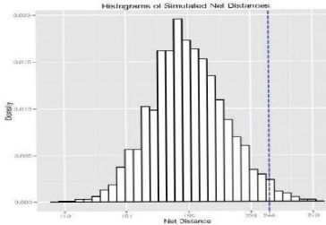
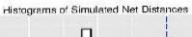
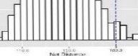
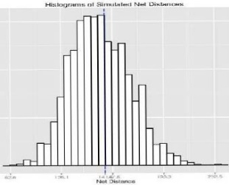
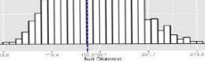
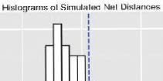
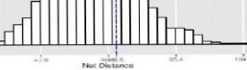
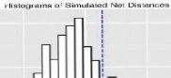
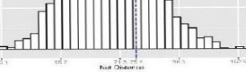
Supplementary Fig. S1. The frequency distribution of simulated mean net distances traveled under the Random Distance-Random Direction Model for each bee species each year. The vertical dash line represents the empirical value. The top graphs are for Year 1 for each bee species and the bottom graphs are for Year 2.

Supplementary Fig. S2. Representative foraging bouts for each of the three bee species.

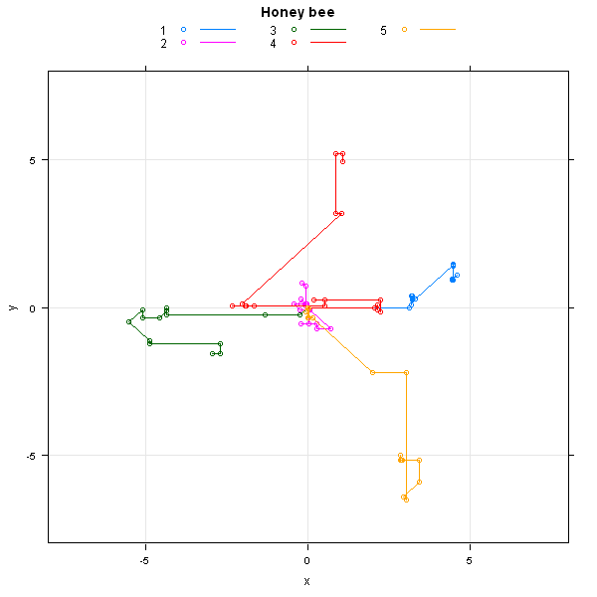
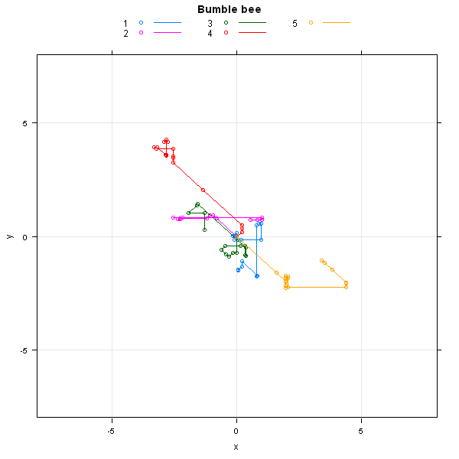
- Bumble bees B) Honey bees

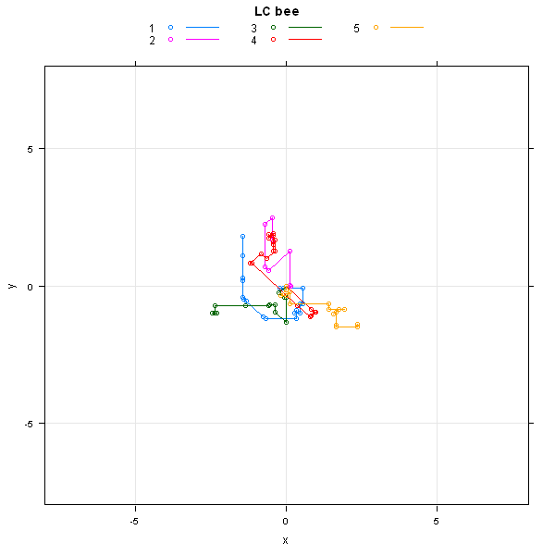
- Leafcutting bees

Bee | Flower | Patch | Foraging bout | AR (1) | Clip | AIC
 | X** |  | X** | X* |  | 3108.9
 | X** | X | X** | X* |  | 3108.9
X | X** |  | X** | X* |  | 3111.2
X | X** | X | X** | X* |  | 3111.2
 | X** | X | X** |  | X | 3111.4
 | X** | X | X** |  |  | 3111.4
 | X** |  | X** |  |  | 3111.4
 | X** |  | X** |  | X | 3111.4
X | X** | X | X** |  | X | 3113.5
X | X** | X | X** |  |  | 3113.5
X | X** |  | X** |  |  | 3113.5
X | X** |  | X** |  | X | 3113.5
 | X** | X |  | X** |  | 3128.9
 | X** |  |  | X** |  | 3128.9
X | X** | X |  | X** |  | 3132.3
X | X** |  |  | X** |  | 3132.3
 | X** | X |  |  |  | 3157.8
 | X** | X |  |  | X | 3157.8
 | X** |  |  |  | X | 3157.8
X | X** | X |  |  |  | 3161
X | X** | X |  |  | X | 3161
 | X** |  |  |  | X | 3161
Supplementary Table S1 Distance models over all bee species for year 1, with AIC values. An X indicates that the variable is included in the model. The variables patch and foraging bout are random variables. The variable clip is added either as a random variable, where in combination with random foraging bout, it creates a model that is sometimes called the “compound symmetry” model or as an AR(1) repeated measure structure, described in the text. Significant variables are followed by an asterisk with *: 0.1 ≤ p <0.05; **: 0.001 ≤ p < 0.01.
Supplementary Table S2. Distance models over all bee species for year 2, with AIC values. An X indicates that the variable is included in the model. The variables patch and foraging bout are random variables. The variable clip is added either as a random variable, where in combination with random foraging bout, it creates a model that is sometimes called the “compound symmetry” model or as an AR(1) repeated measure structure, described in the text. Significant variables are followed by an asterisk with *: 0.1 ≤ p <0.05; **: 0.001 ≤ p < 0.01.
Bee | Flower | Patch | Foraging bout | AR (1) | Clip | AIC
X** | X** |  | X* | X* |  | 3561.3
X** | X** | X | X* | X* |  | 3561.3
X** | X** | X | X** |  | X | 3565.7
X** | X** | X | X** |  |  | 3565.7
X** | X** |  | X** |  |  | 3565.7
X** | X** |  | X** |  | X | 3565.7
X** | X** | X |  | X** |  | 3566.9
X** | X** |  |  | X** |  | 3566.9
 | X** | X | X* | X** |  | 3569.6
 | X** | X | X* | X** |  | 3571.6
 | X** | X |  | X** |  | 3574.7
 | X** |  | X** |  |  | 3574.7
 | X** |  |  | X** |  | 3574.7
 | X** |  | X** |  | X | 3574.7
 | X** | X | X** |  | X | 3576.6
 | X** | X | X** |  |  | 3576.6
X** | X** | X |  |  |  | 3580.3
X** | X** | X |  |  | X | 3580.3
X** | X** |  |  |  | X | 3580.3
 | X** | X |  |  |  | 3591.3
 | X** | X |  |  | X | 3591.3
 | X** |  |  |  | X | 3591.3

Supplementary Table S3. Distance models for each bee species for year 1, with AIC values. An X indicates that the variable is included in the model. The variables patch and foraging bout are random variables. The variable clip is added either as a random variable, where in combination with random foraging bout, it creates a model that is sometimes called the “compound symmetry” model or as an AR(1) repeated measure structure, described in the text. Significant variables are followed by an asterisk with *: 0.1 ≤ p <0.05; **: 0.001 ≤ p < 0.01.
Flower | Patch | Foraging bout | AR (1) | Clip | AIC
Bumble bee
X** |  | X** | X* |  | 2252.1
X** | X | X** | X* |  | 2252.1
X** | X | X** |  |  | 2255.3
X** | X | X** |  | X | 2255.3
X** | X |  | X** |  | 2282.4
X** | X |  |  |  | 2323.2
X** | X |  |  | X | 2323.2
X** |  | X** |  | X | 2363.6
X** |  | X** |  |  | 2363.6
X** |  |  | X** |  | 2395.3
X** |  |  |  | X | 2435.8
Honey bee
X** | X |  |  |  | 689.8
X** | X |  |  | X | 689.8
X** | X | X | X |  | 691
X** | X | X |  | X | 691
X** |  |  |  | X | 691.5
X** | X | X |  | X | 691.7
X** | X | X |  |  | 691.7
X** |  |  |  | X | 691.9
X** |  | X |  | X | 692.9
X** |  | X |  |  | 692.9
X** |  | X | X |  | 693.9
Leafcutting bee
X |  |  |  | X | 265.5
X | X |  |  | X | 265.5
X | X |  |  |  | 265.5
X | X | X |  |  | 267.4
X |  | X |  |  | 267.4
X | X | X |  | X | 267.4
X |  | X |  | X | 267.4
X |  |  | X |  | 267.5
X | X |  | X |  | 267.5
X |  | X | X |  | 269.4
X | X | X | X |  | 269.4

Supplementary Table S4. Distance models for each bee species for year 2, with AIC and BIC values. An X indicates that the variable is included in the model. The variables patch and foraging bout are random variables. The variable clip is added either as a random variable, where in combination with random foraging bout, it creates a model that is sometimes called the “compound symmetry” model or as an AR(1) repeated measure structure, described in the text. Significant variables are followed by an asterisk with *: 0.1 ≤ p <0.05; **: 0.001 ≤ p < 0.01.
Flower | Patch | Foraging bout | AR (1) | Clip | AIC
Bumble bee
X** |  | X* |  |  | 2014.6
X** | X | X* |  |  | 2014.6
X** |  | X* | X |  | 2015.7
X** | X | X* | X |  | 2015.7
X** | X | X* |  | X | 2015.8
X** |  | X* |  | X | 2015.8
X** | X |  | X** |  | 2021.4
X** |  |  | X** |  | 2021.4
X** | X |  |  |  | 2026.2
X** | X |  |  | X | 2027.5
X** |  |  |  | X | 2027.5
Honey bee
X* |  |  | X* |  | 1028.2
X* |  | X | X* |  | 1028.2
X* | X | X | X* |  | 1028.2
X* | X |  | X** |  | 1030
X* | X | X |  | X | 1032.5
X* | X | X |  |  | 1032.5
X* |  | X |  |  | 1032.5
X* |  | X |  | X | 1032.5
X* |  |  |  | X | 1035.8
X* | X |  |  |  | 1036.8
X* | X |  |  | X | 1036.8
Leafcutting bee
X | X | X |  | X | 519.9
X | X |  |  | X | 519.9
X | X |  |  |  | 519.9
X |  |  |  | X | 519.9
X | X | X |  |  | 519.9
X |  | X |  |  | 519.9
X |  | X |  | X | 519.9
X | X |  | X |  | 521.4
X | X | X | X |  | 521.4
X |  | X | X |  | 521.4
X |  |  | X |  | 521.4

Supplementary Table S5. Testing the four models of bee movement for bumble bees and honeybees when the sample size for bumble bees is the same as for honey bees. The one tailed probability values (p) are presented for the randomization tests. A low probability value indicates that the model is not a good fit to the data. For Random Distance or Random Direction, a distance or direction was randomly selected from the empirical distribution of distances or directions. Modeled Distance used the best model to describe distance and Modeled Direction used the transition vector (see Table 1 and text for details). The different seeds represent different starting points and test the robustness of the different models.
 |  | Year 1 |  | Year 2
Model | Seed | Bumble  bee | Honey  bee | Bumble  bee | Honey  bee
RDistance RDirection | 1 | 0.116 | 0.440 | 0.120 | 0.446
RDistance RDirection | 2 | 0.106 | 0.432 | 0.102 | 0.460
RDistance RDirection | 3 | 0.09 | 0.434 | 0.138 | 0.442
RDistance RDirection | 4 | 0.094 | 0.420 | 0.110 | 0.492
RDistance RDirection | 5 | 0.084 | 0.428 | 0.130 | 0.500
RDistance MDirection | 1 | 0.266 | 0.468 | 0.176 | 0.470
RDistance MDirection | 2 | 0.312 | 0.416 | 0.204 | 0.484
RDistance MDirection | 3 | 0.262 | 0.462 | 0.240 | 0.474
RDistance MDirection | 4 | 0.282 | 0.452 | 0.220 | 0.452
RDistance MDirection | 5 | 0.224 | 0.438 | 0.222 | 0.426
MDistance RDirection | 1 | 0.424 | 0.378 | 0.494 | 0.352
MDistance RDirection | 2 | 0.440 | 0.380 | 0.482 | 0.374
MDistance RDirection | 3 | 0.428 | 0.382 | 0.496 | 0.344
MDistance RDirection | 4 | 0.478 | 0.328 | 0.466 | 0.370
MDistance RDirection | 5 | 0.434 | 0.370 | 0.492 | 0.388
MDistance  M Direction | 1 | 0.430 | 0.368 | 0.382 | 0.276
MDistance  M Direction | 2 | 0.360 | 0.382 | 0.400 | 0.314
MDistance  M Direction | 3 | 0.396 | 0.356 | 0.360 | 0.282
MDistance  M Direction | 4 | 0.378 | 0.330 | 0.428 | 0.288
MDistance  M Direction | 5 | 0.394 | 0.368 | 0.400 | 0.314

