Supplementary Information

Monolayer molecular diode
Yating Li,¹ Jiacheng Xie,¹ Li Sun,¹ Junpeng Zeng,¹ Liqi Zhou,² Ziqian Hao,¹ Lijia Pan,¹ Jiandong Ye,¹ Peng Wang,² Yi Shi,^{1,}* Jian-Bin Xu,³ Yun Li, ^{1,}* Xinran Wang^{1,4,5} and Daowei He,^{1,}*
Supplementary note 1: Growth of few-layer organic single crystal on metal substrate
During the solution-shearing process, the droplet of C₆-DNTT saturated solution was dragged by shearing blade across a heated metal film substrate while keeping the bulk of solution into the blade-substrate gap and spreading out at front exposed region (Supplementary Fig. 1). The high surface energy (Supplementary Fig. 3) and high surface smoothness (Supplementary Fig. 4) facilitate the solution to uniformly coat onto the metal surface and then gradually form supersaturated zone for crystalizing large-area crystalline film along with solvent evaporation. For a certain concentration solution, we adjusted the shearing speed and process temperature to enable the C₆-DNTT crystalline film controllable growth.
Below we focus our discussion on Ti substrate, while similar observations are also made on HfO₂ and Pt and Au (Supplementary Fig. 2 and 5). Supplementary Fig. 1b-i show the optical microscope images illustrating the layers and morphology of C₆-DNTT solution-shearing film as a function of shearing speed and process temperature. For Condition I, the incontinuous monolayer (1L) crystalline films, usually with oriented triangle domains or vacuums paralleling to the shearing direction, are observed (Supplementary Fig. 1b and d). Shearing at Condition II leads to the formation of large-area uniform monolayer crystalline films (Supplementary Fig. 1e and g). This trend continues up to Condition III that the small part of second layer (2L) is observed on uniform 1L (Supplementary Fig. 1c and h). Further optimizing the shearing condition, the one-piece of 2L and third layer (3L) crystalline films are achieved at Condition IV (Supplementary Fig. 1f) and V (Supplementary Fig. 1i), respectively.

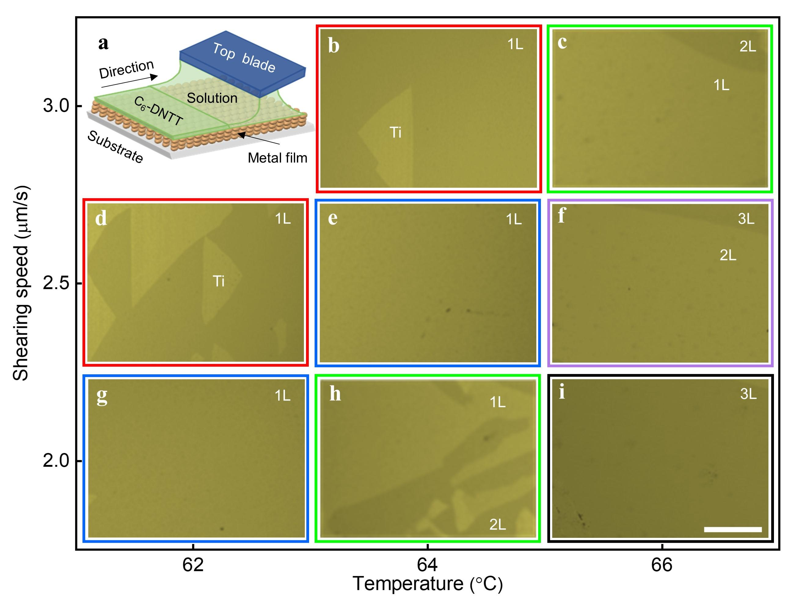
Supplementary Figure 1. (a) Schematic diagram of large-area crystalline film growth method. (b-i) Photograph of first three C₆-DNTT crystalline films under different growth conditions. Red, blue, green, purple and black represent Condition I, II, III, IV and V for solution-sheared crystalline film growth, respectively. The shearing direction is from left to right in b - i. Scale bars are all 100 $μm$.
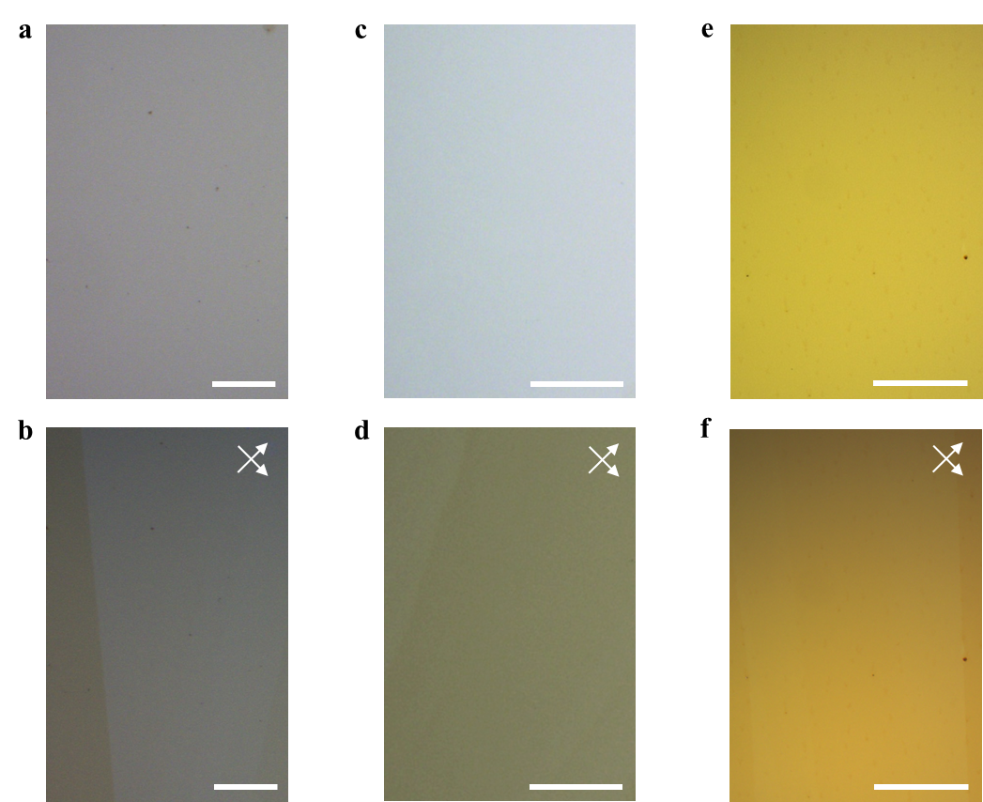
Supplementary Figure 2. Optical microscope images and cross-polarized optical micrograph images of uniform monolayer C₆-DNTT film on HfO₂ (a, b), Pt (c, d) and Au (e, f) substrates, respectively. Scale bars, 200 $μm$.

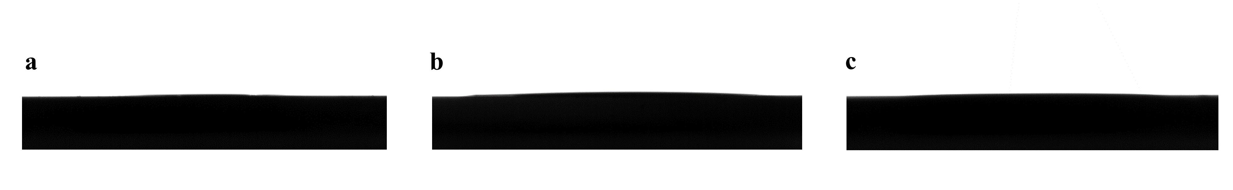
Supplementary Figure 3. Contact angle of 1.9°,3.5° and 2,4° for a droplet of tetralin on Pt (a), Au (b) and Ti (c) substrate, respectively. A low contact angle represents on the possession of high surface energy of the metal film substrate, which can facilitate the C₆-DNTT solution to spread out the metal surface.

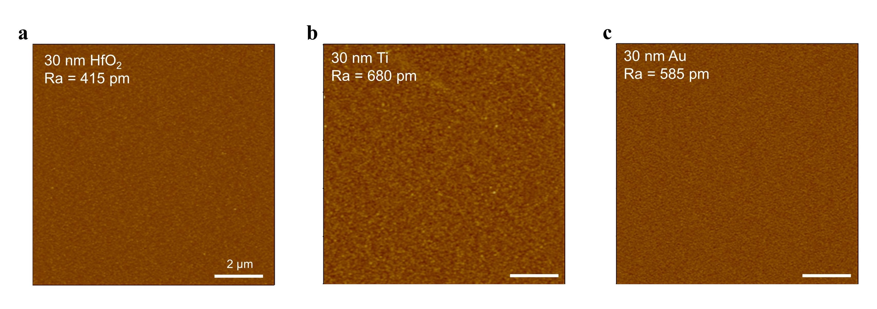
Supplementary Figure 4. Atomic force microscope (AFM) characterization. Surface roughness of HfO₂ (a), Ti (b) and Au (c), respectively.

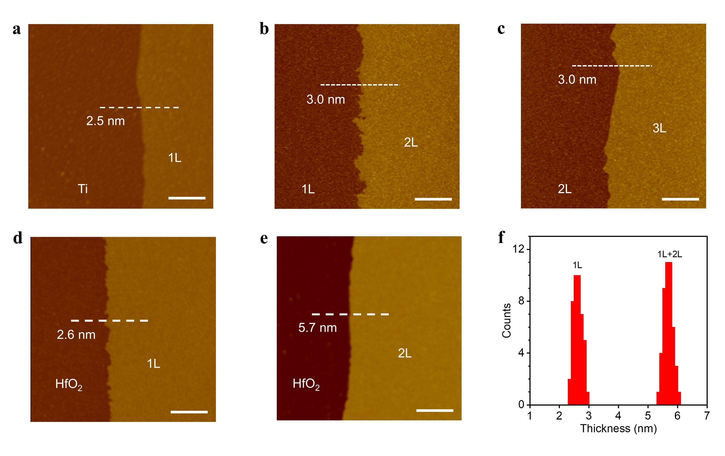
Supplementary Figure 5. Atomic force microscope (AFM) characterization. (a-c) Height of 1L (a), 2L(b) and 3L (c) C₆-DNTT films on Ti, respectively. Height of 1L (d), 2L(e) C₆-DNTT films on HfO₂ substrate, respectively. (f) The height statistics of 1L and 2L C₆-DNTT films on HfO₂ substrate, taken from over 30 samples. Scale bars, $1 μm$.

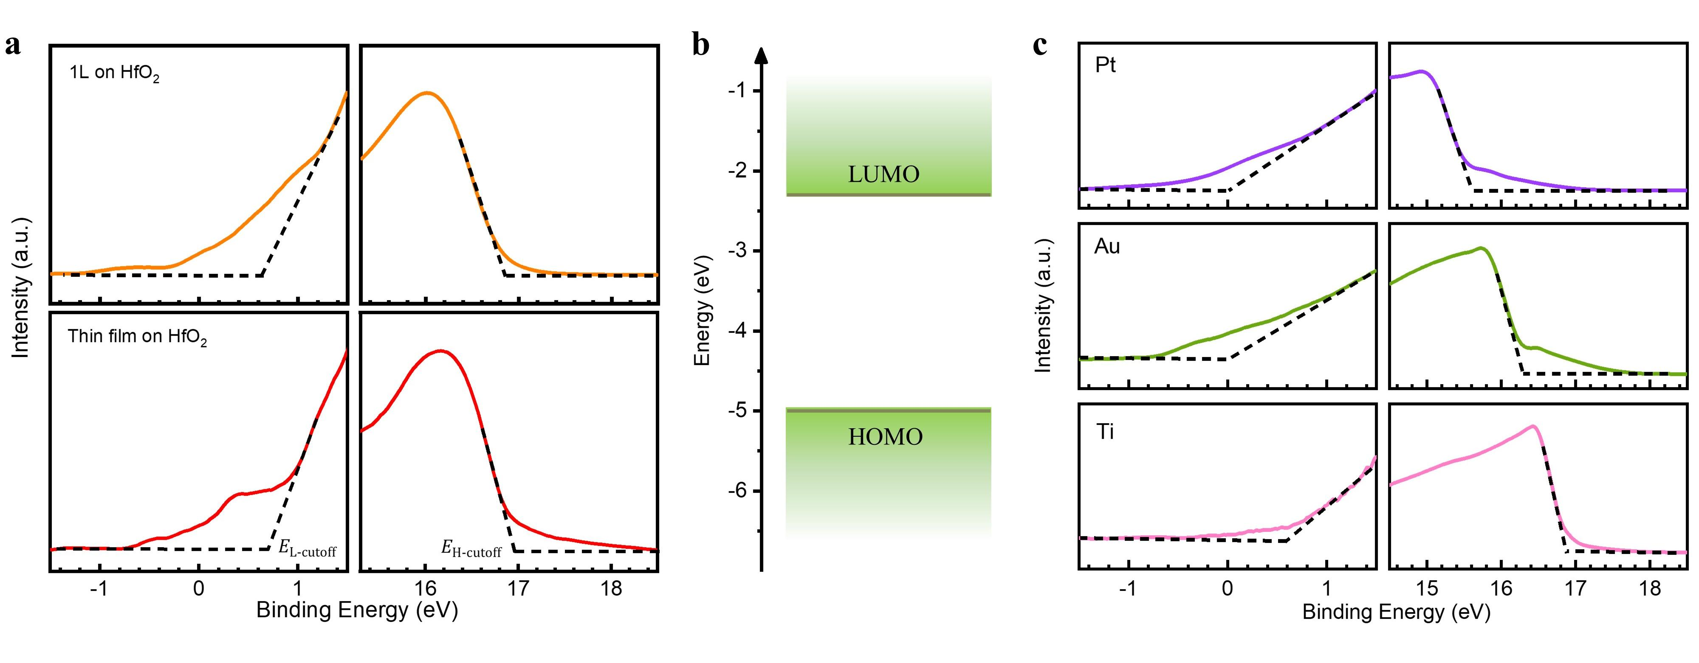
Supplementary Figure 6. (a) UPS spectra of monolayer C₆-DNTT (upper) and thin film (lower) on HfO₂ substrate for HOMO estimation. (b) Energy spectrum of monolayer and thin film C₆-DNTT calculated from UPS, UV-vis. The monolayer and C₆-DNTT solution-sheared thin film have the same LUMO, HOMO and gap which are -2.3 eV, -5.0 eV and 2.7 eV, respectively. (c) UPS spectra of Pt (upper), Au (middle) and Ti (lower) film for Fermi level.

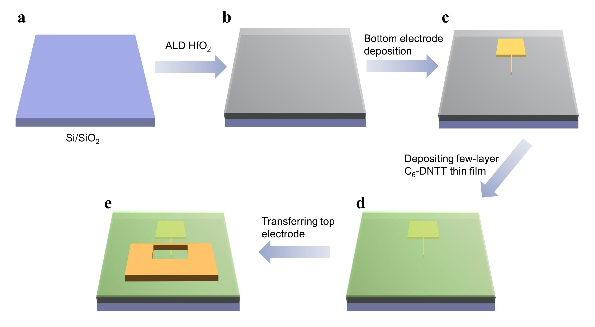
Supplementary Figure 7. The fabrication process of molecular diode. (a) Si substrate with 300 nm SiO₂. (b) deposited 25 nm HfO₂ on Si/SiO₂ substrate by atomic layer deposition (ALD). (c) fabricated bottom electrode by the standard electron-beam lithography and electron-beam evaporation. (d) Solution shearing C₆-DNTT thin film onto the surface of bottom electrode. (e) Transferred top electrode onto C₆-DNTT thin film to fabricate molecular diode.

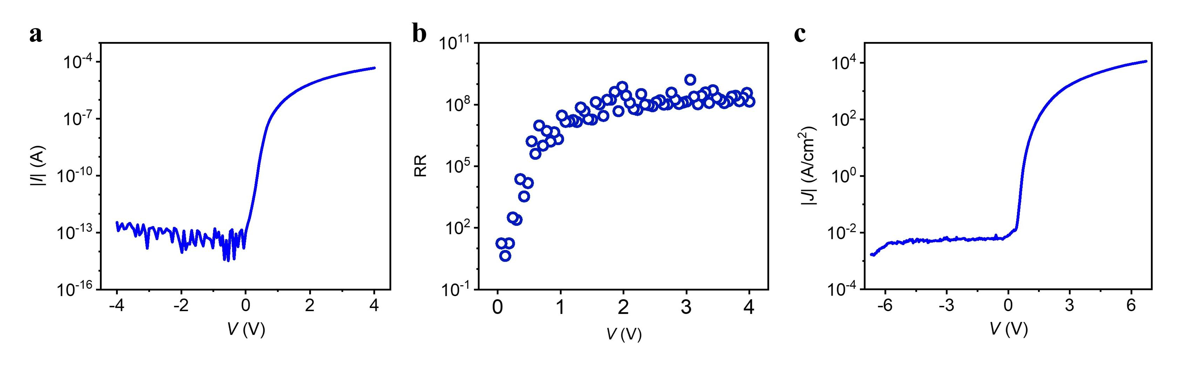
Supplementary Figure 8. Typical semi-log $I\sim V$ characteristics (a) and rectification ratio (b) of Pt / C₆-DNTT / Ti molecular diode at room temperature, respectively. (c) The highest current density (1.1 $×$ 10⁴ $A/{{cm}^{2}}$) for another Pt / C₆-DNTT / Ti molecular diode. The channel scale is $0.2 μm×2 μm$.

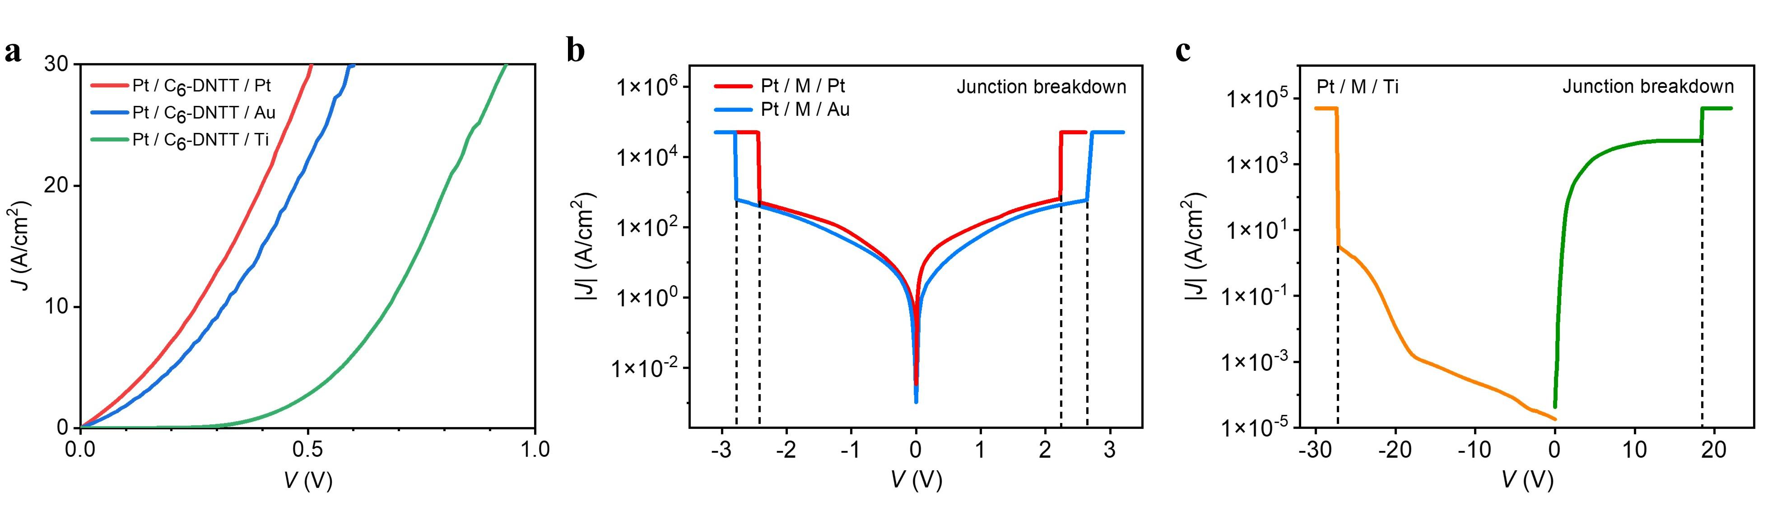
Supplementary Figure 9. (a) Typical $J\sim V$ characteristics of symmetric and non-symmetric molecular diodes with monolayer C₆-DNTT of the same device in Fig 2c. (b) Breakdown voltage characteristics for molecular diodes. The breakdown voltage at forward (reverse) bias is about 2.2 V (-2.4 V) and 2.6 V (-2.8 V) in Pt / C₆-DNTT / Pt, Pt / C₆-DNTT / Au devices, respectively. (c) The representative breakdown voltage of Pt / C₆-DNTT / Ti device is about 18.4 V (-27.4 V) at forward (reverse) bias. The breakdown voltages were measured from two different devices.

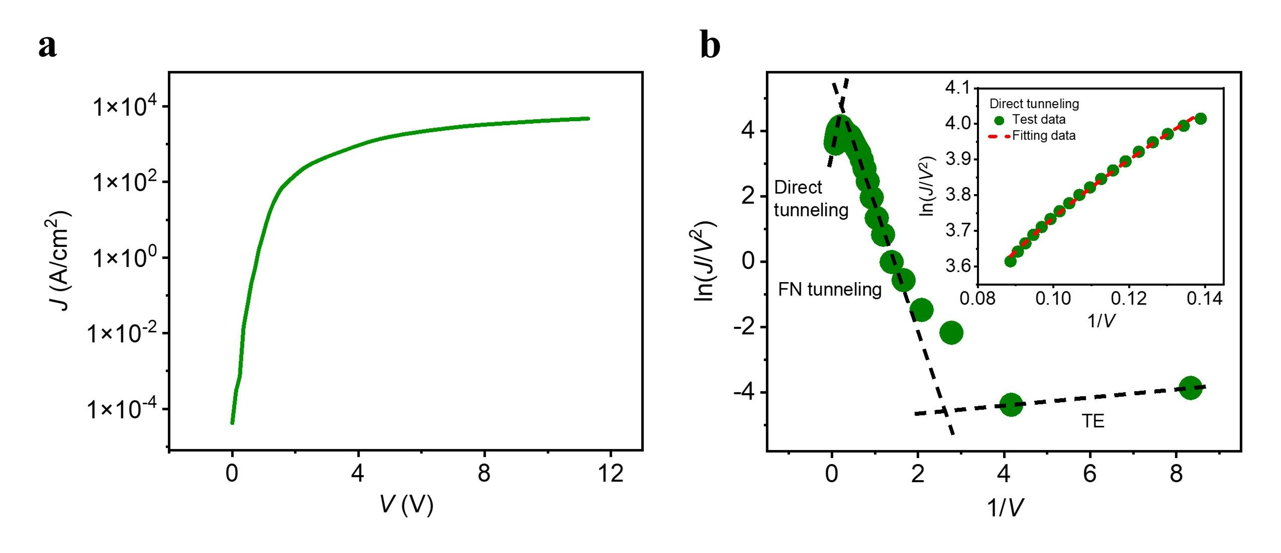
Supplementary Figure 10. (a) The J~V characteristics of Pt / C₆-DNTT / Ti under larger bias condition. (b) The $ln⁡(J/{V^{2}})\sim V^{-1}$ curve generated from the corresponding $J\sim V$ data of the device in a. The three kinds of carrier injection modes, thermally emission (TE), Fowler-Nordheim (FN) tunneling and direct tunneling, were observed.

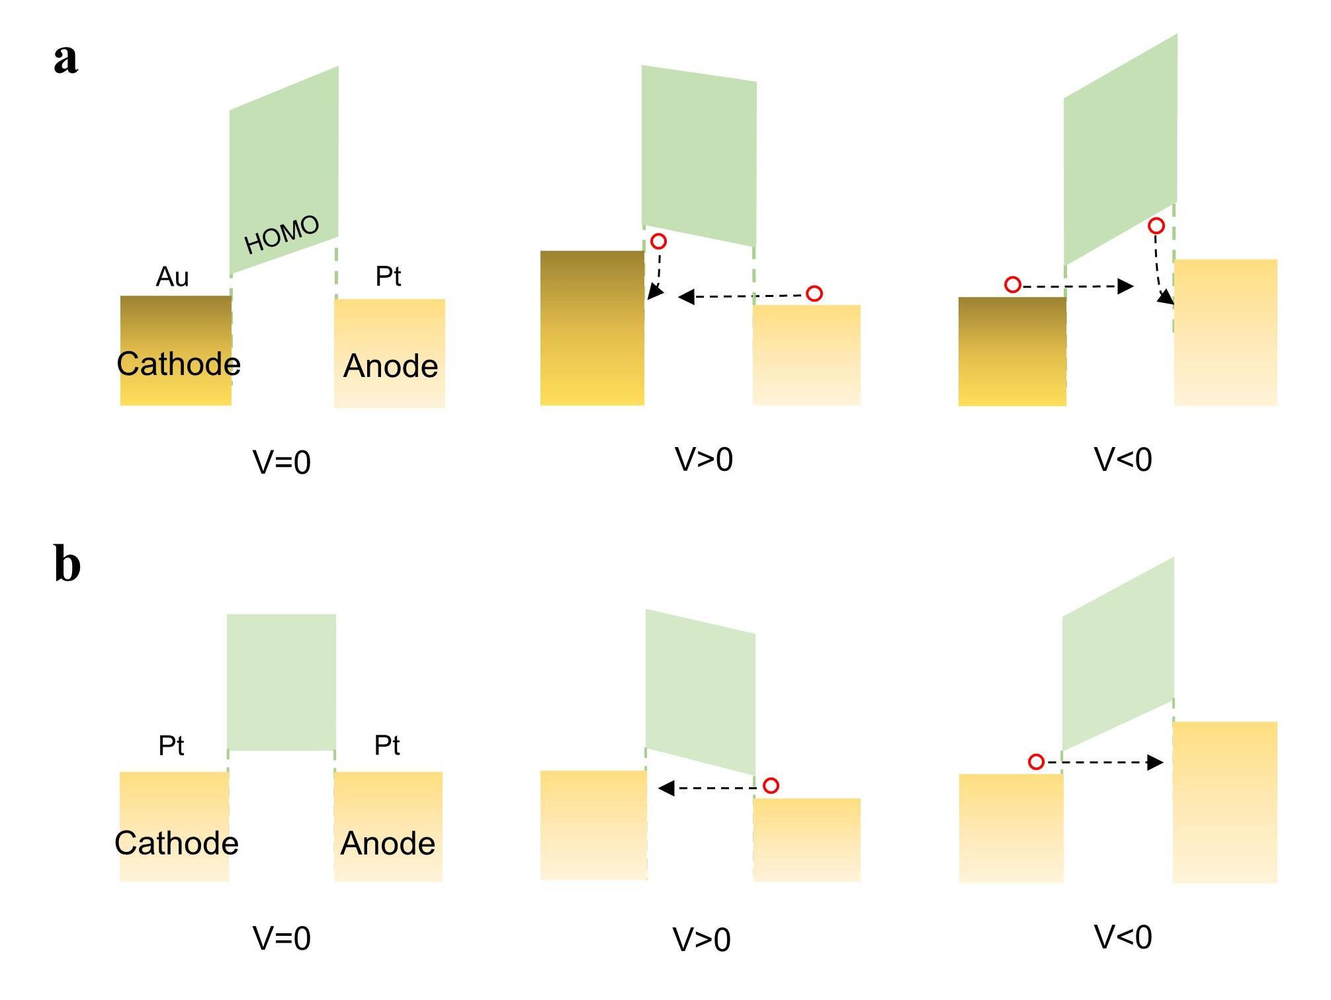
Supplementary Figure 11. Sketch of the corresponding energy level of Pt / C₆-DNTT / Pt (a) and Pt / C₆-DNTT / Au (b) molecular diodes under different bias.

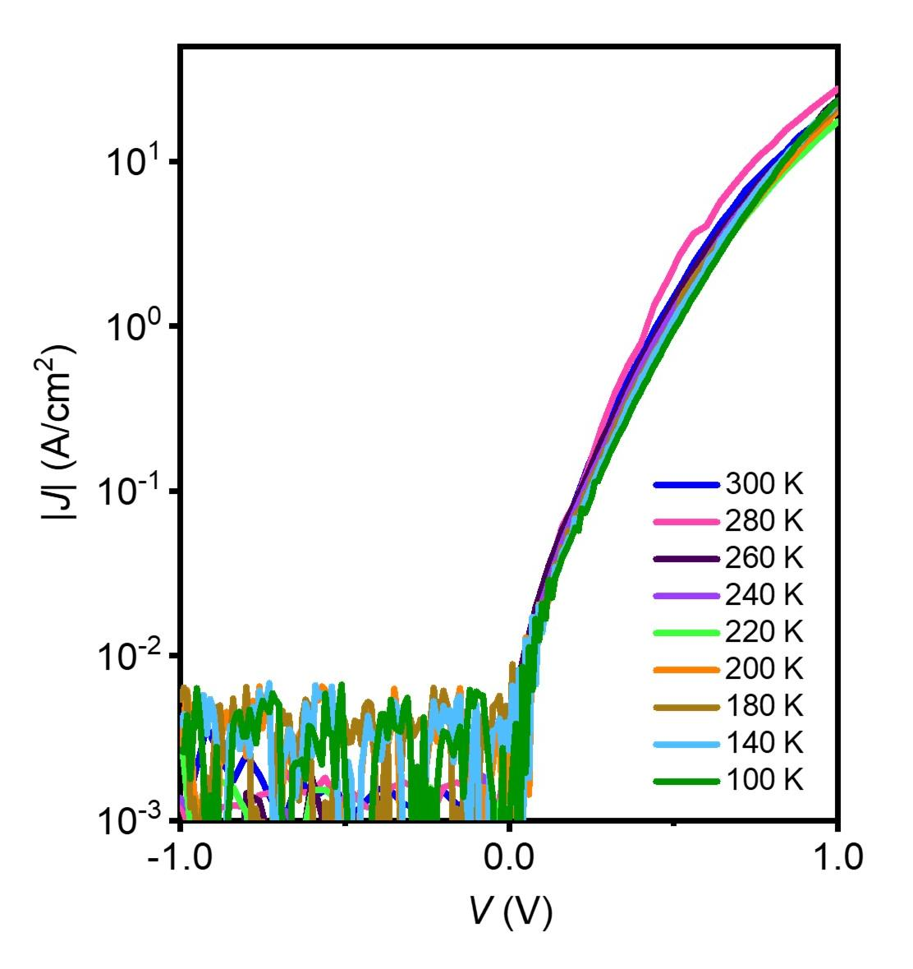
Supplementary Figure 12. Typical $J\sim V$ characteristics of Pt / C₆-DNTT / Ti molecular diodes under different temperature.

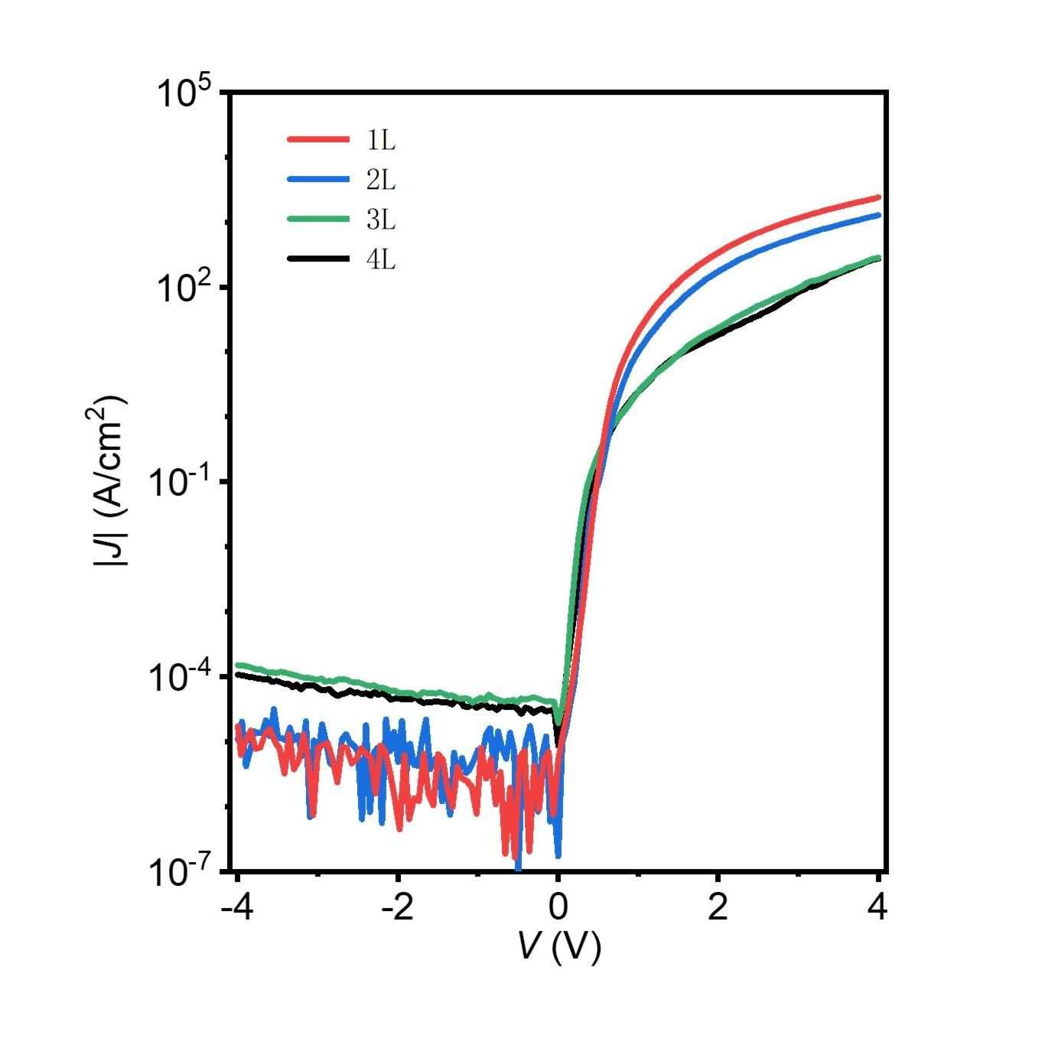
Supplementary Figure 13. Typical $J\sim V$ characteristics of Pt / C₆-DNTT / Ti organic diodes with 1L, 2L, 3L and 4L crystalline thin films at room temperature.

Supplementary Table 1| Several key electrical parameters comparison between typical previously reported organic diodes and values of our devices (partial data used in Fig. 2f).
Structure (from top to bottom) | Unit conductance (S/cm²) | RR | V_{on} (V) | V_{breakdown} (V/cm) | Type of  organic molecule | Top electrode | Ref.
Pt/C₆-DNTT/Ti | 1.2*10³ | 5*10⁸ | ~0.3 | 7.3*10⁷(forward)  1.1*10⁸(reverse) | Monolayer | Metal film | This work
Al/OETS-thiophene/Si | 1*10⁻⁴ | 37 | -0.3 |  | SAM | Metal film | 1
Al/OETS-thiophene(4T)/Si | 9.4*10⁻³ | 26 | ~-0.7 |  | SAM | Metal film | 2
Au/n-alkyl/Si | 1.6 | 2*10⁶ |  |  | Monolayer | Metal film | 3
Au/DPE-2F/Al/Al₂O₃/ polyimide/phosporbronze |  | 600 | ~1.7 |  | Molecule | Metal film | 4
Au/Ti/BTB/Au | 0.926 | 3*10³ | ~1.2 |  | 9 nm film | Metal film | 5
Au/CuPc/F₁₆CoPc/Au | 157.5 | 300 | ~0.5 |  | 7 nm film | Metal film | 6
STM tip/TDO_{n/}Au | 15 | 200 | ~-0.2 |  | SAM | STM tip | 7
Hg/C₁₀H₂₁/Si | 0.1 | 10⁶ | ~0.3 |  | SAM | Liquid metal | 8
EGaIn/Ga₂O₃/SC₁₁Fc/Ag | 8*10⁻⁴ | 200 |  |  | SAM | Liquid metal | 9
EGaIn/Ga₂O₃/SC₁₁Fc₂/Ag | 1*10⁻³ | 500 |  |  | SAM | Liquid metal | 10
EGaIn/Ga₂O₃/SC₁₁Fc/Ag | 1*10⁻³ | 180 | ~0.4 |  | SAM | Liquid metal | 11
EGaIn/Ga₂O₃/SC_{n}Fc/Ag | 5*10⁻⁴ | 151 |  |  | SAM | Liquid metal | 12
EGaIn/Ga₂O₃/SC₁₁BIPY/Ag | 0.08 | 85 | ~0.6 |  | SAM | Liquid metal | 13
EGaIn/Ga₂O₃/FcC₁₁SH/Ag | 8*10⁻⁴ | 98 |  |  | SAM | Liquid metal | 14
EGaIn/Ga₂O₃/SC₁₁Fc₂/Ag | 5*10⁻³ | 1.1*10³ | ~0.25 |  | SAM | Liquid metal | 15
EGaIn/Ga₂O₃/SC_{n}FcC_{13-n}/Ag | 4*10⁻⁴ | 85 | ~0.7 |  | SAM | Liquid metal | 16
EGaIn/Ga₂O₃/S(CH₂)₁₃CH₃/Ag | 1.1*10⁻³ | 50 | ~-0.7 |  | SAM | Liquid metal | 17
EGaIn/Ga₂O₃/S(CH₂)₁₁Fc/Ag |  | 1.1*10³ |  |  | SAM | Liquid metal | 18
EGaIn/Ga₂O₃/SC₁₀XFc/Ag | 1.3*10⁻³ | 100 |  |  | SAM | Liquid metal | 19
EGaIn/Ga₂O₃/SC₁₁BIPY/Ag | 4.6 | 100 | ~0.5 |  | SAM | Liquid metal | 20
EGaIn/Ga₂O₃/HSC₁₁BIPY-HSC_{X}/Ag | 12.6 | 131 |  |  | SAM | Liquid metal | 21
EGaIn/Ga₂O₃/fluorinated benzalkylsilane/Si | 6*10⁻³ | 200 |  | 5*10⁷ | SAM | Liquid metal | 22
EGaIn/Ga₂O₃/S(CH₂)₁₁Fc/Au(Ag, Pt) | 8*10⁻³ | 6.3*10⁵ | ~-1.3 | ±1*10⁷ | SAM | Liquid metal | 23
EGaIn/Ga₂O₃/FSC₁₁/Ag | 0.04 | 617 | ~0.3 |  | SAM | Liquid metal | 24
EGaIn/Ga₂O₃/DS-Fc-X/Au | 0.5 | 99 |  |  | SAM | Liquid metal | 25
Hg/PhC/Si | 0.625 | 1.7*10⁴ |  |  | Monolayer | Liquid metal | 26
EGaIn/Ga₂O₃/ferrocenealkylsilanes/Si | 4.6*10⁻⁵ | 150 | ~0.6 |  | SAM | Liquid metal | 27
EGaIn/GaO_{X}/FcC11X/graphene/Cu | 4.2*10⁻⁴ | 8*10³ | ~1 |  | SAM | Liquid metal | 28
EGaIn/Ga₂O₃/HSC₁₁BIPY-HSC_{X}/Ag | 16 | 126 |  |  | SAM | Liquid metal | 29
EGaIn/S(CH₂)_{n}CO₂H/Au | 0.08 | 316 |  |  | SAM | Liquid metal | 30
EGaIn/Ga₂O₃/S(CH₂)_{n}R(CH₂)_{m}CH₃/Ag | 1.6 | 18.1 |  |  | SAM | Liquid metal | 31
EGaIn/Ga₂O₃/SC₁₁PAH/Ag | 0.8 | 170 | ~-0.6 |  | SAM | Liquid metal | 32
EGaIn/Ga₂O₃/CPh-TPI/Si | 1.8*10⁻³ | 2635 | ~1.5 |  | SAM | Liquid metal | 33
EGaIn/Ga₂O₃/S(CH₂)₁₁MV²⁺X⁻₂/Ag | 0.04 | 2.5*10⁴ | ~-1 |  | SAM | Liquid metal | 34
EGaIn/Ga₂O₃/PTEG-1/Au | 0.03 | 40 |  |  | SAM | Liquid metal | 35
EGaIn/Ga₂O₃/SC₁₁BIPY/Au | 8.5 | 142 | ~0.5 |  | SAM | Liquid metal | 36
EGaIn/Ga₂O₃/S(CH2)₁₁BIPY-MCl₂/Au | 1.2 | 82 | ~0.5 |  | SAM | Liquid metal | 37
Hg/C₁₀SH/Si | 5 | 2*10³ |  |  | SAM | Liquid metal | 38
AgNWs:T-TPU/SEBS/Au/PEDOT:PSS:IONE/DPP4T-oSi10/PEDOT:PSS:PSSNa:ION E/PEIE/Ag/AgNWs:T-TPU/SEBS) | 0.935 | >100 |  |  | 70 nm film | Metal NWs | 39
Al/C₆₀/Cu | 151.25 | 2.6*10⁶ |  |  | 100 nm film | Metal film | 40
Au/PEDOT:PSS/pentacene/Al | 140 | 20 | ~2.5 | 1.2*10⁶(forward)  1.9*10⁶(reverse) | 160 nm film | Metal film | 41
MgAg/CuPc/EB/ITO | 3.76*10⁵ |  | ~0.7 |  | 25 nm film | Metal film | 42
Au/CuPc/Al | 5.86 | 6*10³ |  |  | 50 nm film | Metal film | 43
Au/pentacene/ZnO/ITO | 29 | 3*10³ | 1.5 | 2.5*10⁶ | 100 nm film | Metal film | 44
Al/Pentacne/Au | 3.5 | ~10⁶ | ~1.5 | >1.6*10⁶(reverse) | 160 nm film | Metal film | 45
Au/PQT-12/ZnO/ITO | 160 | ~400 | 1.2 | 1*10⁶ | 150 nm film | Metal film | 46
Al/BCP/C₆₀/HMDS/WO₃/Al | 38.75 | 4.6*10⁴ | ~0.35 | 1.5*10⁶(reverse) | 100 nm film | Metal film | 47
Au/pentacene/Al | 10 | 10⁵ |  |  | 100 nm film | Metal film | 48
Al/PQT-12(P3HT)/ITO | 4*10⁻⁴ |  | ~1 |  | 60-100 nm film | Metal film | 49
Al/pentacene/PFBT/Au | 33 | 1.05*10⁷ |  | 2*10⁶(reverse) | 100 nm film | Metal film | 50
Ag/P(NDI2OD-T2)/PEI/Ag | 0.06 | 10⁶ | 3 |  | 200-700 nm film | Metal film | 51
Al/P3HT/PFBT/Au/Ti | 0.025 | 10⁶ | 0.1 |  | 110 nm film | Metal film | 52
Au/Cr/PgBT(F)2Gtt(p(g2T-TT),  P(NDIMTEG-T))/parylene-C/Au/Cr | 5*10⁴ | 314.3 | -0.166 |  | 250-500 nm film | Metal film | 53
Ag/PEDOT:Tos/PEDOT:Tos-TDAE/Ag | 6 | 30 | ~1.2 |  | 260 nm film  (Lateral diode) | Metal film | 54
Au/C₆₀:polystyrene/Al |  | 10³ |  |  | 700 nm film  (Lateral diode) | Metal film | 55
Cu foil/T2-DPPT(DPPTTT, T-DPPT)/Cu foil | 0.766 | 2.1*10³ | ~1 |  | ~3.3 μm/3.4-4.5 μm film  (Lateral diode) | Metal foil | 56

References
1. Lenfant, S.; Krzeminski, C.; Delerue, C.; Allan, G.; Vuillaume, D., Molecular rectifying diodes from self-assembly on silicon. Nano Lett 2003, 3 (6), 741-746.
2. Lenfant, S.; Guerin, D.; Van, F. T.; Chevrot, C.; Palacin, S.; Bourgoin, J. P.; Bouloussa, O.; Rondelez, F.; Vuillaume, D., Electron transport through rectifying self-assembled monolayer diodes on silicon: Fermi-level pinning at the molecule-metal interface. J Phys Chem B 2006, 110 (28), 13947-13958.
3. Kuikka, M. A.; Li, W. J.; Kavanagh, K. L.; Yu, H. Z., Nanoscale electrical and structural characterization of gold/alkyl monolayer/silicon diode junctions. J Phys Chem C 2008, 112 (24), 9081-9088.
4. Perrin, M. L.; Galan, E.; Eelkema, R.; Thijssen, J. M.; Grozema, F.; van der Zant, H. S. J., A gate-tunable single-molecule diode. Nanoscale 2016, 8 (16), 8919-8923.
5. Nguyen, Q. V.; Martin, P.; Frath, D.; Della Rocca, M. L.; Lafolet, F.; Barraud, C.; Lafarge, P.; Mukundan, V.; James, D.; McCreery, R. L.; Lacroix, J. C., Control of Rectification in Molecular Junctions: Contact Effects and Molecular Signature. Journal of the American Chemical Society 2017, 139 (34), 11913-11922.
6. Li, T.; Bandari, V. K.; Hantusch, M.; Xin, J.; Kuhrt, R.; Ravishankar, R.; Xu, L.; Zhang, J.; Knupfer, M.; Zhu, F., Integrated molecular diode as 10 MHz half-wave rectifier based on an organic nanostructure heterojunction. Nature communications 2020, 11 (1), 1-10.
7. Capozzi, B.; Xia, J. L.; Adak, O.; Dell, E. J.; Liu, Z. F.; Taylor, J. C.; Neaton, J. B.; Campos, L. M.; Venkataraman, L., Single-molecule diodes with high rectification ratios through environmental control. Nat Nanotechnol 2015, 10 (6), 522-U101.
8. Liu, Y. J.; Yu, H. Z., Alkyl monolayer-passivated metal-semiconductor diodes: Molecular tunability and electron transport. Chemphyschem 2002, 3 (9), 799-+.
9. Nijhuis, C. A.; Reus, W. F.; Whitesides, G. M., Molecular Rectification in Metal-SAM-Metal Oxide-Metal Junctions. Journal of the American Chemical Society 2009, 131 (49), 17814-17827.
10. Nijhuis, C. A.; Reus, W. F.; Whitesides, G. M., Mechanism of Rectification in Tunneling Junctions Based on Molecules with Asymmetric Potential Drops. Journal of the American Chemical Society 2010, 132 (51), 18386-18401.
11. Nijhuis, C. A.; Reus, W. F.; Barber, J. R.; Dickey, M. D.; Whitesides, G. M., Charge Transport and Rectification in Arrays of SAM-Based Tunneling Junctions. Nano Lett 2010, 10 (9), 3611-3619.
12. Nerngchamnong, N.; Yuan, L.; Qi, D.-C.; Li, J.; Thompson, D.; Nijhuis, C. A., The role of van der Waals forces in the performance of molecular diodes. Nat Nanotechnol 2013, 8 (2), 113-118.
13. Yoon, H. J.; Liao, K. C.; Lockett, M. R.; Kwok, S. W.; Baghbanzadeh, M.; Whitesides, G. M., Rectification in Tunneling Junctions: 2,2 '-Bipyridyl-Terminated n-Alkanethiolates. Journal of the American Chemical Society 2014, 136 (49), 17155-17162.
14. Jiang, L.; Yuan, L.; Cao, L.; Nijhuis, C. A., Controlling Leakage Currents: The Role of the Binding Group and Purity of the Precursors for Self-Assembled Monolayers in the Performance of Molecular Diodes. Journal of the American Chemical Society 2014, 136 (5), 1982-1991.
15. Yuan, L.; Breuer, R.; Jiang, L.; Schmittel, M.; Nijhuis, C. A., A Molecular Diode with a Statistically Robust Rectification Ratio of Three Orders of Magnitude. Nano Lett 2015, 15 (8), 5506-5512.
16. Yuan, L.; Nerngchamnong, N.; Cao, L.; Hamoudi, H.; del Barco, E.; Roemer, M.; Sriramula, R. K.; Thompson, D.; Nijhuis, C. A., Controlling the direction of rectification in a molecular diode. Nature Communications 2015, 6.
17. Wan, A.; Sangeeth, C. S. S.; Wang, L. J.; Yuan, L.; Jiang, L.; Nijhuis, C. A., Arrays of high quality SAM-based junctions and their application in molecular diode based logic. Nanoscale 2015, 7 (46), 19547-19556.
18. Garrigues, A. R.; Yuan, L.; Wang, L. J.; Mucciolo, E. R.; Thompon, D.; del Barco, E.; Nijhuis, C. A., A Single-Level Tunnel Model to Account for Electrical Transport through Single Molecule- and Self-Assembled Monolayer-based Junctions. Scientific Reports 2016, 6.
19. Song, P.; Yuan, L.; Roemer, M.; Jiang, L.; Nijhuis, C. A., Supramolecular vs Electronic Structure: The Effect of the Tilt Angle of the Active Group in the Performance of a Molecular Diode. Journal of the American Chemical Society 2016, 138 (18), 5769-5772.
20. Kong, G. D.; Yoon, H. J., Influence of Air-Oxidation on Rectification in Thiol-Based Molecular Monolayers. J Electrochem Soc 2016, 163 (9), G115-G121.
21. Kong, G. D.; Kim, M.; Cho, S. J.; Yoon, H. J., Gradients of Rectification: Tuning Molecular Electronic Devices by the Controlled Use of Different-Sized Diluents in Heterogeneous Self-Assembled Monolayers. Angew Chem Int Edit 2016, 55 (35), 10307-10311.
22. Lamport, Z. A.; Broadnax, A. D.; Harrison, D.; Barth, K. J.; Mendenhall, L.; Hamilton, C. T.; Guthold, M.; Thonhauser, T.; Welker, M. E.; Jurchescu, O. D., Fluorinated benzalkylsilane molecular rectifiers. Scientific Reports 2016, 6.
23. Chen, X. P.; Roemer, M.; Yuan, L.; Du, W.; Thompson, D.; del Barco, E.; Nijhuis, C. A., Molecular diodes with rectification ratios exceeding 10(5) driven by electrostatic interactions. Nat Nanotechnol 2017, 12 (8), 797-803.
24. Qiu, L.; Zhang, Y. X.; Krijger, T. L.; Qiu, X. K.; van't Hof, P.; Hummelen, J. C.; Chiechi, R. C., Rectification of current responds to incorporation of fullerenes into mixed-monolayers of alkanethiolates in tunneling junctions. Chem Sci 2017, 8 (3), 2365-2372.
25. Souto, M.; Yuan, L.; Morales, D. C.; Jiang, L.; Ratera, I.; Nijhuis, C. A.; Veciana, J., Tuning the Rectification Ratio by Changing the Electronic Nature (Open-Shell and Closed-Shell) in Donor Acceptor Self-Assembled Monolayers. Journal of the American Chemical Society 2017, 139 (12), 4262-4265.
26. Alon, H.; Garrick, R.; Pujari, S. P.; Toledano, T.; Sinai, O.; Kedem, N.; Bendikov, T.; Baio, J. E.; Weidner, T.; Zuilhof, H.; Cahen, D.; Kronik, L.; Sukenik, C. N.; Vilan, A., Effect of Internal Heteroatoms on Level Alignment at Metal/Molecular Monolayer/Si Interfaces. J Phys Chem C 2018, 122 (6), 3312-3325.
27. Broadnax, A. D.; Lamport, Z. A.; Scharmann, B.; Jurchescu, O. D.; Welker, M. E., Ferrocenealkylsilane molecular rectifiers. J Organomet Chem 2018, 856, 23-26.
28. Song, P.; Guerin, S.; Tan, S. J. R.; Annadata, H. V.; Yu, X. J.; Scully, M.; Han, Y. M.; Roemer, M.; Loh, K. P.; Thompson, D.; Nijhuis, C. A., Stable Molecular Diodes Based on pi-pi Interactions of the Molecular Frontier Orbitals with Graphene Electrodes. Advanced Materials 2018, 30 (10).
29. Kong, G. D.; Jin, J.; Thuo, M.; Song, H.; Joung, J. F.; Park, S.; Yoon, H. J., Elucidating the Role of Molecule-Electrode Interfacial Defects in Charge Tunneling Characteristics of Large-Area Junctions. Journal of the American Chemical Society 2018, 140 (38), 12303-12307.
30. Ai, Y.; Kovalchuk, A.; Qiu, X. K.; Zhang, Y. X.; Kumar, S.; Wang, X. T.; Kuhnel, M.; Norgaard, K.; Chiechi, R. C., In-Place Modulation of Rectification in Tunneling Junctions Comprising Self-Assembled Monolayers. Nano Lett 2018, 18 (12), 7552-7559.
31. Baghbanzadeh, M.; Belding, L.; Yuan, L.; Park, J.; A-Sayah, M. H.; Bowers, C. M.; Whitesides, G. M., Dipole-Induced Rectification Across Ag-TS/SAM//Ga2O3/EGaln Junctions. Journal of the American Chemical Society 2019, 141 (22), 8969-8980.
32. Cho, S. J.; Kong, G. D.; Park, S.; Park, J.; Byeon, S. E.; Kim, T.; Yoon, H. J., Molecularly Controlled Stark Effect Induces Significant Rectification in Polycyclic-Aromatic-Hydrocarbon-Terminated n-Alkanethiolates. Nano Lett 2019, 19 (1), 545-553.
33. Lamport, Z. A.; Broadnax, A. D.; Scharmann, B.; Bradford, R. W.; DelaCourt, A.; Meyer, N.; Li, H.; Geyer, S. M.; Thonhauser, T.; Welker, M. E.; Jurchescu, O. D., Molecular Rectifiers on Silicon: High Performance by Enhancing Top-Electrode/Molecule Coupling. Acs Appl Mater Inter 2019, 11 (20), 18564-18570.
34. Han, Y. M.; Nickle, C.; Zhang, Z. Y.; Astier, H. P. A. G.; Duffin, T. J.; Qi, D. C.; Wang, Z.; del Barco, E.; Thompson, D.; Nijhuis, C. A., Electric-field-driven dual-functional molecular switches in tunnel junctions. Nat Mater 2020, 19 (8), 843-+.
35. Qiu, X. K.; Ivasyshyn, V.; Qiu, L.; Enache, M.; Dong, J. J.; Rousseva, S.; Portale, G.; Stohr, M.; Hummelen, J. C.; Chiechi, R. C., Thiol-free self-assembled oligoethylene glycols enable robust air-stable molecular electronics. Nat Mater 2020, 19 (3), 330-+.
36. Kang, H.; Kong, G. D.; Byeon, S. E.; Yang, S.; Kim, J. W.; Yoon, H. J., Interplay of Fermi Level Pinning, Marcus Inverted Transport, and Orbital Gating in Molecular Tunneling Junctions. J Phys Chem Lett 2020, 11 (20), 8597-8603.
37. Park, J.; Belding, L.; Yuan, L.; Mousavi, M. P. S.; Root, S. E.; Yoon, H. J.; Whitesides, G. M., Rectification in Molecular Tunneling Junctions Based on Alkanethiolates with Bipyridine-Metal Complexes. Journal of the American Chemical Society 2021, 143 (4), 2156-2163.
38. Zhou, A. G. C.; Zhu, L. X.; Yu, H. Z., Metastable Metal-Monolayer-Semiconductor Junctions: DiverseChain-Length-Dependent and Ultraslow Electrical Progression. J Phys Chem C 2022, 126 (17), 7638-7647.
39. Matsuhisa, N.; Niu, S. M.; O'Neill, S. J. K.; Kang, J. H.; Ochiai, Y.; Katsumata, T.; Wu, H. C.; Ashizawa, M.; Wang, G. J. N.; Zhong, D. L.; Wang, X. L.; Gong, X. W.; Ning, R.; Gong, H. X.; You, I.; Zheng, Y.; Zhang, Z. T.; Tok, J. B. H.; Chen, X. D.; Bao, Z. N., High-frequency and intrinsically stretchable polymer diodes. Nature 2021, 600 (7888), 246-+.
40. Ma, L. P.; Ouyang, J.; Yang, Y., High-speed and high-current density C-60 diodes. Applied Physics Letters 2004, 84 (23), 4786-4788.
41. Steudel, S.; Myny, K.; Arkhipov, V.; Deibel, C.; De Vusser, S.; Genoe, J.; Heremans, P., 50MHz rectifier based on an organic diode. Nat Mater 2005, 4 (8), 597-600.
42. Matsushima, T.; Adachi, C., Observation of extremely high current densities on order of MA/cm(2) in copper phthalocyanine thin-film devices with submicron active areas. Jpn J Appl Phys 2 2007, 46 (45-49), L1179-L1181.
43. Ai, Y.; Gowrisanker, S.; Jia, H.; Trachtenberg, I.; Vogel, E.; Wallace, R. M.; Gnade, B. E.; Barnett, R.; Stiegler, H.; Edwards, H., 14 MHz organic diodes fabricated using photolithographic processes. Applied Physics Letters 2007, 90 (26).
44. Pal, B. N.; Sun, J.; Jung, B. J.; Choi, E.; Andreou, A. G.; Katz, H. E., Pentacene-zinc oxide vertical diode with compatible grains and 15-MHz rectification. Advanced Materials 2008, 20 (5), 1023-+.
45. Steudel, S.; Myny, K.; Vicca, P.; Cheyns, D.; Genoe, J.; Heremans, P., Ultra-High frequency rectification using organic diodes. Int El Devices Meet 2008, 93-96.
46. Sun, J.; Pal, B. N.; Jung, B. J.; Katz, H. E., Solution-processed hybrid p-n junction vertical diode. Org Electron 2009, 10 (1), 1-7.
47. Im, D.; Moon, H.; Shin, M.; Kim, J.; Yoo, S., Towards Gigahertz Operation: Ultrafast Low Turn-on Organic Diodes and Rectifiers Based on C-60 and Tungsten Oxide. Advanced Materials 2011, 23 (5), 644-+.
48. Gutierrez-Heredia, G.; Martinez-Landeros, V. H.; Aguirre-Tostado, F. S.; Shah, P.; Gnade, B. E.; Sotelo-Lerma, M.; Quevedo-Lopez, M. A., Full bridge circuit based on pentacene schottky diodes fabricated on plastic substrates. Semicond Sci Tech 2012, 27 (8).
49. Dai, M. Z.; Chen, Y. H.; Chuang, M. Y.; Zan, H. W.; Meng, H. F., Achieving a Good Life Time in a Vertical-Organic-Diode Gas Sensor. Sensors-Basel 2014, 14 (9), 16287-16295.
50. Kang, C. M.; Wade, J.; Yun, S.; Lim, J.; Cho, H.; Roh, J.; Lee, H.; Nam, S.; Bradley, D. D. C.; Kim, J. S.; Lee, C., 1 GHz Pentacene Diode Rectifiers Enabled by Controlled Film Deposition on SAM-Treated Au Anodes. Advanced Electronic Materials 2016, 2 (2).
51. Viola, F. A.; Brigante, B.; Colpani, P.; Dell'Erba, G.; Mattoli, V.; Natali, D.; Caironi, M., A 13.56 MHz Rectifier Based on Fully Inkjet Printed Organic Diodes. Advanced Materials 2020, 32 (33).
52. Ferchichi, K.; Pecqueur, S.; Guerin, D.; Bourguiga, R.; Lmimouni, K., High Rectification Ratio in Polymer Diode Rectifier through Interface Engineering with Self-Assembled Monolayer. Electronic Materials 2021, 2 (4), 445-453.
53. Kim, Y.; Kim, G.; Ding, B. W.; Jeong, D.; Lee, I.; Park, S.; Kim, B. J.; McCulloch, I.; Heeney, M.; Yoon, M. H., High-Current-Density Organic Electrochemical Diodes Enabled by Asymmetric Active Layer Design. Advanced Materials 2022, 34 (7).
54. Wang, H.; Hsu, J. H.; Yang, G.; Yu, C. H., Novel Organic Schottky Barrier Diode Created in a Single Planar Polymer Film. Advanced Materials 2016, 28 (43), 9545-+.
55. Semple, J.; Rossbauer, S.; Burgess, C. H.; Zhao, K.; Jagadamma, L. K.; Amassian, A.; McLachlan, M. A.; Anthopoulos, T. D., Radio Frequency Coplanar ZnO Schottky Nanodiodes Processed from Solution on Plastic Substrates. Small 2016, 12 (15), 1993-2000.
56. Wang, J.; Wang, Y. Z.; Li, K. C.; Dai, X.; Zhang, L. Y.; Wang, H., Lateral Fully Organic P-N Diodes Created in a Single Donor-Acceptor Copolymer. Advanced Materials 2022, 34 (5).

