Supplementary Tables and Figures
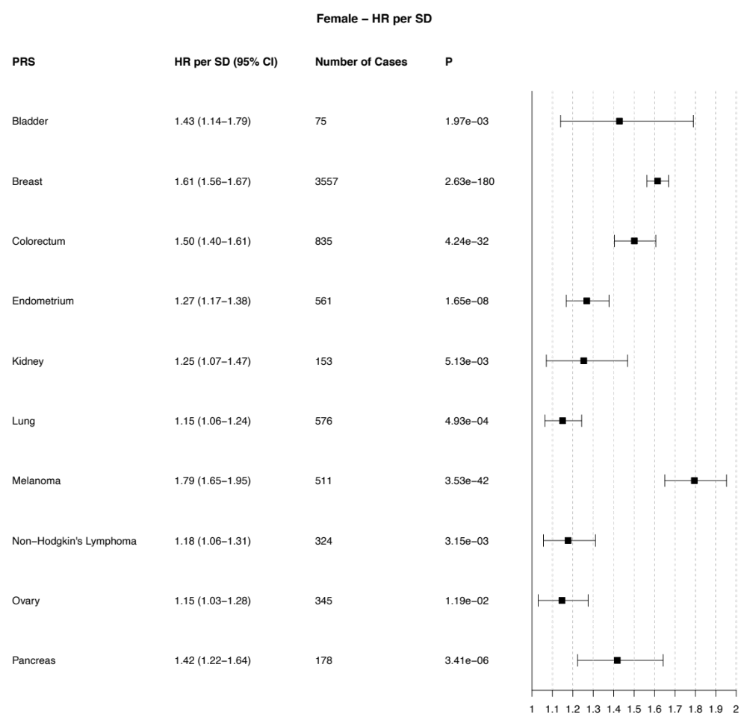
Supplementary Figure S1. The estimated hazard ratios (HR) per standard deviation (SD) of polygenic risk score (PRS) by cancer type [Female]. For each cancer type, Cox proportional hazard (Cox) model was fit to the female UK Biobank (UKBB) cohort, respectively, to evaluate the association between time to cancer incidence and cancer-specific PRS, adjusting for ten genetic principal components. Each model uses age as timescale. Individuals who were lost to follow-up, with genetic sex and self-reported sex mismatch, or those with prevalent cancers were excluded for the analysis. Each PRS is Z-score normalized to mean (μ) of 0 and standard deviation (σ) of 1. CI: Confidence Interval; HR: Hazard Ratio; SD: Standard Deviation; P: P-value; PRS: Polygenic Risk Score.

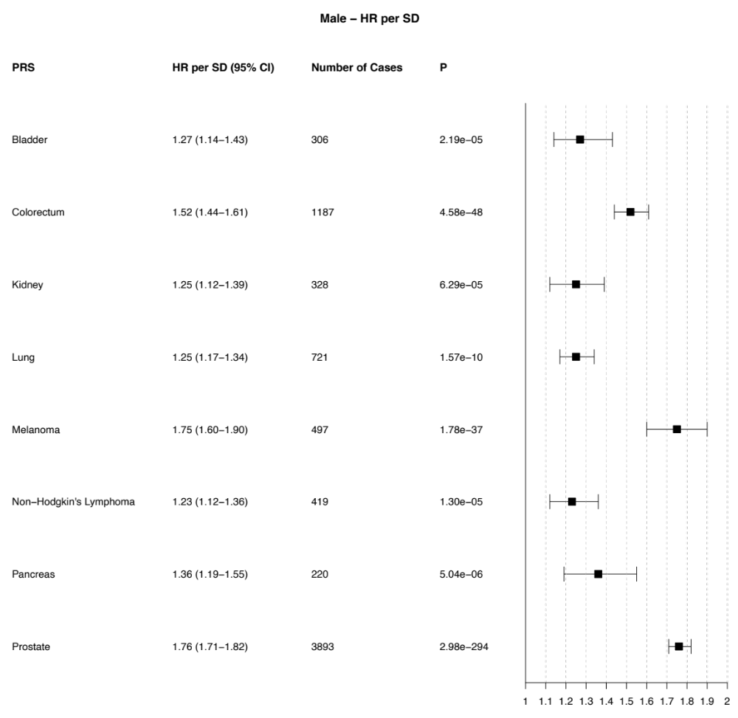
Supplementary Figure S2. The estimated hazard ratios (HR) per standard deviation (SD) of polygenic risk score (PRS) by cancer type [Male]. For each cancer type, Cox proportional hazard (Cox) model was fit to the male UK Biobank (UKBB) cohort, respectively, to evaluate the association between time to cancer incidence and cancer-specific PRS, adjusting for ten genetic principal components. Each model uses age as timescale. Individuals who were lost to follow-up, with genetic sex and self-reported sex mismatch, or those with prevalent cancers were excluded for the analysis. Each PRS is Z-score normalized to a mean (μ) of 0 and standard deviation (σ) of 1. CI: Confidence Interval; HR: Hazard Ratio; SD: Standard Deviation; P: P-value; PRS: Polygenic Risk Score.

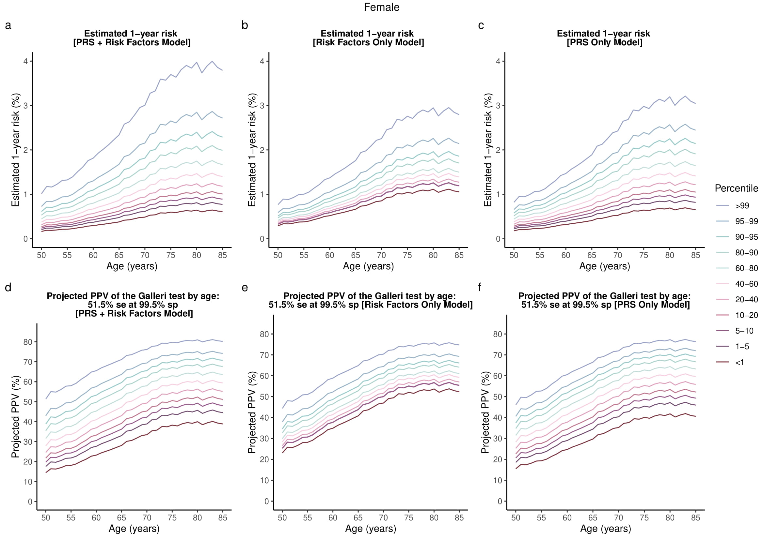
Supplementary Figure S3. a, b, c) Estimated 1-year absolute risk of developing one of the ten cancer types for the three separate multicancer risk prediction models for females. d, e, f) The corresponding PPV of the Galleri test for three separate multicancer risk models. PRS + Risk Factors model which is the pan-cancer risk score model uses cancer-specific PRSs and conventional risk factors as covariates. Risk-factors only model includes conventional risk factors shared across multiple cancer types (BMI, smoking status, and family history of cancer in first-degree relatives). PRS-only model includes the cancer-specific polygenic risk scores. se: sensitivity; sp: specificity; PPV: Positive Predictive Value
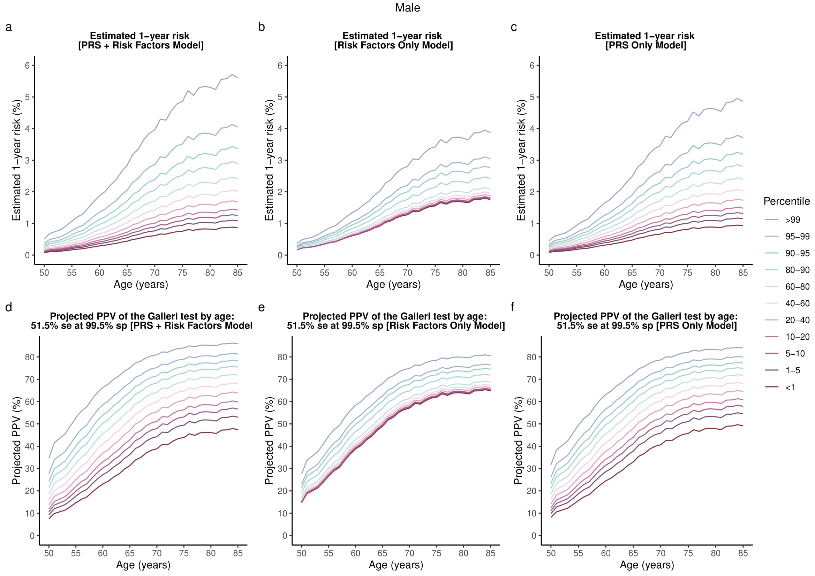
Supplementary Figure S4. a, b, c) Estimated 1-year absolute risk of developing one of the ten cancer types for the three separate multicancer risk prediction models for males. d, e, f) The corresponding PPV of Galleri test for three separate multicancer risk models. PRS + Risk Factors model which is the pan-cancer risk score model uses cancer-specific PRSs and conventional risk factors as covariates. Risk-factors only model includes conventional risk factors shared across multiple cancer types (BMI, smoking status, and family history of cancer in first-degree relatives). PRS-only model includes the cancer-specific polygenic risk scores. se: sensitivity; sp: specificity; PPV: Positive Predictive Value

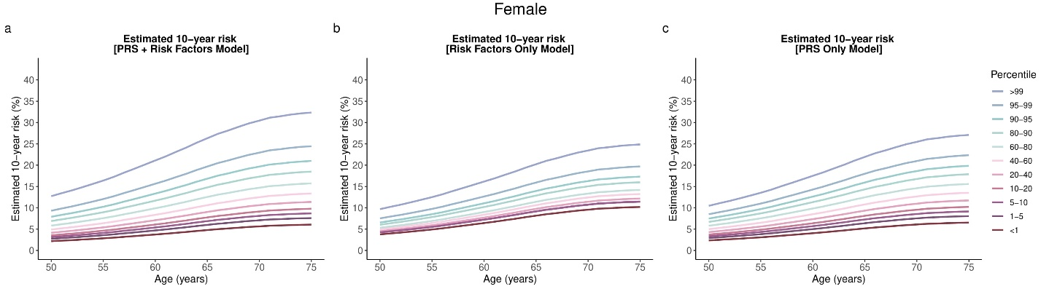
Supplementary Figure S5. a, b, c) Estimated 10-year absolute risk of developing one of the eight cancer types for the three separate multicancer risk prediction models for females. PRS + Risk Factors model which is the pan-cancer risk score model uses cancer-specific PRSs and conventional risk factors as covariates. Risk-factors only model includes conventional risk factors shared across multiple cancer types (BMI, smoking status, and family history of cancer in first-degree relatives). PRS-only model includes the cancer-specific polygenic risk scores. se: sensitivity; sp: specificity

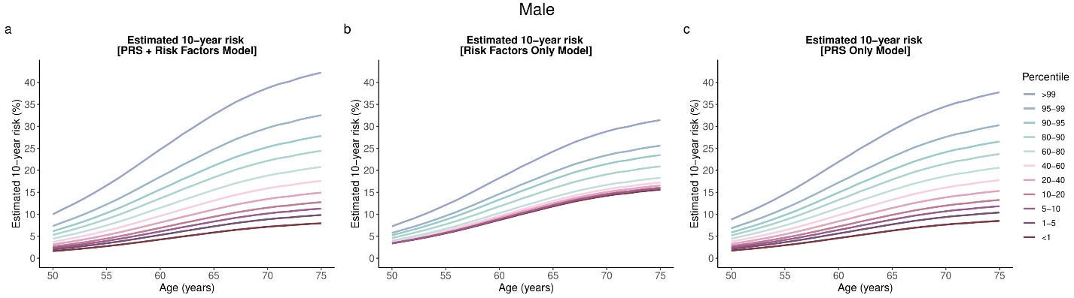
Supplementary Figures S6. a, b, c) Estimated 10-year absolute risk of developing one of the eight cancer types for the three separate multicancer risk prediction models for males. PRS + Risk Factors model which is the pan-cancer risk score model uses cancer-specific PRSs and conventional risk factors as covariates. Risk-factors only model includes conventional risk factors shared across multiple cancer types (BMI, smoking status, and family history of cancer in first-degree relatives). PRS-only model includes the cancer-specific polygenic risk scores. se: sensitivity; sp: specificity

DETECT-A
DETECT-A | All Cancers
Stage I-IV Sensitivity at 98.9% Specificity | 27.1%
1-Year PPV of DETECT-A (Female-only) | 19.4%
Galleri
Galleri | All Cancers
Stage I-IV Sensitivity at 99.5% Specificity | 51.5%
1-Year Projected PPV of Galleri (Female and Male Combined) | 44%
Supplementary Table S1. The reported performance of the DETECT-A and Galleri blood tests [1,2]. DETECT-A: Detecting cancers Earlier Through Elective mutation-based blood Collection and Testing.

Female, Multicancer Model n= 53529, number of events= 2372
ªPRS_{bladder} + … + PRS_{pancreas} + ^{b}Risk Factors
HR per SD (95% CI) | P | 5 Year AUC | C-Statistics (SE)
1.39 (1.34 - 1.44) | 6.36E-63 | 0.60 | 0.60 (0.006)
^{b}Risk Factors Only
HR per SD (95% CI) | P | 5 Year AUC | C-Statistics (SE)
1.19 (1.14-1.23) | 6.06E-21 | 0.55 | 0.55 (0.006)
ªPRS_{bladder} + … + PRS_{pancreas}
HR per SD (95% CI) | P | 5 Year AUC | C-Statistics (SE)
1.33 (1.28 - 1.39) | 4.71E-44 | 0.58 | 0.58 (0.006)
Male, Multicancer Model n= 48240, number of events= 2524
ªPRS_{bladder} + … + PRS_{prostate}+ ^{b}Risk Factors
HR per SD (95% CI) | P | 5 Year AUC | C-Statistics (SE)
1.41 (1.36 - 1.46) | 7.95E-71 | 0.60 | 0.60 (0.006)
^{b}Risk Factors Only
HR per SD (95% CI) | P | 5 Year AUC | C-Statistics (SE)
1.17 (1.13 - 1.21) | 4.24E-19 | 0.57 | 0.55 (0.006)
^{c}PRS_{bladder} + … + PRS_{prostate}
HR per SD (95% CI) | P | 5 Year AUC | C-Statistics (SE)
1.36 (1.31 - 1.41) | 4.12E-54 | 0.58 | 0.58 (0.006)

ªBladder, breast, colorectum, endometrium, kidney, lung, melanoma, non-Hodgkin's lymphoma (NHL), ovary, pancreas PRS
^{b}Body mass index (BMI) smoking status, pack years of smoking, family history of breast, colorectum, lung, and prostate cancer in a first-degree relative (nonadopted father, mother, and siblings)
^{c}Bladder, colorectum, kidney, lung, melanoma, non-Hodgkin's lymphoma (NHL), pancreas, prostate PRS
Supplementary Table S2. Model performance of the pan-cancer risk score (PCRS) or cancer-specific risk scores in the test set. PCRS/cancer-specific risk score is estimated as the weighted sum of the predictors included in each model. The weights are hazard ratios computed by fitting the Cox model to the training data. The performance of cRS was evaluated in the test set. Hazard ratios (HR) per SD, the corresponding p-value, Harrell’s C-index, and the area under the curve (AUC) is reported. Predictors included in each model are shown in Supplementary Figure S2-S5. AUC: area under the curve; CI: Confidence Interval; C-statistic: Harrell’s C-index; HR: Hazard Ratio; SD: Standard Deviation; P: p-value.

 |  |  | Female |  | Male
Parameter | Groups | Number of Person-years (full female cohort) |  | Number of Incident Cancer Cases | Number of Person-years (full male cohort) | Number of Incident Cancer Cases
Age at Study Entry | <44 | 97,994 |  | 1,224 | 92,371 | 297
Age at Study Entry | 45-49 | 148,770 |  | 2,172 | 128,922 | 907
Age at Study Entry | 50-54 | 177,755 |  | 3,283 | 146,836 | 2,397
Age at Study Entry | 55-59 | 205,870 |  | 5,052 | 173,869 | 4,279
Age at Study Entry | 60-64 | 274,851 |  | 7,776 | 241,909 | 9,927
Age at Study Entry | 65+ | 214,592 |  | 6,888 | 215,849 | 11,143
Body Mass Index | Normal (18.5 kg/m^2 - 24.9 kg/m^2) | 440,374 |  | 2,448 | 247,994 | 1,763
Body Mass Index | Underweight (< 18.5 kg/m^2) | 8,078 |  | 40 | 2,034 | 20
Body Mass Index | Overweight (25 kg/m^2 - 29.9 kg/m^2) | 413,488 |  | 2,738 | 497,412 | 3,889
Body Mass Index | Obese (> 30 kg/m^2) | 257,933 |  | 1,889 | 252,322 | 1,899
Family History of Cancer | Yes | 275,713 |  | 2,053 | 250,448 | 2207
Family History of Cancer | No | 844,161 |  | 5,062 | 749,314 | 5,364
Smoking History | Never Smoker | 674,917 |  | 3,959 | 497,334 | 3,098
Smoking History | Former Smoker | 350,339 |  | 2,423 | 382,909 | 3,439
Smoking History | Current Smoker | 94,618 |  | 733 | 119,519 | 1,034
ᵃBreast, Colorectal, Lung, or Prostate Cancer in first-degree relatives (nonadopted father, mother, siblings)

Supplementary Table S3. Descriptive Statistics of the UK Biobank Study Population.

Cancer Type | ICD-10 Code | ICD-9 Code | Incident Cancer Cases (Female) | Incident Cancer Cases (Male) | Number of SNPs included in each PRS
Bladder | C67 | 188 | 75 | 306
Breast | C50 | 174 | 3557 | - | 306
Colorectum | C18-C20 | 153, 154 | 835 | 1187 | 67
Endometrium | C54, C55 | 179, 182 | 561 | - | 16
Kidney | C64 | 189 | 153 | 328 | 12
Lung | C33-C34 | 162 | 576 | 721 | 43
Malignant Melanoma | C43 | 172 | 511 | 497 | 65
Non-Hodgkin Lymphoma | C82, C83.0, C83.3, C83.8, C85.2, C88.4 | 200.3, 200.5, 200.7, 200.8, 202 | 324 | 419 | 20
Ovary | C56 | 183 | 345 | - | 25
Pancreas | C25 | 157 | 178 | 220 | 19
Prostate | C61 | 185 | - | 3893 | 125
Total |  |  | 7,115 | 7,571 | -

Supplementary Table S4. Cancer types with the corresponding ICD-9 and ICD-10 codes, incident cancer cases, and the number of SNPs included in each cancer PRS.

Please see a separate attachment for Supplementary Table S5

Supplementary Table S5. Source literature and summary statistics for the SNPs included in each cancer PRS.

REFERENCES
1. Lennon AM, Buchanan AH, Kinde I, Warren A, Honushefsky A, Cohain AT, et al. Feasibility of blood testing combined with PET-CT to screen for cancer and guide intervention. Science. 2020;369:eabb9601.
2. Klein, E. A. et al. Clinical validation of a targeted methylation-based multi-cancer early detection test using an independent validation set. Ann. Oncol. Off. J. Eur. Soc. Med. Oncol. 32, 1167–1177 (2021).

