Supplementary File
- Model validation
  - Discharge validation
Table 1 shows the evaluation metrics for the period between 1991 and 2017. In most sub-watersheds, the model showed good performance. The model faced problems simulating high peaks of discharge (as seen in Figure 1), which was reflected in NSE values lower than 0. KGE and R² showed good or satisfactory performance in most cases. PBias showed that the model presented good performance in 8 sub-watersheds, satisfactory performance in 4 sub-watersheds, and poor performance in 5 sub-watersheds, especially in Leipzig-Thekla [WS ID 1] and Staitz [WS ID 4]. Some factors that may result in the mismatch between the modelled discharge and measured values are the uncertainties in the input datasets such as climate and soil data, the underestimation of ET in some sub-watersheds (Caldwell et al., 2012), and the presence of dams and water control infrastructure as in the case of Staitz [WS ID 4] and Boehlen [WS ID 14] stations. For the outlet sub-watershed Oberthau [WS ID 17], the model was able to simulate the discharge with good performance, indicating the overall good performance of the model in simulating monthly discharge.
    - ET validation
The AET was validated by comparing the simulated values with the ET estimated from the water balance equation (P-Q) and the MODIS ET product. Table 1 summarises the evaluation metrics for both validation products. When the Simulated AET was compared with the annual water balance equation, PBias values showed that the model has good performance (<10%) in estimating the annual AET. The R² showed that the model had a satisfactory performance in 4 sub-watersheds and poor in the rest. The low R² can be due to the multiple uncertainties underlying the water balance equation on the annual scale, for example, uncertainties in measuring precipitation, groundwater movements, and discharge flow management (Conradt et al., 2013).
MODIS-ET allowed the comparison in the monthly time scale. The KGE and NSE values showed that the model has a satisfactory performance in evaluating the monthly variability as captured by the MODIS product. The monthly modelled AET correlated well with MODIS ET. Figure 2 shows the time series of the modelled AET and MODIS ET.
    - GPP validation
Remote-sensing based products
The simulated GPP was compared to two satellite-based products, GOSIF and CGLS, on a monthly time scale. The time series for the three products are shown in Figure 3, and the validation results are shown in Table 1. The modelled GPP captured well the temporal variability of GPP as evaluated using KGE’ and NSE metrics. The ranges of the two metrics show that the modelled values have an overall satisfactory performance.

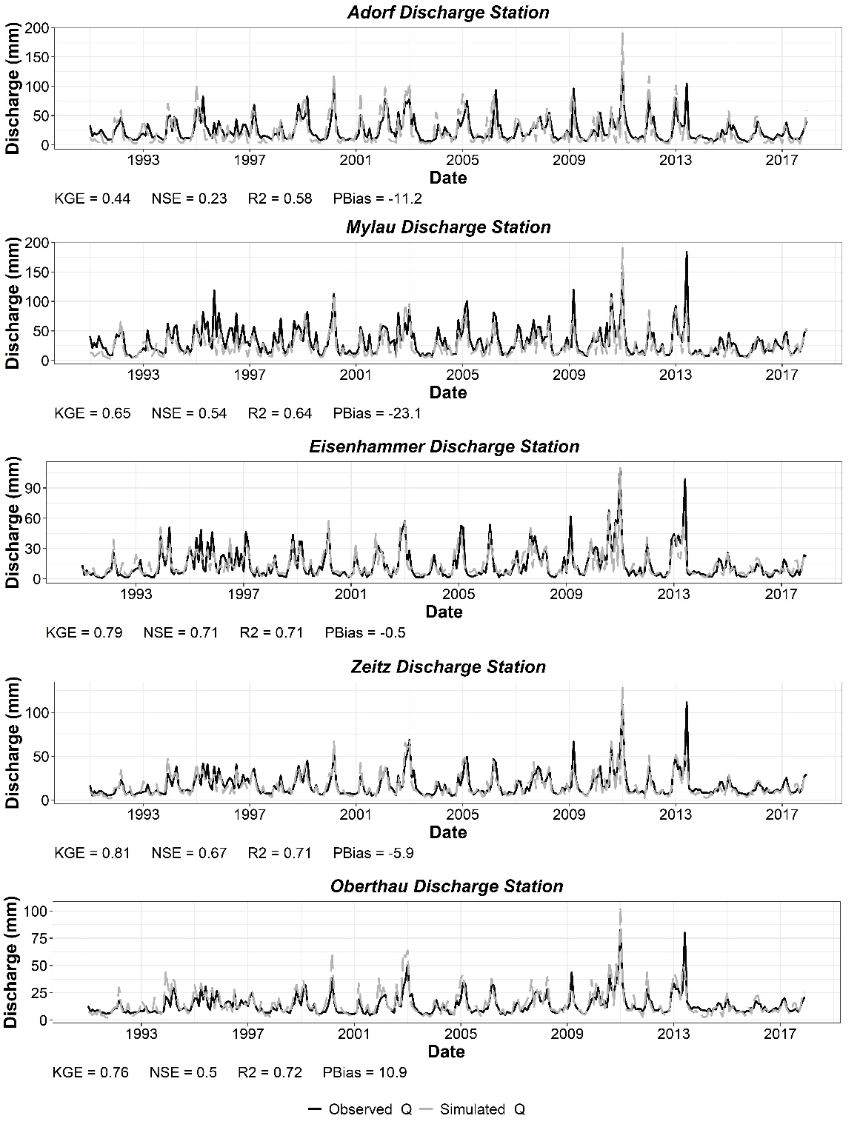
Figure 1 Simulated and observed discharge time series for different gauging stations

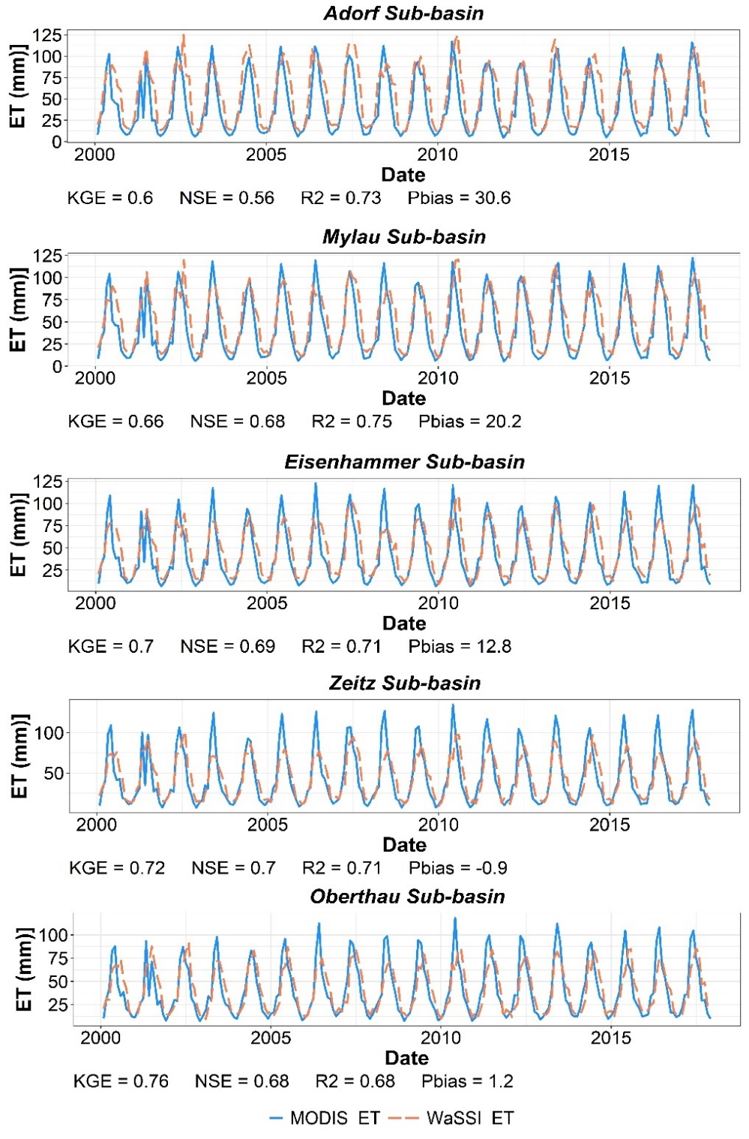
Figure 2 Simulated and MODIS AET time series for different sub-watersheds
WaSSI also correlated well with both products with values ranging between 0.55 and 0.82 showing overall good performance. WaSSI overestimates GPP when compared to both GPP products. However, compared to in-situ data, both products tend to underestimate GPP in CL, NF, and GL landcovers (Li and Xiao, 2019; Swinnen et al., 2019). Therefore, the modelled GPP can offer a good approximation of the GPP of the study area. The uncertainties in the modelled GPP include some factors that were not accounted for by WaSSI such as disturbances (storms, fires, and pests infections), forest stand age, and nitrogen availability (Sun et al., 2015).
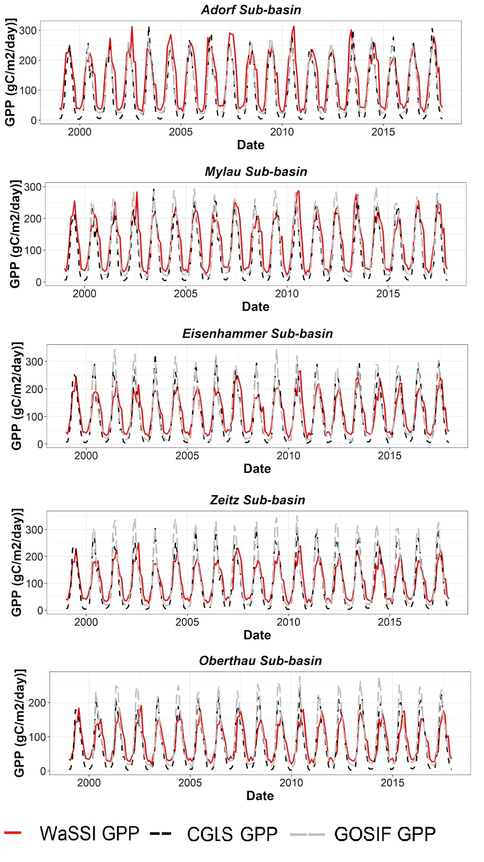
Figure 3 WasSI GPP, CGLS GPP, and GOSIF GPP time series for different sub-watersheds

Eddy covariance towers
Figure 4 presents the scatter plots for WaSSI GPP against EC measurements for NF and GL. WaSSI presented a good performance for modelling GPP in NF and Grasslands with high correlation, high KGE values, and lower bias. However, WaSSI tended to overestimate the low values of GPP for the two landcovers. On the other hand, the validation for the croplands resulted in unsatisfactory performance for WaSSI; therefore, it is not shown in Figure 4. However, the comparison with the croplands site might not be adequate since the types of crops planted in the EC tower area in the Klingenberg site can be different from the crops planted in the study area and the management practices.
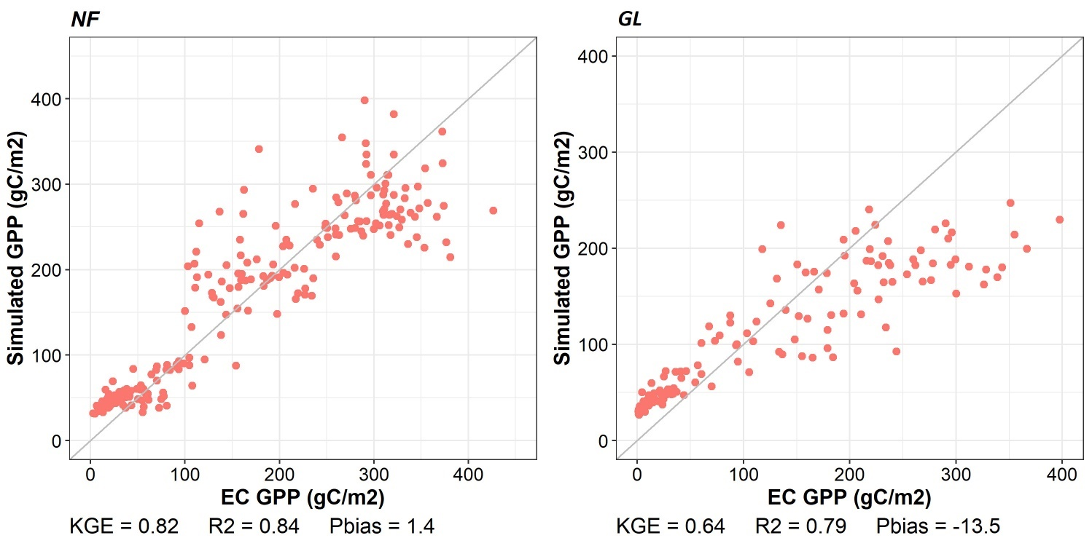
Figure 4 Simulated and EC GPP for specific landcovers, Needleleaf forest (NF, right), and Grasslands (GL, left)
Table 1 Validation results of WaSSI model for Discharge (Q), actual evapotranspiration (AET), and gross primary productivity (GPP)
WS ID | Name | Discharge |  |  |  | ET |  |  |  |  |  |  | GPP
WS ID | Name |  |  |  |  | Annual water balance (P-Q) |  | MODIS-ET (Monthly) |  |  |  | CGLS |  |  |  | GOSIF
WS ID | Name |  |  |  |  | (1991-2017) |  | (2000-2017) |  |  |  | (1999-2017) |  |  |  | (2000-2017)
WS ID | Name | NSE | KGE | PBias | R2 | PBias | R2 | NSE | KGE | PBias | R2 | NSE | KGE | PBias | R2 | NSE | KGE | PBias | R2
1 | Leipzig-Thekla | -0.3 | 0.2 | 76.4 | 0.73 | -11 | 0.68 | 0.64 | 0.72 | 5.9 | 0.65 | 0.66 | 0.58 | 8.9 | 0.69 | 0.52 | 0.57 | -9.9 | 0.55
2 | Thieschitz | -0 | 0.46 | -5.4 | 0.43 | 3.2 | 0.53 | 0.68 | 0.72 | 7.5 | 0.69 | 0.71 | 0.59 | 13.4 | 0.75 | 0.69 | 0.67 | 4.3 | 0.7
3 | Eisenhammer | 0.71 | 0.79 | -0.5 | 0.71 | 1.7 | 0.38 | 0.69 | 0.7 | 12.8 | 0.71 | 0.73 | 0.58 | 13.5 | 0.78 | 0.66 | 0.63 | 4.6 | 0.68
4 | Staitz | 0.4 | 0.41 | 37.1 | 0.5 | -6.4 | 0.22 | 0.64 | 0.67 | 16.7 | 0.69 | 0.72 | 0.58 | 15.3 | 0.78 | 0.68 | 0.63 | 9.6 | 0.7
5 | Laewitz | 0.7 | 0.78 | -14 | 0.72 | 7.4 | 0.66 | 0.69 | 0.68 | 14.1 | 0.72 | 0.74 | 0.58 | 14.8 | 0.8 | 0.69 | 0.63 | 6.6 | 0.71
6 | Mylau | 0.54 | 0.65 | -23 | 0.64 | 19.1 | 0.27 | 0.68 | 0.66 | 20.2 | 0.75 | 0.66 | 0.48 | 36.5 | 0.81 | 0.78 | 0.71 | 12.1 | 0.81
7 | Oelsnitz | 0.49 | 0.67 | -5.9 | 0.64 | 4.5 | 0.55 | 0.61 | 0.62 | 26.6 | 0.74 | 0.69 | 0.49 | 33.7 | 0.81 | 0.73 | 0.65 | 21.4 | 0.8
8 | Adorf | 0.23 | 0.44 | -11 | 0.58 | 7.3 | 0.59 | 0.56 | 0.6 | 30.6 | 0.73 | 0.6 | 0.44 | 41.3 | 0.78 | 0.66 | 0.63 | 28.7 | 0.81
9 | Strassberg | 0.66 | 0.79 | -7.5 | 0.71 | 3.1 | 0.52 | 0.73 | 0.7 | 9.4 | 0.75 | 0.76 | 0.58 | 12.6 | 0.82 | 0.74 | 0.67 | -0.8 | 0.78
10 | Greiz | 0.66 | 0.78 | -10 | 0.7 | 3.5 | 0.44 | 0.73 | 0.69 | 13.4 | 0.76 | 0.74 | 0.55 | 22.7 | 0.82 | 0.76 | 0.68 | 5.2 | 0.78
11 | Streitwald | -0 | 0.57 | 22.1 | 0.69 | -4 | 0.71 | 0.61 | 0.68 | 11.4 | 0.64 | 0.66 | 0.56 | 15.5 | 0.7 | 0.55 | 0.56 | -1.7 | 0.56
12 | Weida | 0.66 | 0.74 | 6.2 | 0.67 | -0.7 | 0.32 | 0.7 | 0.68 | 18 | 0.76 | 0.74 | 0.55 | 24.5 | 0.82 | 0.73 | 0.67 | 13.3 | 0.76
13 | Gera-Langenberg | 0.69 | 0.82 | -6.6 | 0.72 | 4.1 | 0.42 | 0.7 | 0.71 | 9.2 | 0.72 | 0.72 | 0.56 | 18.5 | 0.78 | 0.66 | 0.63 | 3.5 | 0.68
14 | Boehlen | -0.2 | 0.54 | 27.9 | 0.71 | -5.7 | 0.68 | 0.66 | 0.71 | 8.8 | 0.67 | 0.69 | 0.57 | 15.4 | 0.73 | 0.6 | 0.59 | -0.5 | 0.61
15 | Kleindalzig | 0.6 | 0.8 | 3.1 | 0.7 | -2.1 | 0.59 | 0.65 | 0.72 | 7.4 | 0.66 | 0.68 | 0.56 | 16.4 | 0.73 | 0.59 | 0.59 | 4.1 | 0.61
16 | Zeitz | 0.67 | 0.81 | -5.9 | 0.71 | 3.4 | 0.43 | 0.7 | 0.72 | -0.9 | 0.71 | 0.72 | 0.6 | 8.2 | 0.77 | 0.62 | 0.62 | -8 | 0.68
17 | Oberthau | 0.5 | 0.76 | 10.9 | 0.72 | -2.6 | 0.58 | 0.68 | 0.76 | 1.2 | 0.68 | 0.7 | 0.58 | 13.4 | 0.74 | 0.62 | 0.65 | -9.5 | 0.66

References
Conradt, T., Wechsung, F., Bronstert, A., 2013. Three perceptions of the evapotranspiration landscape: Comparing spatial patterns from a distributed hydrological model, remotely sensed surface temperatures, and sub-basin water balances. Hydrol. Earth Syst. Sci. 17, 2947–2966. https://doi.org/10.5194/HESS-17-2947-2013
Li, X., Xiao, J., 2019. Mapping Photosynthesis Solely from Solar-Induced Chlorophyll Fluorescence: A Global, Fine-Resolution Dataset of Gross Primary Production Derived from OCO-2. Remote Sens. 2019, Vol. 11, Page 2563 11, 2563. https://doi.org/10.3390/RS11212563
Sun, S., Sun, G., Caldwell, P., McNulty, S., Cohen, E., Xiao, J., Zhang, Y., 2015. Drought impacts on ecosystem functions of the U.S. National Forests and Grasslands: Part II assessment results and management implications. For. Ecol. Manage. 353, 269–279. https://doi.org/10.1016/J.FORECO.2015.04.002
Swinnen, E., Van Hoolst, R., Toté, C., 2019. Copernicus Global Land Operations ”Vegetation and Energy” Quality Assessment Report for Dry Matter Productivity (DMP) and Gross Dry Matter Productivity (GDMP). Collection 1 km, version 2. Brussels, Belgium.

