Supplementary Material

Supplementary Table 1. The daily proportion of participants of Weibo online polls who reported to be tested positive by PCR or RAT since November 1 2022 in Beijing
Date | Proportion of participants who reported to be positive | No. of participants who reported to be positive | No. of participants | Source and Weibo online polls
Dec 10 | 0.19 | 211 | 1110 | https://weibo.com/u/2987102112
Dec 10 | 0.21 | 214 | 1021 | https://weibo.com/u/7126731879
Dec 11 | 0.30 | 373 | 1243 | https://weibo.com/u/2987102112
Dec 11 | 0.32 | 524 | 1622 | https://weibo.com/chinaetfs
Dec 12 | 0.33 | 2296 | 7043 | https://weibo.com/chinaetfs
Dec 12 | 0.36 | 199 | 552 | https://weibo.com/u/2987102112
Dec 12 | 0.32 | 150 | 458 | https://weibo.com/u/7126731879
Dec 13 | 0.42 | 311 | 740 | https://weibo.com/u/2987102112
Dec 14 | 0.48 | 345 | 718 | https://weibo.com/u/2987102112

Supplementary Table 2. The daily number of passengers of Beijing subway lines managed by Beijing MTR (’0000) *
Date | Line 4 - Daxing Line | Line 14 | Line 16 (north and central) | Line 17 (south)
11/1/2022 | 164.1 | 60.8 | 14.0 | 4.6
11/2/2022 | 162.4 | 61.0 | 13.8 | 4.7
11/3/2022 | 162.7 | 60.7 | 13.7 | 4.7
11/4/2022 | 172.4 | 62.8 | 14.5 | 4.8
11/5/2022 | 96.4 | 30.2 | 7.6 | 2.8
11/6/2022 | 77.5 | 24.8 | 5.8 | 2.4
11/7/2022 | 158.4 | 57.7 | 13.6 | 4.6
11/8/2022 | 154.8 | 55.6 | 13.4 | 4.3
11/9/2022 | 151.7 | 54.7 | 13.2 | 4.2
11/10/2022 | 148.2 | 53.0 | 12.9 | 4.0
11/11/2022 | 147.8 | 52.5 | 13.2 | 3.8
11/12/2022 | 64.4 | 21.4 | 5.1 | 1.9
11/13/2022 | 61.3 | 20.6 | 4.6 | 1.8
11/14/2022 | 148.7 | 53.4 | 12.8 | 3.9
11/15/2022 | 147.7 | 51.3 | 12.4 | 4.0
11/16/2022 | 144.8 | 51.8 | 12.1 | 4.0
11/17/2022 | 140.6 | 50.0 | 11.8 | 3.9
11/18/2022 | 141.3 | 49.8 | 11.9 | 3.9
11/19/2022 | 58.3 | 18.5 | 4.4 | 1.9
11/20/2022 | 45.1 | 14.0 | 3.2 | 1.5
11/21/2022 | 90.8 | 27.0 | 6.9 | 2.7
11/22/2022 | 74.1 | 18.7 | 5.6 | 2.1
11/23/2022 | 57.8 | 14.2 | 4.3 | 1.5
11/24/2022 | 43.1 | 9.9 | 3.4 | 1.2
11/25/2022 | 35.4 | 8.1 | 2.8 | 0.6
11/26/2022 | 16.5 | 4.6 | 1.4 | 0.3
11/27/2022 | 15.5 | 4.9 | 1.2 | 0.3
11/28/2022 | 39.7 | 10.8 | 2.9 | 1.0
11/29/2022 | 43.0 | 11.5 | 3.1 | 1.1
11/30/2022 | 46.4 | 12.1 | 3.3 | 1.2
12/1/2022 | 47.1 | 12.6 | 3.4 | 1.2
12/2/2022 | 48.0 | 13.2 | 3.4 | 1.2
12/3/2022 | 28.6 | 9.3 | 2.0 | 0.9
12/4/2022 | 26.0 | 8.4 | 1.8 | 0.7
12/5/2022 | 58.2 | 20.6 | 4.3 | 1.8
12/6/2022 | 57.8 | 21.5 | 4.4 | 1.9
12/7/2022 | 63.4 | 26.5 | 5.1 | 2.1
12/8/2022 | 63.9 | 26.5 | 5.2 | 2.0
12/9/2022 | 60.5 | 24.1 | 5.0 | 1.8
12/10/2022 | 30.7 | 10.0 | 2.2 | 1.0
12/11/2022 | 25.5 | 8.2 | 1.7 | 0.8
12/12/2022 | 44.5 | 16.2 | 4.0 | 1.4
12/13/2022 | 36.2 | 13.1 | 3.1 | 1.2
12/14/2022 | 34.0 | 12.7 | 2.9 | 1.2
* Data from https://weibo.com/u/2125939111 and https://www.mtr.bj.cn/

Supplementary Table 3. Parameters fitted in the transmission model
Parameter | Description | Estimate (95% CrI)
$$γ_{1}$$ | The scaling factor for translating the mobility data proxy into the contact matrix between November 1 and 11 (see methods) | 0.028 (0.026 – 0.031)
$$γ_{2}$$ | The scaling factor for translating the mobility data proxy into the contact matrix after November 25 (see methods) | 0.092 (0.090 – 0.094)
$$M$$ | The number of local infections on November 1 that might generate community transmission when the simulation was started | 311 (133 – 645)
$$p_{report}$$ | The proportion of infections ascertained as symptomatic cases by Beijing Municipal Health Commission | 0.34 (0.23 – 0.49)

Supplementary Table 4. Fixed parameters in the transmission model
Parameter | Description, assumption, and source | Value
$$T_{GT}$$ | Mean generation time ⁸ | 4.6 days
$$f_{GT}$$ | Probability density function of generation time ⁸ | Gamma (2.20, 2.09)
$${VE}_{S}$$ | Vaccine effectiveness in reducing susceptibility | Assumed to be 0 since most of the vaccinations were given >8 months ago and most of the vaccines were inactivated virus vaccines
$${VE}_{I}$$ | Vaccine effectiveness in reducing infectiousness | Assumed to be 0
$$f_{incubation}$$ | Probability density function of incubation period ^{17,18} | Gamma distribution  Mean: 3.5 days  SD: 2.6 days

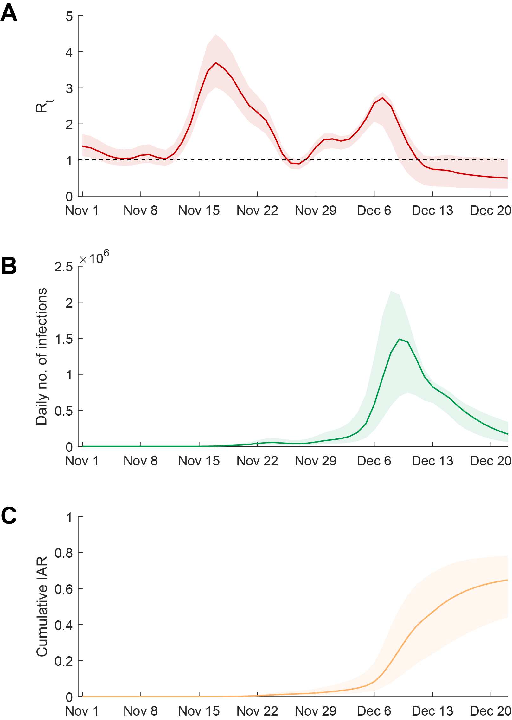
Supplementary Figure 1. Estimated $R_{t}$, daily incidence and cumulative infection attack rate in Beijing, assuming ascertainment probability was 80% after November 11. (A) Estimated $R_{t}$ between November 1 and December 21. The $R_{t}$ between December 15 and 21 were estimated assuming that the Beijing MTR mobility and population mixing level (and hence $R_{t}$) would remain at the same levels of December 14 for the next 7 days. (B) Estimated daily number of infections between November 1 and December 21. (C) Estimated cumulative infection attack rates between November 1 and December 21. Lines indicate the mean of estimates and shades indicate the 95% credible interval (95% CrI).

Supplementary Figure 2. Screenshots of results of Weibo online polls
Source: https://weibo.com/u/2987102112, December 10-14
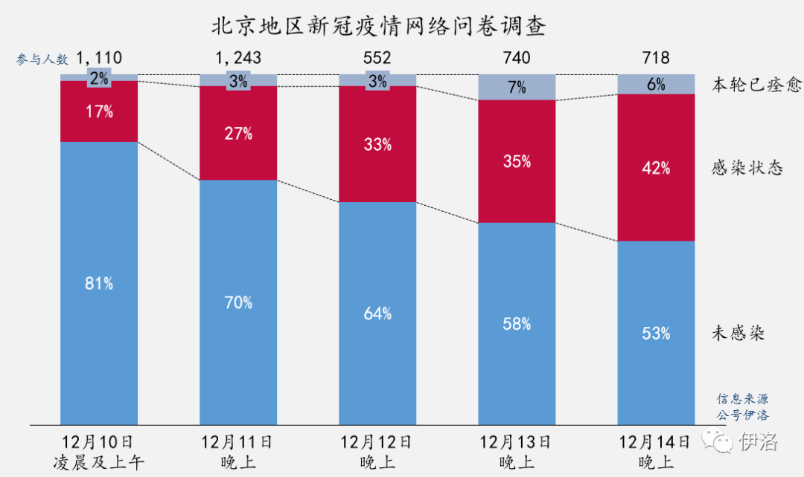
Source: https://weibo.com/u/7126731879, December 10
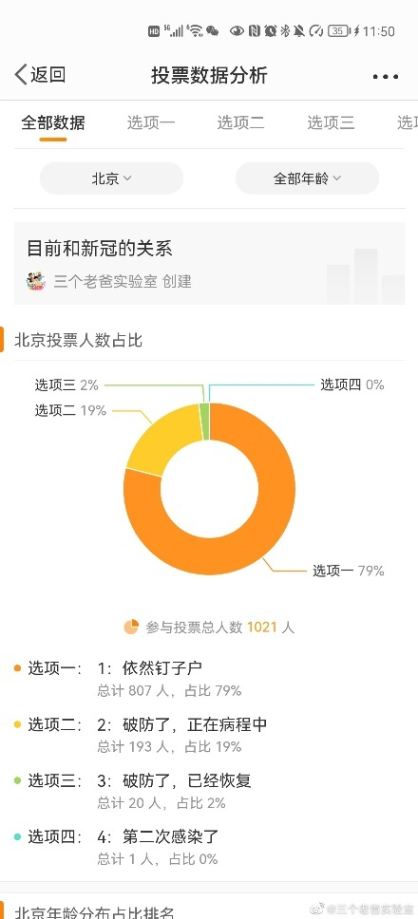

Source: https://weibo.com/u/7126731879, December 12
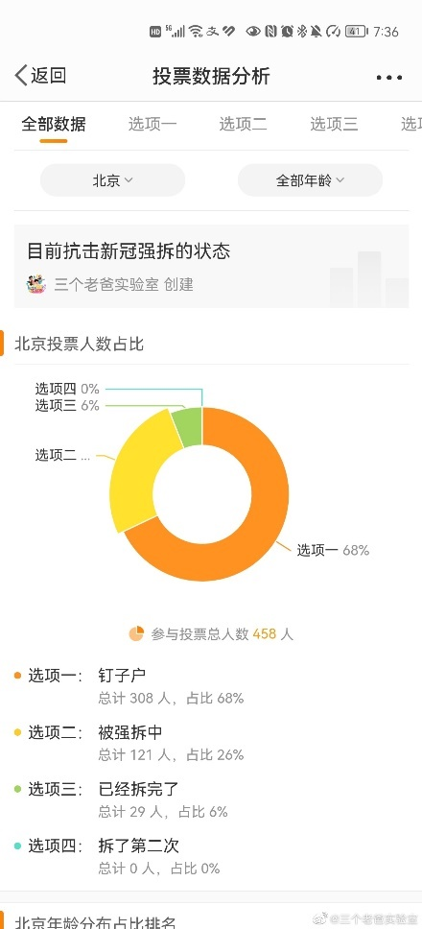
Source: https://weibo.com/chinaetfs, December 11
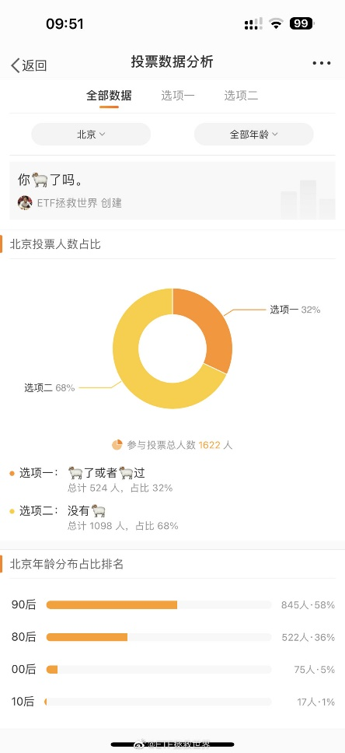
Source: https://weibo.com/chinaetfs, December 12
