Table 1: Data of DT-0111 binding to GPCRs

RECEPTOR TEST CONCENTRATION % INHIBITION OF SPECIFIC CONTROL BINDING
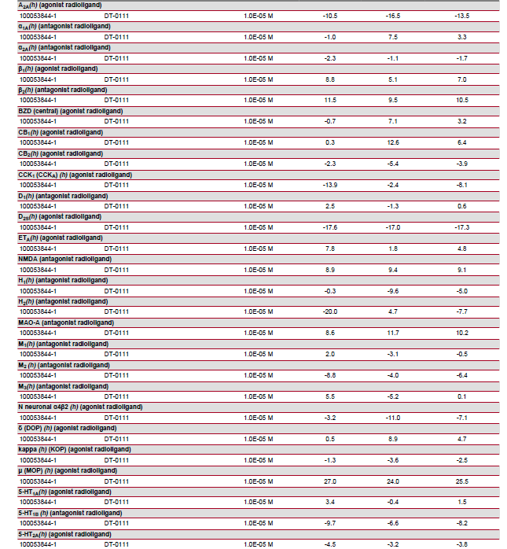
1st 2nd MEAN

