Supplementary material for “Is particulate organic carbon transported to the deep-ocean increasing with the growing ocean carbon sink”

Supplementary Information 1. Explanation of Table S1
Supplementary Information 2. POC flux based on ²³⁴Th method and POC flux at middle ocean (1000-2000 m)

Supplementary Information 1.
Explanation of Table S1
“Table S1” contains global compilation of fluxes of POC from sediment trap studies or ²³⁴Th studies with location information and references. Below is the description of each column in file Table S1.xls in detail.

No.: list of values (total #)
Station: name of location for sinking particle sampling conducted
Lat: Latitude (°)
Long: Longitude (°)
Year: Year of sampling conducted
Trap depth (m): Sediment trap deployed depth
Trap mab. (m): Sediment trap distance from the seafloor
Water depth (m): Total water depth
POC flux (mgC m⁻²d⁻¹): particulate organic carbon flux
POC method: Various methods used to get the particulate organic carbon (POC) data;
Direct measurement: sediment trap;
Isotope method: ²³⁴Th method;
Particulate organic matter conversion: POM flux =1.8 × POC flux, POM flux = 2 × POC flux, POM flux = 2.2 × POC flux
References: related paper or data published
Comments: author comments

Supplementary Information 2.
POC flux based on ²³⁴Th method and POC flux at middle ocean (1000-2000 m)

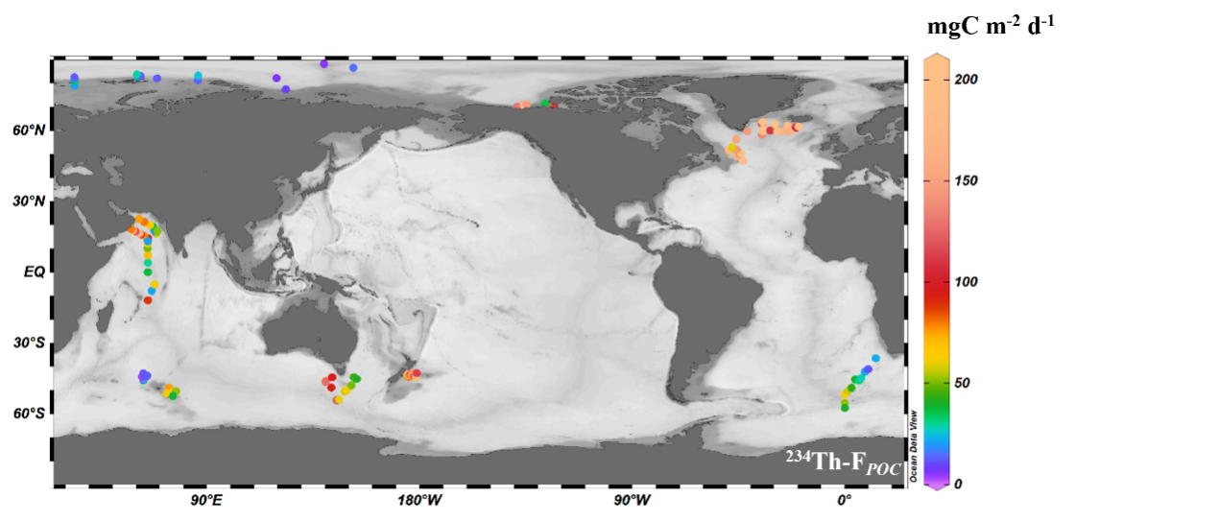

Supplementary Figure 1. ²³⁴Th sampling stations their POC fluxes at
0-200 m.
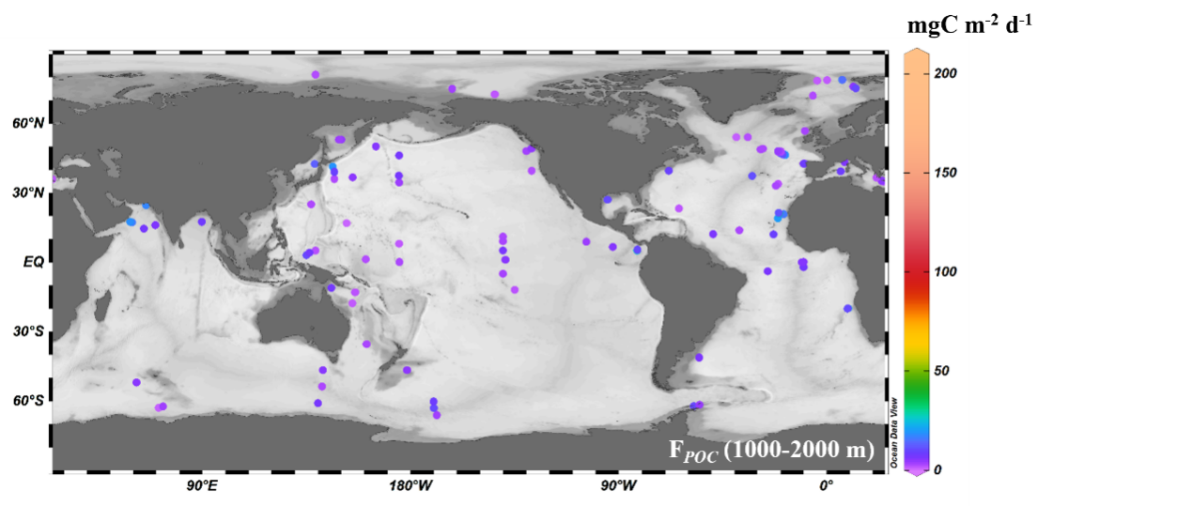
Supplementary Figure 2. Sediment trap deployment stations at middle ocean(1000-2000m) , Each symbol represents the arithmetic mean of the values observed at various times at the same location.

