Supplementary Information
For
Rapid oxidation of gasoline exhausts reveals marked impacts of transient conditions on potential of secondary organic aerosol production
Jinsheng Zhang¹, Jianfei Peng^{1,*}, Ainan Song¹, Zongyan Lv¹, Hui Tong¹, Zhuofei Du¹, Jiliang Guo¹, Lin Wu¹, Ting Wang¹, Mattias Hallquist², Hongjun Mao¹

1 Tianjin Key Laboratory of Urban Transport Emission Research & State Environmental Protection Key Laboratory of Urban Ambient Air Particulate Matter Pollution Prevention and Control, College of Environmental Science and Engineering, Nankai University, Tianjin 300071, China;
2 Department of Chemistry and Molecular Biology, University of Gothenburg, 41296 Gothenburg, Sweden.
*Correspondence: Jianfei Peng (pengjianfei@nankai.edu.cn.)

This file includes:
Supporting Text S1-S2
Supporting Table S1-S2
Supporting Figure S1-S21
Supporting references
Text S1. A fast response flow reactor system for photochemical oxidation
The SOA formation from the vehicle emission is investigated through an improved oxidative flow reactor （referred to as Veh-OFR） by exposing the sampled diluted exhaust to high levels of oxidants. As shown in Fig. S11, the Veh-OFR reactor is a 6.8 L vertical quartz glass cylindrical tube (98 cm long and 9.4 cm internal diameter). The entrance and end of the reactor are sealed with Teflon caps having facilities for entering or extracting gases and particles. The injection flow is divided into sheath flow and sample flow. The sample flow consists of the seed aerosol and diluted exhaust, while the sheath flow mixes the ozone and humid air. The residence time of sampled air is regulated by the flow rate inside the flow reactor. For the tests in this study, the total flow rate through the Veh-OFR reactor is set as 15 L min^{–1} with a residence time of 37s (Fig. S12). The temperature inside the reactor is maintained at 298 K by circulated compressed air cooling through a high-volume fan. The RH inside the OFR is in the range of 35%-40% by controlling the flow ratio of dry and wet zero air into the OFR.
The timescale of SOA formation inside the reactor consists of (1) physical dispersion time, (2) gas-phase oxidation time, and (3) gas-particle equilibration time. Therefore, it is expected to shorten the timescales of these processes to achieve rapid SOA formation.
In the reactor tube, axial diffusion is unavoidable, which will cause a delay in the gas or particle flow peak. The timescale of physical dispersion is determined by the extent of laminar flow. In Veh-OFR, the laminar extent of flow is quantified by a CO pulse. As shown in Fig. S12, due to the type of turbulence flow, the PAM reactor has a long tailing of the peak, which significantly limits identifying continuous pulse changes in precursor gaseous input. By comparison, the Go: PAM (Gothenburg Potential Aerosol Mass Reactor, Go: PAM) and Veh-OFR have shorter tailing, suggesting a greater laminar extent, which is conducive to decreasing the timescale of physical dispersion. In particular, for the Veh-OFR reactor, by adjusting the flow rate ratio of sample flow and sheath flow, an isokinetic injection of sample flow and sheath flow is achieved, further enhancing the laminar extent. Therefore, the outlet CO peak of the Veh-OFR reactor performs more symmetry than other rectors, showing better laminar flow performance. Furthermore, continuous particle pulse measurements are conducted to quantify the time response of the Veh-OFR reactor for axial diffusion. As shown in Fig. S13, the Veh-OFR reactor can distinguish the changes of injection flow pulses in 10s.
The timescale of the gas-phase oxidation process depends on the OH exposure within the reactor. To improve the oxidant production capacity, the Veh-OFR reactor is equipped with eight Philips UVC 45 W fluorescent lamps (λ = 254 nm). We use SO₂ as a surrogate to estimate the OH production capacity of the reactor system, obtaining an upper bound value. The result shows that the maximum OH exposure of the reactor at 15 L min⁻¹ is 3.0×10¹² molec. s cm⁻³, which is equivalent to 23.5 days of atmospheric photochemical oxidation. Such a level of OH exposure production can be against more external OH reactivities in the vehicle exhaust. Meanwhile, considering the fragmentation of aged vapors, this oxidation range should have an upper limit, especially for the latest emission standard vehicle test. Thus, a relative excess of oxidant concentration is generated in the reactor during the vehicle tests, approximately equaling 2.4 to 6.8 days of atmospheric oxidation.
Another important factor driving rapid SOA formation is the timescale of gas-particle equilibrium, which is determined by the condensation sink (CS) inside the reactor. Previous studies have shown that the CS can lead to an order of magnitude variation in SOA yield in the OFR photochemical oxidation of vehicle exhaust., It will not be able to obtain the real SOA production pulse with a large fluctuation of CS inside the reactor. In this study, a constant seed aerosol flow is introduced into the Veh-OFR reactor during the photochemical simulation of the vehicle tests, providing a steady and sufficient CS level. The seed aerosol (~280 µg m⁻³ with a mode mobility diameter of 45 nm) is generated via aerosol atomization (TSI, model 3706) and dried through a silica diffusion drier. The timescale of gas-particle equilibrium in the vehicle test fell into a range of 8.7-25.6 s, which is calculated as:
$τ_{g−p}={\left(2πN_{p}\overline{D_{p}}D_{gas}\overline{β}\right)}^{−1}$ (S1)
where τ_{g-p} denotes the timescale of gas-particle partitioning, Np denotes the particle number concentration, $\overline{D_{p}}$ presents the number mean diameter, D_{gas} is the gas-phase diffusivity, and $\overline{β}$ is the correction factor for the mass transfer flux in the condensing process.
Overall, the timescale of SOA formation should be shortened through these optimizations. Here, pulse experiments are conducted to quantify the response time of SOA formation in the Veh-OFR system, referred to Simonen et al.’s method. Use “on-off-on-off-on-off” to generate continuous toluene pulses under the same conditions during vehicle tests. The results are present in Fig. S14, showing that the 10s interval SOA peaks are conglutinated, while most 15s interval SOA peaks can be identified. This suggests that the Veh-OFR system can distinguish the changes of organic precursor pulses over 15s.
Monodisperse particles are used to quantify the particle wall loss of the Veh-OFR reactor (Fig. S15). The results show that the loss of 40 nm and 60 nm particles are less than 5%, while there is almost no wall loss for 80 nm and 120 nm particles. Therefore, the wall loss would cause little uncertainty in aerosol mass concentration.
Text S2. Condensation sink calculation and modeling
In the oxidation system, the fates of the aged VOCs include condensing onto aerosols, condensing on the reactor walls, exiting the reactor to condense on sampling lines, and reacting with OH to produce volatile fragmentation products, e.g., CO₂. The fraction of the fates depends strongly on the aerosol surface area available for the condensation sink (CS). For ambient experiments with low CS or laboratory experiments without seed aerosol, especially for the sampling with a relatively short residence time, a large aged VOCs vapor may be lost without condensing on the aerosol. Therefore, adding an aerosol seed flow to sample the air with low aerosol CS (such as this study) would reduce the uncertainties associated with VOCs losses.
According to the method reported by Palm et al., CS calculation used the
$CS=\sum_{i}{β(r_{i})r_{i}N_{i}}$ (S2)
where CS is the condensational sink, is the particle radius, and is the particle number size distribution. The r and N_{i} values are measured by SMPS at the outlet of the Veh-OFR reacor. The correction β(r) is the Fuchs–Sutugin correction for gas diffusion to a particle surface in the condensing species, and presents a function of the Knudsen number (Kn):
$β=\frac{Kn +1}{0.377Kn+1+\frac{4}{3α}{Kn}^{2}+\frac{4}{3α}Kn}$ (S3)
where α denotes the sticking coefficient with a transition regime from 0.1 to 1. Here, we assume α = 0.6. The Knudsen number is calculated as follows:
$Kn=3∙\frac{λ_{i}}{r_{i}}$ (S4)
where λ is the mean free path of the condensing gas and is calculated as:
$λ_{i}=3∙\frac{D_{i}}{C_{i}}$ (S5)
where D denotes the diffusion coefficient of gases, according to the report by Tang et al., this value is set as 7 × 10⁻⁶ m² s⁻¹ , equal to an oxidized organic molecule with a molecular weight of approximately 200 g mol⁻¹. C_{i} denotes the root mean square speed of the gas, which is equal to:
$$C_{i}=\sqrt{\frac{8N_{A}kT}{π{MW}_{i}}}$$
where N_{A} is Avagadro’s number, k is the Boltzmann constant, and T is the temperature.

Table S1 Specifications and test procedures of the tested vehicles
code | Displacement | Emission standard | Brand | Type | Fuel | Engine  type | After-  treatment | Cycle
1 | 1.2L | China Ⅳ | Volkswagen | Light-duty | E10 | PFI | TWC | WLTC
2 | 1.2L | China IV | Toyota | Light-duty | E10 | PFI | TWC | WLTC
3 | 1.4L | China Ⅴ | Toyota | Light-duty | E10 | PFI | TWC | WLTC
4 | 1.4T | China Ⅴ | Volkswagen | Light-duty | E10 | GDI | TWC | WLTC
5 | 1.4T | China Ⅵ | Volkswagen | Light-duty | E10 | GDI | TWC+GPF | WLTC
6 | 2.0L | China Ⅵ | Toyota | Light-duty | E10 | GDI | TWC+GPF | WLTC

Table S2 Average primary emissions of test vehicles based on hot-started WLTC cycle
code | Emission standard | NO | CO | THC | NH3 | PN | PM
 |  | mg kg-fuel⁻¹ | g kg-fuel⁻¹ | mg kg-fuel⁻¹ | mg kg-fuel⁻¹ | 1E+10 kg-fuel⁻¹ | mg kg-fuel⁻¹
Vehicle 1 | China Ⅳ | 1035.2 | 180.1 | 2023.6 | 580.9 | 5.9 | 27.4
Vehicle 2 | China IⅤ | 333.7 | 38.2 | 325.6 | 193.1 | 14.4 | 13.1
Vehicle 3 | China Ⅴ | 84.9 | 7.9 | 247.1 | 331.9 | 5.6 | 3.2
Vehicle 4 | China Ⅴ | 340.6 | 4.8 | 561.8 | 105.4 | 8.6 | 16.4
Vehicle 5 | China Ⅵ | 136.9 | 0.4 | 186.0 | 24.4 | 0.6 | 0.9
Vehicle 6 | China Ⅵ | 17.3 | 3.9 | 463.5 | 48.1 | 1.7 | 0.2
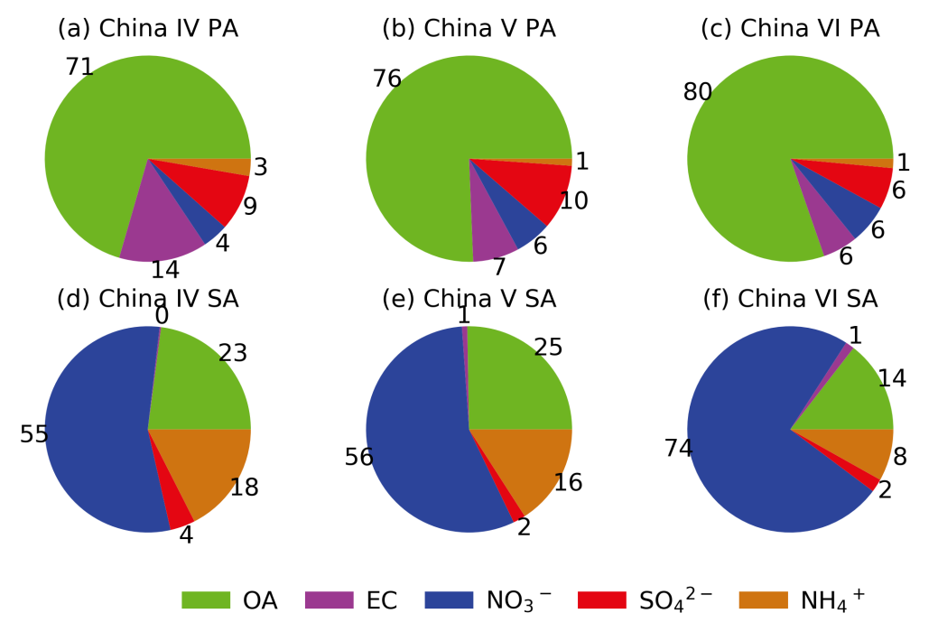
Figure S1. Average mass contributions of organic aerosol (OA), elemental carbon (EC), nitrate (NO₃⁻), sulfate (SO₄²⁻), and ammonium (NH₄⁺) to the total mass of primary aerosols (PA, a-c) and secondary aerosols (SA, d-f) after vehicle exhaust aging. The SA does not contain the PA since the inlet sample flow has been equipped with a filter.

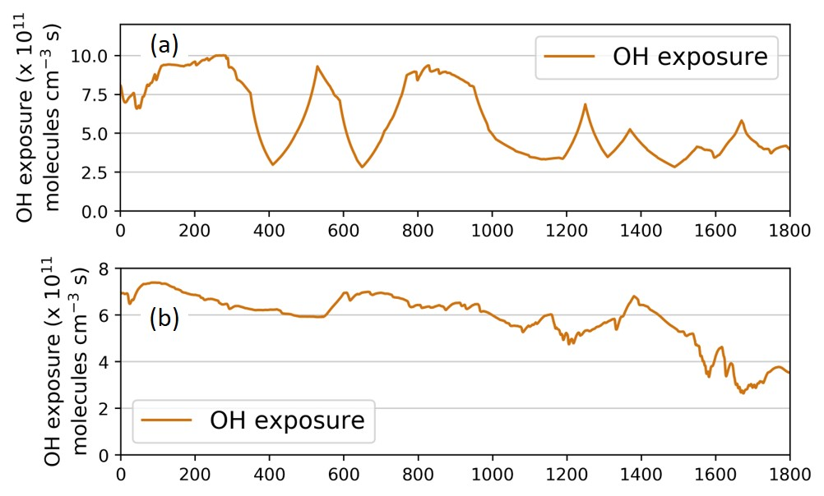
Figure S2.Time-resolved OH exposure during WTLC tests for the (a) China V and (b) China VI vehicles, respectively.

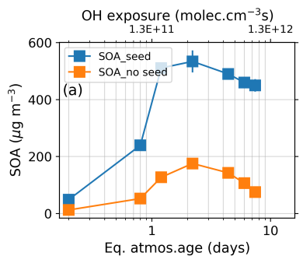
Figure S3. Photochemical aging of diluted exhaust of a China IV vehicle under idling condition. The SOA concentration varied as a function of OH exposure. Two sets of experiments were carried out with and without seed aerosol conditions respectively. The OH exposure is converted to equivalent atmospheric aging time (assuming [OH]_{ambient}=1.5×10⁶ molecule cm⁻³).

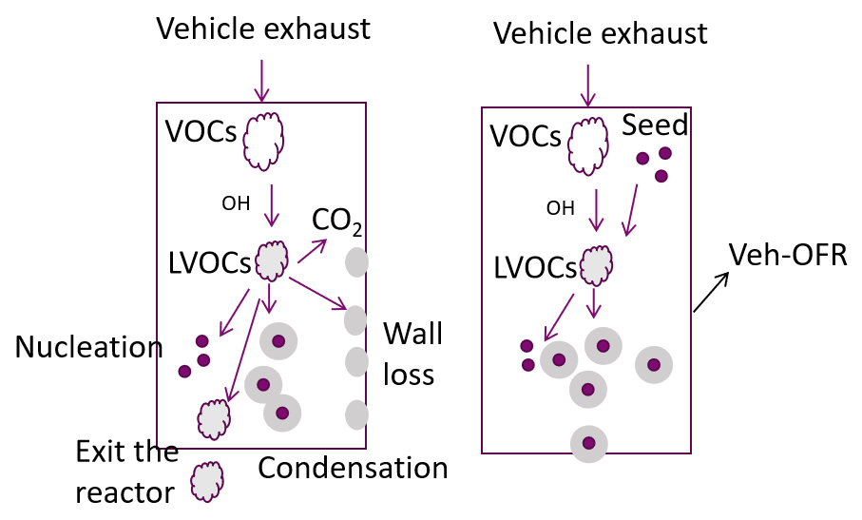
Figure S4. LVOCs fates in the Veh-OFR under the conditions of none-seed (left sub-figure) and seed (right sub-figure).
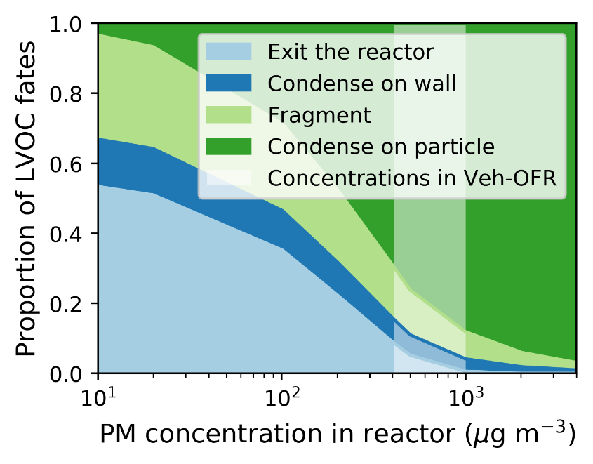
Figure S5. The fates of low volatile VOCs (LVOCs) act as a function of particle concentration in the Veh-OFR reactor. The calculation method is referred to as the method of Palm et al.

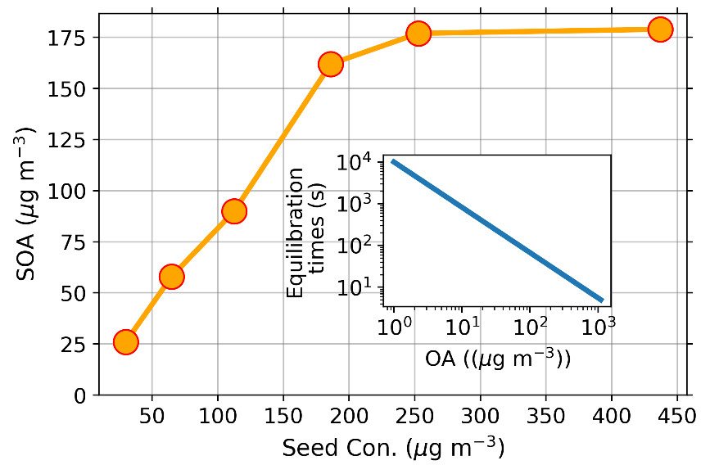
Figure S6. SOA formation as a function of pre-existing seed concentration under the idling condition of the vehicle. The equilibration times as a function of pre-existing particle concentration.

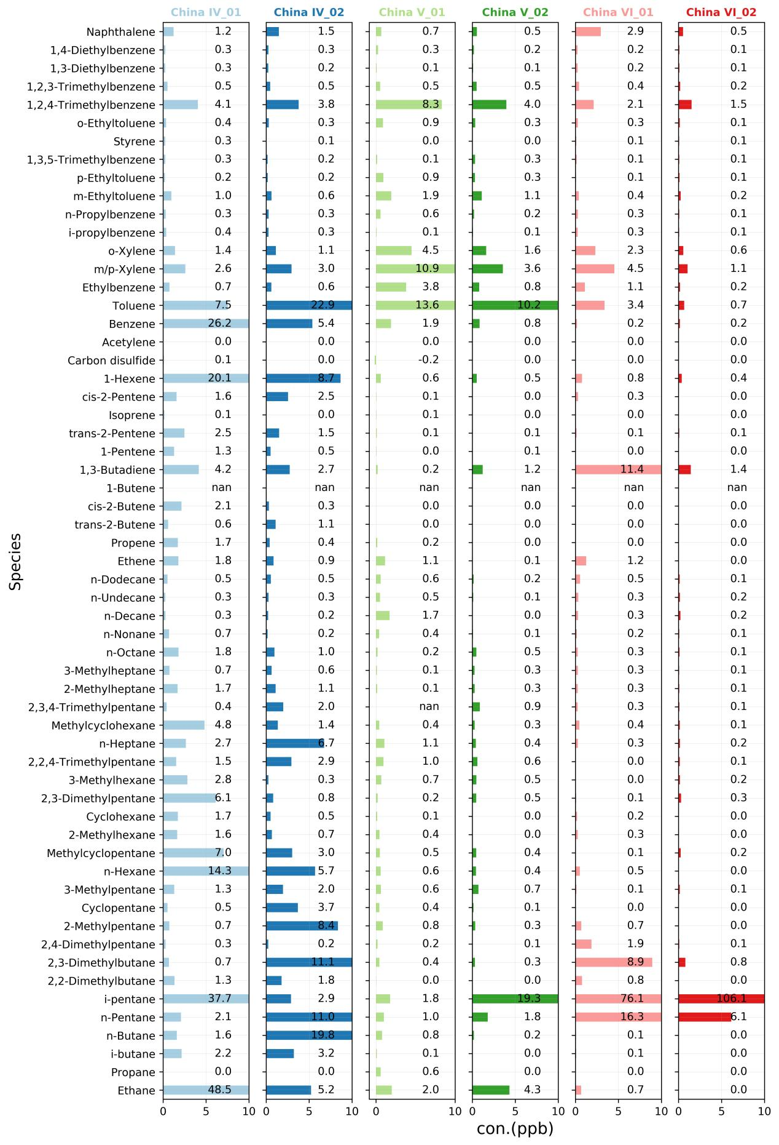
Figure S7 VOCs chemical profiles of vehicle exhaust with different emission standards.
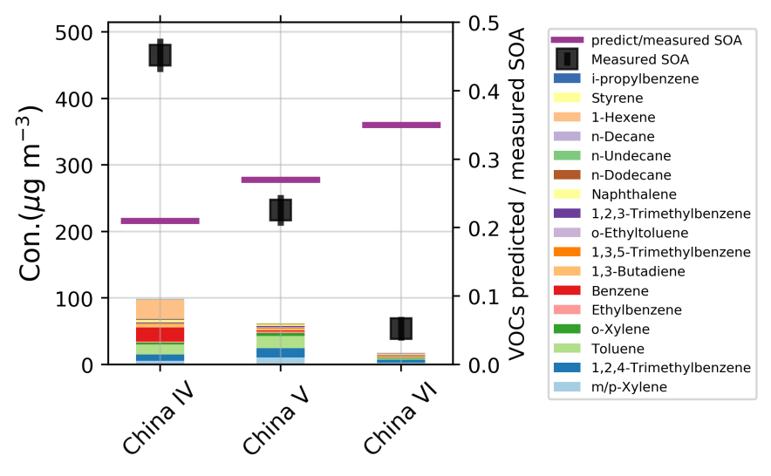
Figure S8. The measured and predicted SOA, and their ratios varied by emission standards. The predicted SOA is calculated based on the VOCs emission combined with recent reported SOA yield.
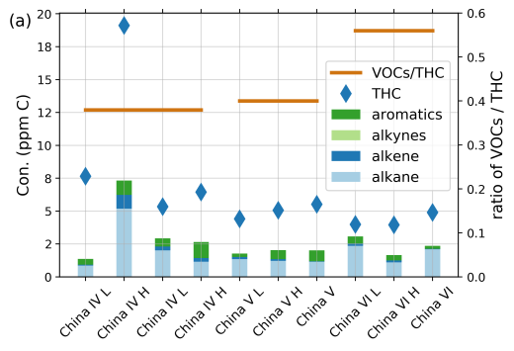
Figure S9. The concentrations of THC (ppm C) and the ratios of VOCs to THC (ppm C : ppm C) of test vehicles. The y-axis presents the concentrations and ratios of diluted exhaust.

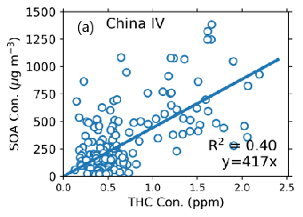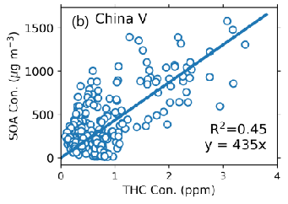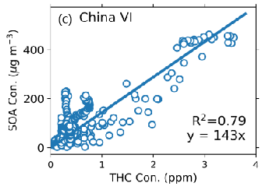
Figure S10. The correlation between SOA and THC from vehicle exhaust with China Ⅳ (a), China Ⅴ (b), and China Ⅵ (c) emission standards under different speed and acceleration driving conditions.

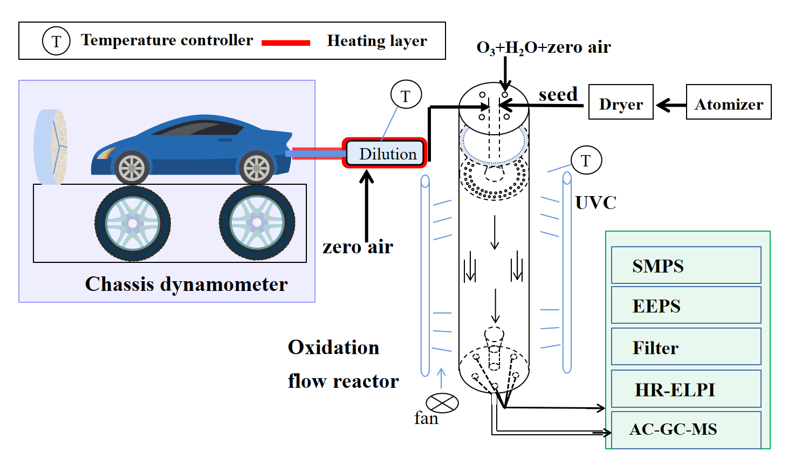
Figure S11. The schematic of the vehicle chassis dynamometer test and the oxidation flow reactor system (Veh-OFR).

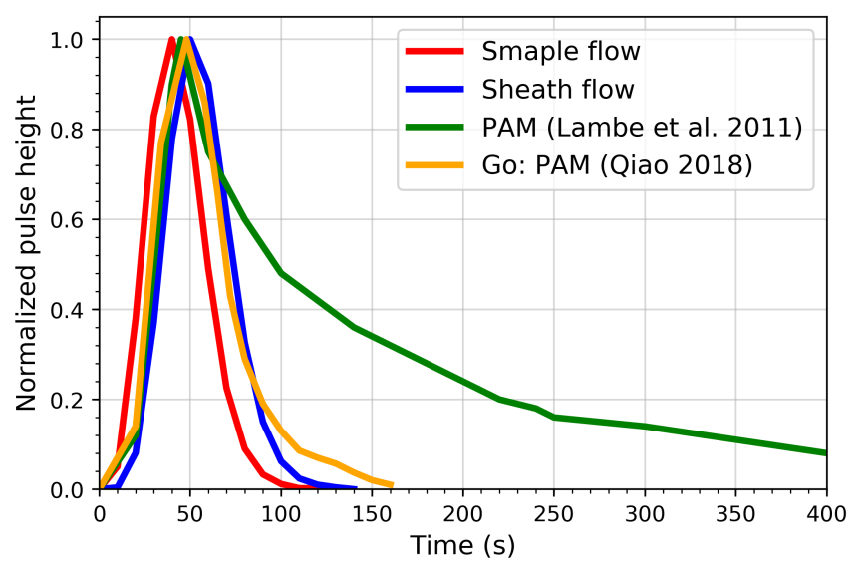
Figure S12. The distribution of residence time of Veh-OFR and the comparisons with other reported OFR reactors
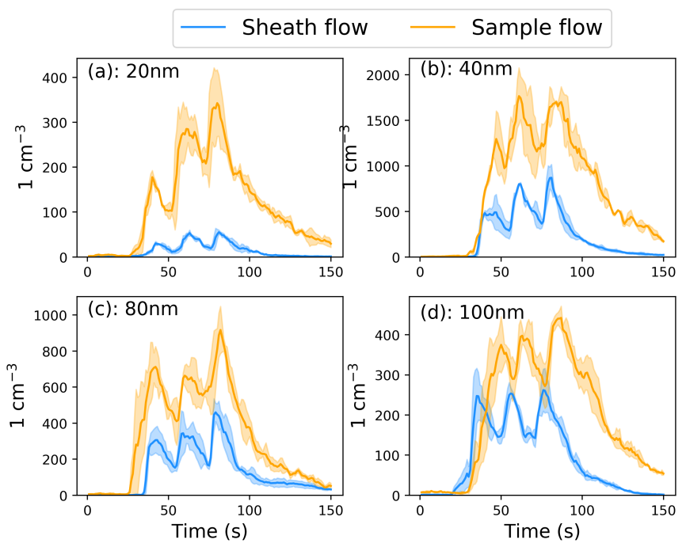
Figure S13. The time response to the 10s interval flow pulses of seed aerosols into Veh-OFR at a rate of 15 L/min. The monodisperse particles, i.e., 20, 40, 80, and 120 nm aerosols, were tested respectively.

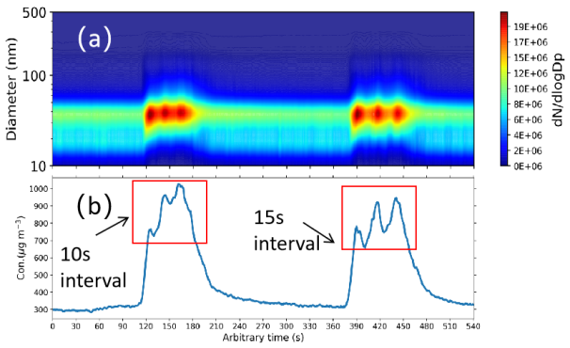
Figure S14. Time response of Veh-OFR to SOA formation formed by aromatic hydrocarbon flow pulses. The two sets of SOA peaks shown in the figure are the precursor pulses with 10s and 15s intervals, respectively.
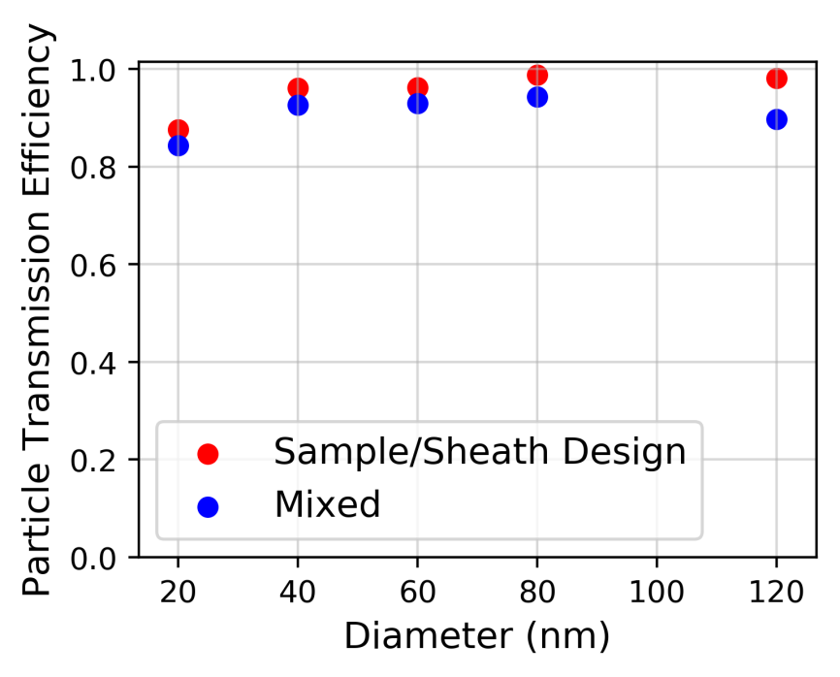
Figure S15. The quantification of particle wall loss in the Veh-OFR reactor under the sample/sheath flows design and mixed flows respectively.

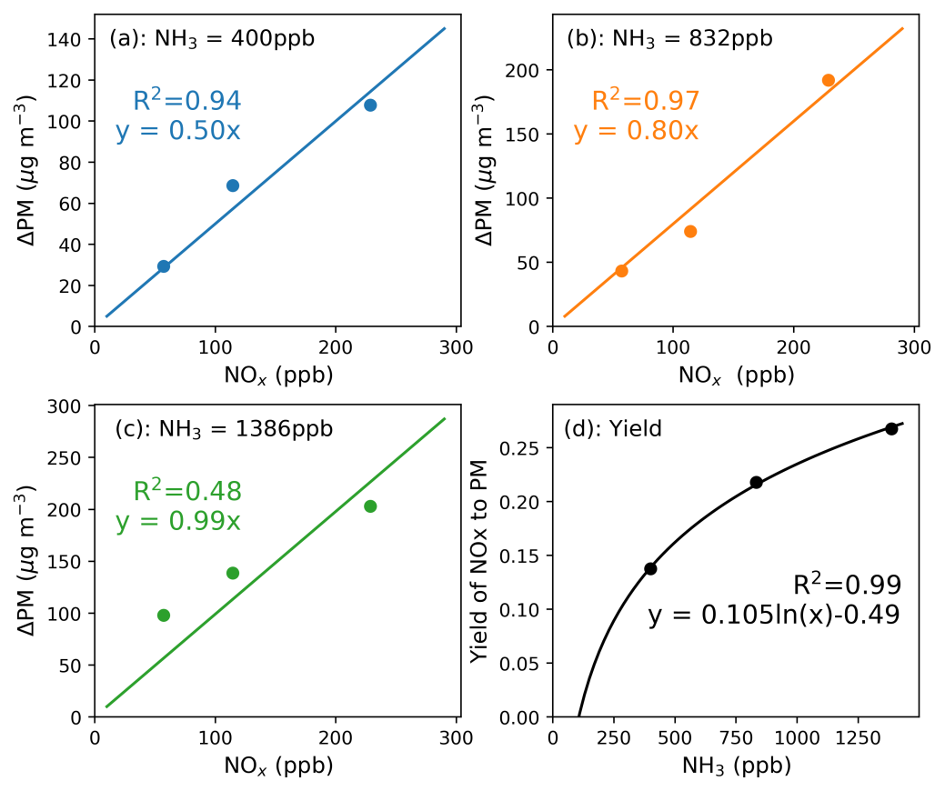
Figure S16. The nitrate formation as a function of NOx under different NH₃ levels (a, b, c). The yield of NOx to nitrate as a function of NH₃ concentration (d).
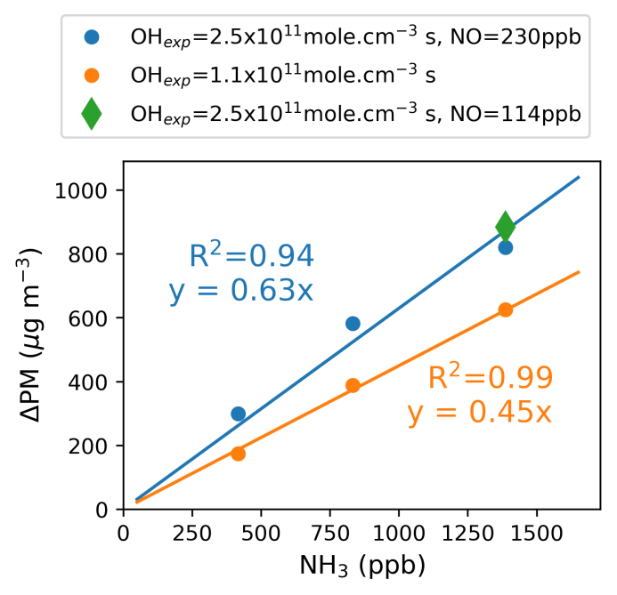
Figure S17. Ammonia secondary aerosol production as a function of NH₃ under different OH exposure.

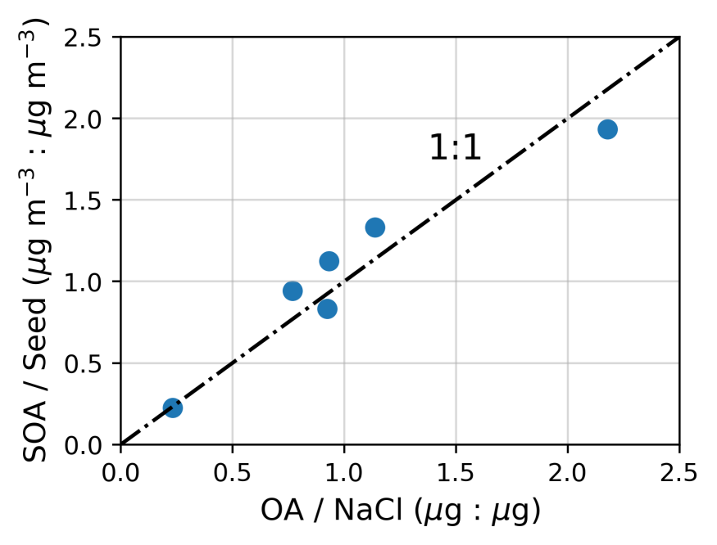
Figure S18. Calculated SOA vs. measured SOA. The ratios of calculated SOA and seed concentrations measured by EEPS vs. the ratios of OA and NaCl compositions analyzed by filters.

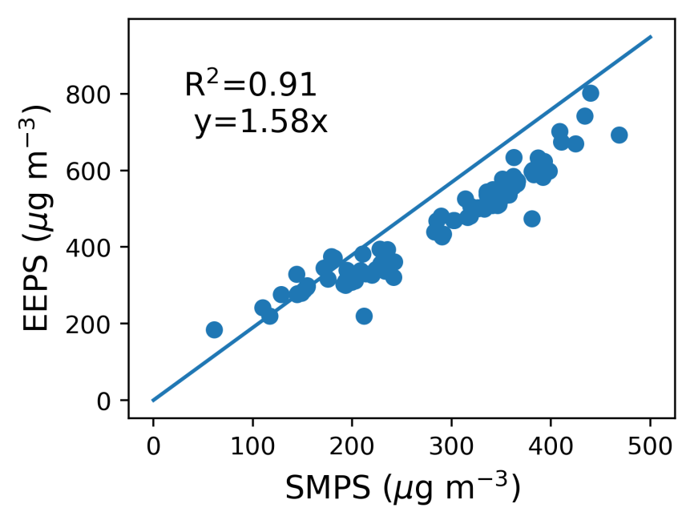
Figure S19. Calibration of the values measured by EEPS using the data of SMPS.

REFERENCES

Peng, Z.; Day, D. A.; Ortega, A. M.; Palm, B. B.; Hu, W. W.; Stark, H.; Li, R.; Tsigaridis, K.; Brune, W. H.; Jimenez, J. L. Non-OH chemistry in oxidation flow reactors for the study of atmospheric chemistry systematically examined by modeling. Atmos. Chem. Phys. 2016, 16, 4283−4305.
Jathar, S. H.; Friedman, B.; Galang, A. A.; Link, M. F.; Brophy, P.; Volckens, J.; Eluri, S.; Farmer, D. K. Linking load, fuel, and emission controls to photochemical production of secondary organic aerosol from a diesel engine. Environ. Sci. Technol. 2017, 51, 1377−1386.
Zhao, Y. L.; Lambe, A. T.; Saleh, R.; Saliba, G.; Robinson, A. L. Secondary organic aerosol production from gasoline vehicle exhaust: Effects of engine technology, cold start, and emission certification standard. Environ. Sci. Technol. 2018, 52, 1253−1261.
Simonen, P.; Saukko, E.; Karjalainen, P.; Timonen, H.; Bloss, M.; Aakko Saksa, P.; Rffnkkff, T.; Keskinen, J.; Dal Maso, M. A new oxidation flow reactor for measuring secondary aerosol formation of rapidly changing emission sources. Atmos. Meas. Tech. 2017, 10, 1519–537.
Palm, B. B.; Campuzano-Jost, P.; Ortega, A. M.; Day, D. A.; Kaser, L.; Jud, W.; Karl, T.; Hansel, A.; Hunter, J. F.; Cross, E. S.; Kroll, J. H.; Peng, Z.; Brune, W. H.; Jimenez, J. L. In situ secondary organic aerosol formation from ambient pine forest air using an oxidation flow reactor. Atmos. Chem. Phys. 2016, 16, 2943−2970.
Seinfeld, J. H. and Pandis, S. N.: Atmospheric chemistry and physics: from air pollution to climate change, 2nd ed., John Wiley & Sons, Inc., Hoboken, New Jersey, USA, 2006.
Zhang, X.; Cappa, C. D.; Jathar, S. H.; McVay, R. C.; Ensberg, J. J.; Kleeman, M. J.; Seinfeld, J. H. Influence of Vapor Wall Loss in Laboratory Chambers on Yields of Secondary Organic Aerosol. Proc. Natl. Acad. Sci. U. S. A. 2014, 111, 5802−5807.

