Table 1: Performance Comparison of RCNN and Faster RCNN for Text Feature detection in Topographic Sheet
 | Sample Image |  |  |  | 1 |  | 2 |  | 3 |  | 4 |  | 5
 | Input Image |  |  |  | 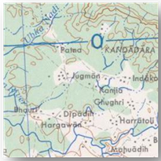 |  | 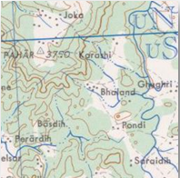 |  | 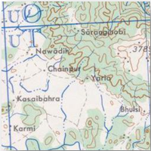 |  | 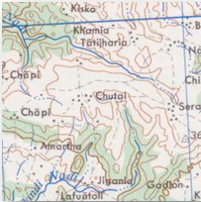 |  | 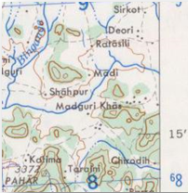
 | RCNN Output |  |  |  | 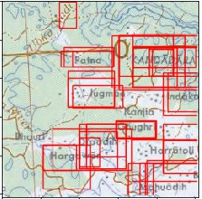 |  | 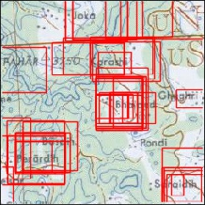 |  | 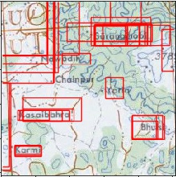 |  | 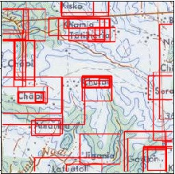 |  | 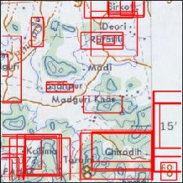
 | FRCNN Output |  |  |  | 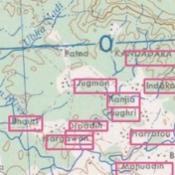 |  | 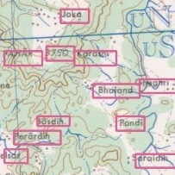 |  | 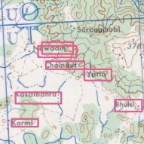 |  | 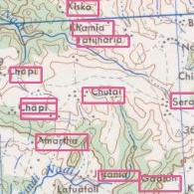 |  | 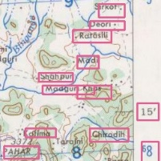
 | Total Text |  |  |  | 12 |  | 12 |  | 8 |  | 16 |  | 15
 | Unclassified |  | RCNN |  | 2 |  | 6 |  | 2 |  | 6 |  | 3
 |  |  | FRCNN |  | 2 |  | 2 |  | 2 |  | 6 |  | 3
 | Misclassified |  | RCNN |  | 2 |  | 3 |  | 6 |  | 4 |  | 1
 |  |  | FRCNN |  | 0 |  | 1 |  | 0 |  | 0 |  | 0
 | Classified Correctly |  | RCNN |  | 10 |  | 6 |  | 6 |  | 10 |  | 12
 |  |  | FRCNN |  | 10 |  | 6 |  | 6 |  | 10 |  | 12
Sample Image |  |  |  | 6 |  | 7 |  | 8 |  | 9 |  | 10
Input Image |  |  |  | 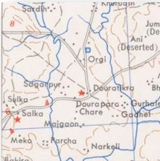 |  | 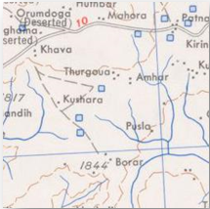 |  | 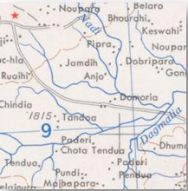 |  | 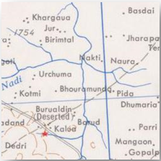 |  | 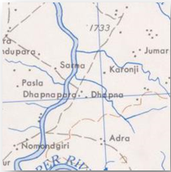
RCNN Output |  |  |  | 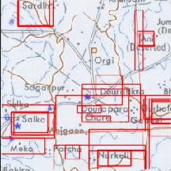 |  | 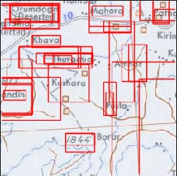 |  | 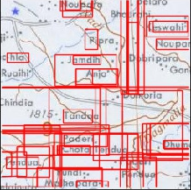 |  | 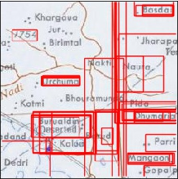 |  | 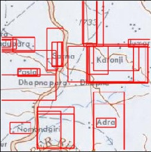
FRCNN Output |  |  |  | 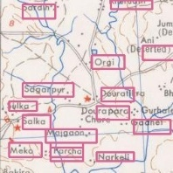 |  | 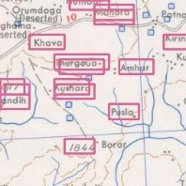 |  | 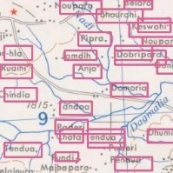 |  | 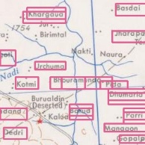 |  | 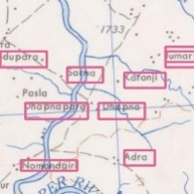
Total Text |  |  |  | 18 |  | 17 |  | 26 |  | 24 |  | 12
Unclassified |  | RCNN |  | 9 |  | 9 |  | 15 |  | 13 |  | 5
 |  | FRCNN |  | 4 |  | 7 |  | 4 |  | 9 |  | 4
Misclassified |  | RCNN |  | 0 |  | 2 |  | 4 |  | 0 |  | 0
 |  | FRCNN |  | 0 |  | 1 |  | 0 |  | 0 |  | 0
Classified Correctly |  | RCNN |  | 9 |  | 8 |  | 11 |  | 11 |  | 7
 |  | FRCNN |  | 14 |  | 10 |  | 22 |  | 15 |  | 8
 | Sample Image |  |  |  | 11 |  | 12 |  | 13 |  | 14 |  | 15
 | Input Image |  |  |  | 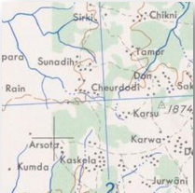 |  | 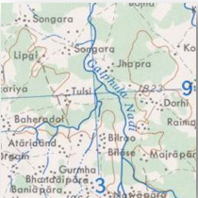 |  | 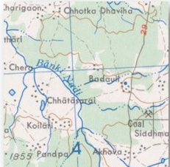 |  | 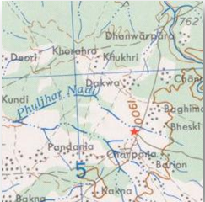 |  | 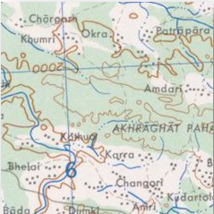
 | RCNN Output |  |  |  | 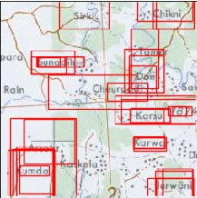 |  | 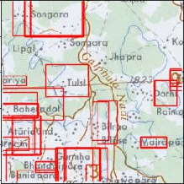 |  | 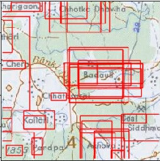 |  | 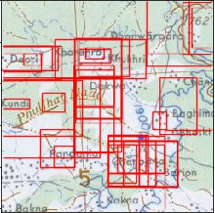 |  | 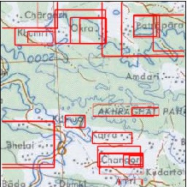
 | FRCNN Output |  |  |  | 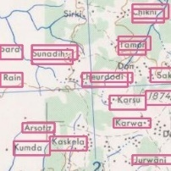 |  | 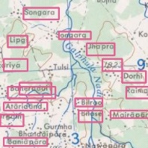 |  | 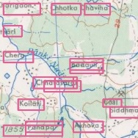 |  | 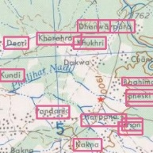 |  | 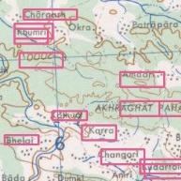
 | Total Texts |  |  |  | 17 |  | 21 |  | 14 |  | 15 |  | 16
 | Unclassified |  | RCNN |  | 2 |  | 0 |  | 0 |  | 3 |  | 0
 |  |  | FRCNN |  | 0 |  | 0 |  | 0 |  | 0 |  | 1
 | Misclassified |  | RCNN |  | 7 |  | 12 |  | 3 |  | 9 |  | 8
 |  |  | FRCNN |  | 3 |  | 5 |  | 1 |  | 4 |  | 6
 | Classified Correctly |  | RCNN |  | 10 |  | 9 |  | 11 |  | 4 |  | 8
 |  |  | FRCNN |  | 14 |  | 15 |  | 13 |  | 11 |  | 10

