Supplementary Appendix
Supplementary Table 1. Multivariable analysis for identification of factors associated with radiographic progression defined as an increase of ≥2 mSASSS units per 2 years in the cervical and in the lumbar spine.

 | Cervical spine |  |  | Lumbar spine
Variable | OR | 95% CI | P value | OR | 95% CI | P value
TNFi use before radiographic interval yes/no | 0.34 | 0.12; 0.95 | 0.04 | 0.97 | 0.47; 2.03 | 0.94
mSASSS at start of each radiographic interval | 1.05 | 1.02; 1.08 | <0.001 | 1.04 | 1.02; 1.07 | <0.001
Male sex | 2.15 | 0.62; 7.43 | 0.23 | 4.75 | 1.34; 16.8 | 0.02
Symptom duration (5 years) | 1.28 | 1.04; 1.57 | 0.02 | 0.89 | 0.72; 1.10 | 0.28
Current smoking | 1.51 | 0.64; 3.57 | 0.34 | 0.54 | 0.23; 1.25 | 0.15
HLA-B27 | 0.51 | 0.24; 2.71 | 0.73 | 0.97 | 0.33; 2.88 | 0.96
Number of exercise sessions per week | 0.93 | 0.78; 1.12 | 0.45 | 1.00 | 0.86; 1.16 | 0.98
Peripheral arthritis | 1.32 | 0.55; 3.17 | 0.54 | 0.91 | 0.43; 1.92 | 0.80
NSAID use at start of each radiographic interval | 0.48 | 0.17; 1.39 | 0.18 | 1.09 | 0.44; 2.72 | 0.85
BMI 25-30 (Reference: BMI <25) | 2.05 | 0.92; 4.56 | 0.08 | 1.07 | 0.48; 2.38 | 0.86
BMI >30 (Reference: BMI <25) | 0.52 | 0.07; 4.02 | 0.53 | 1.85 | 0.75; 4.57 | 0.18
Length of radiographic interval | 0.55 | 0.23; 1.33 | 0.19 | 2.09 | 0.85; 5.15 | 0.11
Analysis performed in 399 intervals from 297 patients. BMI = Body Mass Index; HLA-B27 = human leucocyte antigen B27; mSASSS = modified Stoke Ankylosing Spondylitis Spine Score; NSAID = Nonsteroidal anti-inflammatory drug; TNFi = Tumour necrosis factor inhibitor.

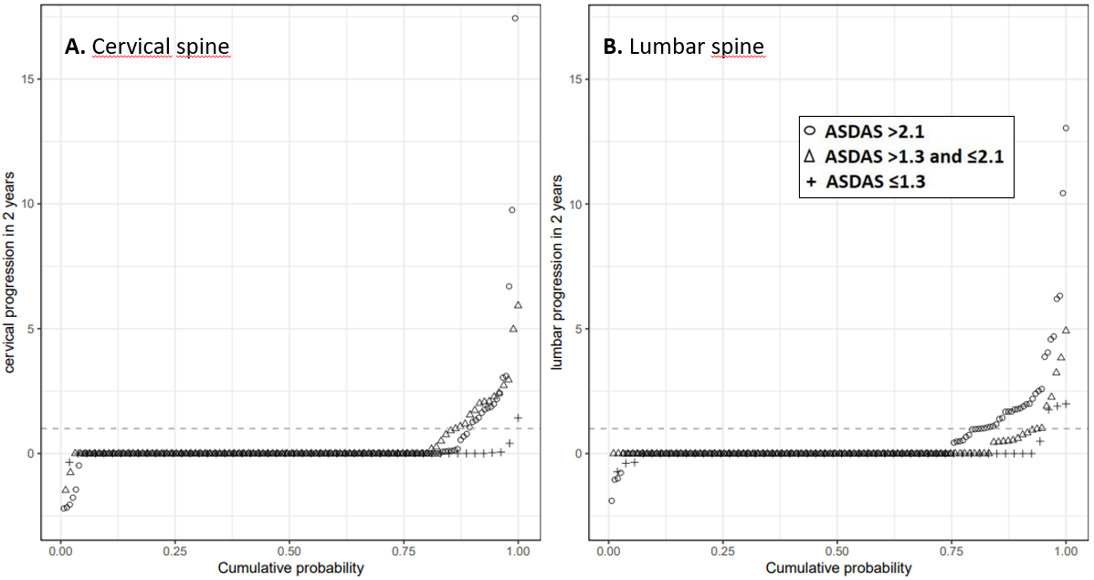
Supplementary Figure 1. Cumulative probability plot of 2-year progression in the modified Stoke Ankylosing Spondylitis Spinal Score (mSASSS) by spinal segments (A. cervical spine; B. lumbar spine); illustrating the change in mSASSS values (range 0-36 per spinal segment) from baseline of each radiographic interval to 2 years in patients already treated with TNFi at start of the respective interval, stratified by the ASDAS cut-off level reached at the beginning of each radiographic level. Radiographic progression was defined as an increase in mSASSS of ≥1 unit in 2 years (dotted line). ASDAS, Ankylosing Spondylitis Disease Activity Score.

