Supplementary results

Differentiation of cells into macrophages and the expression of cell surface markers
To investigate the function of M2 macrophages, THP1 human monocytes and mouse bone marrow macrophage cells were induced to differentiate into different types of macrophages using cytokines indicated in Supplementary Fig. 1a & 1h. Treatment of THP1 cells with PMA, LPS or IFNγ resulted in high expression of CD68 (Supplementary Fig. 1b), TNFα (P<0.005) and IL-1β (P<0.001) (Supplementary Fig. 1c), which are consistent with the characteristics of M1 macrophages. Treatment of THP1 cells with PMA, IL-4 and IL-13 triggered high expression of markers of M2 macrophages, CD206, CD204 (Supplementary Fig. 1b), CCL17 (P<0.005) and CCL22 (P<0.0001) (Supplementary Fig. 1d). Results of RT-qPCR (P<0.005 vs T-M0, P<0.001 vs T-M1) and Western blot (P<0.05 vs T-M0, P<0.005 vs T-M1) analyses showed that the T-M2 macrophages significantly overexpressed CD206, compared to T-M0 and T-M1 macrophages CD206 (Supplementary Fig. 1e, f, g).
Similarly, mouse bone marrow-derived macrophages (BMDMs) were induced to differentiate into M-M0, M-M1 and M-M2 macrophages (Supplementary Fig. 1h). Flow cytometry and confocal microscopy showed that 84.5% (± 3.2%) of the Balb/c mouse bone marrow cells were viable (Supplementary Fig. 1i), and the markers F4/80 and CD11b were highly expressed after induction with mMCSF for 7 days (Supplementary Fig. 1j, k). These results indicate that BMDMs were successfully generated. High expression of iNOS (P<0.001) and IL-12 (P<0.001) in cells induced with LPS and IFNγ is consistent with the characteristics of M1 macrophages (Supplementary Fig. 1l), and the high expression of Arg1 (P<0.001) and Ym1 (P<0.005) in IL-4-treated cells is consistent with the characteristics of M2 macrophages (Supplementary Fig. 1m). Images acquired by laser confocal microscopy indicated that CD68 and CD80 were highly and specifically expressed in the M-M1 macrophages, while CD206 was specifically expressed in the M-M2 macrophages (Supplementary Fig. 1n). RT-qPCR results also showed that CD206 mRNA was significantly more abundant in the M-M2macrophages (P<0.005) (Supplementary Fig. 1o). These results demonstrate that T-M2 and M-M2 cells with M2 characteristics were successfully induced, and that CD206 is a specific marker for T-M2 and M-M2 macrophages.

siRNAs transfected into M-M2 interfere with the expression of CD206
CD206 is specifically expressed by M2 macrophages, with high expression levels correlated with a poor prognosis in breast cancer. However, the role of CD206 in the promotion of breast cancer development by M2 macrophage cells remains unclear. We designed three mouse-specific siRNAs (MS1, MS2 and MS3) for transfection into mouse macrophage cells to to knock-down mouse CD206 expression. RT-qPCR results showed that the MS3 siRNA induced the greatest downregulation, compared to control (NC) siRNA, for CD206 expression in M-M2 cells (Supplementary Fig. 2a). Confocal microscopy showed that MS3 siRNA treatment for 24, 48 and 72 h led to decreased CD206 protein abundance in the M-M2 macrophages (Supplementary Fig. 2b), with the greatest decrease occurring at 48 hours but remaining stable through 72 hours.

siRNAs transfected into T-M2 interfere with the expression of CD206
To further examine the role of CD206 in macrophages, three human-specific siRNAs (HS1, HS2 and HS3) were designed to interfere with the expression of CD206 in human T-M2 macrophages. mRNA and protein levels for CD206 in cells treated with HS1, HS2 or HS3 was found to be significantly reduced 48 and 72 hours after transfection. The knockdown activity of HS1 was strongest as seen by both RT-qPCR (Supplementary Fig. 3a) and by Western blot (Supplementary Fig. 3b, c) analysis, with a peak reduction observed at 48 h. The low abundance of CD206 in T-M2 macrophages was also observed by confocal microscopy at 48 h after HS1 treatment (Supplementary Fig. 3d, e).

Characterization of MCF-7 exosomes
As an important intercellular signal transmission pathway, exosomes allow communication between tumor cells and macrophages (among other cells). To examine the effect of MCF-7 exosomes on T-M0 macrophages, an exosome uptake experiment was conducted. MCF-7 exosomes were characterized by ultracentrifugation, transmission electron microscopy and particle size analysis, which showed that they have a typical double-layer vesicle structure with a diameter of 30-200 nm (Supplementary Fig. 7a, b), which is consistent with the characteristics of exosome from other sources. Western blotting for the exosome marker proteins Hsp70, TSG101, CD63 and CD9, revealed that were present in exosomes from MCF-7 cells (Supplementary Fig. 7c). The exosome uptake experiment showed that DiD-labelled MCF-7 exosomes appeared in T-M0 macrophages after coculture for 48 hours (Supplementary Fig. 7d). 3D reconstruction of the cells by laser confocal microscopy clearly showed that the DiD-labelled exosomes were evenly distributed in the cytoplasm of T-M0 macrophages (Supplementary Fig. 7e).

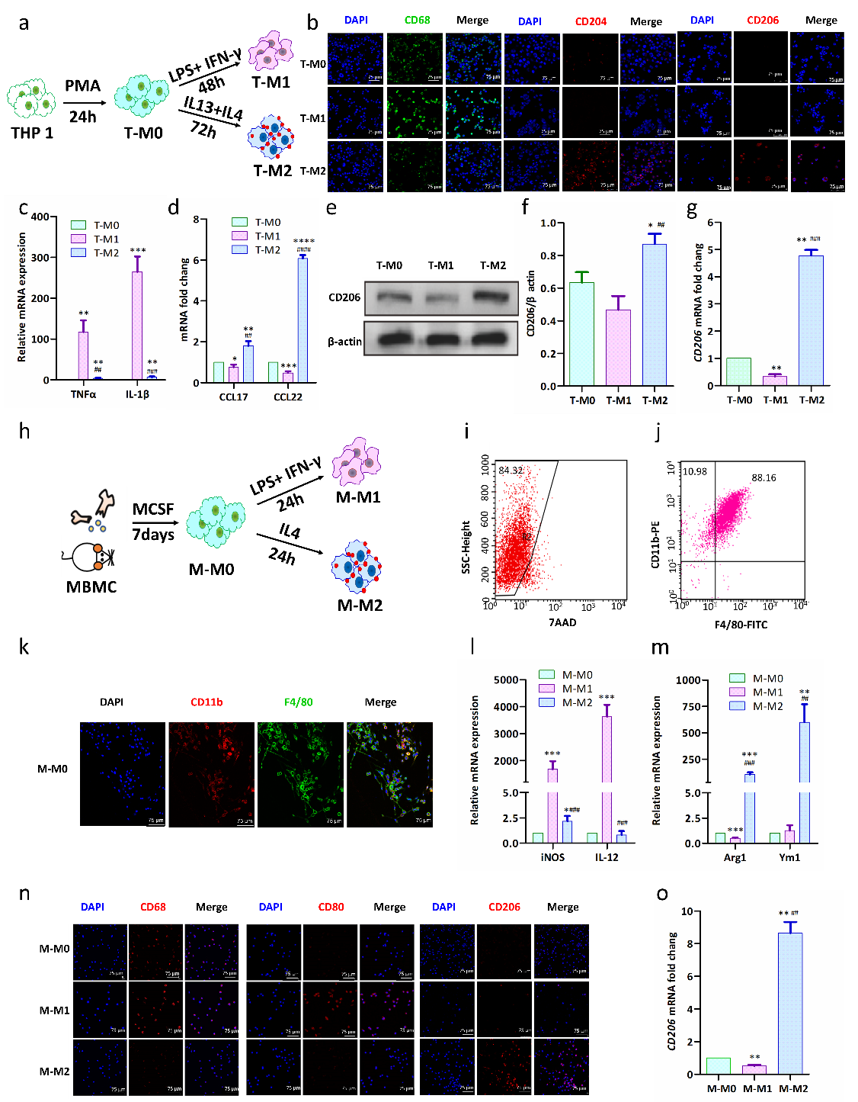

Supplementary Fig 1 Differentiation of macrophages and expression of cell surface markers
a, Scheme illustrating the experimental strategy for polarizing THP1 cells into macrophages.
b, Representative immunofluorescent images of T-M0, T-M1 and T-M2 cells after THP1 induction. CD68, CD204 and CD206 proteins were detected by immunofluorescence with primary and secondary antibodies. Nuclei were counterstained with DAPI (n = 3).
c, Abundance of TNFα and IL-1β mRNA were quantified by RT-qPCR in T-M0, T-M1 and T-M2 cells after induction from THP1 cells. (n = 3 independent cell cultures per group). (* indicates statistical significance vs T-M0, P > 0.05; # indicates statistical significance vs T-M1, P > 0.05). (n =3)
d, Abundance of CCL17 and CCL22 mRNA were quantified by RT-qPCR in T-M0, T-M1 and T-M2 cells after induction from THP1 cells. (n = 3 independent cell cultures per group). (* indicates statistical significance vs T-M0, P > 0.05; # indicates statistical significance vs T-M1, P > 0.05). (n =3)
e-f, Representative Western blots (e) and the quantification (f) of CD206 protein in T-M0, T-M1 and T-M2 cells induced from THP1 cells. CD206 abundance was normalized to β-actin. (n = 3 samples per group). (* indicates statistical significance vs T-M0, P > 0.05; # indicates statistical significance vs T-M1, P > 0.05). (n =3)
g, Abundance of CD206 mRNA in T-M0, T-M1 and T-M2 cells induced from THP1 cells. (n = 3 independent cell cultures per group). (* indicates statistical significance vs T-M0, P > 0.05; # indicates statistical significance vs T-M1, P > 0.05). (n =3)
h, Scheme illustrating the experimental procedure for the polarization of mouse bone marrow-derived macrophages (BMDM).
i. Flow cytometry of M-M0 cells 7 days after induction of harvested BMDMs with mMCSF. The R2 region represents live cells.
j. Flow cytometry of M-M0 cells after BMDMs were induced with mMCSF for 7 days. The upper left panel shows CD11b and F4/80 double-positive cells.
k. Representative immunofluorescence images of M-M0 cells after BMDMs were induced with mMCSF for 7 days.
l. Abundance of iNOS and IL-12 mRNA in M-M0, M-M1 and M-M2 cells induced from BMDMs quantified by RT-qPCR (n = 3) (* indicates statistical significance vs M-M0, P > 0.05; # indicates statistical significance vs M-M1, P > 0.05). (n =3)
m. Abundance of Arg1 and Ym1 mRNA in M-M0, M-M1 and M-M2 induced from BMDMs quantified by RT-qPCR (n = 3) (* indicates statistical significance vs M-M0, P > 0.05; # indicates statistical significance vs M-M1, P > 0.05). (n =3)
n. Representative immunofluorescence images of M-M0, M-M1 and M-M2 cells induced from BMDMs.
o. Abundance of CD206 mRNA in M-M0, M-M1 and M-M2 induced from BMDMs quantified by RT-qPCR (n = 3) (* indicates statistical significance vs M-M0, P > 0.05; # indicates statistical significance vs M-M1, P > 0.05). (n =3)

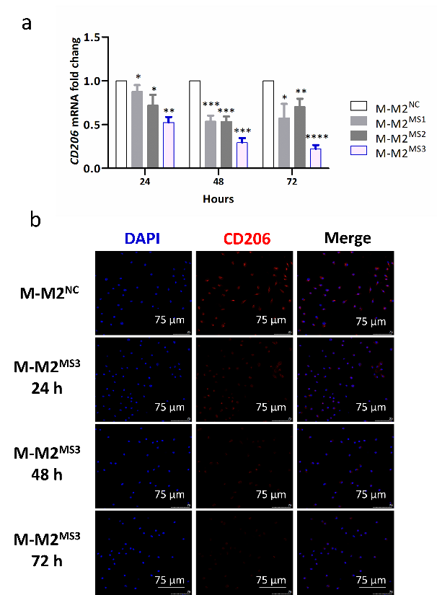

Supplementary Fig 2 siRNAs transfected into M-M2 cells interfere with the expression of CD206
a. CD206 siRNAs were transfected into M-M2 to interfere with the expression of the CD206 gene. CD206 mRNA levels were quantified by RT-qPCR 24, 48 and 72 hours after transfection with the siRNAs. (n =3)
b. The representative immunofluorescence confocal images of M-M2 transfected with MS3 siRNA for 48 h. Nuclei were stained with DAPI (blue) in the left column, CD206 was detected by immunofluorescence (red) in the center and merge of the two images is shown on the right.

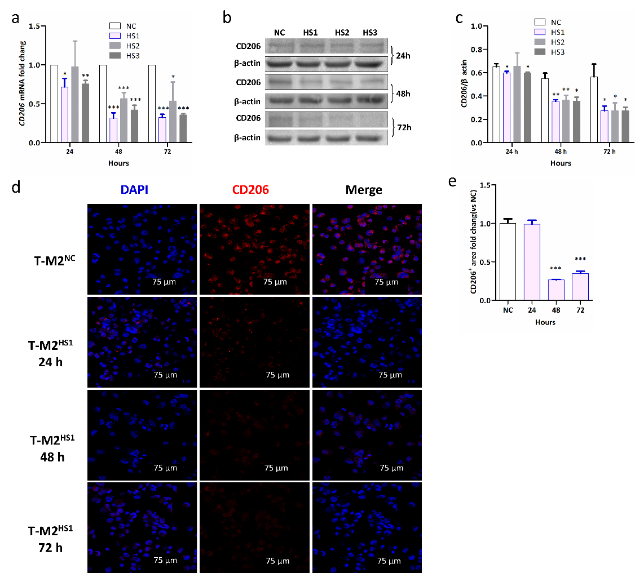

Supplementary Fig 3 siRNAs transfected into T-M2 cells interfere with the expression of CD206
a. siRNAs for CD206 were transfected into T-M2 cells and the abundance of of CD206 mRNA was examined after 24, 48 and 72 hours. Abundance of CD206 mRNA was measured by RT-qPCR.
b-c, Representative western blots (b) and quantification (c) of CD206 protein levels 24, 48 and 72 hours after transfection of T-M2 cells with the NC (negative control), HS1, HS2 and HS3 siRNAs. HS1, HS2 and HS3: siRNA designed to interfere with human CD206 gene expression. (* indicates statistical significance vs NC, P<0.05). (n =3)
d-e, Representative immunofluorescence images (d) and analysis of fluorescence intensity (f) for CD206 (red) 48 h after transfection of T-M2 cells with HS1. (* indicates statistical significance vs NC, P<0.05). (n =3)

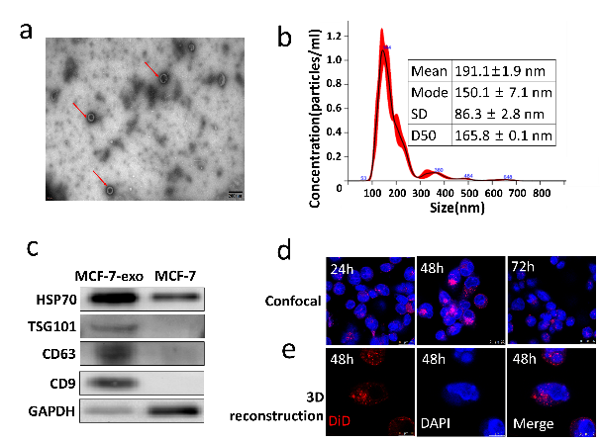

Supplementary Fig 4 Characterization of exosomes from MCF-7 cells
a. Transmission electron microscopy images of MCF-7 exosomes.
b. Particle size analysis of MCF-7 exosomes.
c. Representative Western blot images for proteins detected from exosomes produced by MCF-7 cells and from MCF-7 cells.
d. Representative images and 3D reconstructions generated by laser confocal microscopy of DiD-labeled MCF-7 exosomes co-cultured with T-M0 cells for 24, 48 and 72 h.
e. 3D reconstructions generated by laser confocal microscopy of DiD-labeled MCF-7 exosomes co-cultured with T-M0 cells for 48h.

Supplementary Table 1 Primers used for RT-qPCR
Gene | Species | Primer Fw | Primer Rev
4-Oct | human | GCGATCAAGCAGCGACTA | GGAAAGGGACCGAGGAGTA
ABCB1 | human | GCTGGGAAGATCGCTACTGA | GGTACCTGCAAACTCTGA
ABCG2 | human | TGGAATCCAGAACAGAGCTGGGGT | AGAGTTCCACGGCTGAAACACTGC
CCL17 | human | AGAGCCACAGTGAGGGAGAT | TTAATCTGGGCCCTTTGTGC
CCL17 | human | AGAGCCACAGTGAGGGAGAT | TTAATCTGGGCCCTTTGTGC
CCL22 | human | GCGTGGTGTTGCTAACCTTCA | AAGGCCACGGTCATCAGAGT
CCL22 | human | GCGTGGTGTTGCTAACCTTCA | AAGGCCACGGTCATCAGAGT
CD133 | human | AGTGGCATCGTGCAAACCTG | CTCCGAATCCATTCGACGATA
CD204 | human | GACGTTGGGGAGATGAGGAG | TCTGTGTCCATGAGGTTGGC
CD206 | human | TGAATTGTACTGGTCTGTCCTT | GCTGTGGTGCTGTGCATTTAT
CD86 | human | AGCGGCCTCGCAACTCTTAT | AAAACACGCTGGGCTTCATC
EpCAM | human | TGAGCGAGTGAGAACCTA | CACAACAATTCCAGCAAC
HER2 | human | AGGAGTGCGTGGAGGAAT | AGTGGGTGCAGTTGATGG
IL-β | human | GCCAGTGAAATGATGGCTTATT | AGGAGCACTTCATCTGTTTAGG
LRP | human | TATGTGCCATCTGCCAAAGT | CATGTAGGTGCTTCCAATCA
MMP2 | human | TGTGTTGTCCAGAGGCAATG | ATCACTAGGCCAGCTGGTTG
MMP9 | human | CGCAGACATCGTCATCCAGT | GGACCACAACTCGTCATCGT
MRP1 | human | TTGCCGTCTACGTGACCATT | AGGCGTTTGAGGGAGACACT
MUC1 | human | GCACCGACTACTACCAAGAG | AAGGAAATGGCACATCACT
Nanog | human | ATGCCTCACACGGAGACTGT | AAGTGGGTTGTTTGCCTTTG
P16 | human | TCTGAGAAACCTCGGGAAAC | CTCGCAAGAAATGCCCAC
PAX8 | human | GAAGCAATAGCCGAGGAA | TGTAGAAAGAGCCAAGCAAA
SOX2 | human | GTGAGCGCCCTGCAGTACAA | GCGAGTAGGACATGCTGTAGGTG
TNFα | human | AGCCTGTAGCCCATGTTGTA | GAGGTACAGGCCCTCTGATG
TNFα | human | AGCCTGTAGCCCATGTTGTA | GAGGTACAGGCCCTCTGATG
WT1 | human | AGTCCGCCATCACAACAT | TGGTACAATAATTCCATCCC
GAPDH | human | GCACCGTCAAGGCTGAGAAC | TGGTGAAGACGCCAGTGGA
Arg | mouse | CCAACCAGGAACTGGCTGAAG | GCATCAACCCAGATGACACAGAG
Arg1 | mouse | CTCCAAGCCAAAGTCCTTAGAG | GGAGCTGTCATTAGGGACATCA
CD206 | mouse | AAACACAGACTGACCCTTCCC | GTTAGTGTACCGCACCCTCC
CSF2 | mouse | AAGATATTCGAGCAGGGTCTACGG | CGCATAGGTGGTAACTTGTGTTTCA
Fosl1 | mouse | ACCGGTCCACAGAGGTTCAT | GCCTCTCGGAGTCTGGTCTT
Hif | mouse | GGACGATGAACATCAAGTCAGCA | AGGAATGGGTTCACAAATCAGCA
IL10 | mouse | GCCAGAGCCACATGCTCCTA | GATAAGGCTTGGCAACCCAAGTAA
IL12 | mouse | GGAAGCACGGCAGCAGAATA | AACTTGAGGGAGAAGTAGGAATGG
IL6 | mouse | CAACGATGATGCACTTGCAGA | CTCCAGGTAGCTATGGTACTCCAGA
iNOS | mouse | GCAGAGATTGGAGGCCTTGTG | GGGTTGTTGCTAACTTCCAGTC
Met | mouse | ATTGGACCCAGCAGCCTGA | TTGTCCAGCAAAGTCCCATGA
Mif | mouse | TCCGTGCCAGAGGGGTTTCTGT | ACGTTGGCAGCGTTCATGTCG
Mki67 | mouse | CAGCTCCTGCCTGTTTGGAA | TCTCAGCCTCACAGGCTCATC
MMP2 | mouse | CGACCACAGCCAACTACGAT | GTCAGGAGAGGCCCCATAGA
MMP9 | mouse | GCTGACTACGATAAGGACGGCA | TAGTGGTGCAGGCAGAGTAGGA
NOS2 | mouse | CAAGCACATTTGGGAATGGAGA | CAGAACTGAGGGTACATGCTGGAG
P105 | mouse | TCCGGGAGCCTCTAGTGAGAA | TCCATTTGTGACCAACTGAACGA
Plau | mouse | GCTGTCAGAACGGAGGTGTATG | GGGCCGACCTTTGGTATCAG
Stat3 | mouse | TGCACCTGATCACCTTCGAGAC | CCCAAGCATTTGGCATCTGAC
TGFβ | mouse | TACGGCAGTGGCTGAACCAA | CGGTTCATGTCATGGATGGTG
VEGF | mouse | ACATTGGCTCACTTCCAGAAACAC | TGGTTGGAACCGGCATCTTTA
Ym1 | mouse | CATTCAGTCAGTTATCAGATTCC | AGTGAGTAGCAGCCTTGG
β-actin | mouse | GAAATCGTGCGTGACATTA | AGGCAGCTCGTAGCTCTT

Supplementary Table 2. Complete list of antibodies
Antibody | Company | Catalogue
TLR4 | Abcam, USA | ab13556
MyD88 | Abcam, USA | ab133739
p65 | Abcam, USA | ab32536
p-p65 | Abcam, USA | ab76302
EpCAM | Abcam, USA | ab20160
CD163 | Abcam, USA | ab87099
WT1 | Abcam, USA | ab212951
Her2 | Abcam, USA | ab134182
Pax8 | Abcam, USA | ab183573
CD68 | Abcam, USA | ab201973 for Human; ab283654 for Mouse
CD11b | Abcam, USA | ab197701
CD206 | Abcam, USA | ab252921 for Human; ab64693 for Mouse
CD204 | Abcam, USA | ab123946 for Human; ab151707 for Mouse
ERK1/2 | Cell signaling technology, USA | 4695
p-ERK1/2 | Cell signaling technology, USA | 4370
PI3K | Abcam, USA | ab191606
p-PI3K | Abcam, USA | ab182651
AKT | Abcam, USA | ab38449
p-AKT | Abcam, USA | ab81283

Supplementary Table 3. Complete list of ELISA kits
ELISA kit | Company | Catalogue | Species
Arg1 | Abcam, USA | ab269541 | Mouse
Ym1 | Boster, China | ek2010 | Mouse
MMP2 | Abcam, USA | ab254516 | Mouse
MMP9 | Sangon Biotech, China | D721181 | Mouse
IL-10 | Abcam, USA | ab185986 | Human
CCL17 | Abcam, USA | ab183366 | Human
CCL22 | Abcam, USA | ab223866 | Human
MMP2 | Sangon Biotech, China | D711194 | Human
MMP9 | Abcam, USA | ab246539 | Human

