Sensing of chemical oxygen demand (COD) by amperometric detection –
Dependence of current signal on concentration and type of organic species
Environmental Monitoring and Assessment
Samira Lambertz, Marcus Franke, Michael Stelter, Patrick Braeutigam*
* Corresponding author. Institute for Technical Chemistry and Environmental Chemistry, Center for Energy and Environmental Chemistry (CEEC Jena), Friedrich Schiller University Jena, Fraunhofer Institute for Ceramic Technologies and Systems. E-mail address: patrick.braeutigam@uni-jena.de.

S1 Calculation of the necessary amount of organic species

- Calculation of the oxygen equivalent $n$ for the complete combustion of the organic species:

$$C_{a}H_{b}O_{c}+n O_{2} →x {CO}_{2}+y H_{2}O$$
$$n=\frac{2a+ \frac{b}{2}-\frac{c}{2}}{2}$$
- Calculation of the necessary amount of organic species $m_{organic}$ [g] for a selected amount of COD and sample volume
$$m_{organic}=\frac{n ∙COD}{32000 ∙M_{organic}∙V}$$
with
$$COD:selecte amount of COD in\frac{mg}{L}$$
$$M_{organic}:molar weight for the selected organic species in g/mol$$
$$V:Sample volume in L$$

S2 Exact geometry of the measurement cell
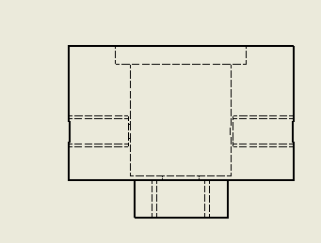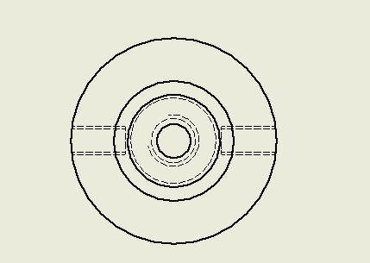
35 mm
5 mm
30 mm
ø 10 mm
ø 7 mm
ø 7 mm
ø 27 mm
ø 35 mm
ø 3 mm
ø 60 mm

S3 Exact geometry of the electrodes and their mounting

S3.1 Working electrode

Seal ring
18 mm
26 mm
2 mm
10 mm
5 mm
BDD electrode and titanium plate
Silver wire
Flat seal
Ø 13 mm
Ø 15 mm
Ø 2 mm

S3.2 Counter electrode
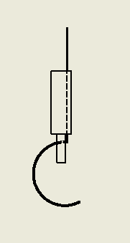
Platinum wire
22 mm
10 mm
3 mm
Ø 7 mm

S3.3 Reference electrode
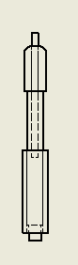
Ø 7 mm
Ø 4,2 mm
22 mm
Commercial reference electrode

S4 Geometry of the stirrer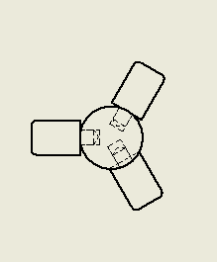
200 mm
Ø 6,4 mm
3 mm
4,5 mm

S5 Knime Workflow for Data analysis
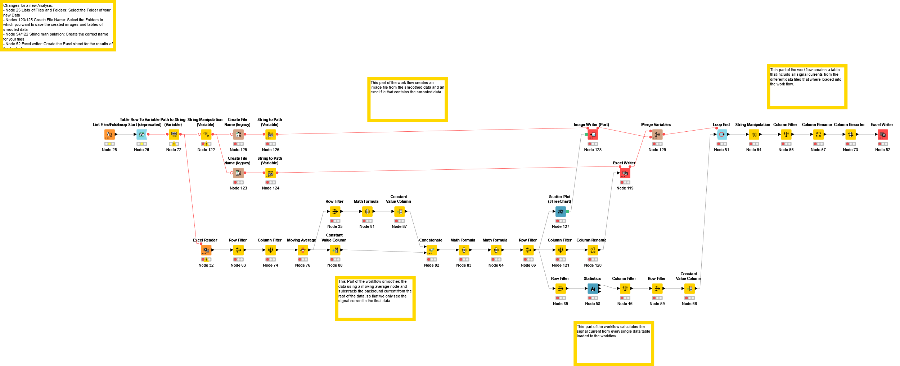

S6 Data for the ANOVA at different COD values

S6.1 COD = 10 mg/L

Organic substance | Average value | Standard deviation | Standard error of the average value
Ascorbic acid | 1,51904E-5 | 2,76552E-6 | 1,59668E-6
Acetic acid | 1,15531E-5 | 2,58459E-8 | 1,82758E-8
Glucose | 1,96076E-5 | 2,53884E-6 | 1,79523E-6
Malonic acid | 1,86538E-5 | 5,89055E-6 | 3,40091E-6
Sucrose | 1,71102E-5 | 5,38545E-6 | 3,10929E-6
Citric acid | 9,42514E-6 | 4,76569E-7 | 3,36985E-7

 | DF | Sum of Squares | Average sum of squares | F-value | Probability > F
Model | 5 | 1,76455E-10 | 3,5291E-11 | 2,12635 | 0,15357
Error | 9 | 1,49373E-10 | 1,6597E-11
Total | 14 | 3,25828E-10

S6.2 COD = 100 mg/L

Organic substance | Average value | Standard deviation | Standard error of the average value
Ascorbic acid | 6,84634E-5 | 2,13436E-6 | 1,23227E-6
Acetic acid | 5,14468E-5 | 8,83946E-6 | 5,10346E-6
Glucose | 6,25174E-5 | 8,92918E-6 | 5,15526E-6
Malonic acid | 6,79278E-5 | 7,93696E-6 | 4,58241E-6
Sucrose | 6,09449E-5 | 4,18889E-6 | 2,41846E-6
Citric acid | 4,62415E-5 | 1,29266E-6 | 7,46316E-7

 | DF | Sum of Squares | Average sum of squares | F-value | Probability > F
Model | 5 | 1,20947E-9 | 2,41894E-10 | 5,93277 | 0,00548
Error | 12 | 4,8927E-10 | 4,07725E-11
Total | 17 | 1,69874E-9

S6.3 COD = 1.000 mg/L

Organic substance |  | Average value |  | Standard deviation |  | Standard error of the average value
Ascorbic acid |  | 2,54134E-4 |  | 9,73564E-6 |  | 5,62088E-6
Acetic acid |  | 1,44004E-4 |  | 8,32407E-6 |  | 4,8059E-6
Glucose |  | 3,1242E-4 |  | 1,88743E-5 |  | 1,08971E-5
Malonic acid |  | 1,57245E-4 |  | 1,26806E-5 |  | 7,32117E-6
Sucrose |  | 2,69467E-4 |  | 1,46553E-5 |  | 8,46124E-6
Citric acid |  | 1,85607E-4 |  | 1,50867E-5 |  | 8,7103E-6
 | DF |  | Sum of Squares | Average sum of squares | F-value |  | Probability > F
Model | 5 |  | 6,91458E-8 | 1,38292E-8 | 73,85434 |  | 1,36802E-8
Error | 12 |  | 2,24699E-9 | 1,87249E-10
Total | 17 |  | 7,13928E-8

S6.4 COD = 10.000 mg/L

Organic substance | Average value | Standard deviation | Standard error of the average value
Ascorbic acid | 7,64011E-4 | 6,42374E-5 | 3,70875E-5
Acetic acid | 1,2157E-4 | 1,75441E-5 | 1,01291E-5
Glucose | 4,72791E-4 | 1,27203E-5 | 7,34406E-6
Malonic acid | 8,72927E-5 | 3,29194E-5 | 1,9006E-5
Sucrose | 5,15462E-4 | 3,14928E-5 | 1,81824E-5
Citric acid | 2,40594E-4 | 3,79886E-5 | 2,19328E-5

 | DF | Sum of Squares | Average sum of squares | F-value | Probability > F
Model | 5 | 1,0359E-6 | 2,07181E-7 | 153,19002 | 1,93612E-10
Error | 12 | 1,62293E-8 | 1,35244E-9
Total | 17 | 1,05213E-6

