Supplementary Information
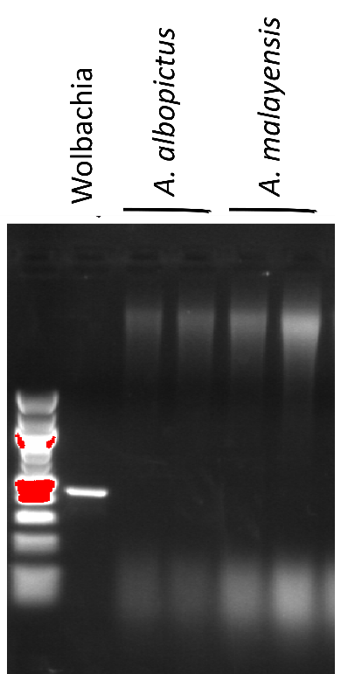
Figure S1. Detection of Wolbachia in A. albopictus and A. malayensis colonies.
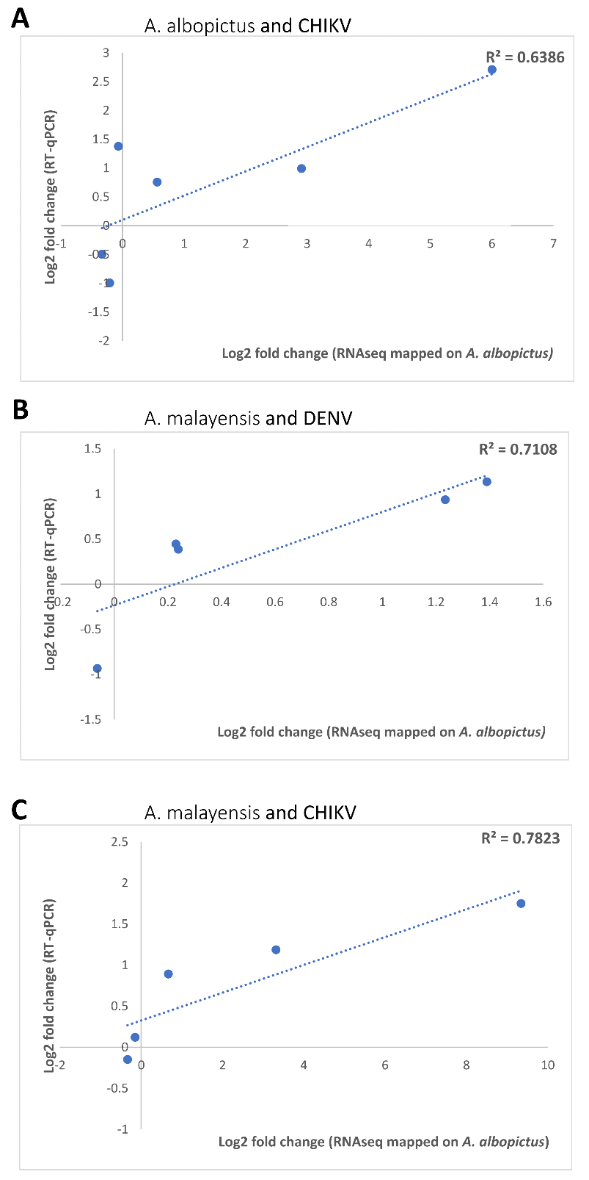
Figure S2. Validation of RNAseq data mapped on A. albopictus by RT-qPCR.
Gene expression comparisons for 6 genes as determined by RNA-seq mapping to the A. albopictus genome and by RT-qPCR. Pearson correlation is indicated for each comparison.

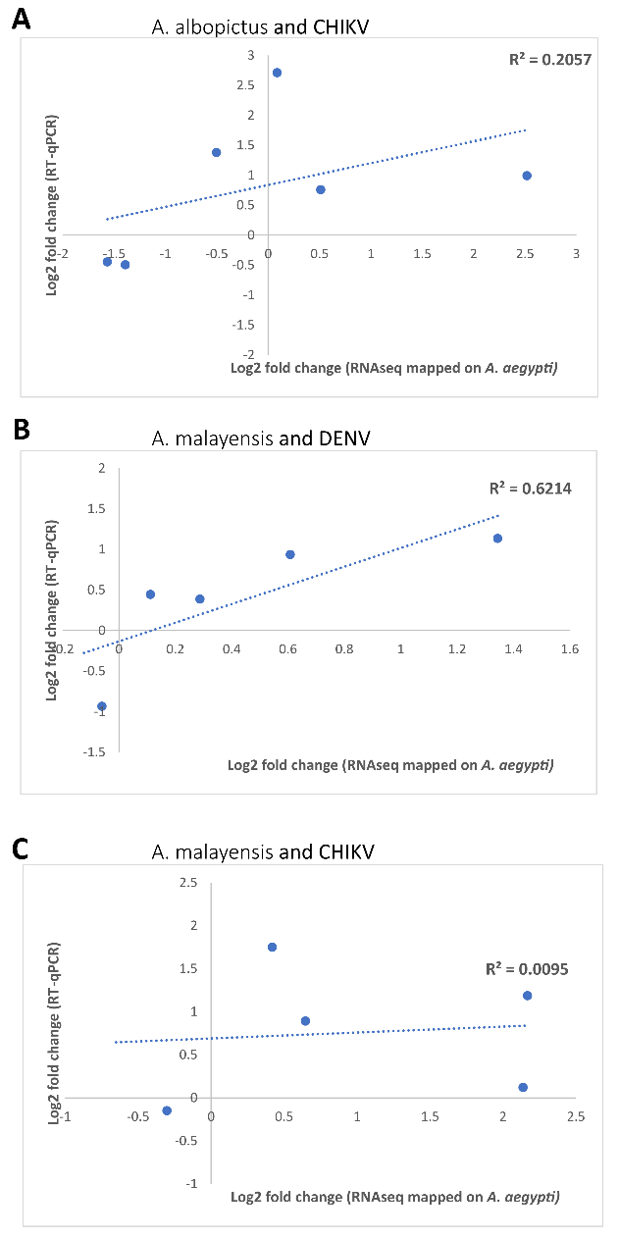
Figure S3. Validation of RNAseq data mapped on A. aegypti by RT-qPCR.
Gene expression comparisons for 6 genes as determined by RNA-seq mapping to the A. aegypti genome and by RT-qPCR. Pearson correlation is indicated for each comparison.

Table S1. Percentages and number of reads homologous to CHIKV and DENV, and to cytochrome c oxidase (COI) from A. albopictus and A. malayensis

Table S2. DEGs for all conditions based on mapping onto A. albopictus genome
Log2 fold change (Log2FC) is provided for each DEG. VectorBase description, GO Function, GO Process, Gene type, UniProt Function and description of D. melanogaster homologs are provided to determine the gene function.

Table S3. Regulation of all immune genes upon CHIKV infection in midguts of A. albopictus at 1 and 4 dpi
Immune categories as in⁵⁴

Table S4. Identification of immune genes in A. malayensis midguts through de novo assembly
Identification was based on de novo transcripts.

Table S5. Regulations of all immune genes upon CHIKV and DENV infection in midguts of A. malayensis at 1 and 4 dpi.
Transcripts were identified from de novo assembly. ¹Gene name is based on identification as in Table S4.

Table S6. Primers used for RT-qPCR.
Gene ID | Forward | Reverse
AALFPA_068948 | CCATCAGCACATGTGGCATC | CAGGATTGCGTGGAGCTTAC
AALFPA_050898 | CTAGTATCGGAACGCTGGGT | AACGGTGACCGGATTGTACT
AALFPA_075385 | CGTGACGAGGAGGAACCGAA | TCTGCCCGAAGCTAGTCAGC
AALFPA_048972 | GACGGTCTGGTCAGCATAGA | ACACTGACGAGCTGGTTGTA
AALFPA_049960 | GCCAGAGTGTTCTCGGTCAA | CGTATCGTGGTGAAACCGGA
AALFPA_047102 | TGTTACACCATGACCCGTGG | GTACTCCTGGTACGGGGTCT
AALFPA_068228 (Actin) | GAACACCCAGTCCTGCTGACA | TGCGTCATCTTCTCACGGTTAG

Data S1. Protein sequences for immune genes in A. malayensis identified by de novo assembly

