Appendices

Table 1 – Tensile Testing results of cylindrical specimens of 12Kh18N10T Austenitic Steel and Ferritic Low-Carbon Steel
Welded materials | № | Specimen diameter | Ultimate tensile strength (UTS), MPa
Ferritic Low-Carbon Steel  (soft zone) | 1 | 6,0 | 383
Ferritic Low-Carbon Steel  (soft zone) | 2 | 6,1 | 379
Ferritic Low-Carbon Steel  (soft zone) | 3 | 3,1 | 422
Ferritic Low-Carbon Steel  (soft zone) | 4 | 3,0 | 422
Ferritic Low-Carbon Steel  (soft zone) | 5 | 3,0 | 419
Ferritic Low-Carbon Steel  (soft zone) | 6 | 1,2 | 474
Ferritic Low-Carbon Steel  (soft zone) | 7 | 1,2 | 457
12Kh18N10T Austenitic Steel  (analogue AISI 304) | 1 | 8,0 | 626
12Kh18N10T Austenitic Steel  (analogue AISI 304) | 2 | 8,0 | 619
12Kh18N10T Austenitic Steel  (analogue AISI 304) | 3 | 4,0 | 621
12Kh18N10T Austenitic Steel  (analogue AISI 304) | 4 | 4,0 | 628
12Kh18N10T Austenitic Steel  (analogue AISI 304) | 5 | 2,0 | 641
12Kh18N10T Austenitic Steel  (analogue AISI 304) | 6 | 2,0 | 652
12Kh18N10T Austenitic Steel  (analogue AISI 304) | 7 | 1,1 | 681
12Kh18N10T Austenitic Steel  (analogue AISI 304) | 8 | 1,2 | 703
12Kh18N10T Austenitic Steel  (analogue AISI 304) | 9 | 1,1 | 706
12Kh18N10T Austenitic Steel  (analogue AISI 304) | 10 | 1,1 | 696
Table 2 – Geometry of tensile specimens of square section 10x10 mm and tensile testing results (set 1)
№ | Average insert width, mm | Specimen thickness, mm | Sample width, mm | Relative thickness | UTS, MPa
 | 9,86 | 10,0 | 10,0 | 0,98 | 402,0
 | 9,91 | 10,0 | 10,1 | 0,98 | 403,3
 | 3,66 | 9,9 | 10,1 | 0,35 | 508,9
 | 3,67 | 9,9 | 9,3 | 0,32 | 504,3
 | 1,01 | 9,8 | 9,2 | 0,09 | 575,8
 | 0,99 | 9,8 | 10,9 | 0,08 | 575,4

Table 3 – Geometry of tensile specimens of square section 3x3 mm and tensile testing results (set 1)
№ | Average insert width, mm | Specimen thickness, mm | Sample width, mm | Relative thickness | UTS, MPa | Note
 | 7,11 | 3,2 | 3,4 | 1,95 | 401,6
 | 6,99 | 3,2 | 3,4 | 1,91 | 395,0
 | 6,22 | 3,2 | 3,4 | 1,70 | 407,7
 | 6,14 | 3,2 | 3,4 | 1,68 | 408,3
 | 3,28 | 3,0 | 2,9 | 1,01 | 412,1
 | 3,04 | 3,1 | 3,0 | 0,91 | 419,4
 | 3,02 | 3,1 | 3,2 | 0,91 | 415,1
 | 3,28 | 3,0 | 3,4 | 0,86 | 423,3
 | 1,97 | 3,1 | 3,2 | 0,59 | 460,8
 | 1,83 | 3,2 | 3,2 | 0,57 | 457,9
 | 1,90 | 3,2 | 3,4 | 0,52 | 473,0
 | 1,87 | 3,2 | 3,0 | 0,51 | 467,0
 | 1,28 | 3,0 | 2,9 | 0,39 | 479,3
 | 1,35 | 3,0 | 3,4 | 0,36 | 504,5
 | 0,56 | 3,0 | 2,9 | 0,17 | 576,9
 | 0,53 | 3,0 | 2,9 | 0,16 | 583,2
 | 0,16 | 3,2 | 3,1 | 0,05 | 600,6
 | 0,09 | 3,2 | 3,2 | 0,03 | 607,0 | Fracture in base metal (BM)
 | 0,09 | 3,1 | 2,9 | 0,03 | 627,5 | Fracture in BM
 | 0,10 | 3,2 | 2,9 | 0,03 | 601,6 | Fracture in BM
 | 0,06 | 3,1 | 3,1 | 0,02 | 609,1
 | 0,07 | 3,2 | 3,4 | 0,02 | 594,8 | Fracture in BM
 | 0,04 | 3,1 | 2,9 | 0,01 | 606,2 | Fracture in BM
Table 4 – Geometry of tensile specimens of square section 1x1 mm and tensile testing results (set 1)
№ | Average insert width, mm | Specimen thickness, mm | Sample width, mm | Relative thickness | UTS, MPa
 | 1,64 | 0,56 | 0,9 | 1,70 | 427,4
 | 1,54 | 0,91 | 0,91 | 1,70 | 420,5
 | 1,72 | 0,98 | 0,92 | 1,53 | 405,5
 | 1,57 | 0,74 | 0,9 | 1,52 | 427,2
 | 1,49 | 0,9 | 0,96 | 1,44 | 407,7
 | 1,48 | 0,88 | 0,95 | 1,43 | 418,4
 | 1,49 | 0,88 | 0,98 | 1,37 | 424,8
 | 1,45 | 0,88 | 0,97 | 1,35 | 420,1
 | 1,48 | 0,88 | 1,00 | 1,32 | 423,8
 | 0,35 | 0,7 | 1,1 | 0,30 | 507,35
 | 0,32 | 1,16 | 1,13 | 0,26 | 527
 | 0,35 | 1,14 | 1,06 | 0,26 | 540,6
 | 0,32 | 1,16 | 1,13 | 0,26 | 533,2
 | 0,35 | 1,16 | 1,24 | 0,26 | 557,9
 | 0,32 | 1,16 | 1,19 | 0,26 | 522,2
 | 0,36 | 1,16 | 1,06 | 0,26 | 534,2
 | 0,34 | 1,16 | 1,08 | 0,25 | 522,7
 | 0,35 | 0,98 | 1,22 | 0,25 | 295,9
 | 0,32 | 1,16 | 1,10 | 0,24 | 539,4
 | 0,30 | 1,16 | 1,08 | 0,22 | 552,4
 | 0,31 | 1,16 | 1,29 | 0,22 | 545,3
 | 0,33 | 1,16 | 1,00 | 0,21 | 524,6
 | 0,32 | 1,14 | 1,33 | 0,21 | 562,9
Table 5 – Geometry of tensile specimens of square section 2.5x2.5 mm without work-hardened layer and tensile testing results (set 2)
№ | Average insert width, mm | Specimen thickness, mm | Sample width, mm | Relative thickness | UTS, MPa | Note
 | 7,07 | 2,5 | 2,7 | 2,46 | 381,0
 | 6,82 | 2,5 | 2,6 | 2,44 | 384,5
 | 3,13 | 2,6 | 2,6 | 1,15 | 392,4
 | 3,18 | 2,5 | 2,7 | 1,13 | 389,8
 | 2,03 | 2,6 | 2,7 | 0,72 | 418,8
 | 1,94 | 2,5 | 2,6 | 0,69 | 412,8
 | 0,91 | 2,6 | 2,6 | 0,33 | 503,2
 | 0,87 | 2,6 | 2,6 | 0,32 | 508,9
 | 0,11 | 2,5 | 2,6 | 0,04 | 584,5 | Fracture in BM
 | 0,11 | 2,5 | 2,6 | 0,04 | 596,1 | Fracture in BM
 | 0,09 | 2,4 | 2,5 | 0,03 | 604,9 | Fracture in BM
 | 0,08 | 2,5 | 2,6 | 0,03 | 598,5 | Fracture in BM
Table 6 – Geometry of tensile cylindrical specimens with a diameter of 8 mm and tensile testing results (set 3)
№ | Average insert width, mm | Specimen diameter, mm | Relative thickness | UTS, MPa
1 | 9,86 | 8,0 | 1,23 | 399
2 | 9,91 | 8,0 | 1,24 | 400
3 | 3,67 | 8,0 | 0,46 | 469
4 | 3,66 | 8,0 | 0,46 | 461
5 | 0,99 | 8,0 | 0,12 | 614
6 | 1,01 | 8,0 | 0,13 | 607
Table 7 – Geometry of tensile cylindrical specimens with a diameter of 2,5 mm and tensile testing results (set 3)
№ | Average insert width, mm | Specimen diameter, mm | Relative thickness | UTS, MPa | Note
 | 6,95 | 2,5 | 2,82 | 393
 | 6,95 | 2,5 | 2,79 | 390
 | 3,15 | 2,3 | 1,38 | 398
 | 3,15 | 2,4 | 1,29 | 409
 | 1,99 | 2,5 | 0,81 | 426
 | 1,99 | 2,5 | 0,79 | 419
 | 0,89 | 2,4 | 0,37 | 476
 | 0,11 | 2,2 | 0,05 | 617 | Fracture in BM
 | 0,11 | 2,4 | 0,04 | 611 | Fracture in BM
 | 0,08 | 2,5 | 0,03 | 655 | Fracture in BM
 | 0,08 | 2,5 | 0,03 | 624 | Fracture in BM
Table 8 – Geometry of tensile cylindrical specimens with a diameter of 1 mm and tensile testing results (set 3)
№ | Average insert width, mm | Specimen diameter, mm | Relative thickness | UTS, MPa | Note
 | 6,95 | 1,1 | 6,21 | 425
 | 6,95 | 1,1 | 6,15 | 399
 | 3,15 | 1,1 | 3,00 | 352
 | 0,89 | 1,1 | 0,79 | 420
 | 0,11 | 1,3 | 0,09 | 704 | Fracture in BM
 | 0,11 | 1,1 | 0,10 | 652 | Fracture in BM
 | 0,08 | 1,2 | 0,07 | 687 | Fracture in BM
Table 9 – Approximating Plot Data (figures 8-10) to equation 1
Graph | UTS of 12Kh18N10Т steel  $σ_{U}^{HZ}$, MPa | UTS of ferritic insert$σ_{U}^{SZ}$ MPa | Empirical coefficient  α | Empirical coefficient  β
Fig. 8, 10х10 mm | 605 | 381 | 2,27 | 1,21
Fig. 8, 3х3 mm | 628 | 403 | 3,08 | 1,34
Fig. 8, 1х1 mm | 670 | 417 | 4,50 | 1,30
Fig. 9, without work-hardened layer | 605 | 384 | 3,21 | 1,49
Fig. 10, 8 mm | 623 | 396 | 4,50 | 1,80
Fig. 10, 2,5 mm | 640 | 398 | 3,33 | 1,18
Fig. 10, 1 mm | 697 | 410 | 4,50 | 1,50

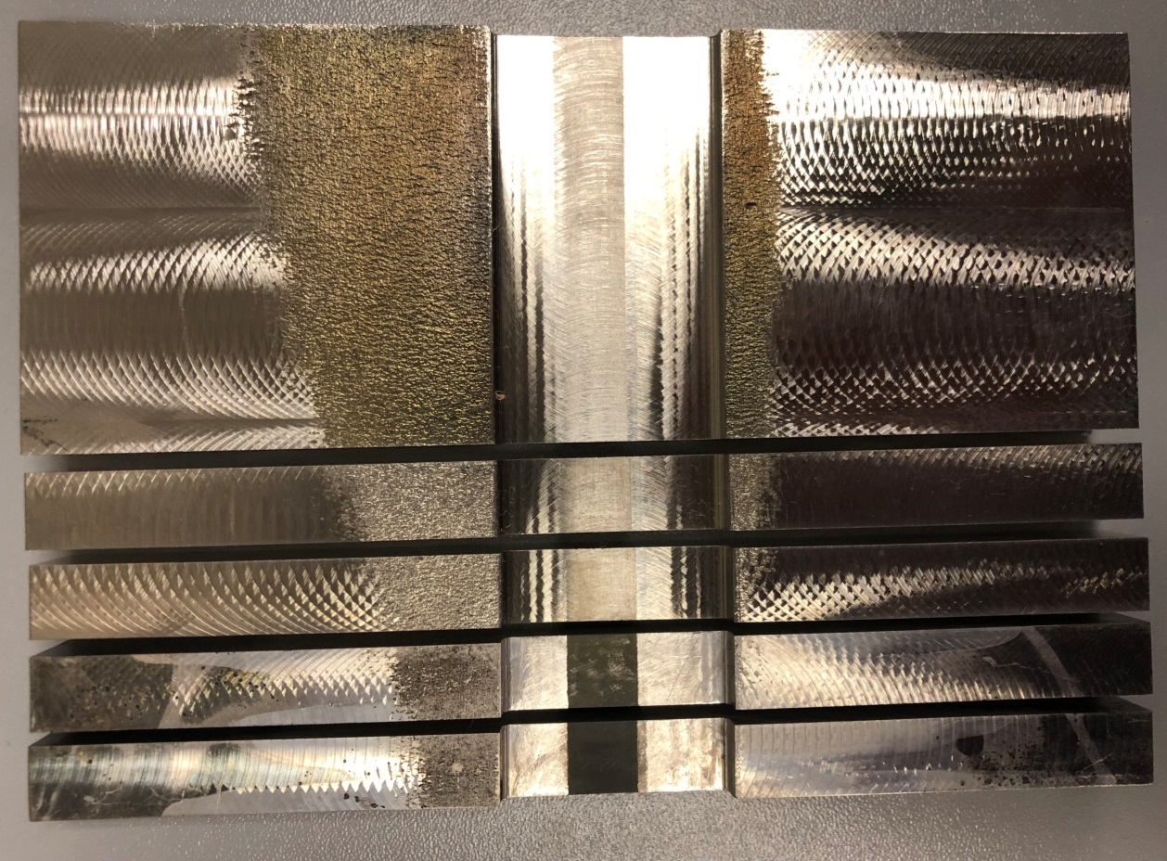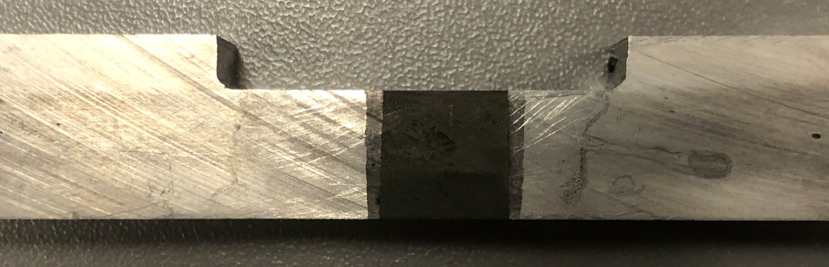
Figure 1 – Photo of tensile specimens cut from a welded sample
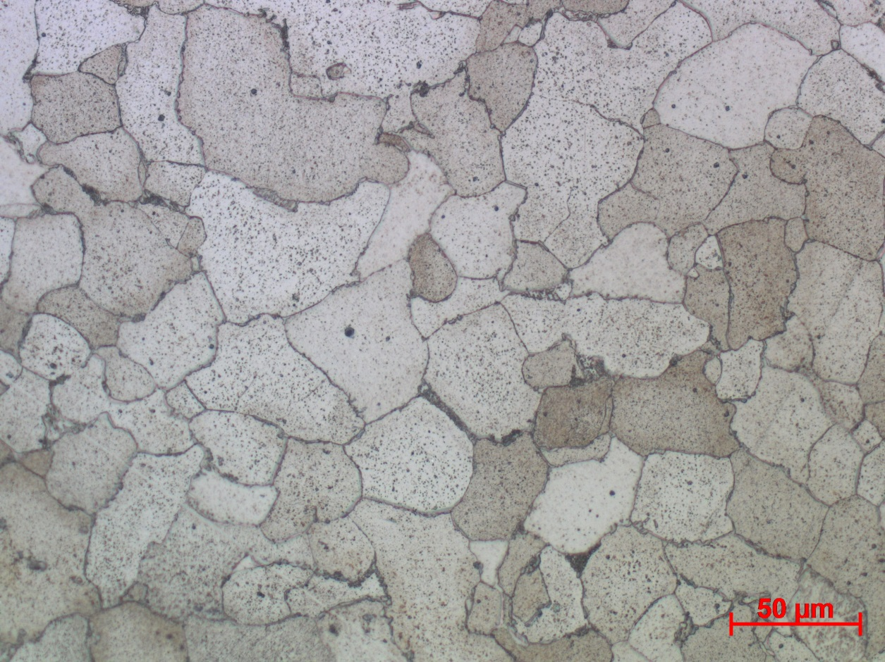
Figure 3 – Microstructure of the ferritic insert, 500х
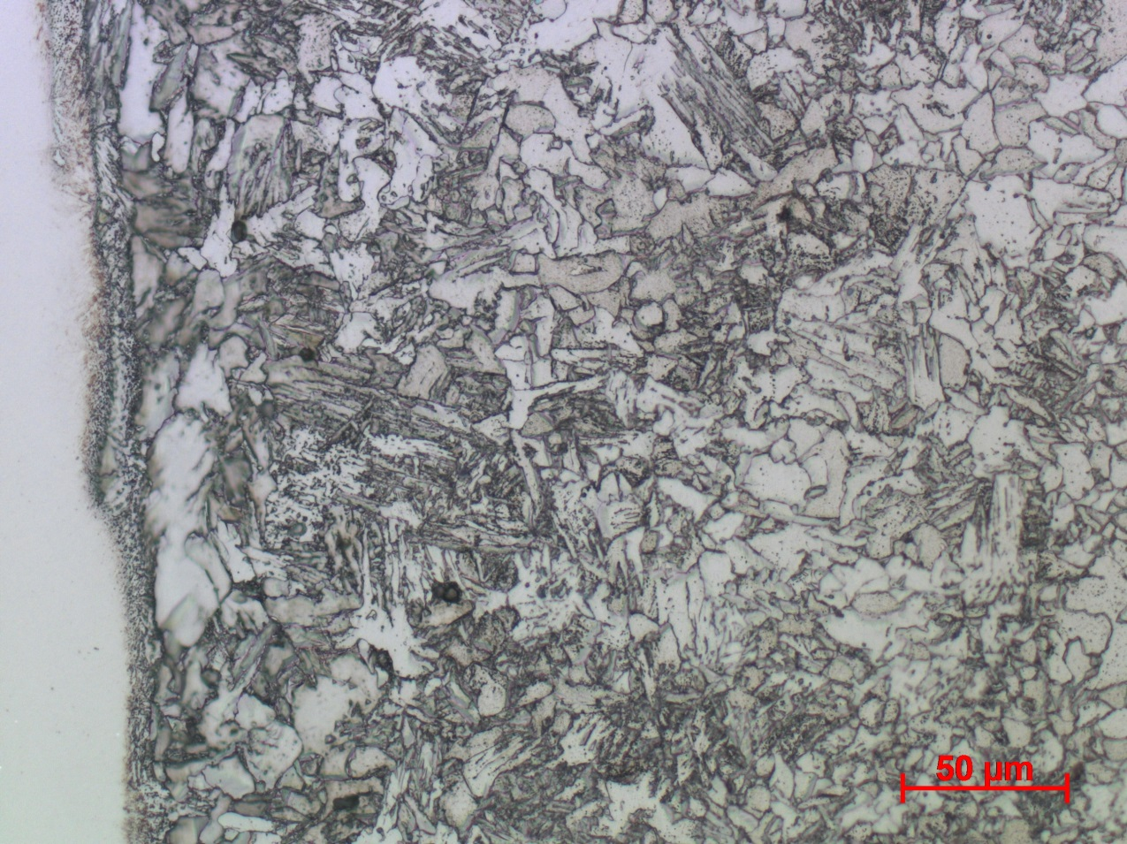
Figure 4 – Microstructure in the HAZ from the side of the ferritic insert after welding, 500х
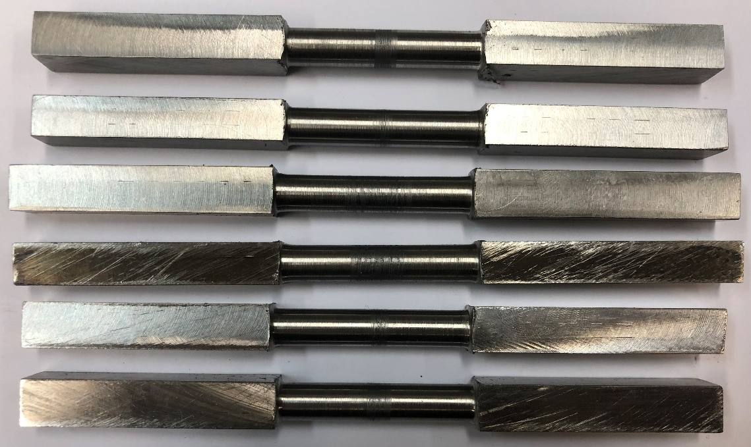
Figure 5 – Photo of 6 tensile specimens with a diameter of 8 mm (set 3)

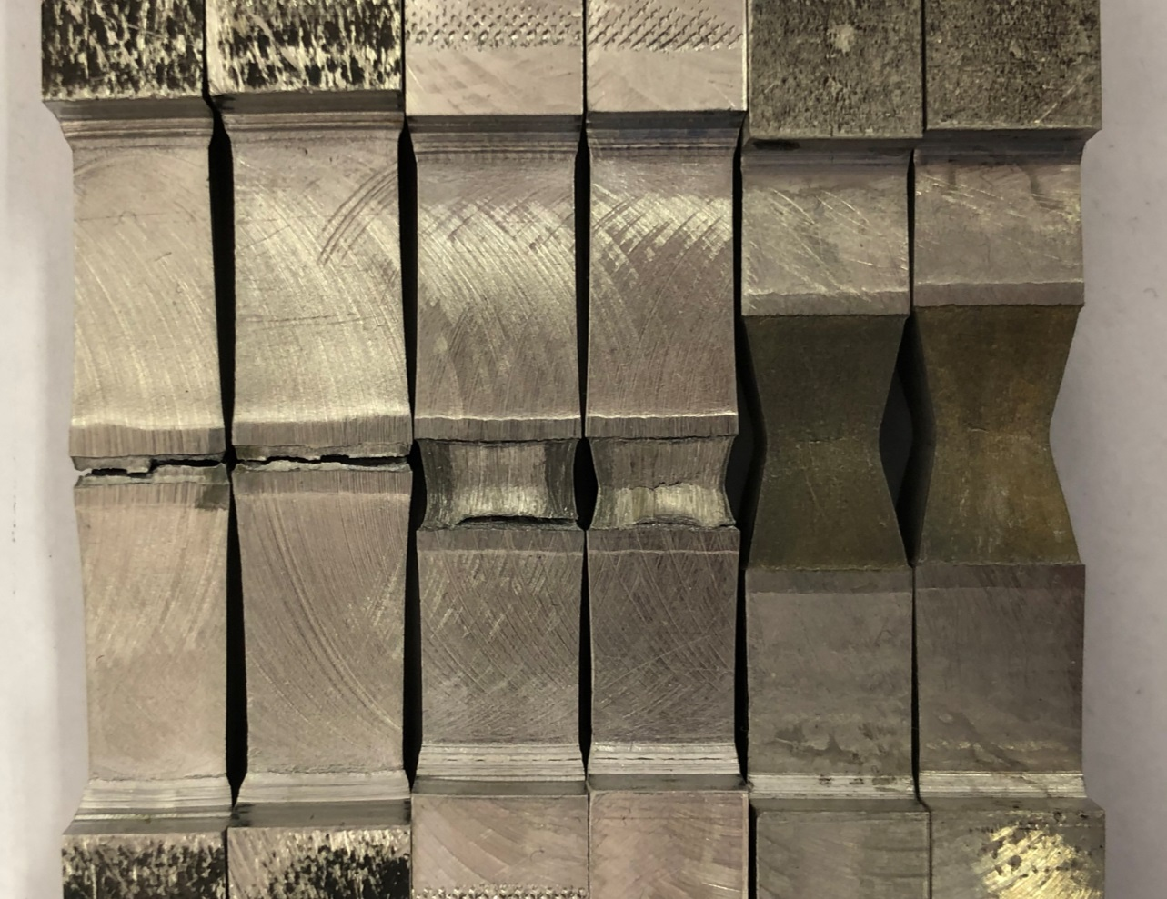
Figure 6 – Photo of specimens of square section 10x10 mm after tensile testing (set 1)
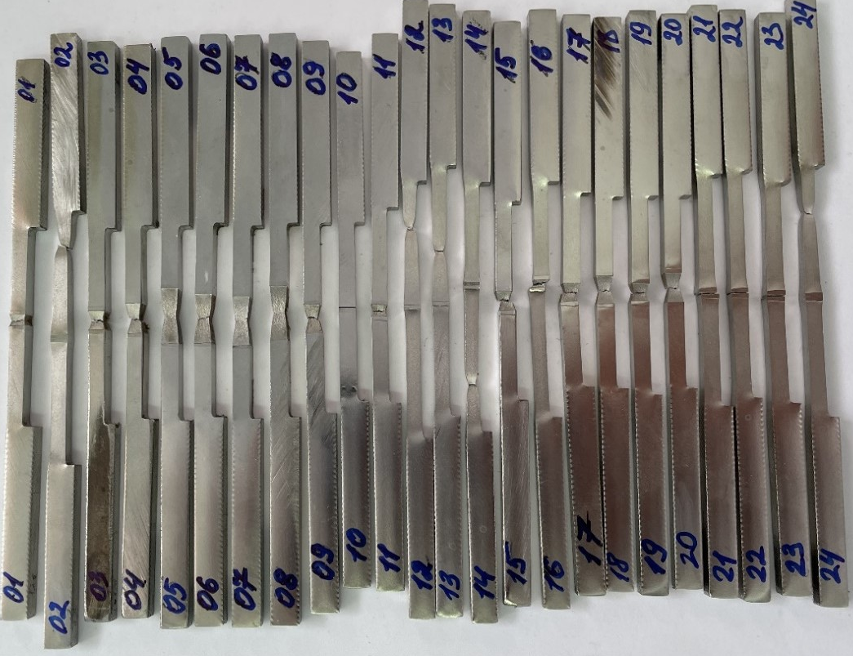
Figure 7 – Specimens photo of square cross-section with a side of 3 mm after tensile testing (set 1)
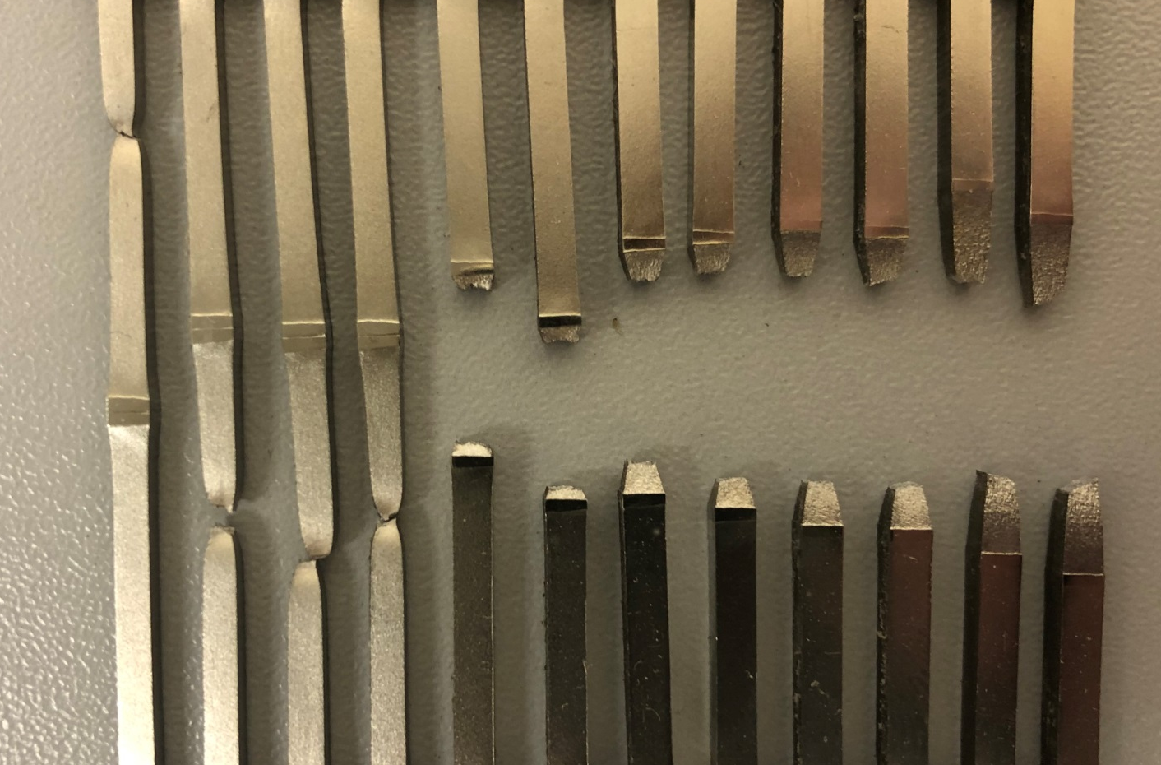
Figure 8 – Specimens photo of square cross-section with a side of 2.5 mm without the work-hardened layer after tensile testing (set 2)

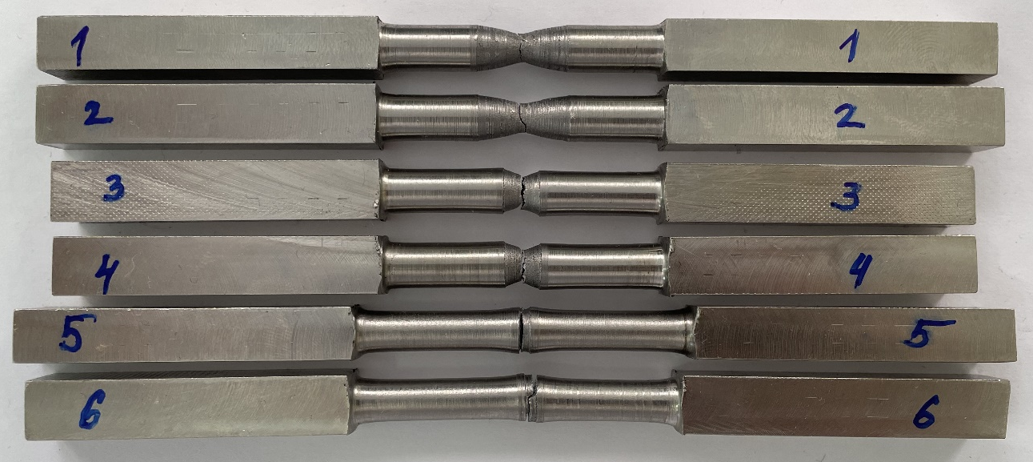
Figure 9 – Tensile cylindrical specimens with a cross-sectional diameter of 8 mm after tensile testing (set 3)
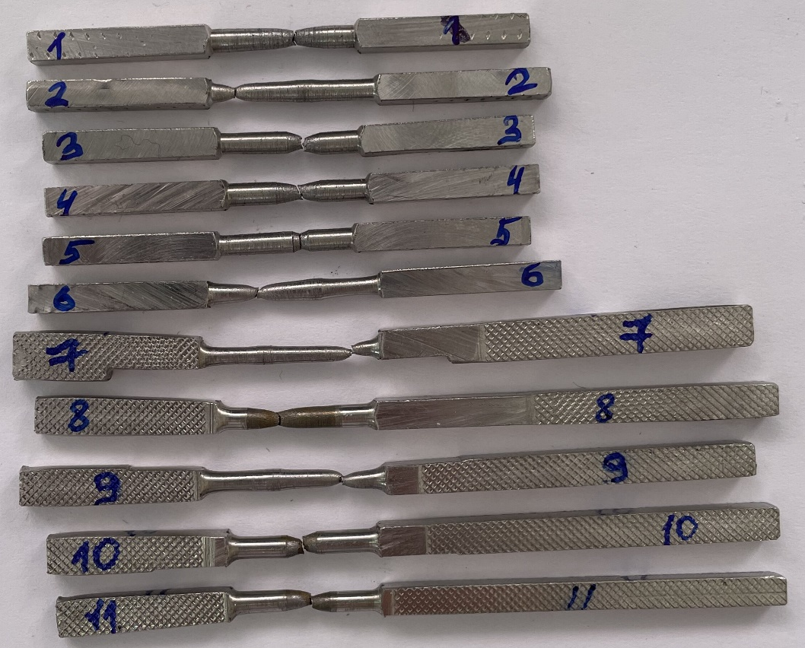
Figure 10 – Tensile cylindrical specimens with a cross-sectional diameter of 2.5 mm after tensile testing (set 3)

