Supplementary Information
Theory of sigma bond resonance in flat boron materials
Lu Qiu^{1,2†}, Xiuyun Zhang^{1,3†}, Xiao Kong¹, Izaac Mitchell¹, Tianying Yan⁴, Sung Youb Kim⁵, Boris I. Yakobson⁶*, and Feng Ding^{1,2}*

¹Center for Multidimensional Carbon Materials, Institute for Basic Science (IBS), Ulsan 44919, Republic of Korea
²School of Materials Science and Engineering, Ulsan National Institute of Science and Technology, Ulsan 44919, South Korea
³College of Physical Science and Technology, Yangzhou University, Yangzhou 225009, P. R. China
⁴Institute of New Energy Material Chemistry, School of Materials Science and Engineering, Nankai Univeristy, Tianjin 300350, P. R. China
⁵Department of Mechanical Engineering, Ulsan National Institute of Science and Technology, Ulsan 44919, South Korea
⁶Department of Materials Science and NanoEngineering, Rice University, Houston, Texas 77005, United States

†These authors contributed equally to this work.
*Correspondence to: biy@rice.edu; f.ding@unist.ac.kr
Supplementary Note 1
Linear combination of atomic orbitals of B₄ unit with resonance
In principle, we need to deal with 12 orbitals (thus a 12×12 matrix) that can form σ bonds, as every B atom (Supplementary Fig. 1a) has 3 sp² hybrid atomic orbitals (AOs) in the B₄ unit of D_{2h} point group (Supplementary Fig. 1b and 1c). A close inspection shows that only 4 AOs can form 3c-2e bonds (Supplementary Fig. 1d and 1e), while the other 8 AOs form either 2c-2e bonds or the dangling bonds (non-bonding). Therefore, we just focus on the 4 AOs, labeled as $\left.{|ϕ}_{A}\right\rangle$, $|\left.ϕ_{B}\right\rangle$, $\left.{|ϕ}_{C}\right\rangle$, and $\left.{|ϕ}_{D}\right\rangle$, that can form 3c-2e bond, which is of specific interest in this study.
The ith molecular orbital (MO) $|\left.ψ_{i}\right\rangle$ can be constructed via linear combination of atomic orbitals (LCAO), i.e.,
$|\left.ψ_{i}\right\rangle =\sum_{j}{c_{ij}|\left.ϕ_{j}\right\rangle }$, (S1)
in which j loops over A, B, C and D, and $c_{ij}$ is the coefficient. Adapting Eq. (S1) in Schrödinger Equation, $\hat{H}|\left.ψ_{i}\right\rangle =E_{i}|\left.ψ_{i}\right\rangle$, in which $\hat{H}$ is the Hamiltonian operator and $E_{i}$ is the eigenvalue of $|\left.ψ_{i}\right\rangle$. Applying linear variation leads to the pseudo-eigenvalue equation¹
$HC=ESC$, (S2)
in which $H$ is the Hamiltonian matrix with element $H_{ij}=\left\langle ϕ_{i}\right.|\hat{H}|\left.ϕ_{j}\right\rangle$, $E$ is the eigenvalue, $C$ is the coefficient, and $S$ is the overlap matrix with element $S_{ij}=\left\langle ϕ_{i}\right.|\left.ϕ_{j}\right\rangle$. We next apply Hückel approximation, i.e.,
$H_{ij}=\left\{\begin{matrix}H_{0}, i=j \\ α, overlap between |\left.ϕ_{i}\right\rangle and |\left.ϕ_{j}\right\rangle \\ 0, otherwise\end{matrix}\right.$ and $S_{ij}=I=\left\{\begin{matrix}1, i=j \\ 0, i≠j \end{matrix}\right.$ (S3)
Eq. (S2) becomes eigenvalue equation, i.e.,
$HC=EC$ (S4)
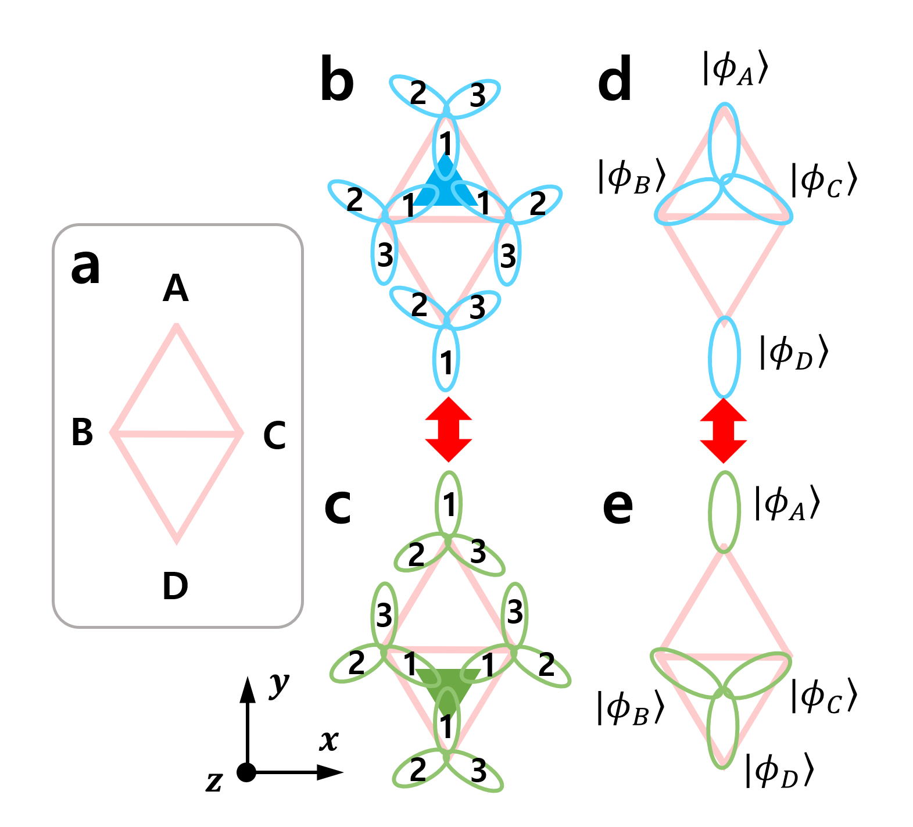
Supplementary Figure 1: (a) B₄ unit of D_{2h} symmetry. (b-c) Two resonant bonding configurations of the B₄ unit with the three sp² hybrid atomic orbitals (AOs) on each B atom labeled and flipped from (b) to (c). (d-e) The resonant configurations for the AOs which can form 3c-2e bonds. The axis on the lower left corner is shown as guide of symmetric operations for constructing molecular orbitals of the resonance bonding configurations.

For the non-resonance treatment, the two bonding configurations in Supplementary Fig. 1d and 1e are equivalent. Taking the bonding configuration in Supplementary Fig. 1d as an example, we observe that $\left.{|ϕ}_{A}\right\rangle$, $|\left.ϕ_{B}\right\rangle$, and $\left.{|ϕ}_{C}\right\rangle$ overlap on the upper triangle, while $\left.{|ϕ}_{D}\right\rangle$ is dangling. Using Hückel approximation in Eq. (S3), the corresponding non-resonance Hamiltonian matrix $H_{non-res}$ of Supplementary Fig. 1d can be written as
$H_{non-res}=\left(\begin{matrix}\begin{matrix}H_{0} & α \\ α & H_{0}\end{matrix} & \begin{matrix}α & 0 \\ α & 0\end{matrix} \\ \begin{matrix}α & α \\ 0 & 0\end{matrix} & \begin{matrix}H_{0} & 0 \\ 0 & H_{0}\end{matrix}\end{matrix}\right)$. (S5)
Note that Eq. (S5) consists of two sub-matrices of 3×3 and 1×1, and the latter gives the non-bonding orbital $\left.{|ψ}^{nb}\right\rangle =\left.{|ϕ}_{D}\right\rangle$ with orbital energy $E^{nb}=H_{0}$ directly. Applying Eq. (S4) on the remaining 3×3 sub-matrix, we have the energy $E^{b}=H_{0}+2α$ for the 3c-2e bonding orbital and two degenerate anti-bonding orbitals with energy $E^{ab}=H_{0}-α$. The bonding orbital for the 3c-2e bond takes the form $\left.{|ψ}^{b}\right\rangle =\frac{1}{\sqrt{3}}(\left.{|ϕ}_{A}\right\rangle +|\left.ϕ_{B}\right\rangle +|\left.ϕ_{C}\right\rangle )$, the same as was defined in the pioneer work of Dilthey on the multicenter orbital².
There are several defects in the above non-resonance treatment: i) the construction of $H_{non-res}$ in Eq. (S5) is arbitrary in the sense that it can be based on either Supplementary Fig. 1d or 1e; ii) it assumes that two resonance bonding configurations in Supplementary Fig. 1d and 1e are distinguishable and thus can be treated independently, but they are not; and iii) more severely, the so constructed MOs do not belong to any irreducible representations of D_{2h} point group. For example, the non-bonding orbital $\left.{|ψ}^{nb}\right\rangle =\left.{|ϕ}_{D}\right\rangle$ in Supplementary Fig. 1d cannot be assigned with any irreducible representation as comparing with the characteristic table of D_{2h} point group in Supplementary Table 1.
Supplementary Table 1. Character table of point group D_{2h}.
D_{2h} | E | C₂ (z) | C₂ (y) | C₂ (x) | i | σ (xy) | σ (xz) | σ (yz) | SALCsª
A_{g} | +1 | +1 | +1 | +1 | +1 | +1 | +1 | +1 | $|\left.χ_{1}^{A_{g}}\right\rangle$, $|\left.χ_{2}^{A_{g}}\right\rangle$
B_{1g} | +1 | +1 | -1 | -1 | +1 | +1 | -1 | -1
B_{2g} | +1 | -1 | +1 | -1 | +1 | -1 | +1 | -1
B_{3g} | +1 | -1 | -1 | +1 | +1 | -1 | -1 | +1
A_{u} | +1 | +1 | +1 | +1 | -1 | -1 | -1 | -1
B_{1u} | +1 | +1 | -1 | -1 | -1 | -1 | +1 | +1
B_{2u} | +1 | -1 | +1 | -1 | -1 | +1 | -1 | +1 | $$|\left.χ^{B_{2u}}\right\rangle$$
B_{3u} | +1 | -1 | -1 | +1 | -1 | +1 | +1 | -1 | $$|\left.χ^{B_{3u}}\right\rangle$$
$$Γ_{res}$$ | 4 | 0 | 2 | 2 | 0 | 4 | 2 | 2
ªsymmetry adapted linear combinations (SALCs) that form the basis of the corresponding irreducible representations, c.f., Eqs. (S8-S11).

The above defects associated with the non-resonance treatment can be resolved by treating the two resonance structures in Supplementary Fig. 1d and 1e in a unified manner, as we show below. Apart from the irreducible representations of D_{2h} point group in Supplementary Table 1, the last row shows the reducible representation $Γ_{res}$ by considering the two resonance bonding configurations in Supplementary Fig. 1d and 1e. Specifically,
$\left|\left.Γ_{res}\right\rangle ={\left(4, 0, 2, 2, 0, 4, 2, 2\right)}^{t}=2\right|\left.A_{g}\right\rangle +|\left.B_{2u}\right\rangle +|\left.B_{3u}\right\rangle$ (S6)
It is important to note that $|\left.Γ_{res}\right\rangle$ is derived by using the fact that the two resonance bonding configurations in Supplementary Fig. 1d and 1e cannot be distinguished, and we thus use subscript res to explicitly emphasize this fact. The second expression of Eq. (S6) demonstrates the decomposition of $|\left.Γ_{res}\right\rangle$ as linear combinations of irreducible representations, including $2|\left.A_{g}\right\rangle$, $|\left.B_{2u}\right\rangle$, and $|\left.B_{3u}\right\rangle$. Accordingly, we can equivalently construct symmetry adapted linear combinations (SALCs) that form the basis of the corresponding irreducible representations of $|\left.Γ_{res}\right\rangle$, using the projection operator³,
${\hat{P}}^{i}=\frac{l_{i}}{h}\sum_{m=1}^{h}{χ_{i}{(R_{m})}^{*}{\hat{R}}_{m}}$ (S7)
in which i denotes the ith irreducible representation $Γ_{i}$ in Supplementary Table 1, $h=8$ is the order of the D_{2h} point group, $l_{i}$ is the dimensionality of $Γ_{i}$, and specifically $l_{i}=1$ for the D_{2h} point group, $χ_{i}{(R_{m})}^{*}$ is the complex conjugate of the character of the ith irreducible representation under the mth symmetry operation ${\hat{R}}_{m}$.
Appying ${\hat{P}}^{A_{g}}$ on $|\left.ϕ_{A}\right\rangle$, and using the indistinguishable feature of the two resonance bonding configurations in Supplementary Fig. 1d and 1e, we can construct a SALC as a basis of irreducible representation A_{g}, i.e.,
$$|\left.χ_{1}^{A_{g}}\right\rangle ={\hat{P}}^{A_{g}}|\left.ϕ_{A}\right\rangle =\frac{1}{8}(\hat{E}+{\hat{C}}_{2}(z)+{\hat{C}}_{2}(y)+{\hat{C}}_{2}(x)+\hat{i}+\hat{σ}(xy)+\hat{σ}(xz)+\hat{σ}(yz))|\left.ϕ_{A}\right\rangle =\frac{1}{8}(|\left.ϕ_{A}\right\rangle +|\left.ϕ_{D}\right\rangle +|\left.ϕ_{A}\right\rangle +|\left.ϕ_{D}\right\rangle +|\left.ϕ_{D}\right\rangle +|\left.ϕ_{A}\right\rangle +|\left.ϕ_{D}\right\rangle +\left|\left.ϕ_{A}\right\rangle \right)=\frac{1}{2}(|\left.ϕ_{A}\right\rangle +|\left.ϕ_{D}\right\rangle )$$
For example, applying ${\hat{C}}_{2}(z)$ on $|\left.ϕ_{A}\right\rangle$ in Supplementary Fig. 1d, we get $|\left.ϕ_{D}\right\rangle$ in Supplementary Fig. 1e, because the two resonance bonding configurations are indistinguishable, so that ${\hat{C}}_{2}(z)|\left.ϕ_{A}\right\rangle =|\left.ϕ_{D}\right\rangle$. Normalizing the above SALC, we have
$|\left.χ_{1}^{A_{g}}\right\rangle =\frac{1}{\sqrt{2}}(|\left.ϕ_{A}\right\rangle +|\left.ϕ_{D}\right\rangle )$ (S8)
Similarly, applying ${\hat{P}}^{A_{g}}$ on $|\left.ϕ_{B}\right\rangle$ and using the indistinguishable resonance bonding configurations, and normalizing, we have
$|\left.χ_{2}^{A_{g}}\right\rangle =\frac{1}{\sqrt{2}}(|\left.ϕ_{B}\right\rangle +|\left.ϕ_{C}\right\rangle )$ (S9)
Note that ${\hat{P}}^{A_{g}}|\left.ϕ_{D}\right\rangle ={\hat{P}}^{A_{g}}|\left.ϕ_{A}\right\rangle$ and ${\hat{P}}^{A_{g}}|\left.ϕ_{C}\right\rangle ={\hat{P}}^{A_{g}}|\left.ϕ_{B}\right\rangle$, so that no additional SALC can be constructed except the two in Eq. (S8) and Eq. (S9), and the linear combination among Eqs. (S8) and (S9).
The SALC as basis of $B_{2u}$ irreducible representation can be constructed by applying ${\hat{P}}^{B_{2u}}$ on $|\left.ϕ_{A}\right\rangle$ and using the indistinguishable resonance bonding configurations in Supplementary Fig. 1d and 1e, i.e.,
$$|\left.χ^{B_{2u}}\right\rangle ={\hat{P}}^{B_{2u}}|\left.ϕ_{A}\right\rangle =\frac{1}{8}(\hat{E}-{\hat{C}}_{2}\left(z\right)+{\hat{C}}_{2}\left(y\right)-{\hat{C}}_{2}\left(x\right)-\hat{i}+\hat{σ}\left(xy\right)-\hat{σ}(xz)+\hat{σ}(yz))|\left.ϕ_{A}\right\rangle =\frac{1}{8}(|\left.ϕ_{A}\right\rangle -|\left.ϕ_{D}\right\rangle +|\left.ϕ_{A}\right\rangle -|\left.ϕ_{D}\right\rangle -|\left.ϕ_{D}\right\rangle +|\left.ϕ_{A}\right\rangle -|\left.ϕ_{D}\right\rangle +\left|\left.ϕ_{A}\right\rangle \right)=\frac{1}{2}(|\left.ϕ_{A}\right\rangle -|\left.ϕ_{D}\right\rangle )$$
Normalizing the above expression, we have
$|\left.χ^{B_{2u}}\right\rangle =\frac{1}{\sqrt{2}}(|\left.ϕ_{A}\right\rangle -\left|\left.ϕ_{D}\right\rangle \right)$ (S10)
Note that ${\hat{P}}^{B_{2u}}|\left.ϕ_{D}\right\rangle =-{\hat{P}}^{B_{2u}}|\left.ϕ_{A}\right\rangle$, and ${\hat{P}}^{B_{2u}}|\left.ϕ_{B}\right\rangle ={\hat{P}}^{B_{2u}}|\left.ϕ_{C}\right\rangle =|\left.0\right\rangle$, so that no additionally independent SALC as basis of $B_{2u}$ irreducible representation can be constructed except Eq. (S10). Following the same reasoning, the last SALC as basis of $B_{3u}$ irreducible representation can be constructed by applying ${\hat{P}}^{B_{3u}}$ on $|\left.ϕ_{B}\right\rangle$ and normalizing, and the result is
$|\left.χ^{B_{3u}}\right\rangle =\frac{1}{\sqrt{2}}(|\left.ϕ_{B}\right\rangle -\left|\left.ϕ_{c}\right\rangle \right)$ (S11)
MO’s can be equivalently constructed as linear combinations of SALC’s, i.e.,
$|\left.ψ_{i}\right\rangle =\sum_{j}{c_{ij}|\left.χ_{j}\right\rangle }$ (S12)
Since Hamiltonian operator $\hat{H}$ is totally symmetric under all symmetry operations, and $|\left.χ_{j}\right\rangle$’s are symmetry adopted as basis of irreducible representations, the Hamiltonian matrix element in Eq. (S4) $H_{ij}=\left\langle χ_{i}\right.|\hat{H}|\left.χ_{j}\right\rangle$ is identically zero except $|\left.χ_{i}\right\rangle$ and $\left.|χ_{j}\right\rangle$ belong to the same irreducible representation³. Therefore, the Hamiltonian matrix, constructed with Eq. (S12), is block diagonal according to the irreducible representation, i.e.,
$H_{res}=\left(\begin{matrix}\begin{matrix}\left\langle χ_{1}^{A_{g}} | \hat{H} | χ_{1}^{A_{g}}\right\rangle & \left\langle χ_{1}^{A_{g}} | \hat{H} | χ_{2}^{A_{g}}\right\rangle \\ \left\langle χ_{2}^{A_{g}} | \hat{H} | χ_{1}^{A_{g}}\right\rangle & \left\langle χ_{2}^{A_{g}} | \hat{H} | χ_{2}^{A_{g}}\right\rangle \end{matrix} & \begin{matrix}0 & 0 \\ 0 & 0\end{matrix} \\ \begin{matrix}0 & 0 \\ 0 & 0\end{matrix} & \begin{matrix}\left\langle χ^{B_{2u}} | \hat{H} | χ^{B_{2u}}\right\rangle & 0 \\ 0 & \left\langle χ^{B_{3u}} | \hat{H} | χ^{B_{3u}}\right\rangle \end{matrix}\end{matrix}\right)=\left(\begin{matrix}\begin{matrix}H_{0} & 2α \\ 2α & H_{0}+α\end{matrix} & \begin{matrix}0 & 0 \\ 0 & 0\end{matrix} \\ \begin{matrix}0 & 0 \\ 0 & 0\end{matrix} & \begin{matrix}H_{0} & 0 \\ 0 & H_{0}-α\end{matrix}\end{matrix}\right)$ (S13)
in which the second expression is constructed according to Hückel approximation in Eq. (S3) and indistinguishable resonance bonding configurations in Supplementary Fig. 1d and 1e. Specifically,
$\left\langle χ_{1}^{A_{g}} | \hat{H} | χ_{1}^{A_{g}}\right\rangle =\frac{1}{2}(\left\langle ϕ_{A}\right.|+\left\langle ϕ_{D}\right.|)\hat{H}(|\left.ϕ_{A}\right\rangle +|\left.ϕ_{D}\right\rangle )=H_{0}$,
$\left\langle χ_{2}^{A_{g}} | \hat{H} | χ_{2}^{A_{g}}\right\rangle =\frac{1}{2}(\left\langle ϕ_{B}\right.|+\left\langle ϕ_{C}\right.|)\hat{H}(|\left.ϕ_{B}\right\rangle +|\left.ϕ_{C}\right\rangle )=H_{0}+α$,
$\left\langle χ_{1}^{A_{g}} | \hat{H} | χ_{2}^{A_{g}}\right\rangle =\frac{1}{2}(\left\langle ϕ_{A}\right.|+\left\langle ϕ_{D}\right.|)\hat{H}(|\left.ϕ_{B}\right\rangle +|\left.ϕ_{C}\right\rangle )=2α=\left\langle χ_{2}^{A_{g}} | \hat{H} | χ_{1}^{A_{g}}\right\rangle$,
$$\left\langle χ^{B_{2u}} | \hat{H} | χ^{B_{2u}}\right\rangle =\frac{1}{2}(\left\langle ϕ_{A}\right.|-\left\langle ϕ_{D}\right.|)\hat{H}(|\left.ϕ_{A}\right\rangle -|\left.ϕ_{D}\right\rangle )=H_{0}$$
$\left\langle χ^{B_{3u}} | \hat{H} | χ^{B_{3u}}\right\rangle =\frac{1}{2}\left\langle (\left\langle ϕ_{B}\right.|-\left\langle ϕ_{C}\right.|) | H | (|\left.ϕ_{B}\right\rangle -|\left.ϕ_{C}\right\rangle )\right\rangle =H_{0}-α$.
Note that Eq. (S13) consists of three sub-diagonal matrices, i.e., 2×2 of irreducible representation $A_{g}$, 1×1 of irreducible representation $B_{2u}$, and 1×1 of irreducible representation $B_{3u}$, respectively. The 1×1 $B_{2u}$ and $B_{3u}$ sub-diagonal matrices in Eq. (S13), i.e., $H_{res}^{B_{2u}}=H_{0}$ and $H_{res}^{B_{3u}}=H_{0}-α$, gives the MO’s characterized by $B_{2u}$ and $B_{3u}$ irreducible representations directly, with the MO’s and orbital energies
$|\left.ψ_{b2u}\right\rangle =|\left.χ^{B_{2u}}\right\rangle =\frac{1}{\sqrt{2}}(|\left.ϕ_{A}\right\rangle -\left|\left.ϕ_{D}\right\rangle \right)$ and $E_{b2u}^{nb}=H_{res}^{B_{2u}}=H_{0}$ (S14)
$|\left.ψ_{b3u}\right\rangle =|\left.χ^{B_{3u}}\right\rangle =\frac{1}{\sqrt{2}}(|\left.ϕ_{B}\right\rangle -\left|\left.ϕ_{C}\right\rangle \right)$ and $E_{b3u}^{ab}=H_{res}^{B_{3u}}=H_{0}-α$ (S15)
The remaining 2×2 sub-diagonal matrix of $A_{g}$ block, i.e.,
$$H_{res}^{A_{g}}=\left(\begin{matrix}H_{0} & 2α \\ 2α & H_{0}+α\end{matrix}\right)$$
can be solved using Eq. (S4) to give a bonding orbital and an anti-bonding orbital, and the result is
$$\left|\left.ψ_{ag}^{b}\right\rangle =0.6153\right|\left.χ_{1}^{A_{g}}\right\rangle +0.7884|\left.χ_{2}^{A_{g}}\right\rangle$$
$=0.4325|\left.ϕ_{A}\right\rangle +0.5573|\left.ϕ_{B}\right\rangle +0.5573|\left.ϕ_{C}\right\rangle +0.4352|\left.ϕ_{D}\right\rangle$ (S16)
$$\left|\left.ψ_{ag}^{ab}\right\rangle =0.7884\right|\left.χ_{1}^{A_{g}}\right\rangle -0.6153|\left.χ_{2}^{A_{g}}\right\rangle$$
$=0.5573\left|\left.ϕ_{A}\right\rangle -0.4352\right|\left.ϕ_{B}\right\rangle -0.4352|\left.ϕ_{C}\right\rangle +0.5573|\left.ϕ_{D}\right\rangle$ (S17)
in which Eqs. (S8) and (S9) are used to convert from SALC to AO. The cartoons of the MO’s derived in Eqs. (S14-S17) are presented in Fig. 1e in the main text. The corresponding orbital energies of Eqs. (S16) and (S17) are
$E_{ag}^{b}=H_{0}+2.56α$ and $E_{ag}^{nb}=H_{0}-1.56α$ (S18)
Comparing the orbital energies of the resonance Hamiltonian $H_{res}$ in Eq. (S13) with those of the non-resonance Hamiltonian $H_{non-res}$, it can be seen that the energy of the non-bonding orbital and one of the anti-bonding orbital remain the same, while the energy of the other anti-bonding orbital is raised by $E_{ag}^{nb}-E^{nb}=-0.56α$ in the resonance. On the other hand, the energy of the bonding orbital is lowered by $Δ=E_{ag}^{b}-E^{b}=0.56α$, in which $Δ$ is clearly attributed to the resonance between the two bonding configurations in Supplementary Fig. 1d and 1e. According to the previous estimation of the boron 3c-2e bond⁴ and borophane⁵, we could roughly estimate that the exchange energy $α≈-3$ eV, and therefore the resonance energy to be $Δ≈-1.5$ eV.
Supplementary Figures
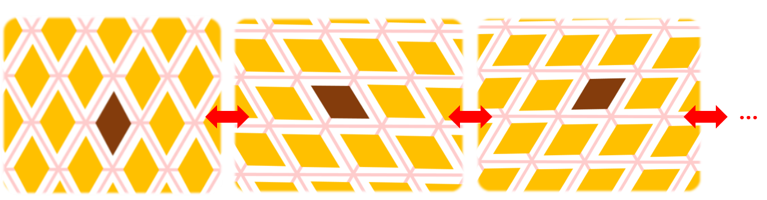 Supplementary Figure 2: Three major resonance hybrid structures for the flat triangular boron sheet.
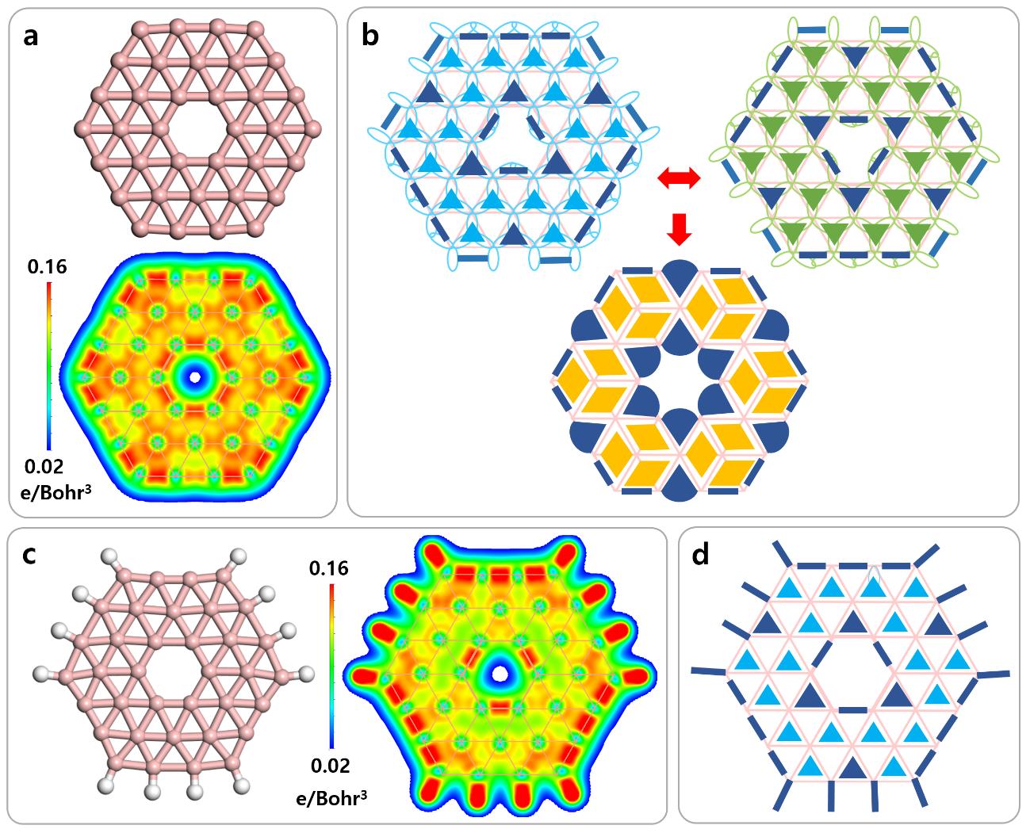
Supplementary Figure 3: Valence electron charge density (VECD) maps of (a) B₃₆, and (c) B₃₆H₁₂ in the cluster surface, and the corresponding (b and d) σ bonding configurations by our theory.
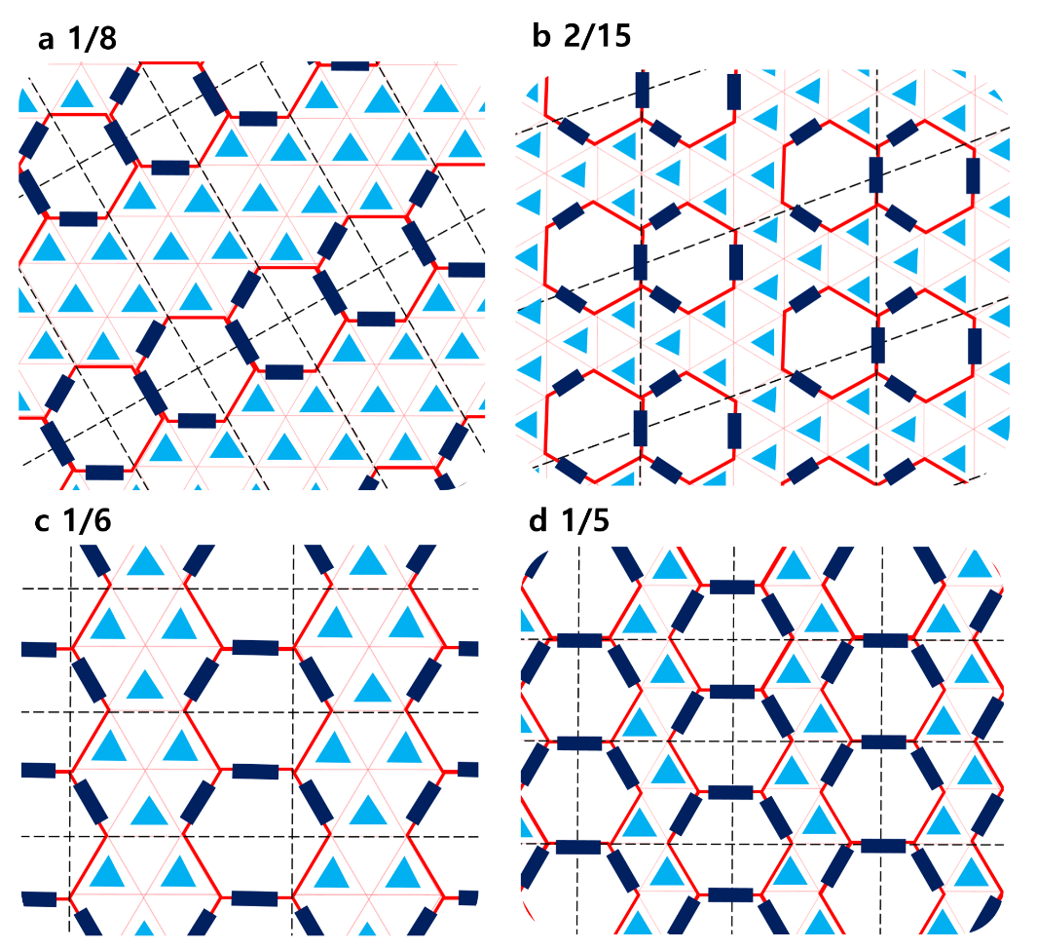
Supplementary Figure 4: σ bonding configurations of 2D boron sheets with hole ratios of (a) 1/8, (b) 2/15, (c) 1/6, and (d) 1/5.

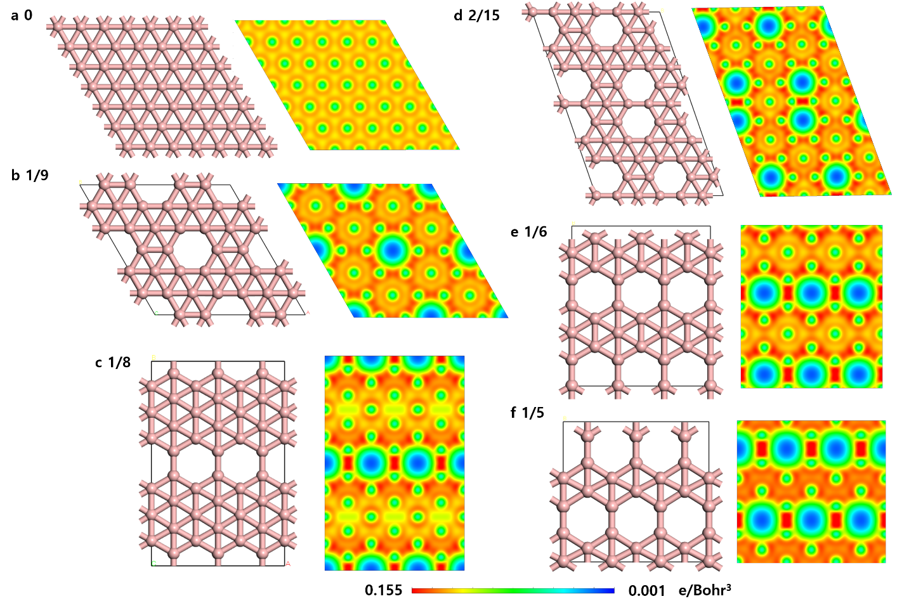
Supplementary Figure 5: VECD maps of 2D boron sheets with hole ratios of (a) 0, (b) 1/9, (c) 1/8, (d) 2/15, (e) 1/6, and (f) 1/5.
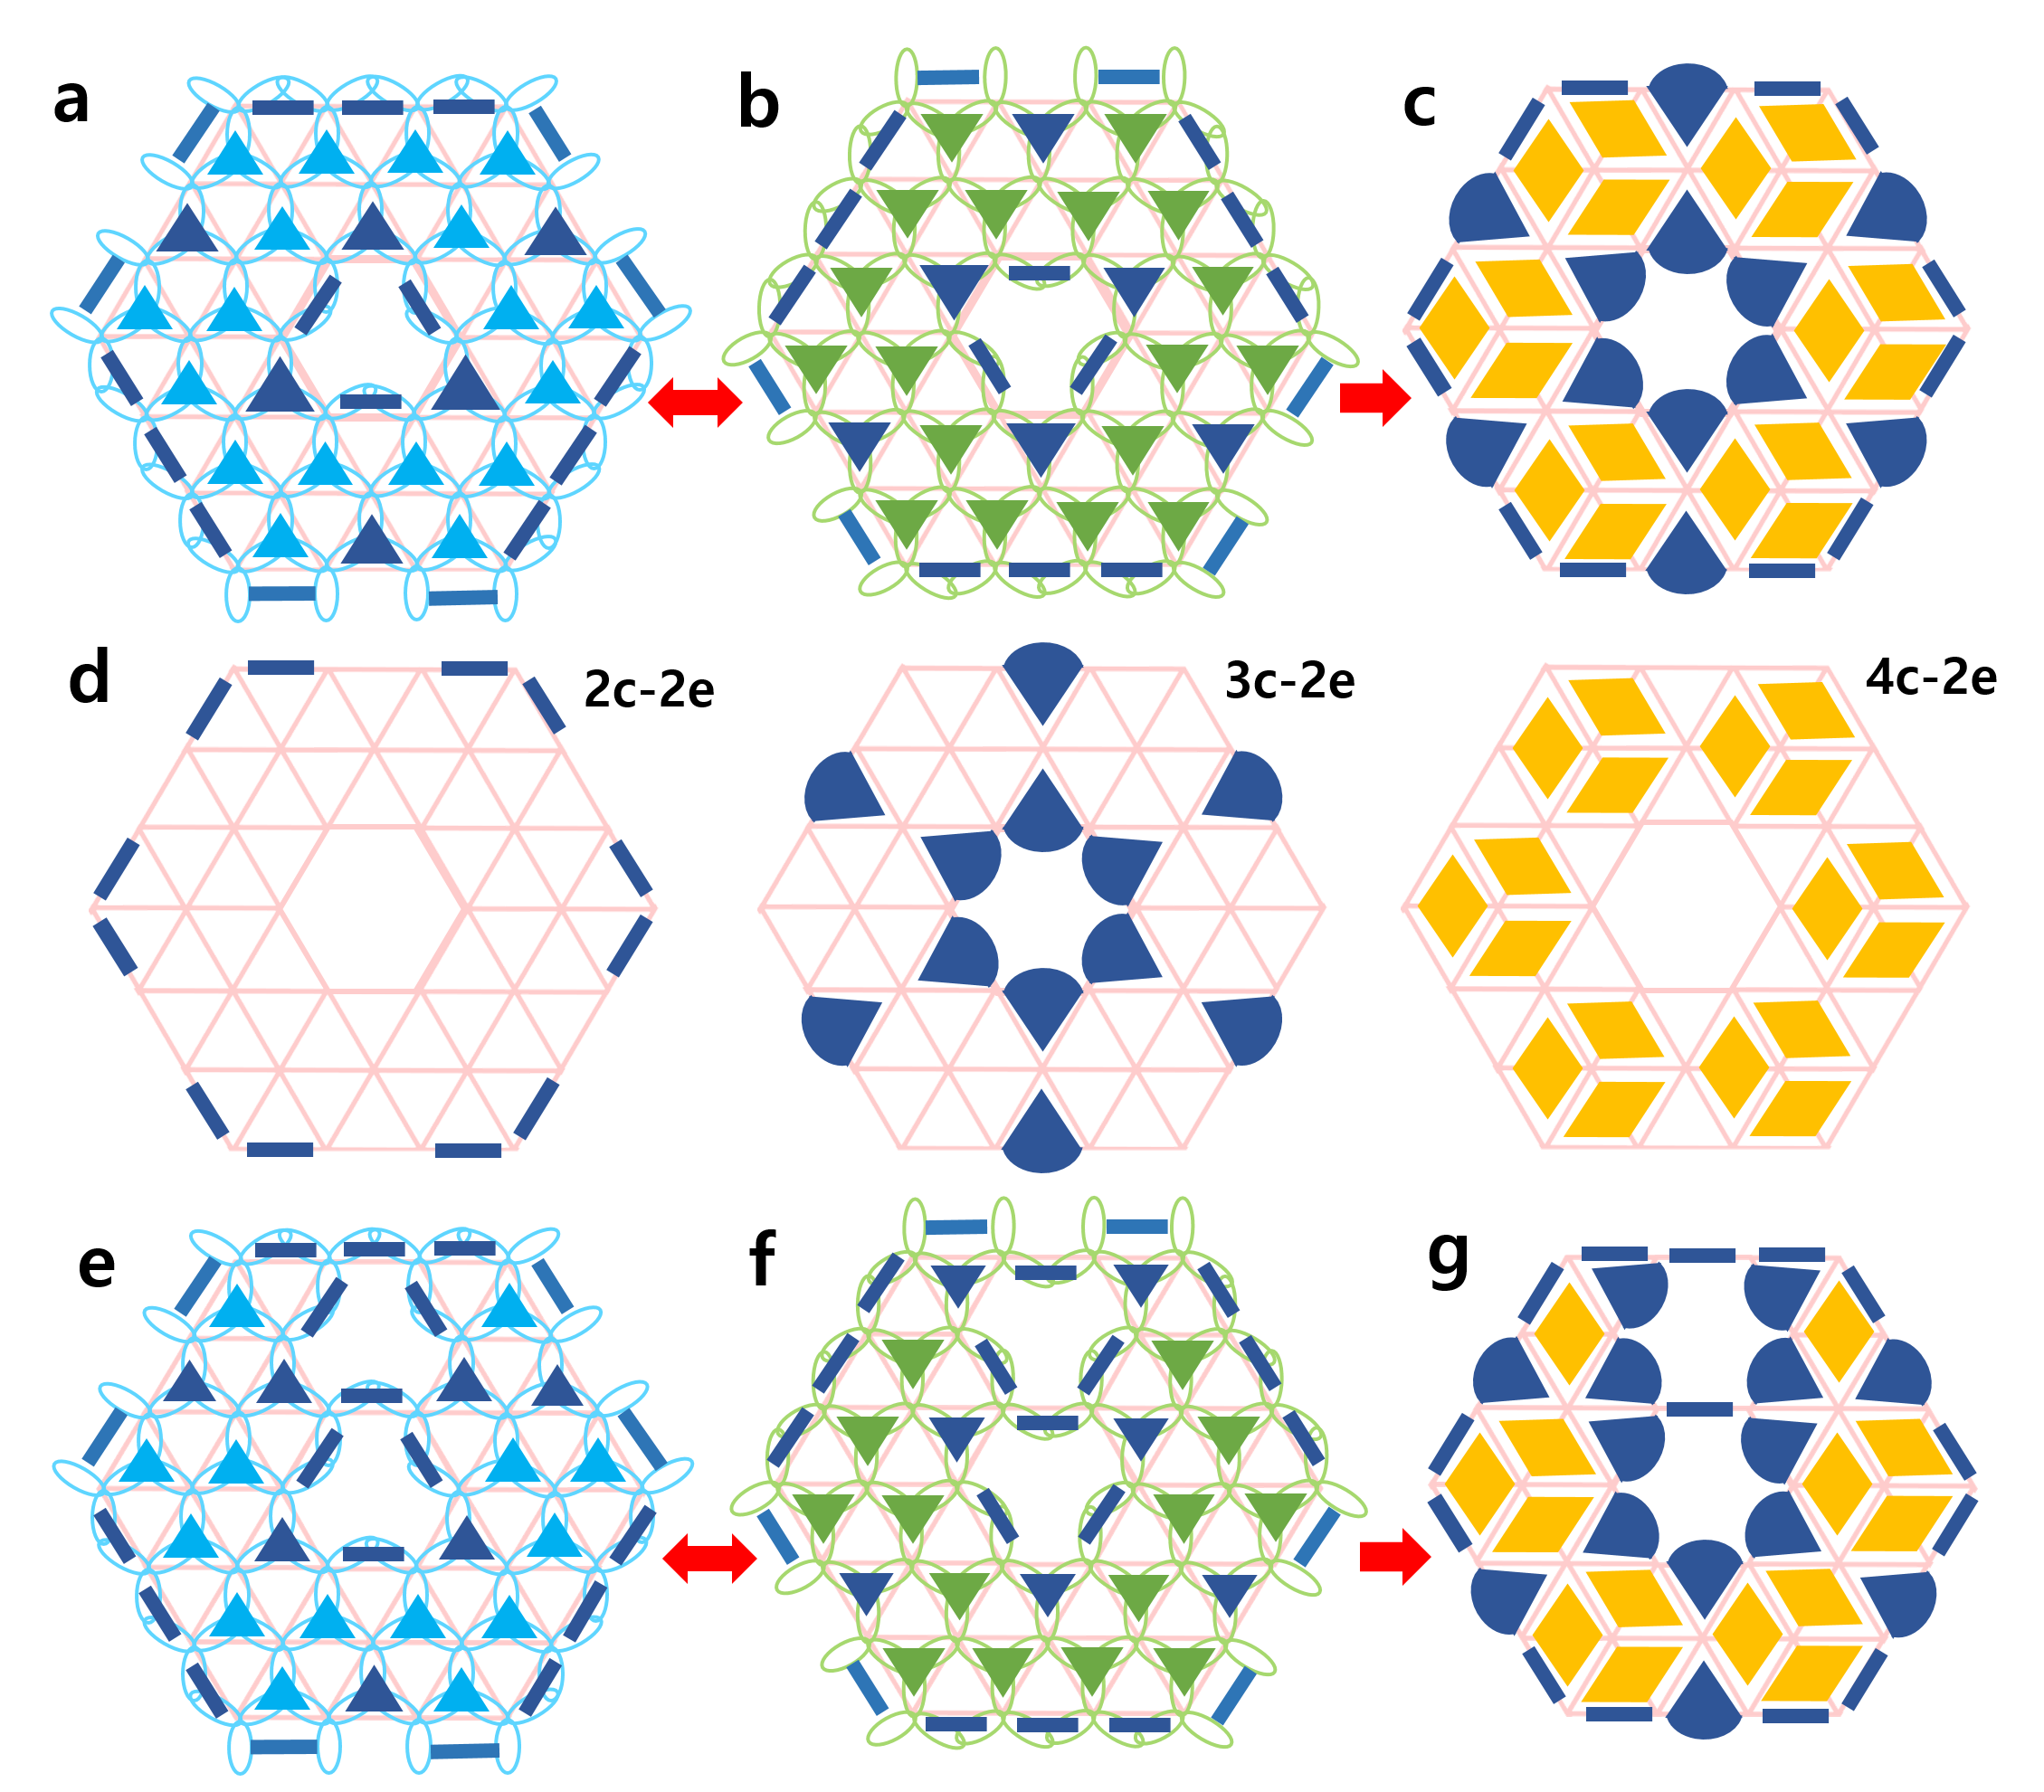
Supplementary Figure 6: σ bonding configurations of the (a-c) B₃₆, and (e-g) B₃₅ clusters before and after resonance based on the proposed theory of resonance, where the resonant bonding configuration of B₃₆ consists of (d) 2c-2e, 3c-2e, and 4c-2e bonds, respectively. The drawn resonant bonding configurations (c) and (g) match well with the AdNDP chemical bonding analysis from Ref. 6 and 7, respectively, as shown in Supplementary Fig. 7.

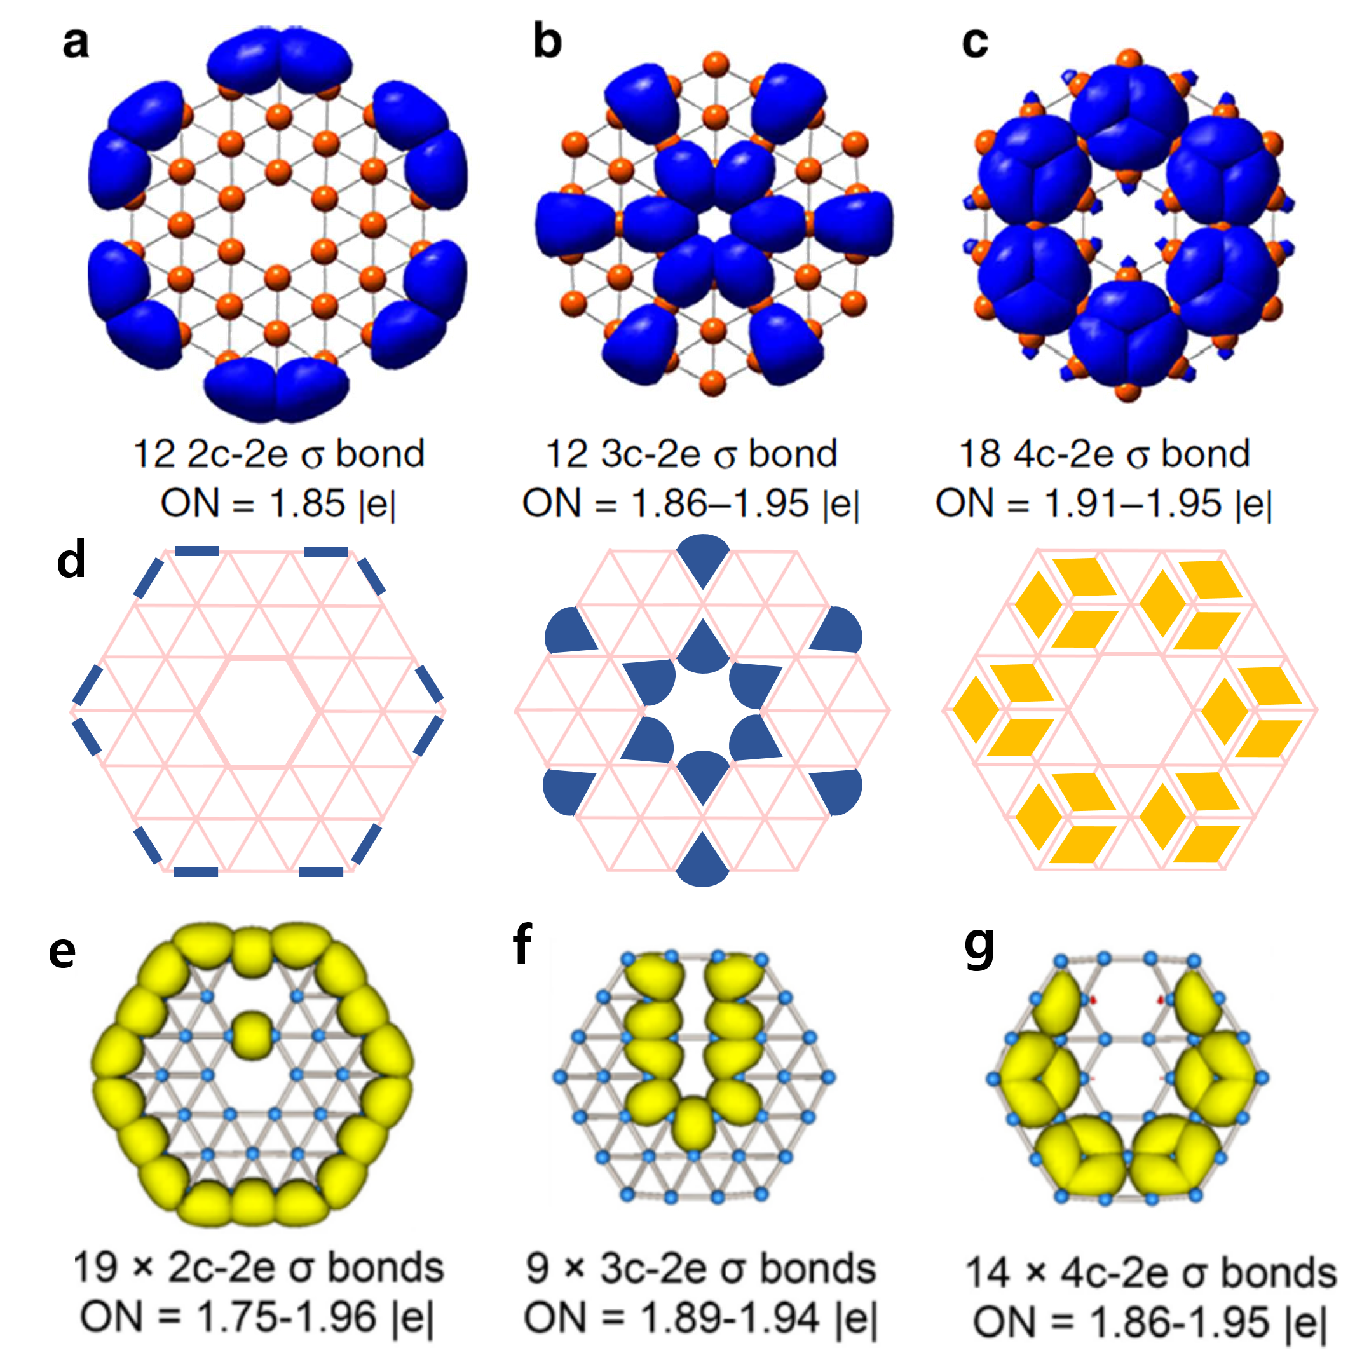
Supplementary Figure 7: The AdNDP chemical bonding analysis of (a-c) B₃₆, and (e-g) B₃₅ clusters match well with the electronic structures predicted by our theory as shown in (d) and Supplementary Fig. 6. (a-c) Preprinted with permission from Ref. 7. Copyright 2014 Nature Publishing Group. (e-g) Preprinted with permission from Ref. 7. Copyright 2014 American Chemical Society.

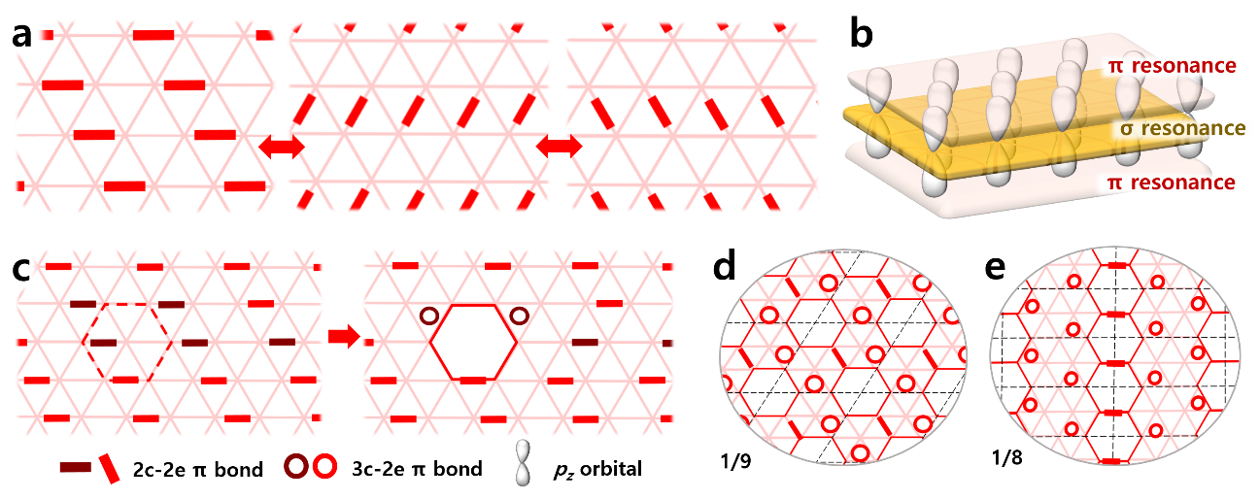
Supplementary Figure 8: π electron distribution in flat boron sheets according to the octet rule and the resonance model. (a) Three major resonance contributing forms of the π system in the flat triangular boron. (b) Schematic diagram showing both the large delocalized σ and π bonds in the flat triangular boron sheet. (c) Introducing a single-atom hole into the flat triangular boron network will delete 3.5 2c-2e and add 2 3c-2e π bonds to the system. (d-e) Representative π bonding configurations of borophene isomers with 1/9 and 1/8 hole ratios.

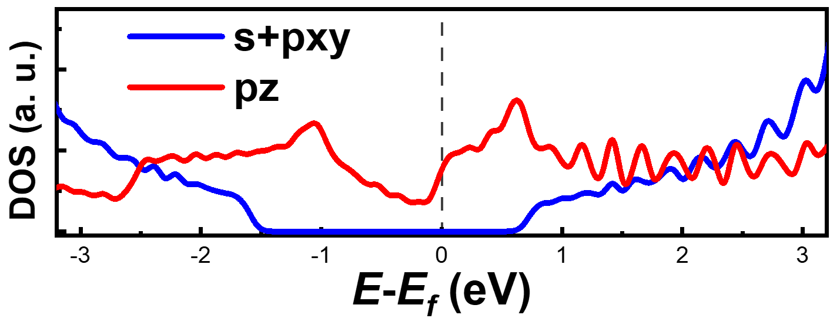
Supplementary Figure 9: Projected density of states (PDOS) for α-borophene, from which we can see that σ orbitals have a gap of ~ 2 eV near the Fermi level.
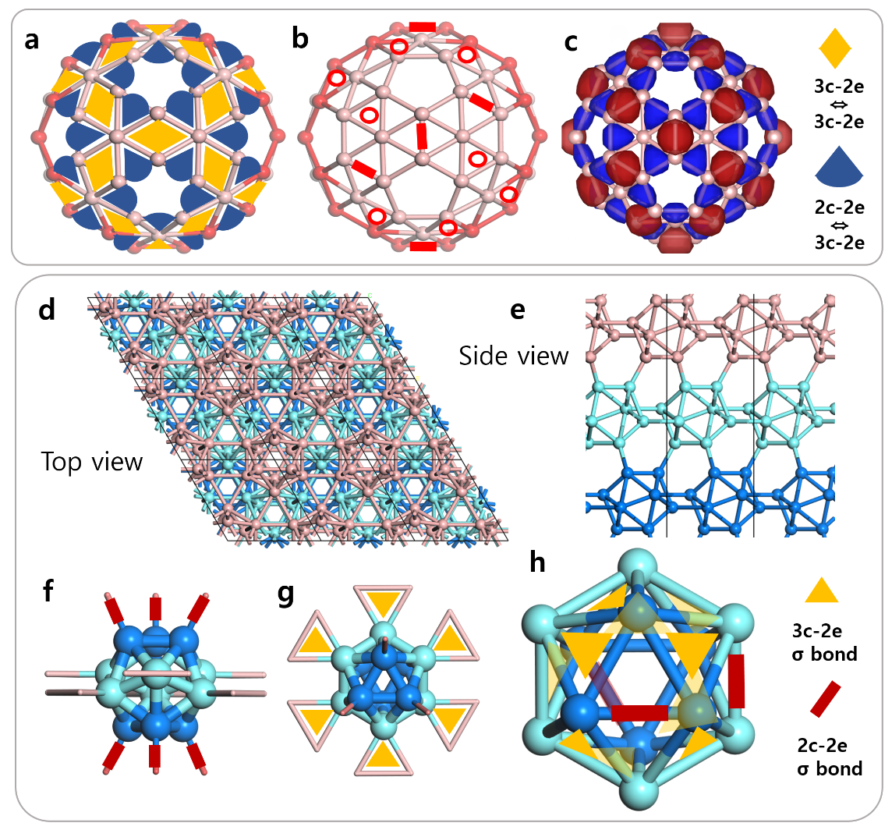
Supplementary Figure 10: (a) σ bonding configuration of a B₈₀ fullerene cage. (b) π bonding configuration of a B₈₀ fullerene cage. There are totally 80$×$3=240 electrons in a B₈₀ fullerene cage with 60 3c-2e σ bonds, 30 2c-2e σ bonds, 20 3c-2e π bonds, and 10 2c-2e π bonds. So the electron-to-orbital ratios of σ and π systems are both 3/4. (c) Chemical bonding analysis of a B₈₀ fullerene cage using the AdNDP method⁸. Atomic structure of bulk alpha boron from (d) top and (e) side views. (f-h) Focusing on the bonds of a B₁₂ cluster in the bulk alpha boron, there are 6 2c-2e (f, side view) and 6 3c-2e (g, top view) inter-cluster σ bonds, and 10 3c-2e and 3 2c-2e (h, top view) intra-cluster σ bonds.

Supplementary References
1. W. Moffitt, Molecular orbitals arid the Hartree field. Proceedings of the Royal Society of London. Series A. Mathematical and Physical Sciences 196, 510-523 (1949).
2. W. Dilthey, The synaptic order, a key concept to understand multicenter. Zeitschrift für Angewandte Chemie 34, 596-599 (1921).
3. Cotton, F. A., Chemical Applications of Group Theory, 3rd Edition, Wiley-Interscience: ISBN: 0-471-51094-7, 1971.
4. W. H. Eberhardt et al., The Valence Structure of the Boron Hydrides. The Journal of Chemical Physics 22, 989 (1954).
5. M. Nakhaee et al., Tight-binding Model for Borophene and Borophane. Physical Review B 97, 125424 (2018).
6. Z. A. Piazza et al., Planar hexagonal B36 as a potential basis for extended single-atom layer boron sheets. Nature Communications 5, 3113 (2014).
7. W.-L. Li et al., The B35 Cluster with a Double-Hexagonal Vacancy: A New and More Flexible Structural Motif for Borophene. Journal of the American Chemical Society 136, 12257-12260 (2014).
8. D. Y. Zubarev, & A. I. Boldyrev, Developing paradigms of chemical bonding: adaptive natural density partitioning. Physical Chemistry Chemical Physics 10, 5207–5217 (2008).

