Supplementary Appendix
The present supplementary appendix should give additional information to the readers of Paulus L.P., et al. Contrast-enhanced Multispectral Optoacoustic Tomography for Functional Assessment of the Gastrointestinal Tract
TABLE OF CONTENTS
Supplementary Tables 3
Supplementary Table 1 – Composition of standardized meal 4
Supplementary Table 2 – Phantom experimental setup 5
Supplementary Figures 6
Supplementary Figure 1 – in vivo Contrast-enhanced MSOT signals using preset B (65µM) 7
Supplementary Figure 2 – in vivo Contrast-enhanced MSOT signals using preset C (650µM) 8
Supplementary Figure 3 – in vivo Contrast-enhanced MSOT signals using preset D (1290µM) 9
Supplementary References 10

Supplementary Tables

Supplementary Table 1
Woman | Man
~ 60 kg | ~ 80 kg
500 kcal | 650 kcal
1½ multigrain bread roll
1 portion of jam
½ cream cheese, lean
½ portion of butter  1 slice of cheese | 1 portion of butter  1 slice of cheese
< 65 kg:  up to 2x 200 mL water  > 65 kg, < 70kg:  100 ml orange juice  up to 2 x 200 mL water  > 70 kg:  200 mL orange juice  up to 2 x 200 mL water | < 85 kg:  200 ml orange juice  up to 2 x 200 mL water  > 85 kg:  300 mL orange juice  up to 2 x 200 mL water
Supplementary Table 1 – Composition of standardized meal
The standardized meal¹ was adjusted to the gender and body weight of the subject. The energy content of approximately 400-700 kcal (8.2 kcal/kg) accounts for about 25% of the daily energy requirement. The nutrient composition is 55% carbohydrates, 29% fat and 16% proteins. For phantom experiments the average standardized meal for women with 100 ml orange juice and 200 ml water was used.

Supplementary Table 2
phantom ID | ICG concentration | blended meal | ICG amount | H₂O | additional acid / base | pH
1 | 212 μM | 112.5 mL | 25 mg | 37.5 mL |  | 5
2 | 106 μM | 112.5 mL | 12.5 mg | 37.5 mL |  | 5
3 | 53.0 μM | 112.5 mL | 6.25 mg | 37.5 mL |  | 5
4 | 10.6 μM | 112.5 mL | 1.25 mg | 37.5 mL |  | 5
5 | 1.06 μM | 112.5 mL | 125 μg | 37.5 mL |  | 5
6 | 0.106 μM | 112.5 mL | 12.5 μg | 37.5 mL |  | 5
7 | 0 μM | 112.5 mL | 0 μg | 37.5 mL |  | 5
8 | 106 μM | 112.5 mL | 12.5 mg | 37.5 mL | + 1.2 ml HCl (32%) | 2.5
9 | 106 μM | 112.5 mL | 12.5 mg | 37.5 mL | + 1.2 ml HCl (32%)  + 2.5 ml NaOH (32%) | 7
10 | 106 μM | 112.5 mL | 12.5 mg | 37.5 mL | + access HCl (32%) | <1
Supplementary Table 2 – Phantom experimental setup
Overview of the phantom experiments and their respective composition.

Supplementary Figures

Supplementary Figure 1
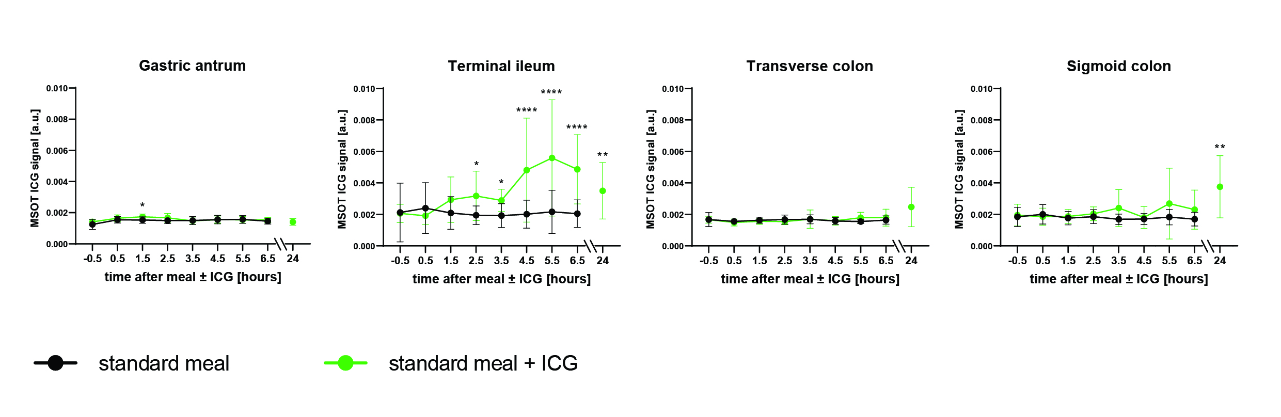
Supplementary Figure 1 – in vivo Contrast-enhanced MSOT signals using preset B (65µM)
MSOT ICG signal quantification of n=10 participants per group at each imaging timepoint of the day with and without ICG ingestion in the gastric antrum, terminal ileum, transverse colon, and sigmoid colon. Dots and whiskers represent mean and SD. Asterisks represent significant differences. * P<0.05 ** P<0.01 *** P<0.001 **** P<0.0001.

Supplementary Figure 2
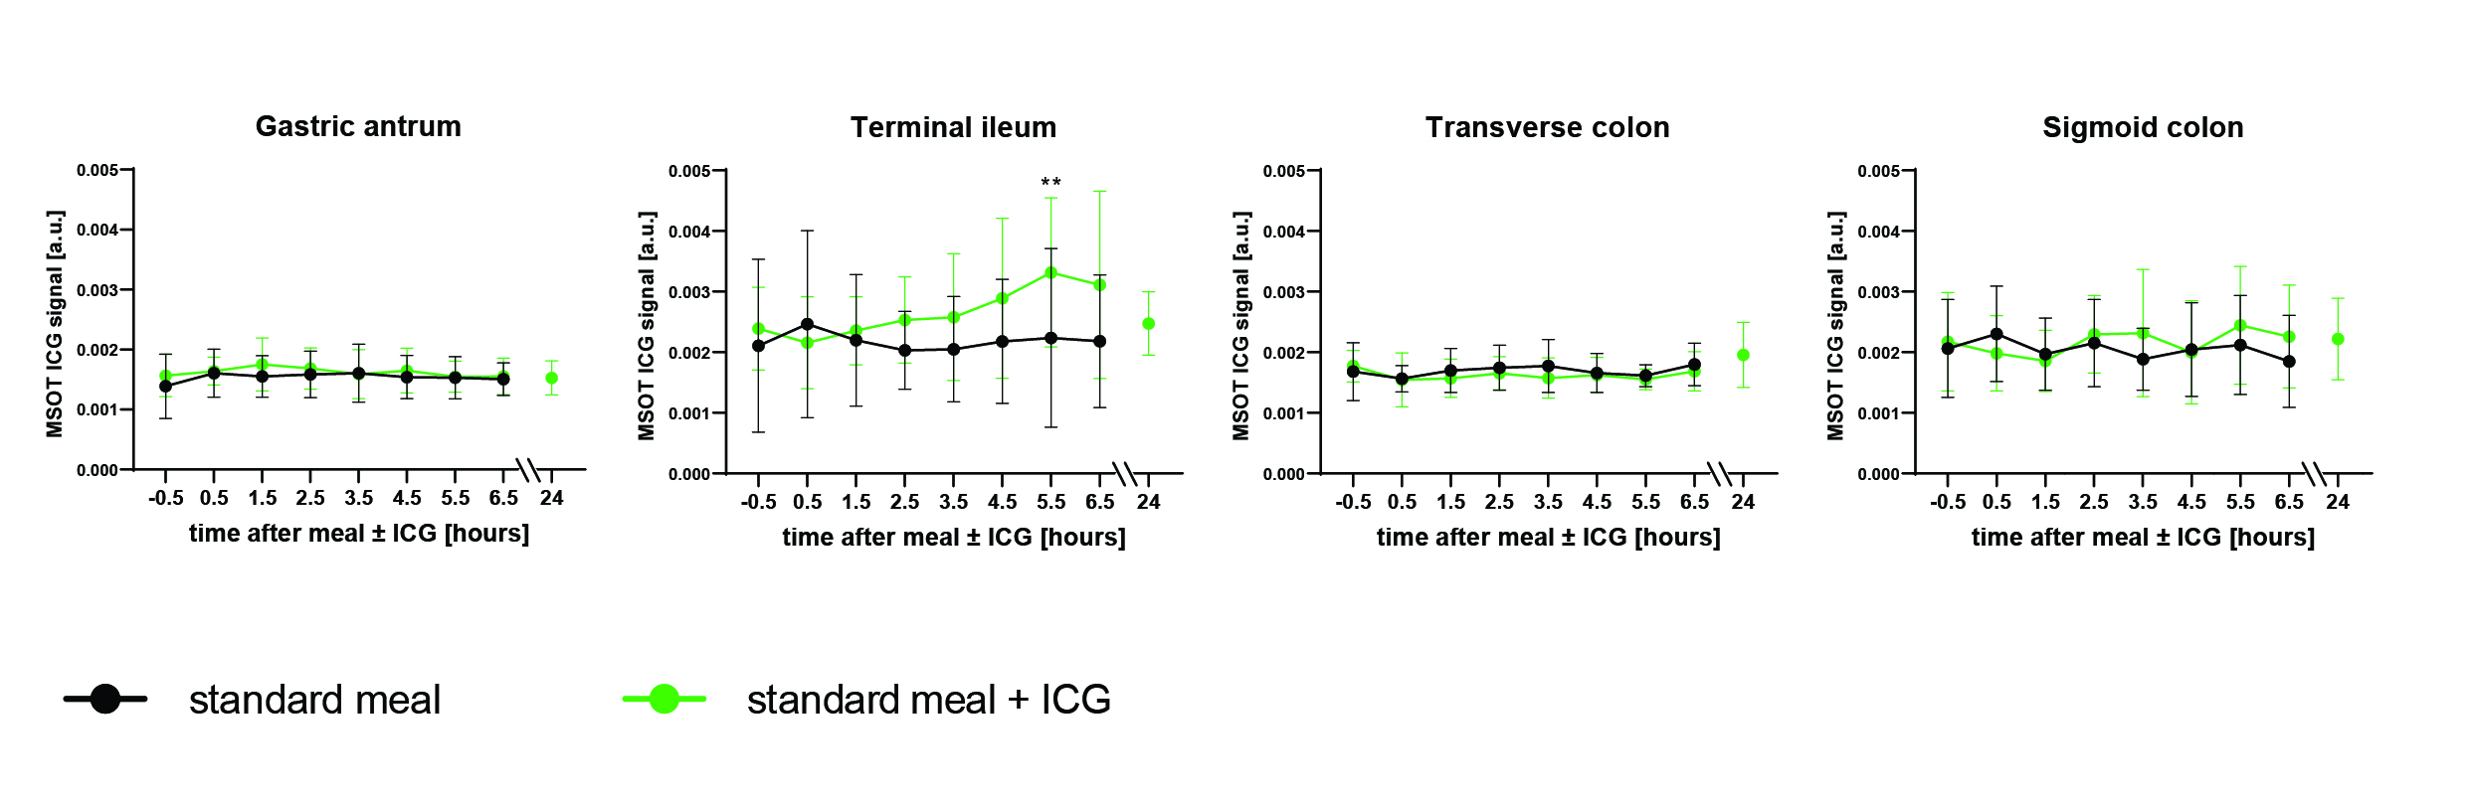
Supplementary Figure 2 – in vivo Contrast-enhanced MSOT signals using preset C (650µM)
MSOT ICG signal quantification of n=10 participants per group at each imaging timepoint of the day with and without ICG ingestion in the gastric antrum, terminal ileum, transverse colon, and sigmoid colon. Dots and whiskers represent mean and SD. Asterikses represent significant differences. ** P<0.01.

Supplementary Figure 3
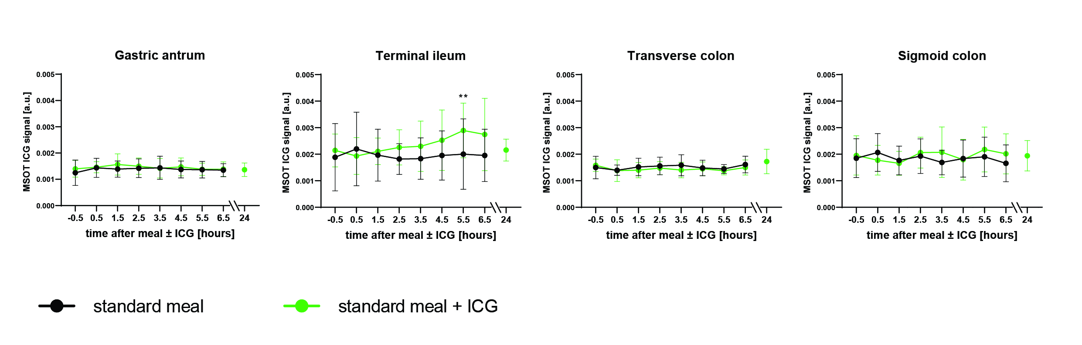
Supplementary Figure 3 – in vivo Contrast-enhanced MSOT signals using preset D (1290µM)
MSOT ICG signal quantification of n=10 participants per group at each imaging timepoint of the day with and without ICG ingestion in the gastric antrum, terminal ileum, transverse colon, and sigmoid colon. Dots and whiskers represent mean and SD. Asterikses represent significant differences. ** P<0.01.

Supplementary References
1 Goertz, R. S., Egger, C., Neurath, M. F. & Strobel, D. Impact of food intake, ultrasound transducer, breathing maneuvers and body position on acoustic radiation force impulse (ARFI) elastometry of the liver. Ultraschall Med 33, 380-385, doi:10.1055/s-0032-1312816 (2012).

