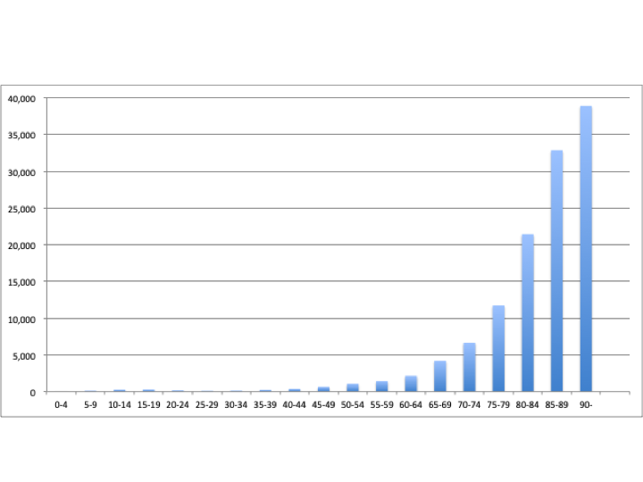Supplementary Figure 1 Age-stratified incidence of femur fracture surgery in 2019.
A unimodal distribution is observed with a peak at >90 years. All supplementary figures are created based on data from the NDB Open Data Japan¹⁹ and the demographics of the Ministry of Internal Affairs and Communications²⁰.

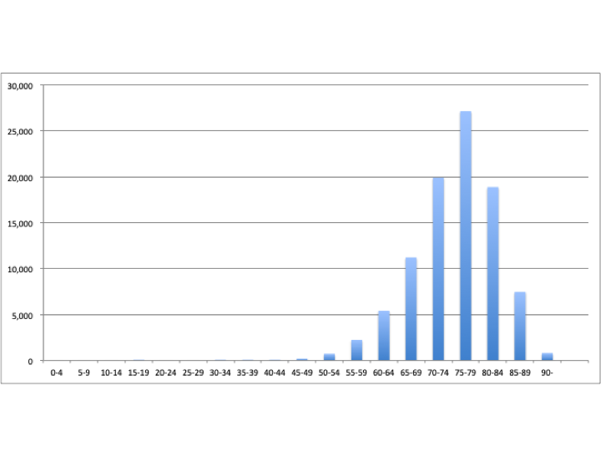
Supplementary Figure 2. Age-stratified incidence of knee arthroplasty in 2019.
A unimodal distribution is observed with a peak at 75–89 years.
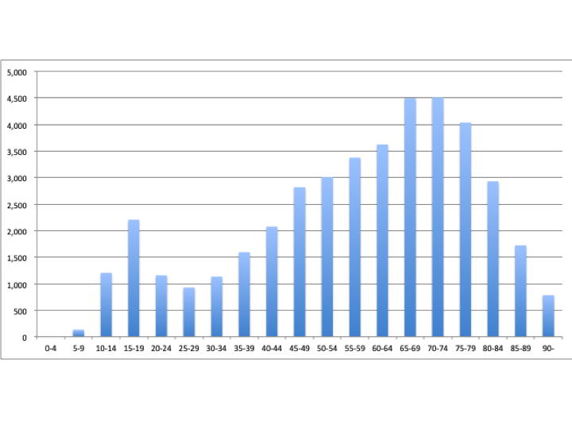Supplementary Figure 3. Age-stratified incidence of lower limb fracture surgery in 2019.
A bimodal distribution is observed with peaks at 15–19 and 65–74 years.
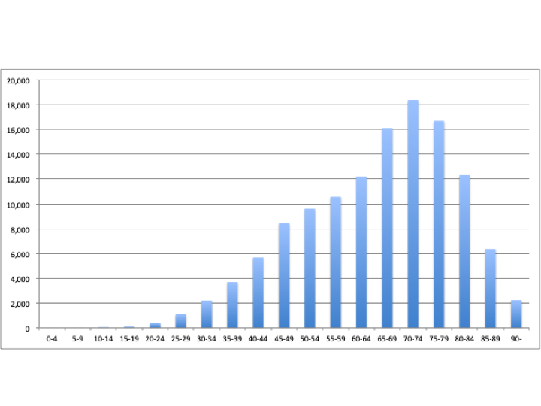
Supplementary Figure 4. Age-stratified incidence of cholecystectomy in 2019.
A unimodal distribution is observed with a peak at 70–74 years.

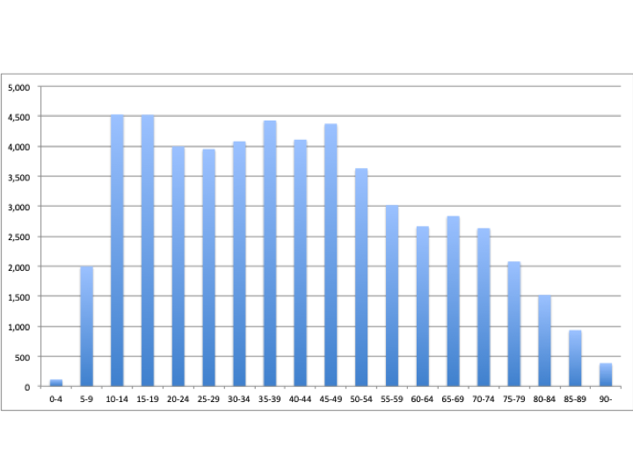
Supplementary Figure 5. Age-stratified incidence of appendectomy in 2019.
An approximately bimodal distribution is observed with peaks at 10–19 and 35–49 years.
Supplementary Table 1 Prefectural incidence rate of femur fracture surgery during 2015–2019 (per 100,000 people)
Year | 2015 | 2016 | 2017 | 2018 | 2019
National average | 93.5 | 95.0 | 98.3 | 97.0 | 97.5
Name of the prefecture
Hokkaido | 84.7 | 87.4 | 91.8 | 92.1 | 92.0
Aomori | 85.5 | 84.8 | 89.9 | 91.8 | 83.7
Iwate | 90.0 | 91.6 | 94.7 | 93.4 | 92.2
Miyagi | 68.4 | 72.7 | 73.6 | 74.7 | 74.8
Akita | 100.3 | 97.0 | 106.5 | 107.6 | 108.7
Yamagata | 122.3 | 121.0 | 128.9 | 129.5 | 123.7
Fukushima | 89.9 | 90.6 | 98.5 | 92.5 | 98.4
Ibaraki | 89.3 | 89.3 | 94.5 | 89.4 | 89.7
Tochigi | 85.1 | 86.0 | 83.4 | 86.2 | 88.8
Gumma | 100.9 | 93.8 | 102.2 | 93.7 | 99.4
Saitama | 68.0 | 68.3 | 74.3 | 73.0 | 74.2
Chiba | 68.7 | 69.5 | 72.3 | 73.0 | 75.3
Tokyo | 67.5 | 67.5 | 72.4 | 69.6 | 70.1
Kanagawa | 75.5 | 78.5 | 77.8 | 78.0 | 81.3
Niigata | 101.9 | 107.8 | 112.7 | 108.5 | 113.1
Toyama | 126.2 | 128.5 | 135.8 | 129.8 | 125.2
Ishikawa | 108.8 | 107.3 | 119.5 | 116.5 | 118.1
Fukui | 118.3 | 120.1 | 129.7 | 130.6 | 123.4
Yamanashi | 129.6 | 131.9 | 137.3 | 133.3 | 134.9
Nagano | 120.4 | 123.0 | 118.6 | 126.3 | 121.2
Gifu | 111.3 | 114.2 | 111.3 | 109.6 | 111.6
Shizuoka | 101.3 | 100.6 | 106.9 | 101.9 | 105.6
Aichi | 76.0 | 79.8 | 80.3 | 78.6 | 79.9
Mie | 105.7 | 108.9 | 108.6 | 107.2 | 107.0
Shiga | 95.9 | 95.8 | 93.7 | 92.4 | 95.0
Kyoto | 97.9 | 100.3 | 99.9 | 103.2 | 100.0
Osaka | 92.3 | 93.2 | 95.9 | 97.0 | 96.7
Hyogo | 108.6 | 111.2 | 116.3 | 116.3 | 115.7
Nara | 102.3 | 107.4 | 109.1 | 111.0 | 113.6
Wakayama | 132.8 | 133.8 | 145.1 | 147.1 | 149.7
Tottori | 144.5 | 143.5 | 153.3 | 155.2 | 149.5
Shimane | 134.4 | 140.9 | 157.1 | 141.0 | 137.2
Okayama | 116.8 | 112.6 | 115.0 | 106.3 | 106.2
Hiroshima | 110.9 | 110.2 | 116.7 | 122.3 | 118.8
Yamaguchi | 129.3 | 131.6 | 127.7 | 122.0 | 125.1
Tokushima | 106.6 | 115.2 | 111.6 | 109.6 | 117.2
Kagawa | 121.7 | 127.2 | 137.7 | 134.3 | 126.7
Ehime | 126.8 | 130.4 | 132.2 | 128.8 | 141.8
Kochi | 137.8 | 132.5 | 140.5 | 134.7 | 126.9
Fukuoka | 104.7 | 105.8 | 112.4 | 106.5 | 108.1
Saga | 128.6 | 136.4 | 135.6 | 145.4 | 137.8
Nagasaki | 136.7 | 138.0 | 146.8 | 140.6 | 139.6
Kumamoto | 134.7 | 148.8 | 140.0 | 141.2 | 141.8
Oita | 136.7 | 146.4 | 147.7 | 144.8 | 142.8
Miyazaki | 130.8 | 129.2 | 127.2 | 130.1 | 136.9
Kagoshima | 123.6 | 121.9 | 130.9 | 127.6 | 126.0
Okinawa | 98.9 | 97.8 | 101.5 | 104.8 | 100.3

Supplementary Table 2 Prefectural incidence rate of knee arthroplasty during 2015–2019 (per 100,000 people)
Year | 2015 | 2016 | 2017 | 2018 | 2019
National average | 60.6 | 60.6 | 65.0 | 69.6 | 74.7
Name of the prefecture
Hokkaido | 90.1 | 89.9 | 98.3 | 104.2 | 104.5
Aomori | 59.2 | 62.5 | 70.1 | 71.8 | 76.6
Iwate | 37.0 | 36.2 | 32.2 | 36.5 | 34.9
Miyagi | 32.2 | 29.3 | 30.5 | 32.9 | 36.7
Akita | 92.5 | 74.5 | 77.7 | 85.5 | 88.8
Yamagata | 105.5 | 95.7 | 97.0 | 96.5 | 102.3
Fukushima | 85.1 | 84.2 | 84.0 | 94.9 | 91.9
Ibaraki | 47.1 | 49.8 | 57.6 | 62.4 | 64.3
Tochigi | 55.3 | 53.4 | 55.3 | 59.3 | 59.4
Gumma | 50.3 | 54.3 | 59.0 | 66.2 | 75.2
Saitama | 39.7 | 40.2 | 45.9 | 49.7 | 54.9
Chiba | 48.9 | 49.2 | 52.9 | 56.8 | 60.7
Tokyo | 48.6 | 47.7 | 51.4 | 55.2 | 58.4
Kanagawa | 43.8 | 44.0 | 49.4 | 52.7 | 53.9
Niigata | 65.3 | 60.8 | 66.4 | 69.5 | 72.6
Toyama | 82.1 | 87.7 | 91.0 | 98.6 | 106.1
Ishikawa | 68.5 | 68.0 | 67.0 | 72.7 | 84.4
Fukui | 77.0 | 70.7 | 80.7 | 96.5 | 98.7
Yamanashi | 60.1 | 53.9 | 65.6 | 59.4 | 59.3
Nagano | 82.5 | 83.7 | 79.3 | 87.3 | 88.3
Gifu | 37.0 | 37.6 | 39.9 | 42.1 | 44.9
Shizuoka | 48.3 | 51.5 | 52.0 | 59.0 | 68.0
Aichi | 35.5 | 37.9 | 37.5 | 40.6 | 45.4
Mie | 43.1 | 39.0 | 41.7 | 44.7 | 52.8
Shiga | 46.7 | 49.0 | 50.7 | 56.0 | 62.7
Kyoto | 66.2 | 67.5 | 68.2 | 69.6 | 84.3
Osaka | 73.8 | 78.2 | 83.0 | 91.5 | 100.9
Hyogo | 73.7 | 74.8 | 79.9 | 80.5 | 85.9
Nara | 81.5 | 74.6 | 84.1 | 94.0 | 107.1
Wakayama | 80.6 | 89.2 | 102.9 | 97.3 | 104.5
Tottori | 63.5 | 61.6 | 66.5 | 75.2 | 78.2
Shimane | 75.1 | 75.1 | 73.1 | 73.4 | 70.8
Okayama | 63.5 | 65.3 | 72.3 | 76.0 | 90.9
Hiroshima | 68.7 | 64.8 | 68.6 | 73.6 | 79.7
Yamaguchi | 58.0 | 57.5 | 56.3 | 66.4 | 78.2
Tokushima | 76.5 | 71.2 | 79.7 | 76.9 | 82.8
Kagawa | 79.5 | 87.8 | 98.3 | 98.0 | 106.8
Ehime | 85.9 | 95.2 | 107.0 | 116.7 | 139.9
Kochi | 96.4 | 94.3 | 95.1 | 104.8 | 109.6
Fukuoka | 66.7 | 66.1 | 72.8 | 75.8 | 80.2
Saga | 77.3 | 70.5 | 73.3 | 80.8 | 87.2
Nagasaki | 71.1 | 69.4 | 70.7 | 78.4 | 86.1
Kumamoto | 98.5 | 93.3 | 100.6 | 111.3 | 123.4
Oita | 89.7 | 85.8 | 99.2 | 101.7 | 104.1
Miyazaki | 87.2 | 85.9 | 101.2 | 106.8 | 110.0
Kagoshima | 87.0 | 81.7 | 90.9 | 103.6 | 112.2
Okinawa | 89.1 | 91.0 | 97.5 | 106.5 | 108.3

Supplementary Table 3 Prefectural incidence rate of cholecystectomy during 2015–2019 (per 100,000 people)
Year | 2015 | 2016 | 2017 | 2018 | 2019
National average | 96.6 | 97.1 | 98.7 | 100.0 | 100.1
Name of the prefecture
Hokkaido | 112.5 | 111.9 | 115.7 | 114.1 | 112.5
Aomori | 110.8 | 107.0 | 105.2 | 104.6 | 110.4
Iwate | 103.1 | 97.6 | 93.4 | 99.0 | 94.6
Miyagi | 115.8 | 112.8 | 118.3 | 122.9 | 117.4
Akita | 97.6 | 97.9 | 94.1 | 104.6 | 95.3
Yamagata | 99.1 | 105.2 | 103.1 | 101.5 | 104.2
Fukushima | 101.3 | 102.1 | 101.7 | 102.0 | 104.0
Ibaraki | 94.7 | 95.4 | 99.2 | 102.2 | 98.3
Tochigi | 98.0 | 101.4 | 99.8 | 99.3 | 106.8
Gumma | 99.9 | 101.6 | 103.9 | 103.9 | 105.1
Saitama | 70.9 | 71.1 | 74.1 | 76.2 | 77.5
Chiba | 79.7 | 81.4 | 85.7 | 87.1 | 85.3
Tokyo | 84.9 | 84.7 | 85.4 | 83.6 | 85.8
Kanagawa | 74.7 | 74.4 | 74.5 | 78.3 | 81.5
Niigata | 68.2 | 67.6 | 69.6 | 69.5 | 70.0
Toyama | 93.2 | 96.4 | 99.4 | 107.0 | 113.0
Ishikawa | 100.3 | 94.6 | 97.9 | 101.9 | 99.9
Fukui | 121.9 | 112.8 | 122.3 | 115.4 | 117.4
Yamanashi | 86.6 | 89.0 | 89.9 | 81.2 | 77.1
Nagano | 93.4 | 89.1 | 91.7 | 93.7 | 103.1
Gifu | 90.5 | 87.3 | 87.7 | 89.7 | 89.9
Shizuoka | 75.2 | 75.8 | 78.4 | 78.5 | 79.3
Aichi | 79.8 | 81.7 | 81.7 | 84.9 | 81.4
Mie | 106.4 | 112.5 | 110.2 | 118.1 | 114.7
Shiga | 98.4 | 104.5 | 99.1 | 102.7 | 102.1
Kyoto | 104.8 | 108.3 | 107.8 | 108.1 | 103.6
Osaka | 109.2 | 110.7 | 112.8 | 113.9 | 114.6
Hyogo | 106.9 | 110.4 | 109.3 | 109.0 | 110.6
Nara | 115.1 | 116.2 | 120.8 | 124.6 | 126.7
Wakayama | 117.7 | 118.9 | 120.0 | 111.3 | 118.6
Tottori | 136.3 | 125.8 | 139.8 | 128.9 | 129.1
Shimane | 96.0 | 95.9 | 110.8 | 98.4 | 115.1
Okayama | 107.4 | 112.2 | 111.2 | 117.3 | 107.9
Hiroshima | 108.4 | 107.5 | 106.4 | 110.8 | 110.3
Yamaguchi | 121.1 | 113.6 | 113.2 | 123.1 | 115.9
Tokushima | 124.6 | 138.1 | 137.6 | 146.6 | 148.1
Kagawa | 124.8 | 124.3 | 133.3 | 124.3 | 132.8
Ehime | 128.2 | 135.1 | 124.6 | 140.4 | 140.4
Kochi | 110.3 | 109.7 | 123.4 | 123.2 | 115.0
Fukuoka | 115.4 | 111.8 | 119.1 | 118.9 | 116.6
Saga | 94.5 | 94.1 | 90.0 | 100.7 | 103.4
Nagasaki | 112.7 | 119.5 | 111.2 | 121.6 | 121.4
Kumamoto | 121.8 | 119.8 | 123.7 | 118.8 | 121.6
Oita | 151.7 | 153.9 | 156.9 | 170.6 | 160.7
Miyazaki | 105.2 | 100.4 | 113.0 | 112.0 | 112.7
Kagoshima | 109.3 | 113.0 | 116.9 | 108.9 | 111.9
Okinawa | 117.5 | 124.0 | 125.4 | 126.4 | 122.5

Supplementary Table 4 Prefectural incidence rate of appendectomy during 2015–2019 (per 100,000 people).
Year | 2015 | 2016 | 2018 | 2019
National average | 44.9 | 43.2 | 43.5 | 44.3
Name of Prefecture
Hokkaido | 46.8 | 43.6 | 47.3 | 44.0
Aomori | 34.4 | 31.2 | 30.8 | 28.9
Iwate | 46.5 | 44.1 | 38.8 | 40.4
Miyagi | 45.4 | 42.4 | 41.8 | 40.7
Akita | 44.0 | 38.0 | 43.6 | 39.6
Yamagata | 43.6 | 36.5 | 38.2 | 36.6
Fukushima | 41.9 | 40.8 | 37.1 | 38.0
Ibaraki | 43.5 | 42.7 | 42.5 | 42.9
Tochigi | 38.6 | 34.1 | 37.1 | 39.1
Gumma | 39.2 | 35.0 | 38.5 | 38.8
Saitama | 37.1 | 37.2 | 35.9 | 37.6
Chiba | 39.2 | 38.8 | 40.6 | 40.0
Tokyo | 47.3 | 46.8 | 46.1 | 48.0
Kanagawa | 45.2 | 41.5 | 43.1 | 45.0
Niigata | 36.0 | 34.3 | 33.6 | 31.2
Toyama | 47.4 | 52.5 | 49.6 | 49.0
Ishikawa | 57.6 | 57.9 | 56.4 | 55.4
Fukui | 54.1 | 52.6 | 56.1 | 56.3
Yamanashi | 37.8 | 39.0 | 39.5 | 36.0
Nagano | 50.6 | 46.5 | 52.5 | 54.3
Gifu | 46.9 | 43.8 | 42.4 | 42.8
Shizuoka | 39.8 | 39.0 | 36.2 | 36.3
Aichi | 43.3 | 41.7 | 39.5 | 41.9
Mie | 46.5 | 47.2 | 42.4 | 44.6
Shiga | 46.9 | 50.0 | 45.5 | 46.7
Kyoto | 51.0 | 50.5 | 49.2 | 46.6
Osaka | 46.6 | 44.0 | 46.4 | 48.1
Hyogo | 46.5 | 42.9 | 43.7 | 44.4
Nara | 45.6 | 46.6 | 47.1 | 47.7
Wakayama | 37.6 | 37.4 | 37.0 | 38.4
Tottori | 55.5 | 57.7 | 52.7 | 58.8
Shimane | 49.4 | 41.2 | 47.8 | 50.4
Okayama | 49.0 | 46.2 | 48.6 | 53.5
Hiroshima | 44.4 | 43.2 | 43.2 | 47.5
Yamaguchi | 33.9 | 36.4 | 38.2 | 38.4
Tokushima | 44.4 | 39.7 | 43.1 | 43.8
Kagawa | 39.8 | 42.8 | 44.7 | 45.0
Ehime | 43.8 | 46.1 | 40.9 | 47.3
Kochi | 42.0 | 38.0 | 40.2 | 40.4
Fukuoka | 49.0 | 46.7 | 50.3 | 48.9
Saga | 48.0 | 51.0 | 47.0 | 46.1
Nagasaki | 44.0 | 44.9 | 38.8 | 39.5
Kumamoto | 52.7 | 48.2 | 45.4 | 45.6
Oita | 51.5 | 49.1 | 47.6 | 51.1
Miyazaki | 43.6 | 41.1 | 44.5 | 43.3
Kagoshima | 47.3 | 45.2 | 47.0 | 45.1
Okinawa | 68.3 | 66.6 | 67.5 | 63.2
Missing data for 2017 is due to anonymisation.
Supplementary Table 5 Prefectural incidence rates of medical specialists in orthopaedics, general surgery, and anaesthesiology (OSS, GSS, ANN, respectively) during 2015–2019 (per 100,000 people)
 | OSS |  | GSS |  | ANN
Year | 2016 | 2018 | 2016 | 2018 | 2016 | 2018
National average | 14.2 | 14.5 | 17.3 | 17.9 | 5.8 | 6.0
Name of the prefecture
Hokkaido | 12.9 | 13.8 | 16.1 | 17.2 | 7.7 | 8.2
Aomori | 12.5 | 12.6 | 15 | 15.7 | 4.6 | 4.9
Iwate | 9.7 | 10.2 | 14 | 15 | 3.7 | 3.8
Miyagi | 12.1 | 12.3 | 18.9 | 19.9 | 5.4 | 5.4
Akita | 13.4 | 14.2 | 16.6 | 17.2 | 3.6 | 3.7
Yamagata | 15.4 | 15.7 | 15.1 | 14.8 | 3.7 | 4.6
Fukushima | 11.3 | 11.1 | 14.6 | 16.1 | 3.9 | 4.3
Ibaraki | 9.8 | 9.8 | 13.5 | 14.2 | 4.3 | 4.4
Tochigi | 10.5 | 11.1 | 17.2 | 18.2 | 5.5 | 5
Gumma | 13.2 | 14.2 | 16.8 | 17.3 | 6.1 | 6.4
Saitama | 8.4 | 8.6 | 11.9 | 13 | 4 | 4.3
Chiba | 10.6 | 10.9 | 15.5 | 16.4 | 4.2 | 4.4
Tokyo | 13.4 | 13.8 | 20.8 | 21.1 | 7.2 | 7.5
Kanagawa | 11.3 | 11.7 | 13.8 | 14.4 | 5.3 | 5.4
Niigata | 12.6 | 12.6 | 11.7 | 12 | 3.3 | 3.9
Toyama | 15.5 | 15.3 | 16.6 | 16.6 | 6.7 | 6.7
Ishikawa | 15.2 | 15.7 | 19.5 | 19.4 | 6.3 | 7.3
Fukui | 15.1 | 15.5 | 18.7 | 19.1 | 5.2 | 5.6
Yamanashi | 15.3 | 15.1 | 17.6 | 18.4 | 5.1 | 5.9
Nagano | 12.9 | 13.2 | 16 | 16.7 | 5.8 | 5.5
Gifu | 11.6 | 11.8 | 12.9 | 14 | 4 | 3.8
Shizuoka | 10.6 | 11.6 | 15.3 | 15.7 | 4.1 | 4.4
Aichi | 11.2 | 11.1 | 13.6 | 13.9 | 4 | 4.3
Mie | 12.7 | 13.5 | 16.3 | 15.9 | 3.3 | 3.4
Shiga | 12.5 | 12.1 | 15 | 14.6 | 5.6 | 5.9
Kyoto | 16.8 | 17.4 | 25.5 | 25.3 | 7.4 | 7.7
Osaka | 14.2 | 15.1 | 18.9 | 19.4 | 6.4 | 6.9
Hyogo | 14.4 | 14.6 | 16.8 | 17.8 | 5.9 | 6
Nara | 17.6 | 18 | 16.6 | 17.8 | 5.4 | 5.8
Wakayama | 16.8 | 17.8 | 18.1 | 19.7 | 6.1 | 6.5
Tottori | 16.5 | 17 | 20.4 | 20 | 6.8 | 6.8
Shimane | 14.8 | 15.1 | 18.1 | 19.3 | 8.4 | 8.5
Okayama | 15 | 15.6 | 21.1 | 21.4 | 7.2 | 7.9
Hiroshima | 15.7 | 15.7 | 19.9 | 20 | 6.1 | 6.1
Yamaguchi | 14.6 | 14.2 | 17.6 | 18.9 | 6.3 | 6.1
Tokushima | 17.2 | 18.5 | 18.8 | 18.1 | 7.5 | 6.7
Kagawa | 18.9 | 18.9 | 18.1 | 20.1 | 7.2 | 7.2
Ehime | 16.1 | 16.1 | 19.2 | 19.6 | 6.1 | 6.4
Kochi | 19 | 18 | 20.7 | 21.2 | 6.8 | 7.5
Fukuoka | 17.4 | 17.8 | 21.4 | 22.9 | 6.9 | 7
Saga | 18.8 | 18.9 | 17 | 18.7 | 7.1 | 7
Nagasaki | 16.9 | 17.3 | 19.7 | 20.3 | 6.3 | 6.8
Kumamoto | 18.2 | 19 | 18.2 | 19.2 | 7.4 | 7.4
Oita | 15.9 | 15.4 | 21.1 | 22.6 | 7.1 | 7.3
Miyazaki | 17.1 | 16.6 | 18.1 | 19.1 | 7.4 | 7.7
Kagoshima | 15 | 15.1 | 17.8 | 19.2 | 7 | 7.4
Okinawa | 11.5 | 11.7 | 16.1 | 16.2 | 6.1 | 6.8

Supplementary Table 6 Prefectural incidence rates of medical facilities (hospitals and beds) during 2015–2019 (per 100,000 people for hospitals and per 1,000 people for beds)
 | Hospitals | Beds
Year | 2017 | 2017
National average | 8.1 | 1,412
Name of the prefecture
Hokkaido | 10.5 | 1,777
Aomori | 7.4 | 1,350
Iwate | 7.4 | 1,379
Miyagi | 6.0 | 1,100
Akita | 6.9 | 1,512
Yamagata | 6.3 | 1,324
Fukushima | 6.8 | 1,357
Ibaraki | 6.1 | 1,092
Tochigi | 5.5 | 1,078
Gumma | 6.6 | 1,236
Saitama | 4.7 | 853
Chiba | 4.6 | 953
Tokyo | 4.7 | 935
Kanagawa | 3.7 | 806
Niigata | 5.7 | 1,253
Toyama | 10.0 | 1,575
Ishikawa | 8.2 | 1,561
Fukui | 8.7 | 1,401
Yamanashi | 7.3 | 1,317
Nagano | 6.2 | 1,150
Gifu | 5.0 | 1,019
Shizuoka | 4.9 | 1,052
Aichi | 4.3 | 899
Mie | 5.4 | 1,121
Shiga | 4.0 | 1,016
Kyoto | 6.5 | 1,359
Osaka | 5.9 | 1,212
Hyogo | 6.4 | 1,182
Nara | 5.9 | 1,258
Wakayama | 8.8 | 1,426
Tottori | 7.8 | 1,513
Shimane | 7.4 | 1,541
Okayama | 8.5 | 1,480
Hiroshima | 8.6 | 1,412
Yamaguchi | 10.5 | 1,931
Tokushima | 14.7 | 1,942
Kagawa | 9.2 | 1,537
Ehime | 10.3 | 1,611
Kochi | 18.1 | 2,545
Fukuoka | 9.0 | 1,672
Saga | 12.9 | 1,818
Nagasaki | 11.1 | 1,942
Kumamoto | 12.1 | 1,962
Oita | 13.6 | 1,737
Miyazaki | 12.9 | 1,755
Kagoshima | 15.1 | 2,073
Okinawa | 6.5 | 1,316

Supplementary Table 7 Prefectural index of the ageing rate during 2015–2019
Year | 2015 | 2016 | 2017 | 2018 | 2019
National average | 0.267 | 0.272 | 0.277 | 0.281 | 0.284
Name of the prefecture
Hokkaido | 0.291 | 0.299 | 0.307 | 0.313 | 0.319
Aomori | 0.301 | 0.311 | 0.319 | 0.326 | 0.333
Iwate | 0.304 | 0.312 | 0.319 | 0.326 | 0.331
Miyagi | 0.257 | 0.264 | 0.271 | 0.278 | 0.284
Akita | 0.339 | 0.348 | 0.356 | 0.365 | 0.373
Yamagata | 0.308 | 0.314 | 0.323 | 0.329 | 0.335
Fukushima | 0.287 | 0.295 | 0.302 | 0.309 | 0.316
Ibaraki | 0.267 | 0.276 | 0.283 | 0.289 | 0.294
Tochigi | 0.259 | 0.267 | 0.274 | 0.280 | 0.286
Gumma | 0.276 | 0.283 | 0.289 | 0.294 | 0.298
Saitama | 0.248 | 0.255 | 0.260 | 0.264 | 0.267
Chiba | 0.259 | 0.266 | 0.271 | 0.275 | 0.278
Tokyo | 0.227 | 0.229 | 0.230 | 0.231 | 0.230
Kanagawa | 0.239 | 0.244 | 0.248 | 0.251 | 0.253
Niigata | 0.298 | 0.306 | 0.313 | 0.319 | 0.324
Toyama | 0.306 | 0.312 | 0.316 | 0.320 | 0.323
Ishikawa | 0.279 | 0.284 | 0.289 | 0.292 | 0.296
Fukui | 0.287 | 0.292 | 0.299 | 0.304 | 0.306
Yamanashi | 0.284 | 0.290 | 0.298 | 0.304 | 0.308
Nagano | 0.301 | 0.307 | 0.312 | 0.315 | 0.319
Gifu | 0.281 | 0.287 | 0.294 | 0.298 | 0.301
Shizuoka | 0.278 | 0.285 | 0.291 | 0.295 | 0.299
Aichi | 0.238 | 0.243 | 0.246 | 0.249 | 0.251
Mie | 0.279 | 0.285 | 0.289 | 0.295 | 0.298
Shiga | 0.243 | 0.248 | 0.253 | 0.258 | 0.260
Kyoto | 0.276 | 0.281 | 0.285 | 0.289 | 0.292
Osaka | 0.262 | 0.268 | 0.272 | 0.275 | 0.276
Hyogo | 0.271 | 0.278 | 0.283 | 0.288 | 0.291
Nara | 0.287 | 0.296 | 0.303 | 0.309 | 0.314
Wakayama | 0.308 | 0.316 | 0.323 | 0.327 | 0.331
Tottori | 0.298 | 0.304 | 0.312 | 0.316 | 0.320
Shimane | 0.326 | 0.332 | 0.336 | 0.340 | 0.343
Okayama | 0.287 | 0.293 | 0.297 | 0.301 | 0.303
Hiroshima | 0.275 | 0.282 | 0.286 | 0.290 | 0.293
Yamaguchi | 0.321 | 0.328 | 0.334 | 0.339 | 0.343
Tokushima | 0.311 | 0.317 | 0.324 | 0.330 | 0.337
Kagawa | 0.299 | 0.308 | 0.312 | 0.316 | 0.319
Ehime | 0.307 | 0.313 | 0.321 | 0.325 | 0.329
Kochi | 0.328 | 0.336 | 0.343 | 0.348 | 0.352
Fukuoka | 0.259 | 0.266 | 0.271 | 0.276 | 0.279
Saga | 0.277 | 0.284 | 0.292 | 0.298 | 0.302
Nagasaki | 0.297 | 0.305 | 0.312 | 0.320 | 0.326
Kumamoto | 0.288 | 0.295 | 0.301 | 0.306 | 0.310
Oita | 0.304 | 0.312 | 0.319 | 0.324 | 0.329
Miyazaki | 0.296 | 0.304 | 0.310 | 0.316 | 0.323
Kagoshima | 0.295 | 0.301 | 0.308 | 0.314 | 0.320
Okinawa | 0.197 | 0.204 | 0.211 | 0.216 | 0.222

