Supplementary figure legends

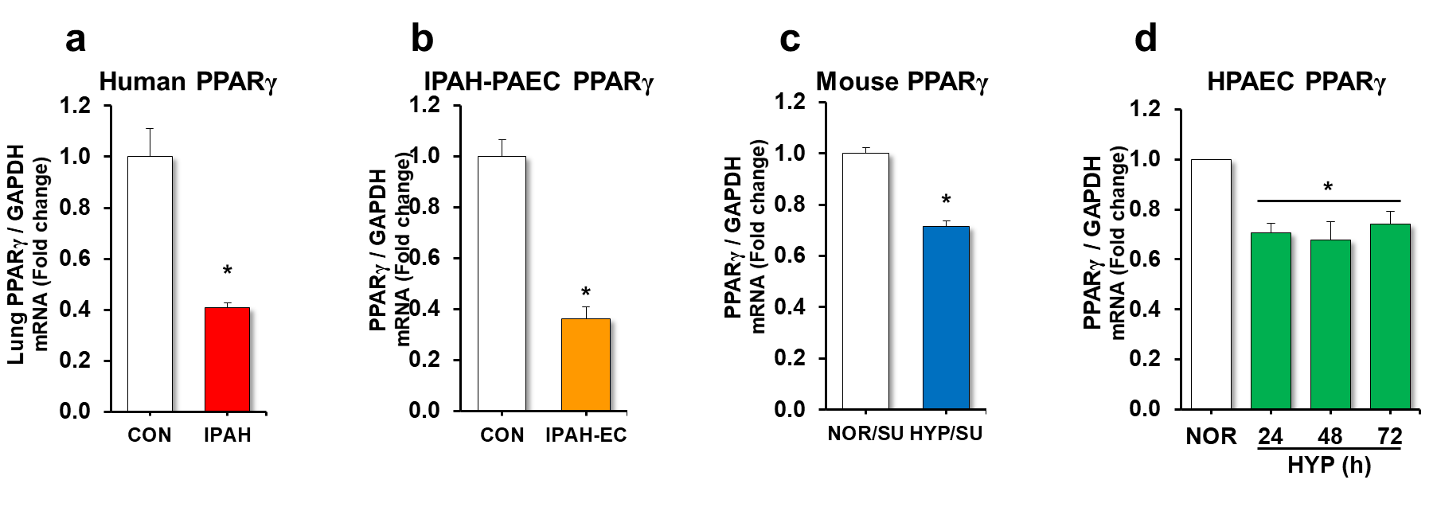
Supplementary Figure 1. PPARγ is reduced in lungs and PAECs isolated from IPAH patients, lungs of hypoxia/sugen-treated mice, and in hypoxia-exposed HPAECs. (a, b) The expression of lung or PAEC PPARγ was measured with qRT-PCR and expressed relative to GPADH mRNA ± SE as fold-change vs. CON. *p<0.05 vs NOR, n=5. (c) Whole lung or pulmonary artery homogenates were collected from mice under normoxic (NOR, 21%)/sugen or hypoxic (HYP, 10% O₂)/sugen mice for 3-weeks. Lung PPARγ expression was measured with qRT-PCR and expressed relative to lung Gapdh mRNA *p<0.05 vs NOR, n=6. (d) HPAECs were exposed with normoxia (NOR, 21% O₂) or hypoxia (HYP, 1% O₂) for 72 hours. Mean HPAEC PPARγ expression was measured with qRT-PCR. All bars represent the mean PPARγ mRNA levels relative to GAPDH ± SE expressed as fold-change vs. NOR. *p<0.05 vs. NOR, n=6.

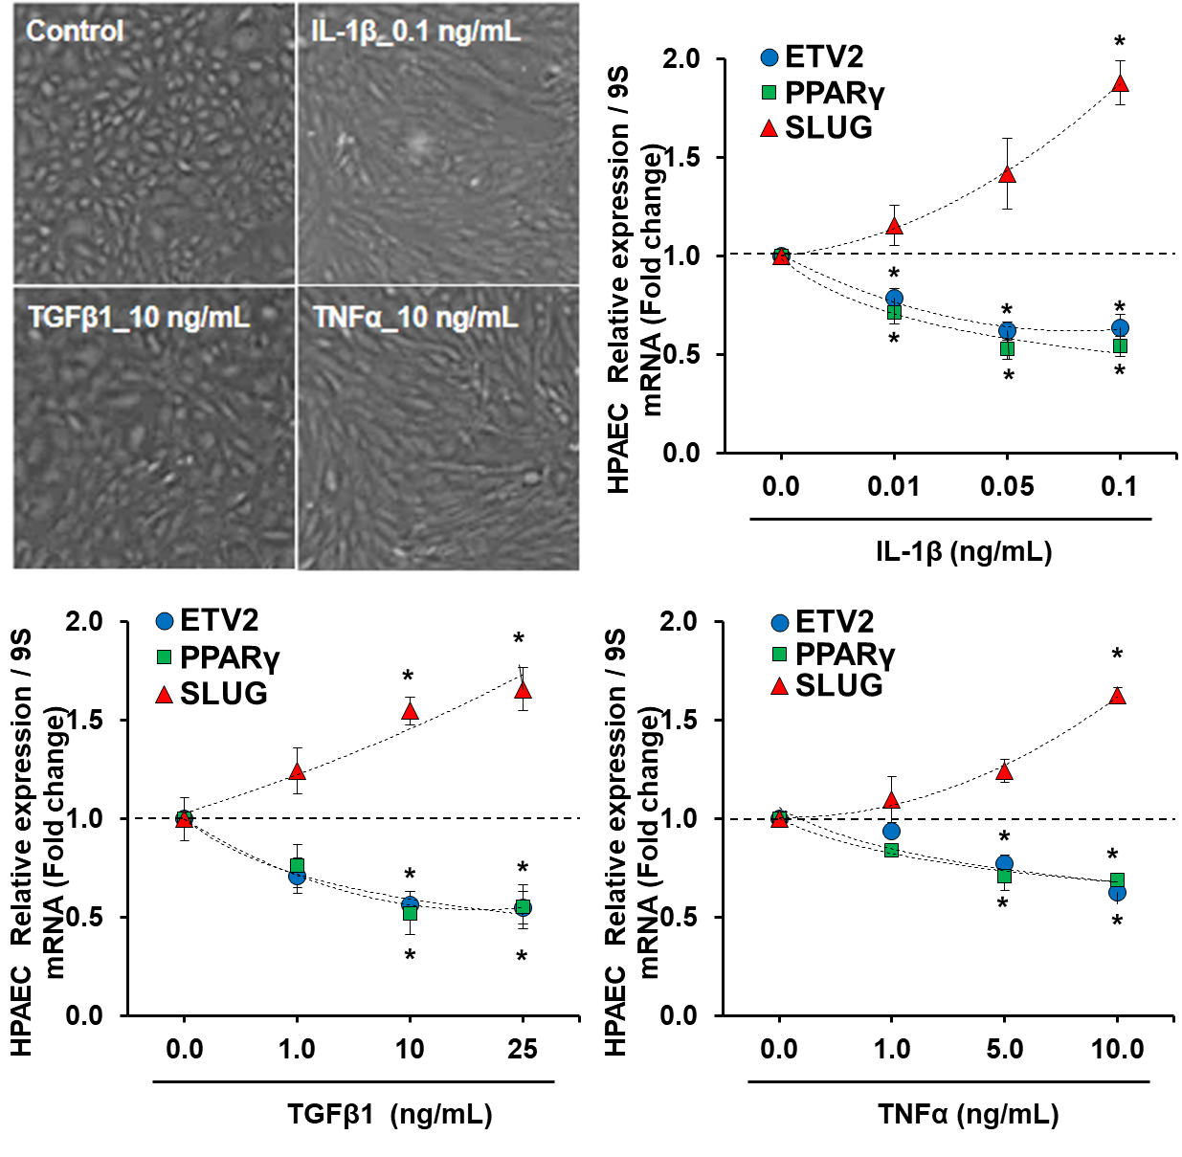
Supplementary Figure 2. Inflammatory mediators reduce PPARγ and ETV2 levels and induce EndoMT maker SLUG in HPAECs. HPAECs were dose-dependently treated with interleukin-1 beta (IL-1β), tumor necrosis factor alpha (TNFα), or transforming growth factor beta (TGFβ) for 72 hours. (Upper left panels) A representative image of i-EndoMT cells with the individual factors (0.1 ng/mL IL-1β, 10 ng/mL TNFα, or 10 ng/mL TGFβ). (Upper right and lower panels) HPAECs cultured with different concentrations of the factors were subjected to qRT-PCR analysis. Mean HPAEC PPARγ, ETV2, and SLUG expression were measured with qRT-PCR. All bars represent the mean PPARγ, ETV2 or SLUG mRNA levels relative to GAPDH ± SE expressed as fold-change vs. NOR. *p<0.05 vs. NOR, n=3.

