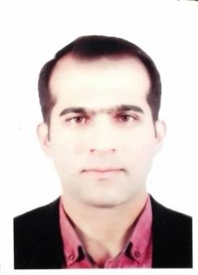
Azhee W. Muhamad is an assistance Lecturer in Basic Education College Department of Computer at Sulaymaniyah University. He got my MSc from the Department of Computer Science at the Hamdard University of India at 2011, His area of interest is Machine Learning, Computer Vision, He is a Ph.D. student whose study focuses on utilizing video processing and deep learning techniques in autonomous Human action recognition. His research interest includes computer vision, machine learning, database management, and multimedia.

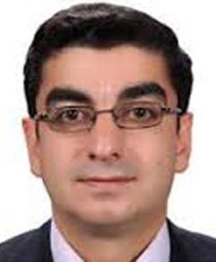
Prof. Aree Ali Mohammed was born in Sulaimani city–Kurdistan Region Iraq. He obtained a BSc degree at the University of Mousle (1995), an MSc degree in France in Computer Science (2003), and a Ph.D. in multimedia systems at the University of Sulaimani (2008). He directed Information Technology Directorate for four years (2010– 2014) and the head of the computer science department/ college of Science / University of Sulaimani for seven years. The main field of interest is multimedia system applications for processing, compression, and security. Many papers have been published in scientific journals throughout the world.

