From polyethylene waste bottles to UIO-66 (Zr) for preconcentration of steroid hormones from river water
Shirley Kholofelo Selahle¹, Azile Nqombolo^{1,2,3}, Philiswa Nosizo Nomngongo^{1,2*}
¹ Department of Chemical Sciences, University of Johannesburg, Doornfontein Campus, P.O. Box 17011, Doornfontein, 2028, South Africa
² Department of Science and Innovation-National Research Foundation South African Research Chair Initiative (DSI-NRF SARChI): Nanotechnology for Water, University of Johannesburg, Doornfontein, 2028, South Africa
³ Department of Pure and Applied Chemistry, University of Fort Hare, Alice, 5700, South Africa
* Corresponding Author: Philiswa N. Nomngongo, pnnomngongo@uj.ac.za

Supplementary data
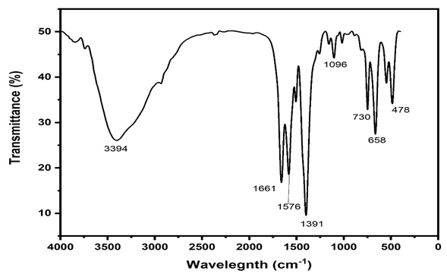
Figure S1: FTIR of PET based UIO-66(Zr)
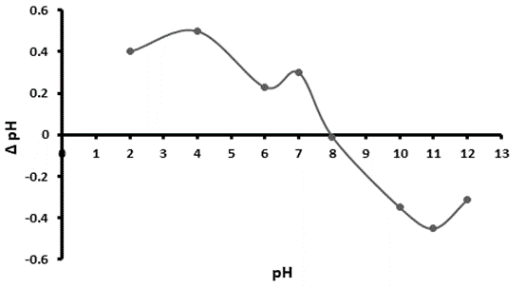
Figure S2: Point of zero charge OF PET based UIO-66(Zr)
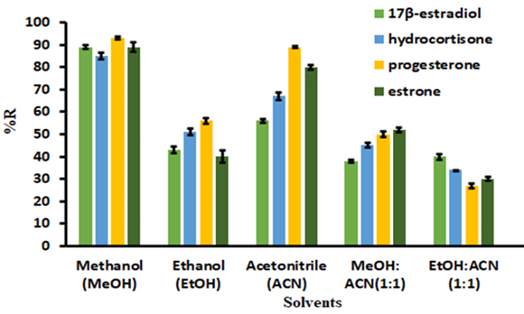
Figure S3: Choice of eluent solution
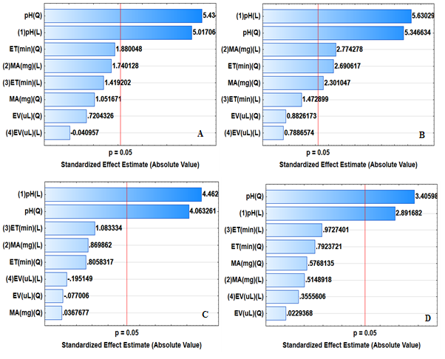
Figure S4: Pareto chart for standardized effects on variables for extraction and preconcentration of A) 17β-estradiol, B) estrone, C) Hydrocortisone and D) progesterone. MA (mg) =Mass of adsorbent, ET (min)= Extraction time, EV (uL)= Eluent volume

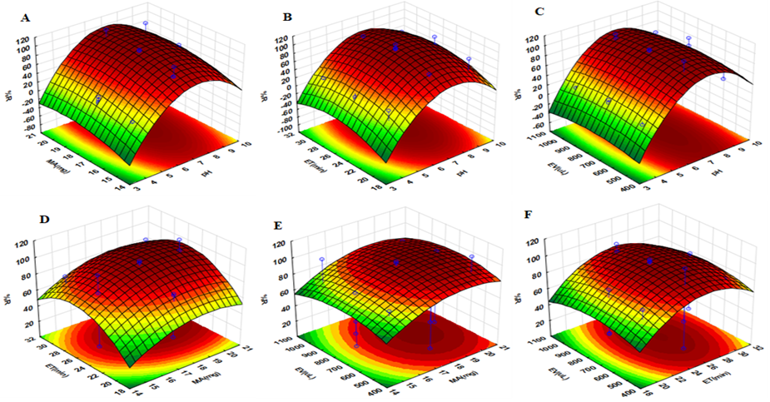
Figure S5: Three dimension response surface plots showing there interactions between: A) pH and mass of adsorbent (MA) while extraction time (ET) and eluent volume (EV) were fixed at 17.5 min and 750 µL; B) pH and ET while MA and EV were fixed at 25 mg and 750 µL; C) pH and EV while MA and ET were fixed at 25 mg and 17.5 min; D) ET and EV while pH amd MA were fixed at 6.5 and 25 mg; E) MA and ET while pH and EV were fixed at 6.5 and 750 µL; F) MA and EV while pH and ET were fixed at 6.5 mg and 17.5 min

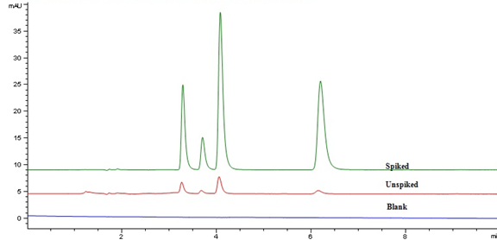
Figure S6: Chromatograms for spiked, unspiked and blank samples
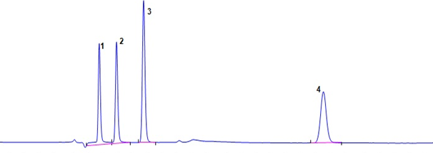
Figure S7: Chromatograms of Rietspruit river water sample showing the targeted analytes. (1) 17β-estradiol, (2) hydrocortisone, (3) estrone and (4) progesterone.
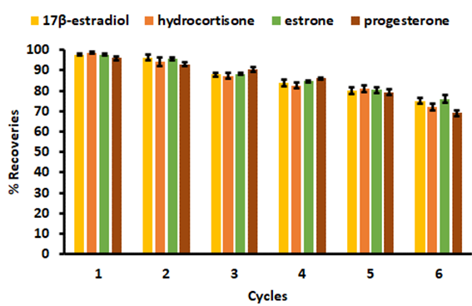
Figure S8: Regeneration and reusability.
Table S1: BBD experimental results
Standards | 4 Factors Box-Behnken design, 3v blocks, 27 runs |  |  |  |  | % Recoveries
runs | Block | pH | MA | EV | ET | %hydro | % estradi | % estro
1 | 1 | 4 | 15 | 750 | 25 | 15.84 | 11.89 | 10.76
2 | 1 | 9 | 15 | 750 | 25 | 56.49 | 42.92 | 32.66
3 | 1 | 4 | 20 | 750 | 25 | 10.58 | 5.54 | 14.43
4 | 1 | 9 | 20 | 750 | 25 | 111.79 | 96.70 | 100.90
5 | 1 | 6.5 | 17.5 | 750 | 20 | 97.57 | 79.14 | 70.23
6 | 1 | 6.5 | 17.5 | 500 | 30 | 72.13 | 80.13 | 74.40
7 | 1 | 6.5 | 17.5 | 1000 | 20 | 55.72 | 50.40 | 60.58
8 | 1 | 6.5 | 17.5 | 1000 | 30 | 79.71 | 70.62 | 69.52
9 | 1 | 6.5 | 17.5 | 750 | 25 | 64.46 | 87.15 | 99.31
10 | 2 | 4 | 17.5 | 500 | 25 | 28.72 | 12.87 | 23.11
11 | 2 | 9 | 17.5 | 500 | 25 | 55.04 | 46.45 | 67.35
12 | 2 | 4 | 17.5 | 1000 | 25 | 15.75 | 17.02 | 31.19
13 | 2 | 9 | 17.5 | 1000 | 25 | 75.38 | 76.20 | 84.61
14 | 2 | 6.5 | 15 | 750 | 20 | 36.89 | 28.10 | 17.97
15 | 2 | 6.5 | 20 | 750 | 20 | 45.68 | 56.91 | 67.53
16 | 2 | 6.5 | 15 | 750 | 30 | 123.33 | 78.45 | 66.74
17 | 2 | 6.5 | 20 | 750 | 30 | 101.30 | 91.29 | 89.36
18 | 2 | 6.5 | 17.5 | 750 | 25 | 89.99 | 100.57 | 109.66
19 | 3 | 4 | 17.5 | 750 | 20 | 21.71 | 27.47 | 11.17
20 | 3 | 9 | 17.5 | 750 | 20 | 85.68 | 81.46 | 91.18
21 | 3 | 4 | 17.5 | 750 | 30 | 13.55 | 21.86 | 34.03
22 | 3 | 9 | 17.5 | 750 | 30 | 50.63 | 71.16 | 68.57
23 | 3 | 6.5 | 15 | 500 | 25 | 65.90 | 78.33 | 65.45
24 | 3 | 6.5 | 20 | 500 | 25 | 121.10 | 109.67 | 89.07
25 | 3 | 6.5 | 15 | 1000 | 25 | 99.90 | 99.89 | 99.22
26 | 3 | 6.5 | 20 | 1000 | 25 | 80.05 | 89.85 | 89.39
27 | 3 | 6.5 | 17.5 | 750 | 25 | 94.04 | 98.40 | 89.49

Table S2: The chemical structure, molar masses and Pk_{a} values, CAS number for the steroid hormones
Steroid hormones | Structures | Molar masses (g mol⁻¹) | LogKow | PK_{a} | CAS number
Estrone | 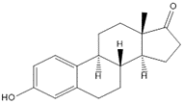 | 270.36 | 3.13 | 10.77 | 53-16-7
Hydrocortisone | 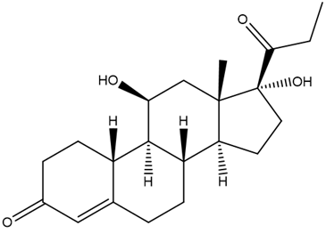 | 362.46 | 1.61 | 12.58 | 50-23-7
17β-estradiol | 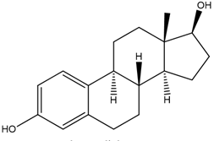 | 272.40 | 4.01 | 10.71 | 50-28-2
Progesterone | 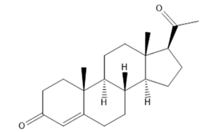 | 314.46 | 3.87 | 18.92 | 57-83-0

Table S3: Parameter and levels used in fractional factorial design
parameters | Minimum | Central | Maximum
pH | 4 | 6.5 | 9
Mass of sorbent (mg) | 15 | 17.5 | 20
Eluent volume(µL) | 500 | 750 | 1000
Extraction time (mins) | 20 | 25 | 30

Table S4: Physicochemical properties of the river water samples.
Sample ID | pH | TDS (mg/L) | EC mS/m
RRU S1-4 | 8.3-9.6 | 290-300 | 0.57-0.60
RRD S5-7 | 8.4-9.6 | 265-270 | 0.55-0.65
VRB S8-9 | 8.6-8.8 | 270-280 | 0.54-0.55
VRA S10 | 8.7-8.8 | 185-191 | 0.37-0.40
VRD S11-12 | 8.5-9.0 | 190-195 | 0.37-0.41
TDS: Total dissolved solids, EC: Electrical conductivity
Table S5: Different adsorption capacities of PET based UIO-66(Zr) (mg/g)
Steroid hormones | Adsorption capacities (mg/g)
17β-estradiol | 279±3
Hydrocortisone | 256±4
Estrone | 239±3
Progesterone | 241±2

Table S6: Comparison of current work with other solid phase methods coupled with various analytical techniques for the detection of steroid hormones in aqueous matrices
Analytes | matrix | Sorbent | Analytical techniques | Linearity | LOD | refs
17β-estradiol | wastewater | Fe₃O₄-Al₂O₃@CNFs | HPLC-DAD | 0.1-1000 µg/L | 25 ng/L | [21]
Glucocorticoids | Environmental water | Graphene oxide+ carbon nanotubes | HPLC-MS/MS | 0.05-1000 ng/L | 0.0075-0.16 ng/L | [22]
Estrone and 17β-estradiol | Environmental samples | MIL-101 (Cr) | UHPLC-MS/MS | 5- 50 000 ng/L | 0.95-23 ng/L | [53]
Estrogens | Surface water | HLB | GC-MS |  | 0.085-1.12 ng/L | [54]
Glucocorticoids | River water samples | (SDS-MWCNTs) | UHPLC-MS/MS | 0.2 -100 ng/mL | 0.019-0.098 ng/L | [22]
17β-estradiol, hydrocortisone, estrone and progesterone | River water samples | PET based UIO-66(Zr) | HPLC-DAD | 0.06-1000 µg/L | 0.055-0.096 µg/L | This work
n.d= not detected, HLB=Hydrophilic lipophilic balanced copolymer, SDS-MWCNTs= Sodium dodecyl sulfate-multi-walled carbon nanotubes

Table S7: Global concentrations of steroid hormones in water systems
Countries | Steroid hormones | Sample matrice | Detected concentration (ng/L) | References
Brazil | 17β-estradiol | River water | 14900 | [55]
South Africa | 17β-estradiol | Wastewater | 15-2000 | [56]
Poland | Estrone | Groundwater | 309 | [57]
China | Progesterone | River water | 8.22-66.2 | [58]
Brazil | Estrone, 17β-estradiol, progesterone, | Surface water | 0-5840 | [59]
South Africa | Progesterone, estrone, 17β-estradiol, estriol | Wastewater and river water | 0-7133 | [60]
South Africa | 17β-estradiol, estrone, hydrocortisone, progesterone | River water | 0-778 | This study

