Supplementary Materials 1 for

Microstructural asymmetries of the planum temporale predict functional lateralization of auditory-language processing

Peipei Qin,^{1, ⁋} Qiuhui Bi,^{2, 1, ⁋} Zeya Guo,¹ Liyuan Yang,¹ Haokun Li,¹ Peng Li,¹ Xinyu Liang,¹ Junhao Luo,¹ Xiangyu Kong,¹ Yirong Xiong,¹ Bo Sun,² Sebastian Ocklenburg,^{3, 4, 5} Gaolang Gong ^{1, 6, 7, *}
*Corresponding author. gaolang.gong@bnu.edu.cn

This file includes:
Figs S1-S3
Tables S1-S10

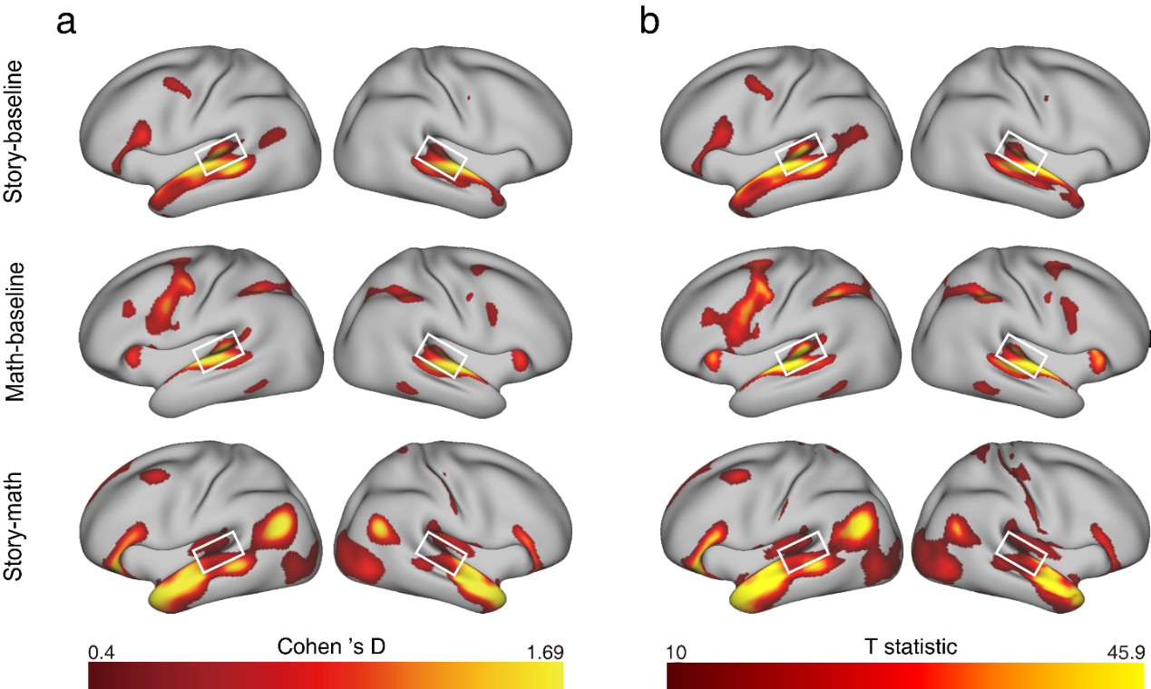

Fig S1. fMRI activation maps of the HCP language processing task. (a) The group Cohen's D effect size maps, showing vertices with a medium effect size (Cohen's D > 0.4). (b) Group T statistic maps from the Permutation Analysis of Linear Models (PALM), showing vertices with T >10. There were three contrasts between task conditions from this task: “story – baseline”, “math – baseline”, and “story – math”. Statistical maps were generated from 997 subjects with quantified fMRI data. A white rectangle is placed around the PT. As shown, bilateral PTs were successfully activated under the three contrasts.

Fig S2. The difference in PT functional activation between subjects with single and duplicated HG. The PT functional activation of the two groups were compared using two-sample t tests after controlling for age, sex, and hemispheric brain volume (ICV). sHG, single Heschl's gyrus; dHG, duplicated Heschl's gyrus; ns, non-significant. Nonsignificant differences (P_{FWE} > 0.05) are colored gray. Cohen’s d values are listed in Table S10.

Fig S3. The difference in PT structural measures between subjects with single and duplicated HG. The PT structural measures of the two groups were compared using two-sample t tests after controlling for age, sex, and hemispheric brain volume (ICV). sHG, single Heschl's gyrus; dHG, duplicated Heschl's gyrus. Nonsignificant differences (P_{FWE} > 0.05) are colored gray. NDI, neurite density index; ODI, orientation dispersion index; ns, non-significant. Cohen’s d values are listed in Table S10

Table S1. Group-level hemispheric asymmetry of PT functional and structural measures
 | L1/R1 |  |  | L1/R2 |  |  |  | L2/R1 |  |  |  | L2/R2
 | T | P_{FWE} | Cohen’s d |  | T | P_{FWE} | Cohen’s d |  | T | P_{FWE} | Cohen’s d |  | T | P_{FWE} | Cohen’s d
Speech perception | 6.82 | <.001* | 0.35 |  | 5.55 | <.001* | 0.52 |  | -1.29 | >.99 | -0.10 |  | 1.40 | >.99 | 0.26
Speech comprehension | 6.54 | <.001* | 0.36 |  | 6.12 | <.001* | 0.57 |  | -0.08 | >.99 | -0.12 |  | 2.94 | >.99 | 0.12
Surface area | 6.83 | <.001* | 0.42 |  | 14.4 | <.001* | 1.48 |  | -2.06 | >.99 | -0.25 |  | 4.88 | <.001* | 0.73
Thickness | -10.0 | <.001* | -0.53 |  | -3.08 | 0.06 | -0.30 |  | -4.39 | <.001* | -0.44 |  | -3.58 | 0.01 | -0.49
Myelin content | -0.99 | >.99 | -0.05 |  | 5.97 | <.001* | 0.58 |  | -6.50 | <.001* | -0.68 |  | 2.67 | 0.23 | 0.36
NDI | -4.43 | <.001* | -0.21 |  | 4.26 | <.001* | 0.40 |  | -4.83 | <.001* | -0.48 |  | 2.59 | 0.29 | 0.30
ODI | 26.7 | <.001* | 1.65 |  | 15.8 | <.001* | 1.71 |  | 8.69 | <.001* | 1.03 |  | 9.17 | <.001* | 1.49
P_{FWE}, corrected P value after Bonferroni correction; *, significant hemispheric asymmetry between the left and right PTs; L1/R1, single HG on the left and single HG on the right; L1/R2, single HG on the left and duplicated HG on the right; L2/R1, duplicated HG on the left and single HG on the right; L2/R2, duplicated HG on the left and duplicated HG on the right; NDI, neurite density index; ODI, orientation dispersion index.

Table S2. The interaction effect of “PT structural AI × HG gyrification pattern” on PT nonspeech-related functional AIs (the first specificity analysis)
 | Working memory |  | Incentive processing |  | Emotion processing |  | Social cognition |  | Motor |  | Relational processing
 | F | P_{FWE} | F | P_{FWE} | F | P_{FWE} | F | P_{FWE} | F | P_{FWE} | F | P_{FWE}
Surface area | 6.54 | 0.32 | 0.68 | >.99 | 3.94 | >.99 | 0.13 | >.99 | 0.20 | >.99 | 0.04 | >.99
Thickness | 2.06 | >.99 | 0.00 | >.99 | 0.45 | >.99 | 1.06 | >.99 | 0.80 | >.99 | 0.20 | >.99
Myelin content | 0.03 | >.99 | 2.86 | >.99 | 0.69 | >.99 | 0.01 | >.99 | 0.19 | >.99 | 0.53 | >.99
NDI | 1.33 | >.99 | 0.84 | >.99 | 0.01 | >.99 | 0.28 | >.99 | 0.03 | >.99 | 0.19 | >.99
ODI | 0.32 | >.99 | 0.05 | >.99 | 0.02 | >.99 | 2.24 | >.99 | 0.35 | >.99 | 3.71 | >.99
PT, planum temporale; HG, Heschl's gyrus; AI, Asymmetry index; P_{FWE}, corrected P value after Bonferroni correction; NDI, neurite density index; ODI, orientation dispersion index.

Table S3. The correlations of PT structural AIs with PT nonspeech-related functional activation AIs after controlling for the HG gyrification pattern (the first specificity analysis)
 | Working memory |  | Incentive processing |  | Emotion processing |  | Social cognition |  | Motor |  | Relational processing
 | R | P_{FWE} | R | P_{FWE} | R | P_{FWE} | R | P_{FWE} | R | P_{FWE} | R | P_{FWE}
Surface area | 0.18 | <.001* | 0.09 | 0.25 | 0.21 | <.001* | 0.05 | >.99 | 0.18 | <.001* | 0.14 | <.01*
Thickness | 0.03 | >.99 | 0.04 | >.99 | 0.09 | 0.17 | -0.01 | >.99 | -0.08 | 0.55 | -0.01 | >.99
Myelin content | 0.01 | >.99 | 0.02 | >.99 | 0.06 | >.99 | 0.04 | >.99 | -0.11 | 0.04* | -0.06 | >.99
NDI | 0.08 | 0.64 | -0.02 | >.99 | 0.09 | 0.26 | 0.01 | >.99 | -0.08 | 0.79 | -0.06 | >.99
ODI | -0.03 | >.99 | 0.02 | >.99 | -0.02 | >.99 | 0.08 | 0.71 | -0.08 | 0.66 | 0.00 | >.99
PT, planum temporale; HG, Heschl's gyrus; AI, Asymmetry index; P_{FWE}, corrected P value after Bonferroni correction; NDI, neurite density index; ODI, orientation dispersion index. *, significant correlation between PT functional and structural AIs

Table S4. The interaction effect of “PT structural measure × HG gyrification pattern” on PT nonspeech-related functional activation for each hemisphere (the first specificity analysis)
 |  | Working memory |  | Incentive processing |  | Emotion processing |  | Social cognition |  | Motor |  | Relational processing
 |  | F | P_{FWE} | F | P_{FWE} | F | P_{FWE} | F | P_{FWE} | F | P_{FWE} | F | P_{FWE}
Left | Surface area | 0.31 | >.99 | 0.81 | >.99 | 4.96 | >.99 | 1.93 | >.99 | 6.30 | 0.74 | 0.00 | >.99
Left | Thickness | 0.17 | >.99 | 0.93 | >.99 | 0.20 | >.99 | 0.56 | >.99 | 4.59 | >.99 | 1.04 | >.99
Left | Myelin content | 2.03 | >.99 | 2.24 | >.99 | 0.00 | >.99 | 7.06 | 0.48 | 4.23 | >.99 | 0.34 | >.99
Left | NDI | 0.79 | >.99 | 0.59 | >.99 | 0.11 | >.99 | 6.02 | 0.86 | 0.02 | >.99 | 0.18 | >.99
Left | ODI | 1.27 | >.99 | 0.01 | >.99 | 0.00 | >.99 | 0.15 | >.99 | 4.06 | >.99 | 0.31 | >.99
Right | Surface area | 0.03 | >.99 | 0.03 | >.99 | 0.31 | >.99 | 0.24 | >.99 | 5.97 | 0.89 | 0.03 | >.99
Right | Thickness | 0.73 | >.99 | 1.13 | >.99 | 0.90 | >.99 | 0.03 | >.99 | 1.83 | >.99 | 5.24 | >.99
Right | Myelin content | 0.72 | >.99 | 1.14 | >.99 | 4.44 | >.99 | 1.10 | >.99 | 11.93 | 0.03* | 1.68 | >.99
Right | NDI | 0.06 | >.99 | 0.12 | >.99 | 1.37 | >.99 | 4.59 | >.99 | 2.86 | >.99 | 1.03 | >.99
Right | ODI | 0.02 | >.99 | 1.87 | >.99 | 2.53 | >.99 | 2.00 | >.99 | 4.21 | >.99 | 0.18 | >.99
PT, planum temporale; HG, Heschl's gyrus; P_{FWE}, corrected P value after Bonferroni correction; NDI, neurite density index; ODI, orientation dispersion index. *, the gyrification pattern of HG showed no significant effect on the correlation between functional and structural measures.

Table S5. The correlations of PT structural measures with PT nonspeech-related functional activation for each hemisphere after controlling for the HG gyrification pattern (the first specificity analysis)
 |  | Working memory |  | Incentive processing |  | Emotion processing |  | Social cognition |  | Motor |  | Relational processing
 |  | R | P_{FWE} | R | P_{FWE} | R | P_{FWE} | R | P_{FWE} | R | P_{FWE} | R | P_{FWE}
Left | Surface area | -0.02 | >.99 | -0.09 | 0.42 | 0.00 | >.99 | 0.01 | >.99 | 0.01 | >.99 | -0.02 | >.99
Left | Thickness | -0.03 | >.99 | 0.04 | >.99 | 0.04 | >.99 | 0.04 | >.99 | 0.02 | >.99 | -0.06 | >.99
Left | Myelin content | -0.04 | >.99 | 0.02 | >.99 | -0.03 | >.99 | 0.03 | >.99 | -0.05 | >.99 | -0.04 | >.99
Left | NDI | 0.06 | >.99 | -0.05 | >.99 | 0.00 | >.99 | -0.03 | >.99 | -0.04 | >.99 | -0.03 | >.99
Left | ODI | -0.03 | >.99 | -0.05 | >.99 | -0.10 | 0.42 | 0.03 | >.99 | -0.04 | >.99 | 0.02 | >.99
Right | Surface area | -0.05 | >.99 | -0.03 | >.99 | -0.05 | >.99 | -0.12 | 0.02* | 0.06 | >.99 | -0.06 | >.99
Right | Thickness | 0.05 | >.99 | 0.01 | >.99 | 0.08 | 0.75 | -0.05 | >.99 | -0.01 | >.99 | 0.00 | >.99
Right | Myelin content | -0.05 | >.99 | 0.01 | >.99 | 0.02 | >.99 | -0.01 | >.99 | -0.23 | <.001* | -0.09 | 0.43
Right | NDI | 0.00 | >.99 | 0.01 | >.99 | -0.01 | >.99 | 0.00 | >.99 | -0.14 | <.01* | -0.11 | 0.15
Right | ODI | -0.02 | >.99 | 0.03 | >.99 | 0.06 | >.99 | 0.01 | >.99 | -0.25 | <.001* | 0.00 | >.99
PT, planum temporale; HG, Heschl's gyrus; P_{FWE}, corrected P value after Bonferroni correction; NDI, neurite density index; ODI, orientation dispersion index. *, significant correlation between PT functional activation and ipsilateral structural measures.

Table S6. The interaction effect of “PT structural AI × HG gyrification pattern” on speech-related functional AIs of the entire hemisphere (the second specificity analysis)
 |  | Entire hemisphere
 |  | Speech perception |  | Speech comprehension
 |  | F | P_{FWE} | F | P_{FWE}
PT | Surface area | 0.10 | >.99 | 0.27 | >.99
PT | Thickness | 0.15 | >.99 | 0.02 | >.99
PT | Myelin content | 0.10 | >.99 | 2.24 | >.99
PT | NDI | 0.05 | >.99 | 0.59 | >.99
PT | ODI | 0.38 | >.99 | 1.34 | >.99
PT, planum temporale; HG, Heschl's gyrus; AI, Asymmetry index; P_{FWE}, corrected P value after Bonferroni correction; NDI, neurite density index; ODI, orientation dispersion index.

Table S7. The correlations of PT structural AIs with speech-related functional AI of the entire hemisphere after controlling for the HG gyrification pattern (the second specificity analysis)
 |  | Entire hemisphere
 |  | Speech perception |  | Speech comprehension
 |  | R | P_{FWE} | R | P_{FWE}
PT | Surface area | -0.05 | >.99 | 0.03 | >.99
PT | Thickness | -0.07 | 0.47 | -0.05 | >.99
PT | Myelin content | -0.02 | >.99 | 0.06 | 0.89
PT | NDI | -0.06 | >.99 | 0.05 | >.99
PT | ODI | 0.02 | >.99 | 0.02 | >.99
PT, planum temporale; HG, Heschl's gyrus; AI, Asymmetry index; P_{FWE}, corrected P value after Bonferroni correction; NDI, neurite density index; ODI, orientation dispersion index.

Table S8. The interaction effect of “PT structural measure × HG gyrification pattern” on speech-related functional activation of the entire ipsilateral hemisphere (the second specificity analysis)
 |  | Entire ipsilateral hemisphere
 |  | Speech perception |  | Speech comprehension
 |  | F | P_{FWE} | F | P_{FWE}
Left PT | Surface area | 3.74 | >.99 | 0.63 | >.99
Left PT | Thickness | 0.11 | >.99 | 0.86 | >.99
Left PT | Myelin content | 0.31 | >.99 | 0.86 | >.99
Left PT | NDI | 0.39 | >.99 | 1.25 | >.99
Left PT | ODI | 0.15 | >.99 | 1.35 | >.99
Right PT | Surface area | 0.44 | >.99 | 0.30 | >.99
Right PT | Thickness | 0.45 | >.99 | 1.35 | >.99
Right PT | Myelin content | 0.52 | >.99 | 0.10 | >.99
Right PT | NDI | 0.71 | >.99 | 0.03 | >.99
Right PT | ODI | 3.68 | >.99 | 0.00 | >.99
PT, planum temporale; HG, Heschl's gyrus; P_{FWE}, corrected P value after Bonferroni correction; NDI, neurite density index; ODI, orientation dispersion index.

Table S9. The correlations of PT structural measures with speech-related functional activation of the entire ipsilateral hemisphere after controlling for the HG gyrification pattern (the second specificity analysis)
 |  | Entire ipsilateral hemisphere
 |  | Speech perception |  |  | Speech comprehension
 |  | R | P_{FWE} | R |  | P_{FWE}
Left PT | Surface area | 0.00 | >.99 | 0.07 |  | >.99
Left PT | Thickness | -0.04 | >.99 | -0.07 |  | 0.99
Left PT | Myelin content | -0.02 | >.99 | 0.03 |  | >.99
Left PT | NDI | -0.08 | 0.62 | -0.05 |  | >.99
Left PT | ODI | 0.02 | >.99 | 0.02 |  | >.99
Right PT | Surface area | 0.02 | >.99 | 0.01 |  | >.99
Right PT | Thickness | 0.03 | >.99 | 0.02 |  | >.99
Right PT | Myelin content | 0.02 | >.99 | -0.01 |  | >.99
Right PT | NDI | 0.04 | >.99 | -0.01 |  | >.99
Right PT | ODI | 0.02 | >.99 | -0.02 |  | >.99
PT, planum temporale; HG, Heschl's gyrus; P_{FWE}, corrected P value after Bonferroni correction; NDI, neurite density index; ODI, orientation dispersion index.

Table S10. The difference in PT functional and structural metrices between groups with single and duplicated HG within each hemisphere (the effect size, Cohen’s D).
 | Left hemisphere | Right hemisphere
Speech perception | 0.20 | 0.04
Speech comprehension | 0.37 | 0.12
Surface area | 0.77 | 0.98
Thickness | 0.02 | 0.17
Myelin content | 0.57 | 0.65
NDI | 0.30 | 0.67
ODI | 0.41 | 0.14
NDI, neurite density index; ODI, orientation dispersion index.

