Interaction between rhizobacterial community assembly and host responses determines poplar salt tolerance

Yangwenke Liaoª, Chaoyang Caoª, Qingyue Zhangª, Peiyao Zhangª, Xiaogang Li^{a*}

ª Co-Innovation Center for Sustainable Forestry in Southern China, College of Biology and the Environment, Nanjing Forestry University, Nanjing 210037, China.

*Corresponding author: Xiaogang Li
Xiaogang Li, Co-Innovation Center for Sustainable Forestry in Southern China, College of Biology and the Environment, Nanjing Forestry University, Nanjing 210037, China.
E-mail: xgli@njfu.edu.cn
Tel: +86-25-8542-8769
Fax: +86-25-8542-8769

Supplementary Information
Supplementary figure legends
Fig. S1 Relative abundance of top 20 orders of bacteria in poplar rhizosphere. The results are presented as mean values ± SD; n = 3. Letters indicate significant differences in abundance between treatments (Duncan’s test, P < 0.05).

Fig. S2 (a) the Venn diagram and (b) heatmap and cluster analysis of expression level of differentially expressed genes (DEGs). NL895_1/2/3, 84K_1/2/3 and SXY_1/2/3, mRNA of one replicate from root of NL895, 84K or SXY.

Fig. S2 (a) The correlation heat map of the genes between the modules. (b) The heatmap of correlated ME.
Fig. S1

Fig. S2
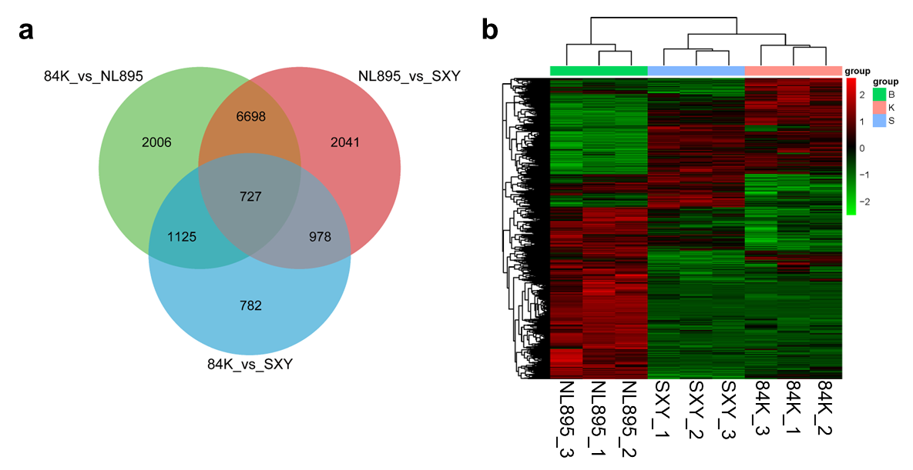

Fig. S3
