Supplementary data
A computational assessment of the interaction of 5Fluorouracil (5FU) drug connected to B₁₂P₁₂ and ScB₁₁P₁₂ nanocages with adenine nucleobase: DFT, AIM, TD-DFT study
M. Rezaei-Sameti, A. Rezaei
¹Department of Applied Chemistry, Faculty of Science, Malayer University, Malayer, 65174, Iran
A-a-1 | B-a-1
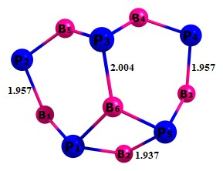 | 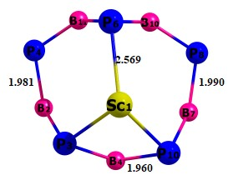
A-b-1 | B-b-1
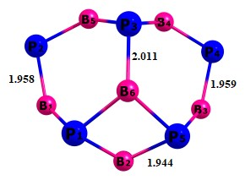 | 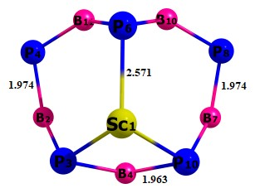
A-d-1 | B-d-1
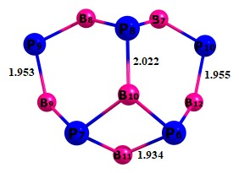 | 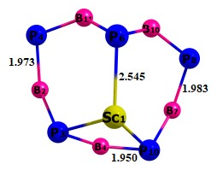

Fig. S1 The bond length of 5-Fu-B12P12 and ScB12P12 nanocage complex interaction with Adenine.

A-a-1 | B-a-1
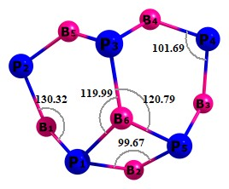 | 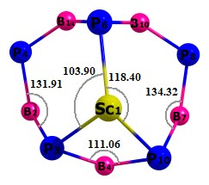
A-b-1 | B-b-1
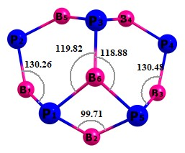 | 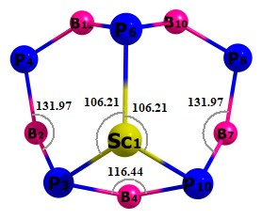
A-d-1 | B-d-1
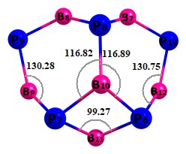 | 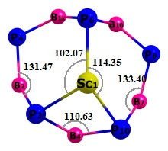

Fig. S2 the bond angle of 5-Fu-B12P12 and ScB12P12 nanocage complex interaction with Adenine.

A-a-1 | B-a-1
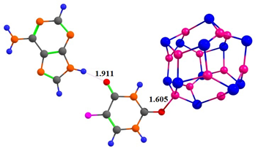 | 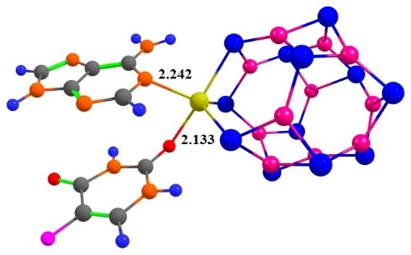
A A-b-1 | a B-b-1
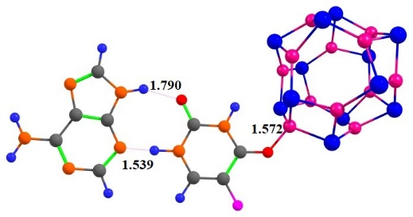 | 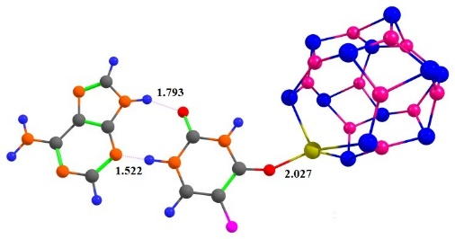
A-c-1 | B-c-1
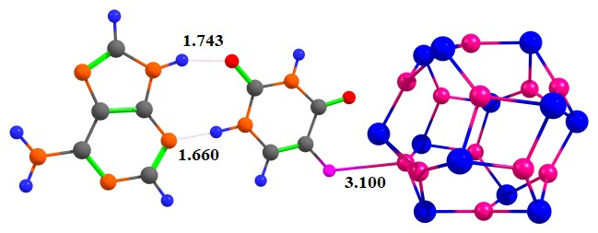 | 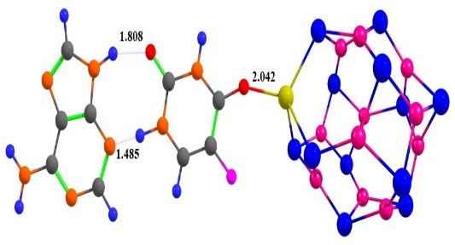
A-d-1 | B-d-1
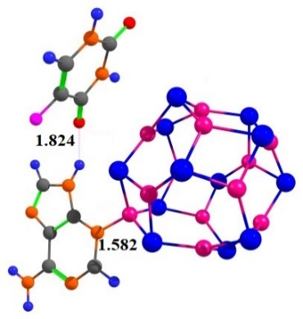 | 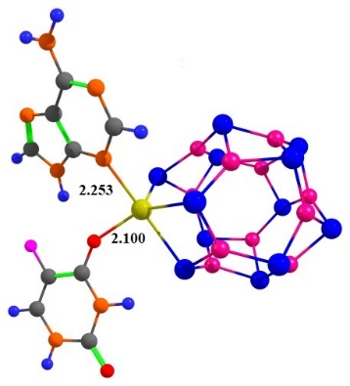

Fig. S3 the bond distance of 5-Fu-B12P12 and ScB12P12 nanocage complex interaction with Adenine.

A-a-1 | A-b-1
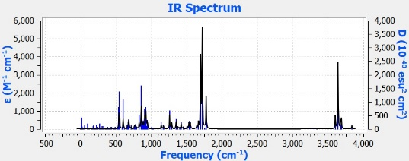 | 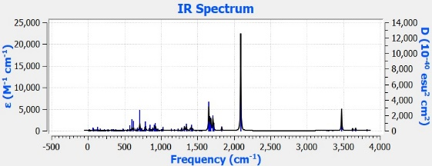
B-a-1 | B-b-1
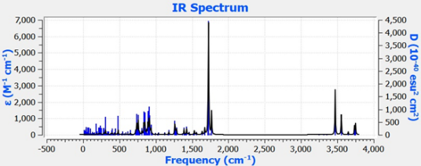 | 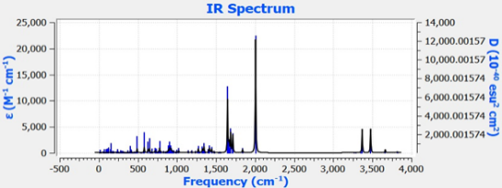
A-c-1 | A-d-1
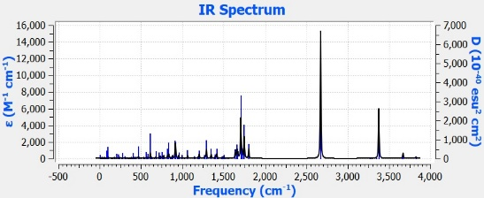 | 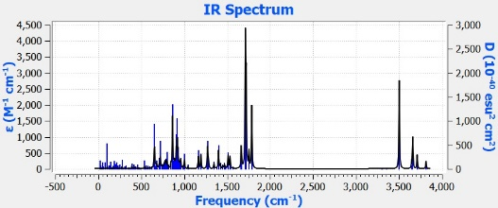
B-c-1 | B-d-1
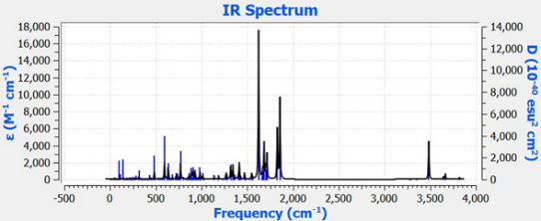 | 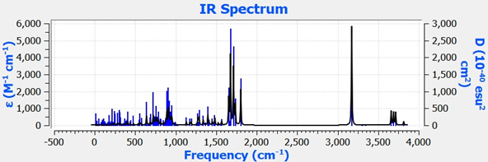

Fig. S4 the IR spectrum of 5-Fu-B12P12 and ScB12P12 nanocage complex interaction with Adenine.

Table S1 Transition exited state of 5-Fu-B12P12 and ScB12P12 nanocage complex interaction with Adenine.
model | Exited state | λ(nm) | ν | f | Configuration orbital
A-a-1 | S₀ S₂₈ | 271.07 | 4.574 | 0.0625 | -0.05(H-7 L+5)-0.05(H-6 L+3)+0.04(H-6 L+6)+0.07(H-5 L+5)-0.08(H-3L+4)+0.04(H-3L+7)-0.02(H-2L+1)+0.10(H-2L+3)+0.27(H-2L+6)
A-a-1 | S₀ S₁₃ | 296.78 | 4.177 | 0.0452 | -0.09(H-7L+5)-0.03(H-7L+8)-0.03(H-6L+4)  +0.06(H-3L+1)+0.2(H-3L+3)-0.02(H-3L+7)  +0.11(H-2L+0)+0.11(H-2L+3)+0.08(H-2L+4)
A-a-1 | S₀ S₁₅ | 293.94 | 4.218 | 0.0362 | -0.09(H-8L+1)+0.05(H-8L+2)+0.03(H-7L+5)  +0.14(H-6L+1)-0.04(H-6L+2)+0.04(H-6L+6)  -0.07(H-3L+4)-0.02(H-3L+6)-0.03(H-3L+7)  +0.05(H-2L)+0.03(H-2L+2)-0.06(H-2L+3)  +0.06(H-2L+4)-0.02(H-1L+5)
B-a-1 | S₀S₂₈ | 292.96 | 4.2321 | 0.0317 | 0.05(H-6L+4)+0.03(H-3L+5)+0.02(H-3L+6)  +0.08(H-3L+7)-0.05(H-2L+6)+0.06(H-2L+11)-0.01(H-1L+6)+0.021(HL)-0.02(HL+7)
B-a-1 | S₀S₁₉ | 312.84 | 3.9632 | 0.0435 | 0.02(H-3L+2)+0.04(H-3L+5)-0.05(H-2L+4)  +0.04(H-2L+6)+0.04(H-1L+6)+0.12(H-1L+7)  +0.04(H-1L+8)+0.03(H-1L+9)+0.03(H-1L+13)-0.07(HL)+0.03(HL+7)
B-a-1 | S₀S₁₈ | 313.58 | 3.9539 | 0.0223 | -0.04(H-6L+2)-0.04(H-6L+3)-0.02(H-6L+8)  -0.02(H-5L+5)-0.02(H-3L+3)+0.05(H-2L+8)  -0.04(H-1L+6)+0.05(H-1L+7)+0.09(H-1L+8)  +0.041(H-1L+10)+0.04(HL+7)-0.02(HL+9)  -0.02(HL+12)
A-b-1 | S₀S₂₀ | 283.30 | 4.3764 | 0.2733 | -0.15(H-14L)+0.26(H-6L)-0.07(H-6L+1)  -0.04(H-4L)-0.08(H-4L+1)-0.03(H-2L)
A-b-1 | S₀S₂₃ | 279.20 | 4.440 | 0.1433 | -0.09(H-14L)-0.04(H-8L+1)+0.08(H-6L)  +0.37(H-6L+1)+0.02(H-6L+2)-0.02(H-4L)  +0.06(H-4L+1)
A-b-1 | S₀S₂₆ | 273.11 | 4.5398 | 0.0791 | +0.03(H-4L+2)+0.03(H-4L+6)+0.05(H-3L+4)  +0.03(H-2L+2)+0.05(H-2L+3)-0.03(H-2L+8)  +0.02(H-1L+1)-0.15(H-1L+2)+0.28(H-1L+6)  +0.02(H-1L+7)
B-b-1 | S₀S₁₆ | 323.19 | 3.8363 | 0.1103 | -0.03(H-5L+2)+0.03(H-2L+1)+0.33(H-2L+2)  +0.07(H-2L+4)+0.03(H-2L+9)+0.08(H-1L+1)  -0.05(H-1L+19)+0.08(HL)+0.02(HL+11)
B-b-1 | S₀S₃ | 398.78 | 3.1091 | 0.0457 | -0.03(H-2L+4)+0.03(H-1L+4)+0.58(HL)  +0.06(HL+3)-0.09(HL+6)-0.02(HL+10)  -0.03(HL+11)
B-b-1 | S₀S₁₉ | 313.77 | 3.9514 | 0.0373 | +0.02(H-6L+15)+0.14(H-2L+1)+0.14(H-2L+7) +0.04(H-1L+1)-0.04(H-1L+4)+0.23(H-1L+7)+0.03(H-1L+9)
A-c-1 | S₀S₂₃ | 272.49 | 4.5501 | 0.0687 | -0.04(H-5L+4)-0.02(H-2L+1)-0.04(H-1L+1)  -0.03(H-1L+3)+0.3(HL+2)-0.19(HL+3)
A-c-1 | S₀S₉ | 295.51 | 4.1957 | 0.0512 | -0.02(H-6L)-0.06(H-4L)-0.08(H-4L+1)  +0.05(H-4L+5)-0.02(H-2L+4)-0.03(H-1L)  +0.02(H-1L+1)+0.03(H-1L+3)-0.04(H-1L+4)  -0.07(HL)+0.12(HL+1)-0.04(HL+3)+0.12(HL+5)
A-c-1 | S₀S₂₄ | 271.74 | 4.5626 | 0.0465 | 0.02(H-8L+4)-0.02(H-5L+4)+0.04(H-4L+3)  -0.04(H-4L+4)+0.08(H-2L+1)+0.09(H-2L+2)  +0.09(H-1L+1)+0.11(H-1L+2)-0.02(H-1L+4)  -0.08(HL+1)+0.03(HL+2)-0.02(HL+5)
B-c-1 | S₀S₁ | 454.42 | 2.7284 | 0.0435 | 0.03(H-6L)+0.74(H-1L)-0.04(H-1L+3)  +0.05(H-1L+6)-0.03(H-1L+12)
B-c-1 | S₀S₁₄ | 328.69 | 3.7720 | 0.0431 | 0.06(H-4L+5)+0.12(H-2L+4)+0.16(H-2L+5)  +0.07(H-2L+7)+0.03(H-2L+8)+0.06(H-2L+10)-0.03(H-1L)-0.03(H-1L+3)-0.05(H-1L+12)-0.05(HL+2)+0.05(HL+7)
B-c-1 | S₀S₂₅ | 302.16 | 4.1033 | 0.0358 | 0.02(H-6L)-0.02(H-6L+12)-0.02(H-5L)  +0.08(H-3L+4)+0.09(H-3L+5)-0.08(H-3L+10) +0.07(H-2L+2)-0.04(H-2L+5)+0.02(H-2L+7)-0.05(H-2L+8)-0.02(H-2L+15)+0.06(H-1L+9)-0.03(HL+2)-0.02(HL+4)+0.05(HL+8)-0.03(HL+14)
A-d-1 | S₀S₂₂ | 280.96 | 4.4128 | 0.0631 | -0.07(H-6L)-0.03(H-5L+5)+0.02(H-2L+2)  +0.05(H-2L+3)+0.02(H-2L+4)-0.07(H-2L+6)  +0.03(H-1L)+0.15(H-1L+2)-0.05(H-1L+4)  -0.06(H-1L+6)-0.05(H-1L+7)+0.03(HL+2)  -0.04(HL+5)
A-d-1 | S₀S₁₀ | 207.62 | 4.1658 | 0.0606 | 0.07(H-6L)-0.02(H-5L)+0.16(H-4L)  +0.06(H-4L+3)+0.03(H-3L)+0.03(H-2L+4)  +0.05(H-1L+2)+0.09(H-1L+3)+0.03(H-1L+4)  -0.05(HL+2)-0.07(HL+5)
A-d-1 | S₀S₃ | 323.90 | 3.8278 | 0.0291 | 0.02(H-3L+4)-0.04(HL)+0.05(HL+1)  +0.04(HL+2)+0.08(HL+3)+0.02(HL+5)  +0.42(HL+6)-0.12(HL+7)
B-d-1 | S₀S₂₉ | 298.43 | 4.1546 | 0.0286 | 0.02(H-9L)+0.07(H-7L)+0.04(H-6L+2)  +0.04(H-5L+7)-0.05(H-4L+8)-0.04(H-3L+5)  +0.02(H-3L+9)-0.03(H-1L+4)-0.03(H-1L+5)  +0.04(H-1L+9)-0.02(H-1L+12)-0.04(HL+8)
B-d-1 | S₀S₃ | 434.02 | 2.8566 | 0.0260 | 0.12(H-3L)+0.30(H-2L)+0.27(H-1L)+0.05(HL)-0.04(HL+6)
B-d-1 | S₀S₃₀ | 297.43 | 4.1685 | 0.0239 | -0.09(H-9L)+0.03(H-3L)-0.05(H-3L+1)  -0.07(H-3L+3)+0.04(H-3L+8)-0.02(H-2L+7)  -0.02(H-2L+10)+0.12(H-1L+6)+0.03(H-1L+8)-0.04(HL+8)

Table S2 NBO parameters of 5-Fu-B12P12 and ScB12P12 nanocage complex interaction with Adenine
Model | Donor(i) → Acceptor(j) | E(2)  Kcal/mol | E(j)-E(i)  (a.u.) | F(i.j)  (a.u.)
A-a-1 | σP3-B51→ n*B16 | 4.53 | 0.45 | 0.044
A-a-1 | P3-B51→ σ* P1-B16σ | 9.66 | 0.91 | 0.085
A-a-1 | σP6-B51→ n* B22 | 3.24 | 0.49 | 0.039
A-a-1 | σP6-B51→ σ* P6-B23 | 0.52 | 0.90 | 0.019
A-a-1 | σP10-B51→ σ* P1-B16 | 9.40 | 0.92 | 0.084
A-a-1 | σP10-B51→ σ*P3-B51 | 0.53 | 0.77 | 0.018
A-a-1 | σP10-B51→ σ* P6-B23 | 1.64 | 0.86 | 0.034
A-a-1 | nO30→ σ*P6-B51 | 0.23 | 0.94 | 0.013
A-a-1 | nO30→ σ* P10-B51 | 2.60 | 0.94 | 0.045
A-b-1 | σP3-B51→σ*P2-B14 | 6.01 | 0.83 | 0.063
A-b-1 | σP3-B51→σ*P10-B51 | 15.95 | 0.79 | 0.107
A-b-1 | σP6-B51→σ*P3-B14 | 0.60 | 0.94 | 0.022
A-b-1 | σP6-B51→σ*P10-B51 | 69.14 | 0.78 | 0.218
A-b-1 | σP6-B51→σ*O30-B51 | 9.76 | 0.78 | 0.078
A-b-1 | πP10-B51→ σ*P10-B51 | 21.60 | 0.54 | 0.106
A-b-1 | πP10-B51→σ*P3-B51 | 1.03 | 0.60 | 0.024
A-b-1 | nO30→σ*P6-B51 | 4.67 | 0.75 | 0.057
A-b-1 | nO30→σ*P10-B51 | 3.17 | 0.72 | 0.046
A-c-1 | σP3-B51→σ*P1-B16 | 9.19 | 0.94 | 0.083
A-c-1 | σP3-B51→σ*P2-B14 | 5.06 | 0.86 | 0.059
A-c-1 | σP3-B51→σ*P6-B51 | 0.66 | 0.95 | 0.023
A-c-1 | σP6-B51→n*B 23 | 4.26 | 0.51 | 0.046
A-c-1 | σP10-B51→σ*P1-B16 | 9.63 | 0.94 | 0.085
A-c-1 | σP10-B51→σ*P11-B19 | 5.78 | 0.87 | 0.064
A-c-1 | σP10-B51→σ*P3-B51 | 0.92 | 0.87 | 0.026
A-c-1 | nO30→σ*P6-B51 | 0.19 | 0.95 | 0.012
A-c-1 | nO30→n*B51 | 1.45 | 0.48 | 0.026
A-c-1 | nO30→n*B51 | 3.59 | 1.06 | 0.061
 | σP3-B51→σ*P3-B51 | 9.09 | 0.88 | 0.080
 | σP3-B51→ σ*P6-B23 | 0.56 | 0.87 | 0.020
 | σP6-B51→σ*P4-B23 | 11.41 | 0.91 | 0.091
 | σP6-B51→σ*P5-B21 | 6.35 | 0.83 | 0.065
 | σP6-B51→σ*P6-B21 | 0.51 | 0.91 | 0.019
 | σP10-B51→σ*P3-B51 | 0.51 | 0.92 | 0.020
 | nO30→σ*P3-B51 | 2.10 | 0.63 | 0.037
 | nO30→σ*P6-B51 | 0.75 | 0.65 | 0.022
 | nO30→σ*P10-B51 | 4.66 | 0.68 | 0.057
B-a-1 | σP3-B51/Sc33→σ*P1-B16 | 13.13 | 0.83 | 0.094
B-a-1 | πP3-B51/Sc33→n*B16 | 88.28 | 0.19 | 0.119
B-a-1 | σP3-B51/Sc33→σ*P1-B18 | 0.62 | 0.76 | 0.020
B-a-1 | σP6-B51/Sc33→n*B22 | 24.80 | 0.31 | 0.084
B-a-1 | σP6-B51/Sc33→σ*P6-B22 | 3.31 | 0.71 | 0.046
B-a-1 | σP6-B51/Sc33→σ*P11-B19 | 0.51 | 0.73 | 0.018
B-a-1 | σP10-B51/Sc33→ σ*P1-B16 | 13.26 | 0.77 | 0.092
B-a-1 | σP10-B51/Sc33→n*B19 | 7.57 | 0.31 | 0.046
B-a-1 | σP10-B51/Sc33→σ*P6-B22 | 0.62 | 0.69 | 0.019
B-a-1 | nO30→ σ*P10-B19 | 0.07 | 1.25 | 0.009
B-a-1 | nO30→σ*P3-B51/Sc33 | 20.61 | 1.30 | 0.150
B-a-1 | nO30→n*B51/Sc33 | 81.37 | 1.00 | 0.256
B-b-1 | σP3-B51/Sc33→σ*P1-B16 | 14.73 | 0.79 | 0.098
B-b-1 | σP3-B51/Sc33→σ*P2-B13 | 0.53 | 0.72 | 0.018
B-b-1 | σP3-B51/Sc33→σ*O30-B51/Sc33 | 7.95 | 0.42 | 0.052
B-b-1 | σP6-B51/Sc33→π*P6-B22 | 5.22 | 0.60 | 0.052
B-b-1 | σP6-B51/Sc33→σ*P7-B23 | 2.78 | 0.78 | 0.042
B-b-1 | σP6-B51/Sc33→σ*P11-B19 | 0.50 | 0.80 | 0.018
B-b-1 | σP10-B51/Sc33→σ*P1-B16 | 14.87 | 0.79 | 0.098
B-b-1 | σP10-B51/Sc33→σ*P8-B19 | 0.52 | 0.72 | 0.018
B-b-1 | σP10-B51/Sc33→σ*O30- B51/Sc33 | 8.51 | 0.42 | 0.054
B-b-1 | nO30→n*B51/Sc33 | 89.20 | 0.96 | 0.266
B-b-1 | nO30→n*B51/Sc33 | 25.13 | 0.60 | 0.111
B-b-1 | σO30-B51/Sc33→σ*P10-B51/Sc33 | 0.77 | 0.84 | 0.024
B-c-1 | σP3- B51/Sc33→RY*B14 | 5.06 | 1.03 | 0.066
B-c-1 | σP3- B51/Sc33→σ*P1-B16 | 14.81 | 0.80 | 0.098
B-c-1 | σP3- B51/Sc33→RY*O30 | 0.05 | 1.31 | 0.007
B-c-1 | σP6- B51/Sc33→n*B 23 | 4.44 | 0.38 | 0.041
B-c-1 | σP6- B51/Sc33→π*P6-B 22 | 12.49 | 0.46 | 0.071
B-c-1 | σP6- B51/Sc33→σ*P3-B14 | 0.52 | 0.89 | 0.019
B-c-1 | σP10- B51/Sc33→σ*P1-B16 | 14.91 | 0.80 | 0.098
B-c-1 | σP10- B51/Sc33→π*P3-B16 | 5.66 | 0.40 | 0.045
B-c-1 | σP10- B51/Sc33→RY*O30 | 0.05 | 1.31 | 0.007
B-c-1 | nO30→n*B51/Sc33 | 64.92 | 0.91 | 0.220
B-c-1 | nO30→RY*B14 | 0.05 | 1.18 | 0.007
B-c-1 | nO30→n*B51/Sc33 | 20.54 | 0.65 | 0.105
B-c-1 | σP3- B51/Sc33→RY*B14 | 5.06 | 1.03 | 0.066
B-d-1 | σP3- B51/Sc33→n*B16 | 25.62 | 0.30 | 0.083
B-d-1 | σ*P3- B51/Sc33→σ*P6-B22 | 12.73 | 0.01 | 0.042
B-d-1 | σ*P3- B51/S33→RY*O30 | 0.22 | 1.69 | 0.071
B-d-1 | σP6- B51/Sc33→n*B22 | 27.18 | 0.30 | 0.085
B-d-1 | σP6- B51/Sc33→σ*P4-B 23 | 0.52 | 0.77 | 0.019
B-d-1 | σ*P6- B51/Sc33→σ*P6-B22 | 15.53 | 0.03 | 0.078
B-d-1 | σP10- B51/Sc33→σ*P1-B16 | 12.73 | 0.76 | 0.090
B-d-1 | σP10- B51/Sc33→σ*P6-B22 | 0.60 | 0.72 | 0.019
B-d-1 | σP10- B51/Sc33→σ*P10-B16 | 4.58 | 0.71 | 0.053
B-d-1 | nO30→n* B51/Sc33 | 87.88 | 0.96 | 0.262
B-d-1 | nO30→n* B51/Sc33 | 21.19 | 1.03 | 0.133
B-d-1 | nO30→σ*P8-B19 | 0.07 | 1.18 | 0.008
B-d-1 | nO30→ σ*P10- B51/Ti51 | 0.06 | 0.86 | 0.010
B-d-1 | nO30→n* B51/Ti51 | 8.49 | 1.02 | 0.121

Table S3 AIM parameters of 5-Fu-B12P12 and ScB12P12 nanocage complex interaction with Adenine
model | ρ (r) | V(r) | H(r) | G(r) | ELF | LOL | Eigenvalues of Hessian |  |  | ε
 |  |  |  |  |  |  | λ₁ | λ₂ | λ₃
A-a-1 | 0.0245 | -0.0227 | 0.0023 | 0.0250 | 0.0533 | 0.191 | 0.1834 | -0.0369 | -0.0370 | 0.0017
B-a-1 | 0.0576 | -0.0630 | -0.0029 | 0.0601 | 0.1440 | 0.2909 | 0.3808 | -0.0799 | -0.719 | 0.1122
A-b-1 | 0.0352 | -0.0338 | 0.0010 | 0.0349 | 0.0888 | 0.2379 | 0.2575 | -0.0569 | -0.0568 | 0.0016
B-b-1 | 0.0349 | -0.0335 | 0.0011 | 0.034 | 0.0872 | 0.2362 | 0.2553 | -0.0560 | -0.0561 | 0.0011
A-c-1 | 0.0398 | -0.0387 | 0.00007 | 0.0388 | 0.1058 | 0.2559 | 0.2896 | -0.0672 | -0.0666 | 0.0101
B-c-1 | 0.0338 | -0.0322 | 0.0011 | 0.0334 | 0.0847 | 0.2334 | 0.2461 | -0.0538 | -0.0537 | 0.0009
A-d-1 | 0.1309 | -0.2727 | -0.0982 | 0.1745 | 0.2360 | 0.3572 | 0.6857 | -0.1990 | -0.1818 | 0.0950
B-d-1 | 0.0594 | -0.0645 | -0.0057 | 0.0587 | 0.1639 | 0.3069 | -0.0808 | 0.3829 | -0.0900 | 0.1139

model | ^{∇2ρ(r)} | λ₁/λ₃ | –G(r)/V(r)
A-a-1 | 0.109 | -4.9567 | 1.1013
B-a-1 | 0.2289 | -0.5296 | 0.9540
A-b-1 | 0.1437 | -4.5334 | 1.0325
B-b-1 | 0.1431 | -4.5508 | 1.0149
A-c-1 | 0.1557 | -4.3483 | 1.0026
B-c-1 | 0.1385 | -4.5828 | 1.0373
A-d-1 | 0.3048 | -3.7717 | 0.6399
B-d-1 | 0.2119 | 0.8977 | 0.9101

* Corresponding author : E-mail: mrsameti@malayeru.ac.ir, mrsameti@gmail.com , Tel/Fax: +98-8132355404

