Picture and biography of Authors

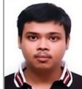
Anindya Kumar Biswas has completed his B.Tech in CSE, M.Tech in IT and PhD at National Institute of Technology (NIT) Raipur, India, under the Ministry of Human Resource Department, Govt. of India. He has published a few research articles in different reputed Journals, Book chapters and Conference proceedings, etc. His research interests include Cryptography, Information Security, Wireless Networks, Blockchain and network security.

Mou Dasgupta (Senior Member, IEEE) is an Assistant Professor in the Department of Computer Application, National Institute of Technology Raipur, India. She has more than 10 years of teaching and research experience. She has obtained her M.Tech. and Ph.D. degrees from Maulana Abul Kalam Azad University of Technology and Indian Institute of Technology (Indian School of Mines) Dhanbad, India, respectively. Her research area includes Cryptography and Information Security, Elliptic Curve Cryptography, Blockchain Technology, Internet-of-Things, Under Water Wireless Sensor Network, etc. At present, she is supervising (sole) two Ph.D. candidates and one candidate is awarded PhD degree under her sole supervision. She has published more than fifty research papers in SCI-indexed international journals, conference of repute, book chapters, etc. and delivered more than twenty keynote lectures/expert talks in International/National Conferences, Workshops, Seminars, Faculty Development Programs, Short-term Courses, etc. Dr. Dasgupta has acted as the member of advisory committee, technical committee, program committee, session chairs, etc. in several International/National Conference, Seminars, Workshops, etc. She is a reviewer of various international and national journals published by IEEE, Springer, Elsevier, Wiley, CSI, IETE, MDPI, Harvard, etc. She is a fellow member of IETE, senior member of IEEE, and life member of ISCA, IAENG, IACSIT and CSTA.

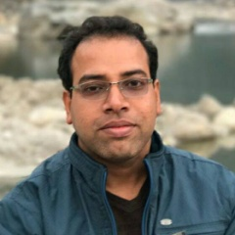
Sangram Ray (Senior Member, IEEE) is an Assistant Professor in the Department of Computer Science and Engineering, National Institute of Technology Sikkim, India. He has more than thirteen years of teaching and research experience, and more than eight years of administrative experience in various capacities including Dean, Head of the Department, Member of Board of Governors, Member of Senate, Faculty In-charge Training & Placement Cell, etc. He has obtained M.Tech. and Ph.D. from Indian Institute of Technology (Indian School of Mines) Dhanbad, India. His research area includes Cryptography and Information Security, Elliptic Curve Cryptography, Content Centric Network, Internet-of-Things, Cyber Security, Blockchain Technology, etc. At present, he is supervising (sole) eight PhD candidates and One Post Doctoral Fellow. One candidate is awarded PhD degree in Visvesvaraya PhD Scheme, sponsored by Ministry of Electronics & IT, Govt. of India, under his sole supervision. He has published more than fifty research papers in SCI-indexed international journals, conference of repute, book chapters, etc. and delivered around fifty keynote lectures / expert talks in International/National Conferences, Workshops, Seminars, Faculty Development Programs, Short-term Courses, etc. Dr. Ray has acted as the member of advisory committee, technical committee, program committee, session chairs, etc. in more than one hundred International/National Conference, Seminars, Workshops, etc. He is a reviewer of around forty international and national journals published by IEEE, Springer, Elsevier, Wiley, CSI, IETE, MDPI, Harvard, etc. He has been granted external funding of more than INR one Crore for R&D projects, FDPs, etc. Currently, he is the Chief Investigator (sole) of two R&D projects funded by Ministry of Science and Technology, Govt. of India and the Ministry of Electronics and Information Technology, Govt. of India, respectively. He is a senior member of IEEE, member of ACM and life member of CSI, ISTE, ISCA, IEI, IAENG, IACSIT and CSTA.

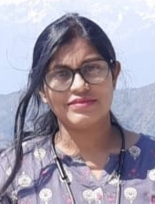
Dipanwita Sadhukhan is a PhD Scholar in the Department of Computer Science and Engineering, National Institute of Technology Sikkim, India under the Ministry of Human Resource Department, Govt. of India. She has obtained B.Tech degree in Information Technology and M.Tech degree in Computer Science and Engineering from Maulana Abul Kalam Azad University of Technology respectively. Her research area includes Cryptography, Information Security, Elliptic Curve Cryptography, Internet of Things, Network security etc.

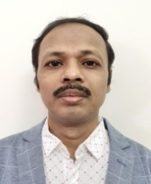
Ashok Kumar Das (Senior member, IEEE) received a Ph.D. degree in computer science and engineering, an M.Tech. degree in computer science and data processing, and an M.Sc. degree in mathematics from IIT Kharagpur, India. He is currently an Associate Professor with the Center for Security, Theory and Algorithmic Research, IIIT, Hyderabad, India. His current research interests include cryptography, system and network security including security in smart grid, Internet of Things (IoT), Internet of Drones (IoD), Internet of Vehicles (IoV), Cyber-Physical Systems (CPS) and cloud computing, intrusion detection, blockchain and AI/ML security. He has authored over 290 papers in international journals and conferences in the above areas, including over 250 reputed journal papers. He was a recipient of the Institute Silver Medal from IIT Kharagpur. He is on the editorial board of IEEE Systems Journal, Journal of Network and Computer Applications (Elsevier), Computer Communications (Elsevier), Journal of Cloud Computing (Springer), Cyber Security and Applications (Elsevier), IET Communications, KSII Transactions on Internet and Information Systems, and International Journal of Internet Technology and Secured Transactions (Inderscience), and has served as a Program Committee Member in many international conferences. He also served as one of the Technical Program Committee Chairs of the first International Congress on Blockchain and Applications (BLOCKCHAIN'19), Avila, Spain, June 2019, and second International Congress on Blockchain and Applications (BLOCKCHAIN'20), L'Aquila, Italy, October 2020.

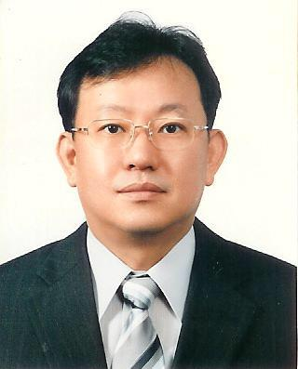
Youngho Park (Member, IEEE) received his BS, MS, and PhD degrees in electronic engineering, Kyungpook National University, Daegu, Korea in 1989, 1991, and 1995, respectively. He is currently a professor at School of Electronics Engineering, Kyungpook National University. In 1996-2008, he was a professor at School of Electronics and Electrical Engineering, Sangju National University, Korea. In 2003-2004, he was a visiting scholar at School of Electrical Engineering and Computer Science, Oregon State University, USA. His research interests include information security, computer networks, and multimedia.

