Supplementary Methods

Study Population:
Patient demographic characteristics such as race, ethnicity and gender were investigator-reported as these were collected by research coordinators at the time of consent for clinical trial participation and recorded in the electronic trial repository, Oncore. Language data was obtained by clerical staff at the time the patient had the initial encounter with the medical system.

Primary language and limited English proficiency designations
Adult patients with a listed primary language other than English in the demographics section of the electronic health record were designated as a patient with a primary language other than English, and those with English listed as their primary language were designated as patients with English as their primary language. While patients with a primary language listed as “unknown” were excluded from our analysis, those with a primary language of “other” were included. If there was evidence of need for an interpreter in the demographic section of the electronic health record or the utilization of an interpreter within six months was documented for a patient with a primary language of “other”, they were considered to have limited English proficiency. Whether or not there was evidence of limited English proficiency, patients with a primary language listed as “other” were considered to have a primary language other than English.

Language of consent documents:
We could not be definitively determined whether a patient signed consent documents in a language different from their primary language for which they were also proficient (e.g., a primary Farsi speaker who was also comfortable in Korean on a study for which a Korean consent was available), and we could only assess if the patient signed consent documents in their primary language (yes versus no).
The additional 30 days for translation of consent documents were permitted in the definition of consent documents in the patient’s primary language to account for the “short form” consent method. A short consent form consisting of a translated standardized document accompanied by verbally translated study-specific information is permitted when obtaining consent from subjects with a primary language other than English was not anticipated. As is generally true, the studied Cancer Center subsequently requires signature of translated written consent documents. Many institutions, including the studied Cancer Center, generally discourage the use of the short form because of concerns regarding the quality of information conveyed. There is also concern related to potential procedural errors that could be problematic at the time of regulatory audit.
The formal process of obtaining consent from a patient for a study has to be in the presence of one of the investigators or sub-investigators of the study at the studied Cancer Center.

Assessment of cost of consent documents
Consent documents were defined as including: 1) a study-specific informed consent document describing the purpose of the study, details regarding study procedures, expected duration, and risks associated with participation, 2) a confidentiality statement for which study specific data can be added to a non-study-specific template and 3) a document stating the research subject’s rights, which is not study-specific. For the purpose of assessing cost, only the document which was entirely study-specific was considered.

Statistical analysis:
Analyses on Patient Population
Pearson Chi-square tests were used to compare gender and race/ethnicity of patients with a primary language other than English and limited English proficiency to patients whose primary language was English. Patients with “unknown” race or ethnicity were excluded from these analyses.
Analyses on Consent Event groups and subgroups
All analyses performed on consent events groups and subgroups were conducted using a logistic regression model with Generalized Estimated Equation method to adjust for repeated. The endpoint for every analysis was consent events in non-industry versus industry sponsored studies.
Analysis of the probability of signing a consent document in a language different than primary in industry versus non-industry sponsored studies
For the analysis evaluating the language of signed consent documents in patients who signed consent documents for both industry and non-industry sponsored studies, if there were multiple consent events per sponsor type (industry or non-industry) we considered the patient to have signed consent documents in a language different than primary for that sponsor type if at least one consent event in that sponsor type was signed in a language different than primary.
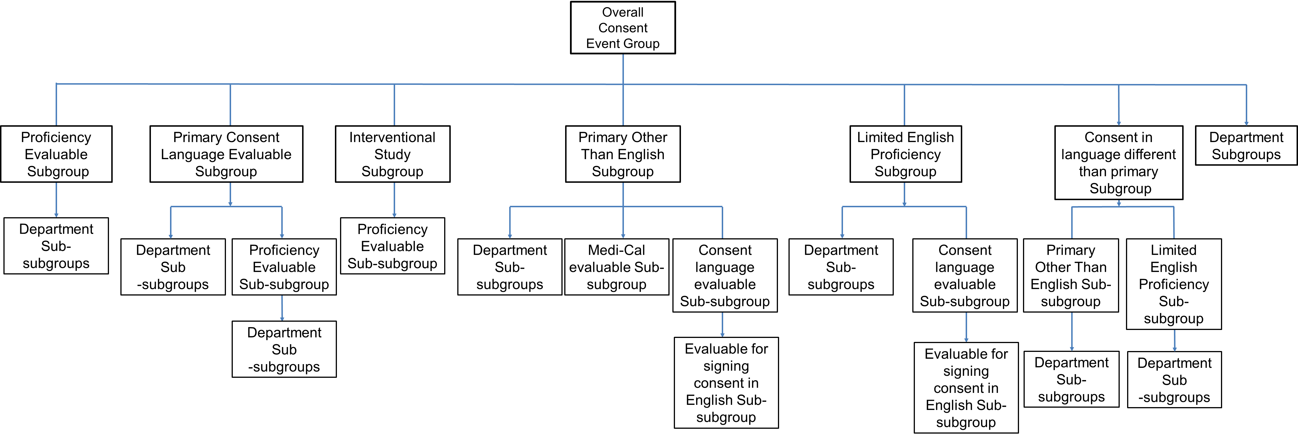
Consent Events groups and subgroups:

Overall Consent Event Group: included all consent events in which the primary language of the study participant was known (including “other”). Note: all groups and subgroups are bolded for ease of identification. The Overall Consent Event Group was further divided into subgroups and sub-subgroups based on the groupings listed below.
Proficiency Evaluable Subgroup: included all consent events for patients with English as a primary language or limited English proficiency (excluded consent events for patients with a primary language other than English who were not designated as limited English proficiency).
Primary Consent Language Evaluable Subgroup: included all consent events in which patients signed consent documents in their primary language (excluded patients who signed consent documents in a language other than their primary language, including exclusion of those with language coded as “other” for whom chart review could not identify the primary language on a study for which non-English consent documents were available).
Interventional Study Subgroup: included all consent events for interventional studies.
Primary Other than English Subgroup: included all consent events for participants with a primary language other than English. This was further subdivided into:
- Medi-Cal Evaluable sub-subgroup: included patients with data available on chart review to determine whether Medi-Cal was the payor.
- Consent Language Evaluable sub-subgroup: included patients for which we could determine if they signed a consent document in their primary language or in a language different than primary.
  - A subgroup of this sub-subgroup included the “Evaluable for signing consent in English” sub-subgroup which included patients for which we could determine if they signed a consent document in their primary language or in English.
Limited English Proficiency Subgroup: Included all consent events for patients with limited English Proficiency. This was further subdivided into:
- Consent Language Evaluable sub-subgroup: included patients for which we could determine if they signed a consent document in their primary language or in a language different than primary.
  - A subgroup of this sub-subgroup included the “Evaluable for signing consent in English” sub-subgroup which included patients for which we could determine if they signed a consent document in their primary language or in English.
Consent in language different than primary subgroup: included all consent events in which patients signed consent documents in a language different than primary. Patients with “other” as their primary language when their language of consent was unknown were excluded if there were non-English consent documents available for the study.
Department Subgroups: divided all consent event into mutually exclusive groups based on department conducting the study (Medicine, Radiology and Molecular Pharmacology, Pediatrics, Radiation Oncology, Surgery, Other).
Primary and Secondary Analyses:
The primary analysis evaluated the odds of patients with limited English proficiency signing consent documents in their primary language in non-industry versus industry sponsored studies, conducted in the Proficiency Evaluable Sub-subgroup of the Primary Consent Language Evaluable Subgroup. All variables of interest were included in the multivariable model, regardless of statistical significance on bivariable analyses.
The secondary analyses evaluated the probability of patients with a primary language other than English signing consent documents (in the Overall Consent Event Group) or signing consent documents in their primary language (in the Primary Consent Language Evaluable Subgroup) in non-industry versus industry sponsored studies. It also evaluated the probability of patients with limited English proficiency signing consent documents (in the Proficiency Evaluable Subgroup) in a non-industry sponsored study versus industry sponsored study.
Handing Missing Data:
Consent events for patients in which primary language was unknown were excluded from all analyses. A complete case analysis was run in all of the multivariable models where an “unknown” category was included for the following variables: Race/ethnicity and gender. However, for consent events for which patients had a primary language of “other” and the language of consent was “unknown” were excluded from any analysis evaluating consent events in the patient’s primary language or in a language different than primary.

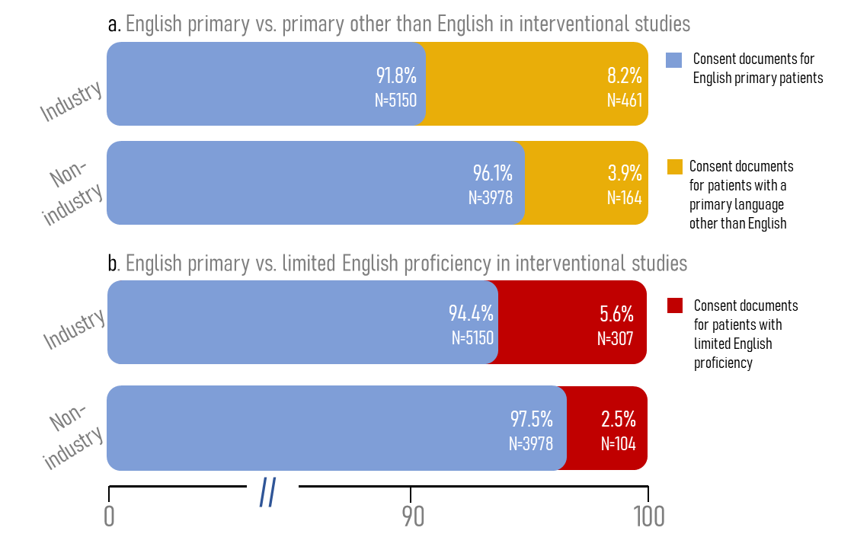
Extended Data Figures

Extended Data Fig.1. Comparison of the proportion of consent events based on primary language and English proficiency in interventional industry versus non-industry sponsored studies.
A. Blue indicates the proportion of consent events for patients with English as their primary language. Yellow indicates the proportion of consent events for patients with a primary language other than English in industry sponsored studies (top bar) versus non-industry sponsored studies (bottom bar) (8.2% versus 3.9%, p<0.001). B. Blue indicates the proportion of consent events for patients with English as their primary language. Red indicates the proportion of consent events for patients with limited English proficiency in industry sponsored studies (top bar) versus non-industry sponsored studies (bottom bar) (5.6% versus 2.5%, p<0.001).
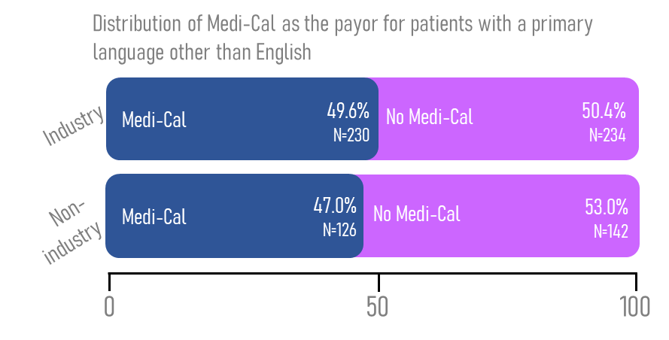
Extended Data Fig.2. Medi-Cal as the payor for patients with a primary language other than English in industry and non-industry sponsored studies.
The proportion of consent events for patients with Medi-Cal as the payor in industry sponsored studies was 49.6% (top bar, blue), and the proportion of patients in non-industry sponsored studies was 47.0% (bottom bar, blue) (49.6% vs 47.0%, p=0.50). The proportion of consent events for patients without Medi-Cal coverage was 50.4% in industry sponsored studies (Top bar, lavender) and 53.0% in non-industry sponsored studies (bottom bar, lavender).

Supplementary Tables
Characteristic, n (%) | Total  n=9213 | English Primary n=8636 (94%) | Primary Other than English n=577(6%) | P  Value§ | Limited English Proficiency n=376 (4%) | P  Value*
Gender^{ⱡ}
Female | 3513 (38.1) | 3255 (37.7) | 260 (45.1) | <0.001¶ | 175 (46.5) | <0.001 ^{ⱡ ⱡ}
Male | 5686 (61.7) | 5368 (62.2) | 316 (54.8) | <0.001¶ | 201 (53.4) | <0.001 ^{ⱡ ⱡ}
Race and Ethnicity^{Ɨ} |  |  |  | <0.001^{Ɨ Ɨ} |  | <0.001¶¶
Asian or Pacific Islander | 901 (9.8) | 680 (7.8) | 221 (38.3) | <0.001 | 139 (37.0) | <0.001
Black | 389 (4.2) | 389 (4.5) | 0 | <0.001 | 0 | <0.001
Other** | 279 (3.0) | 262 (3.0) | 17 (3.0) | 0.74 | 13 (3.5) | 0.80
Hispanic | 902 (9.7) | 687 (7.9) | 215 (37.2) | <0.001 | 160 (42.5) | <0.001
Non-Hispanic White | 5840 (63.4) | 5744 (66.5) | 96 (16.6) | <0.001 | 50 (13.3) | <0.001

Extended Data Table 1. Characteristics of patients who signed consent documents to Cancer Center studies.
§ Comparison between patients with primary language other than English and English primary language.
* Comparison between patients with limited English proficiency and patients with English as primary language.
^{ⱡ} Unknown Total: 14 (0.2%).
¶ Comparison of the proportion of female and male patients between patients with a primary language other than and patients with English as primary language.
^{ⱡ ⱡ} Comparison of the proportion of female and male patients between patients limited English proficiency and patients with English as primary language.
^{Ɨ} Unknown Total: 902 (9.7%).
^{Ɨ Ɨ} Comparison for overall difference between racial and ethnic groups among patients with primary language other than English and patients with English as primary language (English Primary).
¶¶ Comparison for overall difference between racial and ethnic groups among patients with limited English proficiency and patients with English as primary language.
** Other: American Indian; 16 (5.7%), Multiracial; 28 (10.0%), Other; 235 (84.3%).
Abbreviations: n, number. Racial and ethnic groups representing less than 4.0% of the study population were included as “other”.

Language | Number of patients | Percent
Spanish | 231 | 40.8%
Chinese | 118 | 20.8%
Korean | 63 | 11.1%
Farsi, Persian | 33 | 5.8%
Armenian | 30 | 5.3%
Russian | 20 | 3.5%
Vietnamese | 19 | 3.4%
Japanese | 12 | 2.1%
Arabic | 8 | 1.4%
Other | 6 | 1.1%
Tagalog | 6 | 1.1%
Hindi | <5 | <0.4%
Hungarian | <5 | <0.4%
Lithuanian | <5 | <0.4%
Thai | <5 | <0.4%
Afar | <5 | <0.4%
Burmese | <5 | <0.4%
Cambodian | <5 | <0.4%
Danish | <5 | <0.4%
Ethiopian | <5 | <0.4%
French | <5 | <0.4%
Greek | <5 | <0.4%
Hebrew | <5 | <0.4%
Indonesian | <5 | <0.4%
Italian | <5 | <0.4%
Laotian | <5 | <0.4%
Ukrainian | <5 | <0.4%

Extended Data Table 2. Primary languages spoken by patients with a primary language other than English.

 | Non-Industry Sponsored Study | Industry Sponsored Study | P Value
Studies, N (%) | 173 (22.9) | 585 (77.1)
Studies that had at least one translated consent document, N (%) | 39 (14.9) | 222 (85.1)
Consent events, N (%) | 6344 (52.5) | 5738 (47.5)
Median number of consent events per study (range) | 8.0 (1-791) | 5.0 (1-206) | <0.001
Consent events for studies that translated at least one consent, N (%) | 1513 (23.9) | 2951 (51.4) | <0.001
Median number of consent events for studies that translated at least one consent document (range) | 9.5 (1-510) | 8.0 (1-206) | 0.57
Consent events for studies that did not translate any consent, N (%) | 4831 (76.2) | 2787 (23.4) | <0.001
Median number of consent events for studies that did not translated at least one consent (range) | 8.0 (1-791) | 4.0 (1-93) | <0.001
Number of Interventional studies, N (%) | 143 (19.8) | 577(80.2)
Median number of consent events for interventional studies (range) | 8.0 (1-585) | 5.0 (1-206) | <0.001

Extended Data Table 3. Characteristics and distribution of consent events in non-industry and industry sponsored studies.

Department/Division | Proportion (%) | 95% CI | P Value
Medicine |  |  | <0.001
Industry Sponsored Study | 39.8 | 35.0 - 44.7
Non-Industry Sponsored Study | 64.1 | 54.1 - 72.3
Radiology and Molecular Pharmacology |  |  | <0.001
Industry Sponsored Study | 60.0 | 26.2 - 87.8
Non-Industry Sponsored Study | 98.4 | 91.2 - 99.9
Pediatrics |  |  | NA^{ꝉ}
Industry Sponsored Study | 0.0 | 0.0 – 84.1
Non-Industry Sponsored Study | 25.9 | 11.1 – 46.3
Radiation Oncology |  |  | NA^{ŧ}
Industry Sponsored Study | 100.0 | 63.0 - 100
Non-Industry Sponsored Study | 100.0 | 79.4 - 100
Surgical specialties |  |  | 0.05
Industry Sponsored Study | 82.6 | 6.1.2 – 95.5
Non-Industry Sponsored Study | 97.3 | 85.8 – 99.9
Other |  |  | NA*
Industry Sponsored Study | 100 | 54.0 - 100
Non-Industry Sponsored Study | 44.4 | 13.7 – 78.8

Extended Data Table 4. Proportion of consent events in which patients with a primary language other than English signed consent documents in a language different than primary in industry sponsored and non-industry sponsored studies across Departments.
^{ꝉ} P Value could not be generated because there were no patients who signed consent documents in a language different than primary in industry sponsored studies.
^{ŧ} P Value could not be generated because there were no consent documents translated.
* P Value could not be generated because there were no patients who signed consent documents in a language different than primary in industry sponsored studies.

Department/Division | Proportion (%) | 95% CI | P Value
Medicine |  |  | <0.001
Industry Sponsored Study | 27.7 | 22.2 – 32.8
Non-Industry Sponsored Study | 59.5 | 47.8 – 70.4
Radiology and Molecular Pharmacology |  |  | 0.01
Industry Sponsored Study | 55.6 | 21.2 – 86.3
Non-Industry Sponsored Study | 97.4 | 86.1 – 99.9
Pediatrics |  |  | NA ^{ꝉ}
Industry Sponsored Study | 0.0 | 0.0 - 84.2
Non-Industry Sponsored Study | 25.9 | 11.1 – 46.3
Radiation Oncology |  |  | NA^{ŧ}
Industry Sponsored Study | 100.0 | 54.0 - 100
Non-Industry Sponsored Study | 100.0 | 66.3 - 100
Surgical specialties |  |  | 0.08
Industry Sponsored Study | 69.2 | 38.5 – 90.3
Non-Industry Sponsored Study | 93.7 | 69.7 – 99.8
Other |  |  | NA*
Industry Sponsored Study | 100.0 | 29.2 - 100
Non-Industry Sponsored Study | 40.0 | 5.3 - 85.3

Extended Data Table 5. Proportion of consent events in which patients with limited English proficiency signed consent documents in a language different than primary in industry sponsored and non-industry sponsored studies across Departments.
^{ꝉ} P Value could not be generated because there were no patients who signed consent documents in a language different than primary in industry sponsored studies.
^{ŧ} P Value could not be generated because there were no consent documents translated.
* P Value could not be generated because there were no patients who signed consent documents in a language different than primary in industry sponsored studies.

 | Bivariable Analysis for signing consent documents |  |  | Bivariable Analysis for signing consent documents in patient’s primary language
Variable | OR | 95% CI | P  Value | OR | 95% CI | P  Value
Age
Age at consent (per year) | 0.99 | 0.98-0.99 | <0.001 | 0.99 | 0.98-0.99 | <0.001
Language
English Primary |  | Reference |  |  | Reference
Primary Other than English* | 0.50 | 0.43-0.59 | <0.001 | 0.24 | 0.18-0.31 | <0.001
Limited English Proficiency** | 0.47 | 0.38-0.57 | <0.001 | 0.23 | 0.17-0.31 | <0.001
Race and Ethnicity
Non-Hispanic White |  | Reference |  |  | Reference
Asian or Pacific Islander | 0.61 | 0.53-0.69 | <0.001 | 0.61 | 0.53-0.70 | <0.001
Black | 1.22 | 0.92-1.36 | 0.25 | 1.13 | 0.93-1.37 | 0.22
Hispanic | 0.81 | 0.71-0.92 | 0.002 | 0.79 | 0.69-0.90 | <0.001
Other | 1.44 | 1.13-1.83 | 0.004 | 1.44 | 1.13-1.85 | 0.004
Unknown | 3.34 | 2.89-3.94 | <0.001 | 3.36 | 2.84-3.97 | <0.001
Study Type
Interventional |  | Reference |  |  | Reference
Observational | 32.4 | 25.1-41.8 | <0.001 | 32.4 | 25.1-41.8 | <0.001
Gender
Male |  | Reference |  |  | Reference
Female | 0.37 | 0.34-0.40 | <0.001 | 0.36 | 0.33-0.39 | <0.001
Histology
Single Solid Malignancy |  | Reference |  |  | Reference
Healthy | 1.62 | 1.23-2.14 | <0.001 | 1.70 | 1.28-2.26 | <0.001
Multiple Histology | 0.46 | 0.42-0.50 | <0.001 | 0.45 | 0.41-0.49 | <0.001
Single Heme Malignancy | 0.07 | 0.05-0.09 | <0.001 | 0.07 | 0.05-0.09 | <0.001

Extended Data Table 6. Bivariable analysis odds ratio for the association between various factors and signing consent into a non-industry sponsored study.
*Patients with a primary language other than English compared to patients with English as their primary language.
** Patients with limited English proficiency compared to patients with English as their primary language.
Abbreviations, OR; odds ratio, CI; confidence Interval.

Language | OR | 95% CI | P Value
English Primary |  | Reference
Primary Other than English* | 0.615 | 0.52-0.72 | <0.001
Limited English Proficiency** | 0.64 | 0.53-0.79 | <0.001

Extended Data Table 7. Bivariable analysis for odds ratio for the association language and signing consent documents into a non-industry sponsored study with studies for which we could not definitively determine that they did not obtain industry funding coded as industry sponsored studies.
*Patients with a primary language other than English compared to patients with English as their primary language.
** Patients with limited English proficiency compared to patients with English as their primary language.
Abbreviations, OR; odds ratio, CI; confidence Interval.

 | Multivariable Analysis for patients with a primary language other than English signing consent documents |  |  | Multivariable Analysis for patients with a primary language other than English signing consent documents in patient’s primary language |  |  | Multivariable Analysis for patients with limited English proficiency signing consent documents |  |  | Multivariable Analysis for patients with limited English proficiency signing consent documents in patient’s primary language
Variable | OR | 95% CI | P  Value | OR | 95% CI | P  Value | OR | 95% CI | P  Value | OR | 95% CI | P  Value
Age
Age at consent (per year) | 0.97 | 0.97-0.98 | <0.001 | 0.98 | 0.97-0.98 | <0.001 | 0.97 | 0.97-0.98 | <0.001 | 0.98 | 0.97-0.98 | <0.001
Language
English Primary |  | Reference |  |  | Reference |  |  | Reference |  |  | Reference
Primary Other than English* | 0.79 | 0.65-0.96 | 0.019 | 0.40 | 0.29-0.54 | <0.001 | - | - | - | - | - | -
Limited English Proficiency** | - | - | - | - | - | - | 0.78 | 0.61-0.99 | 0.04 | 0.36 | 0.27-0.52 | <0.001
Race and Ethnicity
Non-Hispanic White |  | Reference |  |  | Reference |  |  | Reference |  |  | Reference
Asian or Pacific Islander | 0.55 | 0.48-0.66 | <0.001 | 0.58 | 0.49-0.69 | <0.001 | 0.63 | 0.53-0.73 | <0.001 | 0.58 | 0.55-0.79 | <0.001
Black | 0.95 | 0.76-1.28 | 0.6 | 0.95 | 0.76-1.18 | 0.64 | 1.05 | 0.84-1.30 | 0.66 | 0.95 | 0.76-1.18 | 0.64
Hispanic | 0.67 | 0.58-0.78 | <0.001 | 0.69 | 0.58-0.81 | <0.001 | 0.75 | 0.64-0.88 | <0.001 | 0.68 | 0.57-0.81 | <0.001
Other | 0.99 | 0.77-1.28 | 0.92 | 1.00 | 0.77-1.23 | 0.99 | 1.13 | 0.87-1.45 | 0.36 | 1.00 | 0.77-1.29 | 0.97
Unknown | 1.23 | 0.86-1.41 | 0.31 | 1.12 | 0.89-1.40 | 0.032 | 3.31 | 2.78-3.94 | <0.001 | 1.12 | 0.89-1.40 | <0.001
Study Type
Interventional |  | Reference |  |  | Reference |  |  | Reference |  |  | Reference
Observational | 30.3 | 24.8-37.2 | <0.001 | 29.2 | 23.8-35.9 | <0.001 | 31.3 | 25.6-28.8 | <.0001 | 29.2 | 23..2-35.8 | <.0001
Gender
Male |  | Reference |  |  | Reference |  |  | Reference |  |  | Reference
Female | 0.36 | 0.33-0.39 | <0.001 | 0.36 | 0.32-0.39 | <0.001 | 0.38 | 0.35-0.42 | <.0001 | 0.35 | 0.32-0.39 | <0.001
Histology
Single Solid Malignancy |  | Reference |  |  | Reference |  |  | Reference |  |  | Reference
Healthy | 1.73 | 1.30-2.3 | <0.001 | 1.82 | 1.36-2.43 | <0.001 | 1.78 | 1.37-2.52 | <.0001 | 1.83 | 1.41-2.40 | <0.001
Multiple Histology | 0.33 | 0.30-0.37 | <0.001 | 0.33 | 0.29-0.36 | <0.001 | 0.35 | 0.32-0.39 | <.0001 | 0.33 | 0.30-0.36 | <0.001
Single Heme Malignancy | 0.06 | 0.04-0.09 | <0.001 | 0.06 | 0.04-0.09 | <0.001 | 0.06 | 0.04-0.09 | <.0001 | 0.06 | 0.04-0.09 | <0.001

Extended Data Table 8. Multivariable analysis for odds ratio for the association between various factors and signing consent into a non-industry sponsored study nested by study.
*Patients with a primary language other than English compared to patients with English as their primary language.
** Patients with limited English proficiency compared to patients with English as their primary language.
Abbreviations, OR; odds ratio, CI; confidence Interval.

