Supplementary Information

A Self-powered Aptasensor for Isocarbophos Determination Based on Nanozyme-catalytic Photoelectrochemical Fuel Cell
Chunhong Zhou, Ruiting Wen, Jiuying Tian*, Jusheng Lu*
Jiangsu Key Laboratory of Green Synthetic Chemistry for Functional Materials, School of Chemistry and Materials Science, Jiangsu Normal University, Xuzhou 221116, PR China

* Corresponding author at: School of Chemistry and Materials Science, Jiangsu Normal University, 101 Shanghai Road, Xuzhou 221116, PR China. Tel.: +86-516-83403165.
E-mail addresses: jushenglu@jsnu.edu.cn (J.S. Lu), jiuyingtian@jsnu.edu.cn (J.Y. Tian)
Materials, reagents and apparatus
Isocarbophos, 2-methylimidazole, dicyandiamide, exonuclease I (Exo I), (3-aminopropyl)triethoxysilane (APTES), 1-ethyl-3-(3-dimethyl aminopropyl) carbodiimide hydrochloride (EDC), and N-hydroxysuccinimide (NHS) were purchased from Sigma-Aldrich Co. Ltd. (St. Louis, MO, USA). FeCl₂·4H₂O, Co(NO₃)₂·6H₂O, KH₂PO₄, K₂HPO₄, glucose and methanol were purchased from Sinopharm Chemical Reagent Co., Ltd. (Shanghai, China). The capture DNA and anti- isocarbophos aptamer were synthesized by Sangon Biotech Co. Ltd. (Shanghai, China), and their sequences were listed as follow. Capture DNA: 5'-AAGAA TCGCT GCAGC AAGCT-(CH₂)₆-COOH-3', anti-isocarbophos aptamer: 5'-SH-AGCTT GCTGC AGCGA TTCTT GATCG CCACA GAGCT-3'. Deionized water (>18.2 MΩ cm) used in the experiment was prepared by Milli-Q water purification system.
The materials were characterized by an S-4800 field emission scanning electron microscope (FESEM, Hitachi, Japan), JEM-2100 transmission electron microscope (TEM, JEOL, Japan), X'pert prompd X-ray diffractometer by Ni-filtered Cu Kα radiation (λ = 0.154178 nm, Netherlands), and Thermo Scientific ESCALAB 250xi photoelectron spectrometer (XPS) with a monochromatic Al Kα source (USA).
Cyclic voltammograms (CVs), photocurrent measurements and polarization curves were obtained on a CHI 660E electrochemical workstation (Austin, USA) with a conventional three-electrode system where the modified electrode was used as the working electrode, a platinum wire as the counter electrode and a saturated calomel electrode (SCE) as the reference electrode, respectively. The output voltage curves of the PNFC were measured with galvanostatic polarization technique, and the output power density curves were obtained by plotting the power density (P = V × I) vs the current density (I). All the tests were operated at room temperature.

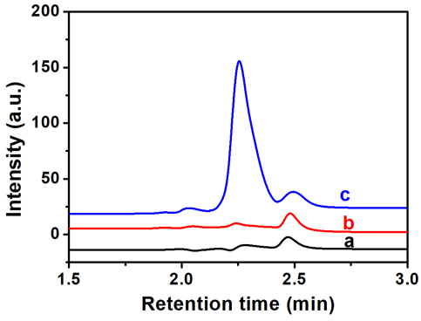
Fig. S1 HPLC chromatograms of glucose (a) and its oxidation product catalyzed (b) or electrocatalyzed by ZIF-67 (c).

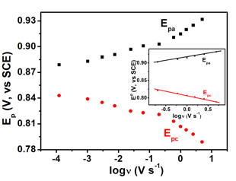
Fig. S2 Plot of the peak potential versus log ν.

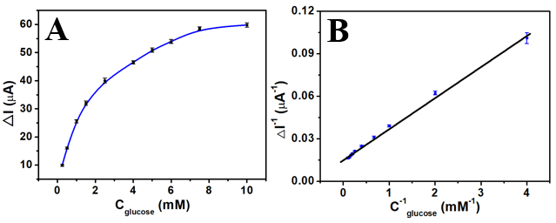
Fig. S3 (A) Michaelis-Menten curve of TNA/g-C₃N₄/ZIF-67 for glucose photo-electrocatalytic oxidation. (B) Lineweaver-Burk plot for determination of photo-electrocatalytic kinetic constant of TNA/g-C₃N₄/ZIF-67.

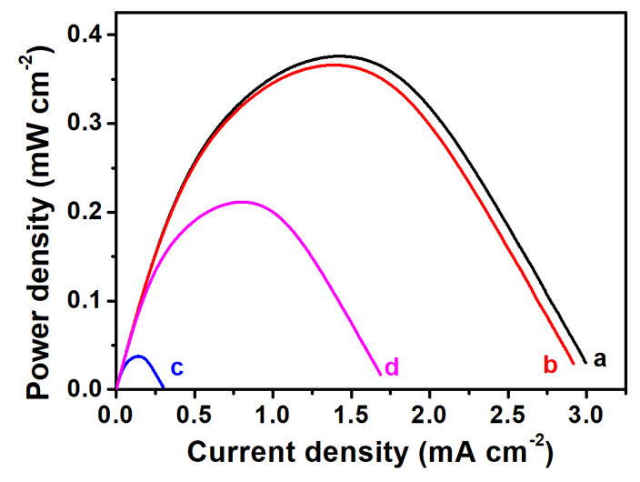
Fig. S4 Output power curves of the PNFC of different cathodes (a-d) and TNA/g-C₃N₄/ZIF-67 as photoanode. (a) ITO/Fe-N-C, (b) ITO/Fe-N-C/cDNA, (c) ITO/Fe-N-C/cDNA/apt-SH in the aerobic solution; (d) ITO/Fe-N-C/cDNA/apt-SH in the aerobic solution containing 50 ng mL⁻¹ of isocarbophos.

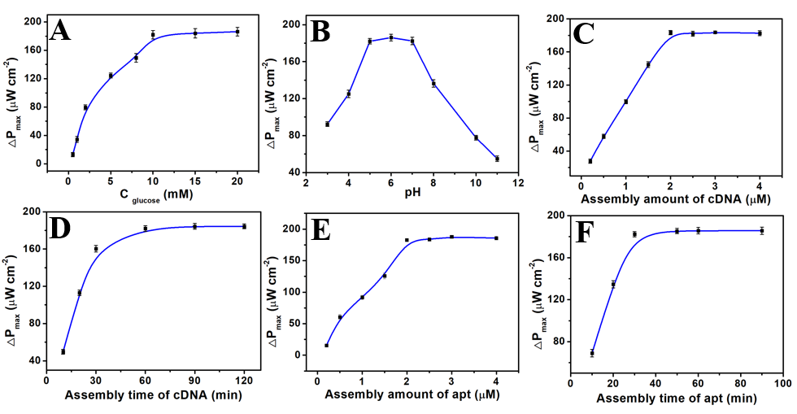
Fig. S5 Effect of experimental conditions on the output power of the PNFC-based self-powered aptasensor. (A) glucose concentration (0.1-20 mM). (B) Medium pH (3-11). (C) Assembly amount of cDNA (0.2-4.0 μM). (D) Assembly time of cDNA (10-120 min). (E) Assembly amount of aptamer (apt) (0.2-4.0 μM). (F) Assembly time of aptamer (10-90 min). Concentration of isocarbophos, 50 ng mL⁻¹.

