Shifts in maize microbial communities and networks are correlated with soil chemical property under different fertilization regimes
Lidong Ji ^{1,2}, Xing Xu ^{1,*}, Fengju Zhang¹, Haili Si ², Lei Li ¹, Guilian Mao ¹
¹School of Agriculture, Ningxia University, Yinchuan, 750021, China
²Institute of Agricultural Resources and Environment, Ningxia Academy of Agriculture and Forestry Sciences, Yinchuan, 750002, China

*Corresponding author:
Xing Xu
School of Agriculture, Ningxia University, Yinchuan, 750021, China
E-mail: xuxingscience@126.com
Lists of tables and figures:
Table S1 Correlation analysis between bacterial and fungal diversity indexes and soil chemical properties.
Table S2 The differences in the bacterial and fungal community structures among samples.
Table S3 The relative abundance of phyla and genera (top 10) for bacteria.
Table S4 The relative abundance of phyla and genera (top 10) for fungi.
Table S5 The results of Monte Carlo permutation test in the RDA in the vegan package of R.
Fig.S1 Rarefaction curves of bacteria (a) and fungi (b).
Fig. S2 Comparison of microbial diversity indexes among all four treatments.
Fig. S3 Shared and unique OTUs in all treatments for bacteria (a) and fungi (b).
Fig. S4 Results of LEfSe analysis showing bacterial taxa that significantly differed in the four treatments (a). Cladogram plotted from LEfSe analysis showing the significant differences (p <0.05) in relative abundance of bacterial taxon among four treatments (b).
Fig. S5 Results of LEfSe analysis showing fungal taxa that significantly differed in the four treatments (a). Cladogram plotted from LEfSe analysis showing the significant differences (p <0.05) in relative abundance of fungal taxon among four treatments (b).
CK (without any treatments), NPK (with only mineral NPK fertilizer (360 kg N ha⁻¹, 120 kg P₂O₅ ha⁻¹, and 45 kg K₂O ha⁻¹)), OF (with only organic fertilizer 9000 kg ha⁻¹), and NPK+OF (mineral NPK fertilizer with organic fertilizer).

Table S1 Correlation analysis between bacterial and fungal diversity indexes and soil chemical properties.
 | Indexes | OM | TN | TP | TK | AN | AP | AK
Bacteria | Observed_species | -0.81** | -0.60* | -0.54 | 0.19 | -0.71* | -0.88** | -0.27
Bacteria | Shannon | -0.63* | -0.39 | -0.40 | 0.26 | -0.52 | -0.76** | -0.10
Bacteria | Chao 1 | -0.90* | -0.75* | -0.61* | 0.02 | -0.81** | -0.93** | -0.47
Fungi | Observed_species | -0.43 | -0.11 | -0.35 | 0.21 | -0.27 | -0.48 | 0.22
Fungi | Shannon | -0.69* | -0.55 | -0.71* | -0.22 | -0.49 | -0.62* | -0.53
Fungi | Chao 1 | -0.59* | -0.37 | -0.28 | 0.22 | -0.51 | -0.65* | 0.15

Table S2 The differences in the bacterial and fungal community structures among samples. The results were analyzed using ANOSIM analysis. p-value < 0.05 (*) and p-value < 0.01 (**) represent the significant difference between the two treatments. CK indicates without any treatments, NPK indicates NPK fertilizer treatment, OF indicates organic fertilizer treatment, NPK+OF indicates treatment of NPK fertilizer combined with organic fertilizer.
Group | Bacteria |  |  | Fungi
Group | R statistic | p-value |  | R statistic | p-value
CK-NPK | 1.0000 | 0.107 |  | 1.0000 | 0.103
CK-OF | 1.0000 | 0.101 |  | 0.6667 | 0.110
CK-NPK+OF | 0.7778 | 0.104 |  | 1.0000 | 0.099
NPK-OF | 1.0000 | 0.108 |  | 1.0000 | 0.106
NPK-NPK+OF | 0.2222 | 0.318 |  | 1.0000 | 0.099
OF-NPK+OF | 0.5185 | 0.187 |  | 1.0000 | 0.101
all | 0.6975 | 0.001** |  | 0.8704 | 0.001**

Table S3 The relative abundance of phyla and genera (top 10) for bacteria. The asterisk (*) follows the taxonomic name represents significant differences (p < 0.05) among the four treatments, respectively.
Classification level | Top 10 bacteria | Relative abundance
Classification level | Top 10 bacteria | CK | NPK | OF | NPK+OF
Phylum | Proteobacteria* | 0.2715 | 0.2224 | 0.2253 | 0.2066
Phylum | Acidobacteriota* | 0.0917 | 0.1490 | 0.1348 | 0.1504
Phylum | Gemmatimonadota* | 0.0682 | 0.1174 | 0.1116 | 0.1084
Phylum | Actinobacteriota | 0.1055 | 0.0873 | 0.0949 | 0.1012
Phylum | Chloroflexi | 0.1014 | 0.0917 | 0.0933 | 0.0834
Phylum | Planctomycetota | 0.0758 | 0.0803 | 0.0835 | 0.0700
Phylum | Bacteroidota* | 0.0712 | 0.0514 | 0.0614 | 0.0855
Phylum | Myxococcota | 0.0502 | 0.0453 | 0.0440 | 0.0438
Phylum | Crenarchaeota | 0.0288 | 0.0337 | 0.0300 | 0.0311
Phylum | Desulfobacterota* | 0.0426 | 0.0276 | 0.0284 | 0.0243
Genus | MND1* | 0.0246 | 0.0200 | 0.0227 | 0.0241
Genus | RB41* | 0.0111 | 0.0208 | 0.0224 | 0.0219
Genus | Pseudomonas | 0.0124 | 0.0267 | 0.0107 | 0.0179
Genus | Haliangium | 0.0118 | 0.0129 | 0.0122 | 0.0119
Genus | Citrifermentans* | 0.0143 | 0.0100 | 0.0094 | 0.0076
Genus | Metagenome* | 0.0096 | 0.0095 | 0.0104 | 0.0078
Genus | Subgroup_10* | 0.0081 | 0.0086 | 0.0077 | 0.0119
Genus | Lysobacter* | 0.0112 | 0.0076 | 0.0074 | 0.0085
Genus | Sphingomonas* | 0.0097 | 0.0080 | 0.0100 | 0.0062
Genus | Defluviicoccus | 0.0115 | 0.0063 | 0.0093 | 0.0048

Table S4 The relative abundance of phyla and genera (top 10) for bacteria. The asterisk (*) follows the taxonomic name represents significant differences (p < 0.05) among the four treatments, respectively.
Classification level | Top 10 fungi | Relative abundance
Classification level | Top 10 fungi | CK | NPK | OF | NPK+OF
Phylum | Ascomycota* | 0.6118 | 0.5464 | 0.4849 | 0.6549
Phylum | Basidiomycota* | 0.0335 | 0.1076 | 0.0735 | 0.0592
Phylum | Mortierellomycota | 0.0692 | 0.0534 | 0.0429 | 0.0555
Phylum | Glomeromycota | 0.0227 | 0.0086 | 0.0184 | 0.0212
Phylum | Chytridiomycota | 0.0227 | 0.0177 | 0.0101 | 0.0113
Phylum | Blastocladiomycota | 0.0001 | 0.0002 | 0.0008 | 0.0000
Phylum | Rozellomycota | 0.0001 | 0.0003 | 0.0001 | 0.0003
Phylum | Olpidiomycota | 0.0000 | 0.0002 | 0.0000 | 0.0004
Phylum | Kickxellomycota | 0.0002 | 0.0000 | 0.0003 | 0.0001
Phylum | Zoopagomycota | 0.0002 | 0.0001 | 0.0000 | 0.0001
Genus | Botryotrichum | 0.2692 | 0.1328 | 0.1895 | 0.1950
Genus | Mortierella | 0.0691 | 0.0531 | 0.0428 | 0.0554
Genus | Fusarium* | 0.0186 | 0.0724 | 0.0193 | 0.0138
Genus | Acremonium* | 0.0821 | 0.0098 | 0.0086 | 0.0058
Genus | Chaetomium | 0.0187 | 0.0136 | 0.0139 | 0.0364
Genus | Clitocybe* | 0.0036 | 0.0005 | 0.0252 | 0.0080
Genus | Neopaxillus* | 0.0073 | 0.0284 | 0.0001 | 0.0003
Genus | Stachybotrys* | 0.0058 | 0.0137 | 0.0081 | 0.0070
Genus | Lophotrichus | 0.0210 | 0.0018 | 0.0046 | 0.0009
Genus | Plectosphaerella* | 0.0190 | 0.0023 | 0.0038 | 0.0008

Table S5. The results of Monte Carlo permutation test in the RDA in the vegan package of R. r² represents the coefficients of determination of soil properties that were related to OTUs. *p<0.05, **p<0.01, ***p<0.001. Soil organic matter (OM), total N (TN), total P (TP), total K (TK), dissolved organic C (AN), available P (AP), available K (AK).
Bacteria
Test: F= 1.4835, 0.004 **
Soil properties | RDA1 | RDA2 | r² | p-value
OM | 0.76694 | -0.64172 | 0.9196 | 0.001 ***
TN | 0.49292 | -0.87007 | 0.6166 | 0.011 *
TP | 0.37449 | -0.92723 | 0.2551 | 0.266
TK | -0.94021 | 0.34059 | 0.1833 | 0.411
AN | 0.59796 | -0.80153 | 0.9478 | 0.001 ***
AP | 0.47998 | -0.87728 | 0.8926 | 0.003 **
AK | -0.27171 | -0.96238 | 0.7909 | 0.004 **
Fungi
Test: F= 2.7082, 0.002 **
Soil properties | RDA1 | RDA2 | r² | p-value
OM | 0.90045 | -0.43495 | 0.5958 | 0.018 *
TN | 0.65143 | -0.75871 | 0.3091 | 0.184
TP | 0.56482 | -0.82521 | 0.4734 | 0.062
TK | -0.96626 | -0.25758 | 0.0611 | 0.774
AN | 0.73856 | -0.67418 | 0.6279 | 0.020 *
AP | 0.60415 | -0.79687 | 0.6951 | 0.007 **
AK | -0.37200 | -0.92823 | 0.5504 | 0.031 *

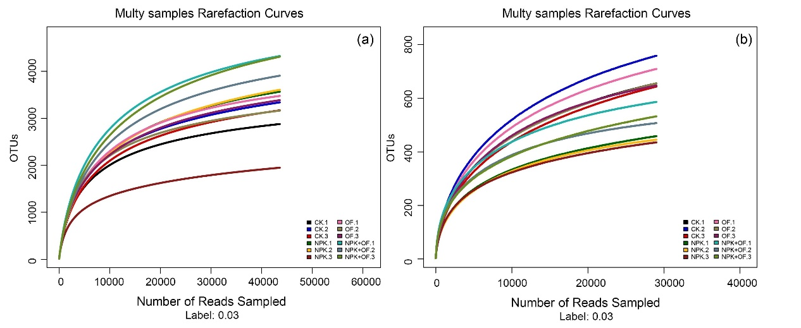
Fig. S1 Rarefaction curves of bacteria (a) and fungi (b).

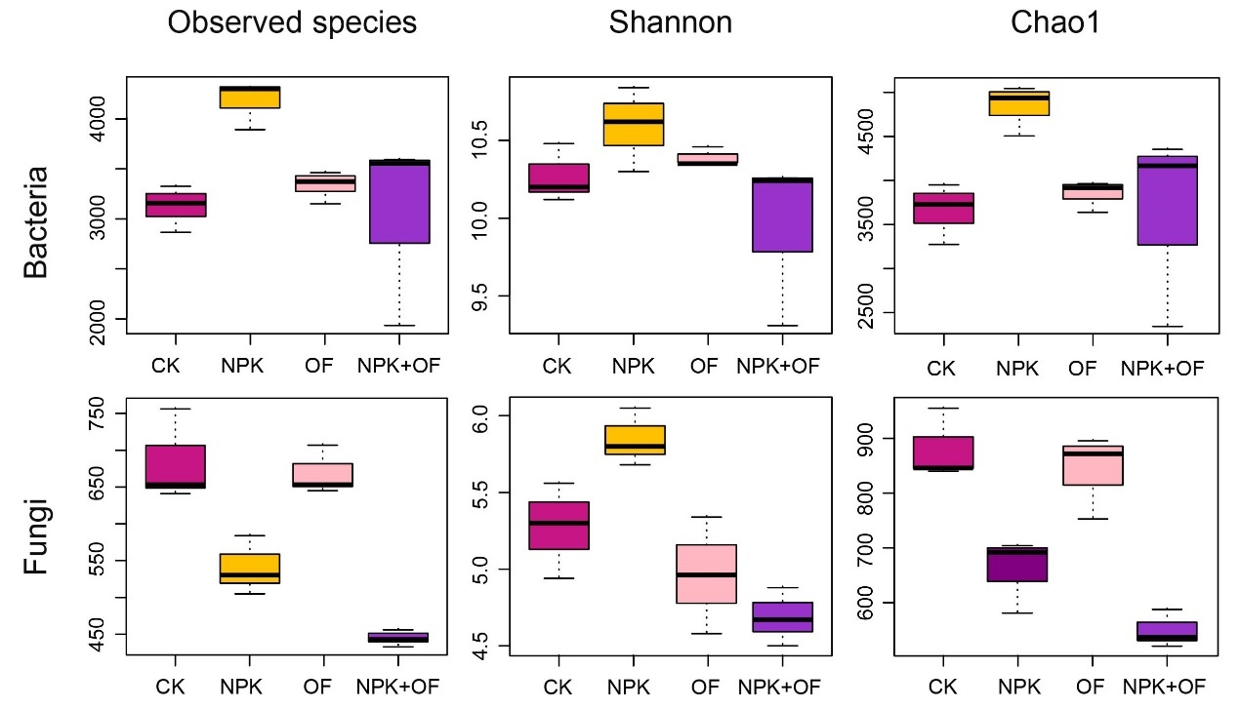
Fig. S2 Shared and unique OTUs in all treatments for bacteria (a) and fungi (b).

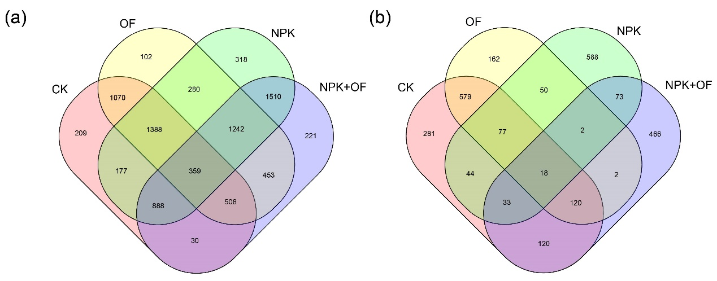
Fig. S3 Comparison of microbial diversity indexes among all four treatments.

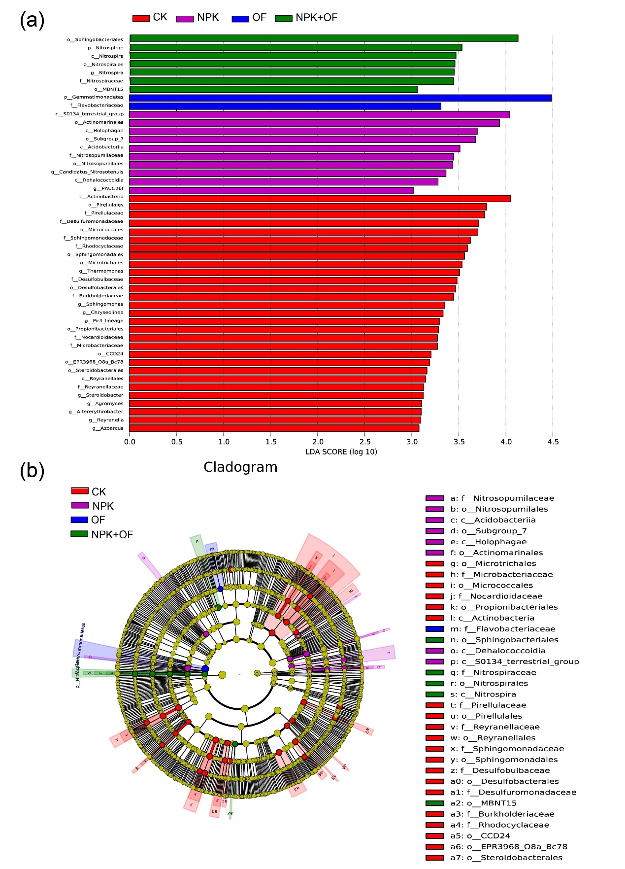
Fig. S4 Results of LEfSe analysis showing bacterial taxa that significantly differed in the four treatments (a). Cladogram plotted from LEfSe analysis showing the significant differences (p <0.05) in relative abundance of bacterial taxon among four treatments (b).
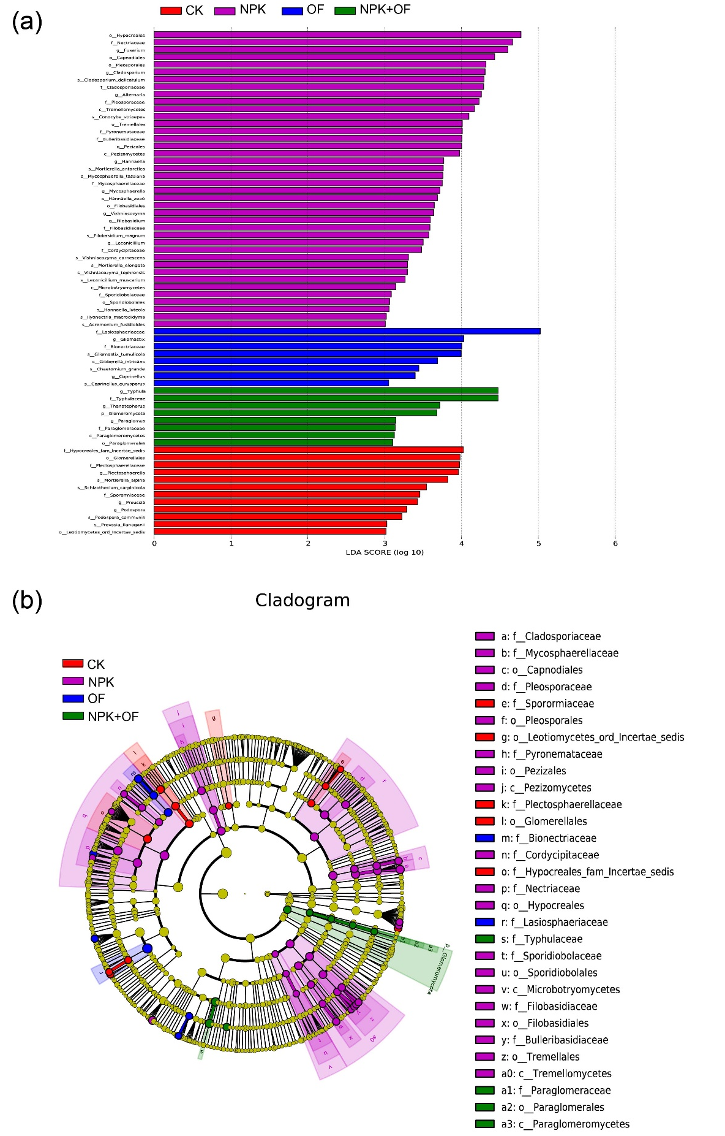
Fig. S5 Results of LEfSe analysis showing fungal taxa that significantly differed in the four treatments (a). Cladogram plotted from LEfSe analysis showing the significant differences (p <0.05) in relative abundance of fungal taxon among four treatments (b).

