Graph 1. Normal Q-Q Plot Number of Poor Population
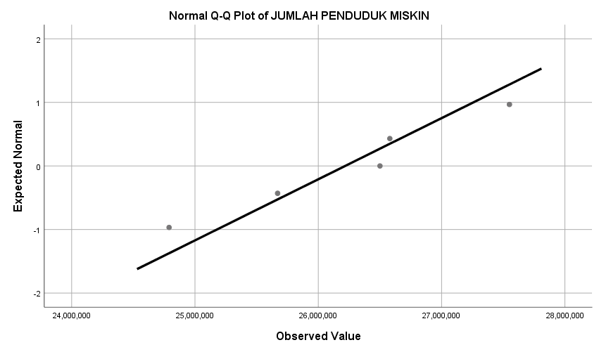
Source: processed data, 2022

Graph 2. Scatterplot of the Number of Poor Population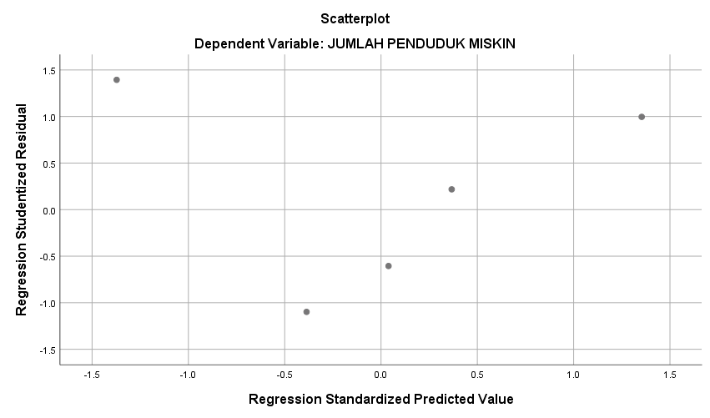
Source: processed data, 2022

