Supplemental Materials, Wilson and Liberles
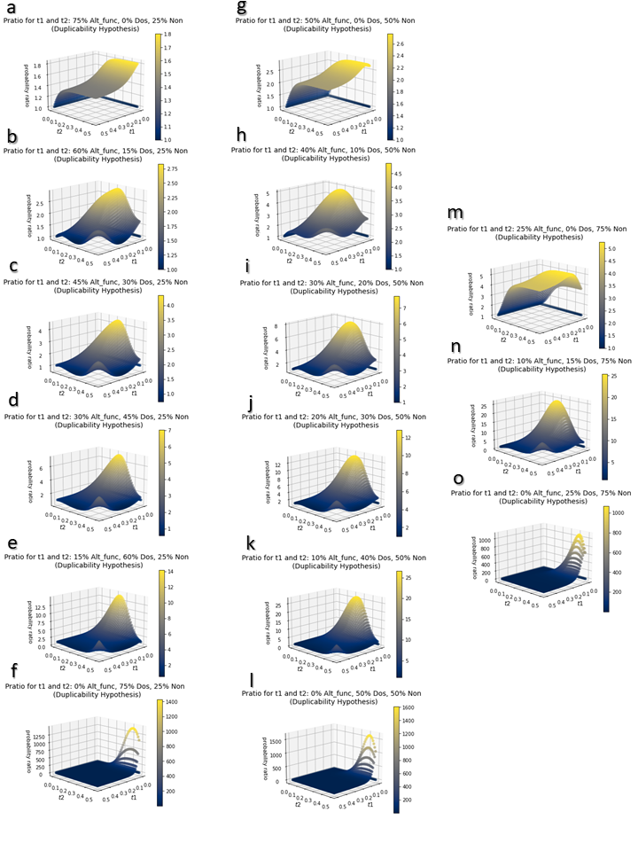
Supplemental Figure 1: Probability ratios for various times for t1 and t2 for given proportion of the starting genome in the Alt_func category, Dos category, and Non category (α_{Alt_func}, α_{Dos}, α_{Non} respectively).
- α_{Alt_func} = 0.75, α_{Dos} = 0.0, α_{Non} = 0.25,
- α_{Alt_func} = 0.60, α_{Dos} = 0.15, α_{Non} = 0.25
- α_{Alt_func} = 0.45, α_{Dos} = 0.3, α_{Non} = 0.25
- α_{Alt_func} = 0.3, α_{Dos} = 0.45, α_{Non} = 0.25
- α_{Alt_func} = 0.15, α_{Dos} = 0.6, α_{Non} = 0.25
- α_{Alt_func} = 0.0, α_{Dos} = 0. 75, α_{Non} = 0.25
- α_{Alt_func} = 0.5, α_{Dos} = 0.0, α_{Non} = 0.5
- α_{Alt_func} = 0.4, α_{Dos} = 0.1, α_{Non} = 0.5
- α_{Alt_func} = 0.3, α_{Dos} = 0.2, α_{Non} = 0.5
- α_{Alt_func} = 0.2, α_{Dos} = 0.3, α_{Non} = 0.5
- α_{Alt_func} = 0.1, α_{Dos} = 0.4, α_{Non} = 0.5
- α_{Alt_func} = 0.0, α_{Dos} = 0.5, α_{Non} = 0.5
- α_{Alt_func} = 0.25, α_{Dos} = 0.0, α_{Non} = 0.75
- α_{Alt_func} = 0.1, α_{Dos} = 0.15, α_{Non} = 0.75
- α_{Alt_func} = 0.0, α_{Dos} = 0.25, α_{Non} = 0.75

