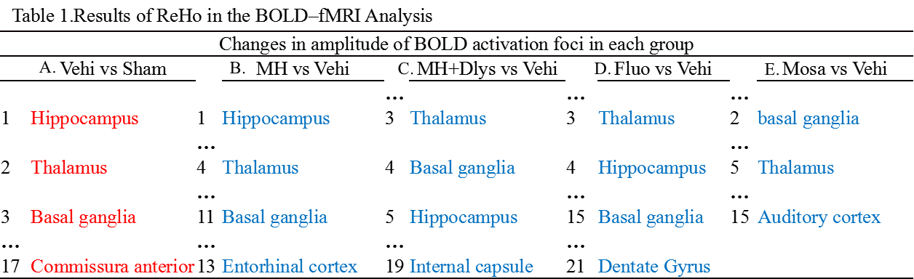
Table 1. The voxel-level height threshold was P < 0.005 (uncorrected) and cluster-extent threshold were 10 voxels. Increased BOLD activation foci: (A) vehicle group versus sham group; decreased BOLD activation foci, (B) MH group versus vehicle group, (C) MH+[D-Lys3]-GHRP-6 group versus vehicle group, (D) fluoxetine group versus vehicle group, and (E) mosapride group versus vehicle.

