Supplementary Figure S1

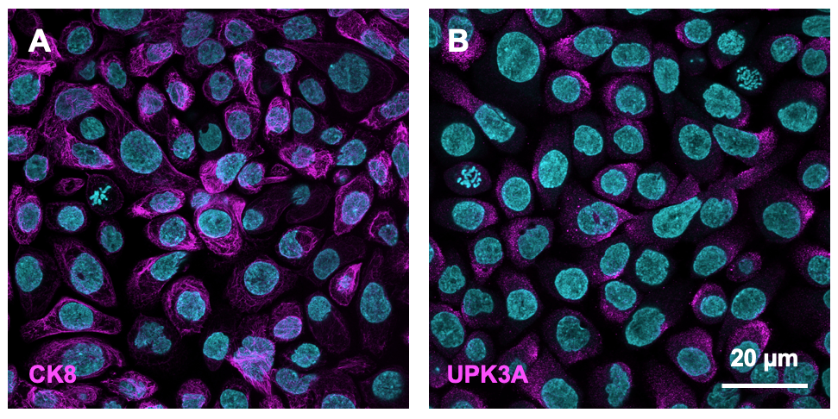

Supplementary Figure S1: 5637 bladder epithelial cells express markers specific to umbrella cells. Immunofluorescence staining of 5637 human bladder epithelial cells for the umbrella cell-specific markers cytokeratin 8 (CK8) (A) and uroplakin IIIa (UPK3A) (B), shown in both cases in magenta. Cell nuclei were labelled with DAPI, shown in cyan. Scale bar: 20 µm for both images.

Supplementary Figure S2

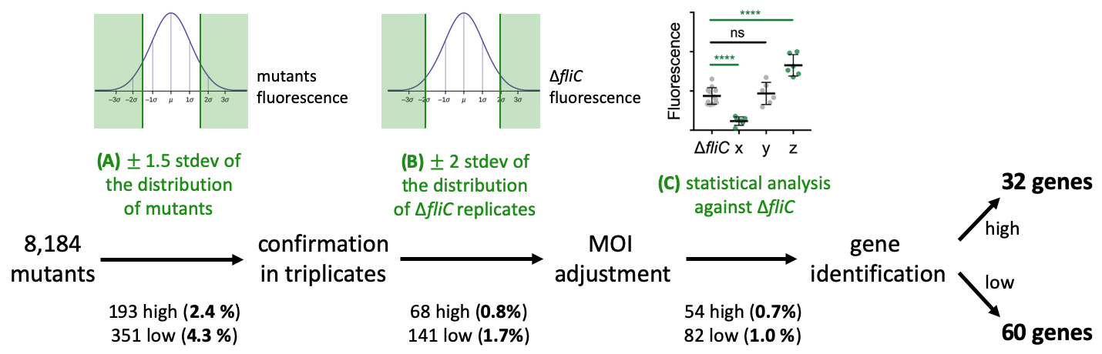

Supplementary Figure S2: Screening procedure and data analysis pipeline. A library of 8,184 UPEC transposon mutants, corresponding to 88 x 96-well plates, was screened to identify mutants exhibiting altered adhesion to bladder epithelial cells using the microscopy-based method described in Figure 1A. (A) For each 96-well plate, the mean GFP fluorescence in each well after spinfection/washing was recorded and mutants with values more than 1.5 standard deviations from the average fluorescence on that plate were selected for retesting. Mutants that did not grow were discarded. (B) Candidate mutants were arrayed in triplicates on a 96-well plate along with 30 replicates of the ∆fliC parental strain and screened following the same procedure. Mutants with values more than 2 standard deviations from the average fluorescence of the ∆fliC parental strain were retained. (C) Overnight cultures of candidate mutants were adjusted to the same final OD₆₀₀ value to ensure the same multiplicity-of-infection (MOI) for each strain, arrayed in 6 replicates per strain on a 96-well plate along with 6 replicates of the ∆fliC parental strain, and screened following the same procedure. For each mutant, the distribution of GFP fluorescence values after spinfection/washing was compared to the distribution for the ∆fliC parental strain using Welch’s t-test and strains with P < 0.05 were selected for further analysis. Genes disrupted were identified as described in the Materials and Methods.
Supplementary Figure S3

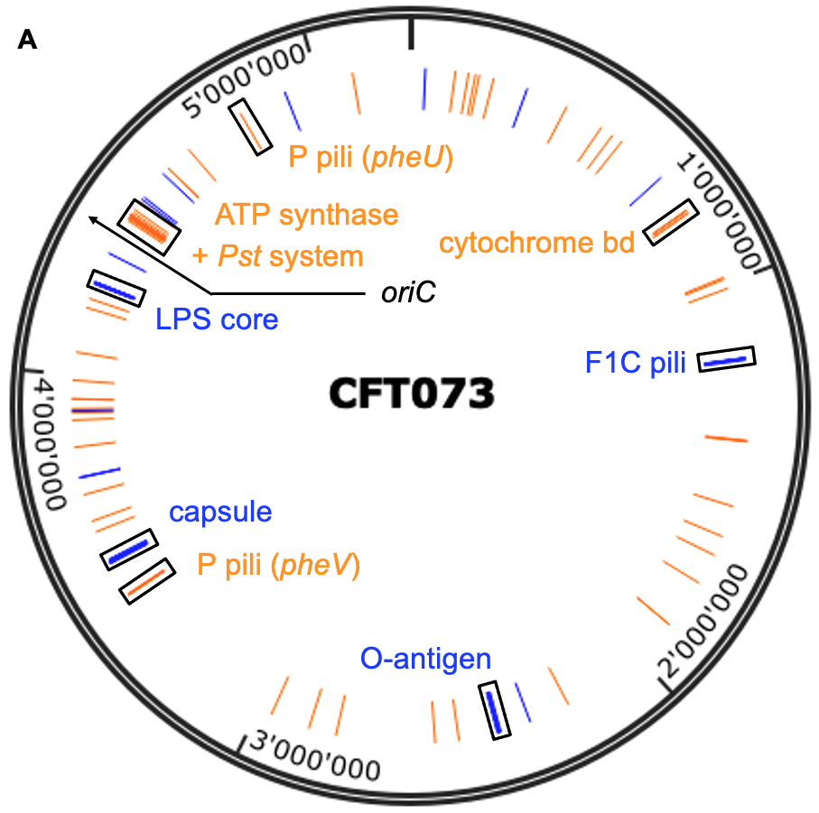
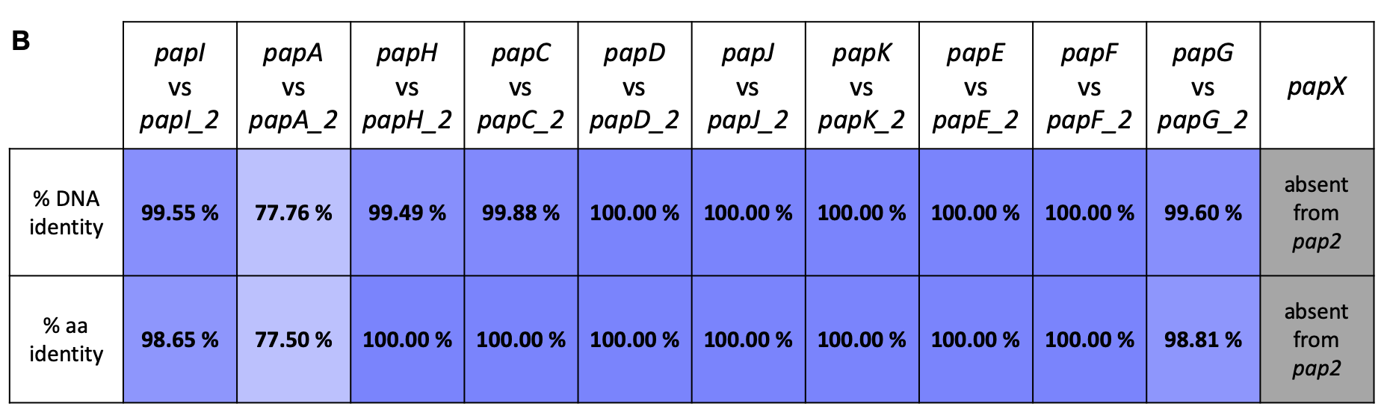

Supplementary Figure S3: Chromosomal transposon insertion sites of UPEC mutants with altered adhesion to bladder epithelial cells. (A) Map of the chromosome of CFT073 showing the position of low-adhesion transposon hits in orange and high-adhesion transposon hits in blue. Hits that are found within the same operon are framed in black and the function of the operon is indicated. The black arrow indicates the position of the origin of replication oriC. (B) Sequence similarity between the pheV (pap1) and pheU (pap2) P pili operons and their associated regulatory genes papI and papX, the latter being absent from the pap2 operon. The percentage of DNA sequence identity between homologous genes was calculated using nBlast. The percentage of amino acid (aa) sequence identity between homologous proteins was calculated using pBlast.

Supplementary Figure S4

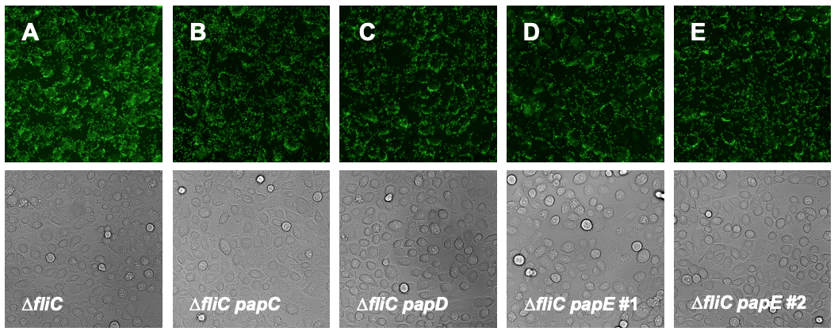
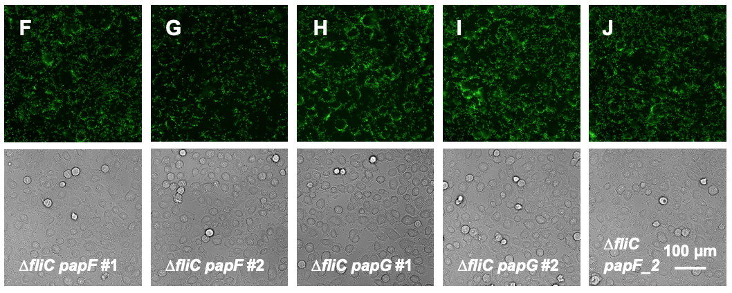

Supplementary Figure S4: Adhesion phenotypes of P pili transposon mutants. Representative images of bladder epithelial cells spinfected with the ∆fliC parental strain (A), ∆fliC papC-Tn (B), ∆fliC papD-Tn (C), ∆fliC papE-Tn #1 (D), ∆fliC papE-Tn #2 (E), ∆fliC papF-Tn #1 (F), ∆fliC papF-Tn #2 (G), ∆fliC papG-Tn #1 (H), ∆fliC papG-Tn #2 (I), and ∆fliC papF_2-Tn (J), imaged on the green fluorescence and phase-contrast channels. Scale bar: 100 µm for all images.

Supplementary Figure S5

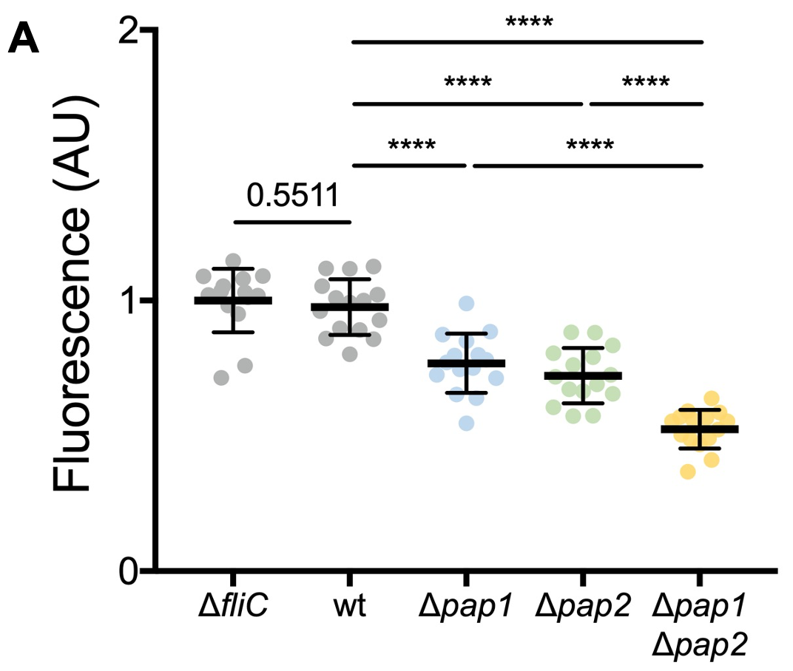
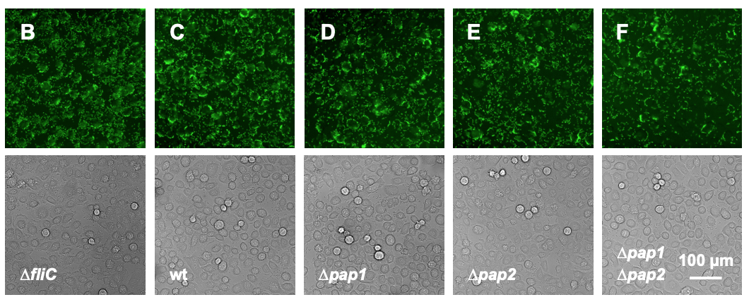

Supplementary Figure S5: Adhesion phenotypes of unmarked P pili operon deletion mutants in the wild-type background. (A) Quantification of GFP fluorescence after spinfection/washing of bladder epithelial cells with the indicated UPEC strains. n = 15 wells from 3 independent experiments; data were normalized to the ∆fliC parental strain; black lines indicate mean and standard deviation; P-values were calculated using Welch’s t-test; **** P < 0.0001. (B-F) Corresponding phase-contrast and green fluorescence images for ∆fliC (B), wild-type (C), ∆pap1 (D), ∆pap2 (E), and ∆pap1 ∆pap2 (F). Scale bar: 100 µm for all images.

Supplementary Figure S6

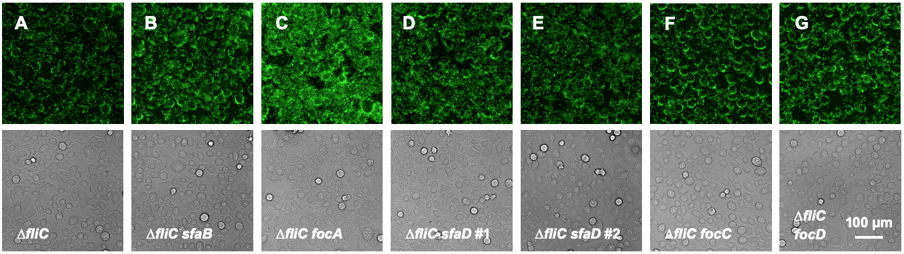

Supplementary Figure S6: Adhesion phenotypes of F1C pili transposon mutants. Representative images of bladder epithelial cells spinfected with the ∆fliC parental strain (A), ∆fliC sfaB-Tn (B), ∆fliC focA-Tn (C), ∆fliC sfaD-Tn #1 (D), ∆fliC sfaD-Tn #2 (E), ∆fliC focC-Tn (F), and ∆fliC focD-Tn (G), imaged on the green fluorescence and phase-contrast channels. Scale bar: 100 µm for all images.

Supplementary Figure S7

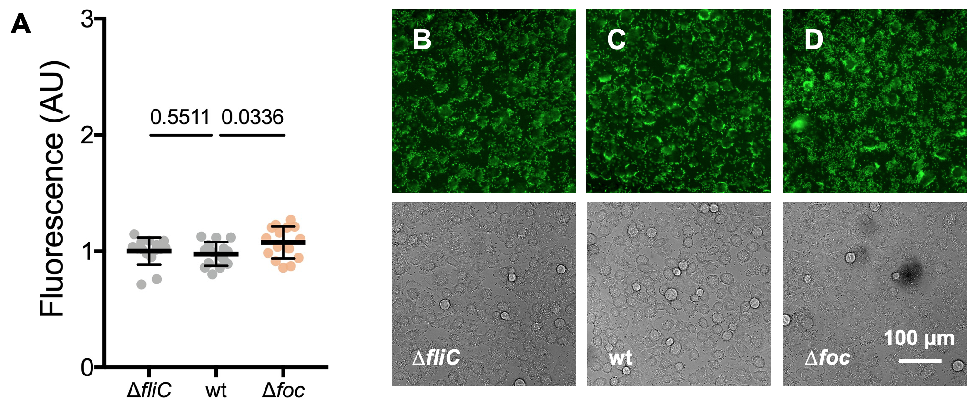

Supplementary Figure S7: Adhesion phenotype of an unmarked F1C pili operon deletion mutant in the wild-type background. (A) Quantification of GFP fluorescence after spinfection/washing of bladder epithelial cells with the indicated UPEC strains. n = 15 wells from 3 independent experiments; data were normalized to the ∆fliC parental strain; black lines indicate mean and standard deviation; P-values were calculated using Welch’s t-test. (B-D) Corresponding phase-contrast and green fluorescence images for ∆fliC (B), wild-type (C), and ∆foc (D). Scale bar: 100 µm for all images.

Supplementary Figure S8

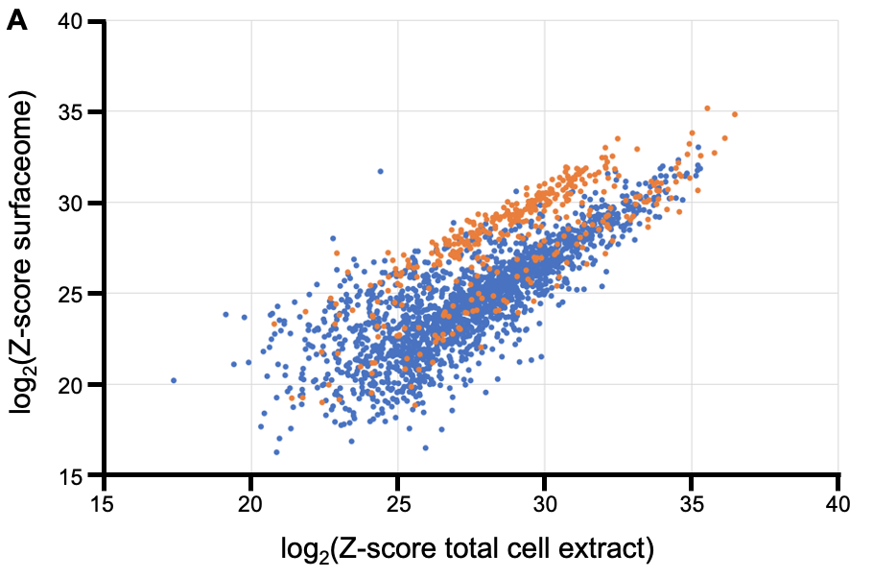
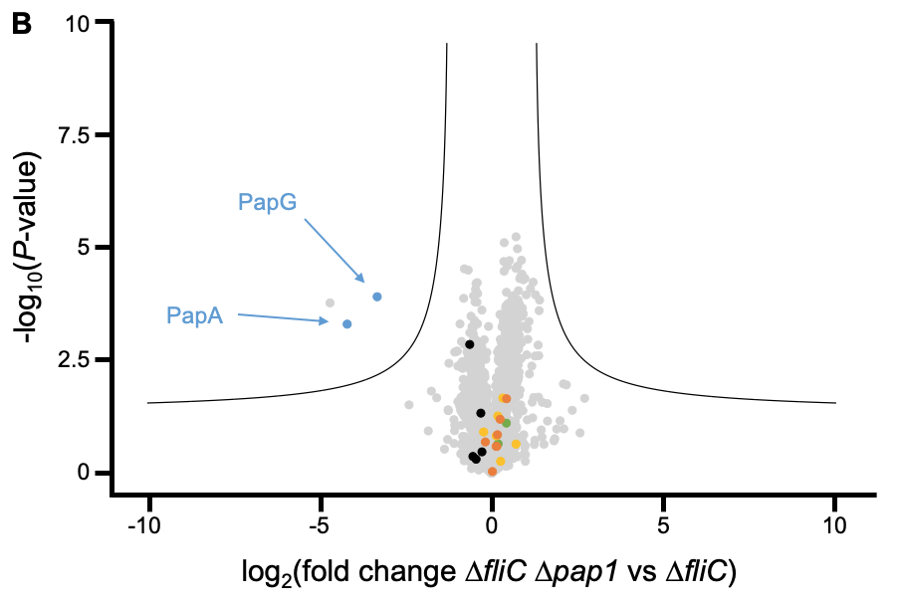
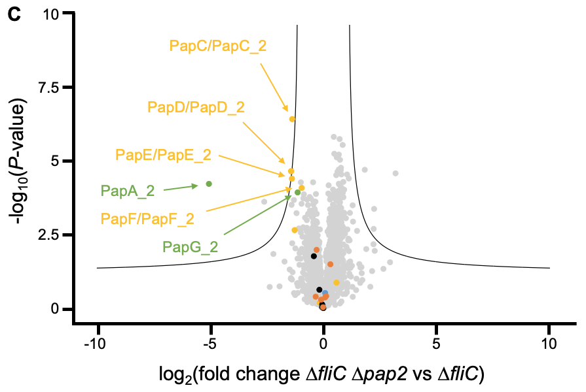
Supplementary Figure S8: Controls related to mass spectrometry analysis of the bacterial surface proteome. (A) Efficiency of the surface protein biotinylation and streptavidin affinity-purification steps. For each protein quantified by mass spectrometry, the Z-score in the surfaceome (corresponding to the fraction of proteins enriched by affinity-purification) is plotted against the Z-score in the total cell extract. Orange: proteins that localize to the outer membrane according to their gene ontology (GO) annotation; blue: other proteins. (B,C) Volcano plots showing changes in surface protein abundances between the ∆fliC ∆pap1 mutant strain and the ∆fliC parental strain (B) or between the ∆fliC ∆pap2 mutant strain and the ∆fliC parental strain (C). Proteins that are part of the following pili operons are colored: type 1 pili (black), P1 pili (blue), P2 pili (green), proteins common to P1 and P2 pili (yellow), F1C pili (orange). The name of the proteins showing a significant change is indicated. n = 4 independent experiments; the black line corresponds to a false discovery rate (FDR) of 0.01 and a S0 of 0.5.

Supplementary Figure S9

background bacterial body pili
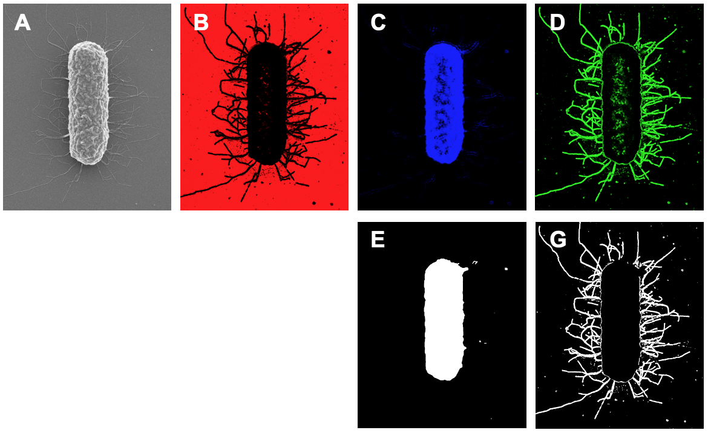
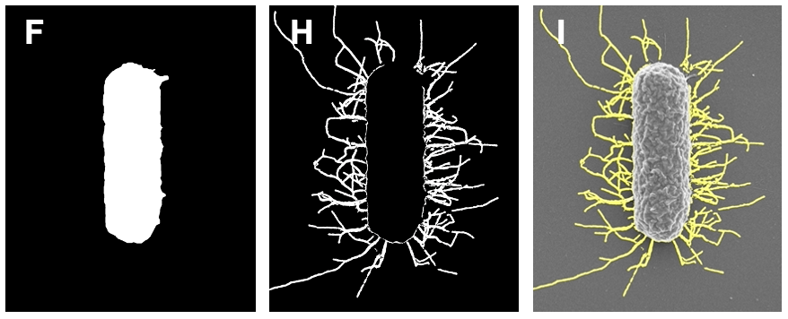

Supplementary Figure S9: Automated quantification of UPEC single-cell piliation on SEM images using Ilastik. (B-D) Channels obtained when applying the trained Ilastik software on the original SEM image shown in (A). (B) Channel 1: background. (C) Channel 2: bacterial body. (D) Channel 3: pili. The image corresponding to the bacterial body (C) is further processed using Fiji to fill holes (E) and keep only circular particles with an area above 250,000 pixels (F). The image corresponding to the pili (D) is then subtracted with the processed bacterial body channel (G) and further processed to keep only non-circular particles with an area above 100 pixels (H). The cleaned pili channel is eventually merged with the original SEM image, resulting in the overlay shown in (I).
Supplementary Figure S10

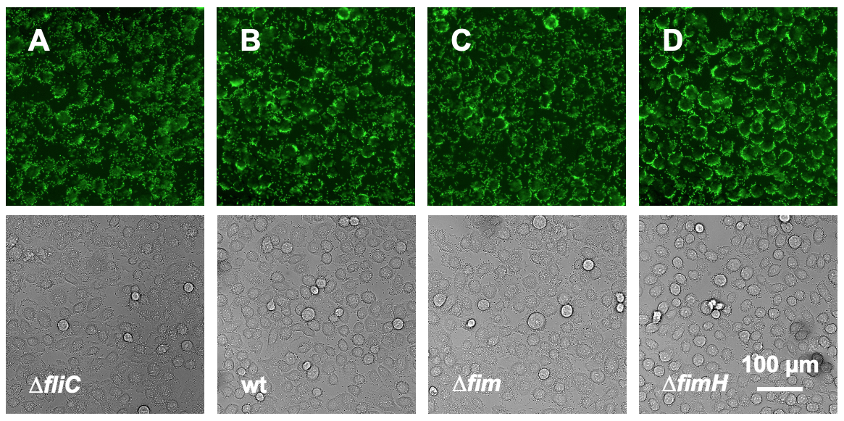
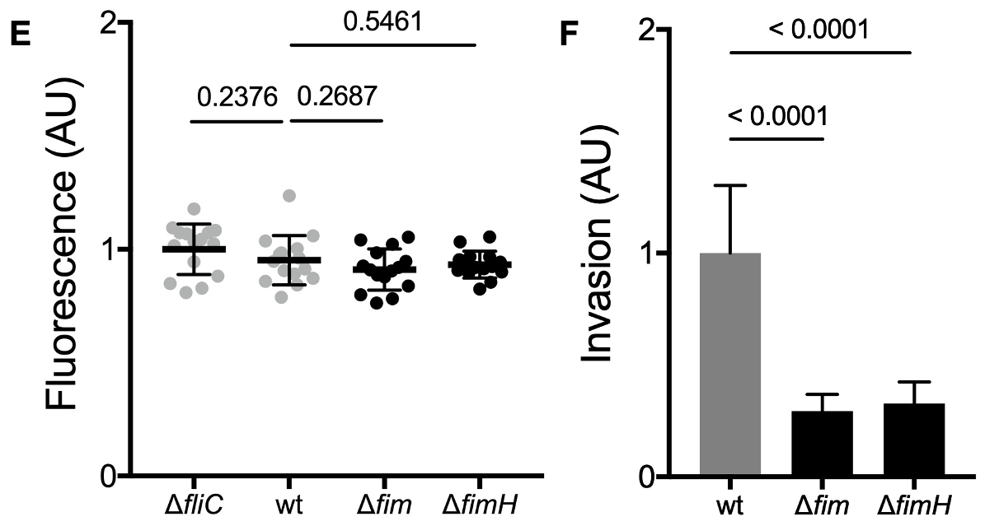

Supplementary Figure S10: Adhesion/invasion phenotypes of unmarked type 1 pili deletion mutants in the wild-type background. (A-D) Representative images of bladder epithelial cells spinfected with ∆fliC (A), wild-type (B), ∆fim (C) and ∆fimH (D). Scale bar: 100 µm for all images. (E) Quantification of GFP fluorescence for each strain. n = 15 wells from 3 independent experiments; data were normalized to the ∆fliC parental strain; black lines indicate mean and standard deviation; P-values were calculated using Welch’s t-test. (F) Quantification of bladder cell invasion for the indicated UPEC strains. n = 3 independent experiments; data were normalized to the wild-type strain; bars indicate mean; error bars indicate standard deviation; P-values were calculated using Welch’s t-test.
Supplementary Table S1: Genes that contribute positively or negatively to early adhesion of UPEC to bladder epithelial cells. Genes corresponding to mutants with increased or decreased adhesion to bladder epithelial cells, along with their KEGG classification, KEGG definition, c accession number in the genome of CFT073, KO accession number in the KEGG database, and number of independent transposon hits in the screen. The individual chromosomal transposon insertion sites are also referenced. Genes that belong to the same operon are framed in black. Transposon insertions that occurred in intergenic regions are indicated in purple.

Supplementary Table S2: Plasmids used in this work

Plasmid name | Description | Reference
pKD4 | kan^{R} template for gene deletion | Datsenko
pKD46 | λ Red recombinase expression under control of P_{BAD} | Datsenko
pCP20 | temperature-sensitive expression of FLP recombinase | Datsenko
pSLC217 | RelE toxin expression under control of P_{RhaB} | Khetrapal
pSLC293 | template for sfGFP expression under control of P_{σ70} | Eshaghi

Supplementary Table S3: Primers used in this work

Primer name | Nucleotide sequence (5’ to 3’) | Reference
attHK_F | GCTGATAAAGCGCAGGTTG | This study
attHK_R | GCGCAACAGGTTATCAGC | This study
fimB_KO_F | GCACAGCTAGTGCGCGTCTGTAATTATAAGGGAAAACGATGAAGT  GTGTAGGCTGGAGCTGCTTCG | This study
fimB_F | GAAGAACTGGTCCACTTACGTTAG | This study
fimH_KO_F | GATTAGCATCACCTATACCTACAGCTGAACCCAAAGAGATGATTTG  TGTAGGCTGGAGCTGCTTCG | This study
fimH_KO_R | GTAATATTGCGTACCTGCATTAGCAATGCCCTGTGATTTCTTTATTG  CATATGAATATCCTCCTTAG | This study
fimH_F | GATGATTCCTCACAATCAGCG | This study
fimH_R | GAACAGACCAGCAAAGTGC | This study
fliC_KO_F | TAATCAACGACTTGCAATATAGGATAACGAATCATGGCACAATGTG  TAGGCTGGAGCTGCTTCG | This study
fliC_KO_R | TGCCGTCAGTCTCAGTTAATCAGGTTACGGCGATTAACCCTGCATA  TGAATATCCTCCTTAG | This study
fliC_F | CAGACGATAACAGGGTTGACGGC | This study
fliC_R | TTGCAATTCCCCTTGTAGGCCTG | This study
focA_KO_F | GTGCGTAGTTCAATTAAAAACAGGAATTAAATATGAAGTTAAAATGT  GTAGGCTGGAGCTGCTTCG | This study
focA_F | TCATAAATGCTGCCTGAGTG | This study
focH_KO_R | AAGAGCAGTAATATCATTACCGCCACAACTGCATTCTAGTTGTAGC  TCATATGAATATCCTCCTTAG | This study
focH_R | TATGACAGACTCGTTCCGTC | This study
P4 | GCGCCATCAGGGCAAAGCCCATCCAGAGTCTTCGGGTCAGGGTTA  AATTCACGGTCGGTGCGTGTAGGCTGGAGCTGCTTC | Eshaghi
P5 | ATAATAAGGCTTTATGCTAGATGCATTCTGCTTTGCGACTCAACCTT  TTTCACCTAAAGTCATATGAATATCCTCCTTAG | Eshaghi
P6 | GCGCCATCAGGGCAAAGCCCATCCAGAGTCTTCGGGTCAGGGTTA  AATTCACGGTCGGTGCTTGACGGCTAGCTCAGTCCTA | Eshaghi
P7 | ATAATAAGGCTTTATGCTAGATGCATTCTGCTTTGCGACTCAACCTT  TTTCACCTAAAGTTTAATGATGATGATGATGATG | Eshaghi
papA_KO_F | ATCGGGTCATTTTAAATTGCCAGATATCTCTGGTGTGTTCAGTATGT  GTAGGCTGGAGCTGCTTCG | This study
papA_F | TAAAAAAGCTGCTGGCGGTG | This study
papA2_F | GGGGCAGCTAAAAAAGGTAC | This study
papG_KO_R | ATCCACAACACTCTATCCGGCTCCGGATAAACCATTTATGGCAATA  TCATATGAATATCCTCCTTAG | This study
papG_R | AATCGCGGATCATTCACCAG | This study
papG2_R | ACATGGACGTAACTCAGTGC | This study
papI_F | GCCATGCAGTAAATCCAGAC | This study
papI2_F | GCGCCGGTTCAGTAAATTAG | This study
R6K_inv1 | ATGGCTCATAACACCCCTTGTATTA | Ducey
R6K_FP1 | ACCTACAACAAAGCTCTCATCAACC | Ducey
R6K_RP1 | CTACCCTGTGGAACACCTACATCT | Ducey

Supplementary Table S4: Primer pairs used for assignment of P pili transposon insertions to the pap1 or pap2 operon

Insertion | First primer | Second primer | Expected size | Extension time | Extension temperature
papC | R6K_FP1 | papA_F or papA2_F | 1.4 kbp | 40 sec | 66°C
papD | R6K_RP1 | papA_F or papA2_F | 3.8 kbp | 105 sec | 66°C
papE #1 | R6K_FP1 | papG_F or papG2_F | 1.9 kbp | 50 sec | 66°C
papE #2 | R6K_RP1 | papG_F or papG2_F | 1.9 kbp | 50 sec | 66°C
papF #1 | R6K_RP1 | papG_F or papG2_F | 1.5 kbp | 40 sec | 66°C
papF #2 | R6K_FP1 | papG_F or papG2_F | 1.3 kbp | 40 sec | 66°C
papG #1 | R6K_FP1 | papG_F or papG2_F | 900 bp | 25 sec | 66°C
papG #2 | R6K_RP1 | papG_F or papG2_F | 200 bp | 15 sec | 66°C
papF_2 | R6K_RP1 | papG_F or papG2_F | 1.4 kbp | 40 sec | 66°C

Supplementary Table S5: qRT-PCR primers used in this work

Primer name | Nucleotide sequence (5’ to 3’) | Reference
q_fimA_F | GGCAATCGTTGTTCTGTCGG | This study
q_fimA_R | AACGGTCCCACCATTAACCG | This study
q_gapA_F | CATCGTTTCCAACGCATCCT | Snyder
q_gapA_R | ACCTTCGATGATGCCGAAGTT | Snyder
q_papA_F | TTTTCGGGTGTCCCAAGTG | This study
q_papA_R | GTTTTCCATGTGGATCGGTG | This study
q_papA2_F | GTGCCTGCAGAAAATGCAGAT | Snyder
q_papA2_R | CCCGTTTTCCACTCGAATCA | Snyder

Bibliography

Datsenko, K. A. & Wanner, B. L. One-step inactivation of chromosomal genes in Escherichia coli K-12 using PCR products. Proc Natl Acad Sci USA 97, 6640–6645 (2000).

Ducey, T. F. & Dyer, D. W. Rapid identification of EZ::TN transposon insertion sites in the genome of Neisseria gonorrhoeae. Epicentre Forum 9, 6-7 (2002).

Eshaghi, M., Mehershahi, K. S. & Chen, S. L. Brighter fluorescent derivatives of UTI89 utilizing a monomeric vGFP. Pathogens 5, (2016).

Khetrapal, V. et al. A set of powerful negative selection systems for unmodified Enterobacteriaceae. Nucleic Acids Res 43, (2015).

Snyder, J. A. et al. Transcriptome of uropathogenic Escherichia coli during urinary tract infection. Infect Immun 72, 9 (2004).

