Appendix
Robustness Checks
Figure A1: Kernel density function of crop yield
- Kharif
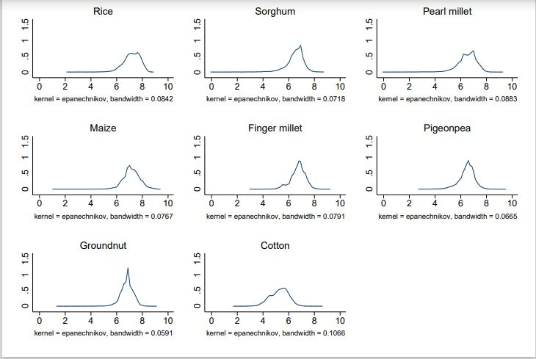
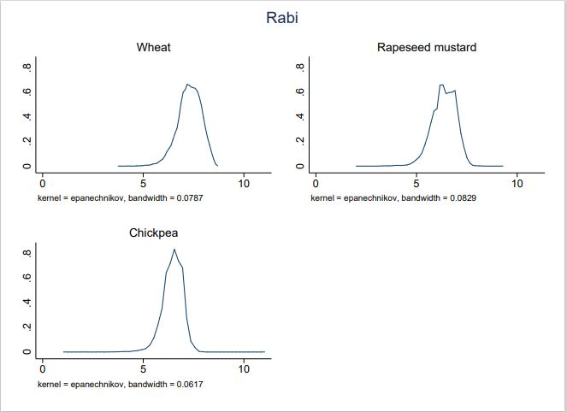
Note: This figure presents the kernel density function of crop yield for different crops across different seasons

Table A1: Mean yield function estimates (considering January 1st as the starting date of the monsoon)
 | (1) | (2) | (3) | (4) | (5) | (6) | (7) | (8) | (9) | (10) | (11)
VARIABLES | Rice | Sorghum | Pearl-millet | Maize | Finger-millet | Pigeon-pea | Groundnut | Cotton | Wheat | Rapeseed-mustard | Chickpea
RD | -0.0008*** | -0.0025*** | -0.0029*** | -0.0025*** | -0.0016*** | -0.0011*** | -0.0016*** | -0.0019*** | -0.0004* | -0.0005 | -0.0003
 | (0.0003) | (0.0005) | (0.0004) | (0.0003) | (0.0003) | (0.0004) | (0.0004) | (0.0004) | (0.0002) | (0.0003) | (0.0003)
GDD | -0.0002 | -0.0000 | 0.0008*** | 0.0001 | 0.0011*** | -0.0005** | -0.0003 | -0.0005** | -0.0001 | 0.0008*** | -0.0000
 | (0.0001) | (0.0003) | (0.0002) | (0.0002) | (0.0002) | (0.0002) | (0.0002) | (0.0002) | (0.0001) | (0.0002) | (0.0002)
HDD | 0.0001 | 0.0002 | -0.0004 | 0.0004** | -0.0001 | 0.0000 | 0.0002 | 0.0007** | 0.0001 | 0.0003 | 0.0001
 | (0.0001) | (0.0003) | (0.0003) | (0.0002) | (0.0002) | (0.0002) | (0.0002) | (0.0003) | (0.0001) | (0.0002) | (0.0002)
RAIN | 0.0001* | -0.0001 | -0.0001 | -0.0003*** | -0.0001** | 0.0001* | 0.0000 | -0.0001 | 0.0000** | 0.0000 | 0.0001*
 | (0.0000) | (0.0000) | (0.0000) | (0.0001) | (0.0000) | (0.0000) | (0.0000) | (0.0001) | (0.0000) | (0.0000) | (0.0000)
SIRR | 0.4260*** | 0.3994*** | 0.2624*** | 0.3998*** | 0.1905*** | -0.0115 | 0.3586*** | 0.4475*** | 0.4583*** | - | 0.0911**
 | (0.0366) | (0.0715) | (0.0849) | (0.0434) | (0.0472) | (0.0628) | (0.0515) | (0.0739) | (0.0417) |  | (0.0382)
SHYV | 0.1548*** | 0.0776** | 0.0490* | 0.0340* | 0.0979*** | - | - | - | 0.0001 | - | -
 | (0.0261) | (0.0357) | (0.0295) | (0.0193) | (0.0367) |  |  |  | (0.0001)
FERT | 0.0008*** | 0.0011*** | 0.0004 | 0.0015*** | 0.0009*** | 0.0006* | -0.0005 | 0.0008** | 0.0009*** | 0.0011*** | 0.0010***
 | (0.0002) | (0.0003) | (0.0003) | (0.0003) | (0.0003) | (0.0003) | (0.0004) | (0.0003) | (0.0002) | (0.0004) | (0.0003)
TRACPH | 1.3399** | 5.8897*** | 0.8122 | -0.7187 | 0.9638** | -0.0772 | 1.8219* | -5.2976*** | 1.2628* | 2.1016 | -2.7257***
 | (0.6552) | (1.3597) | (1.2418) | (0.5225) | (0.4534) | (0.7040) | (1.0116) | (1.1106) | (0.6643) | (1.5949) | (0.7625)
AGLBPH | 0.0129 | -0.3186*** | -0.2806*** | 0.0396 | 0.0318 | 0.1671*** | -0.0367 | -0.2727** | -0.1119*** | 0.0243 | -0.0102
 | (0.0216) | (0.0738) | (0.0725) | (0.0453) | (0.0383) | (0.0453) | (0.0612) | (0.1192) | (0.0173) | (0.0342) | (0.0316)
Observations | 12,531 | 10,194 | 9,040 | 11,818 | 5,017 | 11,141 | 10,553 | 6,727 | 11,391 | 10,469 | 11,730
R-squared | 0.7831 | 0.5964 | 0.6532 | 0.6249 | 0.7005 | 0.5072 | 0.4570 | 0.6110 | 0.8225 | 0.6411 | 0.4981
Mean of dependent variable | 7.169 | 6.492 | 6.481 | 7.160 | 6.731 | 6.460 | 6.772 | 5.282 | 7.284 | 6.352 | 6.454
Note: RD represents the delayed monsoon arrival. Additional control variables are total seasonal growing degree days (GDD) and harmful degree days (HDD), total seasonal rainfall (RAIN), the proportion of cropped area irrigated (SIRR), the proportion of cropped area under high yielding varieties (SHYV), fertilizer used per hectare (FERTPH), number of tractors per hectare (TRACPH) and number of agricultural labor per hectare (AGLBPH). Standard errors are shown in parentheses and robust to within district serial correlation and heteroscedasticity. ***, **, and * represent the significance level at 1%, 5%, and 10% respectively.

Table A2: Variance yield function estimates (considering January 1st as the starting date of the monsoon)
 | (1) | (2) | (3) | (4) | (5) | (6) | (7) | (8) | (9) | (10) | (11)
VARIABLES | Rice | Sorghum | Pearl-millet | Maize | Finger-millet | Pigeon-pea | Groundnut | Cotton | Wheat | Rapeseed-mustard | Chickpea
RD | 0.0004 | 0.0014** | 0.0006* | 0.0004 | 0.0005** | 0.0006** | 0.0010** | 0.0007 | -0.0002 | 0.0004 | 0.0007
 | (0.0003) | (0.0006) | (0.0003) | (0.0003) | (0.0003) | (0.0003) | (0.0004) | (0.0005) | (0.0002) | (0.0003) | (0.0005)
GDD | -0.0002* | 0.0005 | 0.0001 | 0.0000 | 0.0000 | -0.0002 | 0.0003 | 0.0005** | 0.0002** | -0.0003** | -0.0005**
 | (0.0001) | (0.0003) | (0.0003) | (0.0002) | (0.0002) | (0.0002) | (0.0002) | (0.0002) | (0.0001) | (0.0002) | (0.0002)
HDD | -0.0002* | 0.0002 | 0.0004* | -0.0002 | 0.0003* | 0.0003 | 0.0003* | -0.0003 | 0.0002* | 0.0003 | 0.0002
 | (0.0001) | (0.0003) | (0.0002) | (0.0002) | (0.0002) | (0.0002) | (0.0002) | (0.0003) | (0.0001) | (0.0002) | (0.0002)
RAIN | -0.0000 | 0.0000 | 0.0000 | 0.0001*** | 0.0000 | -0.0001 | -0.0000 | 0.0001** | -0.0000 | 0.0000 | 0.0000
 | (0.0000) | (0.0000) | (0.0000) | (0.0000) | (0.0000) | (0.0000) | (0.0000) | (0.0000) | (0.0000) | (0.0000) | (0.0000)
SIRR | -0.0094 | -0.1010** | -0.1077*** | -0.0678** | -0.0120 | -0.1263*** | -0.1209*** | -0.0371 | -0.0316 | - | -0.0523
 | (0.0296) | (0.0465) | (0.0406) | (0.0275) | (0.0307) | (0.0416) | (0.0422) | (0.0410) | (0.0220) |  | (0.0423)
SHYV | -0.0193 | 0.0344 | 0.0274 | -0.0127 | 0.0084 | - | - | - | -0.0001 | - | -
 | (0.0135) | (0.0452) | (0.0218) | (0.0169) | (0.0143) |  |  |  | (0.0000)
FERT | 0.0002* | -0.0003 | -0.0001 | -0.0000 | 0.0002 | -0.0007*** | 0.0002 | -0.0009*** | -0.0001* | 0.0000 | 0.0001
 | (0.0001) | (0.0003) | (0.0002) | (0.0002) | (0.0001) | (0.0002) | (0.0002) | (0.0003) | (0.0001) | (0.0003) | (0.0001)
TRACPH | 0.0013 | -2.1585* | 0.7181 | 0.3118 | 0.2560 | -1.5190*** | -0.5620 | 2.3642*** | 0.0277 | 0.2312 | -0.7346*
 | (0.1802) | (1.0974) | (0.5591) | (0.3422) | (0.2809) | (0.4109) | (0.4646) | (0.6884) | (0.1434) | (0.3703) | (0.3808)
AGLBPH | 0.0212* | -0.0482 | 0.0481 | -0.0233 | -0.0456 | -0.0189 | 0.0204 | -0.1858** | -0.0137 | 0.0294 | 0.0034
 | (0.0116) | (0.0446) | (0.0359) | (0.0344) | (0.0526) | (0.0359) | (0.0205) | (0.0833) | (0.0096) | (0.0234) | (0.0352)
Observations | 12,531 | 10,194 | 9,040 | 11,818 | 5,017 | 11,141 | 10,553 | 6,727 | 11,391 | 10,469 | 11,730
R-squared | 0.1468 | 0.1499 | 0.1991 | 0.0936 | 0.1783 | 0.1359 | 0.1730 | 0.1545 | 0.1618 | 0.1933 | 0.1019
Mean of dependent variable | 0.0942 | 0.193 | 0.186 | 0.145 | 0.0973 | 0.181 | 0.132 | 0.184 | 0.0638 | 0.126 | 0.128
Note: RD represents the delayed monsoon arrival. Additional control variables are total seasonal growing degree days (GDD) and harmful degree days (HDD), total seasonal rainfall (RAIN), the proportion of cropped area irrigated (SIRR), the proportion of cropped area under high yielding varieties (SHYV), fertilizer used per hectare (FERTPH), number of tractors per hectare (TRACPH) and number of agricultural labor per hectare (AGLBPH). Standard errors are shown in parentheses and robust to within district serial correlation and heteroscedasticity. ***, **, and * represent the significance level at 1%, 5%, and 10% respectively.

Table A3: Skewness yield function estimates (considering January 1st as the starting date of the monsoon)
 | (1) | (2) | (3) | (4) | (5) | (6) | (7) | (8) | (9) | (10) | (11)
VARIABLES | Rice | Sorghum | Pearl-millet | Maize | Finger-millet | Pigeon-pea | Groundnut | Cotton | Wheat | Rapeseed-mustard | Chickpea
RD | -0.0008 | -0.0037 | -0.0014* | 0.0005 | -0.0005 | -0.0004 | -0.0023* | 0.0007 | 0.0002 | 0.0012** | -0.0009
 | (0.0008) | (0.0031) | (0.0008) | (0.0012) | (0.0005) | (0.0006) | (0.0013) | (0.0010) | (0.0003) | (0.0006) | (0.0022)
GDD | 0.0005* | -0.0023* | -0.0005 | 0.0010 | 0.0004 | 0.0001 | -0.0011* | -0.0006 | -0.0003 | -0.0002 | 0.0016*
 | (0.0003) | (0.0014) | (0.0009) | (0.0010) | (0.0004) | (0.0006) | (0.0007) | (0.0004) | (0.0002) | (0.0002) | (0.0009)
HDD | 0.0006* | 0.0003 | -0.0009 | 0.0001 | -0.0005 | -0.0000 | -0.0002 | -0.0000 | 0.0001 | 0.0002 | -0.0004
 | (0.0003) | (0.0012) | (0.0007) | (0.0006) | (0.0003) | (0.0004) | (0.0004) | (0.0005) | (0.0002) | (0.0002) | (0.0005)
RAIN | 0.0000 | 0.0000 | 0.0000 | -0.0001 | -0.0000 | 0.0001 | 0.0001 | -0.0000 | -0.0000 | -0.0000 | 0.0001
 | (0.0001) | (0.0001) | (0.0001) | (0.0001) | (0.0000) | (0.0001) | (0.0001) | (0.0001) | (0.0000) | (0.0001) | (0.0001)
SIRR | -0.0653 | 0.0899 | 0.1043 | 0.1690* | -0.0061 | 0.0434 | 0.0707 | -0.0407 | -0.0048 | - | 0.0515
 | (0.0799) | (0.0996) | (0.0905) | (0.0908) | (0.0363) | (0.0873) | (0.0966) | (0.0794) | (0.0419) |  | (0.1305)
SHYV | 0.0982** | -0.2108 | 0.0333 | 0.0651* | -0.0090 | - | - | - | 0.0000 | - | -
 | (0.0412) | (0.2397) | (0.0728) | (0.0391) | (0.0202) |  |  |  | (0.0001)
FERT | -0.0004** | 0.0020 | 0.0005 | 0.0003 | 0.0002 | 0.0001 | 0.0004 | 0.0001 | -0.0001 | -0.0005 | -0.0002
 | (0.0002) | (0.0012) | (0.0009) | (0.0004) | (0.0003) | (0.0003) | (0.0005) | (0.0004) | (0.0001) | (0.0008) | (0.0003)
TRACPH | 0.2972 | 4.8220** | 0.8550 | -0.5057 | -0.0415 | 1.6534 | 1.6820 | -0.7669 | 0.3644 | 0.2529 | 1.0324
 | (0.4404) | (2.4397) | (1.7047) | (0.7778) | (0.3328) | (1.2546) | (1.1365) | (1.1530) | (0.2924) | (1.0400) | (0.6847)
AGLBPH | -0.0541* | 0.0504 | -0.1246 | 0.1362 | -0.1253 | 0.1495** | -0.0890 | -0.0130 | 0.0012 | 0.0715* | 0.1380
 | (0.0322) | (0.1726) | (0.1210) | (0.1451) | (0.1209) | (0.0596) | (0.0649) | (0.1798) | (0.0118) | (0.0432) | (0.1063)
Observations | 12,531 | 10,194 | 9,040 | 11,818 | 5,017 | 11,141 | 10,553 | 6,727 | 11,391 | 10,469 | 11,730
R-squared | 0.0537 | 0.0400 | 0.0466 | 0.0347 | 0.1031 | 0.0446 | 0.0706 | 0.0486 | 0.0296 | 0.0434 | 0.0414
Mean of dependent variable | -0.0437 | -0.121 | -0.0894 | -0.0611 | -0.0215 | -0.0719 | -0.0614 | -0.0394 | -0.00995 | -0.0177 | -0.0490
Note: RD represents the delayed monsoon arrival. Additional control variables include total seasonal growing degree days (GDD) and harmful degree days (HDD), total seasonal rainfall (RAIN), the proportion of cropped area irrigated (SIRR), the proportion of cropped area under high yielding varieties (SHYV), fertilizer used per hectare (FERTPH), number of tractors per hectare (TRACPH) and number of agricultural labor per hectare (AGLBPH). Standard errors are shown in parentheses and robust to within district serial correlation and heteroscedasticity.***, **, and * represent the significance level at 1%, 5%, and 10% respectively.

Table A4: Kurtosis yield function estimates (considering January 1st as the starting date of the monsoon)
 | (1) | (2) | (3) | (4) | (5) | (6) | (7) | (8) | (9) | (10) | (11)
VARIABLES | Rice | Sorghum | Pearl-millet | Maize | Finger-millet | Pigeon-pea | Groundnut | Cotton | Wheat | Rapeseed-mustard | Chickpea
RD | 0.0021 | 0.0185 | 0.0040** | -0.0044 | 0.0018 | 0.0028* | 0.0074* | -0.0003 | -0.0006 | -0.0001 | 0.0119
 | (0.0026) | (0.0177) | (0.0019) | (0.0054) | (0.0013) | (0.0015) | (0.0041) | (0.0027) | (0.0005) | (0.0010) | (0.0104)
GDD | -0.0015* | 0.0105 | 0.0018 | -0.0050 | 0.0007 | -0.0013 | 0.0037 | 0.0005 | 0.0004 | -0.0010 | -0.0045
 | (0.0008) | (0.0076) | (0.0032) | (0.0048) | (0.0008) | (0.0015) | (0.0024) | (0.0010) | (0.0004) | (0.0006) | (0.0044)
HDD | -0.0019** | 0.0006 | 0.0022 | 0.0019 | 0.0010 | -0.0003 | -0.0000 | 0.0007 | 0.0003 | 0.0016* | 0.0003
 | (0.0010) | (0.0061) | (0.0018) | (0.0022) | (0.0007) | (0.0009) | (0.0013) | (0.0010) | (0.0004) | (0.0009) | (0.0017)
RAIN | 0.0000 | -0.0001 | -0.0000 | 0.0002 | 0.0000 | -0.0003** | -0.0001 | 0.0001 | 0.0000 | 0.0002 | 0.0006
 | (0.0002) | (0.0005) | (0.0003) | (0.0004) | (0.0001) | (0.0002) | (0.0002) | (0.0001) | (0.0000) | (0.0001) | (0.0004)
SIRR | 0.2207 | -0.5601** | -0.4078** | -0.6597 | -0.0878 | -0.1652 | -0.5484** | -0.1158 | -0.0044 | - | -0.1979
 | (0.2797) | (0.2781) | (0.1824) | (0.4037) | (0.0763) | (0.1184) | (0.2193) | (0.1574) | (0.0904) | - | (0.4432)
SHYV | -0.2481** | 1.3131 | -0.0231 | -0.2349 | 0.0507 | - | - | - | -0.0000
 | (0.1210) | (1.3834) | (0.2545) | (0.1511) | (0.0405) |  |  |  | (0.0001)
FERT | 0.0016*** | -0.0090 | -0.0010 | -0.0011 | 0.0009 | -0.0017** | -0.0004 | -0.0011 | 0.0000 | 0.0007 | -0.0004
 | (0.0005) | (0.0067) | (0.0025) | (0.0015) | (0.0007) | (0.0008) | (0.0012) | (0.0007) | (0.0002) | (0.0015) | (0.0010)
TRACPH | -0.0858 | -16.6999* | 1.1905 | 2.3900 | 0.8528 | -2.8399* | -4.7304 | 3.8509** | -0.1784 | 0.7903 | -1.7257
 | (0.7582) | (9.1820) | (3.5925) | (3.1192) | (1.1285) | (1.5911) | (3.0896) | (1.8075) | (0.4662) | (0.6243) | (2.0066)
AGLBPH | 0.0617 | -1.0228 | 0.4148 | -0.7394 | -0.2768 | -0.2362 | 0.3417* | -0.5929* | -0.0310 | 0.0648 | 0.5231
 | (0.0605) | (0.9158) | (0.2867) | (0.6916) | (0.2743) | (0.1801) | (0.2052) | (0.3018) | (0.0265) | (0.1162) | (0.4057)
Observations | 12,531 | 10,194 | 9,040 | 11,818 | 5,017 | 11,141 | 10,553 | 6,727 | 11,391 | 10,469 | 11,730
R-squared | 0.0560 | 0.0380 | 0.0657 | 0.0317 | 0.1273 | 0.0634 | 0.0680 | 0.0697 | 0.0439 | 0.0936 | 0.0376
Mean of dependent variable | 0.138 | 0.497 | 0.370 | 0.226 | 0.107 | 0.258 | 0.223 | 0.208 | 0.0386 | 0.137 | 0.217
Note: RD represents the delayed monsoon arrival. Additional control variables include total seasonal growing degree days (GDD) and harmful degree days (HDD), total seasonal rainfall (RAIN), the proportion of cropped area irrigated (SIRR), the proportion of cropped area under high yielding varieties (SHYV), fertilizer used per hectare (FERTPH), number of tractors per hectare (TRACPH) and number of agricultural labor per hectare (AGLBPH). Standard errors are shown in parentheses and robust to within district serial correlation and heteroscedasticity. ***, **, and * represent the significance level at 1%, 5%, and 10% respectively.

