Supplementary file 1- The process of designing and producing the mobile application for pregnant women

Figure 1 show that how we arranged application. In steps one to four, the content, program capabilities, design in the form of a software program, adaptability and usability for pregnant women were discussed. In the final stage, the effectiveness of the educational intervention was performed by a randomized controlled trial. The process of the five steps was as follows: 1-Defining the conceptual framework, bearing in mind the system’s properties and development of appropriate content, 2-Approving the conceptual framework and system of delivery, 3-Arrangement and adjustment of the conceptual framework and content (tailoring), bearing in mind the users’ characteristics, 4-Performance assessment, and, 5-Data collection and analysis. During the first to 4th step, the software has been developed and debugged. In the 5th step, a clinical trial was conducted through the controlled randomized clinical trial.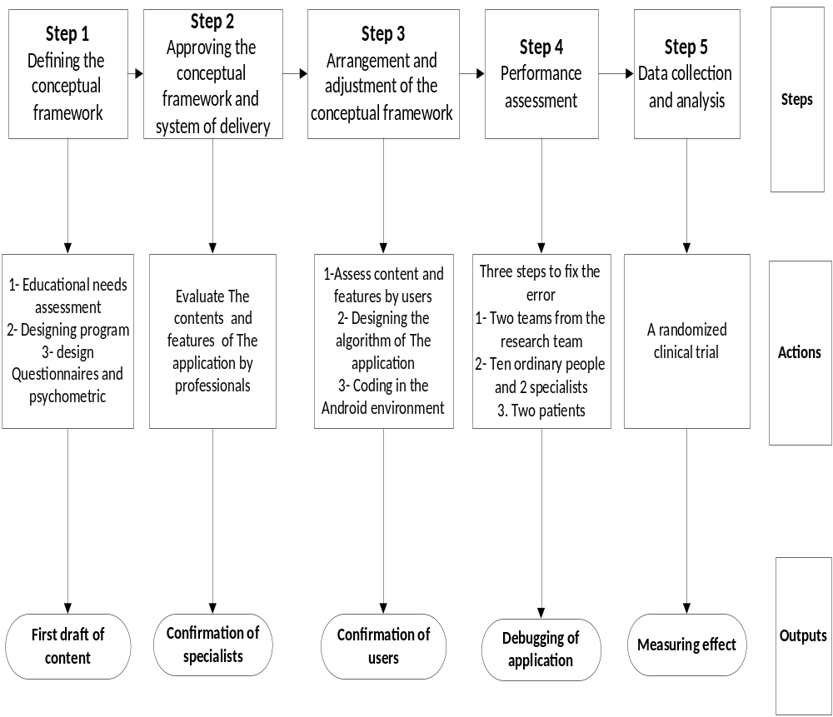
We have used this figure from Ashoorkhani study (The Effect of the Mobile ‘Blood Pressure Management Application’ on Hypertension Self-Management Enhancement: A Randomized Controlled Trial)

Smartphone application; some of the pages of application (Persian)

